|  |  |  |  |  |  |  |  |  |  |  |  |
| --- | --- | --- | --- | --- | --- | --- | --- | --- | --- | --- | --- |
| Hotspot Mobiles, TC/4/192/1,Old No.SP-1/726,  Karyavattom, Trivandrum, Kerala  695581  **Phone : 9562440770, 9633661169**  **Email :** [**hotspotmobiles000@gmail.com**](mailto:hotspotmobiles000@gmail.com) | | | | |  | | INVOICE- {invoiceNumber} | | | | |
|  | | | | |  | | | |  | | |
| INVOICE COMPOSITION SCHEME(B2C ) | | | | | | | | | | | |
| Invoice No : | | {invoiceNumber} | | | | | | |  | | |
| Date : | | {date} | | | | | | |  | | |
| Invoice To : | | | | | Mob : | {mobile} | | | | | |
| {invoiceTo} | | | | | Email : | {email} | | | | | |
| {place} | | | | | State : | {state} | | Code : | | {code} | |
|  | | | | | | | | | | | |
| SL NO | Item Name | | GST% | HSN No | | Qty | Rate | | | | Amount |
| {#items}{slNo} | {itemName} | | {gst} | {hsnNo} | | {qty} | {rate} | | | | {amount}{/items} |
|  |  | |  |  | |  |  | | | |  |

## Other Charges:

**Net** **Amount** **:** **2,033.05**

Amount in Words : Rs. Two Thousand Three Hundred Ninety-Nine And Zero Paise Only

All the Particulars shown in this invoice are true and correct

# Thanks Visit Again - HOTSPOT MOBILES

**CGST** **:**

**SGST** **:**

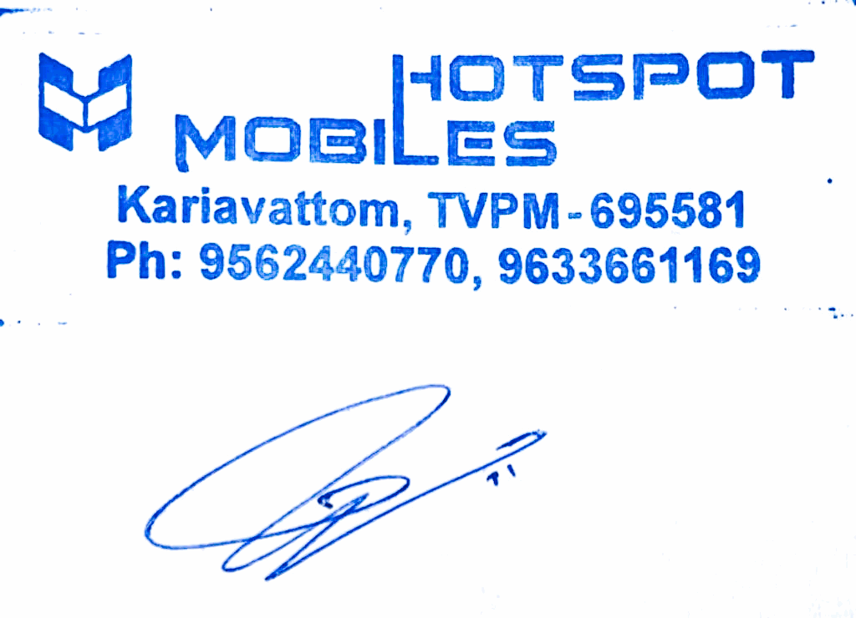**Total** **Amount** **:** **Other** **Charges** **:** **RoundOff** **:**

182.98

182.98

**2,399.00**

0.00

0.00

**Page** **1** **of** **1**