{{invoiceNumber}}

|  |  |  |  |  |  |  |
| --- | --- | --- | --- | --- | --- | --- |
| Hotspot Mobiles, TC/4/192/1,Old No.SP-1/726,  Karyavattom, Trivandrum, Kerala  695581  **Phone : 9562440770, 9633661169**  **Email :** [**hotspotmobiles000@gmail.com**](mailto:hotspotmobiles000@gmail.com) | |  | | | INVOICE | |
|  | |  | | |  | |
| INVOICE COMPOSITION SCHEME(B2C ) | | | | | | |
| Invoice No : |  | | | |  | |
| Date : |  | | | |  | |
| Invoice To : | | Mob : |  | | | |
|  | | Email : |  | | | |
|  | | State : |  | Code : | |  |

|  |  |  |  |  |  |  |  |
| --- | --- | --- | --- | --- | --- | --- | --- |
| **SL.** **NO** | **Item** **Name** | **Gst%** | **HSN** **No** |  | **Qty** | **Rate** | **Amount** |
| 1 | REALME 10000MAH 30W DART CHARGE POWER BANK  MODEL:RMA156  S/N:201215400156002688 COLOR:BLACK | 18.00 |  |  | 1.00 NA | 2,399.00 | 2,399.00 |
| **TOTAL** | | |  |  | **1.00** |  | **2,399.00** |

## Other Charges:

**Net** **Amount** **:** **2,033.05**

Amount in Words : Rs. Two Thousand Three Hundred Ninety-Nine And Zero Paise Only

All the Particulars shown in this invoice are true and correct

# Thanks Visit Again - HOTSPOT MOBILES

**CGST** **:**

**SGST** **:**

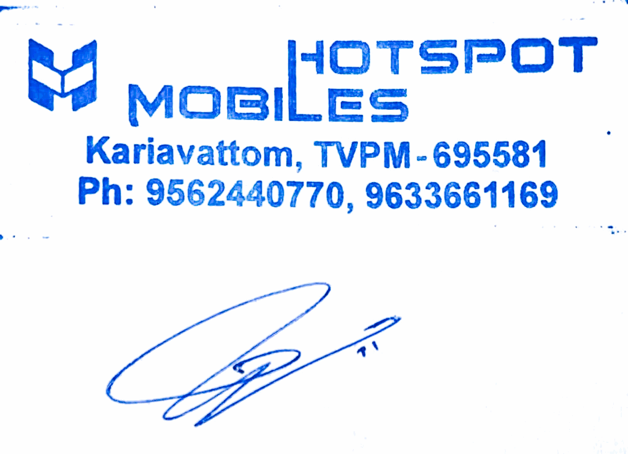**Total** **Amount** **:** **Other** **Charges** **:** **RoundOff** **:**

182.98

182.98

**2,399.00**

0.00

0.00

**Page** **1** **of** **1**