Initial Ethics Review Form

Project Title:

Translating Ecosystem Models with Generative AI

Project description:
Project Aims – provide a plain language description of the project, its aim/objectives and its outputs (< 500 words).

This project invites marine ecosystem modellers to participate in a remote modelling exercise focused on evaluating the effectiveness of generative artificial intelligence (AI) in model translation. Participants will be provided with a published Ecopath with Ecosim (EwE) model and guided through the process of converting it into a size-structured mizer model using AI tools.

Aim
To assess whether AI-assisted workflows can reliably support the translation of marine ecosystem models across frameworks, and to identify best practices for their use.

Objectives

Evaluate the accuracy and consistency of AI-assisted model translation
Document effective prompting strategies and common challenges
Compare AI-generated outputs with human-developed models

Outputs

A co-authored manuscript presenting the translated mizer model
A practical guide outlining best practices and workflows for AI-assisted model development
A dataset of participant reflections and model comparisons to inform future research

Research Methods – describe the methods and approaches you will be using to collect data.

This project employs a qualitative, reflective approach to gather insights on the use of generative AI in marine ecosystem modelling. Rather than a controlled experiment or in-person workshop, participants will complete modelling tasks remotely over a designated submission period.

Data Collection Approaches
Terminal Reflections:
Upon submission of their AI-enabled ecosystem model, participants will document their experiences using structured reflection templates.

Collaborative Documentation:
Participants will be invited to contribute to a shared document capturing “what works” and “what doesn’t work” when using AI for model translation, helping to build a set of best practices and identified pitfalls.

Comprehensive Survey:
Following task completion, participants will complete a survey addressing:

Prior modelling experience and AI familiarity
Perceived utility of AI for specific modelling tasks
Comparative assessment of AI-assisted versus traditional approaches
Confidence in the scientific validity of AI-assisted outputs
Effective AI prompting strategies
Challenges encountered and solutions developed
Quality assessment of AI-generated model components
Time efficiency compared to traditional methods
Recommendations for future modelers

Model Comparison Analysis:
Submitted models will be analyzed for consistency, accuracy, and alignment with the original EwE model, providing objective measures of AI effectiveness.

AI Interaction Transcripts:
With participant consent, AI chat transcripts will be collected to analyze prompting strategies, identify common questions, and evaluate AI response quality.

Data Analysis
The collected qualitative data will be thematically analyzed to identify patterns in AI utilization, common challenges, and effective strategies. This analysis will inform the development of a best practices guide for AI-assisted marine ecosystem modelling, with particular emphasis on applications for underrepresented regions within the FishMIP framework.

Participant Pool – describe who the participants will be, how many people will be involved, how they will be identified and recruited to the project and what their participation will involve (please attach any supporting information including proposed recruitment strategy and consent materials). If the research is being conducted on a pre-existing dataset only, please use the ‘Datasets only’ ethics application form. For mixed methods research, please describe the characteristics of the data.

Participants will be marine ecosystem modellers invited to take part in a remote modelling exercise coordinated through the FishMIP network (which is a global consortium of individuals). We anticipate 10–15 participants, who will be recruited via email invitations sent to previous FishMIP workshop attendees and relevant modelling communities.

Participation will involve completing a model translation task using AI tools, submitting outputs, and reflecting on their experience through structured templates and a post-task survey. A participant information sheet will be provided, and participation in the exercise will imply consent. Participants will be free to withdraw at any time without consequence.

Data Management – briefly outline the arrangements in place for data management (e.g. access, storage, data sharing, see CSIRO Research Data Management for further details).

All data collected during the project—including participant reflections, survey responses, model outputs, and AI interaction transcripts (with consent)—will be stored on a secure CSIRO drive. Access will be restricted to members of the project team listed in this application. Data will be managed in accordance with CSIRO’s Research Data Management policies and relevant privacy legislation.

Funding and External Contractors - describe the sources of any external funding and/or third party contractor arrangements, including any conflicts of interest.

Funding for AI services will be provided by the FishMIP consortium. No additional conflicts of interest have been identified among the project team.

Project Location(s): Hobart
(Sites where the research will be conducted)

Proposed Start Date: August 1, 2025 Proposed Finish Date: January 30, 2026

Principal Researcher / Project Leader
Name: Scott Spillias
Position:Postdoctoral Research Fellow
Business Unit: Environment
Research Group:Sustainable Marine Futures Location:Hobart
Phone:0424818567 Email:scott.spillias@csiro.au

Summary of Project Leader qualifications and relevant expertise

Scott is a CERC Postdoctoral fellow. During his PhD and Master's he completed several successful projects that included human participants, both via remote modelling exercises and surveys.

Describe any conflicts of interest
NA

Provide the names (and Institute if not CSIRO staff) and brief details of the relevant expertise of the project team members.
Kieran Murphy (University of Tasmania) is a quantitative ecologist specialising in macroecological processes, with a focus on understanding the impacts of climate change and fishing on marine ecosystems.

Rowan Trebilco is an EMCR with expertise spanning marine systems ecology, ecosystem assessment, theoretical ecosystem ecology, statistical and mechanistic modelling, fisheries and natural resource management. He draws on this expertise to support sustainable management of marine social-ecological systems. He leads the marine ecosystem modelling and assessment team in COR.

Beth Fulton is a globally recognised ecosystem modeller, who has helped lead and shape the field over the past twenty years.

Julia Blanchard (University of Tasmania) is an ARC Future Felllow in global change ecology with twenty years professional experience in developing and applying ecological and statistical models to study the impacts of human and environmental change on marine ecosystems.

Please check the relevant box to answer Yes or No to each of the following questions
[if answering ‘Yes’ to any questions please ensure further details are provided in the project description above]:

- Has this project been reviewed and conditionally approved or rejected by another ethics committee? | Yes No
- Is the project being externally funded or provided with in-kind support by an external party? | Yes No
- Is the project designed to provide market research or a consultancy service fully paid for by a client? | Yes No
- Will there be any restrictions (or restrictive procedures) placed on the publication of results from this project as a result of the funding or support arrangements? | Yes No
- Will any part of the project be undertaken by or outsourced to a third party? | Yes No
- Are there any potential conflicts of interest for the research team or organisation(s) associated with the project eg. arising from any involvement or role that researchers may have with other projects or external organisations, an existing relationship between a member of the research team and the potential participants? | Yes No
- Will the project specifically target or include any of the following groups as participants?  If YES, please indicate which group/s:  Aboriginal and Torres Strait Islander peoples  People in other countries  People whose primary language is not English  Children and young people  People from a workplace which will be the subject of the research  People with a cognitive impairment, an intellectual disability, or a mental illness  People who may be involved in illegal activities  People in dependent or unequal relationships eg. government agencies and the service providers they fund / or communities to whom the service is provided |  |  |  | Yes No
- Will consent for participation in this project be sought from all participants? |  |  | Yes No
- Will there be any incentive / payment (eg. money, movie tickets, food vouchers) or reimbursement (eg. travel expenses) given to participants? |  |  | Yes No
- Will the information being collected from and stored about participants be in an individually identifiable, potentially identifiable or re-identifiable form? |  |  | Yes No
- Does the project involve limited disclosure to participants or active concealment? |  |  | Yes No
- Are there any risks (eg. social, psychological, financial, physical, legal) to participants, the research team or others arising from their involvement in the research which cannot be mitigated / negated through project design? |  |  | Yes No
- Is it likely that the project will involve the disclosure of unlawful conduct, or concealment of a crime, by individuals or definable groups?  - Will this research project involve access to, use, collection or acquisition of culturally sensitive materials or artefacts? |  |  | Yes No  Yes No
- Will the information to be collected about participants during the project come from any of the following sources:  - another person about the research participant  - an agency, authority or organisation other than CSIRO  - a data source collected previously by CSIRO for a purpose other than this research project |  |  | Yes No
- Will the project involve the collection, handling and/or storage of personal information? (If ‘yes’, please note that you should also complete the threshold Privacy Impact Assessment checklist – see CSIRO Privacy for further details) |  | Yes No

Signature

As Principal Researcher / Project Leader for this research project I certify that:

- the information provided in this application is correct to the best of my knowledge
- I will notify in advance the CSSHREC of any ethically relevant variations to the project
- I will immediately report to the CSSHREC any adverse events or harm that occurs to participants during or resulting from the research
- the research team have read and agree to abide by the principles contained in the National Statement on Ethical Conduct in Human Research 2023.
- I accept the legal and ethical responsibilities associated with this research and will conduct the project in accordance with any conditions specified as part of any ethics clearance which is granted
- I will ensure that data collected during the project will be managed and stored according to CSIRO Policy and any relevant legislation (see CSIRO Record Services and CSIRO Privacy for further details)

Signed: 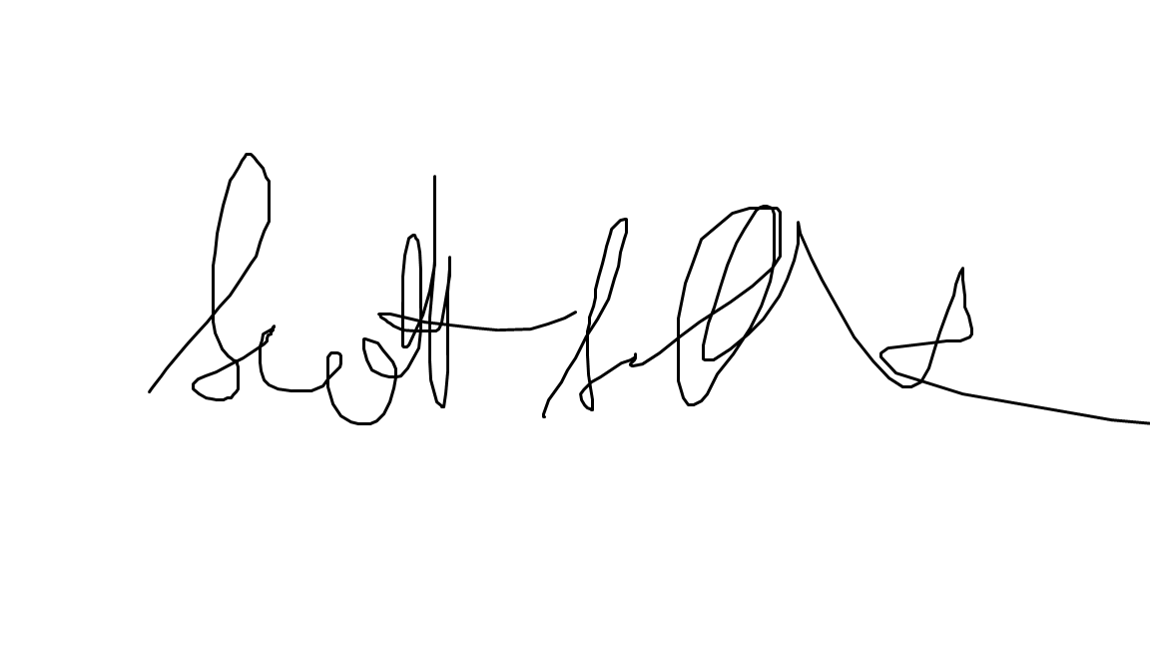
[copy and paste electronic signature or print for manual insertion and then scan]

Name: Scott Spillias Date: July 12, 2025
(Principal Researcher / Project Leader)

As Group Leader for this project I certify that:

- I have read this application and endorse it for review by CSSHREC
- the staff and resources assigned to the project are appropriate to enable its successful completion
- the project design and methodologies are appropriate for achieving the stated research objectives
- the research team have read and agreed to abide by the principles contained in the National Statement on Ethical Conduct in Human Research 2023 and will conduct the project in accordance with any conditions specified as part of any ethics clearance

Signed: 
[copy and paste electronic signature or print for manual insertion and then scan]

Name: Date:
(Group Leader)

Please email this form along with a copy of your project proposal and any supporting information such as participant recruitment and consent materials to csshrec@csiro.au

