**Introduction**

* Joins are used to combine columns from different tables.
* From clause will have table formats (O) eg: EMP,DEPT or EMP E,DEPT D
* Type of Join Specified (S)
* Join condition uses Where(O), ON(S)
* Column Names should have format eg: emp.ename or e.ename

**Types of JOIN**

1. **EQUI JOIN / INNER JOIN**

Used for tables with common columns

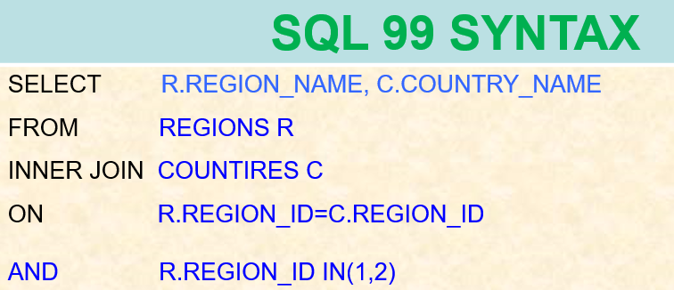

1. **OUTER JOIN**

Inner Join + Missing Data

(FULL OUTER JOIN/ RIGHT OUTER JOIN/ LEFT OUTER JOIN)

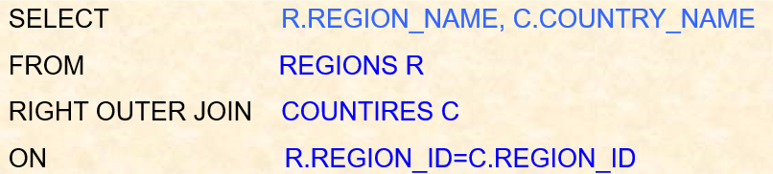

1. **NON EQUI JOIN**

Used for tables without common columns.

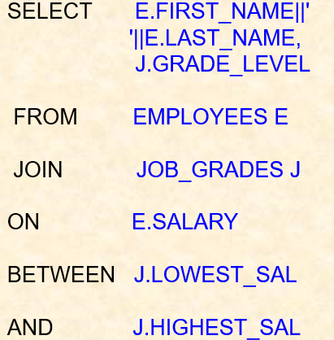

1. **SELF JOIN**

Table is joined to the table itself.

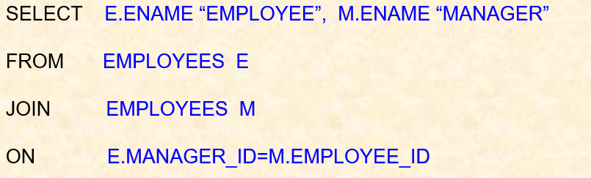

1. **Cross Join**

A Cartesian product is formed when:

* A join condition is omitted
* A join condition is invalid

All rows in the first table are joined to all rows in the second table.

To avoid a Cartesian product, always include a valid join condition in a WHERE clause.

**SQL > SELECT * FROM EMPLOYEES CROSS JOIN DEPARTMENTS;**

**SQL > SELECT EMPLOYEE_ID , FIRST_NAME, JOB_ID, DEPARTMENT_ID, DEPARTMENT_NAME, LOCATION_ID FROM EMPLOYEES CROSS JOIN DEPARTMENTS;**

1. **Natural Join**

* Naturally tables joined on common columns
* Common columns in both the tables should have same datatype
* Can't specify column on which join should be done

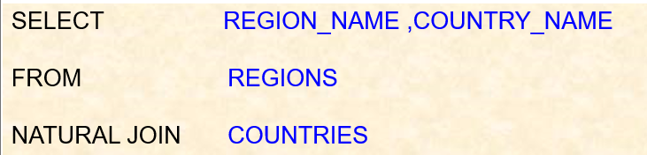

**Using Clause**

* When multiple columns are there we can specify which column should be used for joining.
* Suitable for Common columns in both the tables with different data type.

