|  |
| --- |
| Feb 2022 | PG-DSBA-Online |



**SUPPLY CHAIN MANAGEMENT PROJECT REPORT**

**SUBMITTED BY**

**DEV TRIPATHI**

**PROJECT REPORT ON**

**ADVANCE STATISTICS**

Submitted by

Dev Tripathi

**Contents**

Introduction 1

Problem Statement 1

Need of this analysis 1

Understanding the business opportunity 1

Data Report 3

Data Dictionary 3

Data Collection 3

About the Dataset 4

Exploratory Data Analysis 6

Univariate analysis 6

Bivariate Analysis 18

Clustering 21

**List of Figures**

Figure 1: Data Dictionary 3

Figure 2: Feature information and null count for these feature (in %) 4

Figure 3: Boxplot and distribution plot for ‘retail_shop_num’ variable 6

[Figure 4: Boxplot and distribution plot for ‘distributor_num’ variable 7](https://d.docs.live.net/7542cd3a3268f44e/Desktop/Py-DS-ML-Bootcamp-master/GL/Capstone_project/Dev_Tripathi_FR_ML2.docx#_Toc94469588)

[Figure 5: Boxplot and distribution plot for ‘dist_from_hub’ variable 7](https://d.docs.live.net/7542cd3a3268f44e/Desktop/Py-DS-ML-Bootcamp-master/GL/Capstone_project/Dev_Tripathi_FR_ML2.docx#_Toc94469589)

[Figure 6: Boxplot and distribution plot for ‘workers_num’ variable 8](https://d.docs.live.net/7542cd3a3268f44e/Desktop/Py-DS-ML-Bootcamp-master/GL/Capstone_project/Dev_Tripathi_FR_ML2.docx#_Toc94469590)

[Figure 7: Boxplot and distribution plot for ‘storage_issue_reported_l3m’ variable 8](https://d.docs.live.net/7542cd3a3268f44e/Desktop/Py-DS-ML-Bootcamp-master/GL/Capstone_project/Dev_Tripathi_FR_ML2.docx#_Toc94469591)

[Figure 8: Boxplot and distribution plot for ‘product_wg_ton’ variable 9](https://d.docs.live.net/7542cd3a3268f44e/Desktop/Py-DS-ML-Bootcamp-master/GL/Capstone_project/Dev_Tripathi_FR_ML2.docx#_Toc94469592)

[Figure 9: Boxplot and distribution plot for ‘age_wh’ variable 9](https://d.docs.live.net/7542cd3a3268f44e/Desktop/Py-DS-ML-Bootcamp-master/GL/Capstone_project/Dev_Tripathi_FR_ML2.docx#_Toc94469593)

Figure 10: Countplots for categorical variables 17

Figure 11: Correlation plot for numeric features present in the dataset 18

Figure 12: Zone vs. Warehouse Breakdown with location type 19

Figure 13: Silhouette width calculated based on identified clusters 21

Figure 14: Visualization of formed clusters 22

## Introduction

### Problem Statement

An FMCG company has entered started manufacturing instant noodles two years back. The higher management in the company has noticed a mismatch between supply and demand. Where the demand is high, supply is pretty low, and where the demand is low, supply is pretty high. Since this can cause a considerable amount of inventory cost loss, higher management has decided to optimize the supply chain. The product quantity being supplied to each and every warehouse established in the entire country is to be optimized as per the demand for the that particular location.

### Need of this analysis

Supply chain optimization is one of the keys to business success, especially in the FMCG sector, because the competition has increased many folds. The FMCG companies have to make their products available to the right customer at the right time in the right quantity; otherwise, the consumers generally buy similar products available in the market. Also, companies like this one, which has recently entered manufacturing the product, need to focus on the supply and demand as their consumer base is comparatively small.

### Understanding the business opportunity

The food processing industry is expected to at a rapid pace. According to industry estimates, the food processing industry accounts for nearly 30% of the total food market in India. Furthermore, the total food production in India is estimated to double in the next 10 years. Following are the factors which are expected to fuel the growth in this sector:

* Increasing spending on health and nutritional foods
* An increasing number of nuclear families and working women
* Changing lifestyle
* Functional foods, fresh or processed foods
* Organized retail and private label penetration
* Changing demographics and rising disposable incomes

## Data Report

### Data Dictionary

The dataset contains a total of 24 features. The description of these variables is given in Figure 1.

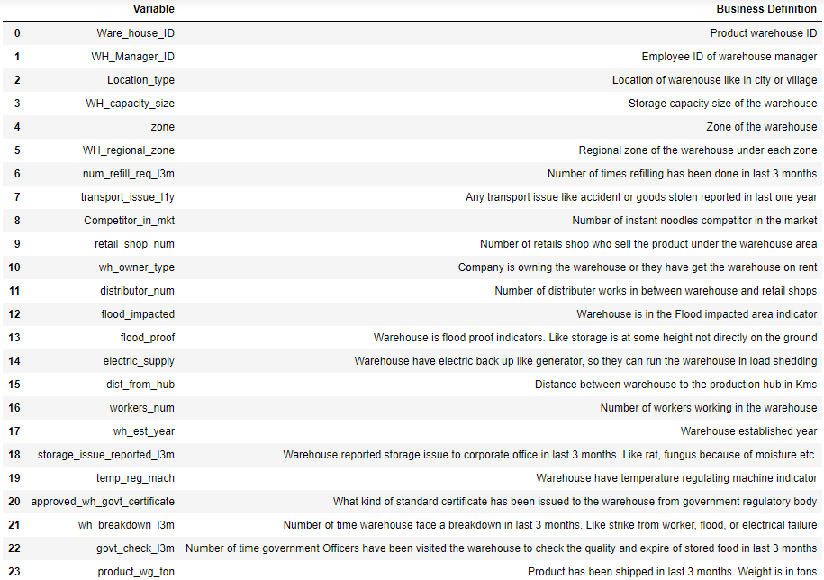

Figure 1: Data Dictionary

### Data Collection

To solve this particular problem, the data required must have been collected from various departments such as the HR department, production department, logistics department etc., present in the concerned company. In our case, company managed to provide us data for warehouses present in different zone and regions. Though by looking at the data we can say that the company has put appreciable amount of efforts to maintain their records as most the entries present in the dataset, were observed to be very less to no missing data at all.

### About the Dataset

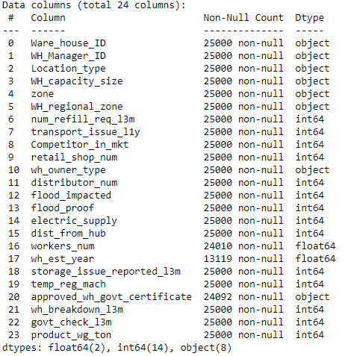 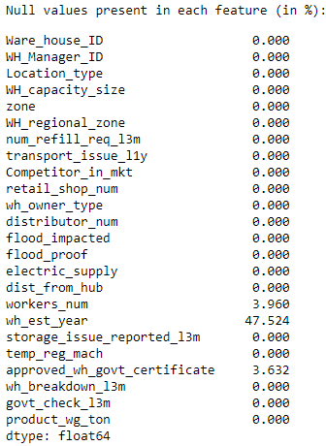

Figure 2: Feature information and null count for these feature (in %)

**Observations:**

* The dataset contains 24 variables and 25000 entries for these variables.
* There 8 features are of object datatype, 2 features are of float datatype and 14 features are integer datatype.
* Only 3 features are having missing values which are **‘wh_est_year’ (47.5%), ‘workers_num’ (4%), and ‘approved_wh_certificate’ (3.632%)**.
* Though the ‘wh_est_year’ should have been removed as it contains more than 40% values as missing values, we chose to keep it after imputing it with a suitable value.
* Also, we have imputed the missing values present in the dataset with median values for **‘workers_num’, ‘approved_wh_certificate’** features and by mode value for **‘wh_est_year’.**
* For further analysis, the **‘wh_est_year’** feature was converted to **‘age_wh’**, representing the warehouse's age at the **present date (2023).**
* Also, the **‘zone’** and **‘WH_regional_zone’** were concatenated to become one single variable **‘Zone’**.

## Exploratory Data Analysis

Before performing EDA, we dropped two variables warehouse ID and warehouse manager ID as these would not help to understand or get insights about the data.

### Univariate analysis

Continuous Features:

1. **‘retail_shop_num’**

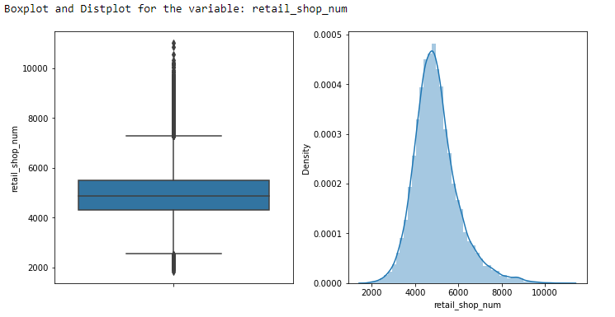

Figure 3: Boxplot and distribution plot for ‘retail_shop_num’ variable

**Observations:**

* From the above plot, we can say that the distribution is right-skewed.
* The Median is around 5000
* Outliers are present in the data for this feature

1. **distributor_num**

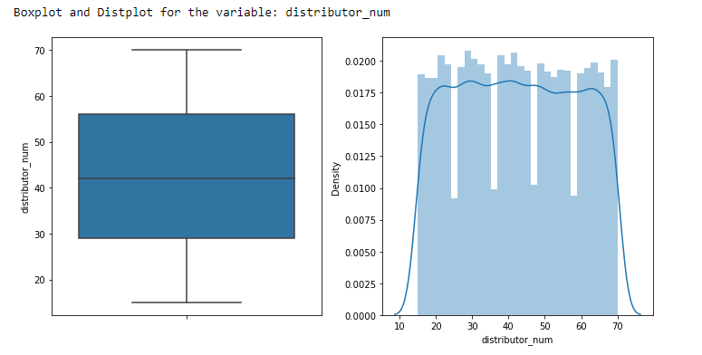**Observations:**

Figure : Boxplot and distribution plot for ‘distributor_num’ variable

The median value is 42. There are no outliers present in the data for this feature. The data has very low to nil skewness.

1. 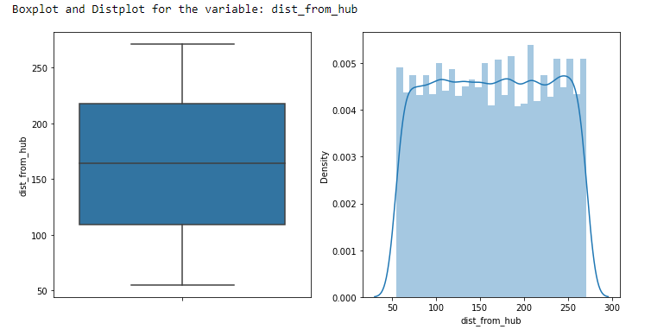**dist_from_hub**

Figure : Boxplot and distribution plot for ‘dist_from_hub’ variable

**Observations:**

We can say from the above plot that the distribution has very low skewness. The Median is around 165. Outliers are not present in the data for this feature.

1. 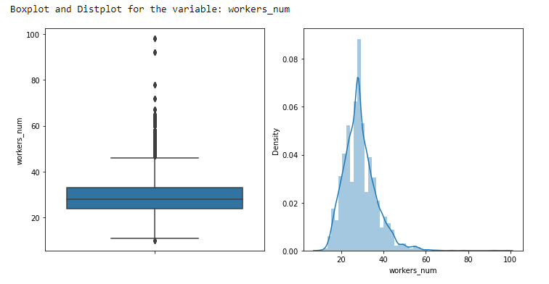**workers_num**

**Observations:**

Figure 6: Boxplot and distribution plot for ‘workers_num’ variable

From the above plot, we can say that the distribution is right-skewed. The Median is around 29. Outliers are present in the data for this feature.

1. 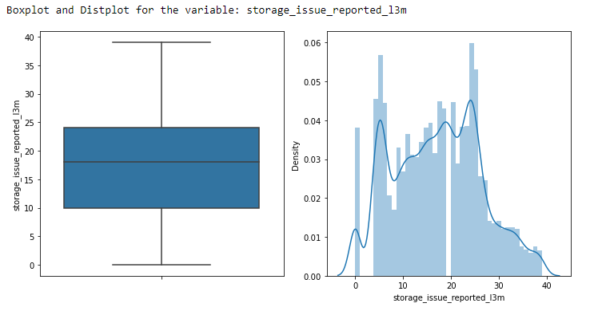**storage_issues_reported_l3m**

Figure 7: Boxplot and distribution plot for ‘storage_issue_reported_l3m’ variable

**Observations:**

From the plot, we can say that the distribution is slightly right-skewed. The Median is around 18. Outliers are not present in the data for this feature.

1. 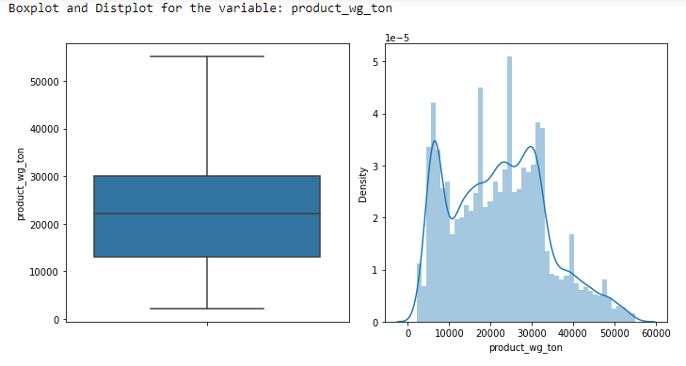**product_wg_ton**

**Observations:**

Figure 8: Boxplot and distribution plot for ‘product_wg_ton’ variable

From the plot, we can say that the distribution is right-skewed. The Median is around 25000. Outliers are not present in the data for this feature.

1. **age_wh**

Figure 9: Boxplot and distribution plot for ‘age_wh’ variable

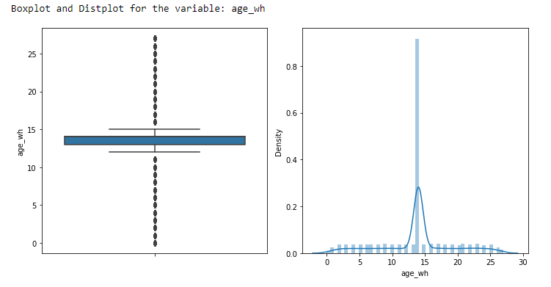**Observations:**

Since we have imputed the 47% missing values and then calculated ‘age_wh’, the insights are not relevant here.

**Categorical Features:**

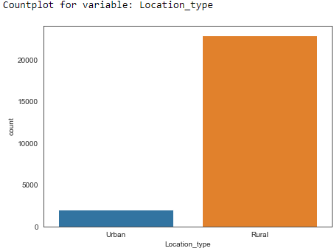

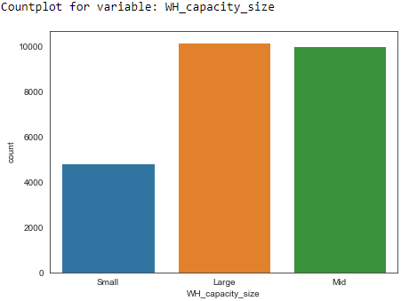

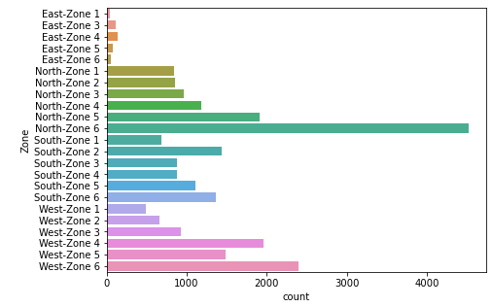

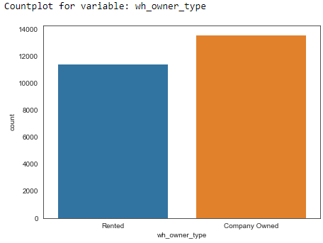

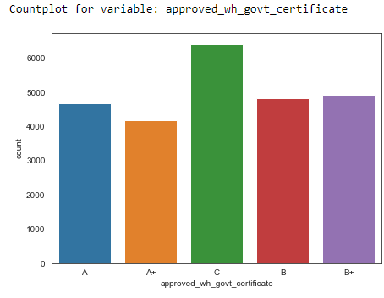

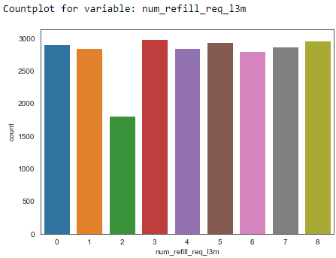

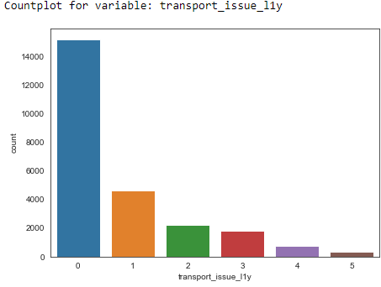

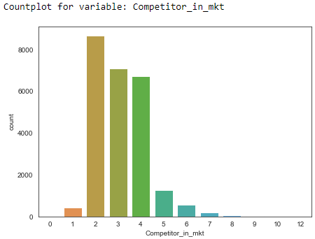

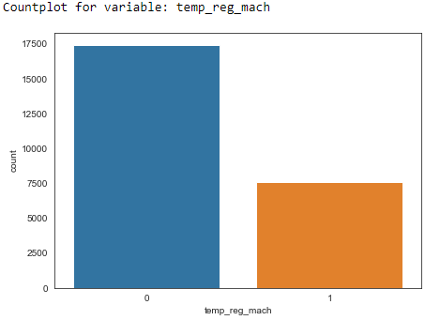

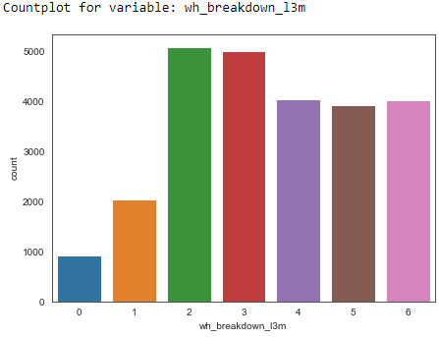

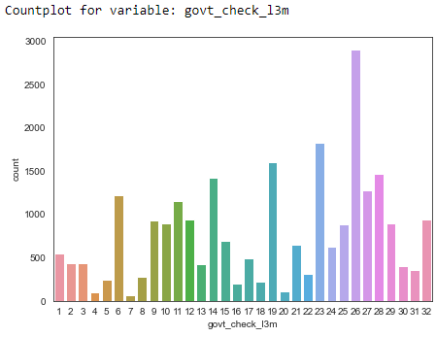

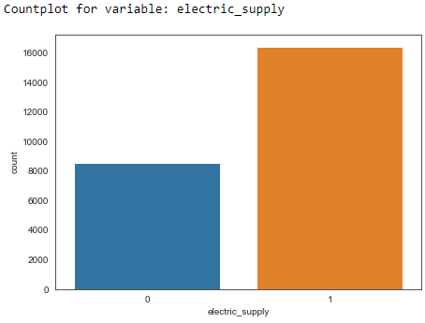

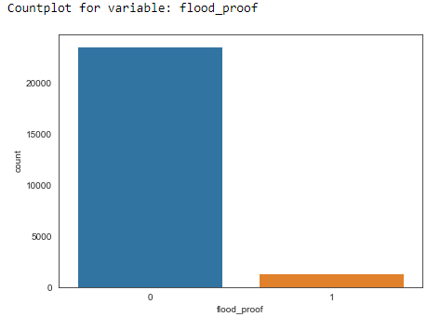

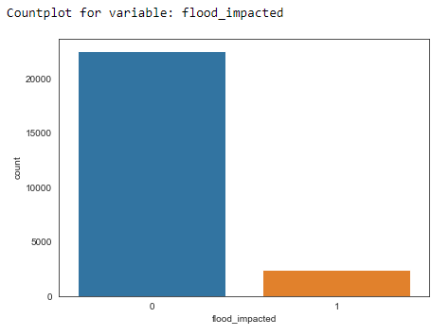

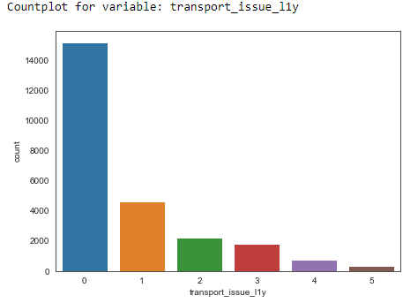

Figure 10: Countplots for categorical variables

**Observations:**

* Most of the warehouses are located in **‘Rural’** area.
* The **‘small’** warehouses are less than half in numbers compared to **‘large’** or **‘mid’** size warehouses.
* The highest number of warehouses are located in **‘North-Zone 6**’ followed by **‘West-Zone 6’**
* The number of refills varies from 0 to 8. Strangely, warehouses that required two refills in the past three months are significantly less than all other values
* Transport issues in last one year are having zero as mode value which is good for business.
* For most of the entries, the competitors in the market are between 2 to 4.
* Out of 25000 warehouses, 17500 warehouses do not have temperature regulatory machines.
* The number of times warehouse breakdown happened ranges between 2 to 6 in the past 3 months.
* The number of times government checks happened is having mode value equal to 26. The variable ranges from 1 to as high as 32
* More than 16000 warehouses are having electric supply
* More than 23000 warehouses are flood proof
* More than 23000 warehouses are flood impacted.

### Bivariate Analysis

Correlation plot:

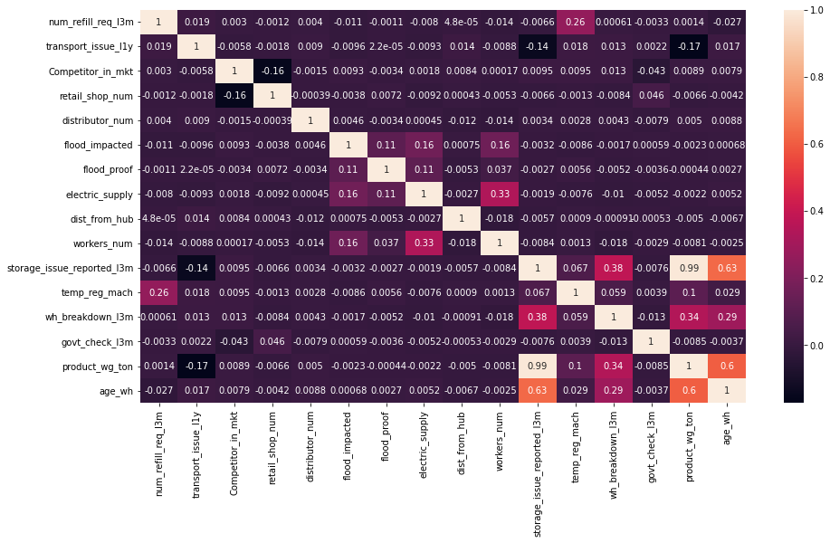

Figure 11: Correlation plot for numeric features present in the dataset

**Observations:**

* Most of the features have very little to no correlation at all
* Our target feature **‘product_wg_ton’** is having very high correlation **(0.99)** with **‘storage_issues_reported_l3m’** and moderate correlation with **‘age_wh’**
* **‘age_wh’** and **‘product_wg_ton’** are also having a high correlation **(0.63)**

**Zone vs. Warehouse Breakdown with location type as a filter:**

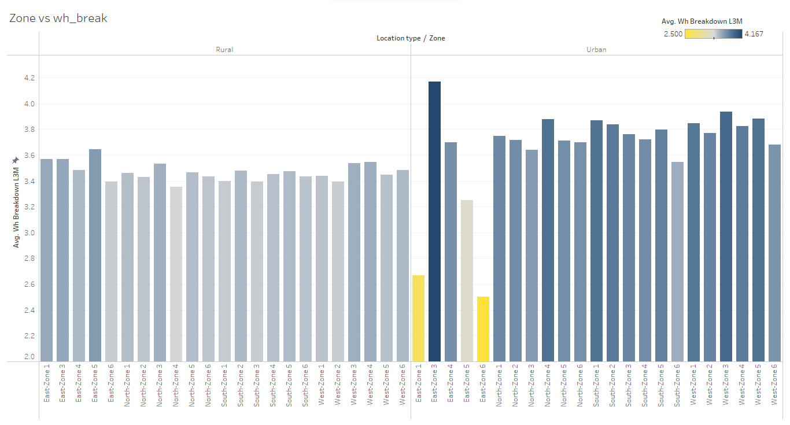

Figure 12: Zone vs. Warehouse Breakdown with location type

Observations:

* For the Urban and East zone 3, warehouses are having maximum average number of breakdowns
* From the Figure 12, it is obvious that the number of breakdowns for Urban area is more than rural area.

## Clustering

Finally, K- Means clustering was used to detect some patterns or clusters from the dataset. Although the Elbow Curve did not show any significant drop in within sum of squares values when plotted against the number of clusters, we assumed the number of clusters as 3. Boxplot of Silhouette width calculated for these clusters was generated (Figure 13):

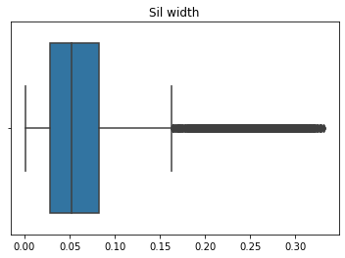

Figure 13: Silhouette width calculated based on identified clusters

Silhouette score for the formed clusters was coming out to be +0.064. Now, for visualization of formed clusters using Principal Components Analysis:

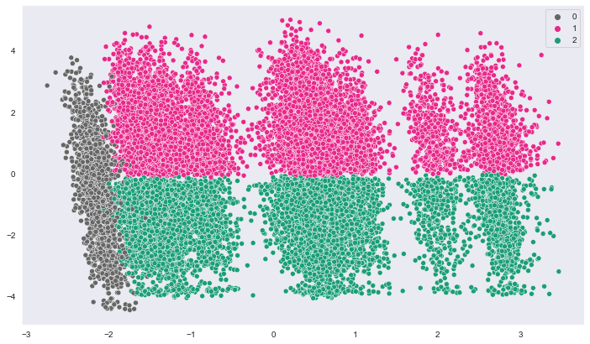

Figure 14: Visualization of formed clusters

Now, let’s have a look at the differences between the clusters identified:

|  |  |  |  |  |  |  |
| --- | --- | --- | --- | --- | --- | --- |
|  | **WH_capacity_size** | **storage_issue_reported_l3m** | **wh_breakdown_l3m** | **product_wg_ton** | **Zone** | **labels** |
| **count** | 12896 | 12896 | 12896 | 12896 | 12896 | 12896 |
| **unique** | 3 | NaN | NaN | NaN | 21 | NaN |
| **top** | Mid | NaN | NaN | NaN | North-Zone 6 | NaN |
| **freq** | 5605 | NaN | NaN | NaN | 2490 | NaN |
| **mean** | NaN | 23.777605 | 4.11616 | 30440.7 | NaN | 2 |
| **std** | NaN | 5.828665 | 1.416405 | 7982.53 | NaN | 0 |
| **min** | NaN | 7 | 1 | 10081 | NaN | 2 |
| **25%** | NaN | 20 | 3 | 25067 | NaN | 2 |
| **50%** | NaN | 24 | 4 | 29130 | NaN | 2 |
| **75%** | NaN | 27 | 5 | 34102 | NaN | 2 |
| **max** | NaN | 39 | 6 | 55151 | NaN | 2 |

Table 1: Statistical description for cluster 1

|  |  |  |  |  |  |  |
| --- | --- | --- | --- | --- | --- | --- |
|  | **WH_capacity_size** | **storage_issue_reported_l3m** | **wh_breakdown_l3m** | **product_wg_ton** | **Zone** | **labels** |
| **count** | 10541 | 10541 | 10541 | 10541 | 10541 | 10541 |
| **unique** | 3 | NaN | NaN | NaN | 21 | NaN |
| **top** | Mid | NaN | NaN | NaN | North-Zone 6 | NaN |
| **freq** | 4415 | NaN | NaN | NaN | 2029 | NaN |
| **mean** | NaN | 9.042785 | 2.705246 | 11952.5 | NaN | 1 |
| **std** | NaN | 5.016138 | 1.671482 | 5736.29 | NaN | 0 |
| **min** | NaN | 0 | 0 | 2065 | NaN | 1 |
| **25%** | NaN | 5 | 1 | 7067 | NaN | 1 |
| **50%** | NaN | 9 | 2 | 11149 | NaN | 1 |
| **75%** | NaN | 13 | 4 | 16133 | NaN | 1 |
| **max** | NaN | 23 | 6 | 30139 | NaN | 1 |

Table 2: Statistical description of cluster 2

|  |  |  |  |  |  |  |
| --- | --- | --- | --- | --- | --- | --- |
|  | **WH_capacity_size** | **storage_issue_reported_l3m** | **wh_breakdown_l3m** | **product_wg_ton** | **Zone** | **labels** |
| **count** | 1563 | 1563 | 1563 | 1563 | 1563 | 1563 |
| **unique** | 1 | NaN | NaN | NaN | 2 | NaN |
| **top** | Large | NaN | NaN | NaN | West-Zone 5 | NaN |
| **freq** | 1563 | NaN | NaN | NaN | 1489 | NaN |
| **mean** | NaN | 16.829814 | 3.488804 | 21759.9 | NaN | 0 |
| **std** | NaN | 9.308235 | 1.709459 | 11789.9 | NaN | 0 |
| **min** | NaN | 0 | 0 | 3058 | NaN | 0 |
| **25%** | NaN | 9 | 2 | 12121.5 | NaN | 0 |
| **50%** | NaN | 17 | 3 | 22058 | NaN | 0 |
| **75%** | NaN | 24 | 5 | 29147.5 | NaN | 0 |
| **max** | NaN | 39 | 6 | 55111 | NaN | 0 |

Table 3: Statistical description of cluster 3

**Observations:**

* There is total 12896 warehouses identified as cluster-1, 10841 warehouses identified as cluster-2 and 1563 warehouses identified as cluster-3
* If we compare the identified cluster-1 with cluster-2, the mean values of **‘strorage_issues_reported_l3m’**, **‘wh_breakdown_l3m’** and **‘product_wg_ton’** are significantly different.
* On the other hand, cluster-3 has the mean values of the same variables in between the values obtained for cluster-1 and cluster-2.
* Almost all the warehouses categorized as cluster-3 are located in **‘West-Zone 5’ (1589 out of 1683).**
* All the warehouses categorized as cluster-3 have **‘Large’** warehouse capacity.