**August 2022 | Accenture DS**



**Project Report on Data Visualization using Power BI for FIFA 2018 data**

**Submitted by**

**Dev Tripathi**

Business Context

In this project, we will be looking at the player data provided by FIFA which contains information such as personal details, wages, physical attributes, technical skills, potential and their positional strengths. This is primarily data of **FIFA 2018**.Through this project, we will get a glimpse of insights behind the beautiful game and the kind of information and decisions, a football manager goes through.

**1. Prepare a rank ordered list of top 10 countries with most players. Which countries are producing the most numbers of footballers that plays at this level?**

The bar chart shows the top countries which produce a high number of football players. The **England** produced 1629 players, which is being followed by **Germany and Spain**.

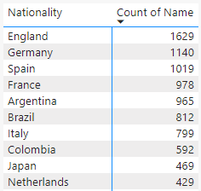

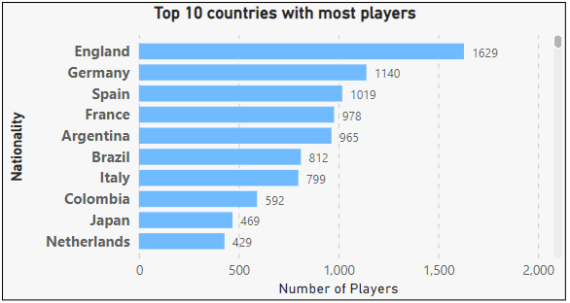

**2. Plot the distribution of overall rating vs. age of players. Interpret what is the age after which a player stops.**

**improving?**

The general trend among the players shows that the overall rating of a player improves up to the age of **31**, after which the overall rating stops improving and it starts decreasing as the player ages. It seems to stop following the above statement towards the end of the curve. This happens because the number of players still playing and are above 40 is very less. 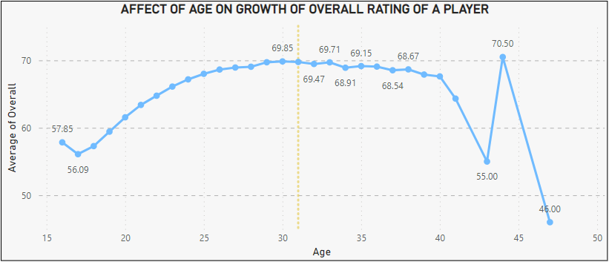

**3. Which type of offensive players tends to get paid the most: the striker, the right-winger, or the left-winger?**

**Visualize through a scatter plotimproving?**

* Both left-winger **(LW)** and right-winger **(RW)** have similar average wages. **LW** has the highest average wage.
* From the scatter plot below, the striker **(ST)** appears to be the least paid on average.
* In terms of the maximum wage, both **ST** and **RW** have got the same amount, whereas LW has a significantly lower maximum wage.

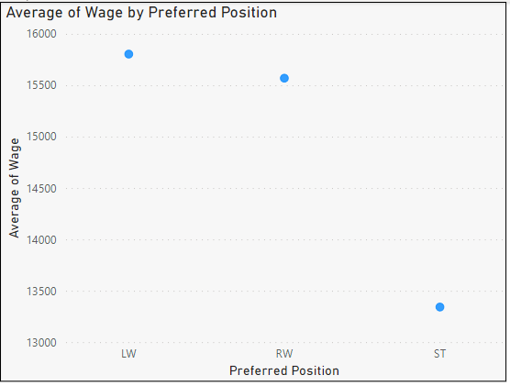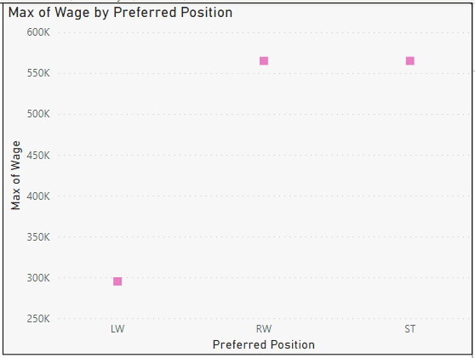

**4.Top 5 players for every preferred position in terms of overall as well as potential points. Who were the best?**

**in 2018? Who were destined to be the future superstars in that year?Visualize through a scatter plotimproving?**

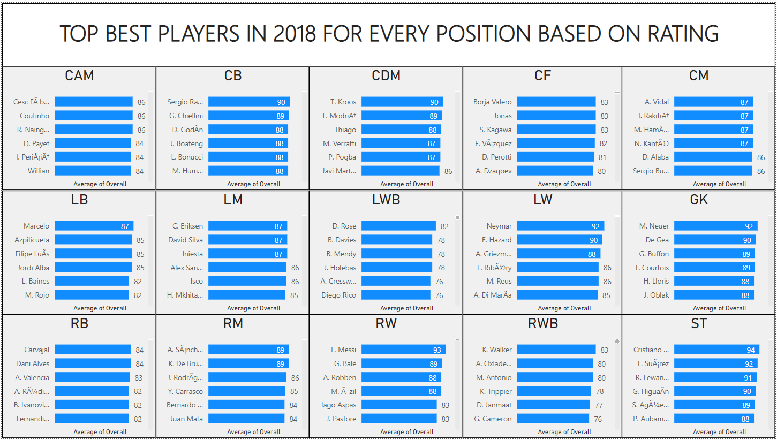

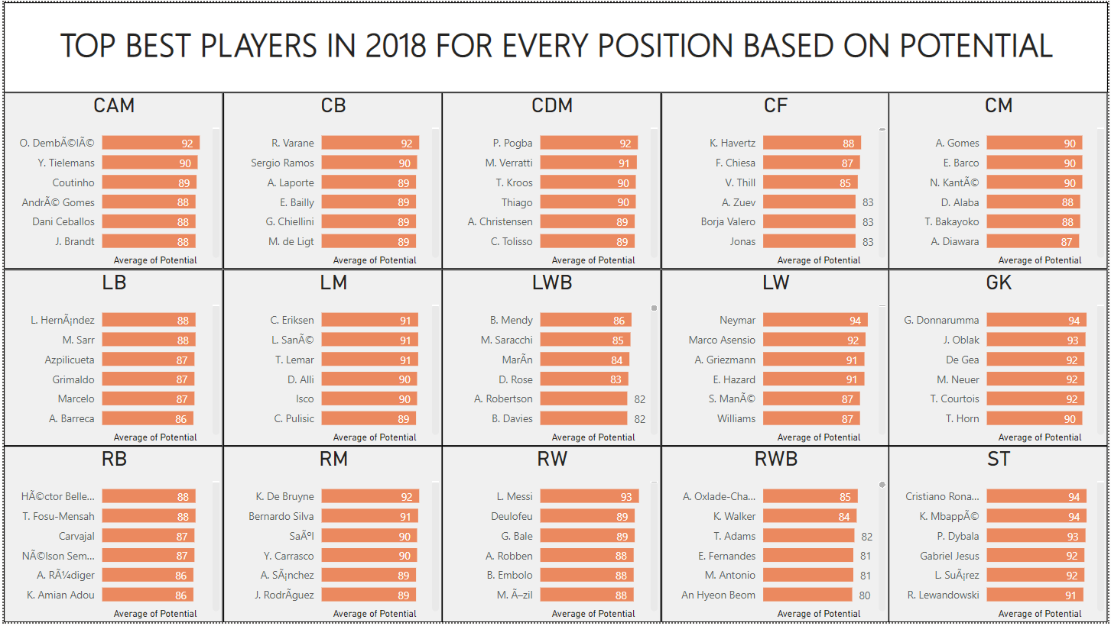

The players like **Cristiano, Neymar, Marcelo, L. Messi,** etc., have top points overall as well as potential points. These players were destined to be the future superstars of that year.

**5. Which club(s) have the maximum share of players from England? Which club(s) have the maximum share of players from Spain? Which club(s) have the maximum share of players from Germany?**

The visual below is a Tree Map that shows the clubs in which most shares of the layers are from England.

The clubs such as **Bolton Wanderers, Shrewsbury** contain a maximum share of players from England.

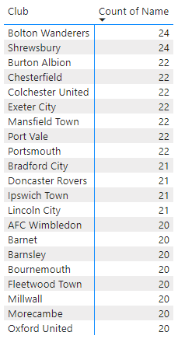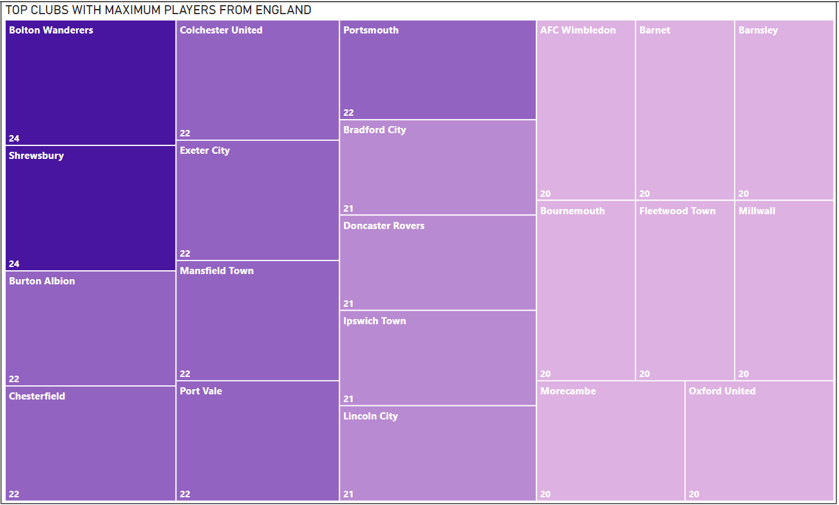

The Tree Map below shows the clubs in which most shares of the players are from Germany.

The club **Holstein Kiel** contains maximum share of players from Germany. These are followed by **SSV Jahn Regensburg club and FC Magdeburg**.

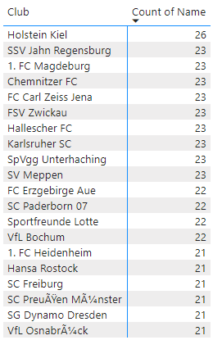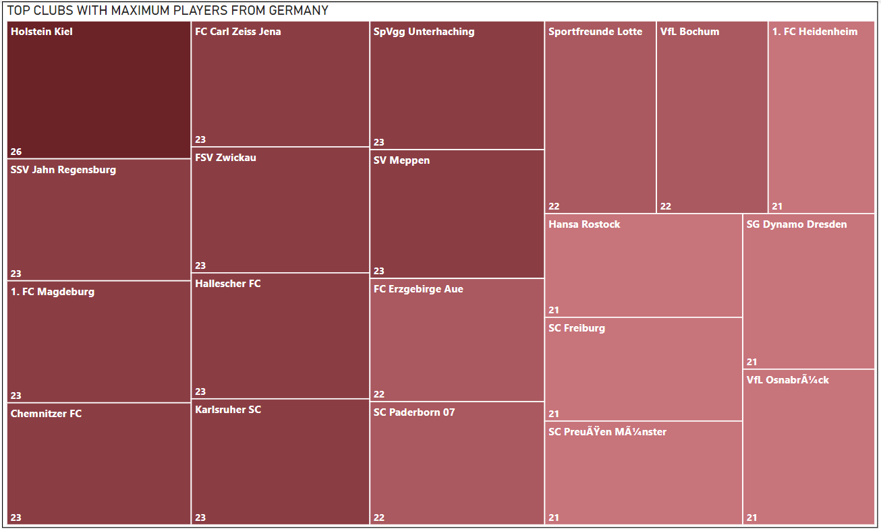

The Tree Map below shows the clubs in which most shares of the players are from Spain. The club **CA Osasuna** contains a maximum share of players from Spain. These are followed by **Athletic club de Bilbao and Lorca Deportivo CF club**.

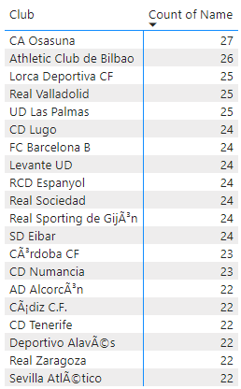

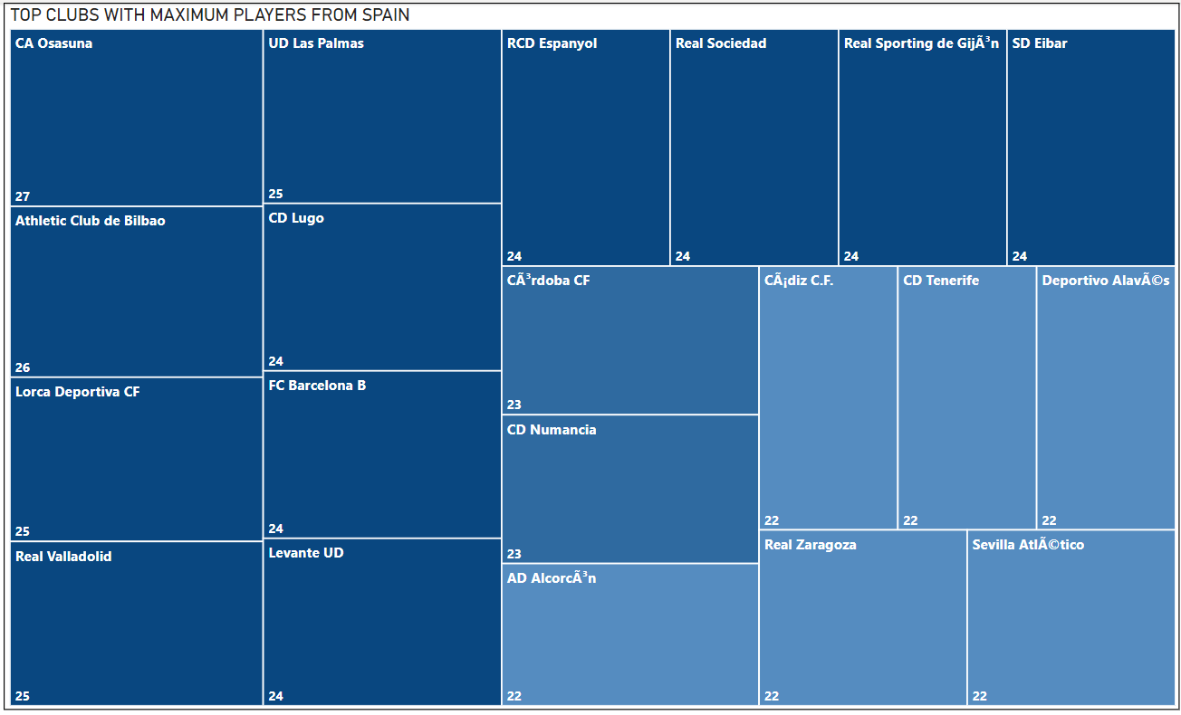

**6. Are the wages of a player influenced by the potential of a player? Check it out for players with age between 16 to 28?**

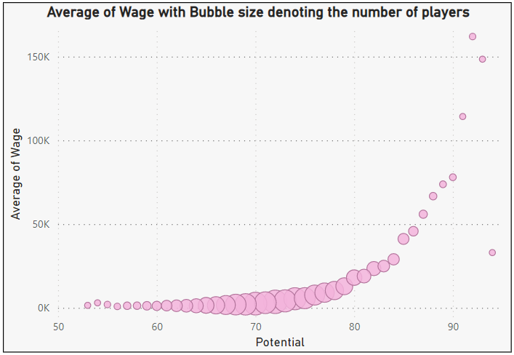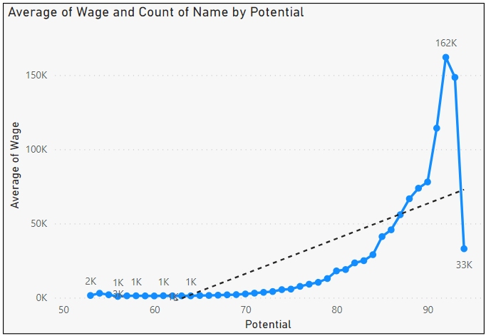The two visuals below show some sort of relationship between the wage (ages 16-28) and that player's potential. The general trend is that a player gets more wage if he has a higher potential. The trend is increasing for the entire distribution except for the right tail. Though the visual on the right shows that there are very few numbers of players who have potential above 85. These may be put in the bucket of exceptional players. One more thing to note here is above the potential value of 70; the wages seem to follow a power distribution.

**7. Do Strikers score higher on "Aggression" than defenders do? Group both the set of players (from an overall score of 80 to 85) and compare their average aggression levels. Which particular position has the highest aggression as a given (players with overall score of 80 to 90)?**

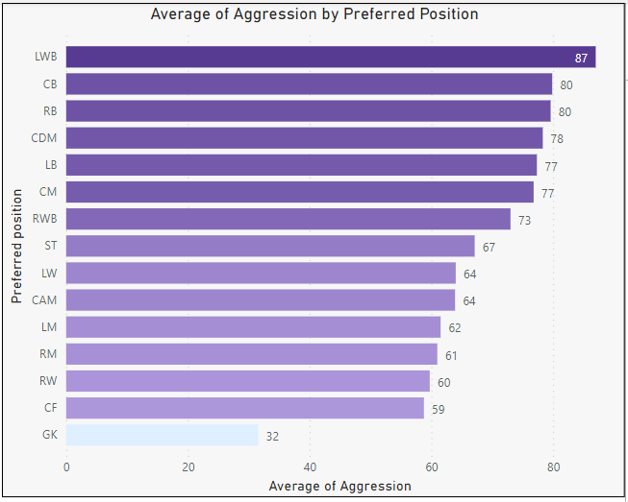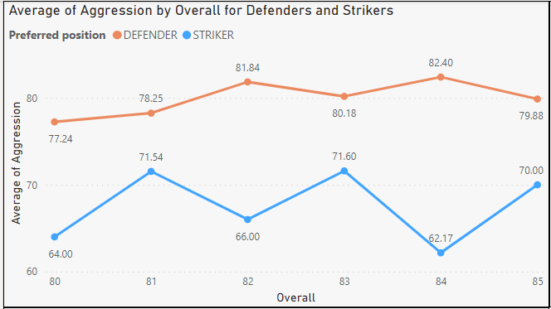Comparing strikers and defenders (CB, LB, RB, LWB, RWB) with an overall score of 80-85 shows that defenders score much higher on aggression levels than strikers. Looking at all positions a player can play at shows that positions such as LWB, CB, RB, CDM, LB, CM, and RWB show much higher levels of aggression. The common element in all these positions is that the player playing at any of these positions has to perform defensive duties.

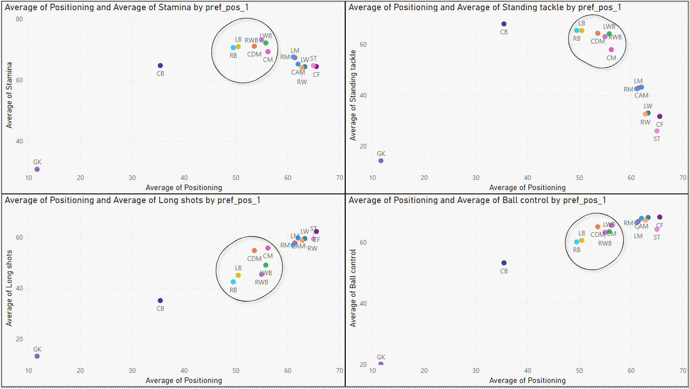

**8. How based on the positional data, players are profiled for different roles/classes. Plot Aggression, Acceleration, Agility, Balance and Ball Control for strikers and Goal Keepers in a single line/Bar plot to understand the positional difference.**

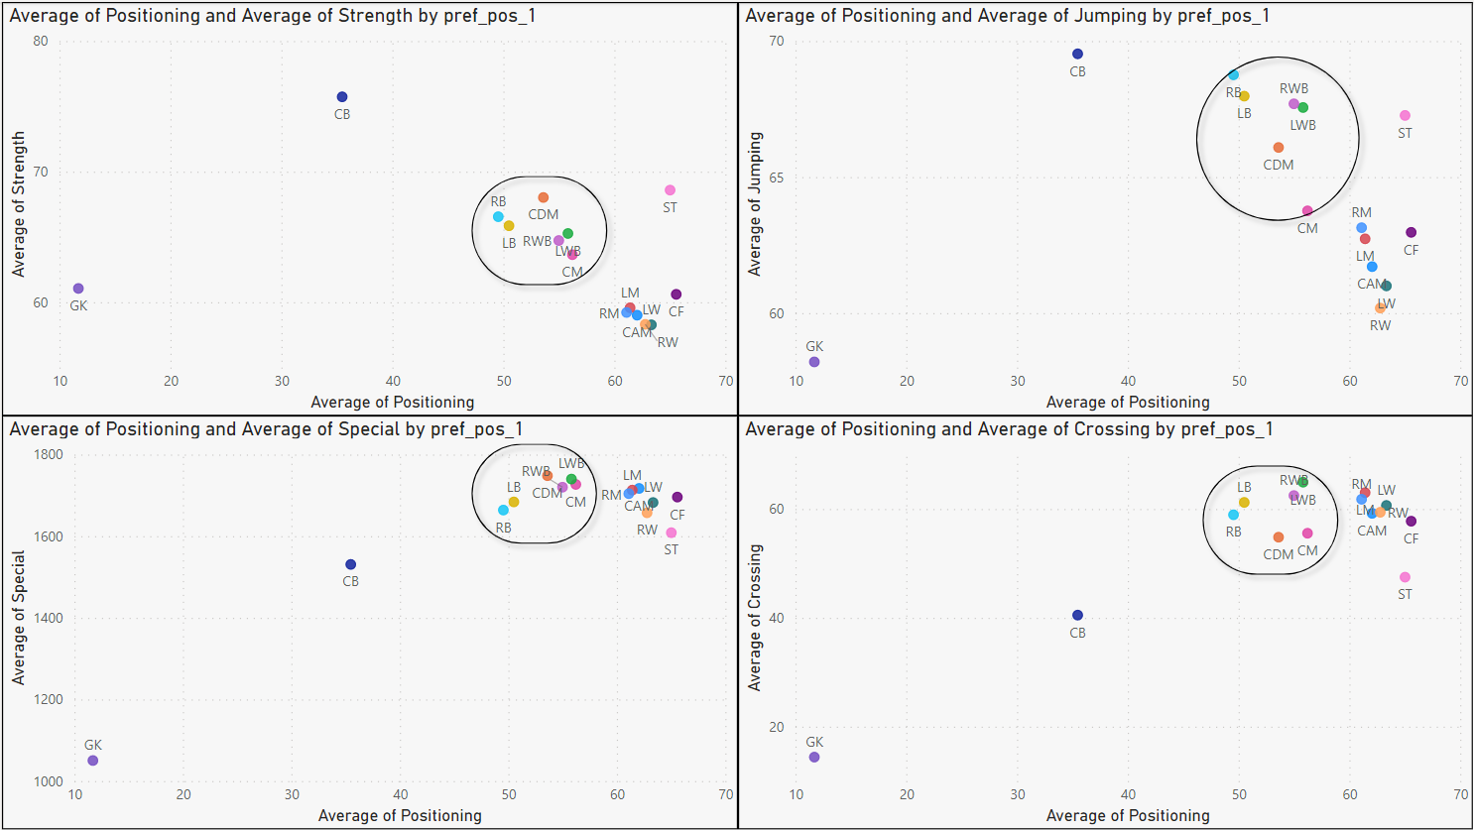

From the above scatter plots, we can observe that the players can be put in 5 buckets based on their attributes:

* Goal Keeper (GK)
* Centre Back (CB)
* Other Defenders (RB, LB, LWB, RWB, CDM, CM)
* Attacking Positions (RM, LM, LW, CAM, CF, CAM)
* Strikers

Although, this can be checked using clustering algorithms such as K-Means Clustering. But for this analysis, we limited ourselves to identifying the patterns only.

The average rating of positional data such as aggression, acceleration, agility, balance, and ball control for a goal-keeper is much lower when compared to a striker.

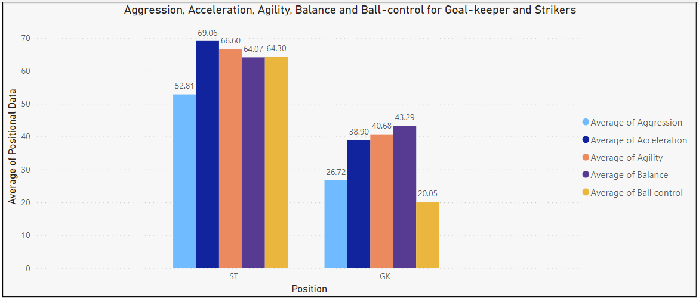

**9. Which clubs consists of the best future players? Consider only the players with Overall <86 and Potential >= 86, plot a graph to show which are the top 10 clubs with the greatest number of best future players.**

The club with the most players that have the potential to be the best in the future is **FC Barcelona** (9), followed by **Atletico Madrid** (8). Several clubs are tied at best with future player counts of 5, 6, and 7.

