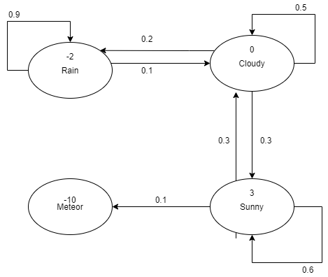
Opdracht 1.1, 1.2:

Opdracht 1.3:
E = C -> R -> C -> S -> M
G = 0 – 2 + 0 + 3 - 10

E = R -> R -> C -> S -> S -> M
G = -2 – 2 + 0 + 3 + 3 – 10

Opdracht 1.4:
Iter | Rain | Cloud | Sunny | Meteor
0 | 0 | 0 | 0 | 0
1 | -1.8 | 0.5 | 0.8 | 0
2 | -3.37 | 0.63 | 1.43 | 0

ITER 1:
vRain 0.1 (0 + 1 * 0)
0.9 (-2 + 1 * 0)
vCloud 0.2(-2 + 1 * 0)
0.5(0 + 1 * 0)
0.3(3 + 1 * 0)
vSunny 0.3 (0 + 1 * 0)
0.6 (3 + 1 * 0)
0.1 (-10 + 1 * 0)

ITER 2:
vRain 0.1 (0 + 1 * 0.5)
0.9 (-2 + 1 * -1.8)
vCloud 0.2(-2 + 1 * -1.8)
0.5(0 + 1 * 0.5)
0.3(3 + 1 * 0.8)
vSunny 0.3 (0 + 1 * 0.5)
0.6 (3 + 1 * 0.8)
0.1 (-10 + 1 * 0)

Opdracht 1.5:
X

Opdracht 2:
X
Opdracht 3:
x

