PhEDEx and dynamic circuits
PhEDEx is the data-placement management tool for the CMS experiment at the LHC. It manages the scheduling of all large-scale WAN transfers in CMS, ensuring reliable delivery of the data.
The ANSE project (in the context of CMS) is exploring possible improvement avenues for PhEDEx, specifically how to make it more aware of the network status, and how to provide it with the means of controlling the network by way of virtual/dynamic circuits and bandwidth-on-demand (BoD).
One of the drivers towards introducing this functionality is the need for better predictability of transfers across WAN, allowing for example, co-scheduling of jobs with data.
Over the course of the past year, the ANSE project has made significant progress towards integrating network-awareness into PhEDEx. We have created and tested a prototype which incorporates the use of virtual-circuits into PhEDEx at the level of the FileDownload agent, i.e. per destination-site. Currently, we are working of finalising the production ready version of that system, which we will present shortly.

PhEDEx architecture

PhEDEx consists of several components: an Oracle database, a website/data-service, a set of central agents and a set of site agents (at each of the PhEDEx sites). The central agents presently run at the T0 (CERN) and deal with routing, request-management, bookkeeping and other activities. The site agents, running at each of CMS’ sites, process the transfers which were queued by the central agents. This signifies that PhEDEx operates in a data-pull mode - the destination site pulls the data to itself when it is ready.
Development work in ANSE is done on our own PhEDEx installation presented in Figure 1
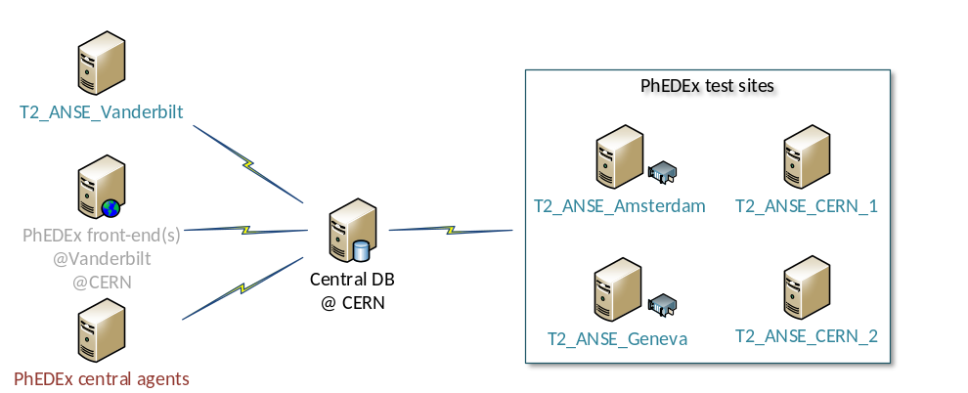
Figure 1 – PhEDEx installation in ANSE

Introducing dynamic circuits

Given PhEDEx’ architecture, there were several points at which it was possible to integrate the control and use of dynamic circuits: per each transfer job, at a site level or at the central (instance) level. The production version of the circuit management software which we are currently working on, runs at a site level; meaning that each site has an instance of this entity running (CircuitManager). The CircuitManagers keeps track of active circuits and manages their lifecycle for each PhEDEx site. Requests and teardowns are forwarded via a backend to a circuit infrastructure’s API of the user’s choice. Currently we support only OSCARS calls (via Dynes) and ODL calls (via MonALISA). This can be easily extended, via a plug-in system for circuit management backends. Figure 2 presents the class diagram of the framework which we are working on. All of the units in light blue have been added in ANSE and the one in purple is an extension of the original FileDownload agent in PhEDEx.

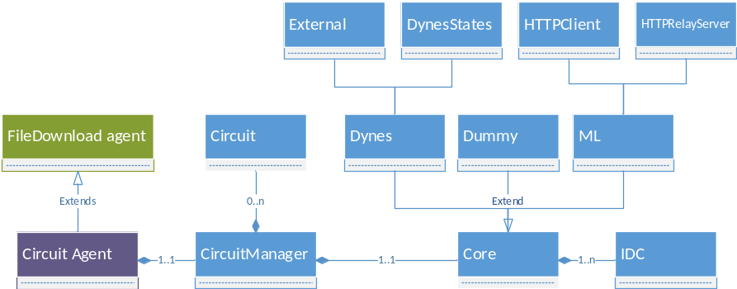
Figure 2 - Class diagram of the circuit management software in PhEDEx

Implementation details

In the prototype phase of this project we included a minimal functionality of the circuit management software in the FileDownload agent. This agent, was the best place where such integration could take place at this level.
The unmodified FileDownload agent is responsible for the actual execution of file-transfers. It transfers files in bulk, copying several files with each transfer command. Each transfer job, therefore, contains information about the source and destination Physical File Names (PFNs) of those files. The FileDownload agent however, actually receives only Logical File Names (LFNs) from the database, plus the name of the chosen source site. It constructs the PFNs from the LFNs and a lookup-table per-site which each site maintains and uploads to the database. This means that if we want to transfer files over alternative paths (other than the one specified by the lookup-table), we needed to introduce a mechanism which allows us to replace the original hostname/IP in each source/destination PFN with the source IP and destination IP of the new path that we want to use. The FileDownload agent was the place where this took place.

Circuit agent

In the production version of our software, we created another agent called the CircuitAgent, which extended the FileDownload agent and added the functionality that we needed. This way, if this agent would misbehave, we could easily and quickly (via a changes in a config file) switch to using the default FileDownload agent, with minimal impact on the infrastructure.
Leveraging the fact that PhEDEx and its agents are event driven (via POE), we introduced a recurring event in the CircuitAgent (every 60 seconds) which checks the current workload of the agent. It is used to estimate the amount of work which remains to be done on a pair of nodes based on the current size of the download queue and past transfer rates. Based on that, it decides whether or not it’s worthwhile to request a circuit for that pair. If it’s worthwhile, a request will be made (to the CircuitManager).
Another change in this agent occurred when the “transferTask” event was triggered. This is the last event which is triggered before a transfer task is actually passed to the transfer backend. It’s in here, that we added a call to the CircuitManager, which checks that for the current pair of source/destination nodes, a new circuit/path has been established. If that’s the case, it will replace the PFNs with ones containing the source/destination IPs of the new path.

CircuitManager

The CircuitManager receives requests from the CircuitAgent agent and chooses one of the available pluggable circuit backends to make requests to a circuit capable infrastructure (OSCARS, etc). The CircuitManager, manages the lifecycle of a circuit on behalf of the CircuitAgent. Once a circuit has been established it is stored in the CircuitManager (as a Circuit object).
We present in Figure 3 a simplified version of the sequence diagram of our software.

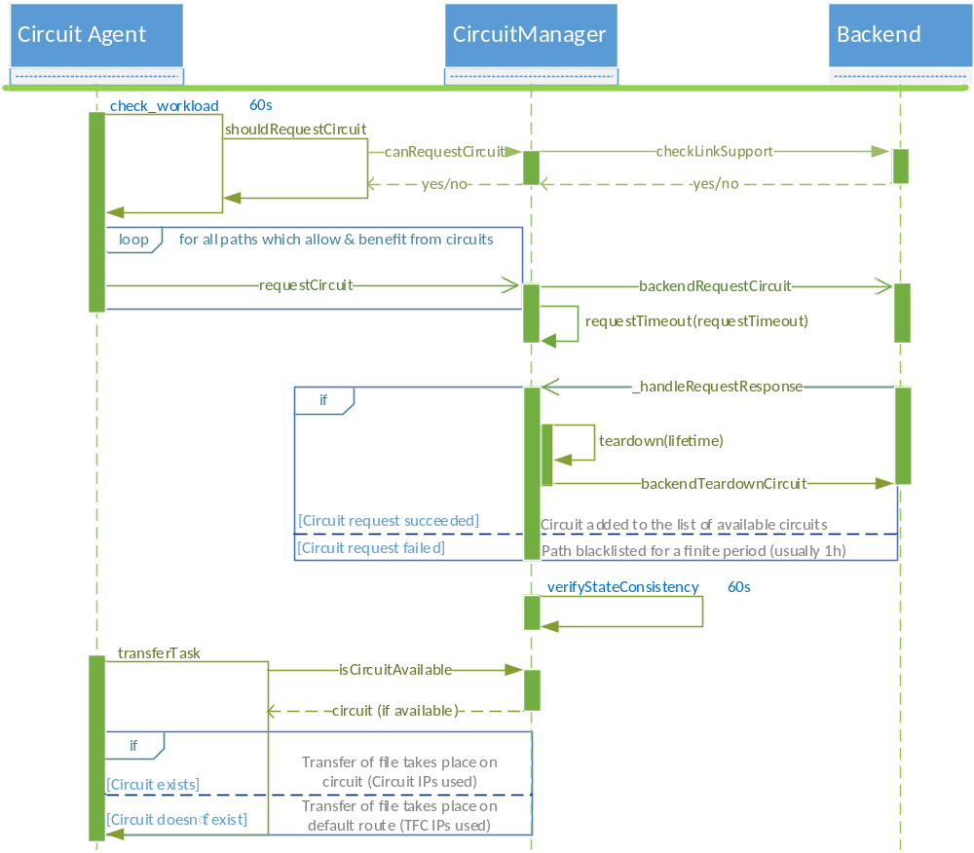
Figure 3 - Sequence diagram of the circuit management framework

Future

The next step for us is to complete work on the production version of this framework (mostly stress testing and bug fixing), while on a longer term we are planning to move this functionality to the central level. This would mean that only one CircuitManagement entity would exist for the whole PhEDEx instance and we would be able to make more informed decisions about which transfers would actually merit and benefit from the creation of a new path/circuit.

