PhEDEx and dynamic circuits
PhEDEx is the data-placement management tool for the CMS experiment at the LHC. It manages the scheduling of all large-scale WAN transfers in CMS, ensuring reliable delivery of the data.
The ANSE project (in the context of CMS) is exploring possible improvement avenues for PhEDEx, specifically how to make it more aware of the network status, and how to provide it with the means of controlling the network by way of virtual/dynamic circuits and bandwidth-on-demand (BoD).
One of the drivers towards introducing this functionality is the need for better predictability of transfers across WAN, allowing for example, co-scheduling of jobs with data.
ANSE project has made significant progress towards integrating network-awareness into PhEDEx. We have developed a prototype that incorporates the use of virtual-circuits into PhEDEx at the level of the FileDownload agent, i.e. per destination-site. This will soon be deployed in production.

PhEDEx architecture

PhEDEx consists of an Oracle database, a website/data-service, a set of central agents and a set of site agents per PhEDEx site. The central agents run at CERN and deal with routing, request-management, bookkeeping and other activities. The site agents process the transfers which were queued by the central agents. PhEDEx operates in a data-pull mode - the destination pulls the data to itself when it is ready.

Introducing dynamic circuits

There were several points at which it was possible to integrate the control and use of dynamic circuits in PhEDEx: per transfer job, per site, or at the central (instance) level. The first version of the circuit management software runs at the site level; meaning each site has an instance of this ‘CircuitManager’. The CircuitManagers tracks active circuits and manages their lifecycles. Requests and teardowns are forwarded via a backend to a circuit infrastructure’s API of the user’s choice. Currently we support only OSCARS (via Dynes) and ODL calls (via MonALISA). This can be extended via a plug-in system.

Implementation details

The prototype included a minimal functionality of the circuit management software in the FileDownload agent. This agent was the best place where such integration could take place at this level.
The FileDownload agent executes file-transfers in bulk, copying many files with each transfer job. Each job contains the source and destination Physical File Names (PFNs). The agent receives only Logical File Names (LFNs) plus the name of the chosen source site. It builds PFNs from the LFNs and a lookup-table per-site, which each site maintains and uploads to the database. In order to transfer files over alternative paths (other than the one specified by the lookup-table), we replace the original hostname/IP in each PFN with the source IP and destination IP of the new path that we want to use.

Circuit agent

We created a ‘CircuitAgent’, which extends the FileDownload agent base classes. This lets us switch between the CircuitAgent and the FileDownload agent, with minimal impact on the infrastructure.
The CircuitAgent checks the workload every minute. It estimates the remaining work per node-pair based on the size of the download queue and past transfer rates. It then decides if it’s worthwhile to request a circuit for that pair. If so, a request will be made to the ‘CircuitManager’.
Before a transfer task is passed to the transfer backend we call the CircuitManager to check if a circuit exists between the endpoints. If so, it updates the PFNs with the source/destination IPs of the new path.

CircuitManager

The CircuitManager receives a request from the CircuitAgent, uses one of the pluggable backends to pass it to a circuit-capable infrastructure, then manages the circuit on behalf of the CircuitAgent.
We present in Figure 1 a simplified version of the sequence diagram of our software.

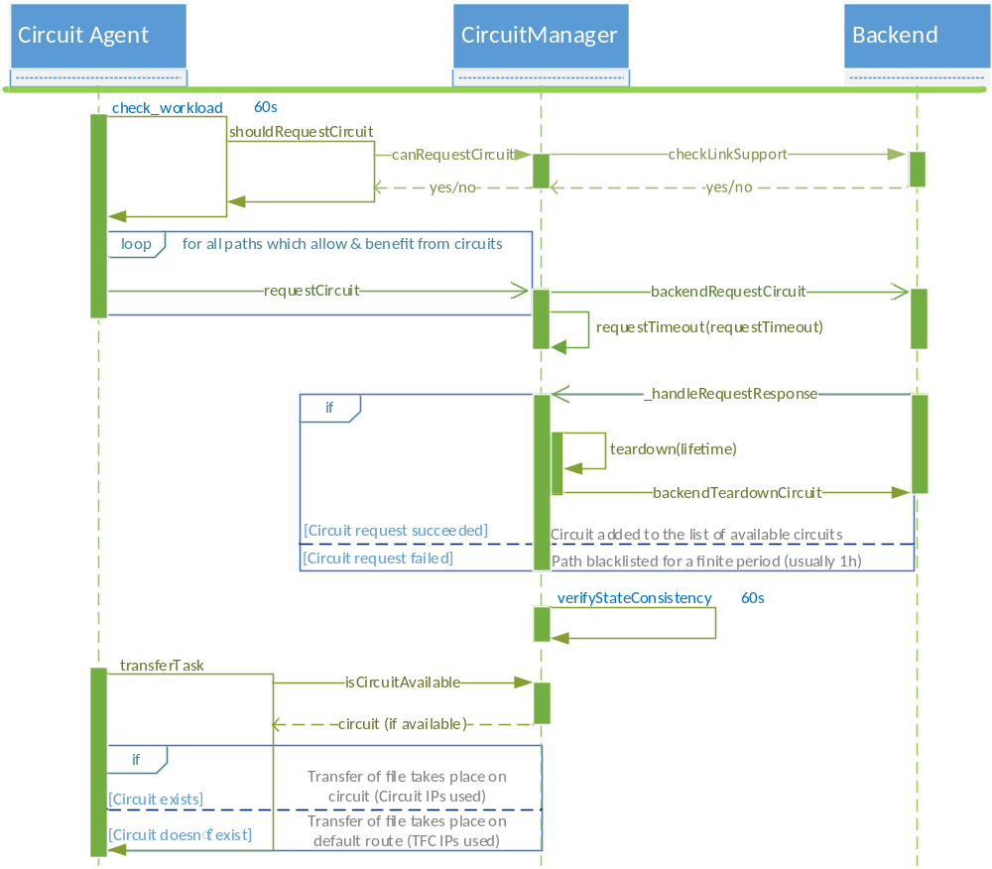
Figure 1 - Sequence diagram of the circuit management framework

Future

The next step is to complete the production version of this framework (mostly stress testing and bug fixing). Longer term, we will move this functionality to a central ‘CircuitManagement’ entity, only one of which would exist for the whole PhEDEx instance. This can then make more informed decisions about which transfers would actually merit and benefit from the creation of a new path/circuit.

