**Technical Log**

By Neil Rafferty (B00451753)

Introduction

The purpose of this log is to document my process in creating a rich internet application for a final year software engineering module, interactive web computing. This log will also illustrate features of this app and discuss how they were achieved.

A new public GitHub repository was created to host the code and potentially provide a reference of work for future employers ([*https://github.com/stormrage-neilr/COM_554_Assignement_1*](https://github.com/stormrage-neilr/COM_554_Assignement_1)*).* This was on Friday the 7th of October.

Project Structure

On Saturday the 23rd of October a project skeleton was created. The skeleton consists of three files shown at the top of figure 1. The html file is the file connects the three. Line 5 of the code shows where the CSS file has been linked to the html (*using the relative directory location).* Line 6 contains the import for the jQuery library *(this is from a google server online)* and line 7 contains the import for the local JavaScript file *(this file is currently empty)*. This creates a basic spike through the three main programming languages.

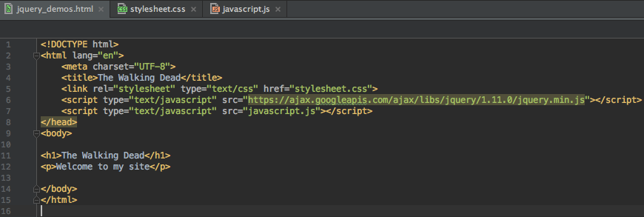

***Figure 1:*** *Initial files and html structure.*

Figure 3 Shows how the site looks when adding the basic CSS from figure 2 and with the minimal html. Note, the CSS is currently only using html tag names to select each

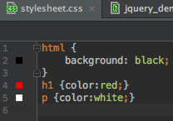 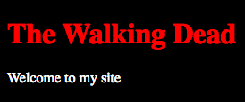

***Figure 2:*** *Initial CSS code.* ***Figure 3:*** *Initial site.*

element.

The Walking Dead TV series was selected as the content for this project. The work done here was minimal, however, it was a good step toward the finished product.

Title Image & Navigation Bar

The next day I replaced the header and paragraph with a title image and a navigation bar. In figure 4 we can see the html structure of these elements. These elements are contained in the body tag of the html document and I added id’s and classes to help me select the corresponding elements when applying my CSS styles. In figure 5 I set the contents of the ul to the centre of the screen. Figure 6 shows the li items being configured to show as a line and the removing of the bullet point normally shown to the left of the list item *(this is the ‘display:inline’ code on line 19)*. Next, we can see how the hover function has been has been configured using CSS *(figure 7).* The effect of figure 4 to 7 can be seen in the navigation bar in figure 9 *(note: register is being hovered over in this screenshot)*.

The title image, taken from blogspot.com *(The walking dead poster 51)*, is stored locally in a folder called ‘res’. The relative

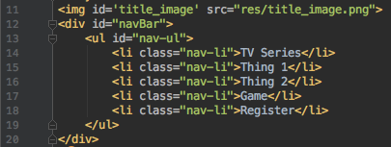

***Figure 4:*** *Title image and navigation bar html.*

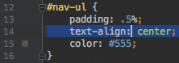 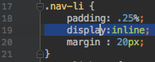

***Figure 5****: nav-ul CSS.* ***Figure 6:*** *nav-li CSS.*

../../Desktop/Screen%20Shot%202016-10-27%20at%2015.45.53.png 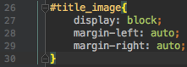

***Figure 7:*** *Hover effect CSS.* ***Figure 8:*** *Title image CSS.*

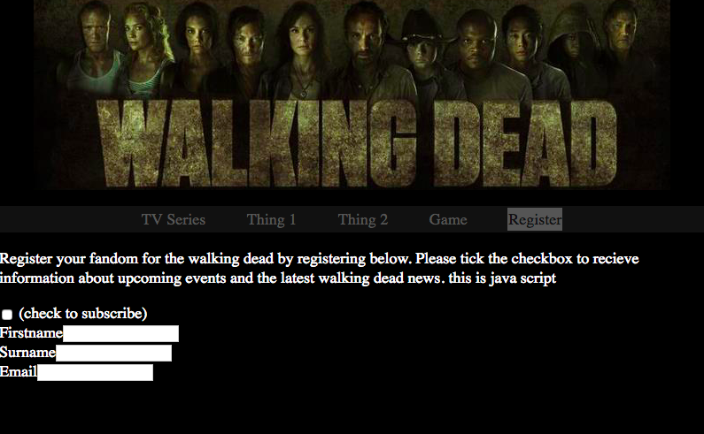

***Figure 9:*** *Title and navigation bar display.*

path to this image can be seen on line 11 in figure 4 and the image has been centred on the screen by setting the left and right margins to auto scale *(figure 8, lines 28 & 29)*.

Menu Item jQuery Functionality

After tinkering with the code, learning from the mode during my studies practicals in class and spending some time on my other modules I started to introduce some jQuery functionality on Wednesday the 26th of October. However, before we discuss how the jQuery code works I want to briefly outline two changes to our html file. The first is that the navBar div tag in figure 4 has been changed to a nav tag and id’s such as

‘home-button’ have been added to the li elements. The second is that section elements have been created for hosting material relevant to the corresponding li *(as shown in figure 10)*.

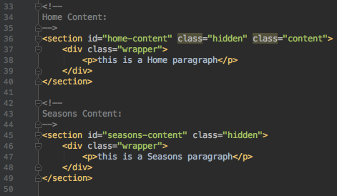 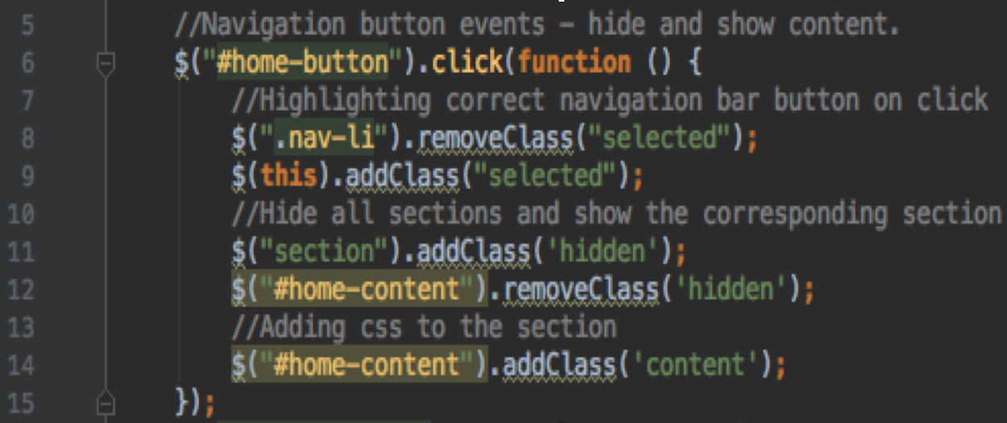

***Figure 10:*** *Sections.* ***Figure 11:*** *Menu item functionality.*

The code in figure 11 adds functionality to the navigation bar li elements. It firstly finds and adds a click event onto the li element using the aforementioned id *(line 6)*. Then the code hides and show the corresponding sections by adding and removing a ‘hidden’ class. This class relates to the CSS property ‘display:none’ making the section vanish and appear as the class is added and removed. Note, the hide() and show() methods may have also been used but I wanted to demonstrate the use of the addClass() and removeClass() methods. This code also adds and removed a ‘selected’ class to highlight the li element that has been selected in a similar way. The result is demonstrated in figure 12 and 13 *(note the change in wording in the two paragraphs)*.

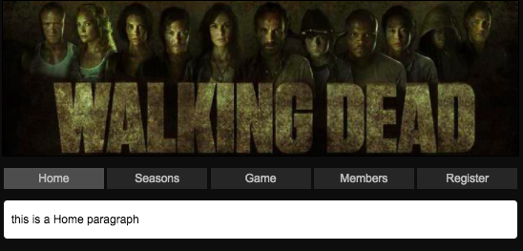 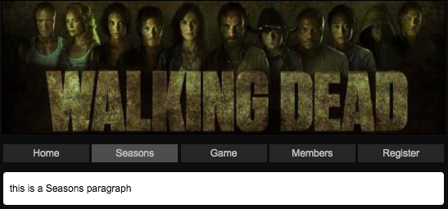

***Figure 12:*** *Home contents.* ***Figure 13:*** *Seasons contents.*

-

CSS screen size

Form- required, email requires, date max submit

*The walking dead poster 51,* viewed 27 October 2016,

<<http://1.bp.blogspot.com/-E6T6LmRhFzI/UM5Dt7Dd1wI/AAAAAAACJlU/-vTS0wIJlnI/s1600/the_walking_dead_poster51.jpg>>.

Register your fandom for the walking dead by registering below. Please tick the checkbox to recieve information about upcoming events and the latest walking dead news.