Weather (2002, in press)

Summer rainfall and wheat grain quality: relationships with the North Atlantic Oscillation

Peter S. Kettlewell¹, David B. Stephenson², Mark D. Atkinson¹ and Philip D. Hollins¹

¹Crop and Environment Research Centre, Harper Adams University College, Shropshire
²Department of Meteorology, University of Reading

There have been numerous studies of the relationships between climate and wheat yield (weight of grain per unit area of ground) e. g. Hooker (1922); Chmielewski and Potts (1995). In contrast, there has been relatively little work examining the effect of climate on the quality of the grain produced, i. e. suitability for use in food production and consumption. Recently, Kettlewell et al. (1999) have shown that the quality of UK wheat grain at summer harvest is strongly influenced by the North Atlantic Oscillation (NAO) in the preceding winter. The NAO is a large-scale alternation in air pressure between northern and southern regions of the North Atlantic Ocean (recently reviewed by Wanner et al. 2001). By exploring the effect of the NAO on wheat quality, we have discovered that the winter NAO influences the following summer England and Wales rainfall. In this article we first discuss the relationships between summer climate and wheat quality, followed by describing the evidence for the effect of the winter NAO on summer rainfall amount, and finally we consider possible predictive skill of the NAO for rainfall amount.

Climate and wheat quality

Some general aspects of wheat development are described in this section, together with the importance of wheat quality in the UK, before the effect of climate is discussed. Almost all the wheat in Britain is sown in autumn and winter, between September and December, rather than in spring (Finch et al. 2002). There is a long vegetative period after germination when leaves and side-shoots emerge in succession until spring. Development of crops sown at different dates is gradually synchronised by the increasing daylength in spring. The stem extends in spring and the ear (head) emerges in late May/early June. Grain growth starts at flowering (anthesis), and this occurs in June in virtually all crops. Grain growth ceases in late July or August and is followed by a ripening period when the grain loses moisture before harvest. In England, where the great majority of UK wheat is grown, harvest normally takes place in August, although in Scotland harvest often extends into September.

The quality of wheat grown in Britain was of relatively little consequence until accession to the European Economic Community (EEC) in 1973. Before this, most of the wheat for baking into bread was imported from North America. The EEC imposed import tariffs which made import of North American wheat prohibitively expensive for milling into the majority of bread flour (Butler 1986). Technological changes to the baking process also allowed more British wheat to be used for breadmaking (Farrand 1974). This created a strong incentive to monitor the quality of British wheat to inform the wheat industry about the quality of raw material available for milling and baking. Thus a national survey of wheat quality began following the harvest in 1974, undertaken by the Home-Grown Cereals Authority (Anon. 1974). The survey has continued every year and covers the UK, although relatively few samples are taken from Scotland or Wales and usually none from Northern Ireland.

There are several aspects of quality measured in the survey, but not all aspects are equally important to all end-users of wheat grain. One quality characteristic, however, is relevant to all users since it has a direct impact on the economics of grain transport. This is specific weight (the bulk density of the grain) – the higher the specific weight the greater the weight of grain that can be loaded into a fixed-volume container. Thus specific weight was chosen for the study described in this article.

National average specific weight recorded in the wheat quality survey shows a remarkably similar pattern over time to that of the preceding winter NAO (Fig 1a). There is a strong association between the two variables (Fig. 1b). The correlation coefficient over this period is 0.64 which is statistically different from zero at the 0.1% level of significance using a two-tailed t test. In other words, there is less than 0.1% chance that such a coefficient could have arisen from sampling uncorrelated variables.

The mechanism underlying this relationship is not immediately obvious, but an intermediate step in studying the NAO-wheat quality mechanism is to examine the effect of climatic factors on specific weight. There are two main aspects of climate which can influence specific weight: solar radiation and rainfall. High solar radiation during grain growth is necessary to enable adequate photosynthesis to provide the supply of carbohydrate for filling the grain (Brocklehurst et al. 1978). Well-filled grain usually has high specific weight (Bayles 1977). Rainfall reduces specific weight through alternate wetting and drying causing wrinkling of the grain surface during grain ripening, and thereby reducing the packing efficiency of the grain (Braken and Bailey 1928). Although temperature can influence grain growth, the effects tend to be small compared with the above mechanisms. Solar radiation and rainfall are negatively related in summer due to cloudiness, thus rain in early grain growth should indirectly reduce specific weight through low solar radiation. So rain both early and late in grain development is expected to be negatively correlated with specific weight.

The timing of grain growth will broadly indicate when rainfall and specific weight should be studied for correlation. A study of wheat development over three years at five sites in England and one in southern Scotland showed that grain growth usually started in early to mid-June (Kirby 1998) and finished in late July to early August (Kettlewell 1998a). Grain growth was followed by a ripening period before harvest during August (Kettlewell, 1998b). These timings suggest that total rainfall from June until the end of August would be most appropriate for studying the specific weight-summer climate relationship.

When a scatter graph of wheat specific weight and the total England and Wales precipitation (EWP) in June, July and August is examined, it can be clearly seen that high EWP tends to be associated with low specific weight and vice versa (Fig. 2). The two variables are strongly negatively correlated (r=-0.62, p<0.001), confirming that, as anticipated, the greater the rainfall in the summer months the lower the quality of the harvested wheat grain.

Winter NAO and summer rainfall amount

Since both the winter NAO and the total summer precipitation are associated with wheat quality, it was natural to investigate whether the winter NAO directly influences summer rainfall amount in Britain. At a regional level, there is a negative correlation between the winter NAO index and summer rainfall (using the Hadley Centre regional precipitation series) for every region of the UK (Fig. 3). The correlation is strongest in eastern Scotland, but is not statistically significant in northern and western Scotland (termed the northern Scotland region on the Hadley Centre website). This contrasts with the effect of the winter NAO on concurrent winter precipitation which is strongest in the northern Scotland region (Wilby et al. 1997).

At a national level, a scatter graph of the summer EWP and winter NAO index shows that a high NAO index in winter is associated with a low summer rainfall and vice versa over the period of the wheat quality survey (Fig. 4). The driest summer over this period, in 1995, was preceded by a winter NAO index of 2.8, and the wettest summer, in 1980, was preceded by a winter NAO of zero. Based on these 27 years of data, the winter NAO is significantly correlated with summer EWP (r=-0.44, p<0.05). Furthermore, over the longest period of available Hurrell NAO data (1865-2000) the NAO-EWP correlation was also found to be negative and statistically significant (Fig. 5; r=-0.23, p<0.01), although the variance in EWP accounted for by the NAO is very small. Comparison of Figs 4 and 5 indicates that the NAO-EWP relationship has strengthened in recent decades.

A correlation can arise from chance coincidence of trends over time in two variables rather than from a relationship between year-to-year variations. To examine this possibility both variables were detrended using the differencing technique (see Stephenson et al. (2000) for a discussion of this detrending technique). When the year to year differences for both the winter NAO index and summer EWP were calculated the correlation coefficients were similar to those between the raw data given in the previous paragraph (1974-2000; r=-0.50, p<0.01; 1866-2000; r=-0.23, p<0.01). This shows that the relationship between the winter NAO and summer precipitation results from short-term year-to-year variations rather than being simply due to coincident long-term trends.

More insight into the relationship between winter conditions and summer precipitation totals can be gained by exploring the spatial structure of the correlations. Figure 6a shows the correlations between the wintertime NAO index and summer precipitation over the Northern Hemisphere for the period 1979-97. A centre of negative correlation can be seen to
be situated over much of northwestern Europe and southern Scandinavia with the most negative correlations situated over the UK. This confirms our findings with UK precipitation indices and suggests that summer wheat quality in other European countries might also be related
to the preceding wintertime NAO. Further to the east, a series of alternating-sign correlations extend over northern Siberia reminiscent of a large-scale wave-like teleconnection. An intriguing centre of negative correlation can also be seen to exist over the Gulf stream region in the western North Atlantic ocean. Figure 6b shows the correlations between the summertime England and Wales precipitation totals and mean sea-level pressure in the preceding winter. There is a centre of positive correlation centred on the Arctic region together with a band of negative correlation situated further south over the Azores and southern Europe regions. This pattern closely resembles the well-known North Atlantic Oscillation pattern (see www.met.rdg.ac.uk/cag for more information on NAO). This analysis therefore confirms the existence of a relationship between winter NAO and the following summer UK precipitation, and justifies the use of the NAO index as a suitable predictor. A lag relationship between the winter NAO and summer rainfall amount is also supported by recent studies of the influence of winter NAO on a summer drought severity index in Britain (Wedgebrow et al. 2001).

Predictive skill

The existence of this lag relationship raises the possibility of using the winter NAO to forecast the summer rainfall amount. Variance accounted for over the 136 year period is, however, too low for any useful predictive skill. Even for the more recent period, covered by the grain quality data, skill in forecasting exact precipitation amount is poor. Therefore the predictive skill for the period 1974 to 2000 was assessed using a simple two category forecast for comparison with observed data.

Regression forecasts of summer precipitation amount were made using the relationship with the NAO shown in Fig. 4. Year was also included in the regression model to take account of a statistically significant trend in summer rainfall amount over this period. However, using the forecasts from the regression with the full set of data will give artificial skill, since the data used to derive the forecasts is also used for validation. Therefore cross validation forecasts were used to reduce artificial skill i. e. the data for the first year (1974) was omitted and the regression coefficients then estimated and used to forecast the EWP for the omitted year. The process was repeated until every year had been forecast. Both the observed data and the cross-validation forecasts were then categorised as either above or below the observed mean (196 mm). Each year was classified into one of four categories: observed below mean and forecast below mean (correct forecast); observed below mean but forecast above mean (incorrect forecast); observed above mean and forecast above mean (correct forecast); observed above mean but forecast below mean (incorrect forecast). The number of years in each of these four categories is shown in Table 1.

There were 20 correct forecasts in 27 years (74% correct). Statistical significance was determined from the odds ratio skill score (ORSS), where a score of one represents perfect skill and a score of zero represents no skill. The high ORSS of 0.82 was tested using Table A2 in Thornes and Stephenson (2001), and this showed, at 95% confidence, that the skill was not due to chance. For comparison with the NAO as a predictor, a persistence forecast was used, i. e. the rainfall was assumed to be the same as in the previous year. The results of the persistence forecast are shown in Table 2. Only 14 out of 27 (52%) of persistence forecasts were correct. This is little different to the 50% expected by chance, and the ORSS of 0.03 was not statistically significant.

The skill of the NAO as a predictor of precipitation category was further evaluated by comparing cross validation forecast category with the observed category for the five driest and the five wettest summers over the 1974-2000 period. All but one of these summers were correctly classified by this forecasting method (Table 3).

Conclusion
This short article has presented the strong 6-month lag relationship between the quality of the summer wheat harvest in the UK and the North Atlantic Oscillation in the preceding winter.
In diagnosing causes for this relationship, we have discovered a weak yet statistically significant (at the 5% level) negative correlation between winter NAO and the following summer precipitation amounts in the UK. This relationship exists over all regions in the UK and over much of northwestern Europe and southern Scandinavia. Furthermore, the relationship is not due to fortuitous trends over a short recent period, but is due to year-to-year variations and is statistically significant and present over the whole period of available historical data since 1865. Due to this relationship some (but not all) of the driest recent summers in England and Wales have followed strong westerly positive NAO winters (e.g. 1995).

Possible mechanisms for this newly discovered relationship remain a mystery that require further investigation. Likely causes must involve memory in the climate system and an obvious candidate for this would be the North Atlantic ocean. However, the details remain unclear about how the memory of winter atmospheric conditions can be communicated back to the atmosphere in summer. Hopefully, future studies with coupled ocean-atmosphere climate models will be able to probe this topic in more detail.

The existence of a six-month lag relationship opens up the exciting possibility of long-lead forecasting of UK summer rainfall totals. Due to the weakness of the relationship, it is difficult to forecast the exact precipitation amount with high amounts of skill. However, the feasibility of a two category forecast has been clearly demonstrated in this paper. More sophisticated approaches could be developed with more optimal predictors and regression models.

It is interesting to note that the biological relationship between wheat quality and NAO is stronger than that between physical quantities such as precipitation and NAO. This characteristic of biological systems to amplify North Atlantic climate signals has been noted in other recent studies (Taylor et al. 2002). Based on the winter NAO, operational forecasts of UK wheat quality of use to the flour industry are now being made freely available on an annual basis
(Atkinson et al. 2002, and see http://www.harper-adams.ac.uk/wheatqualityforecasts/). Further studies of other climatic factors that contribute to the NAO-wheat quality relationship will be published shortly (Atkinson et al. 2003).

Acknowledgements

We are grateful to the Home-Grown Cereals Authority for financial support for this study, with additional support from: ADM Milling, Allied Mills/Weston Research Laboratories, Alvan Blanch, Hydro Agri, PBIC Seeds, Rank Hovis, Syngenta.

References
Anon. (1974) The quality of wheat and barley from the 1974 harvest. Home-Grown Cereals
Authority, London
Atkinson, M. D., Kettlewell, P. S., Hollins, P. D. and Stephenson, D. B. (2002) Regression
forecast of UK harvest wheat quality from the preceding winter North Atlantic Oscillation.
Experimental Long-Lead Forecast Bulletin Volume 11 Number 2 (June 2002). Available at
http://grads.iges.org/ellfb/
Atkinson, M. D., Kettlewell, P. S., Hollins, P. D. and Stephenson, D. B. (2003) Mechanisms of
the long-lead relationship between the winter North Atlantic Oscillation and the quality of
British wheat. In preparation for submission to Clim. Res.
Bayles, R. A. (1977) Poorly filled grain in the cereal crop. I. The assessment of poor grain
filling. J. natn. Inst. agric. Bot., 14, pp. 232-240
Braken, A. F. and Bailey, C. H. (1928) Effect of delayed harvesting on the quality of wheat.
Cereal Chem., 5, pp. 128-145
Brocklehurst, P. A., Moss, J. P. and Williams, W. (1978) Effects of irradiance and water supply
on grain development in wheat. Ann. App. Biol., 90, pp. 265-276
Butler, N. (1986) The international grain trade: problems and prospects. Croom Helm, London
Chmielewski, F. M. and Potts J. M. (1995) The relationship between crop yields from an
experiment in southern England and long-term climate variations. Agric. For. Met., 73, pp. 43-
66
Farrand, E. A. (1972) Potential milling and baking value of home grown wheat. J. Natn. Inst.
Agric. Bot., 12, pp. 464-470
Finch, H. J. S., Samuel, A. M. and Lane, G. P. F. (2002) Lockhart and Wiseman’s Crop
Husbandry. 8th edition. Woodhead Publishing Limited, Cambridge.
Hooker, R. H. (1922) The weather and the crops in Eastern England, 1885-1921. Q. J. R.
Meteorol. Soc., 48, pp. 115-138
Kettlewell, P. S. (1998a) Grain filling. In: Sylvester-Bradley, R., Scott, R. K., Clare, R. W. and
Duffield, S. J. (Eds.) Assessments of Wheat Growth to Support its Production and
Improvement (Volume I), Home-Grown Cereals Authority, London, pp. 55-59
Kettlewell, P. S. (1998b) Ripening. In: Sylvester-Bradley, R., Scott, R. K., Clare, R. W. and
Duffield, S. J. (Eds.) Assessments of Wheat Growth to Support its Production and
Improvement (Volume I), Home-Grown Cereals Authority, London, pp. 60-62
Kettlewell, P. S., Sothern, R. B., and Koukkari, W. L. (1999) UK wheat quality and economic
value are dependent on the North Atlantic Oscillation. J. Cereal Sci., 29, pp. 205-209
Kirby, E. J. M. (1998) Plant Development. In: Sylvester-Bradley, R., Scott, R. K., Clare, R. W.
and Duffield, S. J. (Eds.) Assessments of Wheat Growth to Support its Production and
Improvement (Volume I), Home-Grown Cereals Authority, London, pp. 8-13
Stephenson, D. B., Pavan, P. and Bojariu, R. (2000) Is the North Atlantic Oscillation a random
walk? Int. J. Clim., 20, pp. 1-18
Taylor, A. H., Allen, J. I. and Clark, P. A. (2002) Extraction of a weak climatic signal by an
ecosystem. Nature, 416, pp. 629-632
Thornes, J. E. and Stephenson, D. B. (2001) How to judge the quality and value of weather
forecast products. Meteorol. Appl., 8, pp. 307-314
Wanner, H., Bronnimann, S., Casty, C., Gyalistras, D., Luterbacher, J. Schmutz, C., Stephenson,
D. B. and Xoplaki, E. (2001) North Atlantic Oscillation – concepts and studies. Surveys
Geophys., 22, pp. 321-382.
Wedgebrow, C. S., Wilby, R. L., Fox, H. R. and O’Hare, G. (2002) Prospects for seasonal
forecasting of summer drought and low river flow anomalies in England and Wales. Int. J.
Clim., 22, pp. 219-236
Wilby, R. L., O’Hare, G. and Barnsley, N. (1997) The North Atlantic Oscillation and British
Isles climate variability, 1865-1996. Weather, 52, pp. 266-276
Table 1. Numbers of years above and below the mean for 1974-2000 of June, July, August total England and Wales precipitation for observed data and for cross validation regression predictions from Hurrell’s winter (December, January, February) North Atlantic Oscillation index. Shaded cells show the correct forecasts.

Observed
 |  | Below mean | Above mean | Total
 | Below mean | 10 | 5 | 15
Predicted | Above mean | 2 | 10 | 12
 | Total | 12 | 15 | 27

Table 2. Numbers of years above and below the mean for 1974-2000 of June, July, August total England and Wales precipitation for observed data and for persistence predictions. Shaded cells show the correct forecasts.

Observed
 |  | Below mean | Above mean | Total
 | Below mean | 5 | 6 | 11
Predicted | Above mean | 7 | 9 | 16
 | Total | 12 | 15 | 27

Table 3. Skill in predicting the five most extreme wet and dry summers in England and Wales (June, July, August total precipitation) from the winter North Atlantic Oscillation (Hurrell’s mean December, January, February index) using a two category forecast from 1974 to 2000.

Year | NAO | Observed EWP (mm) | Cross validation forecast EWP (mm) | Correct forecast in relation to mean (196.0 mm)
Driest summers
1995 | 2.8 | 76.6 | 173.3 | yes
1976 | 0.8 | 77.4 | 195.6 | yes
1983 | 1.9 | 107.3 | 176.0 | yes
1984 | 2.9 | 128.3 | 165.4 | yes
1975 | 1.2 | 134.2 | 187.6 | yes
Wettest summers
1980 | 0 | 287.9 | 207.1 | yes
1997 | -0.8 | 285.8 | 212.2 | yes
1985 | -1.7 | 277.0 | 223.2 | yes
1987 | -1.4 | 260.0 | 221.0 | yes
1992 | 0.7 | 259.0 | 194.3 | no

FIGURE LEGENDS
Figure 1. UK mean wheat grain specific weight and Hurrell’s winter (December, January, February mean) NAO index for 1974-2000; (a) time series (specific weight - open circles, broken line; NAO - closed circles, solid line); (b) scatter graph. Specific weight data from Home-Grown Cereals Authority annual cereal quality surveys, Hurrell’s NAO index from the National Center for Atmospheric Research website (http://www.cgd.ucar.edu/~jhurrell/nao.html#seasonal).

Figure 2. Scatter graph of UK mean wheat grain specific weight and summer (June, July, August total) precipitation for England and Wales for 1974-2000. Precipitation data from the Hadley Centre website
(http://www.metoffice.com/research/hadleycentre/CR_data/Monthly/HadEWP_act).

Figure 3. Regional correlations of summer (June, July, August total) precipitation with Hurrell’s winter (December, January, February mean) NAO index for 1974-2000. Precipitation data from the Hadley Centre website
(http://www.met-office.gov.uk/research/hadleycentre/CR_data/Monthly/). All correlations significant (p<0.05) except northern Scotland and north west England.

Figure 4. Scatter graph of summer (June, July, August total) precipitation for England and Wales and Hurrell’s winter (December, January, February mean) NAO index for 1974-2000.

Figure 5. Scatter graph of summer (June, July, August total) precipitation for England and Wales and Hurrell’s winter (December, January, February mean) NAO index for 1865-2000.

Figure 6. Correlation maps of (a) summer (June, July, August total) precipitation (CPC merged analysis) with the preceding winter (December, January, February mean) NAO index (Azores-Stykkisholmur) over the period 1979-1997 (contour interval 0.2 with shading for negative correlations), and (b) winter (December, January, February mean) sea-level pressure (Hadley Centre reconstruction) with the following summer (June, July, August total) England and Wales precipitation over the period 1871-1994 (contour interval 0.1 with shading for positive correlations). The maps were drawn using the datasets in KNMI Climate Explorer (http://climexp.knmi.nl/).

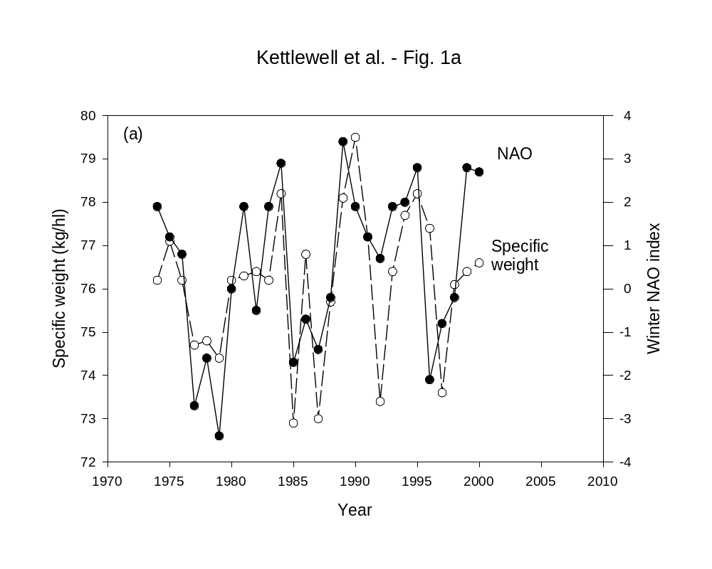
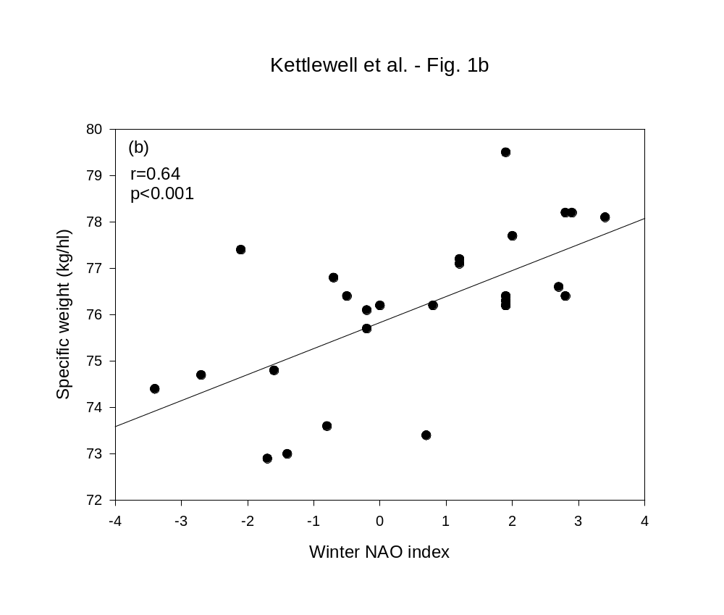
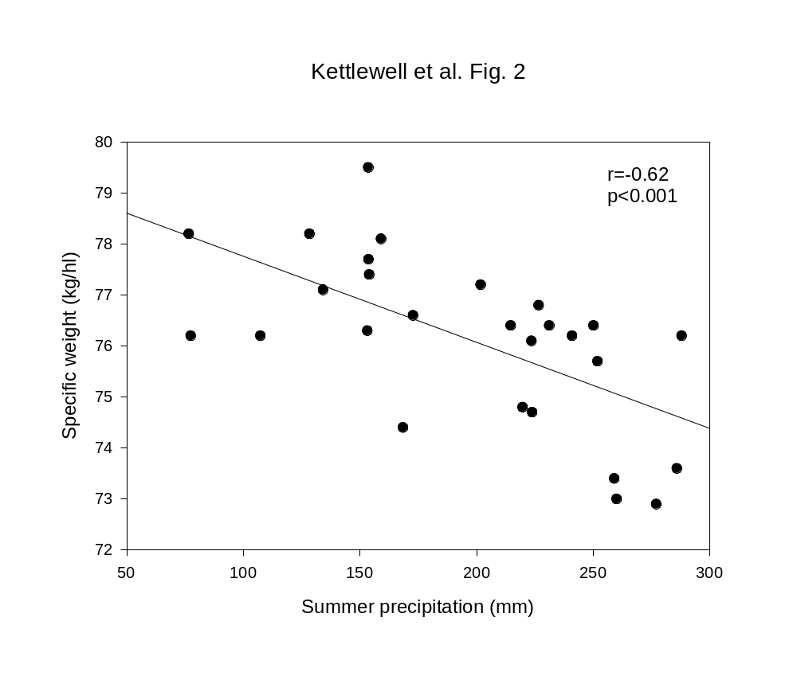
Kettlewell et al. – Fig. 3

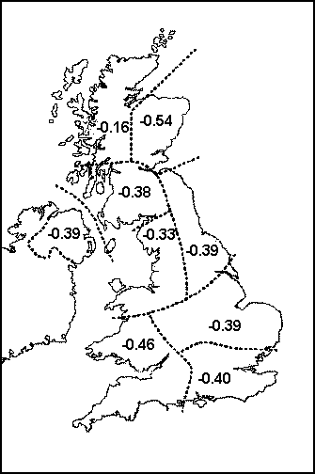

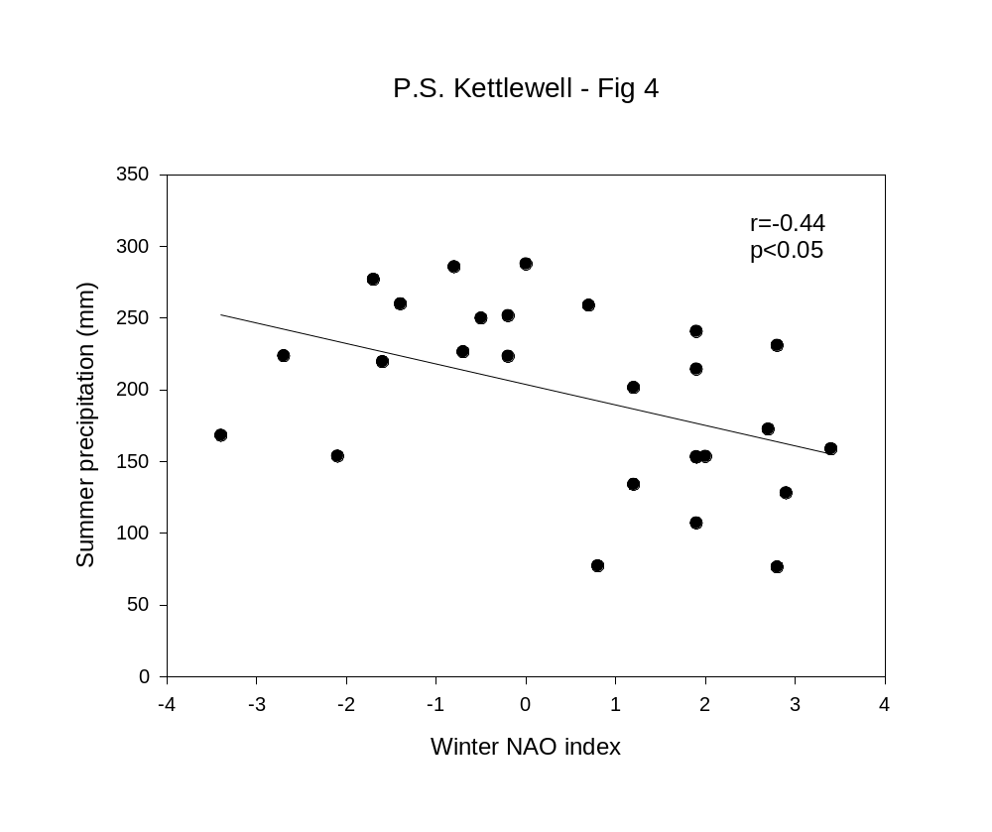
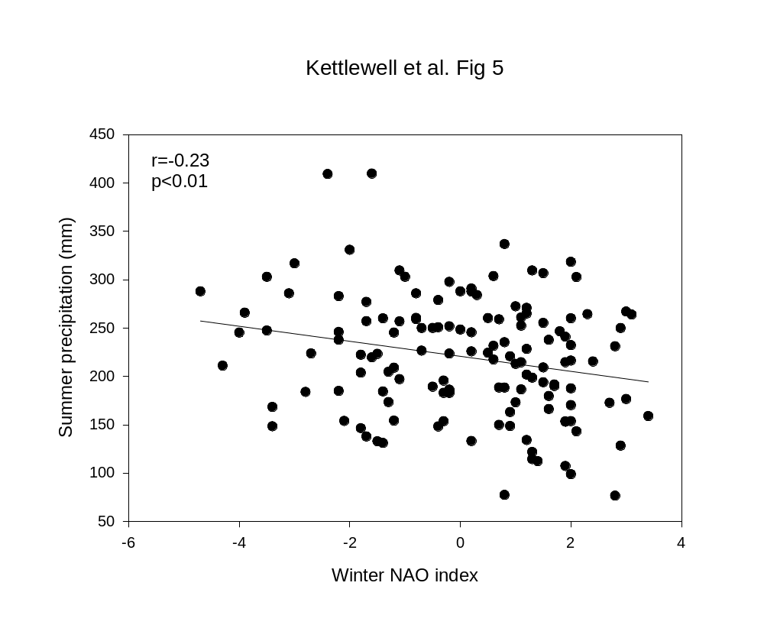
Kettlewell et al. Fig. 6a

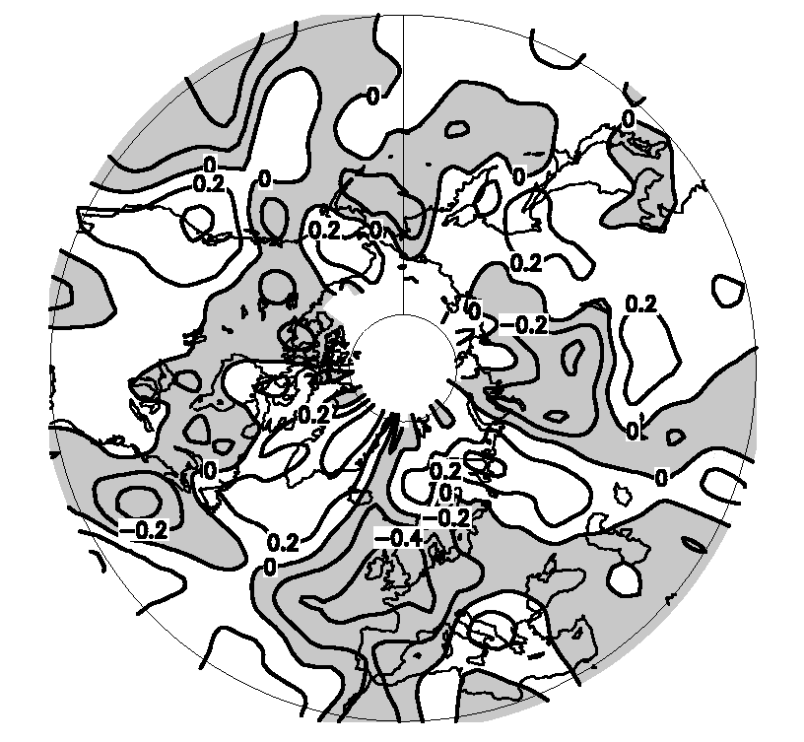
Kettlewell et al. – Fig. 6b

