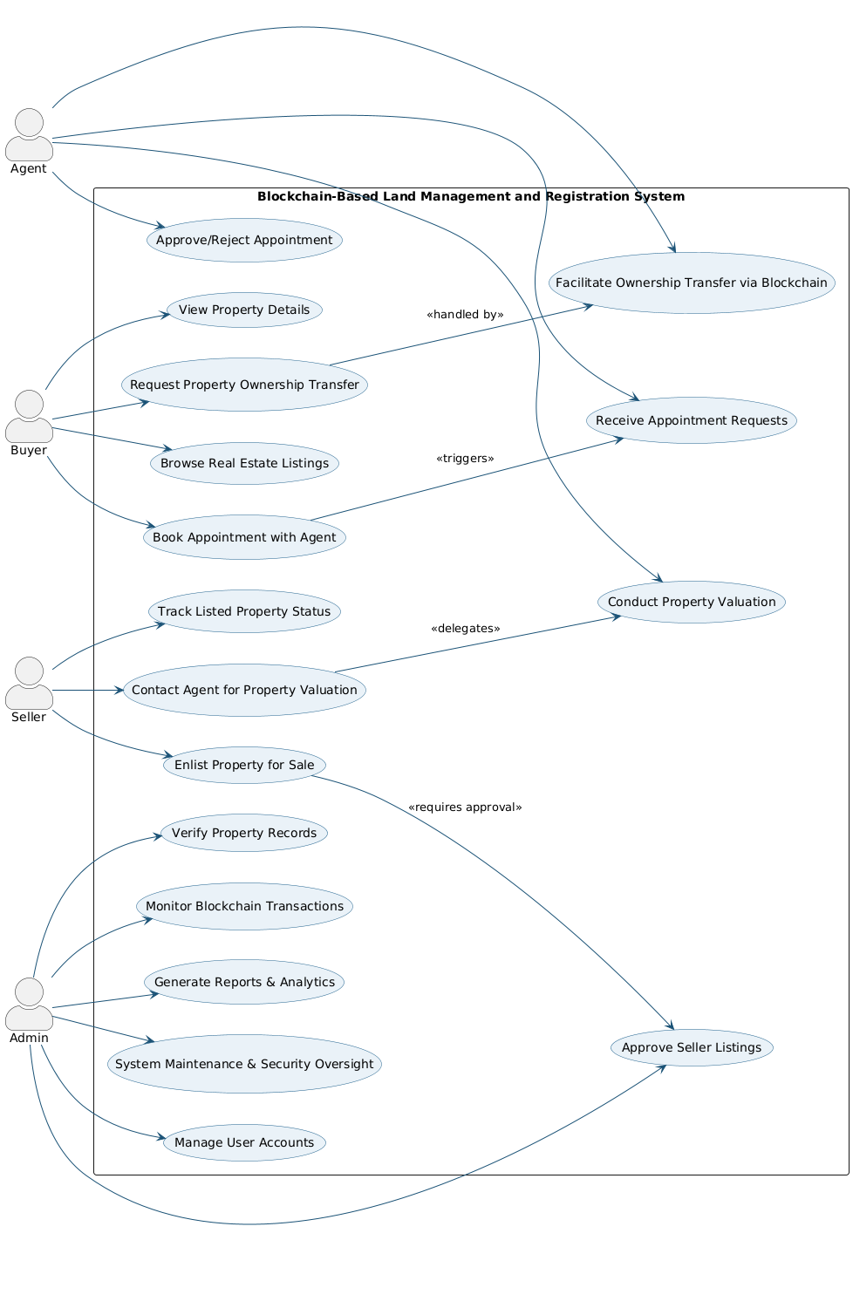

Figure 1: Use Case Diagram

The use case diagram illustrates a Blockchain-Based Land Management and Registration System where four key actors—Agent, Buyer, Seller, and Admin—interact with the system to perform property-related tasks securely through blockchain technology. Buyers can browse listings, view property details, request ownership transfers, and book appointments with agents, while Sellers can enlist properties, track their status, and request valuations. Agents manage appointments, conduct valuations, and facilitate ownership transfers, ensuring smooth property transactions. Admins oversee critical system functions such as approving seller listings, verifying property records, monitoring blockchain transactions, managing user accounts, generating reports, and maintaining security. The integration of blockchain ensures transparent, secure, and tamper-proof property transactions and ownership transfers.

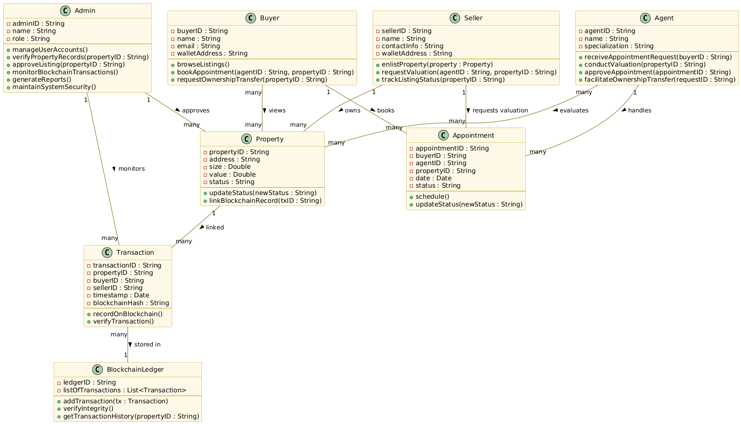

Figure 2: Class Diagram

This class diagram represents the structure of a Blockchain-Based Land Management and Registration System, defining the main entities, their attributes, operations, and relationships. The system includes four key actors: Admin, Buyer, Seller, and Agent, each with specific roles such as managing user accounts, browsing listings, enlisting properties, scheduling appointments, conducting valuations, and facilitating ownership transfers. The Property class maintains details like address, value, status, and blockchain records, while Appointment manages scheduling and status updates between buyers, agents, and sellers. Transactions are represented by the Transaction class, which records ownership changes with attributes such as transaction ID, property ID, participants, timestamp, and blockchain hash, all of which are securely stored and verified in the BlockchainLedger. The diagram highlights strong associations between users, properties, appointments, and transactions, ensuring transparency, security, and traceability of real estate activities through blockchain integration.

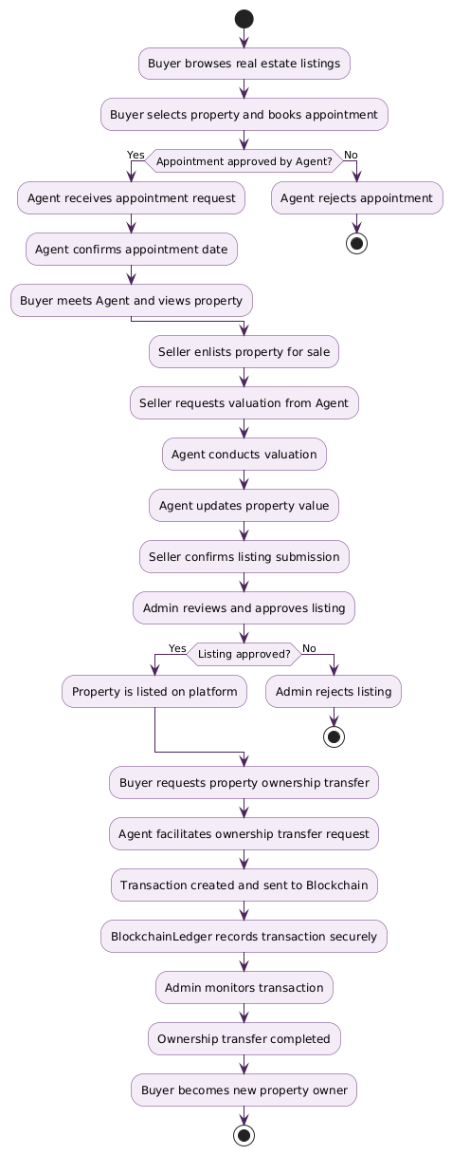

Figure 3: Activity Diagram

This activity diagram illustrates the end-to-end workflow of property transactions in a Blockchain-Based Land Management and Registration System. The process begins with a buyer browsing listings, selecting a property, and booking an appointment with an agent. If the appointment is approved, the buyer meets the agent to view the property, after which the seller enlists the property for sale. The seller then requests a valuation from the agent, who conducts the valuation, updates the property value, and forwards it for seller confirmation. The admin reviews the listing and either approves it (making it available on the platform) or rejects it. Once listed, the buyer can request ownership transfer, which the agent facilitates by creating a transaction that is recorded securely on the blockchain. The admin monitors this process to ensure compliance, and once validated, the ownership transfer is completed, officially making the buyer the new property owner. This flow highlights secure, transparent, and blockchain-enabled real estate management with checkpoints for approval and verification at each stage.

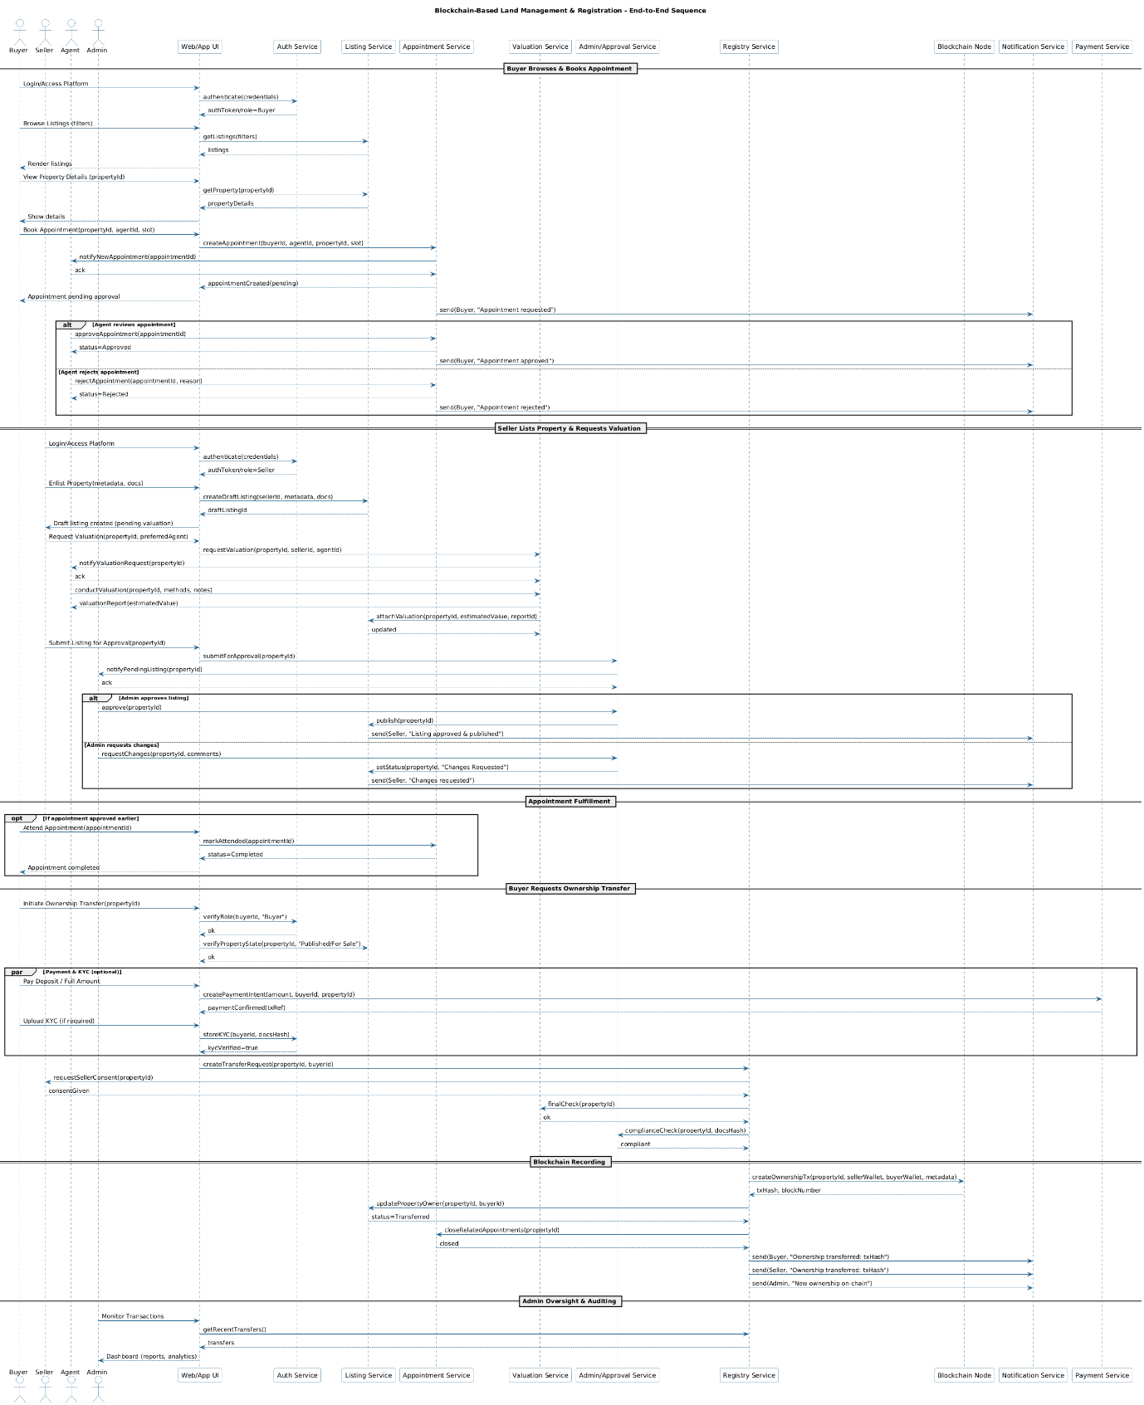

Figure 4: Sequence Diagram

This sequence diagram depicts the end-to-end workflow of a Blockchain-Based Land Management and Registration System, showing how different actors and system services interact to complete property transactions. The process begins with the buyer browsing listings, booking an appointment, and awaiting agent approval. If approved, the appointment is scheduled, and the buyer meets the agent to view the property. The seller then enlists the property and requests a valuation, which the agent conducts and updates before the seller submits the listing for admin review. Upon approval, the property is listed on the platform. The buyer can then request ownership transfer, which the agent facilitates by initiating a blockchain-backed transaction. This transaction is recorded on the blockchain, with notifications sent to the parties involved. The admin monitors the transaction for auditing and compliance, ensuring the secure transfer of ownership. The flow highlights integration across services like listing, appointment, valuation, approval, registry, blockchain recording, notification, and payment, ensuring transparency, immutability, and accountability throughout the property transaction lifecycle.