Trello Board Screenshots:

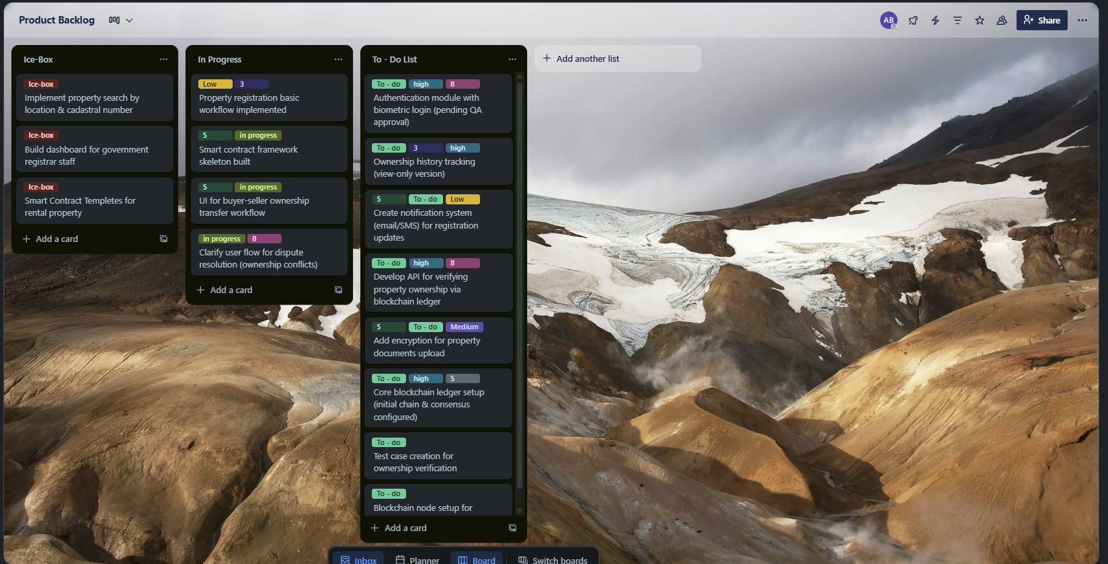

**Figure 1: Trello Board Screenshot: Sprint 1**

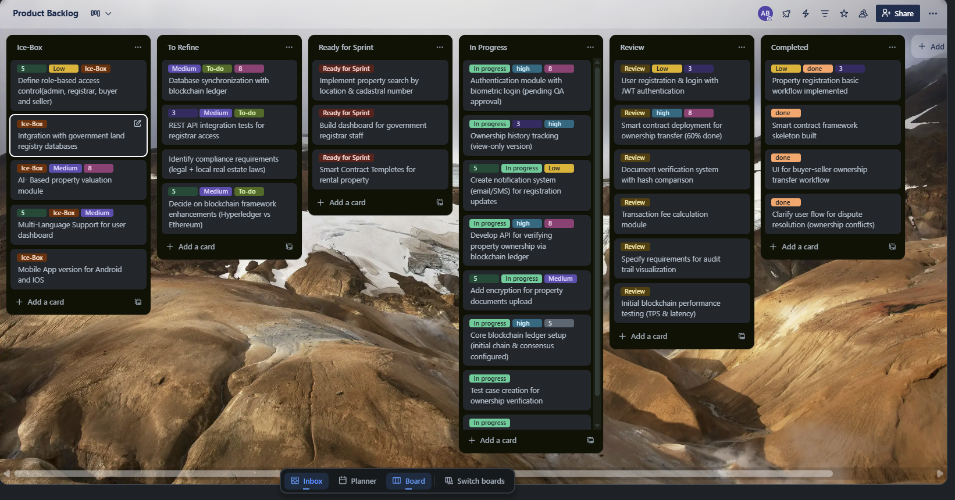

**Figure 2: Trello Board Screenshot- Sprint 6**

This shows the dynamic changes made to Trello throughout SDLC- Software Development Life Cycle.

Gantt Chart:

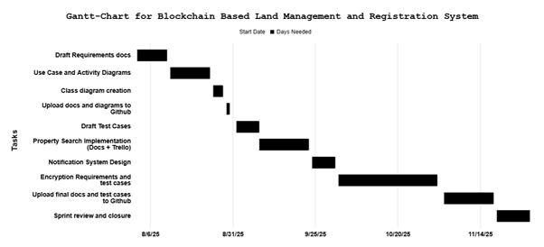

**Figure 3: Gantt Chart Representation of Blockchain-Based Land Management System Development Activities**