Multi-Block Memory Pool Test Report

Test Enviornment Setup:
Components | Details
CPU | Architecture: x86_64  CPU op-mode(s): 32-bit, 64-bit  Byte Order: Little Endian  CPU(s): 32  On-line CPU(s) list: 0-31  Thread(s) per core: 2  Core(s) per socket: 16  Socket(s): 1  NUMA node(s): 1  Vendor ID: AuthenticAMD  CPU family: 23  Model: 49  Model name: AMD EPYC 7302P 16-Core Processor  Stepping: 0  CPU MHz: 1497.318  CPU max MHz: 3000.0000  CPU min MHz: 1500.0000  BogoMIPS: 5999.82  Virtualization: AMD-V  L1d cache: 32K  L1i cache: 32K  L2 cache: 512K  L3 cache: 16384K  NUMA node0 CPU(s): 0-31
Memory | 370GB
GPU | GeForce RTX 2080 Ti, 11GB GDDR

512MB Secotor Bench

- One sector precommit phase1 in multi-sdr without memory pool:

RUST_LOG=trace ./lotus-bench sealing --storage-dir=/mnt/lotus/benchdirs --sector-size=512MB --skip-unseal=true

- Precommit phase1 confirm:
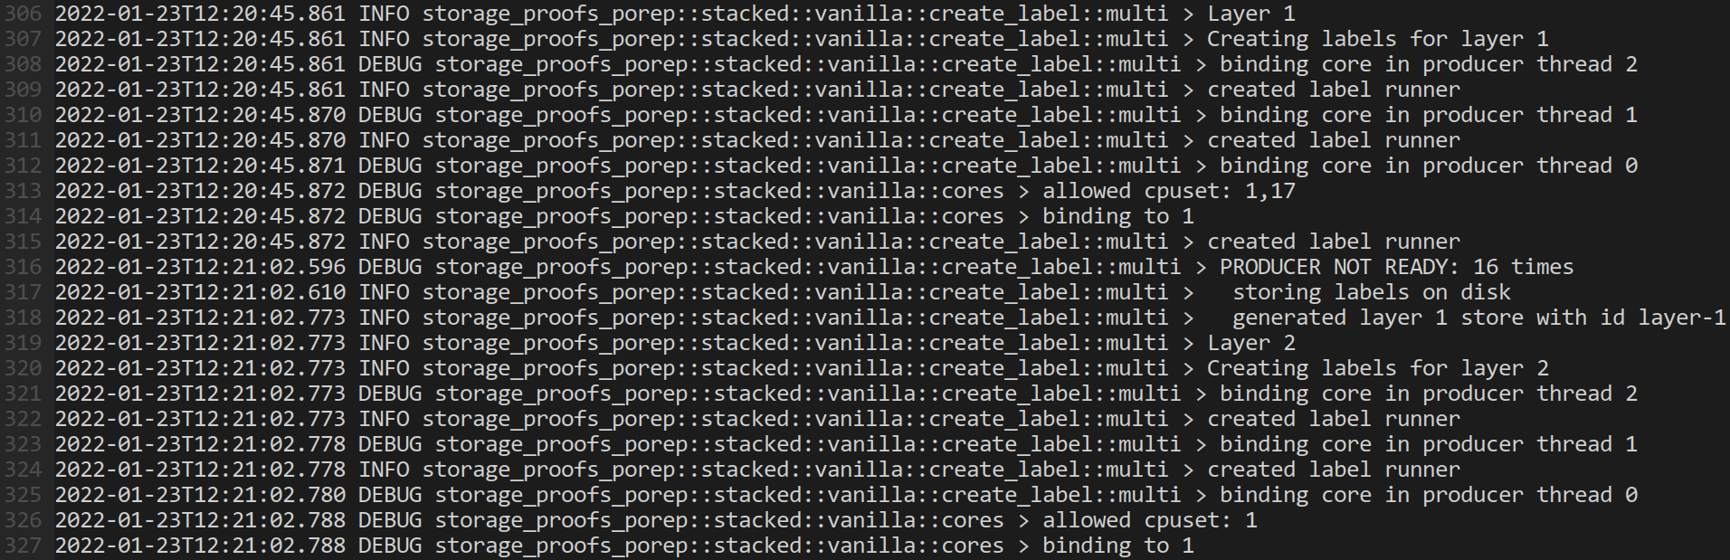

- Results:
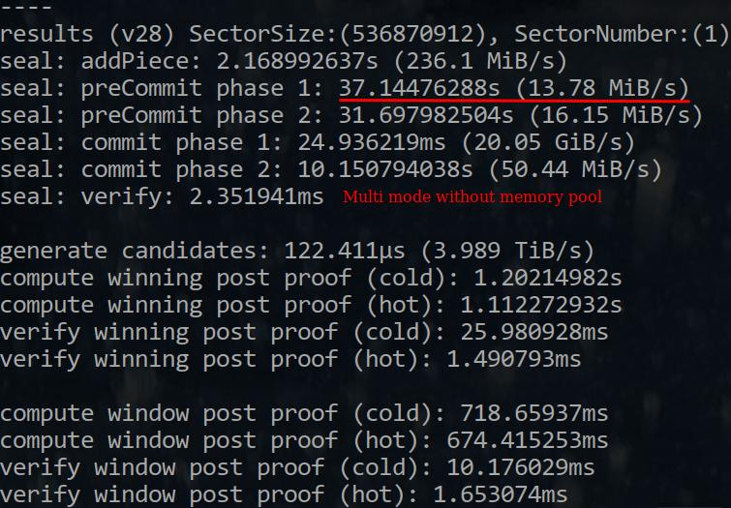

- One sector precommit phase1 in multi-sdr with memory pool enabled:

RUST_LOG=trace ./lotus-bench sealing --storage-dir=/mnt/lotus/benchdirs --sector-size=512MB --skip-unseal=true

- Precommit phase1 confirm:
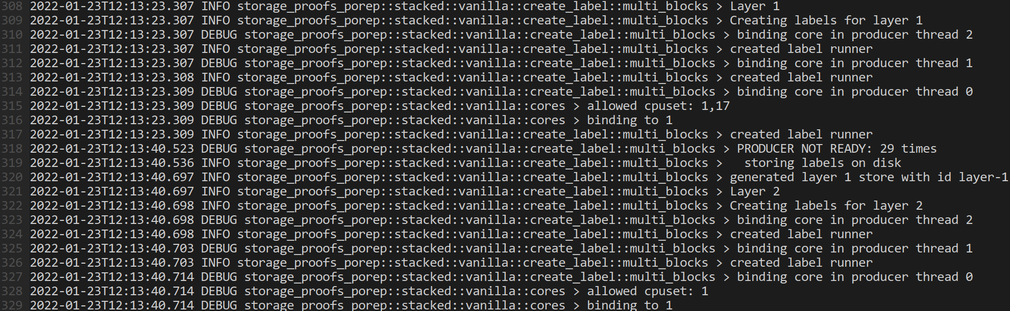

- Results:
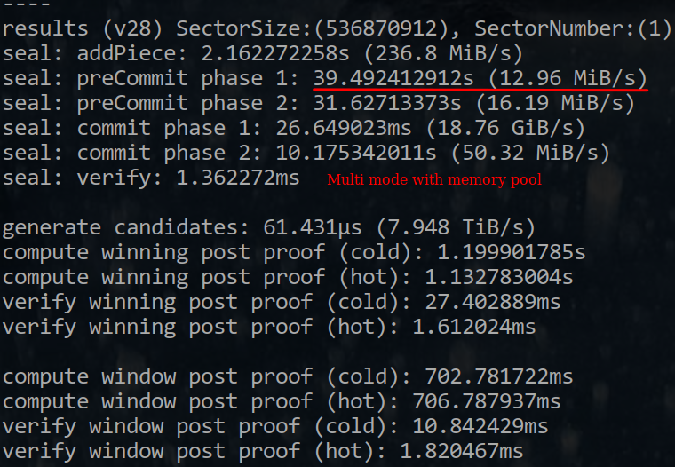

One sector performance competition multi-sdr vs multi-sdr-with-mpool:

37.145s vs 39.492s: 6.318% decreased by the pieces processing

- 6 sectors precommit phase1 in multi-sdr without memory pool:

RUST_LOG=trace ./lotus-bench sealing --storage-dir=/mnt/lotus/benchdirs --num-sectors=6 --parallel=6 --sector-size=512MB --skip-unseal=true --skip-commit2=true

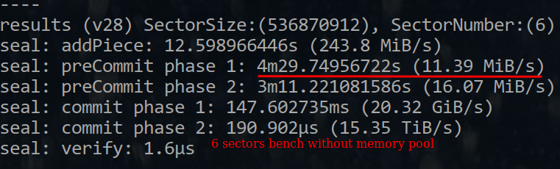

- 6 sectors precommit phase1 in multi-sdr with memory pool enabled:

RUST_LOG=trace ./lotus-bench sealing --storage-dir=/mnt/lotus/benchdirs --num-sectors=6 --parallel=6 --sector-size=512MB --skip-unseal=true --skip-commit2=true

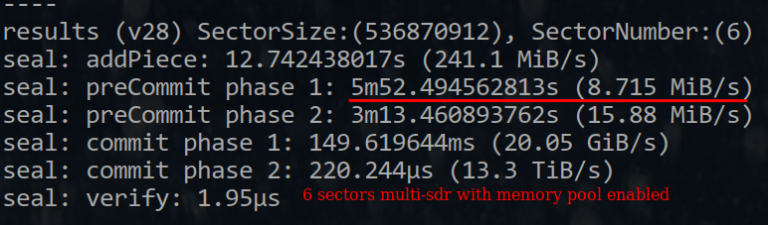

Layer 1 wait on block memory: about 10s

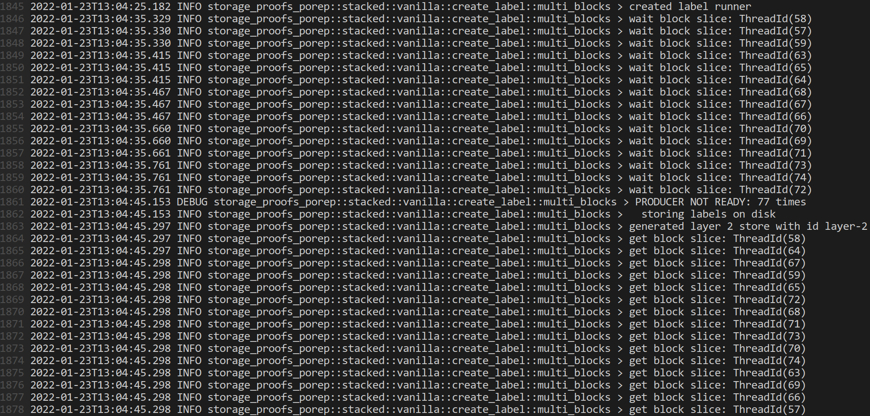

Layer 2 wait on block memory: about 3s

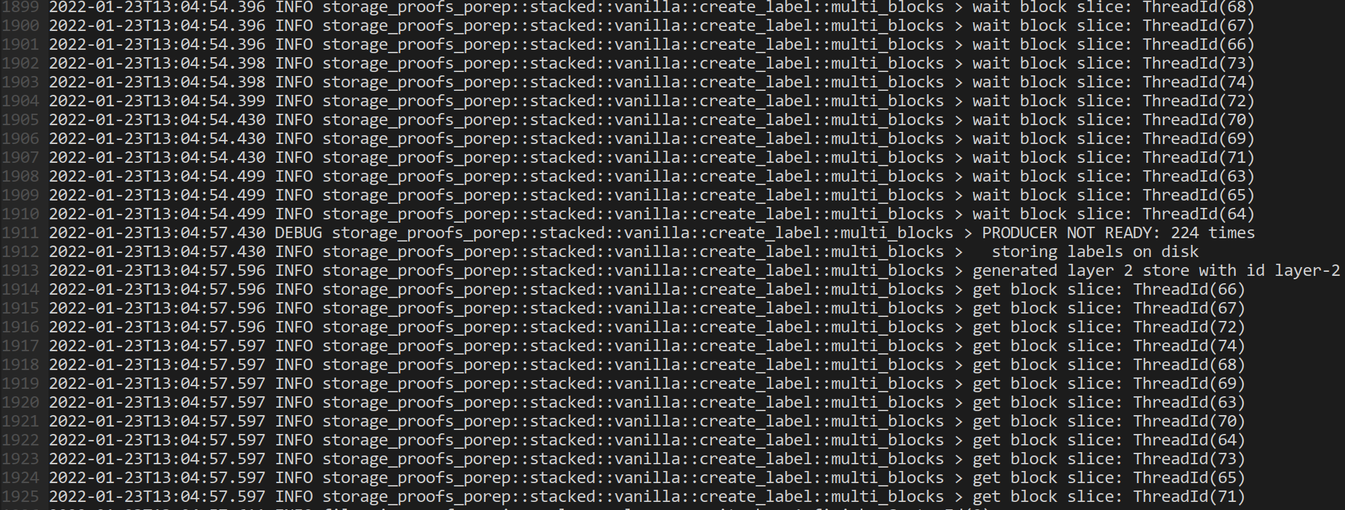
Six sectors performance competition multi-sdr vs multi-sdr-with-mpool:

4m29.750s vs 5m52.495s:

More than Layer1 10s + Layer2 3s can be elimated during pipeline, 30.674% decreased totally is less than 6 * 6.318%, it means the condition wait will improve the parallel mode performance in memory limited, and it will be better if all the task in pool mode with pipeline executing.

32GB Sector Bench

Todo

