Proposal for
About Us:
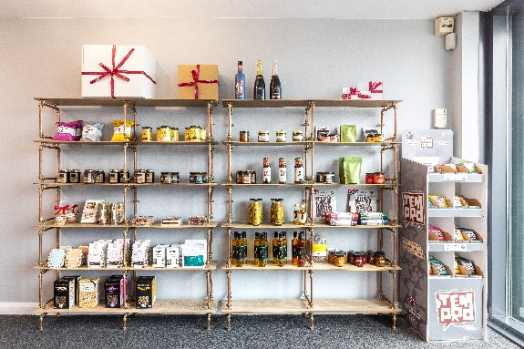
Founded in 2020 and based in Harlow, Essex, Stort Valley Gifting specialises in sustainable gifting, featuring locally sourced food and drink from across the region. We’re passionate about celebrating small producers and creating thoughtful, high-quality gifts that leave a lasting impression.
We’ve been honoured with national recognition — named one of Small Business Britain’s 100 Inspirational UK SMEs in 2022 and awarded FSB Micro Business of the Year: East of England in 2024. In February 2026 we won Theo Paphitis #SBS – Small Business Sunday and were shortlisted for the Entrepreneur of the Year in the Harlow Awards
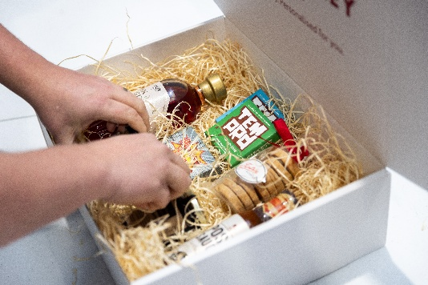
At the heart of everything we do is a personalised approach. We tailor each gift to suit your budget and dietary requirements, with no minimum order quantities. Our branded ribbon is printed in-house, allowing us to accommodate last-minute requests and offer same-day dispatch on smaller orders.
Branded Ribbon:
We offer a wide selection of ribbon colours. Logos and text can be printed in single colours, in black, silver, or gold for that extra impact.
To ensure the best print quality, we ask for your logo in PNG format, ideally in both black & white and transparent versions. This allows us to test and select the version that delivers the sharpest result.
Pricing:
We keep things simple and transparent with a pricing structure designed to suit all budgets:
- Product Cost: Standard retail pricing.
- Boxing Fee: Based on the size of the box, this includes:
  - Sustainable packaging
  - Luxury hamper filling
  - Branded ribbon
  - Gift card (optional)
All prices are inclusive of VAT but exclude shipping unless otherwise stated
Shipping Options
- Alcohol-containing parcels: Sent via courier at £11.00 including VAT
- Parcels under 2kg: Sent via Royal Mail. Pricing from £5.00 including VAT
- Parcels over 2kg or requiring next-day delivery: Sent via courier at £11.00 including VAT
- Chocolate bar sets: Designed to fit through letterboxes and dispatched via Royal Mail as large letters. Pricing from £2.30

Chocolate
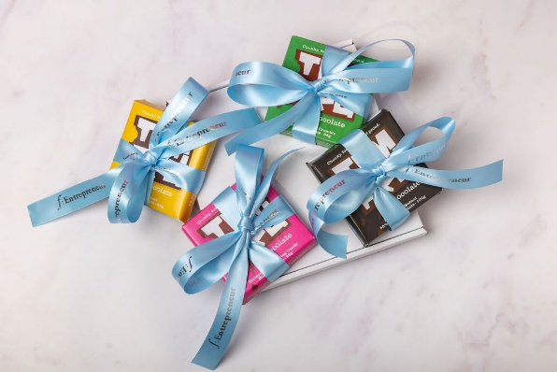
Crafted in Maldon, Essex, our chocolate bar sets feature 100g bars of luxury, hand-poured Temprd chocolate — a truly indulgent gift. Each bar is individually ribboned using your corporate colours, and logo or gift message for a personalised touch. With 17 delicious flavours available — including 5 vegan and 8 gluten-free options — this gift is designed to cater to a wide range of dietary needs, making it a thoughtful choice for any recipient.
1 bar (100g) - £6.25
1 large bar(200g) - £10.50
2 bars - £14.00
4 bars - £25.00
Please note that single bars are ribboned individually. 2 and 4 bar sets are packaged in small, ribboned boxes.
Hamper Box suggestions:

We regularly mix up our gift boxes based on dietary requirements, budgets and seasonality. Please note, some options below may not include photos.

£39.89 including VAT

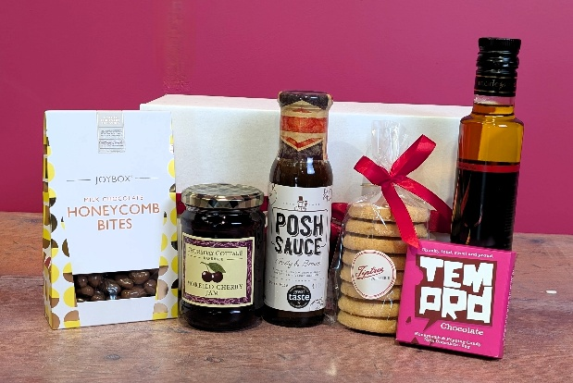
- Tiptree Patisserie handmade shortbread selection*
- 100g Temprd hand poured chocolate bar
- Thursday Cottage caramel sauce, preserve or curd*
- Chiltern Cold Pressed Oil flavoured oil*
- JoyPots chocolate covered treats

Inclusions and ribbon:

All the options listed above include ribbon customised with your logo and/or message, along with a gift card if required. We're also happy to include your own branded materials — such as gift cards, pens, or other small items — to make your gifts even more personal.
Some examples of our custom logo ribbon include:

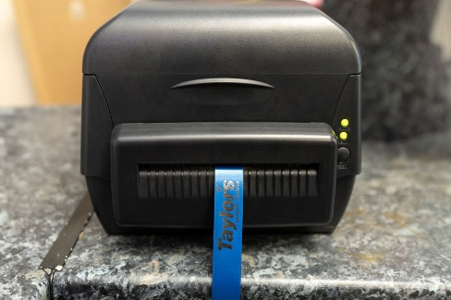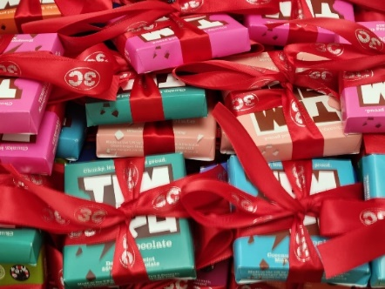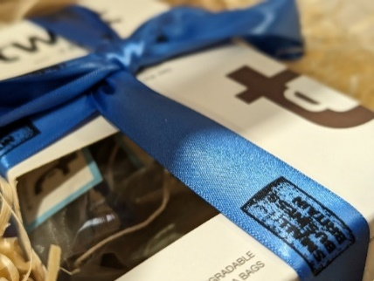

Notes & Useful Information:

Awards & Recognition

Over 20 of our producers have received Great Taste Awards from The Guild of Fine Food for one or more of their products. In addition, several have Great British Food awards.

Customisation & Exclusivity

- Our hampers are individually tailored and custom-designed for each client. They are not typically available for general purchase by individuals or other organisations.
- Each package includes a personalised ribbon featuring your company logo. We offer a wide range of colours and can customise the message to suit your brand.

Packaging & Sustainability

- Gift boxes are sustainably produced by local companies based in Hertfordshire and Essex.
- All packaging is fully recyclable, wherever possible.
- Packaging colours and designs may vary depending on availability at the time of ordering.
- We work with UK-based suppliers when local sourcing is not possible (e.g., hamper filling).

Sustainability & Sourcing

- Our suppliers are artisan producers based in Hertfordshire and Essex, helping us keep food miles low.
- The only exception is Riverside Spirits, a business owned by family members, based in Cheshire.
- We work closely with our producers to ensure they share our values around local and sustainable sourcing.
- Most of our producers do not have retail premises and sell via online platforms or farm shops, meaning their products are not available in major high street retailers.

Pricing & Shipping

- All rates include VAT, although not all items within hampers are subject to VAT. A full VAT breakdown is provided on all sales orders and invoices.
- Shipping costs are calculated based on the final weight of the hamper and are excluded from listed prices unless otherwise stated.
- We typically use Royal Mail for items under 2kg shipping, as it is often the most cost-effective option. Items over 2kg or those that require next day delivery are sent via courier. All parcels (except individual chocolate bar sets) are sent with tracking, unless otherwise agreed.
- Our pricing model is unique: we typically charge standard retail pricing for all items, plus a boxing fee that covers recyclable packaging and personalised ribbon plus an optional gift card.
- Any price changes will be communicated promptly, and alternative options can be provided to help meet budget requirements.
- Delivery dates are a guide only. Deliveries are made Monday to Friday, with Saturday deliveries available during peak periods.
- Telephone numbers are required for courier deliveries and for all orders containing alcohol.

Orders & Payment

- A deposit is required for orders of 15 hampers or more, with full pre-payment required before dispatch.
- Props used in photography (e.g., plates, glasses) are not included unless otherwise stated.
- Re-delivery or re-dispatch due to customer error or recipient unavailability may incur additional charges.

Lead Times

Lead times vary depending on the size of the order and the specific items requested. Here's a general guide:

- Outside of peak periods: We typically offer same-day or next-day dispatch.
- During peak times (e.g., Christmas):
  - Individual hampers are usually dispatched within 24 hours.
  - Larger orders (50+ hampers) may take up to 5 working days.
- Rush options are available on request.

You will always be advised of dispatch dates in advance, and we aim to work closely with you to ensure your order is fulfilled as quickly and efficiently as possible

Alcohol Policy

- Orders containing alcohol can only be placed by and delivered to individuals aged 18 or over.
- It is an offence under the Licensing Act 2003 for anyone under 18 to purchase or attempt to purchase alcohol.

Product Availability & Substitutions

- We proudly support small, local producers, which means some items may occasionally be unavailable.
- We reserve the right to substitute products with alternatives of equal or greater value when necessary.

Dietary Requirements & Allergens

All packages can be adapted to accommodate:
- Vegetarian
- Vegan
- Gluten-Free
- Nut-Free
- Dairy-Free

Please note:

- All products are made and packaged in facilities where nuts and gluten may be present and may therefore contain traces of allergens.
- Refer to individual product packaging for detailed allergen information.

Tastings

We offer free tastings for local corporate clients, giving you the opportunity to:
- Visit our facilities
- Sample a selection of products that may be included in your gift boxes

Damages & Returns

- Any damages must be reported within 24 hours of receipt, with photographic evidence, to: hampers@stortvalleygifting.co.uk

Additional Information

- All pricing and product information is correct as of September 2026 and may be subject to change.
- Customers will be notified of any price adjustments prior to ordering.

