<$Scr_Ps::0><$Scr_H::1>Changelog Pop-up / What’s new menu<!$Scr_H::1><!$Scr_Ps::0>
Occasionally, when StoryBuilder updates a window will be shown. This will summarise what has changed in this update and which developer made that change.
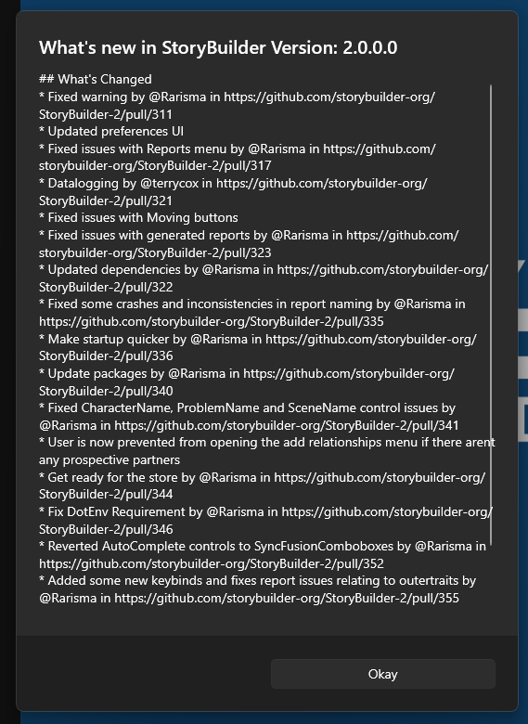

If you decide you want to see this popup again, you can access it in Preferences
