<$Scr_Ps::0><$Scr_H::1>Reports<!$Scr_H::1><!$Scr_Ps::0>

Clicking on the Reports button on the Menu Bar displays a fly-out menu with two reporting options:

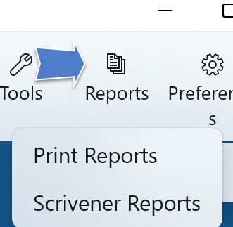

Print Reports

If you select the Print Reports option, a dialog will appear which allows you to check the particular reports you wish to print:

{$SCRImageLink[w:552;h:671]=C:/dev/src/User Manual/Screenshots/Generate Reports Dialog.png}

Clicking Generate will cause all of the selected reports to print on your default printer.

Scrivener Reports

If you use Scrivener, clicking Scrivener Reports will open a file picker to allow you to select a Scrivener .scrivx file from a Scrivener project. The Scrivener project you select is the one you’ll be writing your draft in, and it must have been created before you generate the reports.

{$SCRImageLink[w:680;h:280]=C:/dev/src/User Manual/Screenshots/Scrivener Reports File Picker.png}

When the reports are done: {$SCRImageLink[w:296;h:44]=C:/dev/src/User Manual/Screenshots/Scrivener Reports Generated Status Message.png} you can open your Scrivener project. You’ll see a set of nodes added to the Binder, which contain your reports:

{$SCRImageLink[w:680;h:331]=C:/dev/src/User Manual/Screenshots/Scrivener Binder with StoryBuilder Outline.png}

A convenient way to use these embedded reports is to split your screen, with one pane open to a text node in the Manuscript and the other to a node in the outline:

{$SCRImageLink[w:680;h:511]=C:/dev/src/User Manual/Screenshots/Scrivener Split Screen with StoryBuilder.png}

