<$Scr_Ps::0><$Scr_H::2>Using the Narrative Editor<!$Scr_H::2><!$Scr_Ps::0>
The Narrative Editor is a useful way to quickly turn your Story Plan from the explorer into an actual story.
You can access the Narrator Editor by clicking the Book Icon in the top bar, if you cannot see it try clicking … or updating your copy of StoryBuilder.
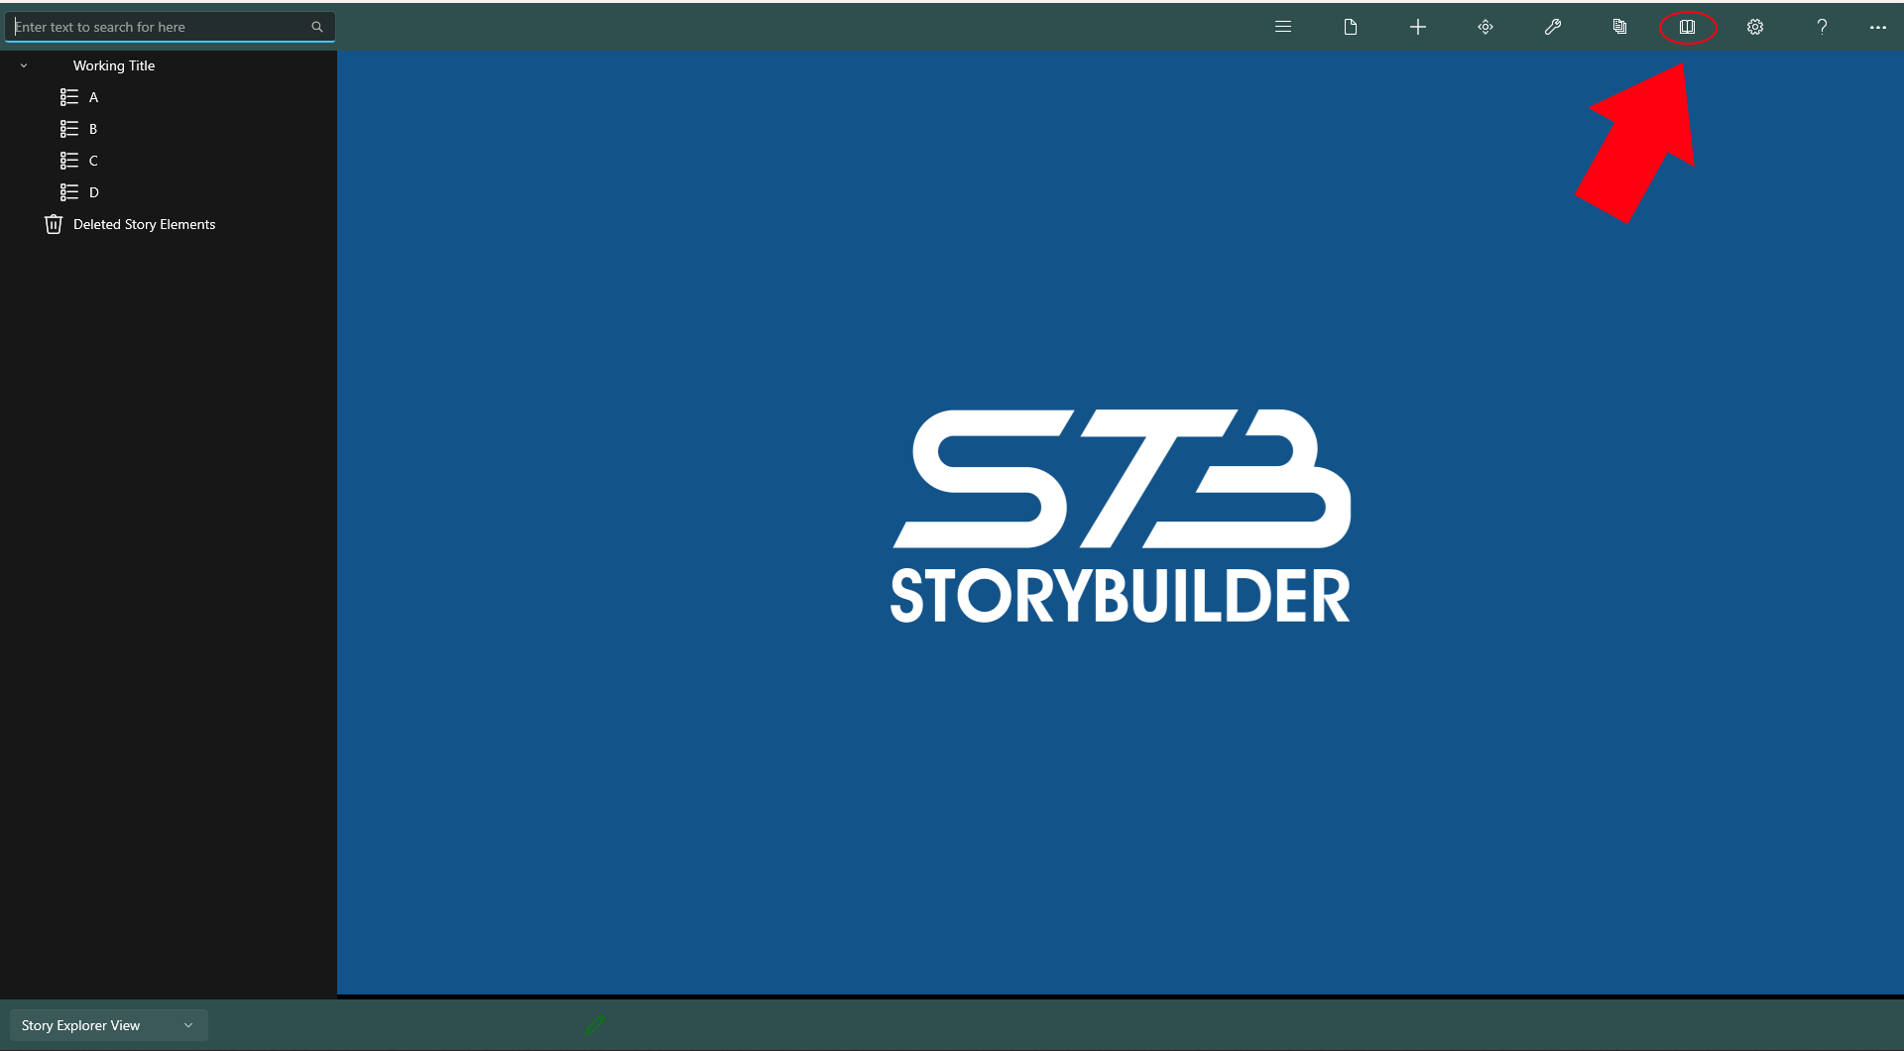

Once you open the Narrative Editor, it will look similar to this. On one side you will the Story Explorer View (The view where you plan your story) and the Narrator View (This is the view that shows your story as it’s told.)
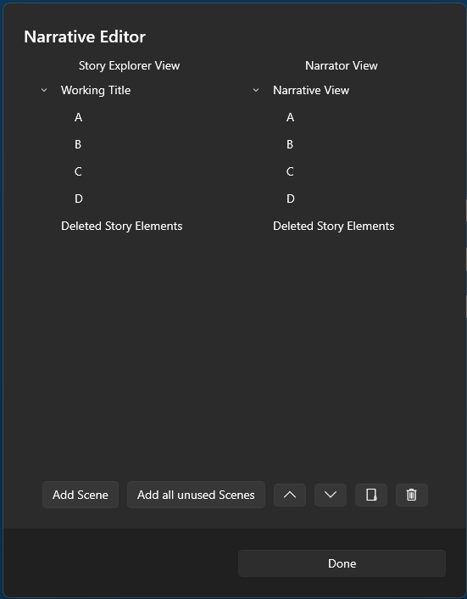
The narrative view is different from the Explorer view and can only contain Scenes and Sections/Folders. Along the bottom there are several buttons:
- Add Scene - Adds a node from the Story Explorer View (Only scenes and folders can be copied over, other types will not be copied over)
- Add all unused scenes - Copies all scenes in the explorer view that are not currently contained in the Narrative view.
- ^/v - Moves the selected node will be moved up / down
- Folder Icon - Creates a Section/Folder in the narrator view
- Trash Icon - Moves a node to the trash
- Done - Closes the Narrative Editor

Notes:
- Internally this is refered to as NarratorTool or NTool
-

