<$Scr_Ps::0><$Scr_H::1>Setting Tab<!$Scr_H::1><!$Scr_Ps::0>

The Setting tab contains elements which make the setting specific and unique.

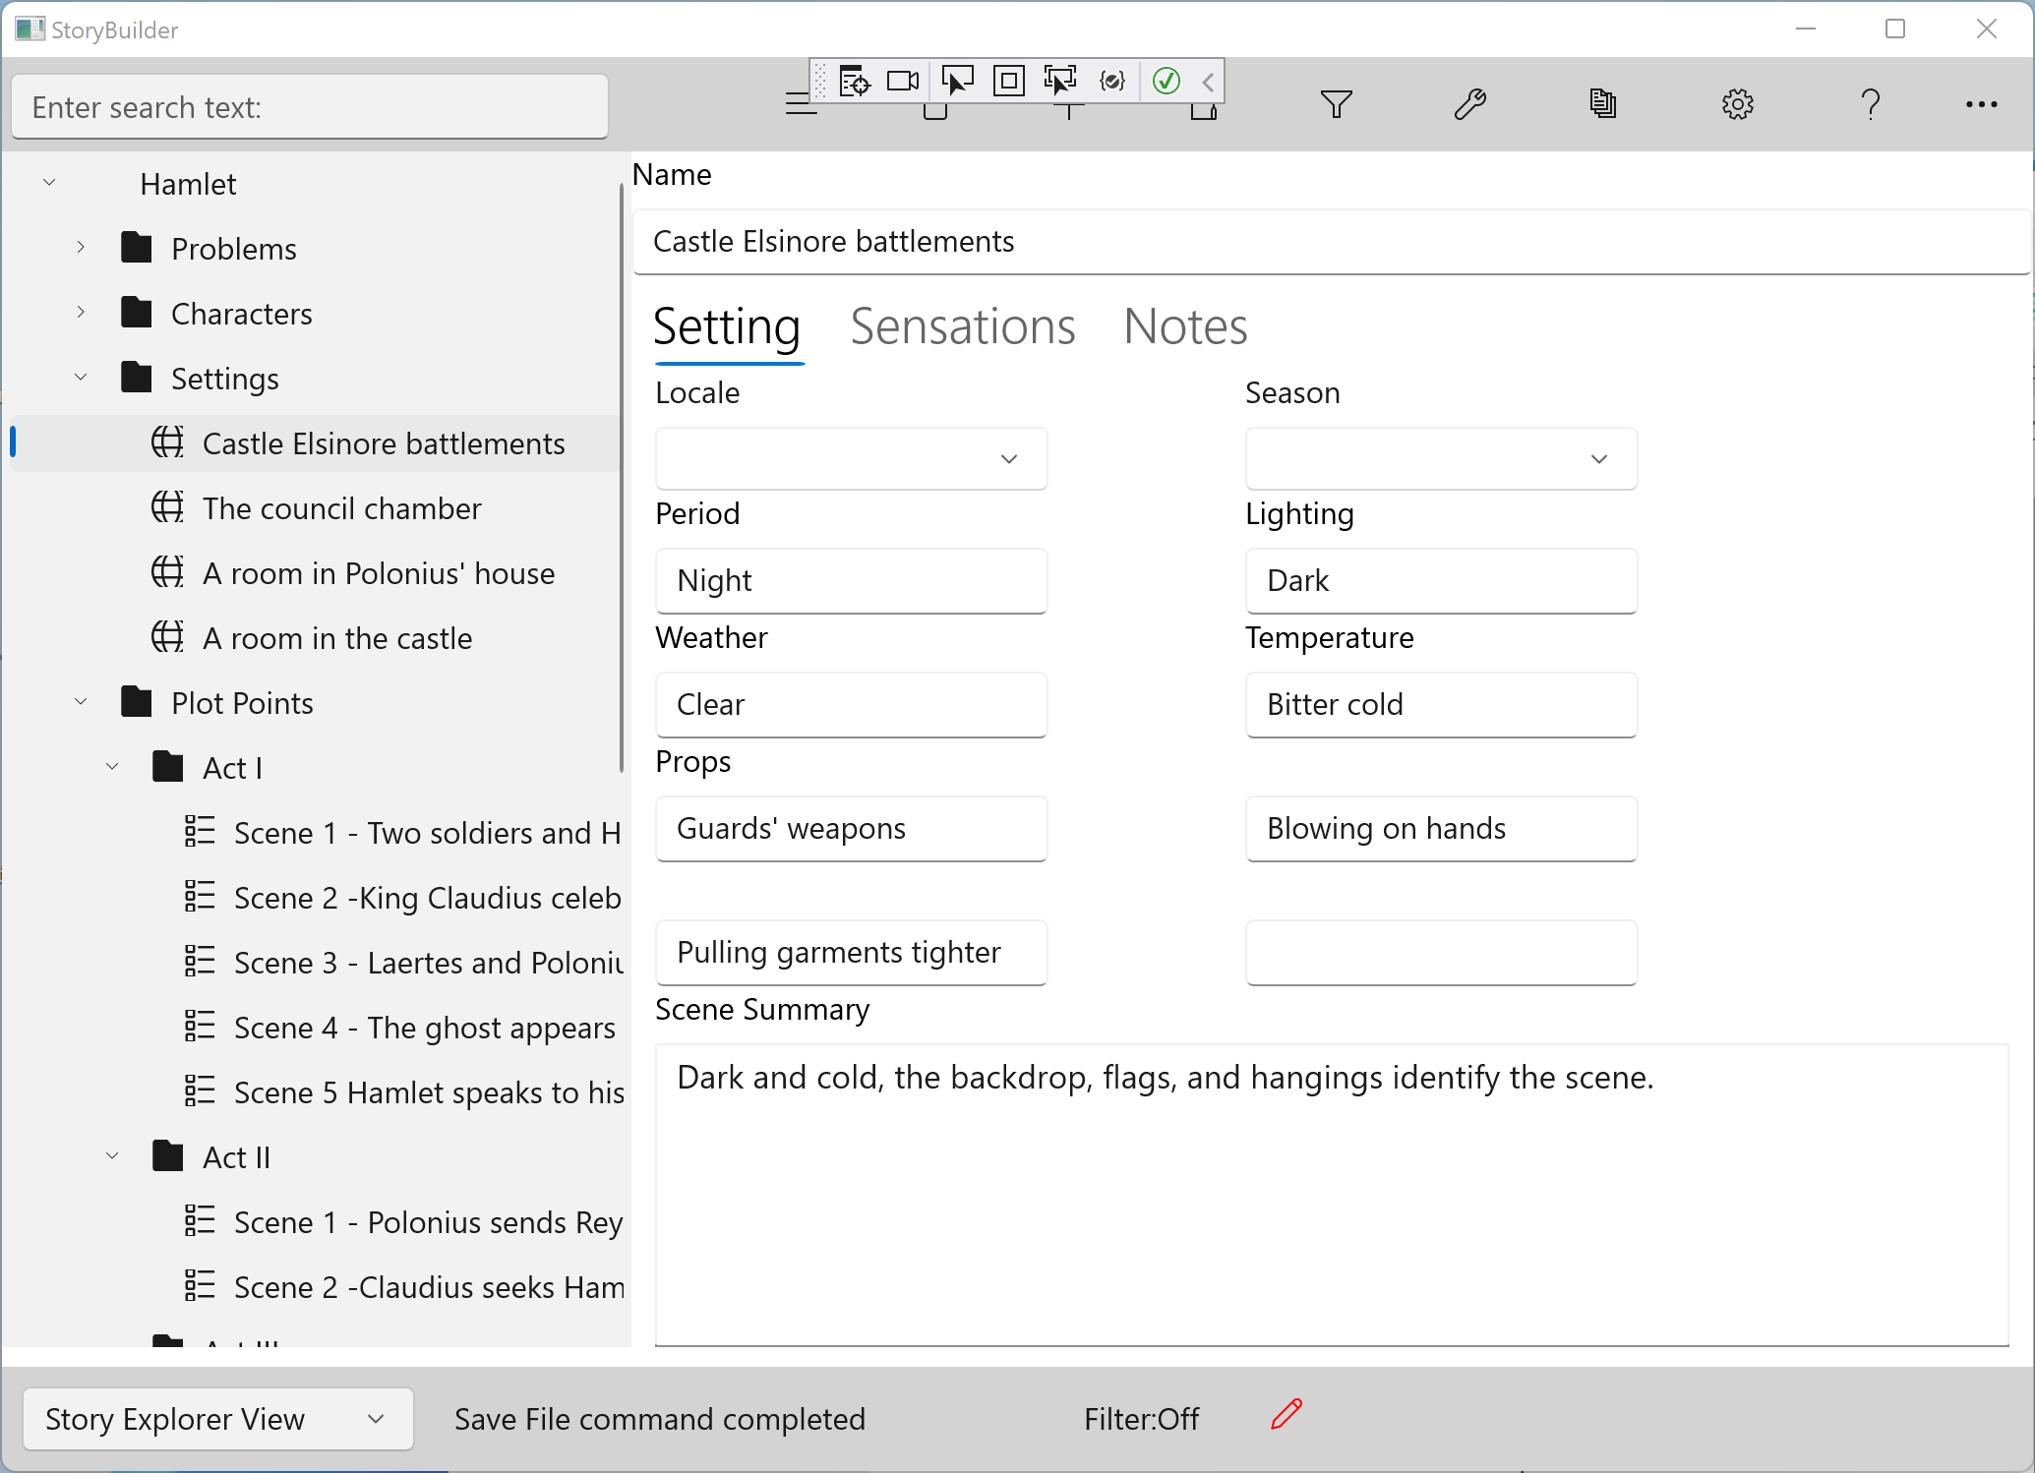

Locale The location of the setting in space.

Season These locate the setting in time.
Period

Lighting These help to define the setting as a source of mood and atmosphere
Weather
Temperature

Props These elements make the scene specific for the characters, and therefore for the reader. An ashtray that a character nervously rocks back and forth is a prop. Props give characters little things to do (‘business’, in stage

If a setting is used in multiple scenes, but the significance of the setting changes, with a different atmosphere or props, you may want to create a separate outline entry for the new setting.

