<<<<<<< Updated upstream=======>>>>>>> Stashed changes<$Scr_Ps::0><$Scr_H::1>Role Tab<!$Scr_H::1><!$Scr_Ps::0>
<<<<<<< Updated upstream
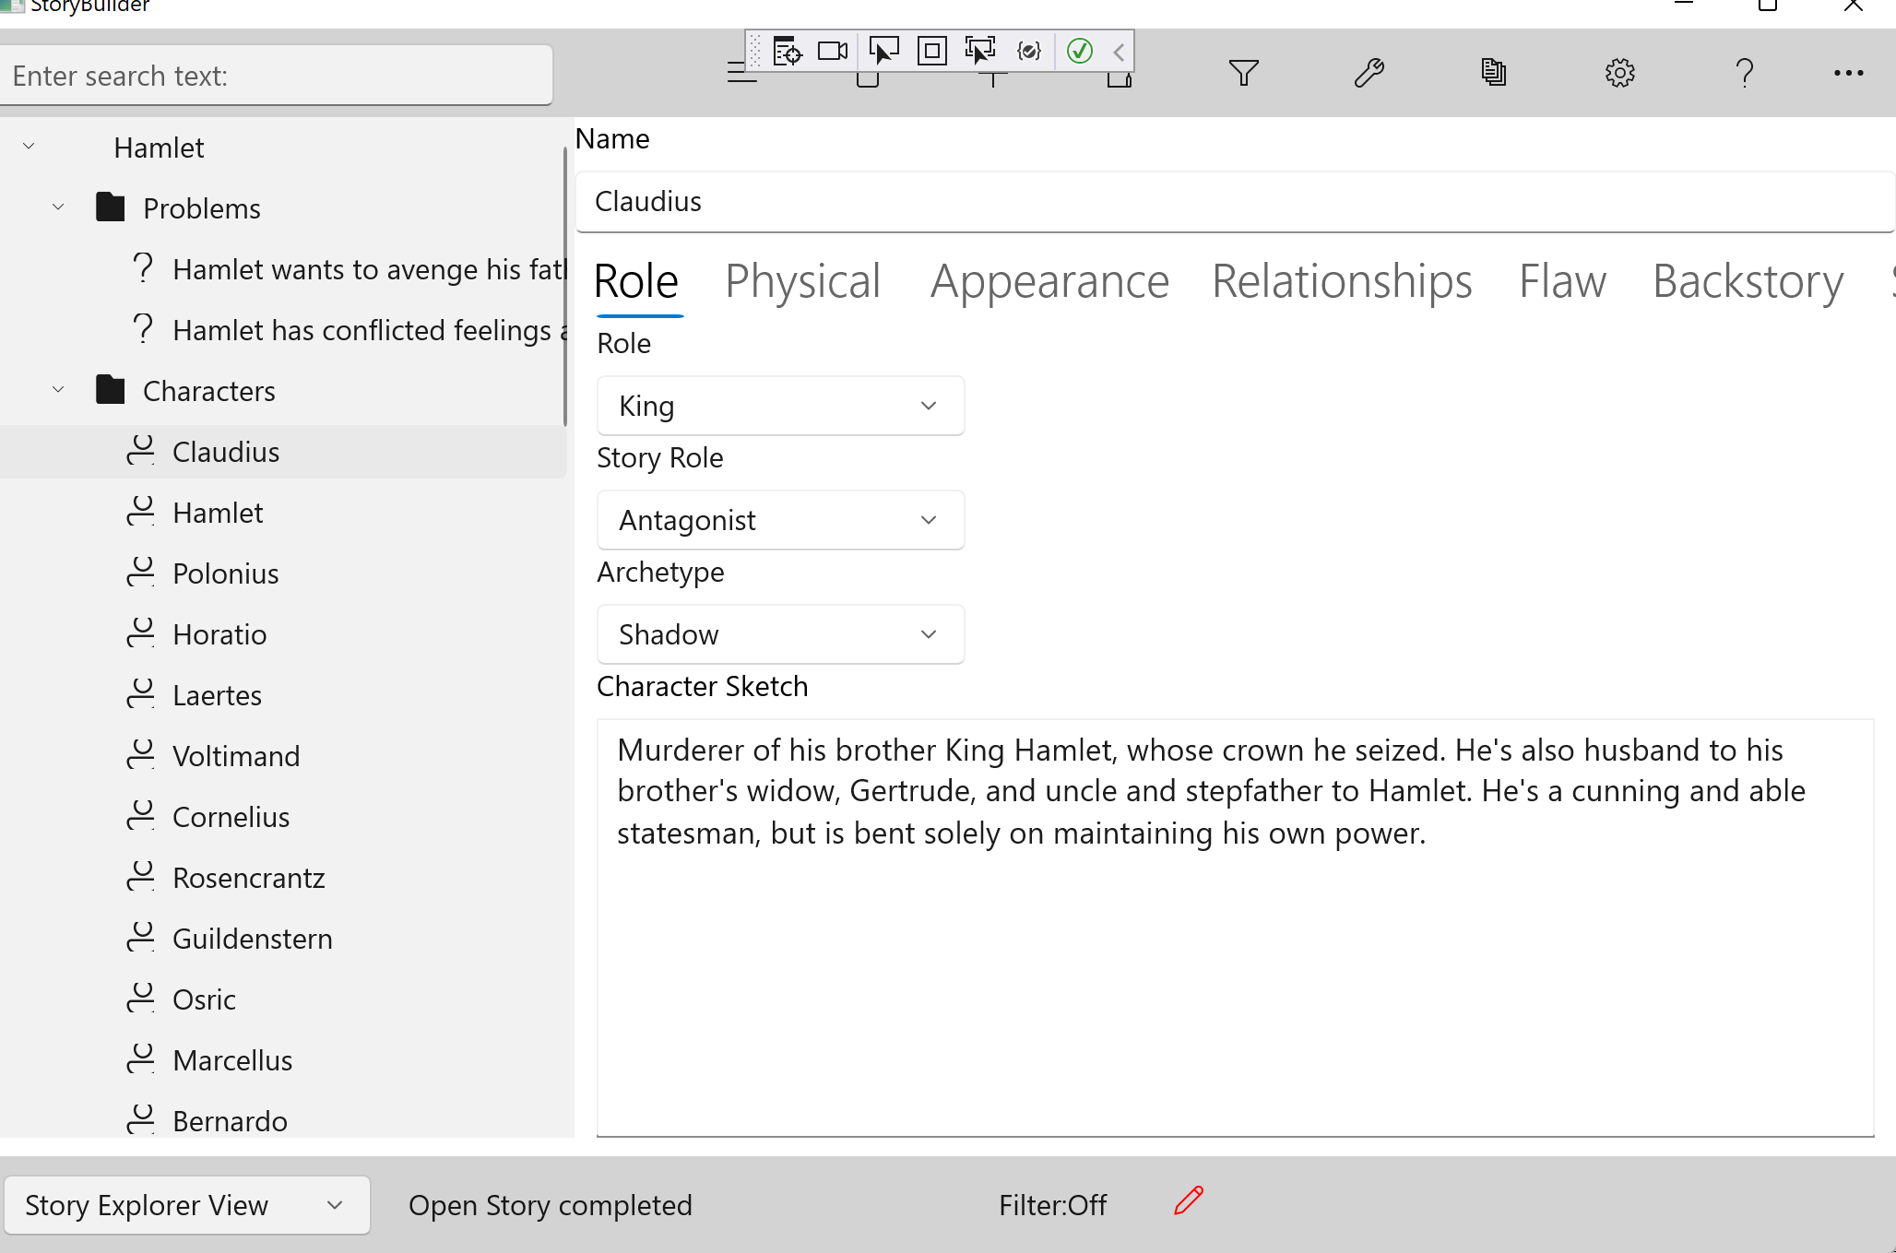=======
{$SCRImageLink[w:680;h:487]=$PROJECT://013F48D5-3D73-47FF-93A6-874C62013859.png}>>>>>>> Stashed changes

The role tab contains the information which defines the relationship between this character and the story.

Unless your story's conception started with a particular character in mind, you should define the role before any other aspects of the character.

Role

The Role is the part played by this character in your story. It's often the character's occupation, since many characters' story context hinges on their job or work. The role may be stereotypical— 'private eye' brings to mind a composite image of thousands of fictional characters. The character himself, though, should be as unique as you can make him.
<<<<<<< Updated upstream
The roles of major characters are often dictated by the genre. For example, a western suggests a cowboy. But placing a character in an unusual milieu can be very effective, as in the TV series McCloud, in which cowboy deputy McCloud is loaned to the NYPD and relocated from Taos, New Mexico to urban New York.=======
The roles of major characters are often dictated by the genre. For example, a western suggests a cowboy. But placing a character in an unusual milieu can be very effective, as in the TV series McCloud, in which cowboy deputy McCloud is loaned to the NYPD and relocated from Taos, New Mexico to urban New York.>>>>>>> Stashed changes

Another useful trick to liven up a role is to cross gender norms in casting the part, such as with a lady alligator wrestler, or a man who runs a wedding dress shop.

Story Role

The story role is the relative importance of the character's part to the story's development.

The more significant a character is to the story, the more fully developed he or she should be. The characters in major roles should ideally be so rounded out that they 'come alive'. Writing scenes for such a well-developed character often becomes a matter of putting him in a situation and watching how he reacts.

StoryCAD assigns four levels to characters:
<<<<<<< Updated upstream
=======
>>>>>>> Stashed changesMajor Role | The protagonist and antagonist are major characters. If the story's dramatic arc hinges on other parts, they may also be major characters. A love triangle involves three major roles: protagonist, love interest, and rival.
<<<<<<< Updated upstream
=======
>>>>>>> Stashed changesSupporting  Role | Supporting roles are defined by the plot. Characters who appear in many scenes, but don't directly carry the plot, are supporting characters. Supporting roles should be well rounded. These roles can often be made very colorful.
<<<<<<< Updated upstream
=======
>>>>>>> Stashed changesMinor Role | The character in a minor role appears briefly in the story, but has a story purpose and dialog. Minor Roles are often used to convey information.
<<<<<<< Updated upstream
=======
>>>>>>> Stashed changesService Role | A service role is a walk on part. Service role characters are created to fill a specific plot requirement but are otherwise not a part of the story. A taxicab driver, needed to get the hero to the airport, is a service role.

Archetype
<<<<<<< Updated upstream
An archetype is a prototype or model from which something is based. The character archetypes listed here derive from Joseph Campbell's The Hero with a Thousand Faces, and are deeply rooted in the myths and legends of many cultures. A significant character's role can often be associated with one of these archetypes.

=======
An archetype is a prototype or model from which something is based. The character archetypes listed here derive from Joseph Campbell's The Hero with a Thousand Faces, and are deeply rooted in the myths and legends of many cultures. A significant character's role can often be associated with one of these archetypes.

>>>>>>> Stashed changesHero | The essence of the hero is not bravery or nobility, but self-sacrifice. The mythic hero is one who will endure separation and hardship for the sake of his clan. The hero must pay a price to obtain his goal.  The hero's journey during a story is a path from the ego, the self, to a new identity which has grown to include the experiences of the story. This path often consists of a separation from family or group to a new, unfamiliar and challenging world (even if it's his own back yard), and finally a return to the ordinary, but now expanded, world.  The hero must learn in order to grow. Often the heart of a story is not the obstacles he faces, but the new wisdom he acquires, from a mentor, a lover, or even from the villain.  Other characters besides the protagonist can have heroic qualities. This can be especially true of the antagonist.  Heroes can be willing and adventurous, or reluctant. They may be group and family oriented, or loners. They may change and grow themselves, or act as catalysts for others to grow and act heroic. The hero can be an innocent, a wanderer, a martyr, a warrior, a vengeful destroyer, a ruler, or a fool. But the essence of the hero is the sacrifice he makes to achieve his goal.
<<<<<<< Updated upstream
=======
>>>>>>> Stashed changesMentor | The mentor is a character who aids or trains the hero. The essence of the mentor is the wise old man or woman. The mentor represents the wiser and more godlike qualities within us.  The mentor's role may be to teach the hero. These characters are often found in the roles of drill instructor, squad leader or sergeant, the older officer policeman, the aged warrior training the squire, trail boss, parent or grandparent, etc. An effective teacher may be an otherwise inept or foolish character who possesses just the skill or wisdom the hero needs for his challenge.  The other major role of the mentor is to equip the hero by giving him a gift or gifts which are important in his quest. These gifts may be weapons, medicine or food, magic, or some important clue or piece of information. Frequently, the mentor requires the hero to have passed some sort of test before receiving the gift. The gift may be a seemingly insignificant object, the importance of which doesn't emerge until later.  The mentor may occasionally be the hero's conscience, returning him to the right path after he strays or strengthening him when he weakens. The hero doesn't always appreciate this assistance, of course.
<<<<<<< Updated upstream
=======
>>>>>>> Stashed changesThreshold  Guardian | The threshold guardian is the first obstacle to the hero in his journey. The threshold is the gateway to the new world the hero must enter to change and grow.  The threshold guardian is usually not the story's antagonist. Only after this initial test has been surpassed will the hero face the true contest and the arch-villain. Frequently the threshold guardian is a henchman or employee of the antagonist.  But the threshold guardian can also be an otherwise neutral character, or even a potential ally— such as the police lieutenant who warns the hero private detective off the case, or the Cowardly Lion who first frightens and then joins Dorothy on her journey to Oz.  The role of the threshold guardian is to test the hero's mettle and worthiness to begin the story's journey, and to show that the journey will not be easy. The hero will encounter the guardian early in the story, usually right after he starts his quest.
<<<<<<< Updated upstream
=======
>>>>>>> Stashed changesHerald | The role of the herald is to announce the challenge which begins the hero on his story journey. The herald is the person or piece of information which upsets the sleepy equilibrium in which the hero has lived and starts the adventure.  The herald need not be a person. It can be an event or force— the start of a war, a drought or famine, or even an ad in a newspaper.
<<<<<<< Updated upstream
=======
>>>>>>> Stashed changesShapeshifter | The shapeshifter changes role or personality, often in significant ways, and is hard to understand. That very changeability is the essence of this archetype. The shapeshifter's alliances and loyalty are uncertain, and the sincerity of his claims is often questionable. This keeps the hero off guard.  The shapeshifter is often a person of the opposite sex, often the hero's romantic interest. In other stories the shapeshifter may be a friend or ally of the same sex, often a buddy figure, or in fantasies, a magical figure such as a shaman or wizard.  The shapeshifter is sometimes a catalyst whose changing nature forces changes in the hero, but the normal role is to bring suspense into a story by forcing the reader, along with the hero, to question beliefs and assumptions.  As with the other archetypes, any character, including the protagonist and antagonist, can take on attributes of the shapeshifter at different times in the story. The hero often assumes the role of shapeshifter to get past an obstacle. Mentors often appear as shapeshifters.
<<<<<<< Updated upstream
=======
>>>>>>> Stashed changesShadow | The Shadow archetype is a negative figure, representing things we don't like and would like to eliminate.  The shadow often takes the form of the antagonist in a story. But not all antagonists are villains; sometimes the antagonist is a good guy whose goals disagree with the protagonist's. If the antagonist is a villain, though, he's a shadow.  The shadow is the worthy opponent with whom the hero must struggle. In a conflict between hero and villain, the fight is to the end; one or the other must be destroyed or rendered impotent.  While the shadow is a negative force in the story, it's important to remember that no man is a villain in his own eyes. In fact, the shadow frequently sees himself as a hero, and the story's hero as his villain.
<<<<<<< Updated upstream
=======
>>>>>>> Stashed changesTrickster | The Trickster is a clown, a mischief maker. He provides the comedy relief that a story often needs to offset heavy dramatic tension. The trickster keeps things in proportion.  The trickster can be an ally or companion of the hero, or may work for the villain. In some instances the trickster may even be the hero or villain. In any role, the trickster usually represents the force of cunning, and is pitted against opponents who are stronger or more powerful.
Character Sketch

Use these notes to provide a thumbnail picture of the character and the overall impression he makes.<<<<<<< Updated upstream

