<$Scr_Ps::0><$Scr_H::1>Key Questions<!$Scr_H::1><!$Scr_Ps::0>

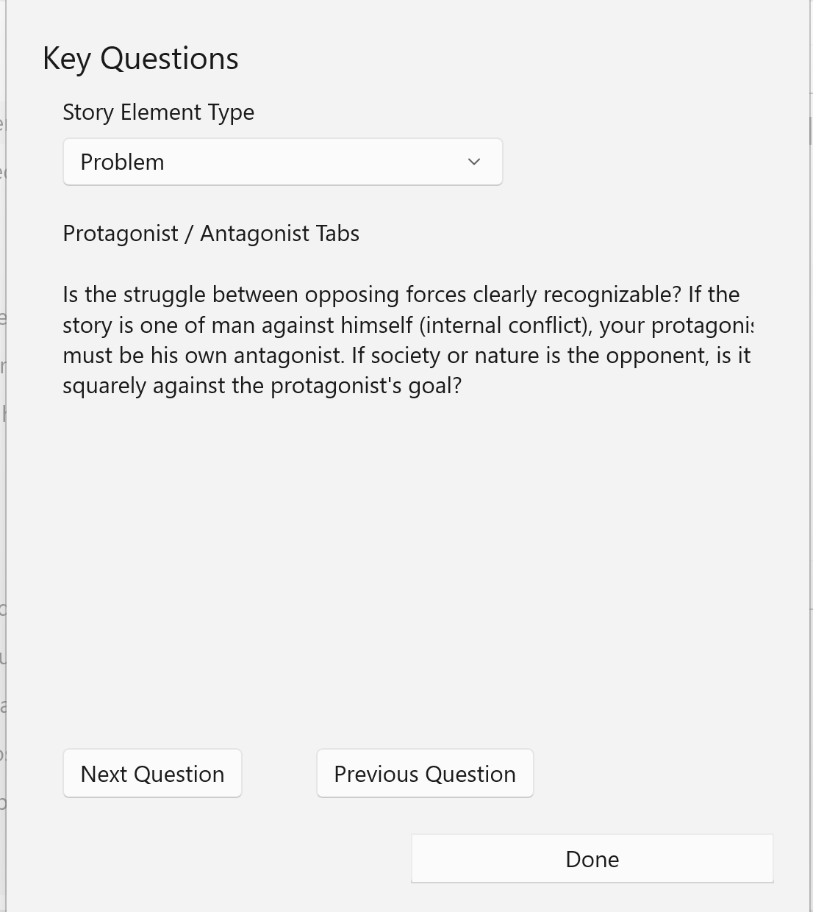

Key Questions contains sub-menus which contain lists of questions appropriate to the Story Overview, Problem, Character, Setting, and Plot forms and story elements.

Use the key questions to refine and test your story elements. If you wish, you can record answers or notes to questions that need highlighting or require more thought.

The questions for a story element type are a circular list. That is, when you've displayed the last question for this form, the next question to display will be the first question for the form. To navigate through the questions, use the Next (>>) and Previous (<<) buttons.

