
By Matthew and Jacob Stoodley

Rules

version : 0.2.2

Setup Diagram
Here is an example of a fully set up board. Come back to this page as you setup to help you understand the instructions.
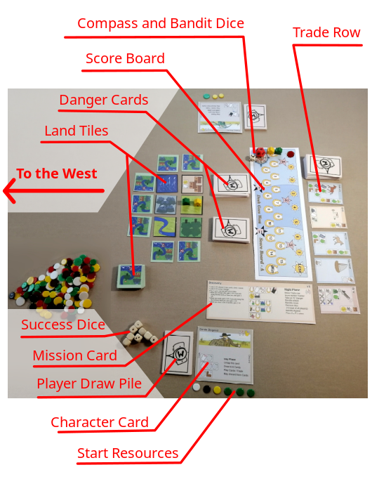
(You will be travelling West. Leave plenty of room to grow that way)

Overview
Deck Goes West is set in the American gold rush where players may compete, work together, or work alone to travel West and complete a given mission. To do this, they will be managing supplies, exhaustion and injuries, and staying safe from Bandits.
All players manage their own personal deck of cards, which will cycle between their own Hand, Discard Pile, and Draw Pile.
During the Day phases of the game, players play cards from their Hand to perform actions. They may also buy cards to gain abilities or perform their own character abilities, so their deck becomes stronger.
During the Night phases, the Bandits will take their turn, maybe even attack the players, and the Trade Row will update.
Day follows Night until the players either:
- Complete their mission / score track
- Run out of time
- Die of Exhaustion

Winning, Losing and Scoring
The game is won by reaching the end of the Score Track first.
Players score points by activating Jobs on the Mission Card with the Horseshoe symbol .
The missions vary, but common ways to do this are :
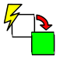 | Revealing Land Tiles |  | Building Railway track |  |  | Clearing all Bandits from a tile
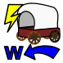 | Moving a Wagon West | 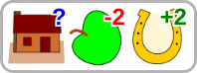 |  | Feeding a Village.

Players lose the game when the Day Tracker reaches the end of it’s track, or when a character dies, by either:
- Having as many Danger Cards in their hand as their Hand Limit.
- Failing to play or discard a single card during the day phase.

Game Contents
- 4 Scoreboards
- 15 Mission Cards
  - 3 Solo
  - 4 Versus
  - 8 Cooperative
- 4 Crib Sheets
- 10 Meeples (Wooden person shaped tokens) - 2 Per player
- 1 Wagon
- Red Bandit Counters – 20 small and 20 big
- Resource Counters – 20 small, and 10 big for each resource
  - Wood – Brown
  - Food – Green
  - Metal – White
  - Gold - Yellow
- Player 1 Marker
- Land Tiles * 48
- 12 Character Cards
- 160 Game Cards
  - 30 Pain
  - 30 Exhaustion
  - 50 Trade
  - 50 Starter
- Dice
  - 2 bandit Dice:
    - d12 (12 sided dice) – Harder
    - d20 (20 sided dice) – Easier
  - 1 Compass Dice - with faces [N, S, W, W , W , + ]
  - 10 Job Dice - with faces [0,0,1,1,1,2]

Versus, Cooperative and Solo play
This game may be played in three ways.
- As a group against each other: Versus
- As a group working together: Cooperative
- As just one single player, working alone: Solo
The missions are different, but whichever you choose, the rules will be largely the same with the following minor differences.
For Versus Play:
- Each player has their own token on the score track.
- The first player to reach the end of the score track wins.
- Players take turns clockwise, starting with the holder of the P1 Token, which changes hands every night phase.
- If the Day Tracker reaches the end of its track, the game ends immediately, and the player with the most points wins.
Ties are broken by distance West, followed by total resources.
For Cooperative Play:
- Turn order is ignored. Players may act in any order they agree. (eg : One player may take several actions in a row)
- All players share a single score counter, and as such, win or lose together.
- If any character dies, or the Day Tracker reaches the end of its track, the whole team lose.
- It may help to play “open hand”. That is showing your hand face up on the table.
For Solo Play:
- You win by reaching the end the score track.
- You lose if the Day Tracker reaches the end of its track.
- You lose if your character dies.

Setup – Choosing a Mission
Missions Cards provide specific objectives and ways of scoring each game. They look like this:
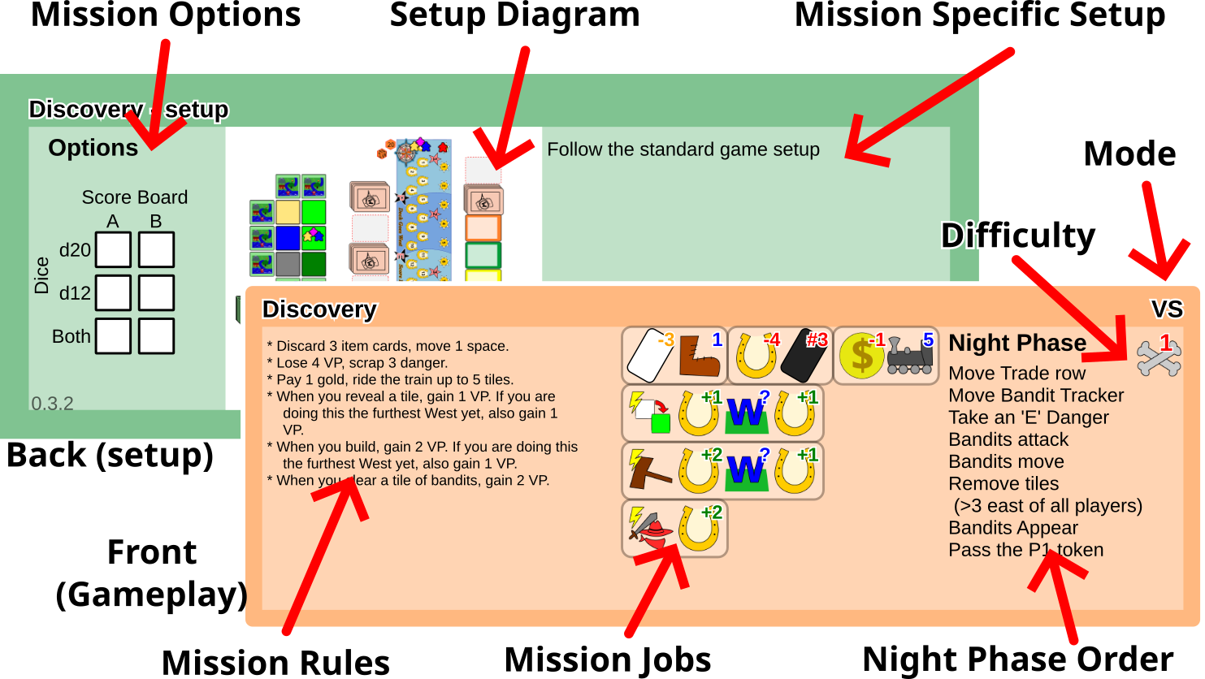
There are 15 Mission Cards. Each has different goals and Jobs, and some have special rules and setup.
If this is your first game, choose one of the following Mission Cards:
- For Versus : "Discovery"
- For Cooperative : “Speed of the Slowest”
- For Solo: “New World”
Otherwise choose at your discretion.

The other Mission Cards will not be used this game. Put them back in the box

Setup – Choosing a Scoreboard and Dice
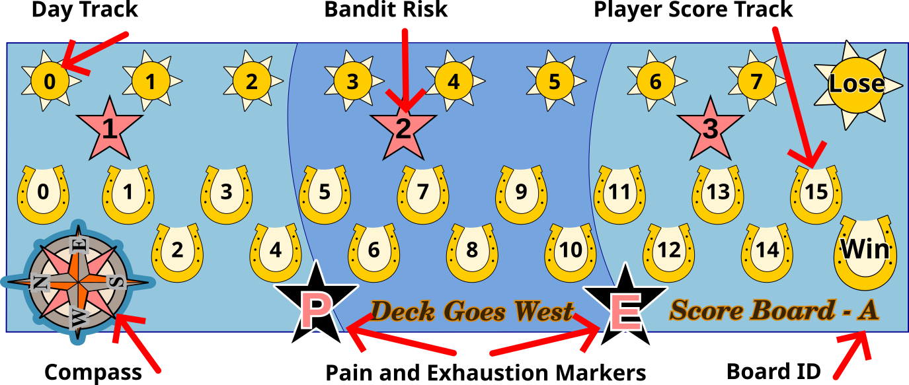
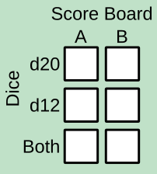
Your chosen Mission Card will have a table of Scoreboards and Dice in it’s Options Section. If this is your first game, choose the top left option. In this case Scoreboard A, with the d20 (20 sided) Bandit Dice.
The d20 is the easiest, and board A is shortest option.
Find the Scoreboard with the correct Board ID. The other Scoreboards will not be needed this game.

Choose an end of the table/play-area to represent East. All game directions will be given relative this East. Place the Scoreboard toward that East with with lots of room to the West. Make sure East on the Scoreboard Compass matches your chosen East. Note that West is toward the bottom of the card. This is the direction players will be aiming to travel.
Place the chosen Bandit Dice and the Compass dice (a dice with sides:[W,W,W,N,S,+]) on the Scoreboard Compass.
Place a red counter on the sun picture with a zero at the start of the Day Track. This will be the Day Tracker.
Place one of the two meeples (wooden person tokens) of each player’s chosen colour on the zero horseshoe on the Player Score Track. Or In cooperative mode, place a counter of any kind, as players share points.

Setup - Game Cards
There are four kinds of Game Cards, that do different things. But they have the same back so they can be shuffled together. They are identified by the symbol in the top right corner.
Item Cards: Starter and Trade
Item Cards help you do things on the board, such as move and gather resources. They come in two varieties:

Starter Cards: Marked by a yellow Star: The cards you will start with.

Trade Cards: Marked by at least one Job, (Icons in a rounded rectangle): Players complete the corner Job to buy these.
Danger Cards: Pain and Exhaustion
Danger Cards clogg up your hand making it more difficult to do anything. To get rid of them players must complete a Job on them, or use another ability. They come in two varieties:

Exhaustion Cards: Marked with a red ‘E’ in a black star. Gained every night, and on some other occasions.

Pain Cards: Marked with a red ‘P’ in a black star. Come from fighting, or running away from Bandits.
Sort the cards into four piles, using the icons above in the top right corner of the cards. Trade Cards have many different Jobs in the corner, but should be sorted together. (More on Jobs later)
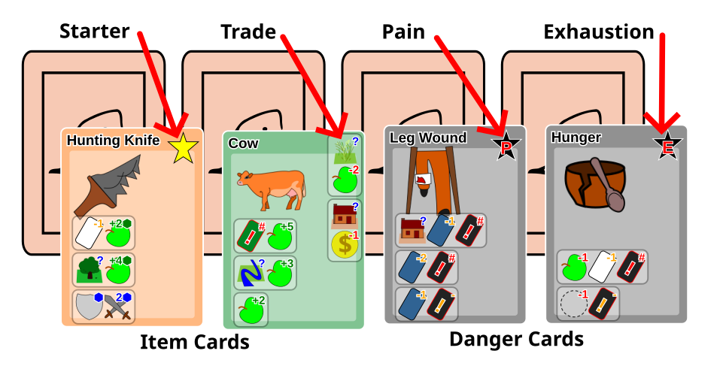

Adding the Cards
Shuffle the Pain and Exhaustion cards separately, and place each pile face down by the “Pain and Exhaustion Markers” on the Scoreboard. Because the cards are face down and have the same backs, those markers help you tell the piles apart. (Setup Diagram : Page 2)
Shuffle the Trade cards, and place them in a draw pile near the top left (North East) corner of the scoreboard. Leave a space to the left for a discard pile. (Setup Diagram : Page 2)
Draw the first 5 cards and place them face up in a row along the top (East side) of the scoreboard, this will be called the “Trade Row”
Leave the Starter Cards for now.

Setup - Land Tiles
Land tiles will be the map on which the players move about and perform various jobs and actions. They are laid out in a grid, and revealed as players ‘step’ onto them.
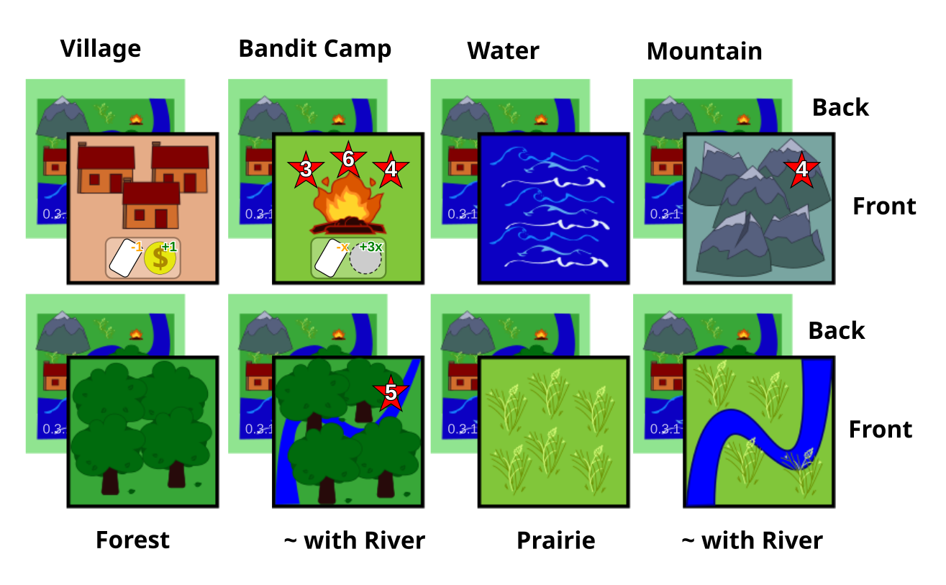

Shuffle all of them together, and place them in a draw pile near the Scoreboard.

Setup – Map Layout
Check your Mission Card. Some missions will have a slightly different map layout or different setup rules, so prioritise those. But for most missions, do as follows.
Draw 6 Land Tiles and lay them out randomly in a face up 2x3 grid to the West of the Pain and Exhaustion Cards.
2 - East to West, by 3 - North to South.
Then around North, South and West of these, place Land Tiles face down, extending the grid. Showing the places players can discover, and where bandits may appear. As shown below:
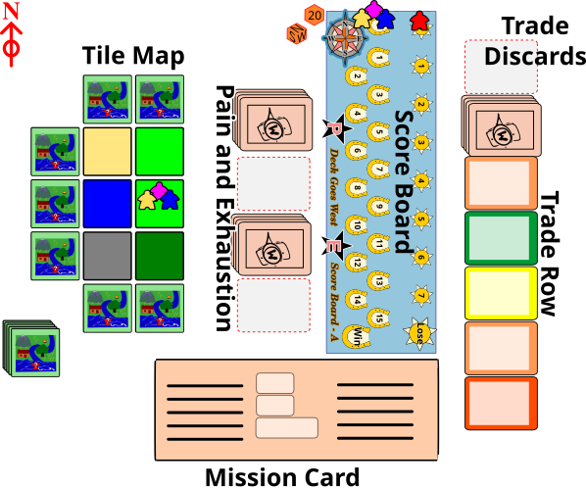
The tiles should be almost touching each other, so meeples can step between them easily.
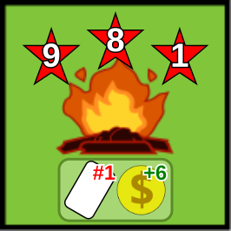
Place the second meeple of each player’s chosen colour on the middle tile North to South on the Eastern side of that grid.
If a Bandit Camp is showing, add a Bandit (Red Token) to it.

Setup – Player Characters
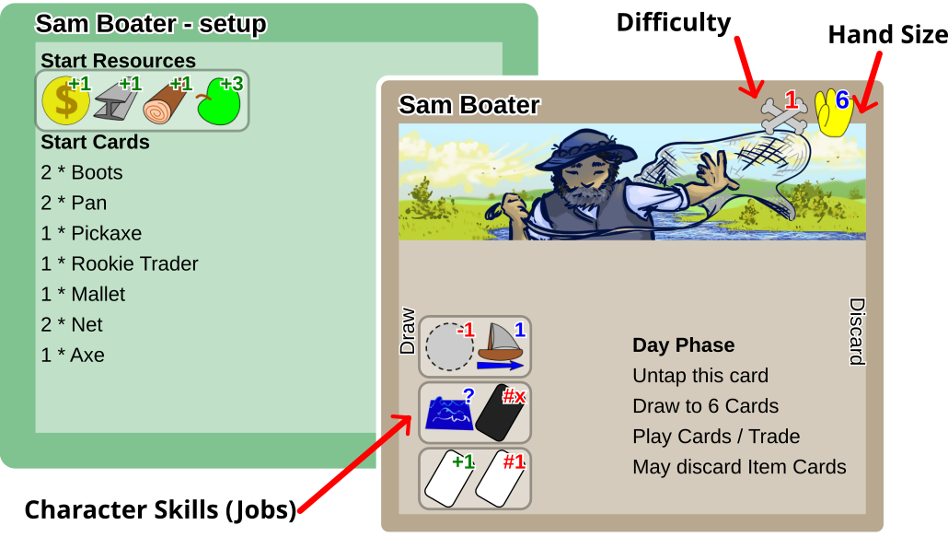
Give each player a Character Card of the agreed difficulty. (If this is your first game, choose 1).

Each player takes the Start Resources (counters) listed on the back of their Character Card. Big counters represent five little ones. Yellow for Gold, White for Metal, Brown for Wood, Green for Food.
Each player takes the Starter Cards listed on the back of their Character Card, shuffles them, and places them as a Draw Pile, face down to the left of their Character Card.
Leave a space to the right of the Character Card for the Discard Pile. During play, Game Cards will cycle from Draw Pile to Hand to Discard Pile and back to the Draw Pile again.
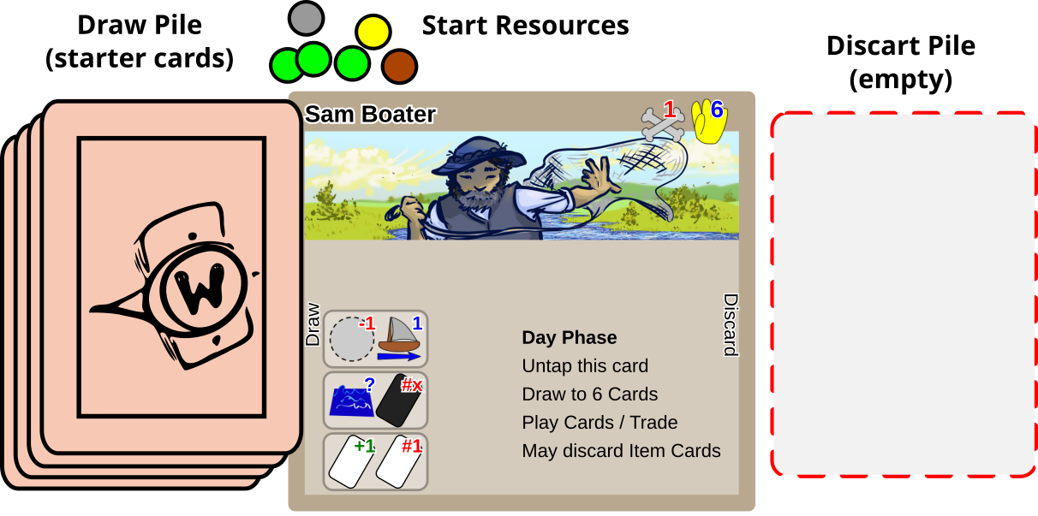

Understanding Jobs
In Deck Goes West, Jobs are literally EVERYWHERE. You find them on Characters, Missions, Item Cards, Danger cards, and Even on some Land tiles. They are how you do EVERYTHING. From travelling, to getting resources, to fighting, to buying cards, even to scoring.
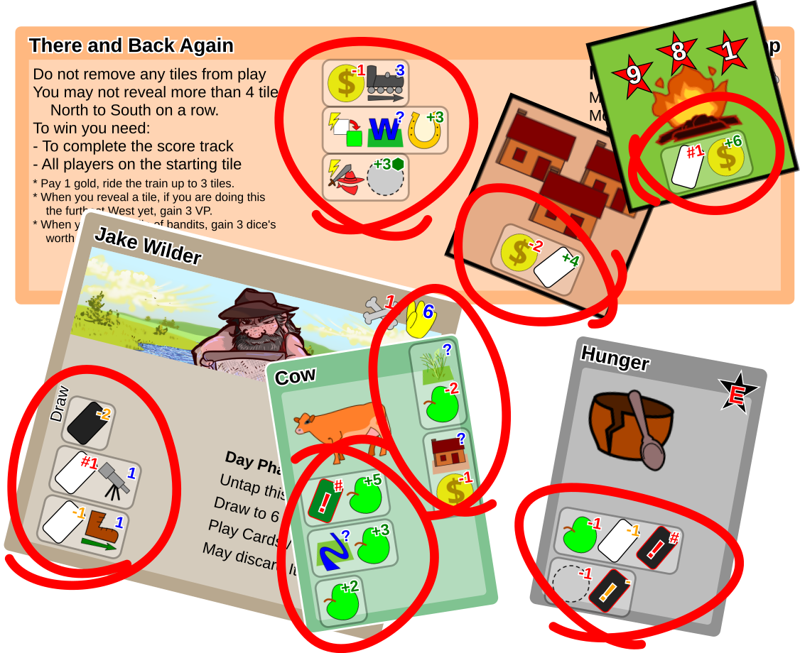
They are rounded rectangles with icons in, each icon represents a step of the Job that must be completed. Eg:
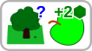 | 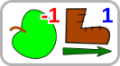 | 
In a Forest, roll 2 Success Dice for Food | Pay 1 Food to move 1 space on Land. | Discard 2 blue Item Cards to Scrap the Danger Card this Job is on.

Jobs – How and When to Use Them
Jobs are used during the “Player Actions” phase of the game (See Order of Play – pages 22-24). How you use Jobs depends on where they are:
You should have all of these out somewhere by this point. Look for them as you read this section.
On the Mission Card:
- Mission Jobs : These can be performed as part of a turn action.
- Event Jobs : Indicated by a lightning symbol ‘’: These trigger whenever the indicated event happens. For example: “Whenever you build a railway, score Victory Points (VP)”. (see page 20)
On Character Cards:
These are the character’s special abilities. You can only perform one special ability per day. To use a Character ability, turn the Character Card by 90°. This is called “Tapping” the card. At the beginning of each day you will untap it again, setting it straight.
On Item Cards (Starter and Trade):
Discard the Item Card to perform one of it’s jobs. If the Job requires you to discard an Item Card, that must be another card as you are already discarding the Item Card to perform its job.
The Top Corner of Trade cards.
These Jobs allow you to buy the cards and add them to your deck. Complete a top-corner-Job to buy the card, then add it to the top of either your draw pile, or discard pile.
On Danger Cards:
Danger cards cannot be discarded normally. You get rid of them by completing the Jobs on them. The last step of each Danger-Job will either be “discard” or “scrap” this card. To discard it, put it in your own discard pile. To scrap it, put it face up beside Danger draw pile it came from.
On Land Tiles:
Your meeple must be standing on the tile, without any bandits.
Lie your meeple down on the tile to perform the Job. This is so that you cannot perform the same job on a tile without leaving and coming back.
Whenever you move your meeple, place it standing up.

Jobs – Resources
(Consider looking through your start cards as you read the Jobs section of the rules, try to work out what each card does as you go. You can reshuffle them after)
There are four kinds of resource in Deck Goes West, each represented by a coloured counter. There are 5 Icons which represent them.
Resource | Gold | Metal | Wood | Food | Any
Icon |  | 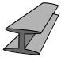 |  |  | 
Colour | Yellow | White | Brown | Green | All the same
For the “Any Resource” icon “”: all resources must be of the same type. But two separate “Any resource” icons in the same Job can represent different resources to each other. (See “X is Variable” below)
A green plus ‘+’ means “gain these resources” (take them from the general supply. A red minus ‘-’ means “pay these resources” (put them back). Big counters are worth 5 little ones.
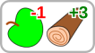
Pay 1 Food, and Gain 3 Wood.

‘X’ is Variable
If the icon has an ‘x’ on it, you can choose what ‘x’ is. It must be a positive integer (including zero), and stay the same for the whole job.
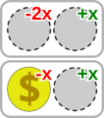
For every 2 of one resource you pay, gain one of another.
Eg: Pay 4 Wood, and gain 2 Food.
Or: Pay 6 Food, and gain 3 Metal.
For every Gold you pay, gain 1 of another resource.
Eg: Pay 1 Gold, and gain 1 Wood.
Or: Pay 5 Gold and gain 5 Food.

Jobs – Dice and Cooperation

‘⬢’ Dice Rolls
The ‘⬢’ Dice symbol means “dice’s worth”. Roll that many Success Dice”, and use the rolled result. Success Dice have faces with dots representing the numbers : [0,0,1,1,1,2].
Example :
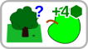
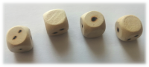
If you are in a Forest, gain 4 dice’s worth of food.
(Roll 4 dice, and collect the result in food)
My meeple is in the forest, I play the job above, and roll 4 Success Dice.
Because I rolled a total of 3, I collect 3 Food.

Cooperation Bonus
If the last step of a job is to gain resources by rolling dice (as above), and there are other players on the same tile, a player may invite the others to join them.
Invited players may activate any of their Jobs that also roll dice for the same resource as the final step, paying their appropriate cost.
All players then roll and gain the full amount they rolled. They also gain half, rounded up, of what the co-worker who rolled the most, apart from themselves, rolled.
Example:
Alice and Bob are on the same Forest tile. Alice invites Bob to ‘hunt’ with her. Alice has a Hunting Knife, Bob has a Knife. Both jobs’ final step is to roll for food.
Alice rolls 4 dice and scores a 3 | Bob rolls 2 dice and scores a 1
Alice collects 4 Food. 3 from her own roll, and 1 from half of Bob’s score rounded up. | Bob collects 3 Food. 1 from his own roll, and 2 from half of Alice’s score rounded up.

Jobs – Normal Movement
Your biggest priority in this game will be getting around the board. You will need to move to gather resources, and revealing new tiles will normally score you points.
Meeples move from one tile to another in any of the four Cardinal (N,E,S,W) directions. You may move onto unrevealed tiles, and reveal them (See Revealing Land : page 17), but you may not move where there is no Tile at all.
To move : Play/Activate all movement jobs you intend to use. Paying all the costs (eg : pay resources, discard cards etc), and calculate how much movement of each type you have. Then move as far as your movement allows, and you wish to.
Different types of movement allow you to step onto different kinds of tiles, and at different Costs. (The tile you are moving from doesn’t matter except for sailing onto land)
ONTO : | Mountain | Water | River | Railway | Everything Else
Walking | 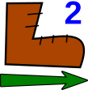 | X | 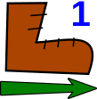 | *
Climbing | 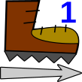 | X
Sailing | X |  |  | Only from Water or River

- If a Land Tile is more than one type: choose the cheaper.
- You may use Climbing or Walking to move off of Water.
* Railway Bonus: When using a Walking movement onto a Railway Tile. You gain that movement back immediately. (Railway Tiles are tiles that someone has built a railway on.)
If there are any Bandits on the Tile you are leaving you must take a Pain Card, and add it to the top of either your draw or discard pile.

Revealing Land
To Reveal a Land Tile, turn it face up, then add Land Tiles face down all around it, though not further East of the Eastmost Tile showing.
This activates the “Reveal Land” event on many mission cards.
If the tile you reveal is a Bandit Camp: Add a bandit to it.
If you run out of land tiles to draw: Remove the Eastmost row, and shuffle it into a draw pile. Move any players on it West 1 space and give them an Exhaustion Card.

By Movement
You may use any kind of movement to try to move onto a face down Land Tile, and reveal it immediately.
If you discover the movent you used was not enough, or not the right type to move onto the tile, you may play more movement Jobs immediately to meet the need. You may also choose not to complete the movement.
If you decide not to move onto the tile, (either because you can’t afford to, or don’t want to). The reveal still costs you 1 movement of whatever type you choose. You may use any remaining movement to continue moving in other directions.

By Telescope

You may also reveal land by activating a Job with the following Icon. Reveal ‘n’ face down Land Tiles within 2 spaces of your Meeple. (‘n’ will be an actual number on the Job)
n
If ‘n’ is greater than 1, complete each reveal before starting the next. This means you may reveal a tile, place tiles face down around it, and then reveal one of the newly added tiles (if it’s in range).
The Jobs with this are usually cheap to do, and allow you to look ahead without having to spend resources on moving.

Railways
As part of “Taming the West” you will try to build railways. The main reason for doing this is to gain points, but they may also help you trade or travel more quickly. Most Mission Cards give points every time you build one.
Once a railway has been built, any player may use it to help them travel. Players can also use them to trade with each other across long distances.

Building a Railway
To build a Railway, you must activate a Job with one of the following icons on it, and then place a Metal token on the tile you are currently on. This makes it a “Railway Tile”. Now if anyone Walks onto it, they keep the movement.
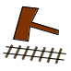 | Build a Railway on Land  (Any tile except Water) | 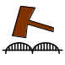 | Build a Railway on Water  (Bridge)
Both of these activate the “Build Railway” event on many Mission Cards and will often score you points.
You cannot do this if there are Bandits on the tile, or if there is already a Railway there.

Railway Movement
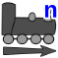
Railway movement, is to move a meeple from one Railway Tile to another Railway Tile, up to the distance ‘n’ (n will be an actual number on the Job) . This can help players rejoin the group if they get stranded, or left behind. As a kind of movement, it may be combined with the others.
It does not matter what tiles are between the two Railway Tiles, as long as the number of tiles is less than the ‘n’.
You may not combine two Railway Movements, to increase the distance between two Railway Tiles to travel.
If there are any Bandits on the Tile you are leaving you must take a Pain Card, and add it to the top of either your draw or discard pile.

Jobs – Cards
There are four things Jobs can do with cards.
  Draw |   Discard |   Scrap | 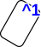  Gain
Take from your draw pile and add to your hand. | Remove from your hand and put in your discard pile. | Remove from your hand and return to whichever pile it came from. | Add to the top of either your draw or discard pile. (Danger only)
These can apply to different kinds of cards. Danger cards cannot be used as Item cards, and visa-versa.
Item Cards | Danger Cards
  Any Item Card. (Not the card you are playing) |   Any Danger Card
  An Item Card of the Colour shown |   A Danger Card of this Type  (E:Exhaustion, P:Pain)
  This Item Card  (coloured to match) |   This Danger Card

Examples:
On the  Cow | 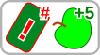 | Scrap the Cow card, (To the Trade Row’s discard pile) and gain 5 Food.
On the  Pickaxe | 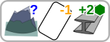 | On a Mountain, discard 1 other card, (along with the pickaxe) and roll 2 dice for Metal.
On the  Leg Wound |  | Discard 2 Blue (Movement) cards, to scrap this Leg Wound card. (To the Pain discard pile)

Jobs – Conditions and Events

Conditions
Some Jobs have conditions on them. They are marked by a blue question mark ‘?’. To be able to perform anything after the condition, you must meet the requirement.

Places
To perform these jobs, your meeple must be on the appropriate tile, and there must be no Bandits on the Tile.
 |  |  |  |  | 
Forest | Prairie | Mountain | Village | Water | River

Events
Events are only found on Mission Cards, and are marked with a lightning bolt ‘’. Whenever the event happens, the player(s) who caused it must complete the whole job.
 | Whenever you build |  | Whenever the Wagon moves West 1 Tile
 | Whenver you Reveal a Tile |  | Whenever the Wagon moves East 1 Tile
 | Whenever you completely remove Bandits from a tile |  | Whenever the Wagon takes Damage
The Wagon is an item that exists only in some missions.
Event Conditions:
 | If this is the furthest West, the event has happened so far. (eg: The furthest West railway build) |  | If this event was triggered by moving West.  (Eg tile revealed by moving West)
Events normally lead to Scoring Points:
 | Gain ‘n’ VP. If you reach the end of the track, Win. |  | Lose ‘n’ VP. (or set to zero if not enough)

Jobs – Battle
Battle Jobs are Jobs that contain any of the four icons below.
Attack | Defence
  Roll ‘n’ Success Dice for hits when attacking |   Roll ‘n’ Success Dice for saves when defending.
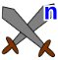Deal ‘n’ hits when attacking | ‘n’ saves when defending
Players initiate a battle by playing Battle Jobs on a tile with Bandits.
Bandits initiate a battle by being on the same tile as players at the Bandits Attack section of the Night Phase.

At the start of the battle, all Players on the Tile may play as many Battle Jobs as they wish, paying any costs such as discarding cards and resources. In every Attack, the damage done is “Hits minus Saves”.
Then, whoever initiated the battle (Players / Bandits) attack first. Then whoever was attacked, counter’s with their own attack.
Players Attack:
All Players roll any attack dice they can from their Jobs, then add any fixed hits and calculate their total Hits.
Someone rolls 1 dice per bandit on the tile, to calculate Saves.
Remove 1 Bandit for every Hit above the total Saves.
If this removes all the bandits on the tile, this activates the Remove Bandits Event on many missions
Bandits Attack:
Bandits roll 1 dice per bandit to calculate Hits.
All players roll any defence dice they can, then add any fixed saves.
All Players on the tile take 1 ‘P’ danger cards for every Hit above Saves

Order of Play
Before playing, Read the Mission Rules on the Mission Card aloud so that every player knows what they are aiming for. Make sure everyone understands what all the Mission Job’s mean.
In Versus games, before you start, choose a first player, and give them the P1 Token. In Cooperative and Solo games this will not matter as players may take turns in any order.
The game is split into two repeating phases "Day" and "Night". During the Day, Players perform their actions, and at Night, the board updates and the Bandits cause trouble.
Players will repeat “Day”, and “Night” phases until, either someone wins, or the Day Tracker reaches the end, and stops the game.

Day Phase : Players Act (page 23)
- Draw Cards
- Untap Character Card (If tapped in previous action phase)
- Player Actions
- Discard Item Cards

Night Phase : Time Advances (pages 26-27)
- Move the Day Tracker
- Move the Trade Row
- Players takes an 'E' Danger Card
- Bandits Attack
- Bandits Move
- Remove Eastern Tiles (Some Missions. Only tiles very east of all players)
- Bandits Appear
- Pass the P1 Token (VS only)

Day Phase – Players Act
Note: The day phase order is shown on every Character Card, including the specific number of cards you should draw.

1 : Untap Character Card
If your Character Card was Tapped/Rotated to perform a Character Job, in the previous Day Phase. Turn it back to straight again.

2 : Draw Cards
All players draw cards from their own personal deck, into their hand, until they have as many cards as their Hand Size. ( Shown on Character card )
If ever a Player needs to draw cards but their Draw Pile is empty, they shuffle their Discard Pile to create a new Draw Pile. If the Discard pile is also empty, they do not draw any more.
If a player’s hand is full without drawing any cards, that Character dies. (Players must play or discard at least 1 card each day)

3 : Player Actions
Players take turns to perform the actions available to them, until all of them have passed. (See Player Actions : Page 24)
* Perform a Job * Purchase a Card * Trade * Attack Bandits
In Cooperative and Solo modes, players can do this in any order, but in Versus, players must take turns in the following way.
The player with the P1 Token takes one action. After him, all players in clockwise order take either 1 or 2 actions, or pass.
Players (including P1) who haven’t already passed, continue taking 1 or 2 actions in clockwise order until all players have passed. (Do not pass the P1 Token until the Night Phase)

4 : May discard Item Cards.
Players may discard as many Item Cards as they wish. They may not discard any Danger cards at this point.

What are Player Actions?

Perform a Job (or more)
Perform any kind of Job that is available to you. If multiple Jobs have the same final step, then you may perform them all as the same Job.

Purchase a Card
To buy cards from the Trade Row, players must complete one of the Jobs in the top right corner of the Card. They can then add the card to the top of either their Draw Pile, or Discard Pile.
After taking the card, to fill in the space it leaves behind, move any cards behind it forward one space, and draw a new card to the back of the row. There should be 5 cards available at all times.
(Tip: before you pass, make sure to check the trade row)

Trade (Cooperative and Versus)
If two Players are on the same Tile, or if both are on Railway Tiles, they may perform a Trade action.
The active player, must discard a card.
Then both players may trade resources from their stock, or item cards from their hands with each other as they see fit.
They may also, by agreement, use their own movement cards, to move each other.

Initiate a Battle
If you are on the same tile as any Bandits, you may initiate a battle against them. Follow the instructions in “Jobs – Battle” (p21)

Tips – Player Actions Phase
Your first Player Actions Phase may seem a little daunting. Here are some Ideas to get you moving.
Look at all the cards in your hand, and the Jobs on your Character Card. Try to use as many as you can.
If you have a “Knife” card, and your Meeple is in a Forest, play the Knife Card to activate this Job. Discard the card and roll 2 Success Dice, and for each success you roll, gain a Food.

If you have a “Pan”, and your Meeple is on a River, Use it. Discard it and Roll 1 dice to try to gain Gold.
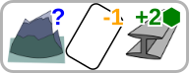
If you have a “Pickaxe” and are on a Mountain. Discard it and another Item Card to Roll 2 dice for Metal.
If you are not in a place where you can use any tools, try to move somewhere you can. Discard a “Boot” Card. Pay a Food resources to move to an adjacent tile. (Play 2 Jobs with walking movement to get onto a mountain)
Don’t forget your character has abilities too. At least one of those will help you move around the map. Tap/Rotate the Characacter Card to use the ability, then pay the cost and move.
If you can, move West onto face down Tiles. Revealing them will probably gain you points.
Don’t forget to shop at the Trade Row. The cards are generally better than the Starter Cards, and will help gain resources more quickly, fight better, or travel across water.
Remember, if you Reveal a Tile -- Build a Railway -- Defeat Bandits – Move a Wagon check the mission card to see if you score points.

Night Phase – Time Advances
The Night Phase is listed on every Mission Card, and varies slightly. Perform the steps that are ON THE MISSION CARD, and use this section as a reference.

Move the Day Tracker
Move the Day Tracker one space along the Day Track on the Scoreboard. If it reaches the end. The game ends immediately.

Move the Trade Row
Place the right most Trade Row card, in the discard pile by it’s draw pile.
Then move all the cards in the Trade row forward 1 space (right).
Draw a card, from the Trade Row draw pile, and add it to the leftmost space on the row.

Everyone takes an Exhaustion Card.
All players take a Danger card from the 'E' draw pile, and put it on top of their own discard pile or if they wish their draw pile.

Bandits Attack
(If there are no bandits on the board, skip this and “Bandits Move”)
Starting from West to East (North before South), Each Group of Bandits on the same tile as a player Initiates a Battle (See Battes : page p19)

Bandits Move
Starting from West to East, (North before South). For every group of bandits not on the same tile as a player and not on a Bandit Camp, roll the Compas Dice. Move the group 1 space in the direction indicated. Or if you roll a '+' add one Bandit to the group
- Bandits may move onto face up or face down tiles.
- If they cannot move in the rolled direction, move them in the opposite direction. If they still cannot move, add a bandit
- If a group of bandits meets group that have not yet moved, roll movement for the other group immediately.
- Two groups on the same tile after this phase become one group.

Remove Eastern Tiles (not on all missions)
As you travel West, the tiles to the East become less and less relevant. To avoid wasting time managing bandits that will never affect you, it helps to remove tiles far enough East to not affect the game.
If the mission card has this step, it will have a number on it. Remove all tiles more than that number of spaces East of the Eastmost Meeple on the map, along with any Bandits on them.
Put the tiles in a discard pile.If the Land Tile Draw Pile is ever empty, shuffle these, cards, to create a new draw pile.

Bandits Appear.
The pink stars on the Scoreboard have a number in them called the Bandit Risk. The current Bandit Risk is the number on the star in the same section of the scoreboard, as the furthest forward token - Either Meeple or Day Tracker. Roll the Bandit Dice, as many times as that Bandit Risk. For each roll, add 1 bandit to every tile with the same number in it's red star on the map.
If after bandits appear, a group of bandits has 6 or more members, split the group as follows.
  - Move 1 bandit in each of the four cardinal directions.
  - If any direction is not possible, do not move that bandit.
  - If this creates another group of at least 6 bandits do the same again.

Pass the P1 Token (Only in Versus missions)
The player who has the P1 Token passes it to the left.
After completing the Night Phase, start the Day Phase again, and repeat until the game is ended.
May we at Story Feet, wish you the best of luck on your adventure.

