1000 bulls GATK fastq to GVCF guidelines (GATKv3.8)
Version: 17/10/2019
http://www.1000bullgenomes.com has been updated and files can be downloaded directly from it. More site updates to come. Alternatively, files can be found on Agriculture Victoria’s server and downloaded using the following commands (using your institute’s specific username and password):
> sftp username@203.12.194.81:/home/bulls1k/Run8/resources
> reget *

These specifications describe the software and steps to process fastq files into bam and GVCF files for the 1000 Bull Genomes Project. Please follow these instructions closely. NOTE: bam and GVCF files will not be accepted if they do not meet these specifications.
We realise this is all computationally demanding, and so Agriculture Victoria offer the following:
- If you submit your raw fastq files to NCBI or EBI, Agriculture Victoria will download them from NCBI or EBI and do all the processing for you.
- If you cannot make the data public and need assistance processing the data please contact Hans Daetwyler to discuss what help may be available.
- If you need help with any aspect of this workflow please contact Amanda Chamberlain.
International Bull IDs of those bulls already included in the project are added into the Project Database and can be requested from Hans Daetwyler.

Data accepted
We accept data from ILLUMINA sequencers. We do not accept data from PacBio or Oxford Nanopore instruments at this time. If you intend to submit BGI or any other non-ILLUMINA generated reads please contact Hans.

Key contacts
Hans Daetwyler hans.daetwyler@ecodev.vic.gov.au
Amanda Chamberlain amanda.chamberlain@ecodev.vic.gov.au
Christy Vander Jagt christy.vanderjagt@ecodev.vic.gov.au

Required software
- Trimmomatic 0.38 (http://www.usadellab.org/cms/?page=trimmomatic )
- You may use other software for trimming and quality control as long as our standards are followed
- FastQC 11.7 (http://www.bioinformatics.babraham.ac.uk/projects/download.html#fastqc )
- BWA 0.7.17 (https://github.com/lh3/bwa)
- Samtools 1.8 (http://www.htslib.org/download/ )
- Tabix 1.8 (http://www.htslib.org/download/ )
- Picard v2.18.2 (http://broadinstitute.github.io/picard/ )
  - Requires Java 1.8 be installed
- GATK 3.8-1-0-gf15c1c3ef (there are two GATK3.8 versions, this exact version must be used) (https://software.broadinstitute.org/gatk/download/auth?package=GATK-archive&version=3.8-1-0-gf15c1c3ef )
  - Requires Java 1.8 be installed
NOTE: It is important to use GATK3.8 for all GATK steps as pointed out by GATK developers (https://gatkforums.broadinstitute.org/gatk/discussion/3536/can-i-use-different-versions-of-the-gatk-at-different-steps-of-my-analysis ). If you do not use this exact GATK version, GATK will not allow us to combine your bam or GVCFs with the other project data when running GenotypeGVCFs, as versions will be inconsistent.

Starting from raw fastq versus bam file extracted fastq
We recommend that partners process their sequence starting from raw fastq format. If you do extract reads from a bam file you can do so with Picard SamToFastq tool (https://broadinstitute.github.io/picard/command-line-overview.html#SamToFastq ), though other tools are available. This tool can output reads based on read groups, so if read groups are specified correctly (see https://gatkforums.broadinstitute.org/gatk/discussion/6472/read-groups for definitions) then this will re-create the original fastq files. Please make sure the original per base quality score (OQ) is associated with reads, Picards RevertSam tool (https://software.broadinstitute.org/gatk/documentation/tooldocs/4.beta.6/picard_sam_RevertSam.php ) can revert previously recalibrated qscores. If you don’t know the quality control that was used on the read data in the bam file and you have raw fastq files available, please start from fastq as per our guidelines in this document.

An example command for picard SamToFastq
java -XX:ParallelGCThreads=12 -Xmx300G -jar picard.jar SamToFastq INPUT=${InputBam} OUTPUT_PER_RG=true COMPRESS_OUTPUTS_PER_RG=true OUTPUT_DIR=${FastqDir} RG_TAG=ID VALIDATION_STRINGENCY=LENIENT
NOTE: this is for a BAM file containing read groups.

Trim and filter fastq
Trim paired reads of adapter, low quality bases (qscore <20) at the beginning and end, then filter out reads with mean qscore less than 20 or length less than 35bp. We recommend Trimmomatic because it is well documented and actively maintained. However there are many programs capable of performing this task, ie qualityTrim (https://bitbucket.org/arobinson/qualitytrim), fastp (https://github.com/OpenGene/fastp), sickle (https://github.com/najoshi/sickle). Using trimmomatic (http://www.usadellab.org/cms/uploads/supplementary/Trimmomatic/TrimmomaticManual_V0.32.pdf ) you should use the following options
- ILLUMINACLIP:${ADAPTERfasta}:2:30:3:1:true
- LEADING:20
- TRAILING:20
- SLIDINGWINDOW:3:15
- AVGQUAL:20
- MINLEN:35
- -summary ${outputfile}.summary
where ADAPTER.fasta is a file which contains a list of adapter sequences. Trimmomatic provides this for modern Illumina adapter sequences, however you should check that it includes those used by your sequencing facility especially if the data was generated some time ago. Trimmomatic performs the operations in the order listed, therefore if your reads have been trimmed previously and are potentially less than the MINLEN then you should apply the MINLEN twice, as the first and last operation to avoid errors. If fastq files are Phred+64 encoded you must use the following option to convert to Phred+33 encoding
- TOPHRED33
Alternatively, you can use seqtk (https://github.com/lh3/seqtk) to convert qscores.
NOTE: If fastq files contain reads that fail Illumina chastity these should also be removed.
NOTE: Should you have Illumina two color chemistry e.g. NovaSeq or NextSeq data you should also trim strings of G from the end of reads, these strings have normal qscores and so most trimming scripts will not trim them, they are however artefacts of the sequencing chemistry. Such sequences may be flagged by FastQC as over represented sequences or kmers. See https://sequencing.qcfail.com/articles/illumina-2-colour-chemistry-can-overcall-high-confidence-g-bases/
We highly recommend checking raw and filtered sequence reads with FastQC (http://www.bioinformatics.babraham.ac.uk/projects/fastqc/).

An example of trimmomatic command
java -jar /usr/local/trimmomatic/0.38/trimmomatic-0.38.jar PE -threads 8 -summary ${Fastq}.summary ${Fastq_R1}.fastq ${Fastq_R2}.fastq ${Fastq_R1}-trimmed.fastq ${Fastq_R1}-singleton.fastq ${Fastq_R2}-trimmed.fastq ${Fastq_R2}-singleton.fastq MINLEN:${MINLEN} ILLUMINACLIP:${ADAPTER.fasta}:2:30:3:1:true LEADING:20 TRAILING:20 SLIDINGWINDOW:3:15 AVGQUAL:20 MINLEN:${MINLEN}
NOTE: the –summary ${Fastq}.summary option is not documented in the V0.32 pdf as it was added in V0.38. At the end of processing, the program prints to screen the results of the trimming. The –summary {file_name} option will also print these results to {file_name}. An example output is below. These data can be useful for evaluating the overall quality and levels of readthrough.
Input Read Pairs: 108316343
Both Surviving Reads: 97709067
Both Surviving Read Percent: 90.21
Forward Only Surviving Reads: 7903324
Forward Only Surviving Read Percent: 7.30
Reverse Only Surviving Reads: 1432840
Reverse Only Surviving Read Percent: 1.32
Dropped Reads: 1271112
Dropped Read Percent: 1.17

An example of FastQC command
/usr/local/bin/fastqc -q -t 12 *fastq.gz -o ${OUTPUTdirectory}

Reference
ARS-UCD1.2_Btau5.0.1Y is the reference genome to be used in this project. This reference has the Btau5.0.1 Y chromosome assembly from Baylor College (Bellott, Hughes et al. 2014) added to ARS-UCD1.2 (Rosen, Bickhart et al. 2018). It can be downloaded from the 1000 bull genomes website and https://sites.ualberta.ca/~stothard/1000_bull_genomes/ There are several files including the .fa.gz file (assembly) and checksums to ensure the download has not altered the files. This exact copy of the reference genome must be used to ensure your bam and GVCF files are compatible with the 1000 Bull Genomes Project pipeline. Non-conforming files will be excluded from the run.

Map fastq
Map trimmed reads (pairs and singles that pass above QC) to the reference using bwa mem (https://github.com/lh3/bwa) specifying read groups (see https://gatkforums.broadinstitute.org/gatk/discussion/6472/read-groups for definitions) with the following options
- -R @RG\\tID:${RGID}\\tPL:${RGPL}\\tLB:${RGLB}\\tSM:${RGSM}
where RGID is the sequencer lane (this is often within the fastq file name and is important for the base quality score recalibration steps later on), RGPL is the sequencing platform (ILLUMINA, SOLID or 454), RGLB is the library name and RGSM must be the international ID of the animal. Other read group tags can be populated but RGID, RGPL and RGSM are required. If your animal does not have an international ID, you should create one that conforms to Interbull standards, ie 3 character breed code + 3 character country code + sex code (M or F) + 12 character animal ID, eg HOLCANM000000352790. See http://www.interbull.org/ib/icarbreedcodes
To perform the subsequent steps you will need to use samtools sort to sort your bam and samtools index to index your sorted bam file (http://www.htslib.org/doc/samtools.html). Using the correct reference will ensure the bam files are sorted correctly, i.e. 1, 2, 3, …, 29, X, Y, MT, other contigs.
Where multiple bam files are generated for an individual you should use Picard MergeSamFiles (https://broadinstitute.github.io/picard/command-line-overview.html#MergeSamFiles) to merge them. Please note that samtools merge is not appropriate for individuals with multiple libraries as it doesn’t handle the read groups properly, so Picard MergeSamFiles is our chosen tool for this task. The correct handling of libraries is important for downstream base quality score recalibration in GATK which is read group aware.

An example of bwa and samtools commands
/usr/local/bin/bwa mem -M -t 12 -R @RG\\tID:${RGID}\\tPL:ILLUMINA\\tSM:${RGSM} ARS-UCD1.2_Btau5.0.1Y.fa ${Fastq_R1}-trimmed.fastq.gz ${Fastq_R2}-trimmed.fastq.gz > ${OutputFile}-pe.sam
samtools sort -o ${OutputFile}-pe.sorted.bam -O BAM ${OutputFile}-pe.sam
samtools index ${OutputFile}-pe.sorted.bam

An example of Picard MergeSamFiles command
java -Xmx80G -jar /usr/local/picard/2.1.0/picard.jar MergeSamFiles ${BAMlist} O= ${INTERNATIONALID}.sorted.bam VALIDATION_STRINGENCY=LENIENT ASSUME_SORTED=true MERGE_SEQUENCE_DICTIONARIES=true

Mark Duplicates
Mark PCR and optical duplicates using Picard MarkDuplicates (https://broadinstitute.github.io/picard/command-line-overview.html#MarkDuplicates) with the following options
- VALIDATION_STRINGENCY=LENIENT
- OPTICAL_DUPLICATE_PIXEL_DISTANCE ${OPTICAL_DUPLICATE_PIXEL_DISTANCE}
where OPTICAL_DUPLICATE_PIXEL_DISTANCE is 100 for data generated on non-arrayed flowcells (ie from GAIIx, HiSeq1500/2000/2500), or 2500 for arrayed flowcell data (eg HiSeqX, HiSeq3000/4000, NovaSeq). Note these are all Illumina instruments, if you have data from other instruments you must work with the supplier to determine this value. See https://sequencing.qcfail.com/articles/illumina-patterned-flow-cells-generate-duplicated-sequences/

An example of Picard MarkDuplicates command
java -Xmx80G -jar /usr/local/picard/2.18.2/picard.jar MarkDuplicates I=${INTERNATIONALID}.sorted.bam O=${INTERNATIONALID}_dedup.bam M=${SAMPLE}_dedup.metrics OPTICAL_DUPLICATE_PIXEL_DISTANCE=${OPTICAL_DUPLICATE_PIXEL_DISTANCE} CREATE_INDEX=true VALIDATION_STRINGENCY=LENIENT

Base Quality Recalibration
Base quality recalibration should be performed according to GATK best practises guidelines (https://software.broadinstitute.org/gatk/guide/article?id=44). This task uses the GATK BaseRecalibrator (https://software.broadinstitute.org/gatk/documentation/tooldocs/3.8-0/org_broadinstitute_gatk_tools_walkers_bqsr_BaseRecalibrator.php ) and PrintReads (https://software.broadinstitute.org/gatk/documentation/tooldocs/3.8-0/org_broadinstitute_gatk_tools_walkers_readutils_PrintReads.php ) tools. Briefly, first GATK BaseRecalibrator is run to build a model of covariation based on the data and a set of known variants, to produce a recalibration table. Secondly, GATK PrintReads is run to adjust the base quality scores in the data based on the recalibration table, this produces a recalibrated bam. An optional third step runs GATK BaseRecalibrator on the recalibrated bam producing an “after recalibration” table. These before and after recalibration tables can then be used to run GATK AnalyzeCovariates (https://software.broadinstitute.org/gatk/documentation/tooldocs/3.8-0/org_broadinstitute_gatk_tools_walkers_bqsr_AnalyzeCovariates.php) which generates plots that visualise the effects of the recalibration process (a recommended quality control step).
BaseRecalibrator requires the following options
- -knownSites:vcf ${KnownVariants}
- --bqsrBAQGapOpenPenalty 45
where bqsrBAQGapOpenPenalty has been tested and a value of 45 proves to work best for Bos whole genome sequencing (as opposed to default of 40 or recommendation of 30 for human). KnownVariants is a list of known variant sites in vcf format. We have generated two new known variants files.
- ARS1.2PlusY_BQSR_v2.vcf.gz is a known variants file of SNP and INDEL generated from Bos Taurus and Bos Indicus Run7 at tranche 99.9 stringency. Please note that this known variants file has been extensively tested on taurus and indicus animals and is expected to work well. It is not recommended for Bos out species.
- ARS1.2PlusY_BQSR_v3.vcf.gz combines ARS1.2PlusY_BQSR_v2.vcf.gz with variants called independently in various out species (see Appendix A for its derivation). This file has been extensively tested on taurus, indicus, bison (Bison bison), yak (Bos grunniens), gir (Bos primigenius indicus), gaur (Bos gaurus) and banteng (Bos javanicus) and is expected to work well. It has also been tested on water buffalo (Bubalus bubalis) for which it does not work well. It is always good to double check the QC metrics (see Appendix A for example of where BQSR has over corrected QV for Water Buffalo sequences) especially if you have animals from an out group not yet tested. Bob and Amanda would be happy to help with questions.
NOTE: We recommend using ARS1.2PlusY_BQSR_v3.vcf.gz for all future submissions and --bqsrBAQGapOpenPenalty 45, however if you have already used ARS1.2PlusY_BQSR_v2.vcf.gz for Taurus or Indicus animals there is no need to rerun. We also recommend that you check the before/after BQSR reports shown in Appendix A to ensure that samples are behaving as expected. The files (vcf.gz and tabix index .tbi) are available at the 1000 bull genomes project website and on Agriculture Victoria’s server (instructions found at the start of this document).
Base Quality Score Recalibration can add a non-trivial amount of time to the total time needed to process samples. Bob Schnabel has developed a method that uses intervals to build and apply the recalibration model that reduces the time taken to run the BQSR (Appendix B, note this really is for advanced users).

An example GATK BaseRecalibrator command
java -Xmx80G -jar $GATK –T BaseRecalibrator –nct 8 -R ARS-UCD1.2_Btau5.0.1Y.fa -I ${INTERNATIONALID}_dedup.bam –knownSites:vcf ${KnownSites} -–bqsrBAQGapOpenPenalty 45 -o ${INTERNATIONALID}.recal.table

An example GATK PrintReads command
java -Xmx80G -jar $GATK –T PrintReads –nct 8 -R ARS-UCD1.2_Btau5.0.1Y.fa -I ${INTERNATIONALID}_dedup.bam -BQSR ${INTERNATIONALID}.recal.table -o ${INTERNATIONALID}_dedup_recal.bam

An example GATK AnalyzeCovariates command
java -Xmx80G -jar $GATK –T AnalyzeCovariates -R ARS-UCD1.2_Btau5.0.1Y.fa -before ${INTERNATIONALID}.recal.table -after after_recal.table -plots recal_plots.pdf

Create GVCF file
Appendix C explains a known issue with HaplotypeCaller and threading for the unmapped contigs.
Create a GVCF file using GATK HaplotypeCaller (https://software.broadinstitute.org/gatk/documentation/tooldocs/3.8-0/org_broadinstitute_gatk_tools_walkers_haplotypecaller_HaplotypeCaller.php ). Follow the described “Single-sample GVCF calling on DNAseq (for `-ERC GVCF` cohort analysis workflow)” with the following options
- -ERC GVCF
- -variant_index_type LINEAR
- -variant_index_parameter 128000
- -o ${INTERNATIONALID}.g.vcf.gz
Where INTERNATIONALID is the international ID of the animal, NOTE: this INTERNATIONALID must match the international ID in the RGSM field in the read groups, which were added in the mapping steps above.
It is essential that GVCF files are gzipped and indexed (.tbi file). GATK will do both of these if you specify as above.

An example GATK HaplotypeCaller command
java -Xmx80G -jar $GATK –T HaplotypeCaller –nct 8 -R ARS-UCD1.2_Btau5.0.1Y.fa -I ${INTERNATIONALID}_dedup_recal.bam -o ${INTERNATIONALID}_dedup_recal.g.vcf.gz -ERC GVCF -variant_index_type LINEAR -variant_index_parameter 128000

CallableLoci (optional)
This step is optional but highly recommended. This will collect statistics and produce a BED file detailing callable, uncallable, poorly mapped and other parts of the genome using GATK CallableLoci. If you perform this step, please include the two output files (summary and BED) with the data submitted to the project. We envisage using this information to identify regions of the genome, across a large number of animals, that can be called with high confidence and also those regions of the genome that may be of lower quality.
See: https://software.broadinstitute.org/gatk/documentation/tooldocs/3.8-0/org_broadinstitute_gatk_tools_walkers_coverage_CallableLoci.php

An example GATK CallableLoci command
java -Xmx15g -jar $GATK -T CallableLoci -R ${RefGenome} -I ${INTERNATIONALID}.realigned.recalibrated.bam -summary ${INTERNATIONALID}.CallableLoci.summary.txt -o ${INTERNATIONALID}.CallableLoci.bed

Calculate read coverage
It is important to know the coverage for a few reasons, one being to ensure compliance with the coverage requirements. Calculating coverage from the raw read numbers and length has been shown to be highly inaccurate of final coverage. Calculate the average read coverage using GATK DepthOfCoverage tool (https://software.broadinstitute.org/gatk/documentation/tooldocs/3.8-0/org_broadinstitute_gatk_tools_walkers_coverage_DepthOfCoverage.php ). Include coverage statistic in the checklist (described below).

An example GATK DepthOfCoverage command
java -Xmx80G -jar $GATK -T DepthOfCoverage -R ARS-UCD1.2_Btau5.0.1Y.fa -I ${INTERNATIONALID}_dedup_recal.bam --omitDepthOutputAtEachBase --logging_level ERROR --summaryCoverageThreshold 10 --summaryCoverageThreshold 20 --summaryCoverageThreshold 30 --summaryCoverageThreshold 40 --summaryCoverageThreshold 50 --summaryCoverageThreshold 80 --summaryCoverageThreshold 90 --summaryCoverageThreshold 100 --summaryCoverageThreshold 150 --minBaseQuality 15 --minMappingQuality 30 --start 1 --stop 1000 --nBins 999 -dt NONE -o ${INTERNATIONALID}_dedup_recal.coverage

Optional additional data
The inclusion of genotype information aids the quality checking process and can identify problems with libraries or alignments. If you have BovineSNP50 or BovineHD (or equivalent) data for your samples it would be very beneficial to include these. Genotype data files should be provided as Illumina GenomeStudio output in TOPTOP (preferred) and FORWARD/FORWARD format. Please contact us if you have Affymetrix or other high density (>100,000 loci per chip) genotype data and would like to contribute it.

1000 bull genomes checklist
Consult the 1000 bull genomes file submission checklist (provided to all project partners) before preparing data. Checklist and International ID key spreadsheets must then be filled in and submitted via email to Christy Vander Jagt and Hans Daetwyler.

Create md5sum for all files to be transferred
An md5sum must be created for all files shared with the consortium. An md5sum is a 128 bit checksum which will be unique for each file. Two non-identical files will not have the same md5sum and therefore the md5sum can be used to cross verify the integrity of a file after download or transfer.

An example md5sum command
md5sum ${INTERNATIONALID}_dedup_recal.g.vcf.gz > ${INTERNATIONALID}_dedup_recal.g.vcf.gz.md5

Submission of files
Bam files (.bam) and their associated indexes (.bai), GVCF files (.g.vcf.gz) and their indexes (.tbi), md5sum files (.md5) and genotype files (optional) may be transferred electronically by uploading them to your consortium server account. The following procedure must be followed:
- Contact Christy Vander Jagt (christy.vanderjagt@agriculture.vic.gov.au) and let her know the timing and size of files to be transferred. Only start uploads once go ahead from AgVic is received as server capacity is finite.
- Files must be uploaded to your account (e.g. username@203.12.194.81:/home/username )
Alternatively, you may send the data on external USB disk drive (USB3 and without power plug strongly preferred). Before sending the drive please send the animal checklist to Christy or Hans. Please label the drive with your name and institution and then send to:
Dr. Hans Daetwyler
AgriBio
Agriculture Victoria
5 Ring Rd.
Bundoora 3083
Australia

NOTE: If you would like your USB disk drives returned, then also please provide completed shipping documentation, including payment information for their return.

References
Bellott, D. W., J. F. Hughes, H. Skaletsky, L. G. Brown, T. Pyntikova, T.-J. Cho, N. Koutseva, S. Zaghlul, T. Graves, S. Rock, C. Kremitzki, R. S. Fulton, S. Dugan, Y. Ding, D. Morton, Z. Khan, L. Lewis, C. Buhay, Q. Wang, J. Watt, M. Holder, S. Lee, L. Nazareth, J. Alföldi, S. Rozen, D. M. Muzny, W. C. Warren, R. A. Gibbs, R. K. Wilson and D. C. Page (2014). "Mammalian Y chromosomes retain widely expressed dosage-sensitive regulators." Nature 508: 494.

Rosen, B. D., D. M. Bickhart, R. D. Schnabel, S. Koren, C. G. Elsik, A. Zimin, C. Dreischer, S. Schultheiss, R. Hall, S. G. Schroeder, C. P. Van Tassell, T. P. L. Smith and J. F. Medrano (2018). Modernizing the Bovine Reference Genome Assembly. World Congress of Genetics Applied to Livestock Production. Auckland. Molecular Genetics 3, 802.

Appendix A: 1000 Bulls BQSR Known Variants
Robert Schnabel & Amanda Chamberlain, October 2019
Base Quality Score Recalibration (BQSR) requires a large number of known variant sites in order to work effectively. For Run 8 we have created two known variants files, ARS1.2PlusY_BQSR_v2.vcf.gz and ARS1.2PlusY_BQSR_v3.vcf.gz. Both files used 1000 Bulls Taurus-Indicus Run7 variants (SNP and INDEL) from tranche99.9 stringency. Both files have been tested extensively by both Mizzou and Ag Victoria to verify that they produced recalibrated BAM files similar to, or superior to, what had previously been achieved using ARS1.2PlusY_BQSR.vcf.gz for Bos Taurus and Bos Indicus animals. Variants from unplaced contigs were excluded in both files.
However, as with ARS1.2PlusY_BQSR.vcf.gz, ARS1.2PlusY_BQSR_v2.vcf.gz is not appropriate for recalibration of outspecies. For this reason we created ARS1.2PlusY_BQSR_v3.vcf.gz which includes additional variants called independently in two populations and then merged with the Taurus-Indicus Tranche99.9 variants producing a final file with ~157 million variants. Note that there is a large amount of overlap between the animals used in the two variant calling steps below.
- 221 outspecies animals, producing 129,281,500 raw variants. Variants were called with GATK GenotypeGVCFs then hard filtered (QD < 6.0, FS > 60.0, MQ < 20.0, MQRankSum < -12.5, ReadPosRankSum < -8.0, SOR > 3.0) producing a final set of 108,427,450 variants.
- 131 outspecies animals, including Bison (Bison bison), Banteng (Bos javanicus), Gayal (Bos frontalis) and Yak (Bos grunniens). Variants were called with GATK GenotypeGVCFs, producing 109,551,631 raw variants, then hard filtered (SNP: DP < 800, AF < 0.01, QD < 2.0, FS > 60.0, MQ < 40.0, MQRankSum < -12.5, ReadPosRankSum < -8.0 INDEL: DP < 800, AF < 0.01, QD < 2.0, FS > 200.0, ReadPosRankSum < -20.0) to produce final set of 66,522,888 variants.
Figure 1 illustrates the recalibration using ARS1.2PlusY_BQSR_v3.vcf.gz and --bqsrBAQGapOpenPenalty 45 for a single sample of 14X coverage from a single library run on 6 lanes of an Illumina Hi-Seq 3000. Figure 2 illustrates the recalibration for the same sample using bqsrBAQGapOpenPenalty of 40, you can see that the reported v empirical Q scores for base substitutions do not fit the expectation (diagonal) at the higher Q score range whereas they do where bqsrBAQGapOpenPenalty of 45 is used (Figure 1). Figure 3 illustrates the recalibration using ARS1.2PlusY_BQSR_v3.vcf.gz of a Boran sample demonstrating that the know variant file performs well for Indicus or Indicus/Taurus cross samples.
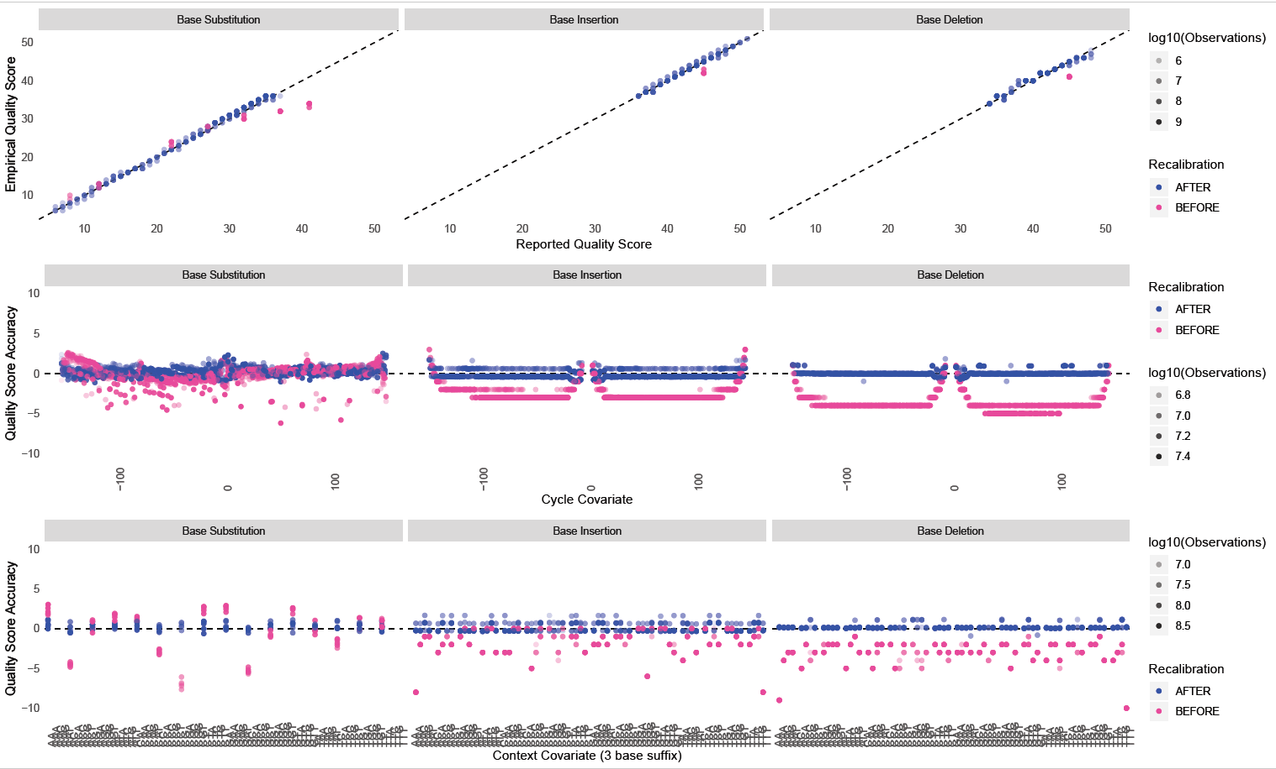
Figure 1. BQSR for an Angus sample (Bos Taurus) using ARS1.2PlusY_BQSR_v3.vcf.gz, --bqsrBAQGapOpenPenalty 45 and the entire genome (2700 Mb) to build recalibration model. Similar results were achieved for Holstein, Hereford, Tuli, Australian Red, Ndama and Jersey samples indicating that the known variant file is sufficent for recalibration of taurus samples.
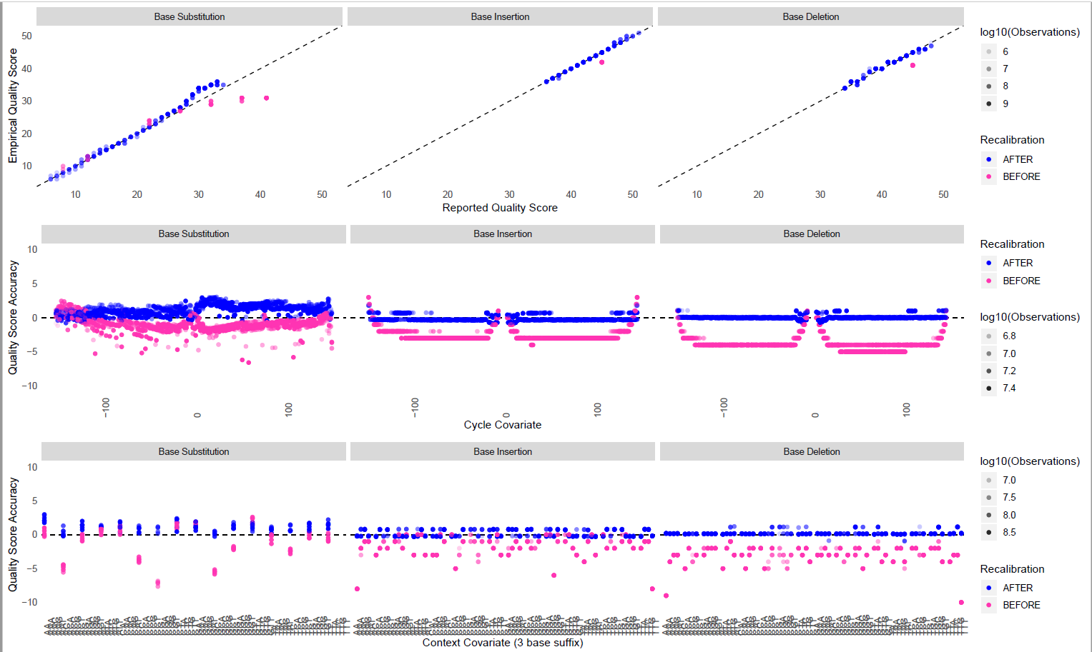
Figure 2. BQSR for an Angus sample (Bos Taurus) using ARS1.2PlusY_BQSR_v3.vcf.gz, --bqsrBAQGapOpenPenalty 40 and the entire genome (2700 Mb) to build recalibration model. Reported v empirical Q scores for base substitutions do not fit the expectation at the higher Q score range.
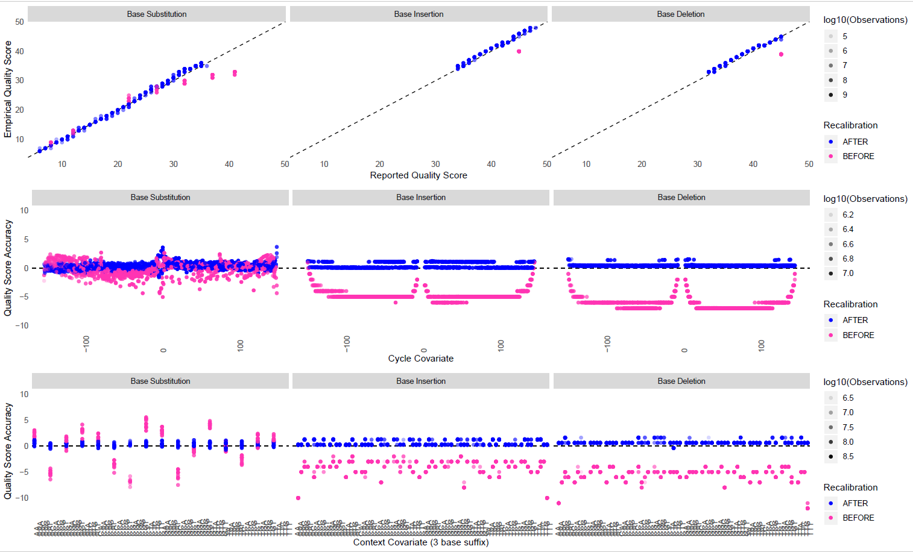
Figure 3. BQSR for a Boran sample (Bos Indicus). Similar results were obtained for Brahman samples indicating that the known variant file is sufficient for recalibration of Indicus samples.
Figure 4 and 5 show the results for tested outspecies samples Bison (Bison bison), Banteng (Bos javanicus), Gaur (Bos gaurus), Gyr (Bos primigenius indicus), Water Buffalo (Bubalus bubalis) and Yak (Bos grunniens). Figure 4 shows that ARS1.2PlusY_BQSR_v3.vcf known variants file and --bqsrBAQGapOpenPenalty 45 has worked effectively for all species. However Figure 5 shows that for Water Buffalo the Q scores have been regressed back so far that the mean q score is now below 20. This is because species such as Water Buffalo are sufficiently diverged from Bos that there are many (potentially millions) fixed differences between Water Buffalo and Bos which are not included in the current known variant file. These fixed differences, are treated as errors by BQSR and have their Q scores significantly scaled back.
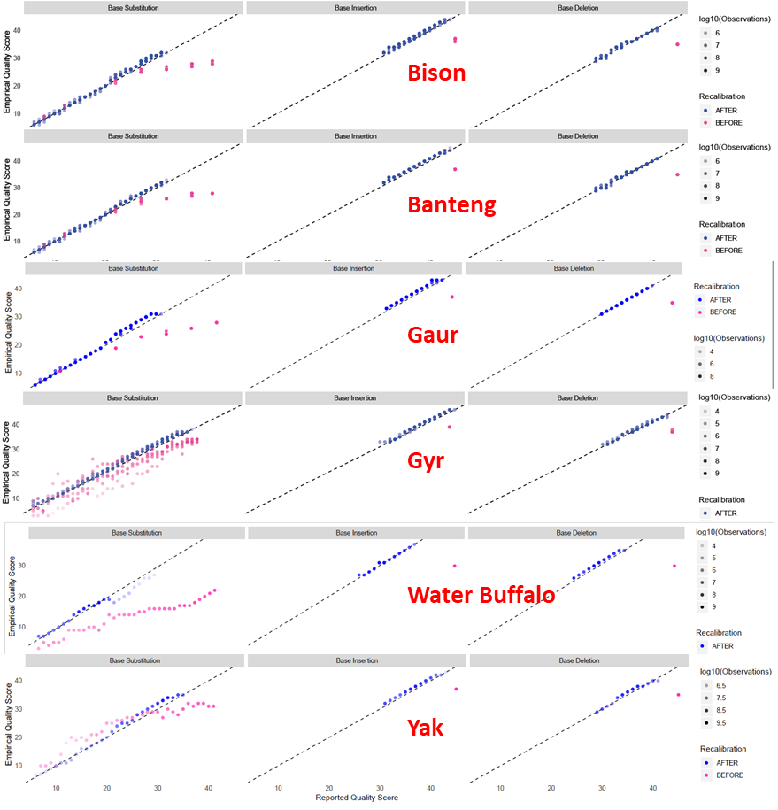
Figure 4. BQSR reported v empirical Q scores results for Bison (Bison bison), Banteng (Bos javanicus), Gaur (Bos gaurus), Gyr (Bos primigenius indicus), Water Buffalo (Bubalus bubalis) and Yak (Bos grunniens) samples demonstrating the effectiveness of the recalibration
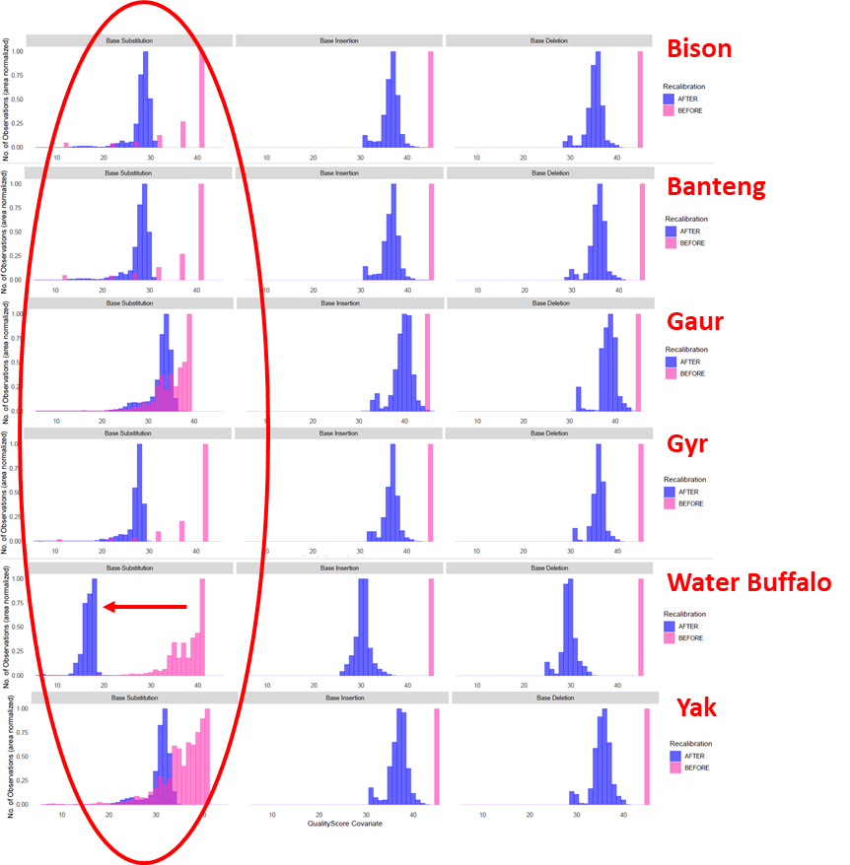
Figure 5. BQSR Q score covariate results for the same Bison (Bison bison), Banteng (Bos javanicus), Gaur (Bos gaurus), Gyr (Bos primigenius indicus), Water Buffalo (Bubalus bubalis) and Yak (Bos grunniens) samples as Figure 4 showing the distribution of Q score covariates. The distributions for base substitutions before and after recalibration show that Q scores for Water Buffalo have been regressed back below 20 indicating that the data were overcorrected due to being significantly diverged from cattle. All other species show acceptable levels of correction.
Contributors should be aware that using the ARS1.2PlusY_BQSR_v2.vcf known variant file will overcorrect outgroup species because outspecies variants are not included. ARS1.2PlusY_BQSR_v3.vcf may also do so if that species has not been included in the variant calling described above. However, you can create your own known variants file for your species, just be sure to check that the Q score covariates are not scaled back too far.

Appendix B: BQSR Using Intervals
Bob Schnabel, June 2018.
For advanced users, please contact Bob if you have questions schnabelr@missouri.edu
Base Quality Score Recalibration can add a non-trivial amount of time to the total time needed to process samples. Everything below assumes that the user has access to a large number of nodes/CPUs and moderately fast storage systems capable of producing I/O >300 MB/sec. At Mizzou, I process one individual on a single node with 64 cores, 512 GB RAM and a 3TB RAID0 of four 1TB SATA disks. By restricting the entire pipeline to a single node and DAS you are able to leverage OS caching for these large files. What is described below will need to be modified and tested/benchmarked for individual environments.
There are two components to the time needed for BQSR, building the model with BaseRecalibrator and PrintReads. Using the entire genome as input to BaseRecalibrator to build the model will produce the best recalibration possible but it comes at the expense of additional runtime. If you “check” your recalibration you will need to run BaseRecalibrator a second time (highly recommended). Therefore, reducing the time needed to build the recalibration model while still achieving accurate recalibration is very beneficial if you are processing many samples. Wall time needed for PrintReads can be reduced by recalibrating each chromosome individually and merging the resulting BAM files back into a single file. While adding the step of merging and sorting adds additional time, given a large number of CPUs and fast storage, the actual wall time needed is substantially reduced compared to doing the entire genome as one job.
The accuracy of the BQSR model is dictated by the amount of data presented to BaseRecalibrator, specifically, the amount of data per read group. Assuming there is enough data, it is possible to use a subset of the genome to build the model, significantly reducing run time. See “Downsampling to reduce run time” here: https://software.broadinstitute.org/gatk/documentation/article.php?id=44 You can see from the figure at the bottom that the RMSE begins to stabilize at 5M reads per read group. In order to test this, I performed a significant number of tests using different sizes of the genome to build the model and compared the results to the full model that used the entire genome. I tested three different subsets of the genome that use 5, 10 or 20 Mb from each of the autosomes and X to build the model that result in using 150, 300 and 600 Mb of the genome. To “check” the model I use three different regions of 5, 10 or 20 Mb that are different from the regions used to build the model. For example, the 5Mb interval list uses position 1Mb to 5 Mb on each chromosome to build the model and positions 5Mb to 10Mb to check the model. By using a small region of each of the chromosomes you minimize the effects any local assembly issues may introduce. By checking the model using a different set of intervals you are essentially “validating” your model using data that was not included in building the model.
The set of intervals to use is determined by the amount of data available per read group which can be approximated based on the size of the BAM file that is used as input. Figure 6 shows the counts of dog and cow BAM files by size available at Mizzou (N=636 total). The cow samples in Figure 6 show two peaks which roughly correspond to samples sequenced to 10X and >20X coverage whereas the dog samples are predominately >20X coverage. Figure 7 shows the linear relationship between BAM file size and average coverage as determined from Picard AlignmentSummaryMetrics.

Figure 6. Counts of cow and dog samples by the size of the BAM file.

Figure 7. The size of the BAM file compared to the average genome coverage of the sample showing a linear relationship between coverage and file size. The red, yellow and green correspond to the UMC thresholds for using a 20, 10 and 5 Mb target interval respectively for BQSR.
Based on these distributions and extensive testing of different target interval sizes, I Identified BAM file size threshold to use for determining which interval set to use for BQSR. BAM files <35 GB generally have coverage <9X and use the 20 Mb interval lists. BAM files between 35 GB and 70GB generally have coverage in the 9-18X range and use the 10 Mb interval lists. BAM files >70 GB generally have coverage over 20X and use the 5 Mb interval lists.
Using an Angus sample with 9X genome coverage as a test case, BQSR was performed using the entire genome, 20 Mb and 5Mb (Figures 8-10). The time required to build the model is shown in Table 1. Note that the 10Mb interval list was not used for recalibration and thus there is not a figure for that test. For this test case, it can be seen that the time required to build the model using 5 Mb is only 5 minutes compared to 120 minutes using the full genome and produces results similar to the full model. For this sample of 9X coverage, the pipeline chooses an interval size of 20 Mb which has almost identical results as the full model but finishes in 14 minutes versus 2 hours. Keep in mind that if you “check” the recalibration you will need to build the model again using the recalibrated data which means that the total time is 28 minutes versus 4 hours for this sample. The PrintReads is not sensitive to the size of the interval used to build the model and for this sample requires about 33 minutes to print the reads (on a per chromosome basis) and an additional 40 minutes to merge the chromosomes back to a single BAM and index. Therefore, using a 20 Mb interval for this sample required a total of 2:35:05 (wall time) to build the model, PrintReads, reassembly BAM and check the recalibration. Using the whole genome to build and check the model took 4:20:38 (wall time). By simply tuning the size of the target interval used to build the model, a user can significantly reduce the total amount of time needed to process hundreds or thousands of samples.
Figure 8. BQSR using the entire genome (2700 Mb) to build recalibration model.
Figure 9. BQSR using 20 Mb target interval from each chromosome (600 Mb total) to build recalibration model and a different 20 Mb interval (600 Mb total) to check the recalibration.
Figure 10. BQSR using 5 Mb target interval from each chromosome (150 Mb total) to build recalibration model and a different 5 Mb interval (150 Mb total) to check the recalibration.
Table 1. Time required to build the recalibration model based on the size of the interval used.
Model | real | user | sys
Genome | 119m29.724s | 1218m23.433s | 2m16.130s
20 Mb | 27m8.469s | 228m57.505s | 0m38.793s
10 Mb | 13m59.878s | 120m5.637s | 0m22.275s
5 Mb | 5m17.058s | 44m33.083s | 0m15.906s

The target intervals and check intervals used at Mizzou are provided and examples of command line calls are shown at the end of this document.

Example commands
Interval files are named based on the size of the region used to build (target) or validate (check) the BQSR models (5, 10, 20, ALL).
Build the model using 5 Mb interval where $ID is the required ID for the sample:
java -Djava.io.tmpdir=/path_to/tmp -XX:ParallelGCThreads=2 -Xmx20g -jar /path_to/GenomeAnalysisTK.jar -nct 24 -T BaseRecalibrator -R /path_to/REF.fa -I $ID.bam -L /path_to/BQSR_5MB_target.interval_list -knownSites /path_to/ARS1.2PlusY_BQSR.vcf.gz --bqsrBAQGapOpenPenalty 30 -o $ID.recalibration_report.grp
Use model to Print reads for chromosome $i:
java -Djava.io.tmpdir=/path_to/tmp -XX:ParallelGCThreads=2 -Xmx20g -jar /path_to/GenomeAnalysisTK.jar -nct 4 -T PrintReads -R /path_to/REF.fa -L $i -I $ID.bam -BQSR $ID.recalibration_report.grp -o $ID.recalibrated$i.bam
Samtools Merge each chr back together based on a file containing the list of individual chromosomes:
samtools merge -@ 10 -f -c -p -b $ID_MergeRealignedRecalibratedFiles.list $ID recalibrated.bam
Samtools index merged BAM:
samtools index $ID. recalibrated.bam
Rebuild recalibration model using the “check” intervals for validation:
java -Djava.io.tmpdir=/path_to/tmp -XX:ParallelGCThreads=2 -Xmx20g -jar /path_to/GenomeAnalysisTK.jar -nct 24 -T BaseRecalibrator -R /path_to/REF.fa -I $ID. recalibrated.bam -L /path_to/BQSR_5MB_check.interval_list -knownSites /path_to/ARS1.2PlusY_BQSR.vcf.gz --bqsrBAQGapOpenPenalty 30 -o $ID.recalibration_report2.grp
Plot recalibration report:
java -Djava.io.tmpdir=/path_to/tmp -XX:ParallelGCThreads=2 -Xmx10g -jar /path_to/GenomeAnalysisTK.jar -T AnalyzeCovariates -R /path_to/REF.fa -before $ID.recalibration_report.grp -after $ID.recalibration_report2.grp -plots $ID.BQSR.pdf

Appendix C: A tip on HaplotypeCaller and threading
Bob Schnabel, June 2018
There is a known issue with threading using GATK when there are a large number of contigs, such as with the unmapped contigs (approx 2000). See https://gatkforums.broadinstitute.org/gatk/discussion/6957/genotypegvcfs-with-draft-quality-reference-genome for discussion related to GenotypeGVCF. The same applies to HaplotypeCaller and the unmapped contigs. The workaround we have found at the University of Missouri is to run HaplotypeCaller on a per chromosome basis using the –L option for each autosome and X, Y, MT. Because each of these chromosomes contains a single contig, you can use the –nct {appropriate number of threads}. We then run the unmapped contigs separately using only a single thread by not specifying –nct. This will significantly reduce the run time for the unmapped contigs. We actually further speed this up by creating many small lists of unmapped contigs that only contain 100 contigs each and run many jobs each using one thread. The resulting GVCF files are then merged using CombineGVCFs, which is very fast. Below is a generalized example.
For chromosomes 1..29,X,Y,MT = {CHR}
GenomeAnalysisTK.jar -nct 5 -ERC GVCF -T HaplotypeCaller -R reference.fa -L {CHR} -I input.bam -o input.{CHR}.g.vcf.gz –[other options]

GenomeAnalysisTK.jar -T CallableLoci -R reference.fa -L {CHR} -I input.bam -summary input.{CHR}.summary.txt -o input.CallableLoci.{CHR}.bed
For the unmapped contigs:
Create a list file containing all of the unmapped contigs named UNMAPPED_contigs.interval_list
NKLS02000031.1
NKLS02000032.1
NKLS02000033.1
NKLS02000034.1 …

create many list files, each with the names of 100 unmapped contigs. These files are named UNMAPPED_contigs{INT}.interval.list where {INT} is just an integer index for the many list files.
For each of the UNMAPPED_contigs{INT}.interval.list, run HaplotypeCaller separately with one thread.
GenomeAnalysisTK.jar -ERC GVCF -T HaplotypeCaller -R reference.fa -L UNMAPPED_contigs{INT}.interval_list -I input.bam -o input.UNMAPPED{INT}.g.vcf.gz –[options]
This will create many g.vcf file that can be combined using the command below where UNMAPPED_contigsMerge.list is a list of the input.UNMAPPED{INT}.g.vcf.gz files.
GenomeAnalysisTK.jar -T CombineGVCFs -R reference.fa -V UNMAPPED_contigsMerge.list -o input.UNMAPPED.g.vcf.gz
And CallableLoci can be run for all the unmapped contigs using:
GenomeAnalysisTK.jar -T CallableLoci -R reference.fa -L UNMAPPED_contigs.interval_list -I input.bam -summary input.CallableLoci.UNMAPPED.summary.txt -o input.CallableLoci.UNMAPPED.bed

