We collected feedback by sending the form out to our family and friends. Overall, our respondents rated our website a 3.7 out of 5. They were impressed by Chieko Asakawa’s contributions, however, some felt that the layout of our website could be more aesthetically pleasing and user friendly. Users also were confused about how to access some of the pages. We graphed the number of users that guessed correctly as to which button they would click to go to certain pages:
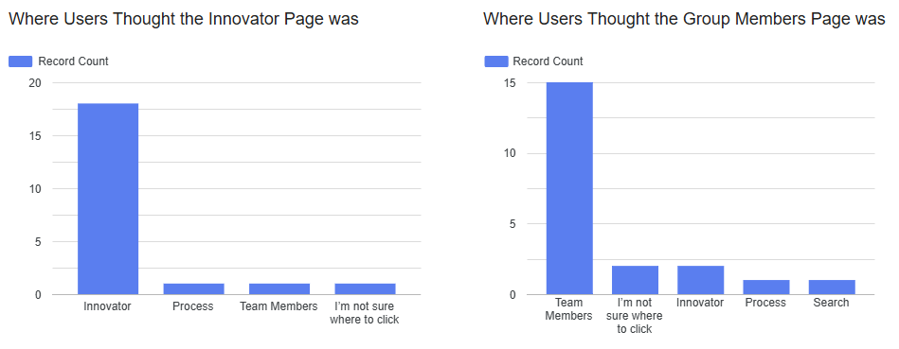We were happy with the success of users being able to find the Innovator Page; however, 25% of users couldn’t immediately find the Team Member Page. We plan to change the name of the button from Team to About Team Members. We also plan to take out some white space on the Team Member page to make it more aesthetically pleasing. We also fixed some linking issues and typos on our pages.

Survey Results: Copy of Website Survey Template - Google Forms
Interview Results: https://hsek12inus-my.sharepoint.com/:w:/r/personal/mastste000_hsestudents_org/Documents/Project Website Feedback.docx?d=w6796f5512ea4429ca045348556c81810&csf=1&web=1&e=kWeBBh
I may prompt you to think aloud if you are quiet.
Innovator- I like the pink and white, it could be more colorful. Make sure images can be visible. Good information. Team page- lines are good to separate, organized, more color. Process page- right information, more CSS and color.
For the first task, I would like you to find who made this website.
[In your notes, write down what they click on; summarize what they are saying]
[Say an appropriate acknowledgment of their work (e.g., "Right - that was challenging to find” or “Terrific work!”)
If they took some time or found it challenging, ask, "How easy was it for you to access this information? or “How can we improve it?"]

She found the team page. And named us all. Said very easy to find it.

For the second task, how would you learn more about the innovator?
[In your notes, write down what they click on; summarize what they are saying]
[Say an appropriate acknowledgment of their work (e.g., "Right - that was challenging to find” or “Terrific work!”)
If they took some time or found it challenging, ask, "How easy was it for you to access this information? or “How can we improve it?”]
[If they were unable to get to the innovator page, click on the innovator page]

She went to the top bar of navigation to find the “Innovator page.” She said it was vvery easy to find the innovator information.

Improvements for innovator page she said she read through all of it and the pictures would guide for more information and going along with the reading if the pictures would show up.

- Great, let’s take a moment here.

  - Who is this innovator?
    - [In your notes, summarize the answer]
    - Chieko Asakawa.
  - [If addressed in the previous question, skip this question, otherwise ask] What are they known for?
        - IBM Braile forum network, creating accessibility for the blind.
    - [In your notes, summarize the answer]
  - What is most memorable about this innovator?
  - Helping the blind.
    - [In your notes, summarize the answer]
  - Is there anything else you would want to know about their contribution?
    - [In your notes, summarize the answer]
Nope, all good she said.
  - How can we improve how we present information about this innovator?
Make sure the pictures show up. Bold some words for it to stand out in the innovator page.
    - [In your notes, summarize the answer]
For the third task, how would you learn more about how the website was created?
[In your notes, write down what they click on; summarize what they are saying]
[Say an appropriate acknowledgment of their work (e.g., "Right - that was challenging to find” or “Terrific work!”)
If they took some time or found it challenging, ask, "How easy was it for you to access this information? or “How can we improve it?”]
[If they were unable to get to the process page, click on the process page]

Deep dive into the innovator page, click on the links to find more about the innovator. Easy to access the information. Then finding how the website was created, clicked on the process page. She said it was easy to click on the different documents with how we created the website.
- Do you have any recommendations for improving how the process is documented?
  - [In your notes, summarize the answer]
CSS layout, make colors match the other pages. Complete the other links that aren’t there.

For the fourth task, how would you get back to the page we started on? [testing navigation to home page]
She said she would use the navigation bar at the top of the website.
Press the top navigation buttons.
[Say an appropriate acknowledgment of their work (e.g., "Right - that was challenging to find” or “Terrific work!”)
If they took some time or found it challenging, ask, "How easy was it for you to access this information? or “How can we improve it?”]
Great. So I have some questions about this website in general.

  - What are your first impressions of the website’s design?
    - [Ask any clarifying questions (e.g., if they critique the website color, ask what color they think it should be)]
    - [In your notes, summarize what they are saying]
  - All info was there, just not pretty to the eye yet. She likes the color scheme of purple and white. Looks great, the pictures just need to show up in the innovator page.
  - Were there any elements of the site that you found confusing or difficult to use?
The pictures were there but not visible in the innovator page.
  - [Can add a specific question the team has (e.g., font size, colors, menu placement)]
  - Is there anything you would suggest to improve the site’s navigation?
No, looks good, they are all linked to each other, and the navigation bars are all the same on the pages.
Closing
- Thank the participant for their time and feedback.
- Summarize what you saw and what they told you. Ask if this is accurate.
  - [In your notes, record their answer]
Overall, every element is there but there needs to be better design style and colors. The pictures also need to show up better rather than just seeing the alt. text. There can be more CSS, but all information is there.
- Ask if there is anything else they would like to add or suggest about the website.
  - [In your notes, summarize the answer]
- [In your notes, record the end time]
She said we checked all the boxes.
End time= 15 minutes and 2 seconds.

Summarization
Need to work on making the website look more cohesive between each page. Also, the pictures need to load for the final website.
Add more CSS to each page, load the pictures on the innovators page, and connect the process page to the innovator page.

