Kinesiology tape: Physiological help or purely in your head?

6 weeks ago I had the unfortunate experience of crashing off my bike during a triathlon. My right hip took a pretty heavy hit (thankfully it saved my carbon bike frame!) but left my hip with considerable swelling and very deep bruising.

I am a big fan of the use of kinesiology tape for aiding muscle function and helping with lymphatic drainage as it helps to create lift, increase blood flow and provide support to tissues. So often though I am asked by clients, “does it really do anything though?” So I wanted to use my unfortunate accident to show that yes, kinesiology tape does work!

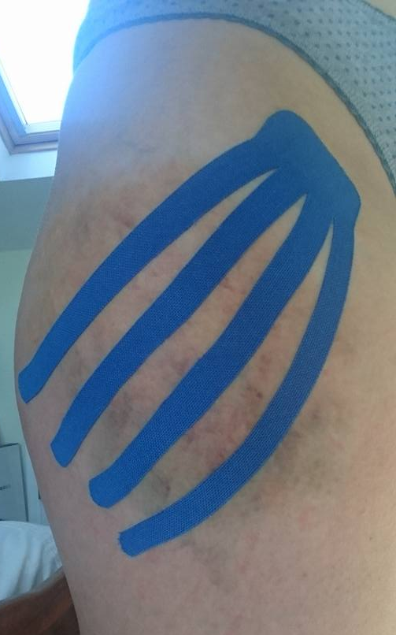
There are several uses for kinesiology tape and therefore many different application types. For this injury, I was using techniques to aid drainage with the hope to reduce swelling and bruising. This was not used in isolation; ice, compression and elevation were also part of the initial treatment programme.

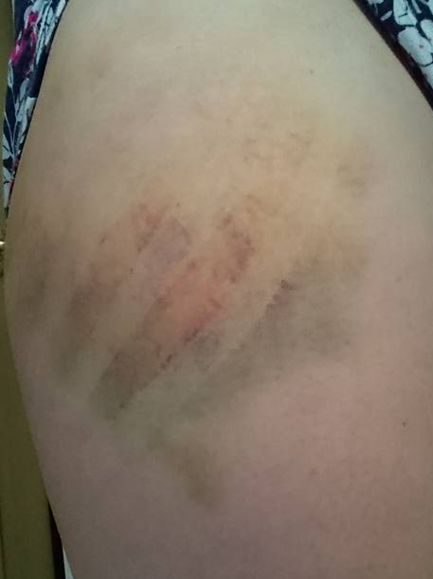
For this technique, an anchor point is used nearest to the lymphatic drainage point in the groin, with fingers of tape placed under tension over the injured area. As the tape tries to recoil back toward the anchor, it draws the bruising with it, helping the swelling and bruising to reduce faster.

After 36hours, the tape was removed. You can clearly see from the patterns where the bruising has reduced where the tape was applied.

This process can be used on any area of the body to aid lymphatic drainage, not just post trauma but also post surgery.

If you have an injury for which you would like to try kinesiology taping, book in with me online today: https://www.comforthealth.co.uk/jenny-buckley/

