# **Brief documentation of Scarlet Spider Game Project**

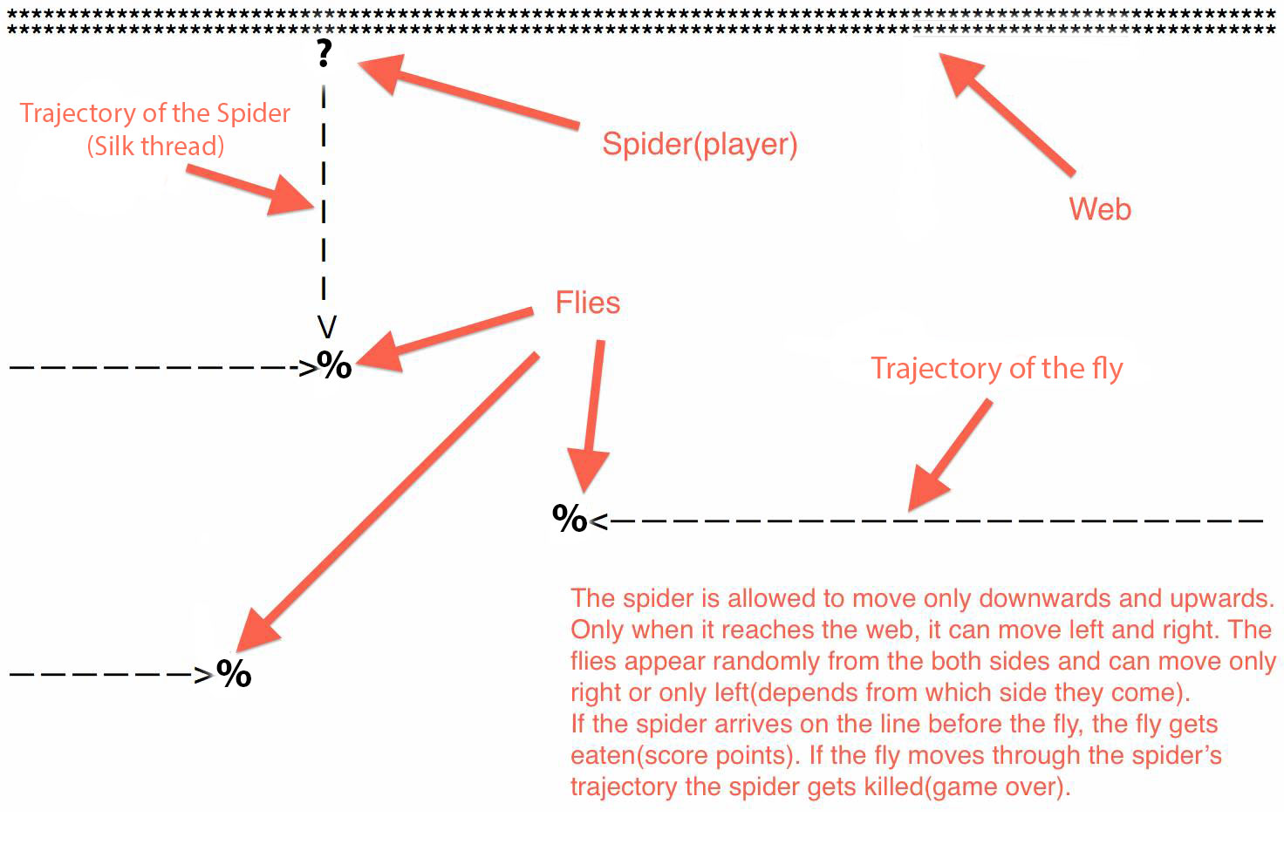

**Team members (username):**

* Plamen Petkov (Plamen_Petkov)
* Tanya Dimitrova (Tanya2013)
* Vasil Stoychev (stoychev.vassil)
* Aleksandar Goranov (agoranov)
* Ivaylo Gashev (gasho)
* Lazar Toshkin (toshkin)

**Scarlet Spider Game explanation**

The gameplay is quite simple. The player is playing as a spider, the aim of the game is to catch as many flies as possible. The first two rows of the console represent the web of the spider (the safe place), also a place where the spider can move in all directions (leftward, rightward, downward and upward). Once the spider is outside of its web it can move only downward and upward by means of very thin silk thread that it produces. The player should be careful when going down for a fly, because other flies that fly in the area above the spider can cut its silk thread which will lead to a fatal end for the little Scarlet Spider.  
  
Every fly give certain amount of points. Some flies give more points than others. It all depends on the color. The only way to catch a fly is to wait for it on the same level as it is until it crashes into the spider. But – don’t forget – Watch your back!

**The game also consists of:**

* Intro with animation
* Main Menu
* Tutorials
* High Scores

*You can see them in the presentation, or better – start the game!

**How we made it?**

**Team and collaboration through TFS**

Our team used **Team Foundation Server** through [codeplex.com](http://codeplex.com) as a source control platform.  
We managed to organize the team with several meetings and a Facebook group.

**The URL of our TFS repository:**

**<https://spiderteam.codeplex.com/SourceControl/latest>**

To connect this project using **Visual Studio** or **Eclipse**, use this URL:

<https://tfs.codeplex.com:443/tfs/TFS25>

To connect using **Subversion**, use this URL:

<https://spiderteam.svn.codeplex.com/svn>

**The game meets the following requirements**

* At least **1 multi-dimensional array**
* At least **3 one-dimensional arrays**
* At least **10 methods**
* At least **3 existing .NET classes**
* At least **2 exception handlings**
* At least **1 use of external text file**