NoName Game

**Basic flow:**

1. Logo
2. Intro
3. Main Menu
4. Select “Play”
5. If first time playing – character creation screen, else list of previous characters for selection along with a button for new character

Characters can be male or female and have one of several skins (blond hair, red hair, etc.)

1. Level selector screen (map)
2. Play level
3. Boss fight
4. Level selector, etc.

**Basic classes (example hierarchy – not final)**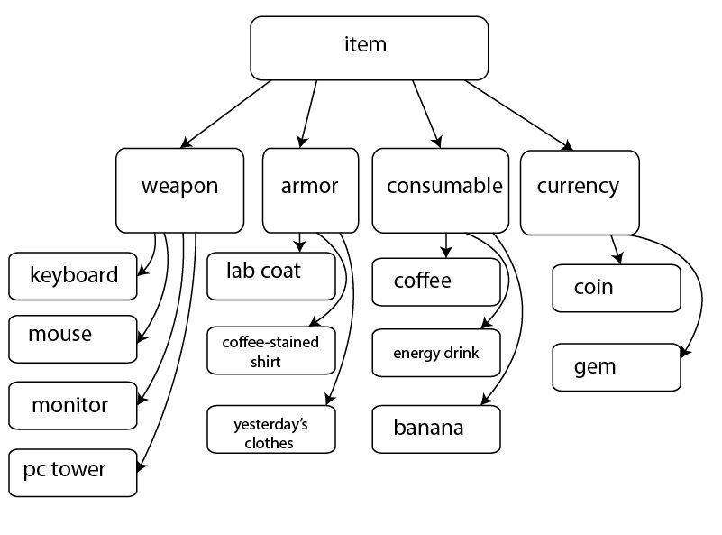

**Example Item interfaces:**

IHealOverTime - Banana

IInstantHeal – Coffee (small heal), EnergyDrink (big heal)

ISpendable – for currency

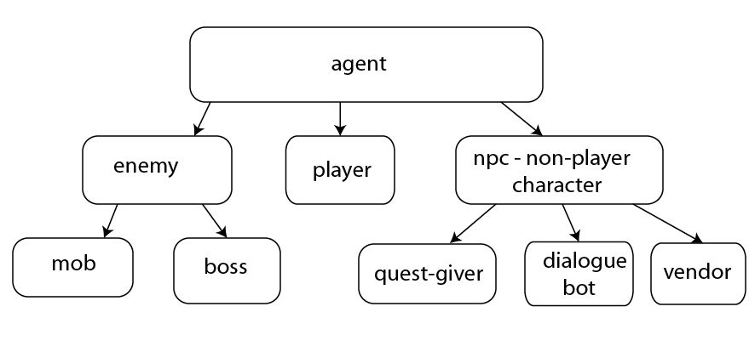

**Example Agent interfaces:**

IMortal – for players, mobs and bosses only. Npcs can’t die

IChattable – for dialogue bots and quest givers, some vendors may also have some dialogue lines

IMercantile – for npcs that can trade items (vendor)

**Example player skills:**

1. “Hack” – hit an enemy with a weapon
2. “HandleExceptions” – explosion killing all enemies in a certain radius around player, only available at high xp levels
3. “Compile” – jump to a selected location, killing enemies at and around the target spot, can have cooldown

**Player:**

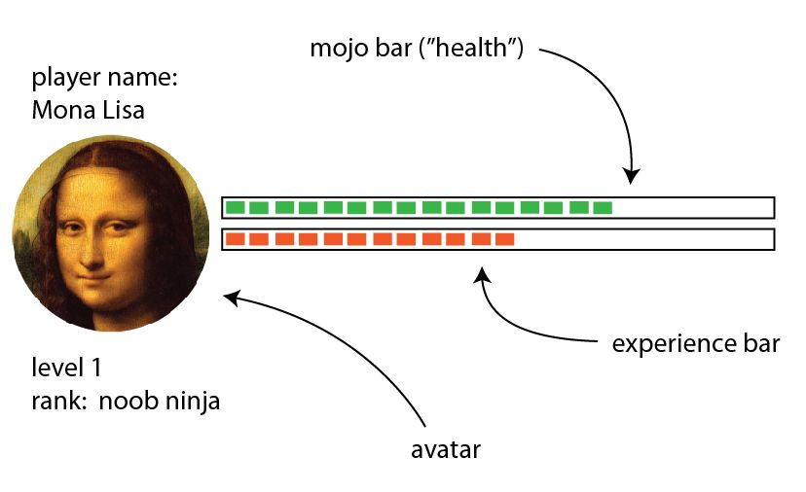

**Player levels and ranks:**

level 1 – noob ninja

level 2 – ninja disciple

level 3 – ninja acolyte

level 4 – master ninja

level 5 – grandmaster ninja

Level-up is attained through amassing enough experience points. New levels and ranks unlock more powerful skills and automatically increase player stats – dps, total mojo, mojo regen rate, etc.

Some of the other ideas we discussed included inventory, trade, collecting items from fallen enemies, boss fights.