Academic inbreeding – preliminary results
Rusinov & Stoylov*
*NBU, Department of informatics
- Staff and administrative composition of academic inbreeding at FEBA
In dark blue a person is considered inbred if he obtained his PHD from FEBA (not Sofia university but the Faculty specifically). In light blue is the “Silver corded correction” – i.e. someone is not counted as inbred if it took him more than one year to return back to FEBA post PHD defense.

- Productivity regressions
Time_from_phd_to_FEBA is defined as the difference between the date of the PHD award and the first hiring of the individual inside of the institution.
Dep. Variable log(Scopus_all + 1) | (1) | (2) | (3) | (4) | (5)
Academically inbred | -0.691***  (0.267) | -0.288  (0.310) | 0.074  (0.294) | -0.069  (0.302) | -0.373  (0.273)
Time_from_phd_to_FEBA |  | -0.0001**  (0.00004) | -0.00004  (0.00005) | -0.00001  (0.00004) | 0.00004  (0.00004)
Academic title (ref. category assistant)
Chief assistant |  |  | 0.921***  (0.296) | 0.618*  (0.327) | 0.406  (0.256)
Associate professor |  |  | 1.296***  (0.281) | 0.886***  (0.269) | 0.344  (0.226)
Professor |  |  | 2.139***  (0.377) | 1.910***  (0.349) | 1.155***  (0.417)
Department (ref
Econometrics and statistics |  |  |  | 1.521***  (0.321) | 0.724**  (0.308)
Economics |  |  |  | 0.399  (0.318) | -0.140  (0.267)
Economics and sectorial governance |  |  |  | 0.439  (0.329) | -0.010  (0.287)
Finance and accounting |  |  |  | -0.100  (0.332) | -0.152  (0.242)
SciVal estimated calculations ( based on % of all Scopus publications)
International collaborations |  |  |  |  | 1.496***  (0.519)
national collaboration |  |  |  |  | 1.692**  (0.684)
institutional collaboration |  |  |  |  | 1.600***  (0.361)
Constant | 1.852***  (0.208) | 1.550***  (0.248) | 0.210  (0.294) | 0.148  (0.294) | 0.464  (0.298)
Observations | 83 | 81 | 81 | 81 | 81
R² | 0.080 | 0.117 | 0.337 | 0.540 | 0.718
Adjusted R² | 0.068 | 0.094 | 0.293 | 0.482 | 0.669

- Inbreeding determinants
All regressions were performed using binary logistic regression.
Variable: Probability of being inbred | (1) | (2) | (3) | (4) | (5)
log(Scopus_all + 1) | -0.491**  (0.196) | -0.358  (0.219) | -0.026  (0.261) | -0.149  (0.304) | -0.689*  (0.411)
Time_from_phd_to_FEBA < 365 days |  | -2.119***  (0.578) | -1.950***  (0.616) | -1.978***  (0.627) | -2.138***  (0.714)
Academic title
Chief assistant |  |  | -1.611  (1.212) | -1.506  (1.231) | -1.458  (1.242)
Associate professor |  |  | -1.405  (1.212) | -1.341  (1.222) | -1.486  (1.236)
Professor |  |  | -3.277**  (1.405) | -3.026**  (1.426) | -3.132**  (1.475)
Department
Econometrics and statistics |  |  |  | 0.362  (0.972) | 0.220  (1.065)
Economics |  |  |  | -0.110  (0.888) | -0.553  (0.953)
Economics and sectorial governance |  |  |  | -0.247  (0.856) | -0.638  (0.902)
Finance and accounting |  |  |  | -0.566  (0.935) | -0.522  (0.955)
International collaboration |  |  |  |  | 1.736  (1.575)
Only national collaboration |  |  |  |  | 1.574  (1.661)
Only institutional collaboration |  |  |  |  | 2.782**  (1.290)
Constant | 0.954**  (0.378) | 2.152***  (0.586) | 3.233***  (1.155) | 3.427***  (1.216) | 3.639***  (1.249)
Observations | 83 | 81 | 81 | 81 | 81

Variable: Probability of being inbred | (1) | (2) | (3) | (4) | (5)
log(Scopus_all + 1) | -0.491**  (0.196) | -0.182  (0.237) | 0.092  (0.272) | -0.072  (0.312) | -0.779*  (0.448)
Time_from_phd_to_FEBA (days) |  | 0.0005***  (0.0001) | 0.0004***  (0.0001) | 0.0004***  (0.0001) | 0.0005***  (0.0001)
Academic title
Chief assistant |  |  | -1.496  (1.194) | -1.329  (1.210) | -1.195  (1.224)
Associate professor |  |  | -1.476  (1.192) | -1.367  (1.199) | -1.502  (1.217)
Professor |  |  | -2.834**  (1.414) | -2.424*  (1.448) | -2.178  (1.543)
Department
Econometrics and statistics |  |  |  | 0.445  (1.035) | 0.417  (1.165)
Economics |  |  |  | -0.244  (0.931) | -0.717  (1.022)
Economics and sectorial governance |  |  |  | -0.470  (0.908) | -0.901  (0.983)
Finance and accounting |  |  |  | -0.853  (0.949) | -0.929  (0.978)
International collaboration |  |  |  |  | 2.193  (1.615)
Only national collaboration |  |  |  |  | 2.273  (1.940)
Only institutional collaboration |  |  |  |  | 3.283**  (1.404)
Constant | 0.954**  (0.378) | 0.865**  (0.425) | 1.985*  (1.061) | 2.298**  (1.168) | 2.413**  (1.193)
Observations | 83 | 81 | 81 | 81 | 81

- Time from PHD to first appointment
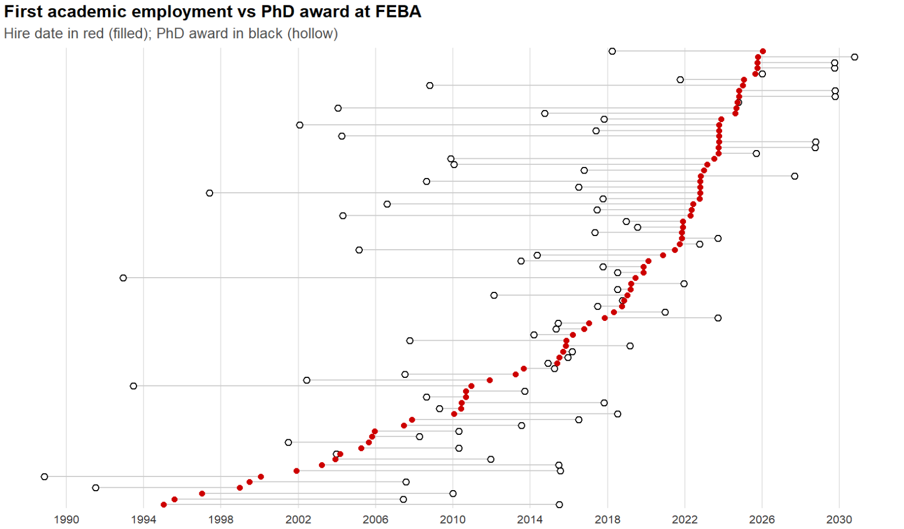

- The effects of the assistant professor reforms post 2010

After 2010, under Bulgarian law, assistants couldn’t stay more than 5 years inside an institution without first obtaining a PhD. This represents a pseudo quasi experimental design – i.e. the academic job market is structurally “shocked”, hence we will investigate the reaction here systematically.

Hiring delay
To analyze hiring dynamics, I construct a measure of time between doctoral completion and first employment:
$$Delay_{i}=Hire _Date_{i}-PhD_Date_{i}$$
The variable is measured both in days and years:
$$Delay Years_{i}=\frac{Hire Date_{i}-PhD Date_{i}}{365}$$

Negative values occur when individuals are hired before formally receiving the PhD. In 2010 Bulgaria introduced a regulatory constraint limiting the period during which individuals can remain in assistant academic positions without a completed doctorate. Individuals graduating after 2010 were exposed to this constraint. A treatment indicator is therefore defined as:
$$Post{2010}_{i}=\left\{\begin{aligned}1 if PhD year≥2010 \\ 0 otherwise \end{aligned}\right.$$
To test whether the 2010 regulation altered hiring behavior, I compare hiring delays across cohorts:
$$Delay Years_{i}=γ_{0}+γ_{1}Post{2010}_{i}+u_{i}$$
and:
$$Delay Years_{i}=γ_{0}+γ_{1}Post{2010}_{i}+Γ_{i}W_{i}+u_{i}$$
where W_{i} includes department and rank fixed effects. The coefficient γ₁ measures the change in average time to first academic appointment for cohorts exposed to the reform.
Because the outcome of interest is the timing of an event (first academic employment), I estimate a duration model using the Cox proportional hazards specification:
$$h\left(t ∣ X_{i}\right)=h_{0}\left(t\right)exp(δ_{1}Post{2010}_{i}+δ_{2}Department_{i})$$
where:
- h(t) is the instantaneous probability of being hired at time t after PhD completion
- h0(t) is the baseline hazard
The hazard ratio e^{δ1}​ indicates whether exposure to the post-2010 institutional regime increases the probability of employment at any point in time.
This model is appropriate because hiring occurs once per individual and the object of interest is the waiting time until employment.
