Assessing academic inbreeding in CEE – the case of Bulgaria
Stoycho Rusinov
Iliyan Vasilev

- Introduction
Academic inbreeding, defined as institutional inbreeding (Horta, 2013), commonly refers to the malign recruitment practices of universities to hire their own doctoral graduates as faculty members, who subsequently remain within the same institution throughout their whole academic careers. This phenomenon was identified early in 1960s, when Bernard Berelson first described it as the tendency of universities to hire “their own doctoral students after graduation, who subsequently remain at the institution to work for their entire careers” (Berelson, 1960).
This manuscript examines the drivers and consequences of academic inbreeding in Central and Eastern Europe. Focusing on Bulgaria, we exploit the country’s relatively high data availability to construct population-based measures of academic inbreeding for three faculties at Sofia University St. Kliment Ohridski – the Faculty of Pedagogy, the Faculty of Physics and Astronomy, and the Faculty of Economics and Business Administration (FEBA) – as well as for New Bulgarian University (NBU), which serves as a reference case.
We conduct regression analysis for two of the four units (NBU and FEBA) because both institutions were established in the 1990s (approximately 30 years prior to the time of writing). At inception, their levels of inbreeding were, by definition, zero. Consequently, any subsequent accumulation of inbreeding reflects hiring decisions made over time rather than inherited institutional structures. Their relatively recent establishment also implies more balanced samples, as academic staff have had less time to reproduce themselves internally. This results in greater variation in the inbreeding indicator, allowing for more informative analysis with respect to key covariates such as time from PhD completion to first appointment and the logarithm of Scopus-indexed research productivity.
Particular attention is devoted to the relationship between the probability of inbreeding (Pr(Inbred hire)) and the time elapsed between PhD completion and first employment at the institution. This relationship is central to the paper’s argument because if faster hires are systematically more likely to be inbred, then inbreeding cannot be understood solely as a preference-based phenomenon. Instead, it may reflect a form of labor market failure, whereby risk-averse institutions minimize search costs by relying on internal candidates. In this sense, inbreeding can be understood as structurally induced outcome of a dual-track hiring system that systematically lowers the costs of internal recruitment while limiting external competition.
Empirically, we show that inbred academic staff exhibit lower research productivity on average in FEBA and NBU. However, this relationship is not uniform across institutions. For example, the Faculty of Physics and Astronomy, where inbreeding reaches approximately 76.6% of all academic staff members, exhibits the highest research productivity in the country. In contrast, the Faculty of Pedagogy, with inbreeding levels approaching 98%, displays substantially lower productivity, with some staff lacking even a single Scopus-indexed publication.
Finally, we situate the Bulgarian evidence within a broader comparative framework by constructing an “Academic Openness Index.” If academic inbreeding is partially driven by labour market dynamics, it should also have macro-level manifestations. This index allows us to explore how national academic systems differ in their openness and how these differences relate to patterns of inbreeding. Most importantly, analysing the specifics of the Bulgarian context allows us to adopt this country as the baseline, reference category in the macro comparisons – especially within the underexplored region of CEE.
- Context
- Academic inbreeding in the broader literature
Early research on academic inbreeding presents a range of perspectives, including both critical and more nuanced aspects of interpretations of its impact on academia. Notably, Theodore Caplow and Reece J. McGee (1958) acknowledged that, despite its potential drawbacks, academic inbreeding may produce certain institutional benefits, such as “continuity of organizational culture, stability”, and the preservation of established academic traditions. The empirical contributions by Stephen Wyer and Clifton F. Conrad (1984), as well as Lowell L. Hargens and G. M. Farr (1973), further explored the relationship between academic inbreeding and faculty performance. These studies based on the first broader empirical observations, affirm that the effects of inbreeding are context-dependent and not uniformly and categorically negative. Critically analysed by Horta (2013), much of this earlier research tended to generalize findings “with no limitation,” lacking sufficient consideration of structural, institutional, and disciplinary variations.
A second, more critical perspective presented in researches on academic inbreeding interrogates its structural logic and its consequences for the epistemic development of scientific activity. From this viewpoint, the systematic recruitment of an institution’s own doctoral graduates operates not just as a personnel practice, but as a mechanism of epistemic reproduction that stabilizes existing knowledge regimes, “methodological orientations, and institutional hierarchies” (Yamanoi, 2005). This can have positive effects but in the limited cases of early scientific development (cite). Individuals trained and employed within the same institutional environment tend to internalize and circulate locally embedded forms of knowledge, which they subsequently transmit to colleagues and students, thereby reinforcing established epistemic patterns (McNeely, 1932). However, rarely are network-based approaches utilized to analyse the phenomena. This is a positive future direction where the scraped databases used here can be repurposed and utilized to generate new insight.
One of the most noticeable side effects of academic inbreeding is the loss of scientific mobility (cite ERA report, and some other paper on inbreeding). Thus, academia becomes characterized by a form of epistemic closure, in which alternative perspectives, methodological pluralism, and critical reflexivity are structurally marginalized. Padilla (2008) observes that in systems with high levels of academic inbreeding, institutional loyalty tends to supersede commitment to the broader scientific community. This shift reflects a deeper transformation in the normative orientation of academic actors – from participation in an open, trans-institutional knowledge system toward embeddedness in localized, self-referential organizational structures. This process implies the national proliferation of academic inbreeding across the entire affected country, hence a consequence of the phenomena may be low international collaboration networks, low mobility and negative flows of scientist in the affected countries.
Academic inbreeding can be understood as contributing to the fragmentation of the scientific field and the weakening of its fundamental universalistic aspirations. Although some organizational perspectives highlight functional advantages such as reduced recruitment costs, lower uncertainty in hiring decisions, and the preservation of institution-specific knowledge (Bean et al., 1996; McGee, 1960; Camerer & Vepsäläinen, 1988). Such arguments tend to reflect institutional policies that prioritizes efficiency and stability over epistemic reflexivity and creativity. This may turn into a risk, transforming universities into self-reproducing systems that privilege predictability and control at the expense of innovation and critical inquiry. In such cases precise micro, meso and macro measurements become crucial to understand how the academic closure of a given system may affects the system innovation potential indicators and other related structural characteristics related to growth and prosperity of the nation.
- Academic inbreeding in the CEE
- Methods and data
- Micro and meso level measurement
For the data component, we exploit the Bulgarian NACID database. In Bulgaria, under the Law on the Development of Academic Staff in the Republic of Bulgaria (LDASRB) and its implementing regulations, academics are required to maintain publicly accessible records of their educational background and academic employment in the NACID register. Using scraping algorithms, we extract this information into a structured dataset to estimate models of the form:
$$Pr(Inbred)=Λ(α+β⋅Time from employment to PhD+θ⋅\log{(Scopus output+1)}+γ'X)$$
where we model the probability of internal hiring (inbreeding) as a function of the time between PhD completion and first academic appointment, research productivity (log Scopus publications), and additional controls including gender, department fixed effects, academic rank, and the share of internationally co-authored publications.
A key explanatory variable is the time from employment to PhD. The appointment of assistant professors at Sofia University “St. Kliment Ohridski” is governed by the Regulations on the Conditions and Procedures for Acquiring Academic Degrees and Holding Academic Positions, which establish two distinct entry routes. Under Article 87(1) and Articles 88–94, assistant positions are filled through open competition with public announcement, standardized application procedures, and examination-based ranking. In parallel, Article 87(2) allows for direct temporary appointment, without competition, of doctoral candidates who have completed training but not yet defended their dissertation, upon internal nomination and rectoral approval, for up to two years. This dual structure implies that some individuals may enter academic employment prior to completing the PhD and before participating in formal competition, making the time between PhD completion and first appointment a meaningful proxy for distinguishing between entry through competitive versus internal appointment channels.
Once we obtain the databases academic inbreeding is estimated on several levels:
- Faculty level - percentage of all internal hires over the entire composition of the academic staff in a given faculty.
- Department level measures – within each faculty the percentage of academic staff members that graduated the same faculty
- University level measures – within the same university the percentage internal academic staff members.
In Bulgaria a staff member can only be someone who is appointed as an assistant, chief assistant or professor.
- Macro level measurement
In the context of modern science, distinguishing between different forms of inbreeding based on mobility patterns is crucial. A useful differentiation can be made between “pure” inbred academics (“settle inbreds” authors’) with training and professional experience entirely confined to a single institution and “mobile” inbred academics (“movebreds” authors’), ultimately being employed by their alma mater, with accumulated experience in other institutional settings during their doctoral or postdoctoral stages. This distinction is crucial, as mobility is widely associated with enhanced research quality, broader collaboration networks, and increased scientific impact (Dillon, 2003; Dietz & Bozeman, 2005). The net negative effects are attributed to academic inbreeding broadly linked to low levels of academic mobility, so reduced mobility rather than inbreeding per-se may be the underlying factor associated with lower scientific productivity Dutton (1980). For that reason using OECD cross-country level data we argue that key dimensions of academic inbreeding on systemic levels are captured by multiple proxies of mobility:
- Mobile doctorate graduates (Mobile_dct_grad)
- International net flows of scientific authors (Net_flows)
- Percentage of international scientific collaboration (pct_int_coll)
- Total number of researchers (Total_researchers)
All variables refer to the most recent available year for each country. To ensure cross-country comparability, absolute counts are normalized by the total number of researchers. This controls for differences in country size and research system scale:
$$Mobile_per_ {1000}_{i} = \left(\frac{Mobile_dct_grad_{i}}{Total_researchers_{i}}\right)/1000$$
$$Flows_per_{1000}_{i} = \left(\frac{Net_flows_{i}}{Total_researchers_{i}}\right)/1000$$
The international collaboration variable is already expressed as a percentage and is therefore not normalized. To combine variables measured in different units, all indicators are standardized using z-scores:
$$Z_{k,i} =\frac{\left(X_{k,i} -\overline{X_{k}}\right)}{sd\left(X_{k}\right)}$$
where k indexes indicators and i indexes countries. The Academic Openness Index is constructed as the average of standardized indicators:
$$Openness_{i}=\frac{Z_mobile_{i} + Z_flows_{i} + Z_collab_{i}}{3}$$
Higher values of the index indicate more open academic systems characterized by greater researcher mobility, positive international flows and higher levels of international collaboration. Lower values indicate more closed systems, often associated with academic inbreeding and limited external circulation. This measurement is important as in closed environments, institutional practices and epistemic frameworks are continuously reproduced, leading to scientific and academic stagnation and diminished adaptability in the face of global academic transformations (Altbach, 2000; Yudkevich et al., 2015). Comparative analyses indicate that universities with more open recruitment systems and higher levels of academic mobility tend to achieve “stronger research outcomes and greater international visibility” (Aghion et al., 2010). Consequently, addressing academic inbreeding is not merely a matter of human resource policy, but a fundamental challenge linked to the epistemic vitality and global competitiveness of contemporary universities.
- Results
- Academic inbreeding as market-based outcome
Figure 1. Factors associated with inbred hiring at FEBA (N=81, consisting of all 4 active departments)
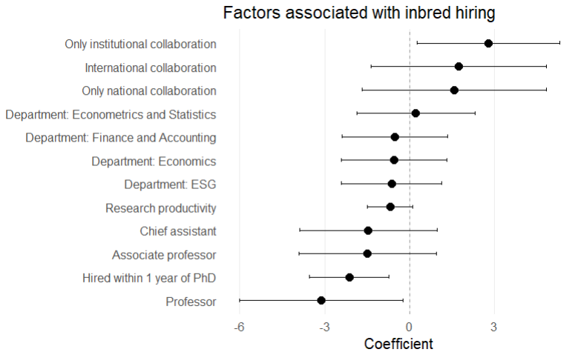
Note: “Time from PhD to hiring” is defined as the difference between the PhD completion date and the first appointment at the institution. Positive values indicate hiring prior to PhD completion, while negative values indicate hiring after PhD completion. A binary indicator is constructed equal to 1 if the time difference is less than one year (in absolute terms), and 0 otherwise. For assistants who haven’t yet obtained their PhDs the date of their hire was multiplied by 4*345 days, because by Bulgarian law they cannot hold this position for more than 5 years.
The results for FEBA indicate that academic inbreeding is strongly associated with rapid entry into academic employment, suggesting that internal candidates are absorbed through non-competitive or weakly competitive channels. The coexistence of competitive and non-competitive hiring channels (as discussed earlier) creates a structurally embedded pathway for internal candidates, reducing uncertainty for institutions while simultaneously limiting openness. At the same time, higher research productivity reduces the likelihood of inbreeding, consistent with a trade-off between expected output and hiring uncertainty. The presented findings support the interpretation of inbreeding as a cost-minimizing equilibrium in academic labor markets rather than purely a normative deviation.

Table 1. Scopus output (2015-2022) per FORD discipline for Sofia University and New Bulgarian University.
 | Sofia University |  |  | NBU
 | Physical science | Education | Economics and business | All
Total output | 3455 | 211 | 303 | 825
Authors | 943 | 186 | 240 | 284
Papers per author | 3,66 | 1,13 | 1,26 | 2,90
% collaborations with external structures
% International collaboration | 71% | 23% | 23% | 41%
% Only national collaboration | 15% | 21% | 18% | 28%
% Only institutional collaboration | 9% | 15% | 18% | 7%
% Single authorship | 5% | 41% | 41% | 24%
Percentage of publications by quartiles (CiteScore)
Q1 | 62% | 18% | 13% | 32%
Q2 | 14% | 9% | 18% | 21%
Q3 | 10% | 34% | 40% | 18%
Q4 | 14% | 39% | 29% | 30%
Percentage inbreeding | 76,6% | 98% | 58% | 43%
Note: The table reports research output, collaboration patterns, publication quality (CiteScore quartiles), and academic inbreeding across disciplines classified according to the Fields of Research and Development (FORD) taxonomy using SciVal data. Output is based on Scopus-indexed publications. Collaboration indicators refer to the share of publications co-authored with international, national, or institutional partners.
Table 1 reveals substantial variation across disciplines, indicating that the relationship between academic inbreeding and research performance is strongly field-dependent. In physical sciences, high levels of inbreeding coexist with strong research performance, reflecting high levels of international collaboration and integration into global research networks. In contrast, education exhibits both extreme inbreeding and weak research performance, accompanied by low international collaboration and high levels of single authorship, consistent with a closed and locally embedded knowledge system. Economics and business display a similar pattern of moderate inbreeding combined with limited international integration and weak performance. By contrast, the reference case of NBU, characterized by lower inbreeding and greater openness, demonstrates stronger research outcomes. These findings suggest that the negative effects of academic inbreeding are not inherent but emerge primarily in closed systems with limited external engagement.
- The Academic openness index
Figure 2. Academic openness index by Country.
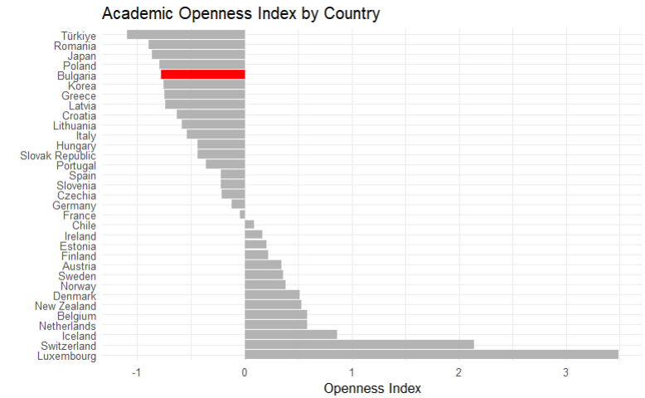
Note: The Academic Openness Index is constructed as the average of standardized indicators capturing researcher mobility, international scientific collaboration, and net flows of scientific authors. Higher values indicate more open academic systems, while lower values indicate more closed systems characterized by limited mobility and stronger internal reproduction. Bulgaria is highlighted for reference.
The distribution of the Academic Openness Index reveals a clear regional pattern, with Central and Eastern European countries consistently occupying the lower end of the openness spectrum. Bulgaria is positioned firmly within this cluster, alongside countries such as Romania and Poland, indicating that low academic openness is not an isolated national feature but part of a broader regional equilibrium. In contrast, Western and Northern European countries exhibit substantially higher levels of openness, reflecting greater researcher mobility, stronger international collaboration, and more permeable academic labor markets.
Figure 3. Academic openness index by Country.

Note: The Academic Openness Index measures the degree of mobility, international collaboration, and cross-border flows of researchers in national academic systems. Innovation performance is proxied by the WIPO Global Innovation Index rank (lower values indicate better performance). The dashed line represents the fitted linear relationship between academic openness and innovation rank.
Figure 3 reveals a clear negative relationship between academic openness and innovation rank, indicating that more open academic systems tend to achieve substantially stronger innovation outcomes. Countries in Central and Eastern Europe cluster in the low-openness, low-performance region of the distribution, while highly open systems such as those in Northern and Western Europe consistently exhibit superior innovation performance. Although some outliers exist, the overall pattern supports the interpretation that academic openness constitutes an important structural determinant of national innovation capacity.

References

Padilla, L. E. (2008). How have Mexican faculty been trained? A national perspective and a case study. Higher Education, 56, 167–183. Pelz, D. C., & Andrews, F. M. (1966). Scientists in organizations. New York: Wiley.
Dietz, J. S., & Bozeman, B. (2005). Academic careers, patents, and productivity: Industry experience as scientific and technical human capital. Research Policy, 34, 349–367.
Dillon, N. (2003). The postdoctoral system under the spotlight: A European Union Directive regulating fixed-term contracts has focused attention on scientific career structures and could have long-term effects on European science. EMBO Reports, 4(1), 2–4.
Dutton, J. E. (1980). The impact of inbreeding and immobility on the professional role and scholarly performance of academic scientists. Paper presented at the annual meeting of the American Educational Research Association, Boston, pp 7–11, April 1980.
Berelson, B. (1960). Graduate education in the United States. New York: McGraw-Hill.
Caplow, T., & McGee, R. (1958). The academic marketplace. New York: Doubleday
McGee, R. (1960). The function of institutional inbreeding. The American Journal of Sociology, 65(5), 483–488.
Hargens, L. L., & Farr, G. M. (1973). An examination of recent hypotheses about Institutional Inbreeding. The American Journal of Sociology, 78(6), 1381–1402.
Altbach, P. G. (2000). The changing academic workplace: Comparative perspectives. Boston College Center for International Higher Education.
Aghion, P., Dewatripont, M., Hoxby, C., Mas-Colell, A., & Sapir, A. (2010). The governance and performance of universities: Evidence from Europe and the U.S. Economic Policy, 25(61), 7–59. https://doi.org/10.1111/j.1468-0327.2009.00238.x
Cruz-Castro, L., & Sanz-Menéndez, L. (2010). Mobility versus job stability: Assessing tenure and productivity in Spain. Research Policy, 39(1), 27–38. https://doi.org/10.1016/j.respol.2009.11.008
Horta, H. (2013). Deepening our understanding of academic inbreeding effects on research information exchange and scientific output. Higher Education, 66(4), 487–510. DOI 10.1007/s10734-012-9559-7
Horta, H., Veloso, F., & Grediaga, R. (2010). Navel gazing: Academic inbreeding and scientific productivity. Management Science, 56(3), 414–429
Yudkevich, M., Altbach, P. G., & Rumbley, L. E. (Eds.). (2015). Academic inbreeding and mobility in higher education: Global perspectives. Palgrave Macmillan.

