The Brexit Tuition Shock and the Price Elasticity of International Students
Evidence from a Natural Experiment
Online appendix
Stoycho Rusinov and James Rafiki Aketch

A1. Control-group construction
The analysis uses UCAS applicant counts by origin country and application cycle. Treated origins are European Union countries excluding Ireland, and candidate donors are non-EU origins. For each country c, the outcome is the natural logarithm of the applicant count. The pre-reform window covers 2014-2020 and contains seven observations per country.
Y_{ct} = ln(App_{ct})
Donors are selected on the shape of the pre-reform trajectory instead of the level of applications. Each logged series is standardized within country over 2014-2020. Pairwise Euclidean distances are then calculated between the standardized paths, and every treated origin is matched to the three non-EU paths with the smallest distances. This step removes the mechanical influence of market size while retaining the timing and direction of pre-reform movements.
z_{ct} = (Y_{ct} - mean_{c}) / s_{c}
After donor selection, estimation returns to logged levels. For each treated origin j, nonnegative donor weights that sum to one minimize pre-reform squared prediction error. Country-specific weights are set to zero outside the relevant three-country pool, averaged across the 26 treated origins, and normalized. The final normalization changes the weights only up to floating-point precision. The procedure follows the synthetic-control principle of choosing a transparent weighted comparison path before estimating post-reform effects (Abadie et al., 2010; Abadie & Cattaneo, 2018).
The resulting global donor weights enter the saturated difference-in-differences regression as fixed observation weights. Treated observations receive unit weight, and donor weights are multiplied by 26 so that the treated and control sides carry equal total weight. The specification includes country and cycle fixed effects and the time-varying controls described in the manuscript. Donor selection and weighting use only pre-treatment outcomes.

A2. From post-reform effects to price elasticities
Clifton-Sprigg et al. (2025) derive a mechanical elasticity from a synthetic-DiD average treatment effect. To state the structural
assumptions needed for the present transformation, consider a segmented constant-elasticity demand system indexed by origin jj and year tQj,tjPj,tjt.
logQj,t=μjLet Qj,t denote applicants from origin j and Pj,t the effective price they face. A signed country-specific elasticity model is
logQj,t=μj+δt-ηjlogPj,t+Xj,t' θ+ηjlogPj,t+Xj,t'θ+εj,t.
where:
- μjμj are country fixed effects, or time-invariant demand shifters;
- δtδt are year fixed effects, including common shocks;
- Xj,t'X′j,t is a vector of observed controls;
- ηjηj < 0 is the signed demand elasticity for origin j;
- εj,t is j
- εj,ta mean-zero demand disturbance.
The signed elasticity is ηj=-∂logQj,t∂logPj,tηj = ∂ log Qj,t/∂ log Pj,t. No constant is added inside the applicant logarithm because every sample count is strictly positive; this is the same direct-log convention used in all three code files. Let ${Post}_{t}$ be an indicator equal to 1 in years after the new fee regime is introduced (post-2020) and 0 otherwise, and let $1\left[Country j in EU\right]$ indicate EU origin countries (excluding Ireland). The Brexit shock enters the price equation as the system of simultaneous equations defining the country-specific reaction to the exogenous tuition shock:
logPj,t=ϕjlogPj,t=ϕj+kj 1Country j in EU Postt 1{j∈EU}Postt+νj,t.
- ϕjϕj is the pre-reform log price level for origin j;
- kjkj is the Brexit-induced log price change jfor origin j;
- νj,tνj,t is a mean-zero price disturbance.
Combining equations (1) and (2) yields:
logQj,t=μj+δt-ηj ϕj+kj 1Country j in EU Postt+νj,t+Xj,t'θ+εj,t
=μj-ηjϕj+δt-ηjkj1Country j in EU Postt+Xj,t'θ+εj,t-ηjνj,t
αj≡μj-ηjϕjεj,t*≡εj,t-ηjνj,tμjϕj
logQj,t=αjlogQj,t=μj+δt+ηjϕj+kj1{j∈EU}Postt+νj,t+Xj,t'θ+εj,t.
logQj,t=μj+ηjϕj+δt+ηjkj1{j∈EU}Postt+Xj,t'θ+εj,t+ηjνj,t.
Let αj = μj + ηjϕj and εjt* = εjt+ηjνjt. The fixed effects absorb time-invariant components, giving the reduced-form specification below. The reported tables use Driscoll–Kraay standard errors with one lag. Because the panels contain only nine or ten time periods, inference should also be treated as a short-panel sensitivity concern.
logQj,t=αj+δt+βj1Country j in EUPostt{j∈EU}Postt+Xj,t'θXj,t'θ+εj,t*.
βj=-ηjkjβjηjkjηj=-βjkjCountry j in EU=1Δνj≈0kj
Δ log PjBrexit=kj
£9250£22,200kj=kll≠j
kj≈log22,200-log9250≈0.875
The country-specific DiD coefficient is βj=ηjkj, so the signed elasticity is ηj=βjkj. Under the maintained price equation and Δνj ≈ 0, the Brexit price change is:
ΔlogPjBrexit=kj.
Under a common change from £9,250 to £22,200, the homogeneous log price shock is:
kj=log22,200-log9,250=0.875.
and since:
PVsubjectiveδ,wj=max1,t=130Rtwj1+δt.
The baseline uses a 3% discount rate and 2% nominal wage growth. Country-specific wjprice shocks are then:
$k_{j}$δ, wj=log22,200-logPVsubjectivewj.
kjwj=log22 200-logPVloanwj
A near-zero income gradient βj≈c⋅kjβafter this rescaling is consistent with loan-valuation mechanics explaining much of the raw cross-country pattern. Intentionally, we discount one year of the loan since the student is required to pay for one year of education at a time.

A3. Initial and later post-reform effects
The executable code separates the post-reform period into an initial window covering 2021-2023 and a later window covering 2024-2025. The saturated regression estimates one country-specific effect in each window while retaining country and cycle fixed effects and the same control variables as the main specification.
Δ_{j} = β_{j,later} - β_{j,initial}
Because the estimated country effects are predominantly negative, a positive difference indicates partial recovery after 2023, while a negative difference indicates that the decline intensified. A value near zero indicates persistence. The comparison is descriptive. It shows whether the initial contraction weakened, stabilized, or deepened once the fee regime was established and the most acute pandemic disruption had passed.

A6.2 Overseas earnings thresholds
Tables A3 and A4 group the treated EU origins by their Plan 2 overseas lower and upper earnings thresholds. The values are stated in pounds. The 2020-2021 schedule represents the pre-reform repayment environment, while the 2025-2026 schedule is used for the later calibration.
Table A3
Plan 2 overseas earnings thresholds in 2020-2021
Countries | Lower threshold | Upper threshold
Bulgaria, Romania | £10,920 | £19,655
Croatia, Czech Republic, Hungary, Latvia, Lithuania, Poland, Slovakia | £16,380 | £29,480
Cyprus, Estonia, Greece, Italy, Malta, Portugal, Slovenia, Spain | £21,840 | £39,305
Austria, Belgium, Finland, France, Germany, Luxembourg, Netherlands, Sweden | £27,295 | £49,130
Denmark | £32,755 | £58,960
Table A4
Plan 2 overseas earnings thresholds in 2025-2026
Countries | Lower threshold | Upper threshold
Bulgaria, Romania | £11,390 | £20,500
Croatia, Czech Republic, Greece, Hungary, Latvia, Lithuania, Poland, Portugal, Slovakia | £17,085 | £30,750
Cyprus, Estonia, France, Italy, Malta, Slovenia, Spain | £22,780 | £41,000
Austria, Belgium, Denmark, Finland, Germany, Luxembourg, Netherlands, Sweden | £28,470 | £51,245
Sources. Student Loans Company 2020-2021 schedule and Student Loans Company 2025-2026 schedule.

A6. Income-contingent loan calibration

A6.1 RPI calibration
Student-loan interest-rate years change in September, while the repayment projection is organized from April to March. Each calibration year therefore uses five months from the earlier rate year and seven months from the later rate year. The weighted RPI is 1.9583% for April 2021 to March 2022 and 3.6583% for April 2025 to March 2026.
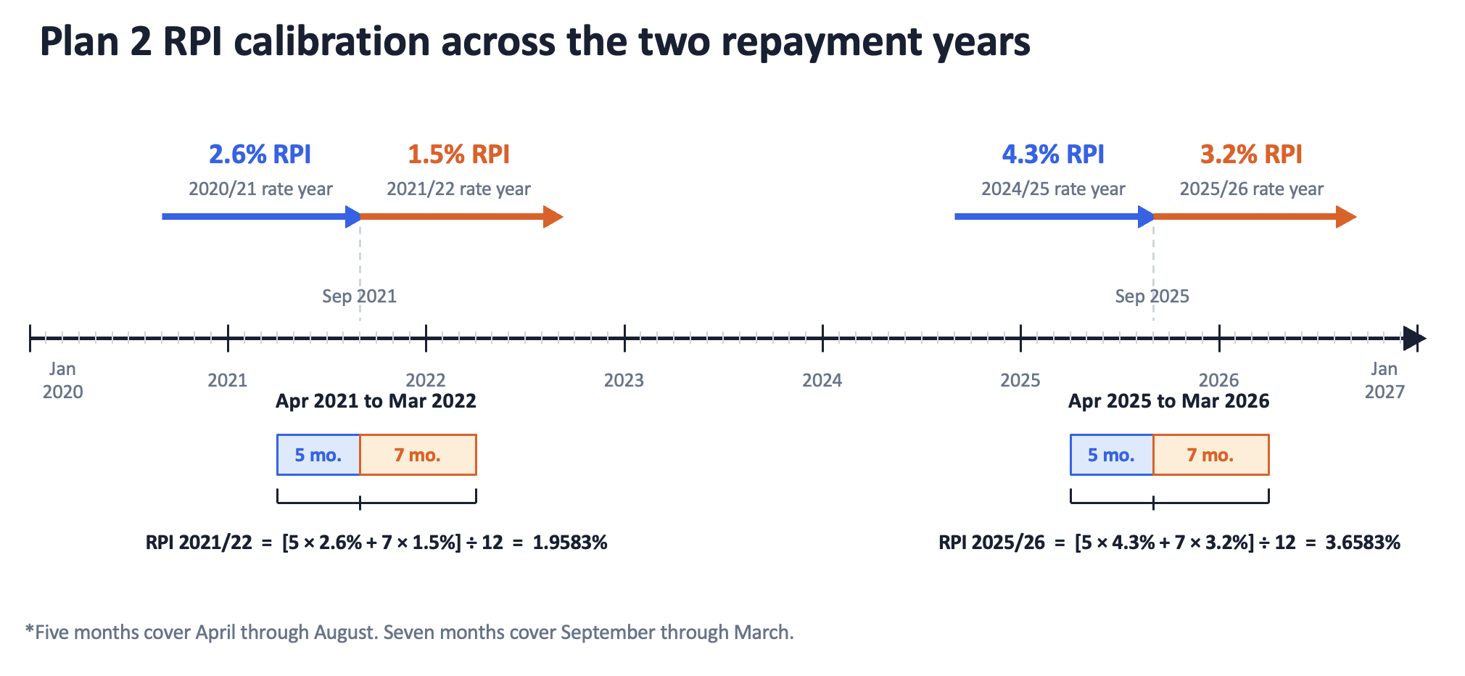
Figure A2
Plan 2 RPI calibration across the two repayment years
Note. Five months cover April through August and seven months cover September through March. Source values come from the Student Loans Company announcements listed in the references.

A4. Log and arc elasticities
Using ΔQ/Q = exp(β) − 1, Malta’s β = −0.362 implies −30.4%, Lithuania’s β = −2.173 implies −88.6%, and the pooled ATT β = −1.109 implies −67.0%, all relative to the control trajectory.
A naive arc elasticity divides the proportional quantity change by the 140% arithmetic price increase:
ηarc=exp-1.109-11.4=-0.479.
For a finite log price change Δ log P≈0.875 so %ΔP≈140%
ηarc≈-72.19%140%≈-0.52
k and log quantity change β, the exact relationship is:
ηarc=ΔQ/QΔP/Pηarc=ΔQ/QΔP/P=eβ-1ek-1.
k=Δ log Pβ=Δ log Qηlog=-βk
limk→0 eβ-1ek-1=limk→0 e-ηlog k-1ek-1=ηlog
βk

The signed log elasticity is ηlog = β/k. If β = ηlog k, then:
limk→0eηlogk-1ek-1=ηlog.
The measures coincide only as the price change approaches zero. A constant-elasticity demand curve is linear in log-log space, not convex there. In levels, the large positive price change makes the secant percentage-change measure substantially flatter than the signed log elasticity in this application.
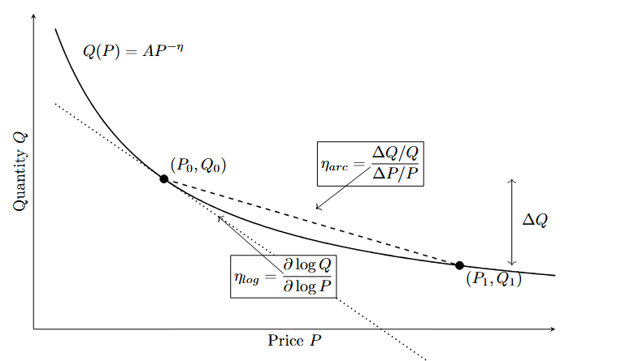
Figure A1
Constant-elasticity demand and alternative elasticity measures
Note. The dashed line represents the arc measure between the two equilibria. The dotted line represents the signed log elasticity at the initial equilibrium. For the Brexit calibration, the absolute arc elasticity is smaller than the absolute log elasticity.

A5. Detailed regression results
Table A1
Variable | Weighted  TWFE | Weighted  country FE | Weighted  no FE | Unweighted  TWFE
Intercept |  |  | 6.844***(0.032)
Austria | -0.549*** (0.053) | -0.525***(0.051) | -0.961***(0.046) | -0.686***(0.080)
Belgium | -0.603***(0.066) | -0.579***(0.063) | -0.434***(0.059) | -0.740***(0.093)
Bulgaria | -1.887***(0.131) | -1.864***(0.128) | -1.007***(0.101) | -2.025***(0.158)
Croatia | -1.655***(0.109) | -1.631***(0.105) | -2.572***(0.098) | -1.792***(0.130)
Cyprus | -0.902***(0.067) | -0.879***(0.066) | 0.255***(0.042) | -1.040***(0.096)
Czech Republic | -1.137***(0.056) | -1.114***(0.051) | -0.901***(0.052) | -1.275***(0.065)
Denmark | -1.046***(0.109) | -1.023***(0.105) | -1.609***(0.093) | -1.184***(0.132)
Estonia | -1.447***(0.118) | -1.424***(0.115) | -2.237***(0.104) | -1.585***(0.144)
Finland | -1.756***(0.206) | -1.733***(0.204) | -1.817***(0.174) | -1.894***(0.232)
France | -0.597***(0.062) | -0.574***(0.059) | 1.179***(0.060) | -0.735***(0.085)
Germany | -0.681***(0.072) | -0.658***(0.071) | 0.652***(0.063) | -0.819***(0.100)
Greece | -0.866***(0.078) | -0.842***(0.078) | 0.105(0.077) | -1.003***(0.103)
Hungary | -1.114***(0.077) | -1.091***(0.075) | -1.032***(0.073) | -1.252***(0.089)
Italy | -0.925***(0.112) | -0.902***(0.110) | 0.676***(0.098) | -1.063***(0.139)
Latvia | -1.512***(0.127) | -1.488***(0.122) | -1.928***(0.122) | -1.649***(0.145)
Lithuania | -2.173***(0.277) | -2.150***(0.271) | -1.412***(0.244) | -2.311***(0.297)
Luxembourg | -0.493***(0.047) | -0.470***(0.040) | -1.237***(0.040) | -0.630***(0.068)
Malta | -0.362***(0.045) | -0.338***(0.049) | -2.335***(0.041) | -0.499***(0.049)
Netherlands | -0.535***(0.024) | -0.512***(0.026) | -0.491***(0.037) | -0.672***(0.047)
Poland | -1.668***(0.149) | -1.645***(0.146) | -0.135(0.141) | -1.806***(0.164)
Portugal | -0.939*(0.350) | -0.916*(0.345) | -0.087(0.321) | -1.077*(0.362)
Romania | -1.711***(0.136) | -1.688***(0.133) | -0.363*(0.130) | -1.849***(0.157)
Slovakia | -1.516***(0.119) | -1.493***(0.119) | -1.570***(0.094) | -1.654***(0.125)
Slovenia | -1.280***(0.121) | -1.256***(0.120) | -3.108***(0.094) | -1.417***(0.147)
Spain | -0.508***(0.083) | -0.484***(0.079) | 0.964***(0.065) | -0.645***(0.086)
Sweden | -0.967***(0.140) | -0.944***(0.138) | -0.630***(0.124) | -1.104***(0.166)
Observations | 520 | 520 | 520 | 520
Weights | Yes | Yes | Yes | No
Country fixed effects | Yes | Yes | No | Yes
Year fixed effects | Yes | No | No | Yes
Adjusted R² | 0.98 | 0.98 | 0.27 | 0.98
Within R² | 0.82 | 0.87 |  | 0.81

Country-specific post-reform log effects under alternative specifications
Note. Driscoll-Kraay standard errors with one lag are in parentheses. + p < .10, * p < .05, ** p < .01, *** p < .001.

Variable | S1 Saturated DiD | S2 + GDPpc | S3 + GDPpc + Pop | S4 + GDPpc + Pop + YouthUnempl
Austria | -0.529*** | -0.521*** | -0.499*** | -0.504***
 | (0.058) | (0.059) | (0.052) | (0.057)
Belgium | -0.581*** | -0.583*** | -0.570*** | -0.575***
 | (0.073) | (0.070) | (0.064) | (0.068)
Bulgaria | -1.855*** | -1.888*** | -1.770*** | -1.781***
 | (0.149) | (0.138) | (0.095) | (0.105)
Croatia | -1.616*** | -1.657*** | -1.528*** | -1.529***
 | (0.127) | (0.117) | (0.097) | (0.101)
Cyprus (European Union) | -0.887*** | -0.920*** | -0.948*** | -0.944***
 | (0.069) | (0.059) | (0.060) | (0.054)
Czech Republic | -1.121*** | -1.121*** | -1.070*** | -1.075***
 | (0.064) | (0.060) | (0.071) | (0.072)
Denmark | -1.035*** | -1.037*** | -1.025*** | -1.030***
 | (0.131) | (0.127) | (0.122) | (0.127)
Estonia | -1.412*** | -1.412*** | -1.393*** | -1.407***
 | (0.132) | (0.124) | (0.120) | (0.132)
Finland | -1.680*** | -1.669*** | -1.625*** | -1.622***
 | (0.217) | (0.220) | (0.206) | (0.206)
France | -0.575*** | -0.571*** | -0.541*** | -0.537***
 | (0.069) | (0.068) | (0.058) | (0.057)
Germany | -0.659*** | -0.650*** | -0.581*** | -0.584***
 | (0.077) | (0.079) | (0.055) | (0.058)
Greece | -0.819*** | -0.835*** | -0.735*** | -0.719***
 | (0.067) | (0.059) | (0.035) | (0.042)
Hungary | -1.076*** | -1.098*** | -1.008*** | -1.020***
 | (0.086) | (0.082) | (0.080) | (0.078)
Italy | -0.886*** | -0.892*** | -0.824*** | -0.811***
 | (0.118) | (0.113) | (0.091) | (0.084)
Latvia | -1.474*** | -1.488*** | -1.383*** | -1.389***
 | (0.154) | (0.145) | (0.126) | (0.129)
Lithuania | -2.163*** | -2.187*** | -2.157*** | -2.164***
 | (0.347) | (0.334) | (0.331) | (0.339)
Luxembourg | -0.505*** | -0.490*** | -0.575*** | -0.577***
 | (0.056) | (0.056) | (0.085) | (0.090)
Malta | -0.351*** | -0.376*** | -0.523*** | -0.526***
 | (0.044) | (0.050) | (0.064) | (0.065)
Netherlands | -0.521*** | -0.523*** | -0.522*** | -0.527***
 | (0.023) | (0.023) | (0.024) | (0.027)
Poland | -1.612*** | -1.649*** | -1.516*** | -1.524***
 | (0.165) | (0.152) | (0.132) | (0.135)
Portugal | -0.863+ | -0.867+ | -0.833+ | -0.836+
 | (0.421) | (0.420) | (0.417) | (0.421)
Romania | -1.653*** | -1.680*** | -1.577*** | -1.597***
 | (0.154) | (0.145) | (0.124) | (0.135)
Slovakia | -1.472*** | -1.482*** | -1.385*** | -1.396***
 | (0.117) | (0.113) | (0.116) | (0.110)
Slovenia | -1.201*** | -1.218*** | -1.171*** | -1.177***
 | (0.121) | (0.117) | (0.099) | (0.107)
Spain | -0.492*** | -0.488*** | -0.490** | -0.476**
 | (0.094) | (0.096) | (0.099) | (0.102)
Sweden | -0.910*** | -0.906*** | -0.916*** | -0.927***
 | (0.143) | (0.142) | (0.141) | (0.151)
c_log_GDPpc |  | 0.279 | 0.332 | 0.376
 |  | (0.254) | (0.262) | (0.236)
c_log_Pop15_64 |  |  | 1.646** | 1.617**
 |  |  | (0.359) | (0.340)
c_YouthUnempl |  |  |  | 0.002
 |  |  |  | (0.003)
Num.Obs. | 468 | 468 | 468 | 468
R2 Within | 0.817 | 0.818 | 0.830 | 0.830
R2 Within Adj. | 0.804 | 0.805 | 0.818 | 0.817
FE: Domicile_named_country | YES | YES | YES | YES
FE: Year | YES | YES | YES | YES
Weights | YES | YES | YES | YES

Table A2
Country-specific log effects in the initial and later post-reform windows
Country | Post | Country | Post | Country | Post 2023 | Country | Post 2023
Austria | -0.524***(0.072) | Italy | -0.813***(0.102) | Austria | -0.585***(0.032) | Italy | -1.093***(0.030)
Belgium | -0.551***(0.078) | Latvia | -1.429***(0.189) | Belgium | -0.681***(0.022) | Latvia | -1.636***(0.033)
Bulgaria | -1.795***(0.169) | Lithuania | -2.026***(0.384) | Bulgaria | -2.025***(0.048) | Lithuania | -2.394***(0.113)
Croatia | -1.591***(0.158) | Luxembourg | -0.490***(0.066) | Croatia | -1.751***(0.039) | Luxembourg | -0.498***(0.038)
Cyprus | -0.869***(0.072) | Malta | -0.321***(0.040) | Cyprus | -0.952***(0.056) | Malta | -0.423***(0.041)
Czech Republic | -1.107***(0.078) | Netherlands | -0.518***(0.030) | Czech Republic | -1.183***(0.045) | Netherlands | -0.561***(0.021)
Denmark | -0.962***(0.114) | Poland | -1.529***(0.175) | Denmark | -1.173***(0.055) | Poland | -1.877***(0.057)
Estonia | -1.341***(0.128) | Portugal | -0.705(0.495) | Estonia | -1.607***(0.033) | Portugal | -1.291***(0.135)
Finland | -1.571***(0.206) | Romania | -1.604***(0.188) | Finland | -2.035***(0.063) | Romania | -1.873***(0.051)
France | -0.542***(0.073) | Slovakia | -1.397***(0.111) | France | -0.679***(0.006) | Slovakia | -1.695***(0.090)
Germany | -0.615***(0.070) | Slovenia | -1.229***(0.161) | Germany | -0.781***(0.027) | Slovenia | -1.355***(0.151)
Greece | -0.778***(0.062) | Spain | -0.465**(0.106) | Greece | -0.997***(0.035) | Spain | -0.572***(0.067)
Hungary | -1.064***(0.111) | Sweden | -0.825***(0.126) | Hungary | -1.190***(0.064) | Sweden | -1.180***(0.033)
Observations | 520
Weights | YES
Country FE
Time FE
Adj. R2: | 0.98
Within R2: | 0.84

References
Abadie, A., & Cattaneo, M. D. (2018). Econometric methods for program evaluation. Annual Review of Economics, 10, 465-503. https://doi.org/10.1146/annurev-economics-080217-053402
Abadie, A., Diamond, A., & Hainmueller, J. (2010). Synthetic control methods for comparative case studies. Journal of the American Statistical Association, 105(490), 493-505. https://doi.org/10.1198/jasa.2009.ap08746
Clifton-Sprigg, J., Homburg, I., Huyghe, A., & Vujić, S. (2026). International student migration. Did Brexit close the door to EU students? In B. Elsner & S. W. Polachek (Eds.), Migration, human capital and the labor market (Research in Labor Economics, Vol. 53A). Emerald Publishing. https://doi.org/10.1108/S0147-91212026000053A002
Driscoll, J. C., & Kraay, A. C. (1998). Consistent covariance matrix estimation with spatially dependent panel data. Review of Economics and Statistics, 80(4), 549-560. https://doi.org/10.1162/003465398557825
Student Loans Company. (2020, August 11). Student loans interest rates and repayment threshold announcement. GOV.UK. https://www.gov.uk/government/news/student-loans-interest-rates-and-repayment-threshold-announcement
Student Loans Company. (2021, August 12). Student loans interest rates and repayment threshold announcement. GOV.UK. https://www.gov.uk/government/news/student-loans-interest-rates-and-repayment-threshold-announcement--2
Student Loans Company. (2024, August 13). Student loans interest rates and repayment threshold announcement. GOV.UK. https://www.gov.uk/government/news/student-loans-interest-rates-and-repayment-threshold-announcement--5
Student Loans Company. (2025, August 19). Student loans interest rates and repayment threshold announcement. GOV.UK. https://www.gov.uk/government/news/student-loans-interest-rates-and-repayment-threshold-announcement--6

