The Brexit Tuition Shock and the Price Elasticity of International Students: Evidence from a Natural Experiment
Stoycho Rusinov*
James Rafiki Aketch**

*Center for the Study of Democracy & University of Mannheim, Germany
University of Mannheim, Germany
email: stoycho.rusinov@csd.eu

**School of Economics, University College Dublin

ABSTRACT
This paper estimates the price elasticity of EU demand for UK higher education using the post-2021 Brexit-induced loss of Home Fee status and student-loan access as an externally imposed tuition shock. Unlike standard studies based on enrollment, we use UCAS applicant counts to observe expressed demand before universities ration admissions. A weighted difference-in-differences design produces country-specific post-reform effects that synthetic difference-in-differences estimates closely reproduce. The reform reduced EU applicant numbers by approximately 67% on average, with substantial and persistent variation across origins. When the reform is treated as a common nominal price change, the implied elasticities exceed conventional estimates and surpass 1.5 in absolute magnitude for several countries, with applicants from lower-income origins appearing more responsive. However, the pre-Brexit fee was financed through an income-contingent loan whose present value varies with origin-specific earnings, repayment thresholds, and the subjective discounting of future payments. We map the same estimated treatment effects across country-specific effective price changes and a range of subjective discount rates to reveal the dualistic nature of income-contingent financing. The relationship between elasticity and GDP per capita becomes statistically insignificant at approximately a 6% subjective discount rate and reaches income neutrality at approximately a 14.9% subjective discount rate. Many implied elasticities then approach the ranges reported in the literature, although some remain above one in absolute magnitude. The results show that cross-border demand elasticity depends on baseline financing conditions and that the UK student-loan system operated as an equalizing institution for European educational mobility.

JEL codes: I22; I23; F22; J61; D12; C23
Keywords: Brexit; international student mobility; higher education demand; tuition fees; price elasticity; EU students; UCAS applicants; difference-in-differences; synthetic control; income-contingent loans; educational mobility; heterogeneous treatment effects.

1. Introduction
International higher-education demand studies struggle to isolate own-price elasticity because they generally infer demand from enrollment changes, lack sufficient exogenous price variation, or face both problems simultaneously. Many estimates of the price elasticity of college enrollment “treated the application decision as exogenous, focusing only on how price affects the college-going behavior of admitted applicants” (Savoca, 1990), and so “ignored the possibility that a tuition change affects enrollment through the applicant pool” itself (p. 123). Standard demand models using enrollment data thus conflate the desire to attend with the university’s choice to admit. Recent extensions retain this enrollment-based approach. For example, McQuone and Simons (2025), updating Conlon et al. (2021), estimate short-run elasticities between −0.54 and −0.81 for non-EU students, magnitudes that remain too small to account for the post-2021 collapse observed in several EU-origin applicant series.
To address the lack of exogenous tuition variation and the limitations of enrollment as a demand proxy, we treat the number of Universities and Colleges Admissions Service (UCAS) applicants from each domicile as expressed origin-country demand before universities ration places. Applicant counts are observed before admission decisions, offers, acceptances, and enrollment. Identification comes from within-country changes over time around the externally imposed loss of Home Fee status and loan access. Because the financial consequences varied across origin countries, the design also permits country-specific treatment effects that can be mapped to constant-elasticity demand responses under the maintained price-shock assumptions.
First, we show that applicants from lower-income EU countries have declined more relative to their richer counterparts; we then argue that this, by itself, does not mean that their preferences are inherently more elastic. Although Brexit caused a common shock in nominal prices, how countries absorbed it varied because the value of the income-contingent loan lost depended on country-specific earnings, repayment thresholds, and how individuals subjectively discounted future repayments. In countries where poverty was endemic or generational, loan payments were delayed; in richer countries, payments were made immediately because expected earnings were higher. We later show that the relationship between elasticity and GDP per capita becomes statistically insignificant at a “subjective” discount rate of about 6% and reaches income neutrality at about 14.9%, and that as subjective discount rates increase, elasticities move towards the conventional rates in the literature. Countries' responses to price changes therefore depend on the financing conditions embedded in the pre-Brexit system, illustrating that demand elasticity cannot be understood without accounting for the actual price applicants experience. Finally, we examine how fiscal drag from nominal wage convergence in the EU may have affected the income neutrality of the estimated elasticities.

2. Context

2.1. Brexit and higher education
Between 1940 and the early 1990s, the US market for baccalaureate education grew far more competitive, moving from largely local markets to a nationally integrated system. Hoxby (1997) argues that this intensified competition over students and institutional quality can explain real tuition increases of about 50 percent among selective private colleges. A related shift toward market competition later occurred in England, where reforms from 2012 expanded tuition-fee competition, encouraged private providers, and increased information for prospective students. Brown (2011) questioned whether these reforms would improve quality and financial sustainability, warning the evidence was limited, and the system could become more stratified and wasteful. These reforms developed alongside a longer-standing commitment to widening participation, which sought to make higher education accessible to groups that had not tradditionally considered it.
Against the broader expansion of globalized higher education, Brexit was a major reversal of UK-EU integration. Calhoun (2017) reads the Leave vote partly as a populist reaction against London-centered globalization and cosmopolitan elites seen to have benefited disproportionately, accompanied by nostalgia for an earlier Britain and frustration with existing conditions. For higher education, the most consequential outcome was the rupture of academic and financial ties with the EU. The 2020/21 academic year was the last in which new EU students generally qualified for Home Fee status and government-supported loans. From 2021/22 they became liable for international fees, which often doubled or tripled their costs. Brexit thus produced one of the largest discrete tuition shocks faced by a clearly defined group of students in twenty-first-century British higher education.
Brexit also raised financial and reputational concerns about recruiting EU students and staff, accessing European research funding, and UK students studying abroad (Mayhew, 2022). Even so, the UK remained the world’s second most popular destination for international students in 2023. About 730,000 international students were enrolled at UK universities in 2023/24, some 25 percent of the student population, and their fees generated 23 percent of total university income (Cuibus et al., 2025). Cuibus et al. (2025) report that EU numbers fell sharply after Brexit and then stabilized, so that by 2023/24 EU students were only 7 percent of newly enrolled international students. Mayhew (2022) notes that the decline in EU enrollments during 2021/22 was offset by growth among UK and non-EU students, which illustrates that enrollment is an equilibrium outcome jointly determined by applications, offers, acceptances, and institutional capacity.
This shift also reshaped student mobility. As early as 2006, Findlay et al. (2006) note that UK students’ decreasing mobility to Europe was more than compensated by rising flows to other destinations, especially North America and Australia (p. 291). Locke and Marini (2021) note a rapid pre-2016 increase in EU faculty in UK institutions, many of which had come to rely on academics from other EU countries for much of their research and teaching. Luthra (2020) argues that rejecting free movement left EU staff feeling insecure about their legal rights and public acceptance at work.

2.2. Previous attempts to capture demand elasticities in higher education
Causal evaluation of the 2021 reform became possible only once enough post-treatment UCAS observations accumulated. Before that, policy reports relied on forecasting. Conlon et al. (2021), for instance, estimated error-correction models and used the resulting elasticities to simulate the response to the new regime. Once data through 2022 arrived, the literature moved from ex ante forecasting to ex post evaluation. Neville et al. (2024) document a sharp decline in successful EU applications after 2021, even net of COVID-19. Clifton-Sprigg et al. (2025) separate the components of Brexit and conclude that international tuition fees, not the referendum result or visa requirements, drove the contraction in EU student mobility. Crawford et al. (2025) provide complementary evidence to Conlon et al. (2021) on demand elasticities.
Savoca (1990) argues that enrollment-based estimates understate demand sensitivity by conflating application, admissions, and matriculation decisions. If tuition and admissions policy are set independently, the enrollment elasticity equals the sum of the application and matriculation elasticities, which she estimates at −0.49, so true demand elasticity may be more than twice the conventional estimates. Consistent with this, Dwenger et al. (2012) find that among German high-school graduates, living in a state with tuition fees lowers the probability of applying to a home-state university by 2 percentage points (against a 69% baseline), with stronger responses among higher-achieving students.
Savoca’s (1990) criticism applies more broadly, however, to models that treat observed enrollment as demand without explicitly modeling the preceding application and admission stages. It is especially relevant to BLP-type models, building on McFadden (1974), when elasticities are derived from enrollment shares across differentiated alternatives. Although such models are micro-founded and can accommodate preference heterogeneity, fully representing the student demand curve becomes increasingly demanding once applicants face different choice sets, prices, admission probabilities, and financial conditions. This becomes even more difficult when students from different countries face distinct circumstances at the time of application.
On the other hand, when elasticity is estimated using over-time variation rather than cross-sectional variation, estimates based on enrollment rather than the number of applicants are also problematic, especially since tuition is now endogenous. This creates a simultaneity problem between tuition and enrollment. To that end, Leslie and Brinkman (1987) write the conventional elasticity as ε = E/P, with E the percentage change in enrollment and P the percentage change in price. To read this ratio causally, one requires tuition to be exogenous to demand and to other determinants of enrollment. This condition is rarely satisfied because institutional variation is driven by competitive pricing and quality changes, not exogenous shocks. To illuminate this point, Hoxby (1997) shows that greater integration and competitiveness in the US market raised average tuition and quality, increased differentiation, strengthened sorting by student quality, and changed subsidies. Posted tuition may respond to the same forces that drive enrollment, and when tuition rises alongside quality and differentiation, the product is no longer held constant. Campbell and Siegel (1967) give an example where tuition rose 148% between 1927 and 1963, more than total direct costs, implying that their tuition elasticity of −0.44 understates the true total-cost elasticity.
Methodologically, Conlon et al. (2021), seeking a specific EU elasticity for the UK, acknowledge that tuition fees are “among the variables that are the same across countries”, then estimate elasticities from a country panel with no within-year cross-country price variation, so they identify the tuition coefficient only through the common time series. Conlon et al. (2021) nonetheless claim the cointegrating coefficient measures the causal effect over future periods (p. 19) and find a statistically significant long-run elasticity implying that a 10% fee increase for EU full-time first-year undergraduates lowers demand by 3.5% (an elasticity of 0.35, which we return to later). Clifton-Sprigg et al. (2025) divided the ATT implied post-2021 change in applications by a 140% price change to obtain about 0.40. In the Appendix, we show why this understates the true slope of an isoelastic demand curve when the price shock is large.
Our closest predecessor is Sá (2014, 2017, 2019) who used UCAS application data and a related difference-in-differences design to estimate the response to the 2012 tuition reform. The 2014 working paper reports magnitudes between 0.14 and 0.26, while later versions report both a reform-specific 0.110 and a full-period 0.356 (Sá, 2017; Sá, 2019) elasticities. The gap between the latter two decomposes into four parts. First, the 0.110 reflects the 18.7% application decline relative to the 170% arithmetic fee increase; on the log-log scale of Table 10, it becomes 0.207 over ln(27,000/10,000), or 0.208, accounting for 40.0% of the 0.246 gap. Second, valuing the reform by the sector-average increase from £10,395 to £24,120 (Sá, 2014, Section 6.1) rather than the maximum-fee increase from about £10,000 to £27,000 (Sá, 2017, Section 4) raises the implied elasticity to 0.246, a further 15.3%. Third, the 2014 coefficient of −0.250, using 2012 and 2013 as post-treatment, gives 0.297 and explains another 20.8%, consistent with the later recovery as the annual coefficient narrows from −0.237 in 2013 to −0.182 in 2014 and −0.172 in 2015. The remaining 24.0% reflects sample coverage and specification.
Overall, the literature has remained broadly consistent in finding that price elasticities in higher education typically range in absolute magnitude from approximately 0.10 to 0.70-0.80 (Savoca, 1990; Sá, 2014; Crawford et al., 2025; Conlon et al., 2021; Dwenger et al., 2012) depending on the choice of denominator, fee assumptions, type of price variation, and baseline assumptions. Although, most of those papers failed to account for the implicit effects of the income-contingent loans that were supporting such numbers, we will reconcile our estimates regardless. We retain this range as a later benchmark for the subjective present-value calibrations that follow in the methodology section.

2.3. Watch the denominator
The major problem in the literature, as we understand it so far, is that nominal tuition changes are confused with the change students actually experience when elasticity is computed. Sá (2019) for the tuition reforms from 2012 and Clifton-Sprigg et al. (2025) for the actual Brexit shock, and most of the literature compute price shifts as if students are jumping from one tuition to another without discounting the fees. This understates the denominator in the elasticity equation (change in demand/change in prices) because students exposed to the pre-Brexit loan regime (or pre 2012 prices) can subjectively discount the loan's present value and experience the old price as much lower than the posted tuition.
To demonstrate similar mechanisms, a large experimental literature documents substantial subjective discounting of delayed outcomes, although estimated rates vary considerably across settings and elicitation methods. Drawing on 927 estimates from 56 studies, Matousek et al. (2022) report a publication-bias-corrected mean annual discount rate of 33%. Their results also indicate that discounting differs across domains, with individuals displaying greater impatience over health outcomes than over money, while negative framing is associated with greater patience.
More directly relevant to the valuation of deferred loan repayments, Li et al. (2022) elicit time preferences from 2,100 UK adults by asking participants to choose when to repay hypothetical credit balances of £500 or £5,000 under different borrowing costs. They estimate mean annual discount rates of 6-7% across the full sample. However, these averages are pulled downward by more than half of participants who selected immediate repayment and were assigned a discount rate of zero. Among participants who preferred to delay repayment, estimated annual discount rates range from approximately 9% to 15%, while those selecting the maximum delay at an interest rate of 35% reveal discount rates of at least 35%. Li et al. (2022) also conclude that “persons aged 60 and financially literate tended to minimally delay repayment and have a consistent choice trajectory, while participants aged 18–30 who are financially less literate tended to make more contradictory choices and have a higher discount rate.” (p. 65), although this changes with higher loan sizes. Their estimated mean conditional discount rates range between 0.11 and 0.24 across both of their treatment groups.
Evidence from consequential financial decisions points in a similar direction. Warner and Pleeter (2001) examine more than 65,000 military personnel who had to choose between an immediate lump-sum payment and a future annuity. The break-even discount rates exceeded 17%; most participants selected the lump sum, demonstrating a strong preference for immediate payment and reducing government separation costs by approximately $1.7 billion.
The subjective discount-rate parameter introduced in our methodology can be compared with estimates from Li et al. (2022) and the broader literature on subjective discounting. In order to make the distinction between nominal and experienced prices, the present design calculates elasticities over a range of possible subjective discount rates; it then examines how strongly students would have had to discount future income-contingent repayments for the observed drop in the number of applicants after Brexit to be consistent with the elasticity range mentioned in the previous literature (which is given at the end of section 2.2).

3. Data
The primary source is the most recent UCAS (2025) data release, covering application cycles from 2016 to 2025. UCAS centralizes applications to UK institutions, letting us observe applicant behavior before admissions decisions, which is central to the design because applicant counts capture expressed demand before rationing. The data report applicant counts by country of domicile with demographic breakdowns. We use country-level rather than university-specific data (unlike Sá (2014, 2017, 2019)) because of a UCAS limitation. Once a student registers, they can choose up to five universities and can be accepted at all five, which double- or triple-counts the same applicant. Country-level aggregation removes this problem, since each applicant is counted once per country and the entire demand pool is captured. We aggregate across all categories of sex and gender to obtain total demand from each origin country, keeping domicile as the key dimension of variation. Deriving gender-, age-, or subject-specific elasticities raises concerns about small cells and OLS aggregation; to avoid these, we use only country-level statistics and propose the other disaggregations as future work.
UCAS (2025) also reports the typical changes in definitions as in previous editions. UCAS (2024) includes the time series from 2006 to 2024, while UCAS (2025) only includes the series from 2016 onwards. Because definitions and methodologies may differ between database versions, we don’t merge the two UCAS editions and use them separately instead. We also want to mention that UCAS is, at its core, an administrative database. Administrative databases, although often census-level within their administrative universe, have their own internal limitations because they are generated for operational purposes, may contain restricted or changing measures, and can embed structured data-quality problems (Connelly et al., 2016; Hand, 2018). However, microdata covering thousands of vastly heterogeneous student populations applying to UK higher education institutions for the period between 2020 and 2021 does not exist and could not be obtained post-factum. Using the Higher Education Statistics Agency (HESA) only provides enrollment numbers. Although both HESA and UCAS are vastly superior to most similar data out there, they still suffer from the same pathologies of being administrative databases.
The unit of observation is the origin-country-year, a panel of both EU countries (treated) and non-EU countries used to build the pseudo EU (control). The outcome is the log number of applicants from country i in year t. To study heterogeneity in the response, the UCAS data are merged with World Bank macroeconomic indicators, including GDP per capita and labor-market variables. Table 1 reports descriptive statistics.
Table 1. Descriptive statistics of the core variable in the analysis for both the treated and control groups. Statistics are computed on the 468 country-year World Bank estimation sample (52 countries over 2016 to 2024). Education spending as a share of GDP is available for 321 of these observations and does not restrict the sample.
Variable | n | mean | sd | median | min | max
Donors matching sample (applicants > 100)*
Applicants | 546 | 1,519.61 | 2,359.97 | 645 | 100 | 26655
Baseline DiD sample**
Applicants | 520 | 1765.11 | 3903.00 | 667.5 | 30.0 | 36385.00
Synthetic DiD sample**
Applicants | 1200 | 1095.35 | 2864.01 | 330.0 | 25.00 | 36385.0
World Bank (WDI) regression sample**
Applicants | 468 | 1767.95 | 3745.32 | 715.00 | 35.00 | 33660.00
log_app | 468 | 6.63 | 1.23 | 6.57 | 3.56 | 10.42
EU | 468 | 0.50 | 0.50 | 0.50 | 0.00 | 1.00
Post | 468 | 0.44 | 0.50 | 0.00 | 0.00 | 1.00
did | 468 | 0.22 | 0.42 | 0.00 | 0.00 | 1.00
event_time | 468 | 0.00 | 2.58 | 0.00 | -4.00 | 4.00
regression_weight | 468 | 1.00 | 0.77 | 1.00 | 0.00 | 4.18
GDPpc | 468 | 46395 | 26718 | 43080 | 2543 | 136772
Pop15_64 | 468 | 42599339 | 138073628 | 6552302 | 305378 | 988168271
YouthUnempl | 468 | 15.32 | 8.43 | 13.56 | 0.30 | 47.22
EduSpendGDP | 321 | 4.59 | 1.43 | 4.59 | 0.38 | 8.74
c_log_GDPpc | 468 | 0.00 | 0.78 | 0.15 | -2.68 | 1.30
c_log_Pop15_64 | 468 | 0.00 | 1.73 | -0.22 | -3.28 | 4.80
c_YouthUnempl | 468 | 0.00 | 8.43 | -1.75 | -15.02 | 31.91
Note: “*” denotes the 2024 UCAS data edition, containing a panel spanning 2006 to 2024 (utilized period 2014 to 2020); “**” denotes the 2025 UCAS data edition, containing a panel spanning 2016 to 2025 (utilized period 2016 to 2025)

Country-specific average wages ($w_{j}$) are taken from Eurostat’s Average full-time adjusted salary per employee indicator (nama_10_fte) for 2024 (Eurostat, 2025) and for 2021 in the robustness extension. The indicator reports gross annual wages and salaries in current euros and applies a harmonized full-time adjustment based on the ratio of usual weekly hours worked by full-time employees to those worked by all employees in the EU Labour Force Survey. It is available for 25 of the 26 treated Member States. The Netherlands is omitted from the wage-based calculations because Eurostat does not publish nama_10_fte for it and instead refers users to a national register-based measure constructed using a different methodology.
Macroeconomic controls come from the World Bank’s World Development Indicators via the WDI R package (Arel-Bundock, 2022): GDP per capita in PPP constant international dollars (NY.GDP.PCAP.PP.KD), working-age population 15-64 (SP.POP.1564.TO), and youth unemployment 15-24 (SL.UEM.1524.ZS). Country codes were harmonized to ISO3 with the countrycode package (Arel-Bundock et al., 2018) and merged with the UCAS panel on country-year. World Bank data run through 2024 (World Bank, 2025). Lebanon was missing GDP per capita and youth unemployment for 2024, so we filled both with the average of the previous two years to keep the panel balanced.

4. Empirical strategy

4.1. Constructing the counterfactual European Union
The control group is built in two stages, with the full derivation in Online Appendix I. First, each origin country’s pre-treatment path is converted into a standardized log-applicant trajectory for 2014 to 2020. We start in 2014 because Croatia joined the EU (becoming treated) in 2013, so this window avoids contaminating the pre-treatment trajectories, for the donor pool we keep only countries with at least 100 applicants per year. For every treated EU country, the three closest non-EU donors are selected by Euclidean distance between standardized pre-treatment paths, so donor choice depends on trajectory shape, not market size.
Second, synthetic-control weights are estimated separately for each treated country over the pre-treatment period, then collapsed into a single global donor-weight vector for the saturated DiD regressions. Treated observations receive unit weight, while donor weights are scaled so aggregate control mass equals aggregate treated mass. This keeps the outcome in logged levels while using the donor pool only to build a comparable weighted counterfactual. Table 2 lists the counterfactual European Union and its regression weights.
Table 2. Donor countries used to construct the synthetic counterfactual European Union, with global and regression weights.
Donor country | Global weight | Global weight × 26
Korea, Republic of | 0.16 | 4.18
Trinidad and Tobago | 0.12 | 3.08
Russian Federation | 0.11 | 2.80
Malaysia | 0.10 | 2.53
Mauritius | 0.08 | 2.07
Egypt | 0.07 | 1.85
New Zealand | 0.04 | 1.11
United States of America | 0.04 | 1.10
Qatar | 0.04 | 1.00
Israel | 0.04 | 1.00
Zimbabwe | 0.04 | 0.96
United Arab Emirates | 0.04 | 0.92
Indonesia | 0.03 | 0.80
Mexico | 0.02 | 0.62
Australia | 0.02 | 0.44
Tanzania, United Republic of | 0.02 | 0.43
China | 0.01 | 0.33
Norway | 0.01 | 0.33
Lebanon | 0.01 | 0.27
Ireland | 0.01 | 0.20
Switzerland | <0.00 | <0.01
Turkey | <0.00 | <0.01
Botswana | <0.00 | <0.01
Iran, Islamic Republic of | <0.00 | <0.01
Uganda | <0.00 | <0.01
Brunei Darussalam | <0.00 | <0.01

Note: Estimates based only on donor countries with recorded number of applicants of at least 100.

An alternative is to estimate each treated country separately using the synthetic difference-in-differences estimator of Arkhangelsky et al. (2021). We use a common weighting scheme instead, because the country-specific coefficients later enter a second-stage regression on income and on $k_{j}$, and per-country donor selection would define each coefficient against a different counterfactual. That difference would not be random, since donor weights are chosen on pre-treatment fit, pre-treatment applicant counts are income-related, and wealthier EU countries would draw on wealthier donors, so the induced error in the second-stage dependent variable would correlate with the regressor of interest. With seven pre-treatment years, per-country weights would also be fitted largely to noise (Abadie, 2021). We nonetheless apply the estimator to the full donor pool later as a robustness check.

4.2. Identification strategy and parallel trends
The closest design to ours, Sá (2014, 2017, 2019) exploits within-country, across-time variation in fees. Her treatment is binary and uniform, since Scottish students either pay or do not and English students face one fee level then another, with no cross-sectional variation in the size of the shock leaving the identification to rest on only 2 country-clusters and only 18 country-year contrasts. We instead exploit cross-country, across-time variation, where the shock $k_{j}$ itself differs across countries because the present value of the foregone loan differs with the average wage. The identifying variation thus has two dimensions at once, whether you are treated (EU vs non-EU) and how intensely (which EU country you are from) you are treated. This corrects the mentioned limitation in Sá (2014, 2017, 2019) and extends the analysis to international student higher education demand.
The baseline regression period used in the estimation panel starts in 2016 and therefore omits Bulgaria and Romania's accession in 2007, Croatia's entry in 2013, the cessation of the transitional labour-market restrictions in 2014, and the increase in the fee cap in England in 2012/13. However, this does not mean that all earlier events are excluded from the pre-treatment period; the 2016 referendum and the £250 rise in tuition fees in 2017 are still included. We thus examine whether these events caused differential EU-control movements using the event-study leads and the leads-only specification. The donor-selection step described in section 4.1 makes use of the longer 2014–2020 window in order to obtain a more robust donor-matching sample.
Following these design choices, we estimate a weighted dynamic difference-in-differences specification. This traces the evolution of applicant counts around the Brexit tuition reform:
$$\log{A_{it}}=α_{i}+γ_{t}+\sum_{l≠0}{δ_{l}}\left(EU_{i}×1\left\{t-2020=l\right\}\right)+ε_{it}$$ | (1)
The coefficients $δ_{l}$ measure year-by-year deviations in log applicant counts for EU-origin countries (except Ireland) relative to the omitted pre-reform year ($l=0$, i.e. 2020), again estimated with the weights from the previous subsection.
Figure 1. Event-study estimates comparing EU applicants to the synthetic control group.
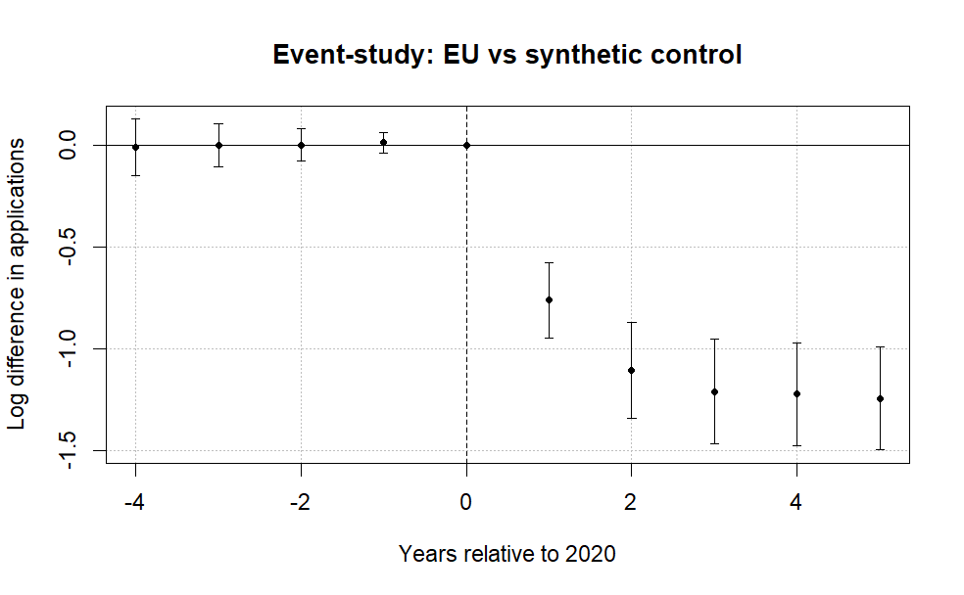
Note: The figure plots coefficients from a difference-in-differences event-study comparing EU applicants to a synthetic control group of non-EU countries. The horizontal axis shows years relative to 2020, the last pre-treatment year. Points represent estimated differences in log applicant counts and bars denote 95% confidence intervals clustered at the country level. The dashed vertical line marks the final pre-treatment year. Pre-treatment coefficients are small and close to zero, while a sharp decline in EU applicant numbers emerges beginning in 2021 after the tuition reform took effect. A joint Wald test cannot reject the null that the pre-treatment coefficients are jointly zero (p = 0.96), providing no strong evidence of differential pre-trends.

Figure 1 reports the event-study coefficients from equation (1). The pre-treatment leads are small and a joint Wald test fails to reject that they are jointly zero (p = .96), providing no evidence of differential pre-trends in this short window. The post-treatment decline persists through 2024 and 2025, which is inconsistent with a purely transitory pandemic explanation.
A leads-only specification likewise finds no evidence of anticipatory adjustment before the reform. The early leads show no systematic pattern and are jointly statistically indistinguishable from zero (p = .96). Allowing country-specific dynamic effects yields similar patterns, with post-treatment coefficients consistently negative across EU countries and pre-treatment estimates near zero (Figure 2). The one exception is Portugal, whose applicant count did not immediately fall in 2021, which traces to a UCAS reporting issue where some Recorded Prior Acceptances were mistakenly submitted as Portugal-domiciled in the 2021 cycle, so the true count is lower than reported (UCAS, 2022). Figure 2 also provides an important correction to Clifton-Sprigg et al. (2025), as they used UCAS data capped at 2022, when applicants were still adjusting to the new regime. The stable level of the collapse is revealed after 2022 and is much larger than the original estimates.

Figure 2. Saturated DiD event-study estimates by country.
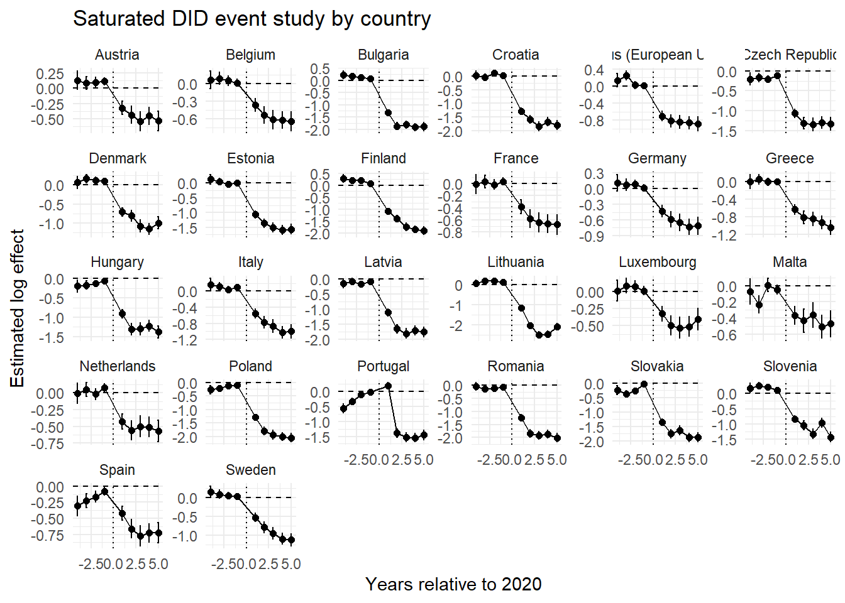Note: Each panel reports country-specific dynamic treatment effects from the saturated difference-in-differences specification comparing EU countries with the pooled control group. Coefficients represent differences in log applicant counts relative to the baseline year (2020).

4.3. Baseline elasticity estimates and heterogeneous price shocks
Let $C$ denote the set of origin countries, partitioned into the treated EU markets $Ω⊂C$ (with Ireland removed), with $J=\left|Ω\right|$, and the candidate donor pool $D=C\backslash Ω$ of non-EU markets. The counterfactual European Union gives a synthetic untreated group, letting us estimate the weighted saturated two-way DiD model:
$$\log{(A_{it})} = α_{i} + γ_{t} +\sum_{\begin{aligned}j∈Ω \\ \end{aligned}}^{ }{β_{j} \left(1\left\{i=j\right\}×Post_{t}\right)} +ρ^{'}X+ ε_{it}$$ | (2)
where $A_{it}$ denotes the applicant count from origin country $i∈C$ in year $t∈[2016, 2025]$, $1\left\{i=j\right\}$ indicates EU member states, and $Post_{t}$ marks the new tuition regime in 2021. Importantly, as long as the two groups remain under different but unchanged tuition fee regimes, their relative applicant-count trajectories should remain stable. When the treated group moves from the UK home-fee regime into the international fee regime already faced by the control group, $β_{j}$ will capture the resulting change in the treated country-specific applicant-count trajectory relative to the control group. This relative change identifies the reduction in applicant numbers when the treated group ceased to benefit from UK home-fee status.
To compare the initial and later post-reform periods, we split the post-treatment window into 2021–2023 and 2024–2025. The specification becomes:
$$\begin{matrix}\log{(A_{it})} & = & α_{i} + γ_{t} + \sum_{\begin{aligned}j∈Ω \\ \end{aligned}}^{ }{(β_{j}^{I}\left(1\left\{i=j\right\}×I_{t}\right)}+\sum_{\begin{aligned}j^{ }∈Ω \\ \end{aligned}}^{ }{β_{j}^{L} \left(1\left\{i=j\right\}×L_{t}\right)}+ρ^{'}X+ ε_{it } \\ & & \end{matrix}$$ | (3)
Here $β_{j}^{I}$ is the country-specific log effect for 2021–2023 and $β_{j}^{L}$ is the corresponding effect for 2024–2025. Even though other time-varying shocks may differ across the two windows, the difference
$$Δ_{j}=β_{j}^{L}-β_{j}^{I}$$
can be interpreted as the change in the residual application collapse after the early contemporaneous shocks had subsided, revealing whether the post-reform decline weakened, persisted, or intensified beyond the initial adjustment period (more information in the appendix).
Under a constant-elasticity demand curve, each country-specific log effect maps into a signed price elasticity according to (see the appendix):
$$η_{j}\left(δ\right)=\frac{{\hat{β}}_{j}}{k_{j}\left(δ\right)}$$
Here the numerator is the estimated country-specific log demand effect from the model in eq. (2) containing all the additional controls, and the denominator is the corresponding log price change. We first retain the conventional nominal benchmark, in which the annual price rises from £9,250 to £22,200 and the common log change is 0.875 (as in Clifton-Sprigg et al. (2025)). The loan-adjusted specification then allows the denominator to vary by origin and by the “subjective” discount rate $δ$. Both figures are annual prices, and the initial balance is one year of pre-Brexit tuition, L = £9,250. The interest rate applied to the outstanding balance is
$$i_{jt}=\overline{RPI}+0.03×\left\{\begin{aligned}0, Y_{jt}≤τ_{j}^{L} \\ \frac{Y_{jt}-τ_{j}^{L}}{τ_{j}^{U}-τ_{j}^{L}}, τ_{j}^{L}<Y_{jt}<τ_{j}^{U} \\ 1 , Y_{jt}>τ_{j}^{U}\end{aligned}\right.$$
Under Plan 2, borrowers repay 9% of annual earnings above the country-specific lower overseas threshold. The upper threshold determines the income-related interest loading, which rises linearly from RPI to RPI plus 3 percentage points (UK Government, n.d.-a, n.d.-c; Student Loans Company, 2021). For the baseline $\overline{RPI}$ we use the weighted average of the RPI values from April 2025 (Student Loans Company, 2024) to March 2026 (Student Loans Company, 2025) (see appendix). We fix the 2025/26 table’s (Student Loans Company, 2026) lower $(τ_{j}^{L})$ and upper $(τ_{j}^{U})$ thresholds throughout the simulation, hold $\overline{RPI}$ at 3.66%, $Y_{jt}$ is assumed to have nominal wage growth of $g=2\%$ per year, and the loan is written off when T=30-year (UK Government, n.d.-b), the 2024 wage value from Eurostat is extrapolated for 2025 with a growth of 2% ($Y_{it}=w_{j}^{GBP}{\left(1+g\right)}^{t-1}$). With these assumptions, the initial balance and interest recursions are
$$B_{j0}=L, {\tilde{B}}_{jt}=B_{j,t-1}(1+i_{jt})$$
The annual payment equals 9% of earnings above the lower threshold, capped at the balance after interest. The interest recursion begins in the first simulated post-graduation year, even if the borrower earns below the threshold and makes no repayment. The ending balance then becomes the opening balance for the following year.
$$p_{jt}=min\left\{0.09⋅max\left[0,w_{j}^{GBP}{\left(1+g\right)}^{t-1}-τ_{j}^{L}\right],{\tilde{B}}_{jt}\right\}, B_{jt}={\tilde{B}}_{jt}-p_{jt}$$
Discounting the resulting contractual payment stream at the annual subjective discount rate $\left(δ\right)$gives:
$$PV_{subjective,j}\left(δ\right)=\sum_{t=1}^{30}{\frac{p_{jt}}{{\left(1+δ\right)}^{t}}}$$
The country-specific experienced price shock is the log difference between the average post-Brexit international fee and the subjective present value of the former loan.
$$k_{j}\left(δ\right)=log\left(22 200\right)-log\left(PV_{subjective,j}\left(δ\right)\right)$$
Hence, the pre-Brexit price is the subjective present value of repayments generated by the origin-country wage path. We use the 2024 average annual salary from Eurostat because a student entering in 2021 completes a standard three-year degree in 2024, then convert euro wages into pounds using the 2025/26 rate of 0.85 (posted by the SLC itself). The post-Brexit fee is treated as payable during study once UK government loan access disappears.
The subjective discount rate, $δ$, follows the idea outlined by Li et al. (2022) and is thus a calibration parameter that cannot be independently estimated without using micro data. We adjust this rate across a range of values until the estimated elasticities match those in the existing literature. Broadly speaking, the body of research concerning students' subjective discounting is very limited. At present, there is no stable method for estimating the discount rates that students experience when applying as compared to the ones they actually encounter. Drawing on the estimates presented in the literature review (Li et al., 2022; Matousek et al., 2022; Warner & Pleeter, 2001), we examine annual rates ranging from 3% to 35%. The 3% figure represents a low-discount "objective" rate (the actuarial rate), the higher end of the range reflects the strong present orientation observed in experimental and consequential financial decisions (Matousek et al., 2022). The way in which we use access to financing is also in line with Solís (2017), who demonstrates that the availability of credit can have a substantial effect on enrollment.
Furthermore, we examine whether the loan adjustment changes the association between the country-specific elasticities and national income. At each subjective discount rate, we estimate
$$η_{j}(δ)=\frac{\hat{β_{j}}}{k_{j}(δ)} =α+γ_{δ}\log\left(GDPpc_{j}\right)+X^{'}ρ+ u_{ }$$ | (4)

We report the elasticities at income neutrality, which is defined as the subjective discount rate $δ^{*} ={\arg{\min\left|\hat{γ}\right| }}_{δ∈D}$over the calibration grid $D$. This is the diagnostic point at which the loan-adjusted elasticities no longer vary systematically with national income. It is also informative because it captures the redistributive duality of income-contingent financing. This duality is, on the one hand, revealed by the fact that expected wages relative to the country-specific lower thresholds determine whether and when repayments begin. They compress cross-country income differences through threshold protection. On the other hand, the timing of the resulting payment stream determines how strongly subjective discounting reduces its present value, providing a second form of compression through delayed repayment. An income gradient in $η_{j}(δ)$ may reflect an incomplete adjustment for treatment intensity rather than systematic preference heterogeneity. Income neutrality is not sufficient to identify a uniquely correct discount rate. However, comparing neutral rates across alternative wage-threshold calibrations reveals which side of this duality dominates the loan income-equalizing nature.

5. Results

5.1. Estimated baseline elasticities
Figure 3 reports country-specific elasticities from the difference-in-differences estimates without any time-varying controls. The figure translates the treatment effects into implied demand responses to the Brexit shock. The source regression tables are provided in the appendix.
Figure 3. Decomposition of the post-Brexit demand elasticities by treated country.
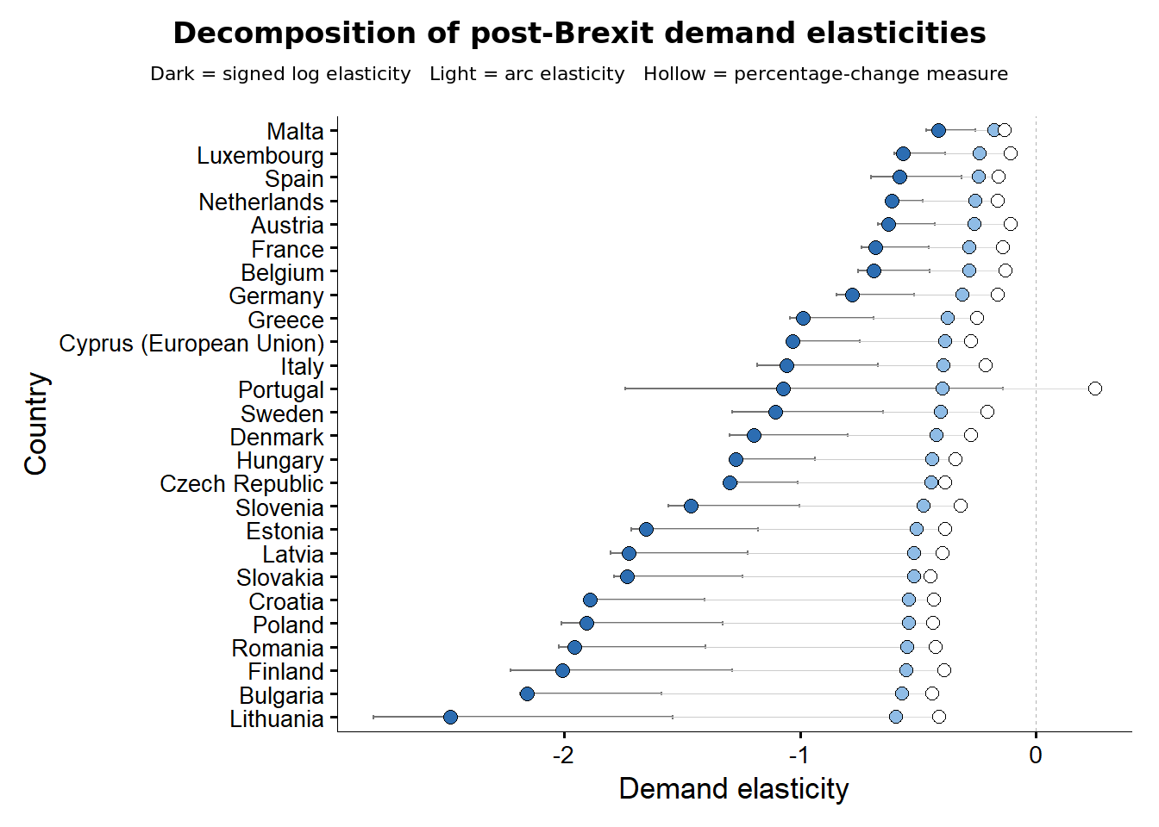
Note: Signed structural log elasticities divide each country-specific effect β_{j} by the common log price change of 0.875. Arc elasticities use [exp(β_{j}) − 1]/1.4, the mechanical percentage-change measure uses the observed change in applications divided by 1.4. R uses natural logarithms. The saturated estimates use Driscoll–Kraay standard errors with one lag. See the online appendix for detailed regressions.

The estimates show a large and widespread post-reform contraction. Country-specific effects correspond to applicant reductions ranging from about 30% for Malta to about 89% for Lithuania and 85% for Bulgaria, relative to the control group. The average effect implies a decline of approximately 67%. The implied signed elasticities are negative in every treated country, but their magnitudes vary substantially. Under the common price-shock assumption, lower-income origins such as Bulgaria, Romania, Lithuania, Croatia, and Latvia appear more responsive than Malta, Spain, Luxembourg, the Netherlands, and Austria, with a lot of elasticities sitting in the interval between -2.5 and -1.
The country-specific effects are also positively related to GDP per capita, which means that richer countries saw smaller declines. For all the different origins, the Pearson correlation between the estimated effect and log GDP per capita is around 0.51 to 0.56 (0.58 when the Netherlands are included in the sample) in the fixed-effects specification and is statistically significant at the usual levels (see Figure 5, Panel A). The slope is most evident in the fixed-effects specifications and still appears when the saturated model takes into account the observed macroeconomic controls. The result shows that in order to account for the drop in applicants in certain cases while still assuming that the price change was the same in all cases, one would have to accept elasticity coefficients smaller than --2.5 for countries such as Lithuania and about --2 for Bulgaria. These figures are very different from the conventional estimates mentioned in the earlier part of the literature.
Figure 4 presents the country-specific elasticities assuming homogeneity but with a different set of common time-varying covariates. It also shows that both the order of the countries and the individual magnitudes remain stable when the macroeconomic controls are introduced one at a time; the only noticeable change is a slight downward adjustment in the country-specific treatment effect as the controls absorb the common variation, even though this leaves the relative position of each origin basically unaltered. The fact that this gradient persists after the numerator adjustments shifts the identification issue to the denominator, meaning a similar nominal tuition rise could have led to economically different price shocks when the lost loan is taken into account across countries.

Figure 4. Saturated DiD specifications with macroeconomic controls added. Namely GDP per capita (PPP, constant prices), population and the percentage of youth unemployment as separate models.
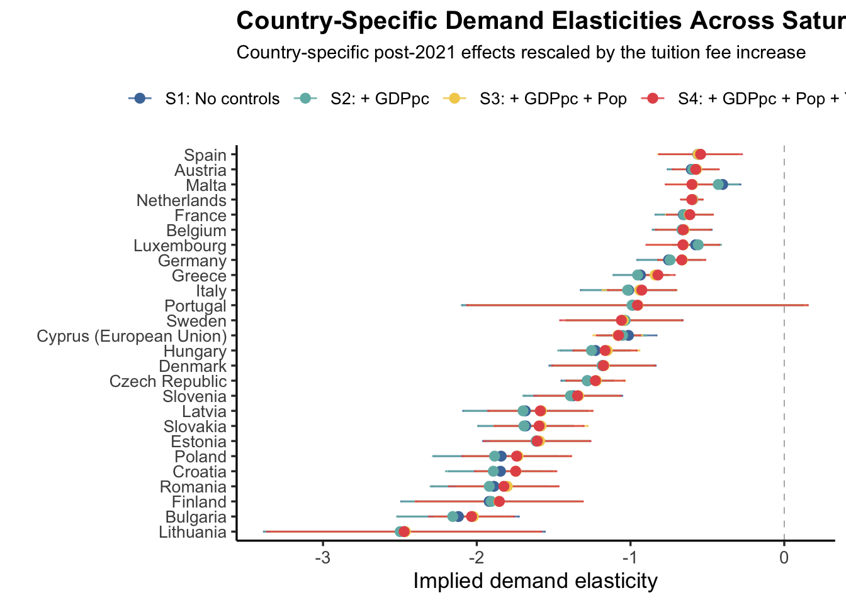
Note: All saturated models use the demeaned version of the free covariates – namely, the GDP per capita, the population and the youth unemployment. Used are Driscoll-Kraay (L=1) standard errors consistently and across all the presented models. See the online appendix for detailed regressions.

5.2. Loan-corrected elasticities and income neutrality
Since prior to Brexit EU applicants were able to finance their studies in the UK by means of an income-contingent loan the amount of which took into account the redistributive aspect of the system, in this section we rescale the obtained DID effects from figure 4 (Model S4) differently. For graduates whose expected earnings stayed below the country-specific thresholds, protection was provided, and delayed repayments enabled the remaining amount to be discounted even more in the future. Because of this, applicants with lower incomes had to make their repayments later and in some cases the amounts were smaller, so the pre-Brexit loan had a lower subjective present value and the jump to the international fee of £22,200 was thus greater than the nominal 140% comparison indicates. When the bigger effects for those from lower-income backgrounds are divided by their larger effective price increases and the smaller effects for those from higher-income backgrounds are divided by their smaller price increases, both the income gradient and the cross-country dispersion decrease. Panel B thus illustrates the two aspects of the loan’s equalising function working at the same time.
Panel B replaces the common nominal price change with the country-specific effective change $k_{j}(δ)$ and plots the resulting loan-adjusted elasticity against GDP per capita at three subjective discount rates. The middle panel marks the discount rate of 14.9 percent, at which the estimated income coefficient$γ_{δ}$ is exactly zero (zero up to the decimal point of precision). Statistical insignificance of the gradient is reached earlier, at 6.1 percent, so the whole plausible range of student discount rates is consistent with no systematic link between national income and price responsiveness.
Figure 5. The cross-country income gradient in demand responsiveness, before and after loan adjustment.
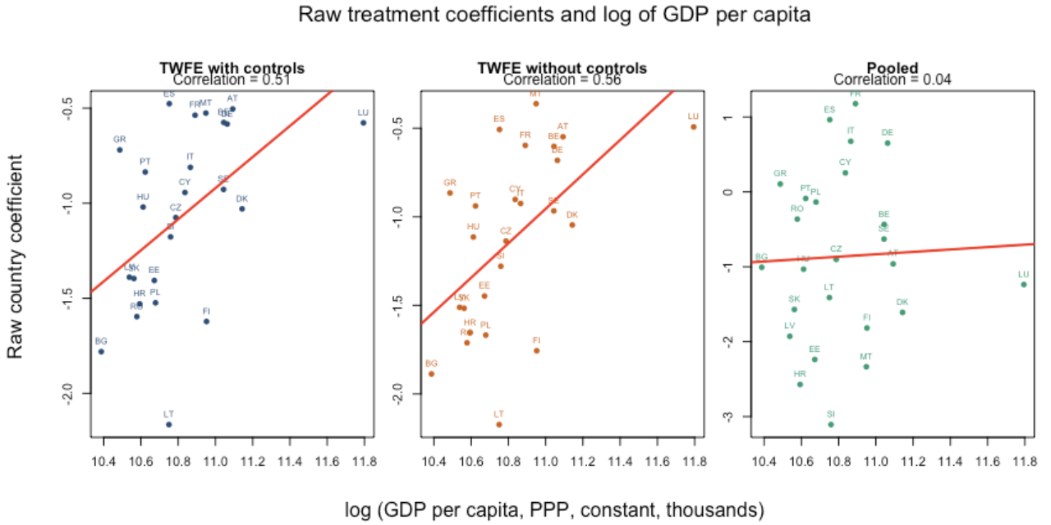
Panel A. Raw treatment effects against GDP per capita

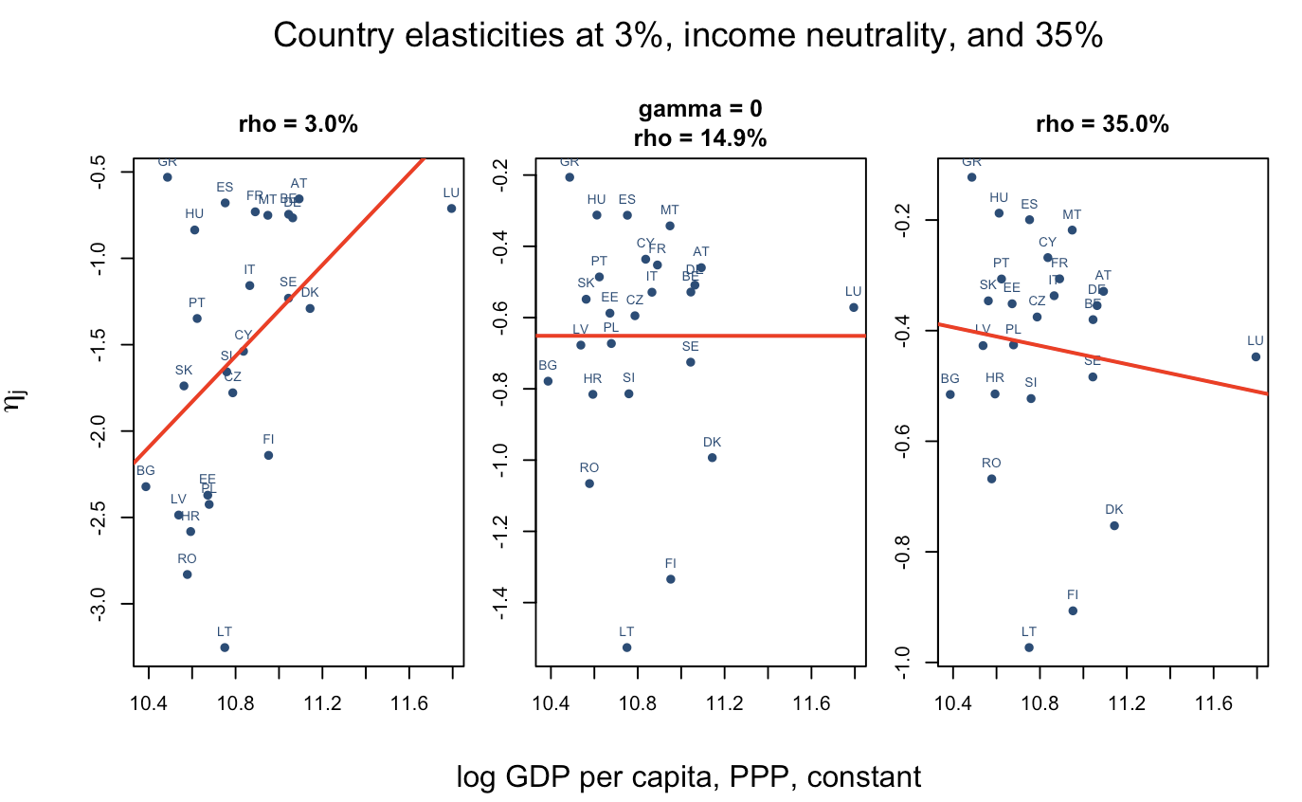
Panel B. Loan-adjusted elasticities against GDP per capita at three discount rates

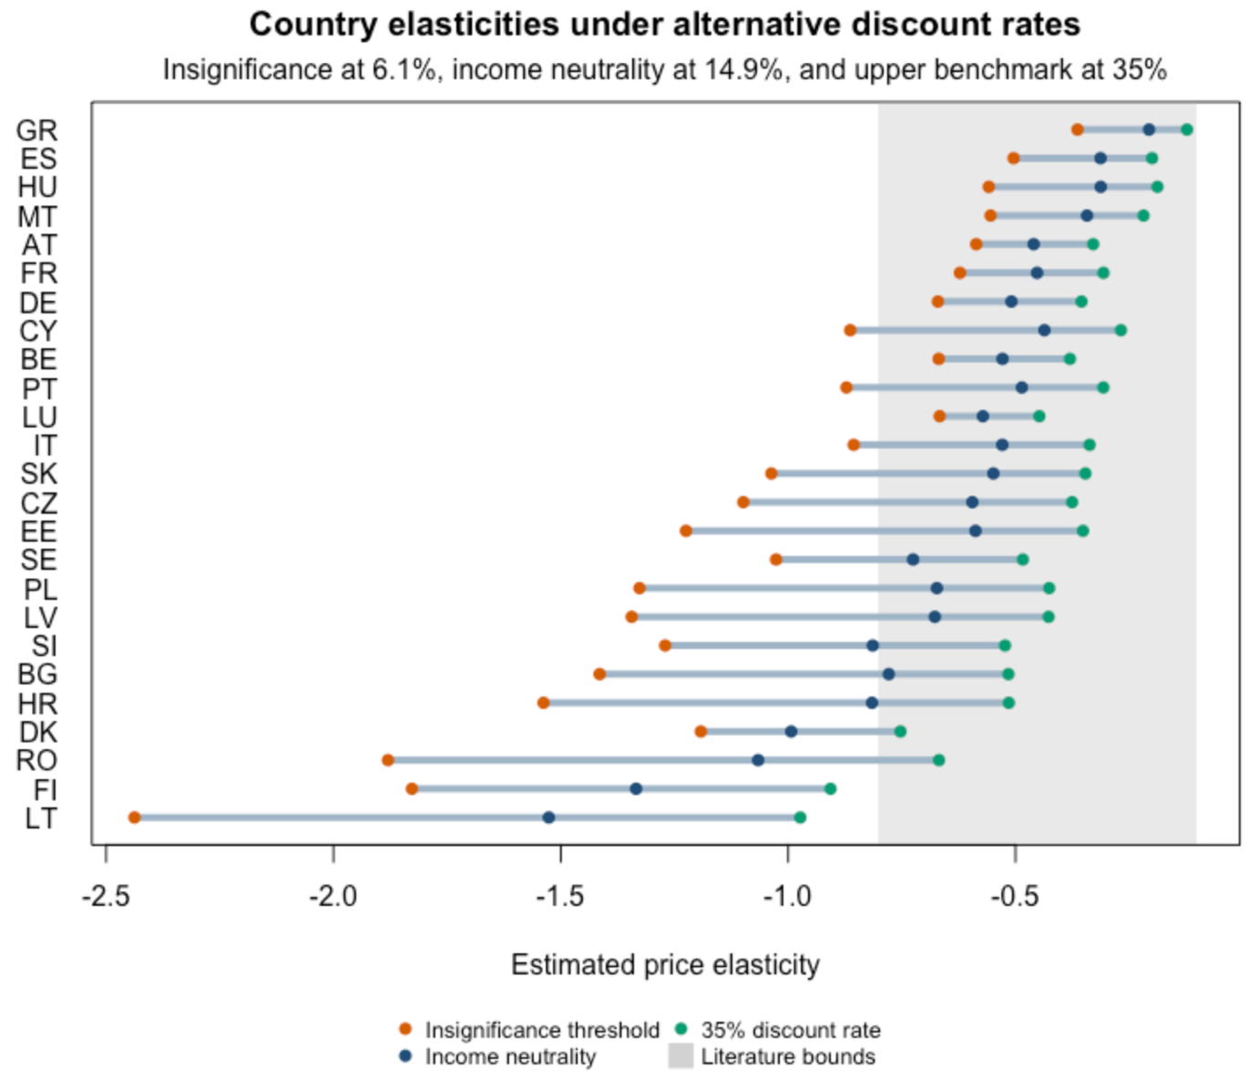
Panel C. Country-specific loan-adjusted elasticities under alternative discount rates
Note: Panel A plots the raw country-specific treatment effect against log of GDP per capita (PPP, constant for 2022), when ${\hat{β}}_{j}$ is estimated by pooled and with country and year fixed effects. Panel B plots the loan-adjusted elasticity $\frac{β_{j}}{k_{j}\left(δ\right)}$ against the log of GDP per capita at subjective discount rates of 6.1, 14.9 and 35 percent, where 14.9 percent is the rate at which the income coefficient $γ_{δ}$ equals zero. Panel C reports the country-specific loan-adjusted elasticities under the insignificance threshold (6.1 percent), income neutrality (14.9 percent) and the upper benchmark (35 percent), with the range of prior literature estimates shaded. Details in the online appendix.

Finally, panel C shows the same adjustment at the country level. Under the income-neutral calibration and the higher benchmark rate, the loan-adjusted elasticities for most origins fall inside the range reported in the earlier literature ( shaded in the panel). This means that the reconciliation does not depend on implausible elasticities. It only requires that the pre-Brexit loan be valued from the perspective of each origin.
Figure 5's Panel C also indicates that income neutrality is only achieved at a relatively high subjective discount rate. This is because, given the 2025/26 SLC thresholds and the modeled first-repayment-year wages, 23 of the 25 countries are situated above their lower repayment thresholds, so there is only limited initial threshold protection. This situation is in part due to the fact that nominal wage growth has been faster than adjustments to the administratively set thresholds after 2020. The resulting convergence of wages and thresholds produces a kind of fiscal drag within the loan agreement, causing graduates to enter into repayment and thus weakening the protective effect of the loan without altering the repayment rate. Section 6.3 examines this mechanism by combining 2021 wages with the 2021/22 SLC thresholds and the exchange rate to reconstruct the economic information set available when students applied, before possible fiscal drag in the 2024 thresholds.

5.3. Descriptive initial and later post-reform effects
Figure 6 compares country-specific log effects in the initial 2021–2023 window with those in 2024–2025. The differences between the dots describe how the estimated post-reform association changed across the two periods (detailed tables in the appendix).
Figure 6. Initial and later post-reform log effects on the same measurement axis.
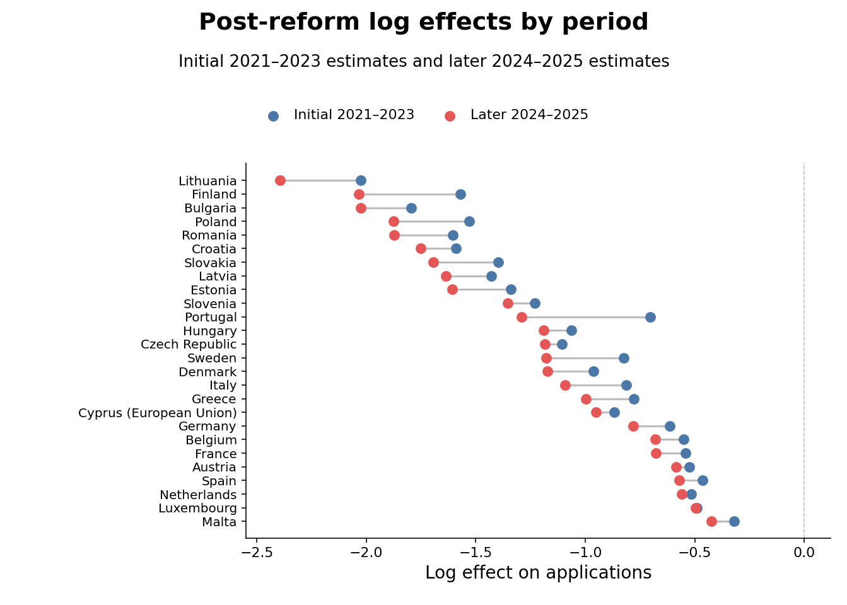
Note: The figure reports country-specific log effects, not elasticities. The initial period is 2021–2023 and the later period is 2024–2025. Both sets of estimates use Driscoll–Kraay standard errors with one lag. The period split is descriptive and does not separately identify a COVID effect.

For nearly all EU-origin countries, the 2024–2025 estimates remain strongly negative and are often more negative than the 2021–2023 estimates, with $Δ_{j}<0$. Such a pattern suggests that the initial reduction was sustained or deepened as successive applicant cohorts adjusted to the higher price, updated their expectations about studying in the United Kingdom, and redirected applications toward alternative destinations. This persistence is not consistent with a fully transitory disruption such as COVID or other contemporaneous changes that occurred immediately after the pandemic's onset in 2020. In fact, if temporarily restricted mobility was the driving reason behind the collapse, then the 2024–2025 coefficients should have been closer to zero than the initial estimates and $Δ_{j}$ positive (or perhaps began to recover as in Sá (2014, 2017, 2019)).
The initial estimates range from −0.321 for Malta to −2.026 for Lithuania; the corresponding 2024–2025 estimates are −0.423 and −2.394. Excluding Portugal, whose 2021 count has a documented reporting issue, the later coefficients are generally larger in absolute value. These patterns support persistence at the country level, again contradicting a COVID-driven or mobility-attraction story, implying that UK higher education grew steadily less popular among EU students until the system reached a stable equilibrium.

5.4. ATT wealth heterogeneity
Table 3. Average treatment effect and macroeconomic interactions with country and year fixed effects and Driscoll–Kraay standard errors (L = 1)
Variable | M1 | M2 | M4 | M5 | M6
did | -1.109*** | -1.049*** | -0.980*** | -0.960*** | -1.210***
 | -0.097 | -0.109 | -0.1 | -0.091 | -0.118
c_log_GDPpc |  | -0.727* | -0.459 | -0.698* | -0.004
 |  | -0.254 | -0.257 | -0.28 | -0.294
c_log_Pop15_64 |  |  | 3.075*** | 3.212*** | 2.629***
 |  |  | -0.456 | -0.515 | -0.458
c_YouthUnempl |  |  |  | -0.014* | -0.008+
 |  |  |  | -0.004 | -0.004
did × c_log_GDPpc |  |  |  |  | 0.808***
 |  |  |  |  | -0.135
did × c_log_Pop15_64 |  |  |  |  | 0.100***
 |  |  |  |  | -0.013
did × c_YouthUnempl |  |  |  |  | 0.011
 |  |  |  |  | -0.006
Num. Obs. | 520 | 468 | 468 | 468 | 468
R² | 0.962 | 0.963 | 0.968 | 0.969 | 0.974
Adjusted R² | 0.957 | 0.958 | 0.964 | 0.964 | 0.97
Within R² | 0.585 | 0.586 | 0.644 | 0.653 | 0.708
Adjusted within R² | 0.584 | 0.584 | 0.641 | 0.649 | 0.703
AIC | 167.5 | 124.4 | 53.4 | 57.3 | -18.4
BIC | 431.3 | 381.6 | 314.8 | 322.8 | 259.5
RMSE | 0.25 | 0.24 | 0.22 | 0.22 | 0.21
Standard errors | Driscoll-Kraay (L=1)
Country fixed effects | X | X | X | X | X
Year fixed effects | X | X | X | X | X
Significance | =+ p < 0.1 | * p < 0.05 | ** p < 0.01 | *** p < 0.001

Note: Models I–V use two-way fixed effects. Model I uses 520 observations for 52 countries in 2016–2025. Models II–V use 468 observations in 2016–2024 because the World Bank controls are capped at 2024. GDP per capita is NY.GDP.PCAP.PP.KD, purchasing-power-parity GDP per capita in constant 2021 international dollars. Logged GDP and population are demeaned over the estimation sample before interactions are formed. All models use Driscoll–Kraay standard errors with one lag. Significance codes are + p < .10, * p < .05, ** p < .01, and *** p < .001

Following an extensive pooled DiD specification (table 3), the uncontrolled ATT is −1.109, equivalent to exp(−1.109) − 1 = −67.0%. Interestingly, dividing 67% by 140% produces an elasticity of about 0.48, which is very similar to Clifton-Sprigg et al. (2025) as well as Sá (2019). Obviously, when the demand is isoelastic, the actual shift in the denominator cannot be a simple percentage change as we explained in the appendix section.
To reconcile the correct isoelastic number with other estimates in the literature that assume a common elasticity — for example, Conlon et al.’s (2021) long-run elasticity of −0.354 — requires a specific attribution. Applied to the 140% gross fee increase, that elasticity assigns a log quantity change of −0.354 × ln(2.4) = −0.310 to price, or exp(−0.310) − 1 = −26.7%. The remaining −0.799 log points would be attributed to non-price channels. At their more elastic bound of −0.648, the price channel accounts for a larger share, leaving a residual log change of −0.542.
The same arithmetic runs in reverse. Attributing the whole of our ATT to price, the annual fee increase required for an elasticity of −0.354 to generate it is exp(1.11/0.354) =22.9, a rise of 2,194 percent. Against the pre-Brexit home fee of £9,250, that implies an annual charge of approximately £212,200 rather than the roughly £22,200 actually levied once EU applicants moved to international rates. To obtain Conlon et al. (2021) number of $η_{j}=-0.354$ we have to solve for a denominator that gives $k=\frac{1.109}{0.354}=3.13$, so $PV_{loan}=\frac{£22,200}{e^{3.13}}=£968$. That is 10.5 percent of the £9,250 principal. Therefore, the estimates are equal only for an applicant whose income-contingent loan was worth about a tenth of its face value in present-value terms.
A possible criticism is that the collapse in applicants was about more than price. Visa requirements, relocation costs, uncertainty surrounding the change in Home-fee status, and other frictions may all have contributed. This would mean that part of the observed shock was manufactured by forces outside the price channel and that, once these forces were removed, the estimated elasticities would collapse back towards the conventional values in the literature. Accepting this criticism, however, would mean accepting that these non-price forces, or another persistent and unobserved exogenous force distinct from COVID-19 and other temporary post-2021 shocks, were responsible for at least 70% of the estimated ATT. However, the much more favorable alternative is that perhaps price really was perceived subjectively and that the main reason for the collapse was financial. The present value of expected loan repayments for Bulgaria, for example, was £10310.39 under a 3% discount rate, implying only an 77% log increase in the effective tuition price after 2021. From a historical perspective, the UK experienced a much larger nominal tuition shock in 2012, when the fee cap increased from £3,000 to £9,000. Yet UCAS estimated that young people were only about 5% less likely to apply than expected. Application rates returned to their long-term trend in 2013 and 2014, while entry rates continued to increase (UCAS, 2014; Murphy et al., 2019). Why did a tripling of the fee cap under an income-contingent loan system produce only a mild and temporary reduction in demand, while the post-Brexit loss of the same financing system produced a persistent collapse? Answered simplistically: the larger sticker-price shock had the smaller response when loan financing survived and the smaller effective-price shock had the enormous response when loan financing disappeared. This implies that the £10310.39 was not perceived as the actuerial calculation but probably subjectevely discounted to a much lower value. For example, the same calculation for bulgaria, under 14.9% subjective discounting yields 2254.3 pounds, and 229% experienced price change.
Table 3 also relates the post-reform effect to country-level economic characteristics. The ATT remains large and negative as the observed controls are added. In the interacted specification, the GDP-per-capita and working-age-population interactions are positive and precisely estimated, while the youth-unemployment interaction is not statistically distinguishable from zero.

6. Robustness

6.1. Control-group robustness
We assess sensitivity to control-group choice using several alternative donor pools and an Ireland-only comparison. Prior work motivates these checks, but it does not eliminate the need to evaluate them in the present sample (Clifton-Sprigg et al., 2025), it was established that:
- The event-study estimates provide no evidence of differential pre-trends in the available window.
- The leads-only specification provides no evidence of anticipatory adjustment.
- The Croatian accession design in Clifton-Sprigg et al. (2025) provides related quasi-experimental evidence from an earlier policy change.
We compare the baseline with four alternatives: very poor countries (14 controls), very rich countries (12 controls), OECD countries (14 controls), and Ireland alone. The three multi-country groups are detailed in Table 4.
Table 4. Sample compositions for the alternative control groups
 | Poor | Rich | OECD
Control-group composition | Pakistan, Nepal, Bangladesh, Ethiopia, Uganda,  Tanzania, United Republic of, Rwanda, Mozambique, Malawi,  Sierra Leone, Ghana, Nigeria, Kenya, Zimbabwe | United States of America, Canada, Australia, Norway, Switzerland, Singapore, Qatar, United Arab Emirates, Kuwait, Saudi Arabia, Israel, Japan | Australia, Canada, Chile, Colombia, Iceland, Israel, Japan,  Korea, Republic of, Mexico, New Zealand, Norway, Switzerland,  Turkey, United States of America
EU group | 26
Observations | 400 | 380 | 400

A further concern is that the Graduate Route, introduced in July 2021, may have raised the appeal of UK study independently of tuition by letting international graduates stay up to two years after finishing (Home Office, 2021), therefore treating the control group and biasing the effect downwards. This is mitigated in two ways. First, because the Route reached treated and control countries alike after 2021, any common increase in appeal is absorbed by year fixed effects and cannot identify the DiD coefficient. Second, the Ireland-only specification is also introduced specifically for that purpose, since Irish citizens kept Common Travel Area rights and did not rely on the Route as other international students did, which limits control-group contamination.
Because this design does not build the control group by constrained optimization, we weight the counterfactual as:
$$w_{j}=\frac{\frac{1}{d_{j}+0.001}}{\frac{1}{J}\sum_{k=1}^{J}{\frac{1}{d_{k}+0.001}}}$$
where $d_{j}=\sqrt{\frac{1}{T}{\sum_{t<2021}^{ }{\left(log\left(A_{jt}\right)-\overline{log\left(A_{t}^{EU}\right)}\right)}}^{2}}$. The results are presented in Figures 7 and 8 for the ATT and the country-specific responses, respectively.

Figure 7. Robustness of the Brexit effect across alternative control-group definitions (pooled DiD estimates).
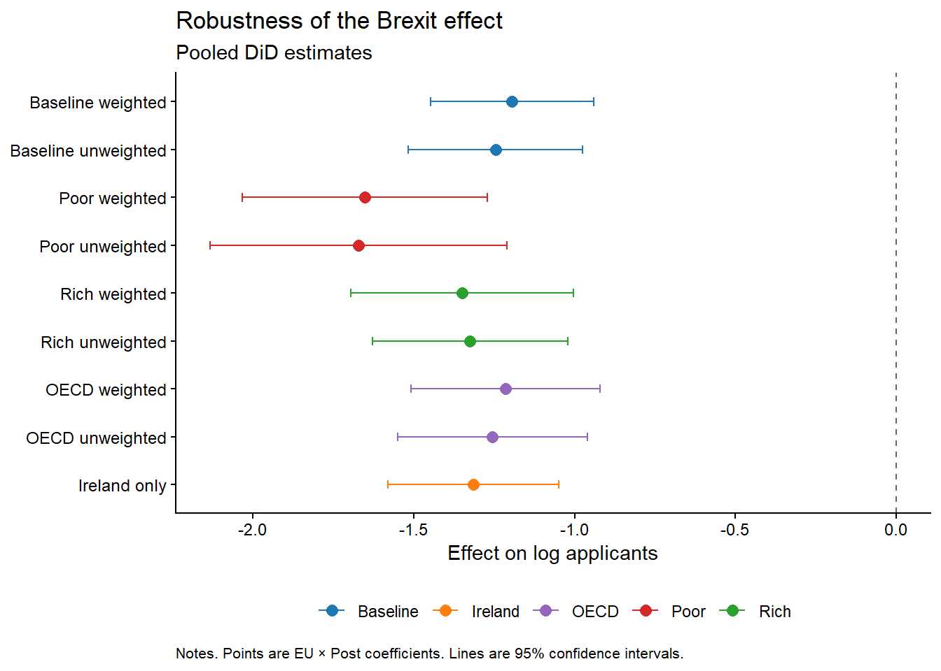
Note: Points are EU × Post coefficients from the pooled difference-in-differences specification; horizontal bars denote 95% confidence intervals. Baseline is the synthetic donor pool used in the main specification; Poor, Rich, and OECD are the alternative control groups described in Table 4, each shown weighted and unweighted; Ireland is a single-country comparison.
Figure 8. Saturated difference-in-differences robustness across control-group specifications.
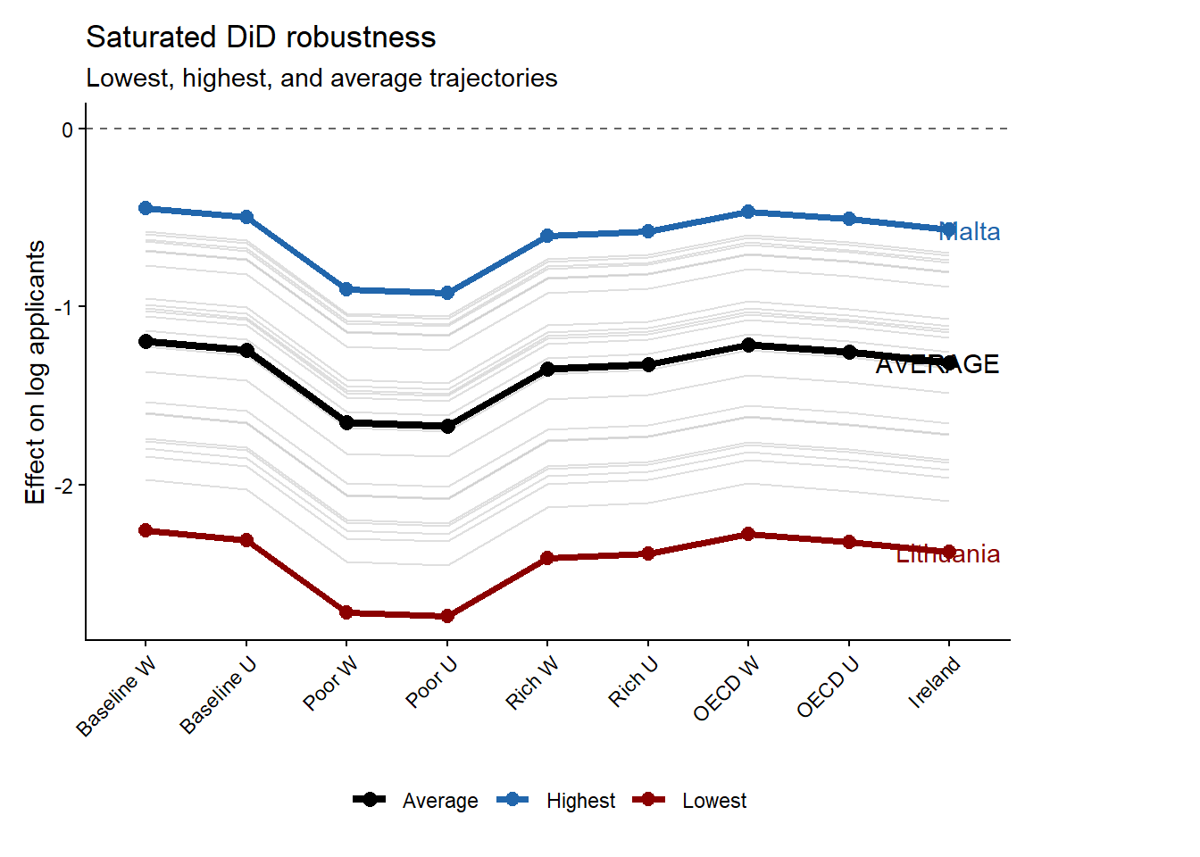
Note: Grey lines show country-specific dynamic treatment trajectories under each alternative control-group specification; the black line marks the cross-specification average. Malta (blue) and Lithuania (red) mark the upper and lower bounds of the estimated effects.

Figures 7 and 8 show that the estimated EU × Post coefficient remains large and negative across the baseline, OECD, high-income, low-income, and Ireland comparisons. Figure 8 demonstrates that the poor-country control group generates the most negative estimates. This is informative because it shows that the decline is not a generic post-pandemic fall in applicant numbers from low-income origins. If that were the mechanism, low-income non-EU countries should absorb much of the EU decline and push the coefficient toward zero.
The Irish case also survives as a robustness check against the Graduate route visa in 2021 both in figure 8 and 7. If the result were driven by common shocks to nearby or culturally connected markets or the Graduate route visa, the comparison with Ireland should substantially weaken the estimate. It does not. The estimate remains close to the other robustness results, reinforcing the interpretation that the post-2021 break reflects the EU-specific loss of Home Fee status and loan access. Figure 8 also strengthens the robustness of the saturated DiD results by showing that the ranking of the post-Brexit responses is preserved regardless of the chosen baseline. Another important point is that the weighting of the control group appears to affect the final estimates only at the margin. As a further check that does not rely on the constrained donor weights, we estimate the average treatment effect on the full donor pool with the standalone synthetic difference-in-differences estimator of Arkhangelsky et al. (2021). The estimator returns an ATT of −1.26 (jackknife standard error in 95% CI (-1.464, -1.053)), which falls squarely within the range of the pooled and saturated estimates reported above and confirms that the headline collapse in EU applicant numbers does not hinge on how the counterfactual is weighted.

6.2. Rambachan–Roth parallel-trends checks and synthetic difference-in-differences comparison
In response to a further round of peer review we run two additional robustness checks. The first re-examines the parallel-trends assumption behind the event study in the identification section using the HonestDiD implementation of the sensitivity analysis of Rambachan and Roth (2023), which replaces the binary test of whether pre-trends are flat with a measure of how large a post-treatment violation of parallel trends would have to be before the estimated effect loses its significance. Because the pre-treatment leads are jointly indistinguishable from zero (a joint Wald test gives p = 0.96) and are about two orders of magnitude smaller than the post-treatment coefficients, the loan-driven collapse in EU applicant numbers survives the relative-magnitudes sensitivity analysis across the full range of violations we examine. The robust confidence set for the first post-treatment year never crosses zero, running from −0.94 to −0.58 when no violation is permitted (Mbar equal to zero), from −0.95 to −0.56 when the post-period distortion is allowed to be as large as the worst pre-period deviation (Mbar equal to one), and still only from −0.98 to −0.53 at twice that size (Mbar equal to two). The breakdown value therefore exceeds two, so the result is not an artifact of an assumed pre-trend (Roth, 2022).
The second check re-estimates 26 separate synthetic difference-in-differences regressions, one per treated country, so the Arkhangelsky et al. (2021) estimator collapses to $N_{tr}=1$:
τjsdid=Yj,post-t≤T0 λtjYjt-i∈D​ωijYi, post-t≤T0 λtjYit
Table 5 compares these estimates with the saturated weighted DiD coefficients. After consistently removing aggregates, territories, dependencies, and UK home nations from the donor pool, the two sets correlate at 0.96 and have a mean absolute difference of 0.15 log points, with the synthetic DiD estimates larger than the weighted TWFE ones. Portugal and Slovakia have the largest discrepancy at about 0.50 log points but that is expected given Portugal’s documented 2021 reporting issue and Slovakia large baseline effect of about -1.52 log points. The ranking is similar across designs, although several level differences remain economically meaningful. All effects are statistically significant under a placebo based variance covariance matrix (jackknife was not possible due to fact we were using only one treated entity). As expected the correlation with the log of GDP per capita under Synthetic DiD is stronger when compared with TWFE, the log-GDP correlation rises from 0.585 under TWFE to 0.661 under synthetic DiD (including the Netherlands)

Table 5. Per-country saturated DiD (TWFE) and synthetic difference-in-differences estimates
Country | Saturated TWFE | Synthetic DiD | Absolute difference
Lithuania | -2.17 | -2.22 | 0.05
Bulgaria | -1.89 | -1.88 | 0.01
Finland | -1.76 | -1.71 | 0.04
Romania | -1.71 | -1.91 | 0.20
Poland | -1.67 | -1.99 | 0.32
Croatia | -1.66 | -1.79 | 0.13
Slovakia | -1.52 | -1.93 | 0.42
Latvia | -1.51 | -1.73 | 0.22
Estonia | -1.45 | -1.52 | 0.08
Slovenia | -1.28 | -1.25 | 0.03
Czech Republic | -1.14 | -1.41 | 0.28
Hungary | -1.11 | -1.39 | 0.28
Denmark | -1.05 | -1.10 | 0.06
Sweden | -0.97 | -1.01 | 0.05
Portugal | -0.94 | -1.43 | 0.49
Italy | -0.93 | -0.97 | 0.05
Cyprus (European Union) | -0.90 | -0.87 | 0.03
Greece | -0.87 | -0.98 | 0.11
Germany | -0.68 | -0.74 | 0.06
Belgium | -0.60 | -0.67 | 0.07
France | -0.60 | -0.73 | 0.13
Austria | -0.55 | -0.62 | 0.07
Netherlands | -0.54 | -0.67 | 0.13
Spain | -0.51 | -0.86 | 0.35
Luxembourg | -0.49 | -0.58 | 0.09
Malta | -0.36 | -0.60 | 0.23
N | 520 | 950 per regression
Note: Coefficients are on the log-applicant scale. Saturated TWFE effects are the country-specific EU × Post coefficients from the weighted model with 520 country-year observations. Synthetic DiD effects are 26 single-treated-unit estimates against 94 eligible sovereign-country controls (applicants more than or equal to 25). The correlation is 0.96 and the mean absolute difference is 0.15 log points.

6.3. Wage-threshold convergence and repayment protection
As a timing robustness check, we reconstruct the economic information set prevailing when prospective students applied by combining 2021 wages with the 2021/22 country-specific repayment thresholds and exchange rate. The new weighted average RPI is 1.96% (see appendix). Under this calibration, the estimated relationship between national income and the country elasticities is already statistically insignificant at a subjective discount rate of 3 percent. Exact income neutrality occurs at approximately 2.9 percent. However, the elasticities reach the literature bounds at similar subjective discount rates.
Figure 9. Country-specific loan-adjusted elasticities under the reconstructed 2021 information set (2021 wages, 2021/22 repayment thresholds, and exchange rate).
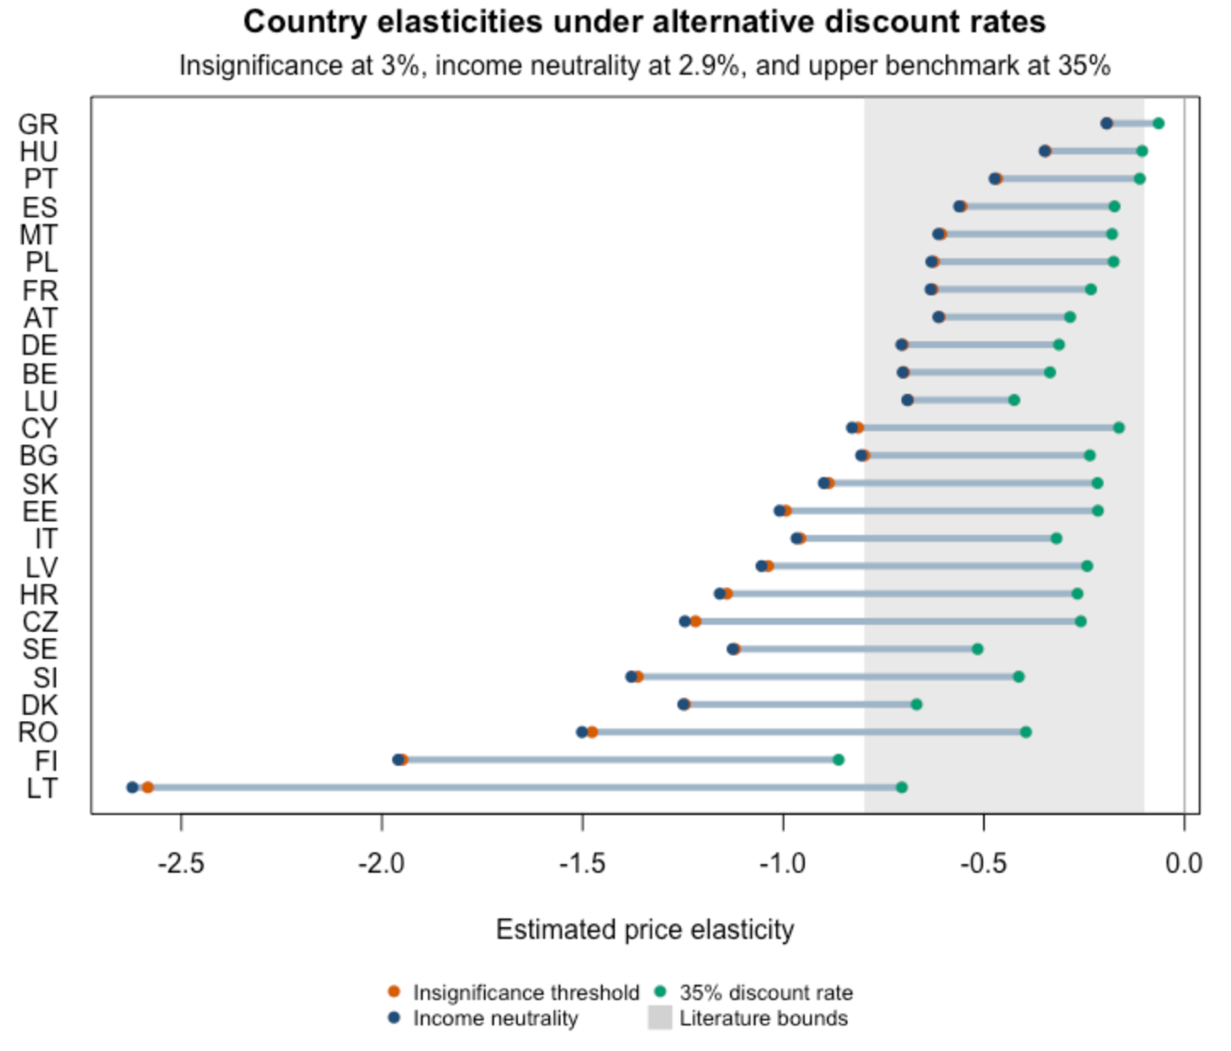

The reason why the income neutrality occurs much earlier in Figure 9, can be summarized by the ratio between the country-specific wage and the applicable repayment threshold, $\left(R_{jt}=\frac{w_{jt}}{τ_{jt}^{L}}\right)$ during and after 2021. When ($R_{jt}<1$), no immediate repayment is required. When the ratio exceeds one, repayment begins and the present value of the pre-Brexit loan increases. In 2021, 10 of the 25 countries in the wage-calibrated sample had ratios below one. The income-contingent system therefore provided substantial protection to graduates represented by these countries by postponing the beginning of repayment. This lowered the perceived value of the loan and enlarged the effective post-Brexit price increase appearing in the elasticity denominator. Because the largest application declines were generally concentrated among lower-income countries, their larger price denominators moderated the corresponding elasticity estimates. Repayment protection consequently counteracted the original relationship between national income and application responses, producing income neutrality at a comparatively low subjective discount rate. Although similar subjective discount rates are required to pull the country estimates toward the literature range, threshold protection causes the income gradient to disappear much earlier.
The robustness exercise shows that low-rate income neutrality does not, however, imply that the resulting elasticity levels are plausible. At the 2.9 percent neutral rate, only 13 of the 25 country estimates lie within the literature range of −0.80 to −0.10 (Figure 9). Lithuania illustrates the distinction. Its 2021 wage exceeded its repayment threshold, producing a relatively high loan present value and a small log price shock. Combined with its controlled TWFE coefficient of approximately −2.16, this generates an elasticity of approximately −2.6 (Figure 9). The aggregate income gradient is therefore neutral because contrasting country patterns cancel one another, even though several individual elasticities remain exceptionally large. This reveals the duality of the income contingent financing. On one side the income differences between applicants are compressed due to lower repayment thresholds relative to the expected earnings (that is why the income gradient collapses immediately on Figure 9), and the other side income contingent loans compress income differences by allowing subjective discounting to compensate for the lack of immediate financing.
In 2021, the repayment thresholds performed most of the equalization by protecting graduates in lower-wage countries. Following wage-threshold convergence, in 2025 this contractual protection weakened and subjective discounting performed more of the equalizing work. Which means that the movement from 2.9 to 14.9 percent thus reflects a change in repayment exposure across countries, while the underlying treatment estimates remain unchanged.

7. Discussion

7.1. Why now and not in 2012?
The central puzzle is why EU applicant numbers have not recovered, as they did after the 2012 reform, even though the UK remains the second most popular destination for international students globally (Cuibus et al., 2025). The explanation lies in access to the UK higher education market and the nature of the tuition shock itself because the 2012 and 2021 tuition shocks were not equivalent. The 2012 fee increase was accompanied by continued access to income-contingent tuition loans that covered the regulated fee. The nominal price increased, but students were not required to pay the corresponding amount upfront and could subjectively discount repayments occurring in the future; this was applied to both sides of the denominator since both the new and the old price were based on income contingent loans (plan 1 and 2). The 2021 reform simultaneously removed this financing mechanism and exposed new EU applicants to international tuition fees. This specific situation created the conditions required to better understand the structure of the European higher educational inequality.
To see this, Figure 10 traces the correlations between the implied elasticities and country characteristics across alternative subjective discount rates. At low discount rates, the elasticities are positively correlated with GDP, GNI, and consumption per capita. These correlations weaken as subjective discounting increases, with the GDP and GNI gradients crossing zero near the income-neutral discount rate. Most remaining correlations retain broadly stable signs but are estimated imprecisely.
Intergenerational income persistence follows a particularly interesting pattern. Its correlation with the elasticities is slightly negative at 3%, changes sign near 4%, and then stabilizes at approximately 0.3. Since the estimated elasticities are negative, this positive correlation means that applicants from countries with stronger intergenerational income persistence appear less price sensitive under moderate and high discounting. This implies a positive selection mechanism. Applicants reaching UK universities from less mobile societies may disproportionately come from affluent families that are better able to absorb the loss of public financing. The HC1 confidence interval nevertheless includes zero at the margin, so the pattern remains suggestive.
The correlation profiles also show that the cross-country ranking of the elasticities is not invariant to the valuation of the loan. The same estimated treatment effects produce different cross-country gradients because the experienced price change depends on starting earnings, repayment thresholds, repayment duration, and subjective discounting. The income-contingent loan compressed these differences and operated as an equalizing institution for European educational mobility. Its withdrawal made household liquidity, access to private finance and (probably) intergenerational income persistence central determinants of entry into the UK market.
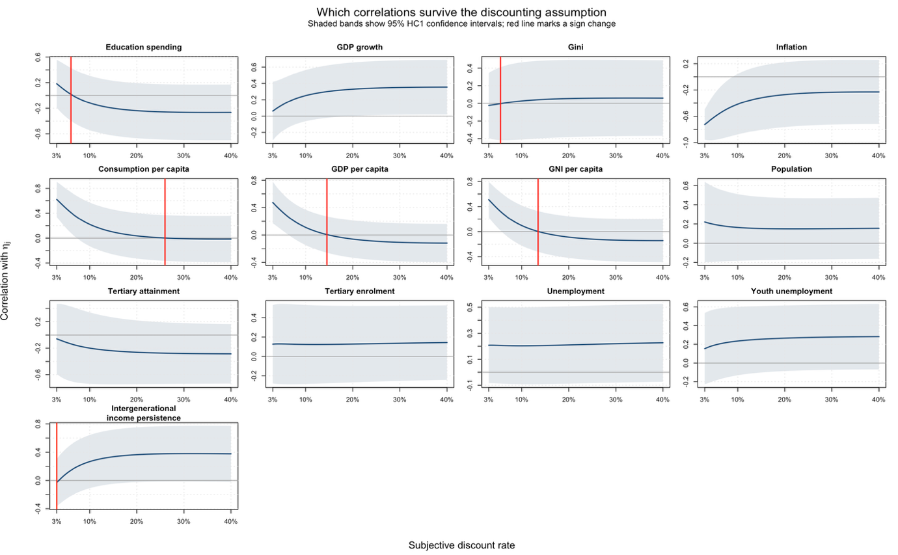
Figure 10. Implied demand elasticity as a function of the economic value of the UK student loan.
Note: all of the covariates were z-score normalized with the scale function in R and pushed through univariate OLS regressions across a sequence of multiple discount rates. Used are HC1 standard errors across all specifications. N is equal to 25. All data is collected from World Bank developmental indicators except the intergenerational wealth indicator that comes from “IGE_Munoz_VanderWeide_June2025.dta” pull and is converted from STATA to R programmatically.

7.2. Are elasticities above one plausible?
The income-neutral panel of Figure 5 shows that the elasticities for Finland, Lithuania and Romania remain larger than one in absolute magnitude even after the income gradient is removed. These estimates are not inconsistent with a well-defined demand curve. Under the constant-elasticity demand function ($Q(P)=AP^{η}$), doubling the price changes demand by the factor ($2^{η}).$ An elasticity of −1 therefore implies a 50 percent decline, while an elasticity of −2 implies a 75 percent decline. Values above one in absolute magnitude remain compatible with positive applicant numbers.
EU applicants also possessed a wider substitution margin than domestic students. The 2012 reform increased tuition within the UK system and preserved income-contingent financing, leaving domestic applicants principally to choose among institutions facing similar rules. Following Brexit, EU applicants could instead substitute toward comparable programmes in Ireland, the Netherlands or Germany. Elasticities above one consequently describe the reallocation of internationally mobile applicants across national higher education markets. They do not require an equivalent collapse in total European participation. Their magnitude reflects both the high substitutability of the UK as an educational destination and the political decision to replace income-contingent access with an immediate market price.
Another possible reason for the higher elasticities is the lack of well-established student credit institutions across poorer EU countries capable of buffering the loss of income-contingent financing. Given the existence of similar mechanisms across the EU, we might have expected students to be more willing to continue their education in the UK. Decades of an integrated higher education market across the Union may have discouraged national governments and banking systems from focusing on the infrastructure and implementation of student financing because receiving systems absorbed the costs, thereby producing price-sensitive students.

7.3. Income neutrality and fiscal drag in the post-Brexit world
As discussed, income-contingent financing shifted some of the cost to the future and linked repayment to future earnings. As shown in Section 6.3, in 2021 average wages in ten of the twenty-five countries included in the calibration were initially below their relevant repayment thresholds. The loan thus functioned as a kind of cross-country social insurance, safeguarding graduates in countries with lower wages by allowing repayment to be deferred and thereby lowering the perceived value of the pre-Brexit price. However, wage convergence in 2024, within the union, altered this situation by deepening the income gradient, which in turn led to a kind of 'fiscal drag' affecting the income thresholds.
The political significance of threshold protection lay in allowing an income-neutral application response without requiring equal incomes across Europe. The 2021 repayment system gave the appearance of equality. When nominal wages later rose, eight of the ten countries which had originally been protected went above their thresholds. The progressivity of the loan decreased even though the repayment rate was not formally increased. This is similar to fiscal drag, since growth in nominal wages causes graduates to enter into repayment even if their real purchasing power has not increased in proportion. As a result, the distributional effects of a fixed loan agreement can change without a new political decision. After Brexit, the protection was completely eliminated for new EU students, resulting in a very aggressive international tuition fee that replaced an obligation that had been sensitive to the country and dependent on the future. By removing the loan, the educational risk shifted from the repayment system to students and their families, revealing differences in national incomes that the earlier financing arrangement had partly absorbed.

8. Conclusion
The manuscript contains three main findings. First, the estimated price elasticities of demand for international students are considerably higher than the usual range of 0.10 to 0.80, typically observed in the literature, with absolute values exceeding 1.5 in several EU countries. Second, when Brexit is treated as a common price shock, a clear income gradient emerges, with applicants from lower-income countries showing much greater responsiveness. Third, once the price change is adjusted to take into account country-specific and subjectively discounted valuations of the lost income-contingent loan, the order of the elasticities changes and their absolute magnitudes are reduced; the income gradient disappears at an annual subjective discount rate of about 14.9%, at which point most of the implied elasticities fall within the ranges stated in the literature, although a few do not. The variation at the start is primarily due to differences in the financial intensity of the Brexit shock, not permanent differences in preferences. At the income-neutral level, the elasticities show only weak and imprecisely estimated correlations with the other national indicators. Marginal associations remain in the cases of intergenerational income persistence, youth unemployment, and GDP growth. This indicates that the findings do not reveal a stable macroeconomic profile for price-sensitive applicants; rather, they show that the income-contingent loan reduced differences in how the price of UK education was experienced before 2021 and acted as an equalizing institution with respect to educational mobility in Europe.
Most member states lacked comparable financial infrastructure to fund international students. In countries like India, where high tuition fees for studying abroad and restricted household liquidity had long influenced how students moved internationally, banks and specialized education lenders had already created products to help cover the cost of studying overseas. Since the EU functioned within a quite different institutional setup, in which movement of students within Europe and, prior to Brexit, access to UK student financing meant that there was no need for such private financing markets, Brexit led EU applicants to have to pay international tuition fees without having a similar financing infrastructure already existing. This resulted in severe liquidity problems, especially for applicants from less affluent member states, and likely caused some of their demand to shift to other higher-education systems.
In conclusion, the findings suggest a need for further study of student mobility, intergenerational income persistence, educational inequality, and the role of subjective discounting in decisions about education. Models examining demand for international higher education should account for the portability of student finance, the possibility of substituting one national education system for another, and capacity limitations in receiving countries. Because these factors raise an important issue about how scarce places and public support are distributed between domestic and internationally mobile applicants, future research should determine whether greater international openness expands educational opportunities and at what point fixed capacity limits access for one group in favor of another.

References
Abadie, A. (2021). Using synthetic controls: Feasibility, data requirements, and methodological aspects. Journal of Economic Literature, 59(2), 391–425. https://doi.org/10.1257/jel.20191450
Arel-Bundock, V. (2022). WDI: World Development Indicators and other World Bank data (R package version 2.7.8) [Computer software]. https://CRAN.R-project.org/package=WDI
Arel-Bundock, V., Enevoldsen, N., & Yetman, C. J. (2018). countrycode: An R package to convert country names and country codes. Journal of Open Source Software, 3(28), 848. https://doi.org/10.21105/joss.00848
Arkhangelsky, D., Athey, S., Hirshberg, D. A., Imbens, G. W., & Wager, S. (2021). Synthetic difference-in-differences. American Economic Review, 111(12), 4088–4118. https://doi.org/10.1257/aer.20190159
Brown, R. (2011). After Browne: The new competitive regime for English higher education (CSHE Research & Occasional Paper Series No. CSHE.7.11). Center for Studies in Higher Education, University of California, Berkeley. https://escholarship.org/uc/item/9569q5n5
Calhoun, C. (2017). Populism, nationalism and Brexit. In W. Outhwaite (Ed.), Brexit: Sociological responses (pp. 57–76). Anthem Press. https://calhoun.faculty.asu.edu/sites/g/files/litvpz3321/files/publications/articles/populism_brexit.pdf
Campbell, R., & Siegel, B. (1967). The demand for higher education in the United States, 1919–1964. American Economic Review, 57(3), 482–494. https://www.jstor.org/stable/1812115
Clifton-Sprigg, J., Homburg, I., Huyghe, A., & Vujić, S. (2025). International student migration: Did Brexit close the door to EU students? (IZA Discussion Paper No. 18178). IZA Institute of Labor Economics. https://www.iza.org/publications/dp/18178/international-student-migration-did-brexit-close-the-door-to-eu-students
Conlon, G., Lader, R., Halterbeck, M., & Hedges, S. (2021). EU exit: Estimating the impact on UK higher education (Research Report No. DFE-RR1093). Department for Education. https://assets.publishing.service.gov.uk/government/uploads/system/uploads/attachment_data/file/958998/EU_exit_estimating_the_impact_on_UK_higher_education.pdf
Connelly, R., Playford, C. J., Gayle, V., & Dibben, C. (2016). The role of administrative data in the big data revolution in social science research. Social Science Research, 59, 1–12. https://doi.org/10.1016/j.ssresearch.2016.04.015
Crawford, C., & Jin, W. (2014). Payback time? Student debt and loan repayments: What will the 2012 reforms mean for graduates? (IFS Report R93). Institute for Fiscal Studies. https://doi.org/10.1920/re.ifs.2014.0093
Crawford, C., Maris, R., Petit, F., & Wyness, G. (2025). Degrees of demand: Price elasticity in higher education (CEPEO Working Paper Series No. 25-13). UCL Centre for Education Policy and Equalising Opportunities. https://ideas.repec.org/p/ucl/cepeow/25-13.html
Cuibus, M., Walsh, P. W., & Němeček, F. (2025). Student migration to the UK. The Migration Observatory, COMPAS, University of Oxford. https://migrationobservatory.ox.ac.uk/resources/briefings/student-migration-to-the-uk/
Driscoll, J. C., & Kraay, A. C. (1998). Consistent covariance matrix estimation with spatially dependent panel data. Review of Economics and Statistics, 80(4), 549–560. https://doi.org/10.1162/003465398557825
Dwenger, N., Storck, J., & Wrohlich, K. (2012). Do tuition fees affect the mobility of university applicants? Evidence from a natural experiment. Economics of Education Review, 31(1), 155–167. https://doi.org/10.1016/j.econedurev.2011.10.004
Eurostat. (2025). Average full-time adjusted salary per employee [Data set]. https://doi.org/10.2908/NAMA_10_FTE
Findlay, A., King, R., Stam, A., & Ruiz-Gelices, E. (2006). Ever reluctant Europeans: The changing geographies of UK students studying and working abroad. European Urban and Regional Studies, 13(4), 291–318. https://doi.org/10.1177/0969776406065429
Hand, D. J. (2018). Statistical challenges of administrative and transaction data. Journal of the Royal Statistical Society, Series A, 181(3), 555–605. https://doi.org/10.1111/rssa.12315
Home Office. (2021, July 1). Graduate route for best and brightest launches. GOV.UK. https://www.gov.uk/government/news/graduate-route-for-best-and-brightest-launches
Hoxby, C. M. (1997). How the changing market structure of U.S. higher education explains college tuition (NBER Working Paper No. 6323). National Bureau of Economic Research. https://doi.org/10.3386/w6323
Leslie, L. L., & Brinkman, P. T. (1987). Student price response in higher education: The student demand studies. Journal of Higher Education, 58(2), 181–204. https://doi.org/10.1080/00221546.1987.11778239
Li, H., Campbell, D., & Erdem, S. (2022). Measuring time preferences using stated credit repayment choices. Journal of Quantitative Economics, 20, 43–67. https://doi.org/10.1007/s40953-021-00283-7
Locke, W., & Marini, G. (2021). The rapid increase in faculty from the European Union in UK higher education institutions and the possible impact of Brexit. In F. Huang & A. R. Welch (Eds.), International faculty in Asia (Vol. 21). Springer. https://doi.org/10.1007/978-981-33-4980-3_12
Luthra, R. R. (2020). Mitigating the hostile environment: The role of the workplace in EU migrant experience of Brexit. Journal of Ethnic and Migration Studies, 47(1), 190–207. https://doi.org/10.1080/1369183x.2020.1726173
Matousek, J., Havranek, T., & Irsova, Z. (2022). Individual discount rates: A meta-analysis of experimental evidence. Experimental Economics, 25(1), 318–358. https://doi.org/10.1007/s10683-021-09716-9
Mayhew, K. (2022). Brexit and UK higher education. Oxford Review of Economic Policy, 38(1), 179–187. https://doi.org/10.1093/oxrep/grab043
McFadden, D. (1974). Conditional logit analysis of qualitative choice behavior. In P. Zarembka (Ed.), Frontiers in econometrics (pp. 105–142). Academic Press. https://eml.berkeley.edu/reprints/mcfadden/zarembka.pdf
McQuone, R., & Simons, J. (2025). Counting the cost: Modelling the economic impact of a potential levy on international student fees. Public First. https://www.publicfirst.co.uk/couting-the-cost
Murphy, R., Scott-Clayton, J., & Wyness, G. (2019). The end of free college in England: Implications for enrolments, equity, and quality. Economics of Education Review, 71, 7–22. https://doi.org/10.1016/j.econedurev.2018.11.007
Neville, R., Rowe, F., & Singleton, A. (2024). Unraveling the Brexit–COVID-19 nexus: Assessing the decline of EU student applications into UK universities. Data & Policy, 6, Article e45. https://doi.org/10.1017/dap.2024.42
Rambachan, A., & Roth, J. (2023). A more credible approach to parallel trends. Review of Economic Studies, 90(5), 2555–2591. https://doi.org/10.1093/restud/rdad018
Roth, J. (2022). Pretest with caution: Event-study estimates after testing for parallel trends. American Economic Review: Insights, 4(3), 305–322. https://doi.org/10.1257/aeri.20210236
Sá, F. (2014). The effect of tuition fees on university applications and attendance: Evidence from the UK. SSRN. https://doi.org/10.2139/ssrn.2481553
Sá, F. (2017). The effect of university fees on applications, attendance and course choice: Evidence from a natural experiment in the UK [Accepted manuscript]. King’s College London. https://kclpure.kcl.ac.uk/ws/files/97277490/The_E_ect_of_University_Fees_SA_Accepted13July2017_GREEN_AAM.pdf
Sá, F. (2019). The effect of university fees on applications, attendance and course choice: Evidence from a natural experiment in the UK. Economica, 86(343), 607–634. https://doi.org/10.1111/ecca.12278
Savoca, E. (1990). Another look at the demand for higher education: Measuring the price sensitivity of the decision to apply to college. Economics of Education Review, 9(2), 123–134. https://doi.org/10.1016/0272-7757(90)90040-C
Solís, A. (2017). Credit access and college enrollment. Journal of Political Economy, 125(2), 562–622. https://doi.org/10.1086/690829
Student Loans Company. (2021). Overseas earnings thresholds for Plan 2 student loans, 2021–22. GOV.UK. https://www.gov.uk/government/publications/overseas-earnings-thresholds-for-plan-2-student-loans
Student Loans Company. (2024). Student loans interest rates and repayment threshold announcement. GOV.UK. https://www.gov.uk/government/news/student-loans-interest-rates-and-repayment-threshold-announcement--5
Student Loans Company. (2025). Student loans interest rates and repayment threshold announcement. GOV.UK. https://www.gov.uk/government/news/student-loans-interest-rates-and-repayment-threshold-announcement--6
Student Loans Company. (2026). Overseas earnings thresholds for Plan 2 student loans, 2025–26. GOV.UK. https://www.gov.uk/government/publications/overseas-earnings-thresholds-for-plan-2-student-loans/overseas-earnings-thresholds-for-plan-2-student-loans-2024-25
Student Loans Company. (n.d.). Overseas earnings thresholds for Plan 2 student loans, 2020–21. GOV.UK. Retrieved February 11, 2022, archived under https://web.archive.org/web/20220211005047/https://www.gov.uk/government/publications/overseas-earnings-thresholds-for-plan-2-student-loans/overseas-earnings-thresholds-for-plan-2-student-loans-2020-21
UCAS. (2014, November 7). UCAS analysis answers five key questions on the impact of the 2012 tuition fees increase in England. https://www.ucas.com/corporate/news-and-key-documents/news/ucas-analysis-answers-five-key-questions-impact-2012-tuition-fees-increase-england
UCAS. (2022). UCAS undergraduate sector-level end of cycle data resources 2021 [Data set]. https://www.ucas.com/data-and-analysis/undergraduate-statistics-and-reports/ucas-undergraduate-sector-level-end-of-cycle-data-resources-2021
UCAS. (2024). UCAS Undergraduate end of cycle data resources 2024 [Data set]. https://www.ucas.com/data-and-analysis/undergraduate-statistics-and-reports/ucas-undergraduate-end-of-cycle-data-resources-2024
UCAS. (2025). Undergraduate sector-level end of cycle data resources 2025 [Data set]. https://www.ucas.com/data-and-analysis/undergraduate-statistics-and-reports/ucas-undergraduate-end-of-cycle-data-resources-2025
UK Government. (n.d.-a). Repaying your student loan: What you pay. GOV.UK. https://www.gov.uk/repaying-your-student-loan/what-you-pay
UK Government. (n.d.-b). When your student loan gets written off or cancelled. GOV.UK. https://www.gov.uk/repaying-your-student-loan/when-your-student-loan-gets-written-off
UK Government. (n.d.-c). How interest is calculated (Plan 2). GOV.UK. https://www.gov.uk/guidance/how-interest-is-calculated-plan-2
Warner, J. T., & Pleeter, S. (2001). The personal discount rate: Evidence from military downsizing programs. American Economic Review, 91(1), 33–53. https://doi.org/10.1257/aer.91.1.33
World Bank. (2025). World Development Indicators [Data set]. https://databank.worldbank.org/source/world-development-indicators

The Brexit Tuition Shock and the Price Elasticity of International Students
Evidence from a Natural Experiment
Online appendix
Stoycho Rusinov and James Rafiki Aketch

A1. Control-group construction
The analysis uses UCAS applicant counts by origin country and application cycle. Treated origins are European Union countries excluding Ireland, and candidate donors are non-EU origins. For each country c, the outcome is the natural logarithm of the applicant count. The pre-reform window covers 2014-2020 and contains seven observations per country:
Y_{ct} = ln(App_{ct})
Donors are selected on the shape of the pre-reform trajectory instead of the level of applications. Each logged series is z-standardized within country over 2014-2020:
z_{ct} = (Y_{ct} - mean_{c}) / s_{c}
Pairwise Euclidean distances are then calculated between the standardized paths, and every treated origin is matched to the three non-EU paths with the smallest distances. This step removes the mechanical influence of market size while retaining the timing and direction of pre-reform movements.
After donor selection, estimation returns to logged levels. For each treated origin j, nonnegative donor weights that sum to one minimize pre-reform squared prediction error. Country-specific weights are set to zero outside the relevant three-country pool, averaged across the 26 treated origins, and normalized. The final normalization changes the weights only up to floating-point precision. The procedure follows the synthetic-control principle of choosing a transparent weighted comparison path before estimating post-reform effects (Abadie et al., 2010; Abadie & Cattaneo, 2018).
The resulting global donor weights enter the saturated difference-in-differences regression as fixed observation weights. Treated observations receive unit weight, and donor weights are multiplied by 26 so that the treated and control sides carry equal total weight. The specification includes country and cycle fixed effects and the time-varying controls described in the manuscript. Donor selection and weighting use only pre-treatment outcomes.

A2. From post-reform effects to price elasticities
Clifton-Sprigg et al. (2025) derive a mechanical elasticity from a synthetic-DiD average treatment effect. To state the structural assumptions needed for the present transformation, consider a segmented constant-elasticity demand system indexed by origin j and year t.
Let A_{j,t} denote applicants from origin j and Pj,t the effective price they face. A signed country-specific elasticity model is
$$logA_{j,t}=μ_{j}+δ_{t}+η_{j}logP_{j,t}+X_{j,t}'θ+ε_{j,t}.$$
where:
- $μ_{j}$ are country fixed effects, or time-invariant demand shifters;
- $δ_{t}$ are year fixed effects, including common shocks;
- $X_{jt}^{'}$ is a vector of observed controls;
- $η_{j}<0$ is the signed demand elasticity for origin j;
- $ε_{jt}$ is a mean-zero demand disturbance.
The signed elasticity is $η_{j}=\frac{∂\log{Q_{jt}}}{∂\log{P_{jt}}}$. No constant is added inside the applicant logarithm because every sample count is strictly positive. Let ${Post}_{t}$ be an indicator equal to 1 in years after the new fee regime is introduced (post-2020) and 0 otherwise, and let $1\left[Country j in EU\right]$ indicate EU origin countries (excluding Ireland). The Brexit shock enters the price equation as the system of simultaneous equations defining the country-specific reaction to the exogenous tuition shock:
$$logP_{j,t}=ϕ_{j}+k_{j}1\{j∈EU\}{Post}_{t}+ν_{j,t}.$$
- ϕj is the pre-reform log price level for origin j;
- kj is the Brexit-induced log price change for origin j;
- νj,t is a mean-zero price disturbance.
Combining equations (1) and (2) yields:
$$logA_{j,t}=μ_{j}+δ_{t}+η_{j}\left[ϕ_{j}+k_{j}1\{j∈EU\}{Post}_{t}+ν_{j,t}\right]+X_{j,t}^{'}θ+ε_{j,t}.$$
$$logA_{j,t}=\left(μ_{j}+η_{j}ϕ_{j}\right)+δ_{t}+η_{j}k_{j}1\{j∈EU\}{Post}_{t}+X_{j,t}^{'}θ+\left(ε_{j,t}+η_{j}ν_{j,t}\right).$$
Let αj = μj + ηjϕj and $ε_{jt}^{*} = ε_{jt}+η_{j}ν_{jt}$. The fixed effects absorb time-invariant components, giving the reduced-form specification below. The reported tables use Driscoll–Kraay standard errors with one lag. Because the panels contain only nine or ten time periods, inference should also be treated as a short-panel sensitivity concern.
$$logA_{j,t}=α_{j}+δ_{t}+β_{j}1\{j∈EU\}{Post}_{t}+X_{j,t}^{'}θ+ε_{j,t}^{*}.$$
The country-specific DiD coefficient is $β_{j}=η_{j}k_{j}$, so the signed elasticity is $η_{j}=\frac{β_{j}}{k_{j}}$. Under the maintained price equation and $Δν_{j} ≈ 0$, the Brexit price change is:
$$ΔlogP_{j}^{Brexit}=k_{j}.$$
Under a common change from £9,250 to £22,200, the homogeneous log price shock is:
$$k_{j}=log\left(22,200\right)-log\left(9,250\right)=0.875.$$
and since:
$$PV_{subjective}\left(δ,w_{j}\right)=max\left\{1,\sum_{t=1}^{30}{\frac{R_{t}\left(w_{j}\right)}{{\left(1+δ\right)}^{t}}}\right\}.$$
Country-specific price shocks are then specified as:
$$k_{j}\left(δ\right)=log\left(22,200\right)-log\left[PV_{subjective,j}\left(δ\right)\right].$$
A near-zero income gradient after this rescaling is compatible with loan-valuation mechanics explaining much of the raw cross-country pattern. Intentionally, we discount one year of the loan since the student is required to pay for one year of education at a time.

A3. Initial and later post-reform effects
We separate the post-reform period into an initial window covering 2021-2023 and a later window covering 2024-2025. The saturated regression estimates one country-specific effect in each window while retaining country and cycle fixed effects and the same control variables as the main specification, produces:
Δ_{j} = β_{j,later} - β_{j,initial}
Because the estimated country effects are predominantly negative, a positive difference indicates partial recovery after 2023, while a negative difference indicates that the decline intensified. A value near zero indicates persistence. The comparison is descriptive. It shows whether the initial contraction weakened, stabilized, or deepened once the fee regime was established and the most acute pandemic disruption had passed.

A4. Log and arc elasticities
Using ΔQ/Q = exp(β) − 1, Malta’s β = −0.362 implies −30.4%, Lithuania’s β = −2.173 implies −88.6%, and the pooled ATT β = −1.109 implies −67.0%, all relative to the control trajectory.
A naive arc elasticity divides the proportional quantity change by the 140% arithmetic price increase:
$$η_{arc}=\frac{exp\left(-1.109\right)-1}{1.4}=-0.479.$$
However, for a finite log price change k and log quantity change β, the exact relationship is:
$$η_{arc}=\frac{ΔQ/Q}{ΔP/P}=\frac{e^{β}-1}{e^{k}-1}.$$
The signed log elasticity is $η_{\log{ }} =\frac{β}{k}$. If $β = η_{\log{ }}k$, then:
$$\lim_{k→0}\frac{e^{η_{log}k}-1}{e^{k}-1}=η_{log}.$$
The measures coincide only as the price change approaches zero. A constant-elasticity demand curve is linear in log-log space, not convex there. In levels, the large positive price change makes the secant percentage-change measure substantially flatter than the signed log elasticity in this application.
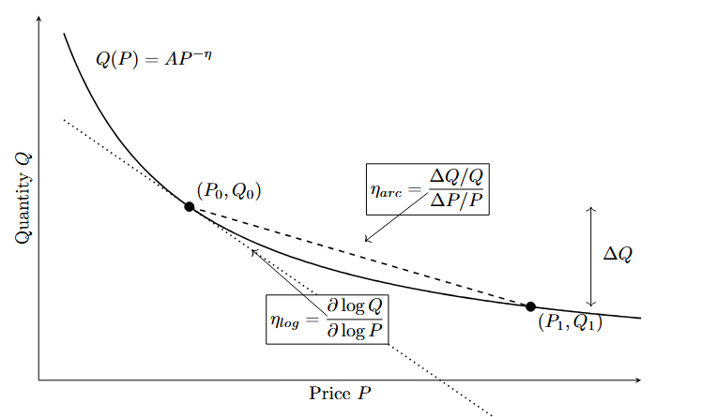
Figure A1
Constant-elasticity demand and alternative elasticity measures
Note. The dashed line represents the arc measure between the two equilibria. The dotted line represents the signed log elasticity at the initial equilibrium. For the Brexit calibration, the absolute arc elasticity is smaller than the absolute log elasticity due to the massive price shift.

A5. Detailed regression results
Table A1
Country-specific post-reform log effects under alternative specifications
Variable | Weighted  TWFE | Weighted  country FE | Weighted  no FE | Unweighted  TWFE
Intercept |  |  | 6.844***  (0.032)
Austria | -0.549***  (0.053) | -0.525***  (0.051) | -0.961***  (0.046) | -0.686***  (0.080)
Belgium | -0.603***  (0.066) | -0.579***  (0.063) | -0.434***  (0.059) | -0.740***  (0.093)
Bulgaria | -1.887***  (0.131) | -1.864***  (0.128) | -1.007***  (0.101) | -2.025***  (0.158)
Croatia | -1.655***  (0.109) | -1.631***  (0.105) | -2.572***  (0.098) | -1.792***  (0.130)
Cyprus | -0.902***  (0.067) | -0.879***  (0.066) | 0.255***  (0.042) | -1.040***  (0.096)
Czech Republic | -1.137***  (0.056) | -1.114***  (0.051) | -0.901***  (0.052) | -1.275***  (0.065)
Denmark | -1.046***  (0.109) | -1.023***  (0.105) | -1.609***  (0.093) | -1.184***  (0.132)
Estonia | -1.447***  (0.118) | -1.424***  (0.115) | -2.237***  (0.104) | -1.585***  (0.144)
Finland | -1.756***  (0.206) | -1.733***  (0.204) | -1.817***  (0.174) | -1.894***  (0.232)
France | -0.597***  (0.062) | -0.574***  (0.059) | 1.179***  (0.060) | -0.735***  (0.085)
Germany | -0.681***  (0.072) | -0.658***  (0.071) | 0.652***  (0.063) | -0.819***  (0.100)
Greece | -0.866***  (0.078) | -0.842***  (0.078) | 0.105  (0.077) | -1.003***  (0.103)
Hungary | -1.114***  (0.077) | -1.091***  (0.075) | -1.032***  (0.073) | -1.252***  (0.089)
Italy | -0.925***  (0.112) | -0.902***  (0.110) | 0.676***  (0.098) | -1.063***  (0.139)
Latvia | -1.512***  (0.127) | -1.488***  (0.122) | -1.928***  (0.122) | -1.649***  (0.145)
Lithuania | -2.173***  (0.277) | -2.150***  (0.271) | -1.412***  (0.244) | -2.311***  (0.297)
Luxembourg | -0.493***  (0.047) | -0.470***  (0.040) | -1.237***  (0.040) | -0.630***  (0.068)
Malta | -0.362***  (0.045) | -0.338***  (0.049) | -2.335***  (0.041) | -0.499***  (0.049)
Netherlands | -0.535***  (0.024) | -0.512***  (0.026) | -0.491***  (0.037) | -0.672***  (0.047)
Poland | -1.668***  (0.149) | -1.645***  (0.146) | -0.135  (0.141) | -1.806***  (0.164)
Portugal | -0.939*  (0.350) | -0.916*  (0.345) | -0.087  (0.321) | -1.077*  (0.362)
Romania | -1.711***  (0.136) | -1.688***  (0.133) | -0.363*  (0.130) | -1.849***  (0.157)
Slovakia | -1.516***  (0.119) | -1.493***  (0.119) | -1.570***  (0.094) | -1.654***  (0.125)
Slovenia | -1.280***  (0.121) | -1.256***  (0.120) | -3.108***  (0.094) | -1.417***  (0.147)
Spain | -0.508***  (0.083) | -0.484***  (0.079) | 0.964***  (0.065) | -0.645***  (0.086)
Sweden | -0.967***  (0.140) | -0.944***  (0.138) | -0.630***  (0.124) | -1.104***  (0.166)
Observations | 520 | 520 | 520 | 520
Weights | Yes | Yes | Yes | No
Country fixed effects | Yes | Yes | No | Yes
Year fixed effects | Yes | No | No | Yes
Adjusted R² | 0.98 | 0.98 | 0.27 | 0.98
Within R² | 0.82 | 0.87 |  | 0.81
Note. Driscoll-Kraay standard errors with one lag are in parentheses. + p < .10, * p < .05, ** p < .01, *** p < .001.

Variable | S1 Saturated DiD | S2 + GDPpc | S3 + GDPpc + Pop | S4 + GDPpc + Pop + YouthUnempl
Austria | -0.529***  (0.058) | -0.521***  (0.059) | -0.499***  (0.052) | -0.504***  (0.057)
Belgium | -0.581***  (0.073) | -0.583***  (0.070) | -0.570***  (0.064) | -0.575***  (0.068)
Bulgaria | -1.855***  (0.149) | -1.888***  (0.138) | -1.770***  (0.095) | -1.781***  (0.105)
Croatia | -1.616***  (0.127) | -1.657***  (0.117) | -1.528***  (0.097) | -1.529***  (0.101)
Cyprus (European Union) | -0.887***  (0.069) | -0.920***  (0.059) | -0.948***  (0.060) | -0.944***  (0.054)
Czech Republic | -1.121***  (0.064) | -1.121***  (0.060) | -1.070***  (0.071) | -1.075***  (0.072)
Denmark | -1.035***  (0.131) | -1.037***  (0.127) | -1.025***  (0.122) | -1.030***  (0.127)
Estonia | -1.412***  (0.132) | -1.412***  (0.124) | -1.393***  (0.120) | -1.407***  (0.132)
Finland | -1.680***  (0.217) | -1.669***  (0.220) | -1.625***  (0.206) | -1.622***  (0.206)
France | -0.575***  (0.069) | -0.571***  (0.068) | -0.541***  (0.058) | -0.537***  (0.057)
Germany | -0.659***  (0.077) | -0.650***  (0.079) | -0.581***  (0.055) | -0.584***  (0.058)
Greece | -0.819***  (0.067) | -0.835***  (0.059) | -0.735***  (0.035) | -0.719***  (0.042)
Hungary | -1.076***  (0.086) | -1.098***  (0.082) | -1.008***  (0.080) | -1.020***  (0.078)
Italy | -0.886***  (0.118) | -0.892***  (0.113) | -0.824***  (0.091) | -0.811***  (0.084)
Latvia | -1.474***  (0.154) | -1.488***  (0.145) | -1.383***  (0.126) | -1.389***  (0.129)
Lithuania | -2.163***  (0.347) | -2.187***  (0.334) | -2.157***  (0.331) | -2.164***  (0.339)
Luxembourg | -0.505***  (0.056) | -0.490***  (0.056) | -0.575***  (0.085) | -0.577***  (0.090)
Malta | -0.351***  (0.044) | -0.376***  (0.050) | -0.523***  (0.064) | -0.526***  (0.065)
Netherlands | -0.521***  (0.023) | -0.523***  (0.023) | -0.522***  (0.024) | -0.527***  (0.027)
Poland | -1.612***  (0.165) | -1.649***  (0.152) | -1.516***  (0.132) | -1.524***  (0.135)
Portugal | -0.863+  (0.421) | -0.867+  (0.420) | -0.833+  (0.417) | -0.836+  (0.421)
Romania | -1.653***  (0.154) | -1.680***  (0.145) | -1.577***  (0.124) | -1.597***  (0.135)
Slovakia | -1.472***  (0.117) | -1.482***  (0.113) | -1.385***  (0.116) | -1.396***  (0.110)
Slovenia | -1.201***  (0.121) | -1.218***  (0.117) | -1.171***  (0.099) | -1.177***  (0.107)
Spain | -0.492***  (0.094) | -0.488***  (0.096) | -0.490**  (0.099) | -0.476**  (0.102)
Sweden | -0.910***  (0.143) | -0.906***  (0.142) | -0.916***  (0.141) | -0.927***  (0.151)
c_log_GDPpc |  | 0.279  (0.254) | 0.332  (0.262) | 0.376  (0.236)
c_log_Pop15_64 |  |  | 1.646**  (0.359) | 1.617**  (0.340)
c_YouthUnempl |  |  |  | 0.002  (0.003)
Num.Obs. | 468 | 468 | 468 | 468
R2 Within | 0.817 | 0.818 | 0.830 | 0.830
R2 Within Adj. | 0.804 | 0.805 | 0.818 | 0.817
FE: Domicile_named_country | YES | YES | YES | YES
FE: Year | YES | YES | YES | YES
Weights | YES | YES | YES | YES
Table A2
Country-specific log effects in the initial and later post-reform windows
Country | Post | Country | Post | Country | Post 2023 | Country | Post 2023
Austria | -0.524***  (0.072) | Italy | -0.813***  (0.102) | Austria | -0.585***  (0.032) | Italy | -1.093***  (0.030)
Belgium | -0.551***  (0.078) | Latvia | -1.429***  (0.189) | Belgium | -0.681***  (0.022) | Latvia | -1.636***  (0.033)
Bulgaria | -1.795***  (0.169) | Lithuania | -2.026***  (0.384) | Bulgaria | -2.025***  (0.048) | Lithuania | -2.394***  (0.113)
Croatia | -1.591***  (0.158) | Luxembourg | -0.490***  (0.066) | Croatia | -1.751***  (0.039) | Luxembourg | -0.498***  (0.038)
Cyprus | -0.869***  (0.072) | Malta | -0.321***  (0.040) | Cyprus | -0.952***  (0.056) | Malta | -0.423***  (0.041)
Czech Republic | -1.107***  (0.078) | Netherlands | -0.518***  (0.030) | Czech Republic | -1.183***  (0.045) | Netherlands | -0.561***  (0.021)
Denmark | -0.962***  (0.114) | Poland | -1.529***  (0.175) | Denmark | -1.173***  (0.055) | Poland | -1.877***  (0.057)
Estonia | -1.341***  (0.128) | Portugal | -0.705  (0.495) | Estonia | -1.607***  (0.033) | Portugal | -1.291***  (0.135)
Finland | -1.571***  (0.206) | Romania | -1.604***  (0.188) | Finland | -2.035***  (0.063) | Romania | -1.873***  (0.051)
France | -0.542***  (0.073) | Slovakia | -1.397***  (0.111) | France | -0.679***  (0.006) | Slovakia | -1.695***  (0.090)
Germany | -0.615***  (0.070) | Slovenia | -1.229***  (0.161) | Germany | -0.781***  (0.027) | Slovenia | -1.355***  (0.151)
Greece | -0.778***  (0.062) | Spain | -0.465**  (0.106) | Greece | -0.997***  (0.035) | Spain | -0.572***  (0.067)
Hungary | -1.064***  (0.111) | Sweden | -0.825***  (0.126) | Hungary | -1.190***  (0.064) | Sweden | -1.180***  (0.033)
Observations | 520
Weights | YES
Country FE
Time FE
Adj. R2: | 0.98
Within R2: | 0.84

A6. Income-contingent loan calibration

A6.1 RPI calibration
Student-loan interest-rate years change in September, while the repayment projection is organized from April to March. Each calibration year uses five months from the earlier rate year and seven months from the later rate year. The weighted RPI is 1.9583% for April 2021 to March 2022 and 3.6583% for April 2025 to March 2026.
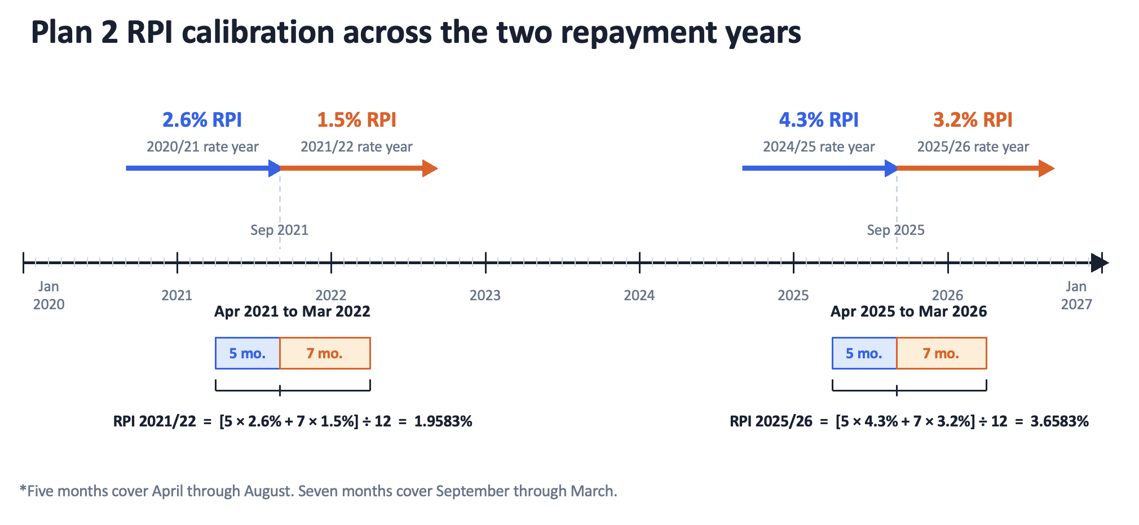
Figure A2
Plan 2 RPI calibration across the two repayment years
Note. Five months cover April through August and seven months cover September through March. Source values come from the Student Loans Company announcements listed in the references (Student Loans Company, 2020, 2021, 2024, 2025)

A6.2 Overseas earnings thresholds
Tables A3 and A4 group the treated EU origins by their Plan 2 overseas lower and upper earnings thresholds. The values are stated in pounds. The 2020-2021 schedule represents the pre-reform repayment environment, while the 2025-2026 schedule is used for the later calibration.

Table A3
Plan 2 overseas earnings thresholds in 2020-202.
Countries | Lower threshold | Upper threshold
Bulgaria, Romania | £10,920 | £19,655
Croatia, Czech Republic, Hungary, Latvia, Lithuania, Poland, Slovakia | £16,380 | £29,480
Cyprus, Estonia, Greece, Italy, Malta, Portugal, Slovenia, Spain | £21,840 | £39,305
Austria, Belgium, Finland, France, Germany, Luxembourg, Netherlands, Sweden | £27,295 | £49,130
Denmark | £32,755 | £58,960
Source: Student Loans Company (n.d.)
Table A4
Plan 2 overseas earnings thresholds in 2025-2026, Source: Student Loans Company (2026).
Countries | Lower threshold | Upper threshold
Bulgaria, Romania | £11,390 | £20,500
Croatia, Czech Republic, Greece, Hungary, Latvia, Lithuania, Poland, Portugal, Slovakia | £17,085 | £30,750
Cyprus, Estonia, France, Italy, Malta, Slovenia, Spain | £22,780 | £41,000
Austria, Belgium, Denmark, Finland, Germany, Luxembourg, Netherlands, Sweden | £28,470 | £51,245

References
Abadie, A., & Cattaneo, M. D. (2018). Econometric methods for program evaluation. Annual Review of Economics, 10, 465-503. https://doi.org/10.1146/annurev-economics-080217-053402
Abadie, A., Diamond, A., & Hainmueller, J. (2010). Synthetic control methods for comparative case studies. Journal of the American Statistical Association, 105(490), 493-505. https://doi.org/10.1198/jasa.2009.ap08746
Clifton-Sprigg, J., Homburg, I., Huyghe, A., & Vujić, S. (2026). International student migration. Did Brexit close the door to EU students? In B. Elsner & S. W. Polachek (Eds.), Migration, human capital and the labor market (Research in Labor Economics, Vol. 53A). Emerald Publishing. https://doi.org/10.1108/S0147-91212026000053A002
Driscoll, J. C., & Kraay, A. C. (1998). Consistent covariance matrix estimation with spatially dependent panel data. Review of Economics and Statistics, 80(4), 549-560. https://doi.org/10.1162/003465398557825
Student Loans Company. (2020, August 11). Student loans interest rates and repayment threshold announcement. GOV.UK. https://www.gov.uk/government/news/student-loans-interest-rates-and-repayment-threshold-announcement
Student Loans Company. (2021, August 12). Student loans interest rates and repayment threshold announcement. GOV.UK. https://www.gov.uk/government/news/student-loans-interest-rates-and-repayment-threshold-announcement--2
Student Loans Company. (2024, August 13). Student loans interest rates and repayment threshold announcement. GOV.UK. https://www.gov.uk/government/news/student-loans-interest-rates-and-repayment-threshold-announcement--5
Student Loans Company. (2025, August 19). Student loans interest rates and repayment threshold announcement. GOV.UK. https://www.gov.uk/government/news/student-loans-interest-rates-and-repayment-threshold-announcement--6
Student Loans Company. (2026). Overseas earnings thresholds for Plan 2 student loans, 2025–26. GOV.UK. https://www.gov.uk/government/publications/overseas-earnings-thresholds-for-plan-2-student-loans/overseas-earnings-thresholds-for-plan-2-student-loans-2024-25
Student Loans Company. (n.d.). Overseas earnings thresholds for Plan 2 student loans, 2020–21. GOV.UK. Retrieved February 11, 2022, archived under https://web.archive.org/web/20220211005047/https://www.gov.uk/government/publications/overseas-earnings-thresholds-for-plan-2-student-loans/overseas-earnings-thresholds-for-plan-2-student-loans-2020-21

From $\frac{ΔlnQ}{ΔlnP}=β$ we have that $ΔlnQ=-1.109$, hence $ΔlnP=\frac{1.109}{0.354}=3.13$, therefore $\frac{P_{1}}{P_{0}}=e^{3.13}=22.94$ and subtracting 1 gives 2194%.
The IFS performed a lifecycle simulation of the pre- and post-2012 student-finance systems for young, full-time, English-domiciled students. It estimated average total loan repayments in real net-present-value terms of £15,075 under the old system and £22,843 under the new system, both in discounted 2014 terms (Crawford & Jin, 2014, p. 24). The modeled repayment burden therefore increased by 51.5%, compared with the 166.7% increase in the annual fee cap from £3,375 to £9,000. Combining the former increase with UCAS’s estimate that young application rates were approximately 5% below their expected trajectory yields an implied log elasticity of $\ln{(0.95)/\ln\left(\frac{22843}{15075}\right)=}-0.123$ For comparison, using the change in the nominal fee cap itself gives $\ln{(0.95)/\ln\left(\frac{9000}{3375}\right)}≈-0.05$
The estimation was based only on countries having more than 25 country-year observations across the entire panel. Including countries with country-year observations of less than 25 changes the estimate by about 0.03. Therefore, N1=26, N0=94, effective observations were 1200 in total after filtration. The panel was fully balanced.

