The Brexit Tuition Shock and the Price Elasticity of International Students: Evidence from a Natural Experiment
Stoycho Rusinov*
James Rafiki Aketch**
*Center for the Study of Democracy, Sofia
New Bulgarian University, Department of Informatics
email: stoycho.rusinov@csd.eu

**School of Economics, University College Dublin

ABSTRACT
This paper estimates the price elasticity of EU demand for UK higher education using the Brexit-induced loss of Home Fee status and student-loan access as a quasi-experimental tuition shock. Unlike standard demand studies that rely on enrollment outcomes, the analysis uses UCAS application data, so demand is observed before universities ration admissions. The average post-Brexit treatment effect implies a roughly 67 percent decline in applicant numbers, with substantial variation across EU origin countries. Under a common price shock, applicants from lower-income member states appear more responsive. Once the same treatment effects are rescaled using country-specific effective price shocks that account for the removal of income-contingent loans, the income gradient becomes statistically indistinguishable from zero. Much of the apparent cross-country heterogeneity is therefore consistent with heterogeneous treatment intensity. The UK student-loan system functioned as an equalizing institution for European educational mobility, and its removal turned a nominally uniform reform into an uneven economic shock. Exploratory bivariate results also associate loan-adjusted elasticities with education spending, although the small cross section and multiple comparisons make that finding provisional.

JEL codes: I22; I23; F22; J61; D12; C23
Keywords: Brexit; international student mobility; higher education demand; tuition fees; price elasticity; EU students; UCAS applicants; difference-in-differences; synthetic control; income-contingent loans; educational mobility; heterogeneous treatment effects.

- Introduction

International higher-education demand studies struggle to isolate own-price elasticity because elasticity calculations typically rely on enrollment changes in response to price shifts, lack sufficient exogenous price variation to isolate the coefficient or suffer both problems at once. Many estimates of the price elasticity of college enrollment “treated the application decision as exogenous, focusing only on how price affects the college-going behavior of admitted applicants” (Savoca, 1990), and so “ignored the possibility that a tuition change affects enrollment through the applicant pool” itself (p. 127). Standard demand models using enrollment data therefore conflate the desire to attend with the university’s choice to admit. Similar problems have proliferated across studies such as McQuone and Simons (2025), which extend Conlon et al. (2021) and produce elasticities too small to explain the collapse in EU applicant numbers after the 2021 Brexit-related tuition hikes in the United Kingdom.
To address the lack of exogenous tuition variation and the limitations of enrollment as a demand proxy, we treat the number of Universities and Colleges Admissions Service (UCAS) applicants from each domicile as expressed origin-country demand before universities ration places. Applicant counts are observed before admission decisions, offers, acceptances, and enrollment. Identification comes from within-country changes over time around the externally imposed loss of Home Fee status and loan access. Because the financial consequences varied across origin countries, the design also permits country-specific treatment effects that can be mapped to constant-elasticity demand responses under the maintained price-shock assumptions.
It is misleading to read the larger decline from lower-income EU countries as proof of inherently more elastic preferences. Although Brexit imposed a common regulatory change, its effective financial consequences differed substantially across origins. Under equal treatment intensity, the larger declines from poorer countries would suggest greater price responsiveness. That interpretation changes once pre-Brexit access to income-contingent loans is valued from each country’s perspective. Rescaling by country-specific effective price changes nearly eliminates the positive relationship between elasticity and GDP per capita, which is consistent with much of the cross-country heterogeneity reflecting treatment intensity generated by the loan system. Demand elasticity therefore cannot be interpreted independently of the baseline financing conditions faced by applicants.

- Context

Brexit and higher education
Between 1940 and the early 1990s the US market for baccalaureate education grew far more competitive, moving from largely local markets to a nationally integrated system. Hoxby (1997) argues this intensified competition over students and institutional quality and can explain real tuition increases of about 50 percent among selective private colleges. A related shift toward market competition later occurred in England, where reforms from 2012 expanded tuition-fee competition, encouraged private providers, and increased information for prospective students. Brown (2011) questioned whether these reforms would improve quality and financial sustainability, warning the evidence was limited and the system could become more stratified and wasteful. These reforms developed alongside a longer-standing commitment to widening participation, which sought to make higher education accessible to groups that had not traditionally considered it.
Expanding formal access does not guarantee that institutions adapt to a more diverse student body. Macdonald and Stratta (2001) found that tutors in an institution with a well-established access policy mostly helped non-traditional students adjust to existing provision, instead of reconsidering whether that provision reflected their needs.
Against the broader expansion of globalized higher education, Brexit was a major reversal of UK-EU integration. Calhoun (2017) reads the Leave vote partly as a populist reaction against London-centered globalization and cosmopolitan elites seen to have benefited disproportionately, accompanied by nostalgia for an earlier Britain and frustration with existing conditions. For higher education, the most consequential outcome was the rupture of academic and financial ties with the EU. The 2020/21 academic year was the last in which new EU students generally qualified for Home Fee status and government-supported loans. From 2021/22 they became liable for international fees, which often doubled or tripled their costs. Brexit therefore produced one of the largest discrete tuition shocks faced by a clearly defined group of students in twenty-first-century British higher education.
Brexit raised financial and reputational concerns about recruiting EU students and staff, accessing European research funding, and UK students studying abroad (Mayhew, 2022). Even so, the UK remained the world’s second most popular destination for international students in 2023. About 730,000 international students were enrolled at UK universities in 2023/24, some 25 percent of the student population, and their fees generated 23 percent of total university income (Cuibus et al., 2025). Cuibus et al. (2025) report that EU numbers fell sharply after Brexit and then stabilized, so that by 2023/24 EU students were only 7 percent of newly enrolled international students. Mayhew (2022) notes the decline in EU enrollments during 2021/22 was more than offset by growth among UK and non-EU students, which illustrates that enrollment is an equilibrium outcome jointly determined by applications, offers, acceptances, and institutional capacity.
This shift also reshaped student mobility. As early as 2006, Findlay et al. (2006) note that UK students’ decreasing mobility to Europe was more than compensated by rising flows to other destinations, especially North America and Australia (p. 291). Locke and Marini (2021) note a rapid pre-2016 increase in EU faculty in UK institutions, many of which had come to rely on academics from other EU countries for much of their research and teaching. Luthra (2020) argues that rejecting free movement left EU staff feeling insecure about their legal rights and public acceptance at work.

Previous attempts to capture demand elasticities in higher education
Causal evaluation of the 2021 reform became possible only once enough post-treatment UCAS observations accumulated. Before that, policy reports relied on forecasting. Conlon et al. (2021), for instance, estimated error-correction models and used the resulting elasticities to simulate the response to the new regime. Once data through 2022 arrived, the literature moved from ex ante forecasting to ex post evaluation. Neville et al. (2024) document a sharp decline in successful EU applications after 2021, even net of COVID-19. Clifton-Sprigg et al. (2025) separate the components of Brexit and conclude that international tuition fees, not the referendum result or visa requirements, drove the contraction in EU student mobility. Crawford et al. (2025) provide complementary evidence to Conlon et al. (2021) on demand elasticities.
Methodologically, Conlon et al. (2021), seeking a specific EU elasticity, acknowledge that tuition fees are among the variables that are the same across countries, then estimate elasticities from a country panel with no within-year cross-country price variation, so the tuition coefficient is identified only through the common time series. They nonetheless claim the cointegrating coefficient measures the causal effect over future periods (p. 19) and find a statistically significant long-run elasticity implying that a 10% fee increase for EU full-time first-year undergraduates lowers demand by 3.5% (an elasticity of 0.35, which we return to later). Clifton-Sprigg et al. (2025) divided the ATT implied change in applications by a 140% price change to obtain about 0.40. In the Appendix we show why this understates the true slope of an isoelastic demand curve when the price shock is large.
Our closest predecessor is Sá (2014, 2017, 2019), who used UCAS application data and a related difference-in-differences design to estimate the response to the 2012 tuition reform. The elasticity estimates are easy to conflate. The 2014 working paper reports magnitudes between 0.14 and 0.26, while later versions report both a reform-specific 0.110 and a full-period 0.356 (Sá, 2017; Sá, 2019). The gap between the latter two decomposes into four parts. First, the 0.110 divides the 18.7% application decline by the 170% arithmetic fee increase; on the log-log scale of Table 10 it becomes 0.207 over ln(27,000/10,000), or 0.208, accounting for 40.0% of the 0.246 gap. Second, valuing the reform by the sector-average increase from £10,395 to £24,120 (Sá, 2014, Section 6.1) rather than the maximum-fee increase from about £10,000 to £27,000 (Sá, 2017, Section 4) raises the implied elasticity to 0.246, a further 15.3%. Third, the 2014 coefficient of −0.250, using 2012 and 2013 as post-treatment, gives 0.297 and explains another 20.8%, consistent with the later recovery as the annual coefficient narrows from −0.237 in 2013 to −0.182 in 2014 and −0.172 in 2015. The remaining 24.0% reflects sample coverage and specification. Identification remains contestable.
Simultaneity between tuition and enrollment is a further identification concern, especially in earlier studies using aggregate variation. Leslie and Brinkman (1987) write the conventional elasticity as ε = E/P, with E the percentage change in enrollment and P the percentage change in price. Reading this ratio causally requires tuition to be exogenous to demand and to other determinants of enrollment, which is unlikely when identification relies on ordinary institutional variation over time. Hoxby (1997) shows that greater integration and competitiveness in the US market raised average tuition and quality, increased differentiation, strengthened sorting by student quality, and changed subsidies. Posted tuition may therefore respond to the same forces that drive enrollment, and when tuition rises alongside quality and differentiation the product is no longer held constant. Estimates from joint time-series variation may thus confound movement along a demand curve with changes in quality, strategy, and pricing. The Brexit design provides cleaner identifying variation, since the loss of Home Fee status and loan eligibility came from external regulation, not universities responding to contemporaneous EU demand.
Leslie and Brinkman (1987) also note that a tuition elasticity from a time-series study cannot be used directly as a total-cost elasticity, because tuition and total cost did not move proportionally over time. This is why Brexit matters empirically, since it generated implicit tuition variation by sharply changing the effective price faced by EU applicants, letting us identify how demand responds to the actual cost of study rather than nominal tuition alone. Campbell and Siegel (1967) give an example where tuition rose 148% between 1927 and 1963, more than total direct costs, so their tuition elasticity of −0.44 understates the true total-cost elasticity. Leslie and Brinkman (1987) further conclude that each $100 tuition increase, given 1982-83 average weighted prices of $3,420 for tuition and room and board, lowers the 18-24 participation rate by about three-quarters of a percentage point. With a national participation rate near 0.33 in 1982, US enrollments would fall about 2.1 percent per $100 increase, all else equal, implying a price elasticity of about −0.73, largely consistent with some of our estimates.
Savoca (1990) argues that enrollment-based estimates understate demand sensitivity by conflating application with admissions and matriculation decisions. If tuition and admissions policy are set independently, the enrollment elasticity equals the sum of the application and matriculation elasticities, which she estimates at −0.49, so true demand elasticity may be more than twice conventional estimates. Consistent with this, Dwenger et al. (2012) find that among German high-school graduates, living in a state with tuition fees lowers the probability of applying to a home-state university by 2 percentage points (against a 69% baseline), with stronger responses among higher-achieving students.
The Brexit-derived elasticities may exceed standard estimates. Heller (1997) argues tuition increases reduce enrollment, so higher education is not a luxury good, and the studies he reviews converge on each $100 increase lowering enrollment by roughly 0.5 to 1.0 percentage points, consistent with Leslie and Brinkman (1987). Aid cuts also reduce enrollment, with effects varying by aid type, and lower-income students are more sensitive to tuition and aid than middle- and upper-income students. Hemelt and Marcotte (2011) likewise confirm the negative tuition-enrollment relationship, though their design is not directly comparable to Brexit.
A further branch, BLP-type models (building on McFadden, 1974), derives elasticities from estimated preference heterogeneity across differentiated alternatives, whereas the present design derives elasticity from observed variation in exposure to a large policy-induced price shock. The former better recovers substitution matrices across choices; the latter better identifies a destination-level demand response to a discrete change in the relative price of UK higher education.

- Data
The primary source is the most recent UCAS release (2025), covering application cycles from 2016 to 2025. UCAS centralizes applications to UK institutions, letting us observe applicant behavior before admissions decisions, which is central to the design because applicant counts capture expressed demand before rationing. The data report applicant counts by country of domicile with demographic breakdowns. We aggregate across all categories of sex and gender to obtain total demand from each origin country, keeping domicile as the key dimension of variation. Deriving gender-, age-, or subject-specific elasticities is a natural extension left for future work, as we focus on aggregate flows here for space.
The unit of observation is the origin-country-year, a panel of both EU countries (treated) and non-EU countries used to build the pseudo EU (control). The outcome is the log number of applicants from country i in year t. To study heterogeneity in the response, the UCAS data are merged with World Bank macroeconomic indicators, including GDP per capita and labor-market variables. Table 1 reports descriptive statistics.

Table 1. Descriptive statistics of the core variable in the analysis for both the treated and control groups. Statistics are computed on the 468 country-year World Bank estimation sample (52 countries over 2016 to 2024). Education spending as a share of GDP is available for 321 of these observations and does not restrict the sample.
Variable | n | mean | sd | median | min | max
Applicants | 468 | 1767.95 | 3745.32 | 715.00 | 35.00 | 33660.00
log_app | 468 | 6.63 | 1.23 | 6.57 | 3.56 | 10.42
EU | 468 | 0.50 | 0.50 | 0.50 | 0.00 | 1.00
Post | 468 | 0.44 | 0.50 | 0.00 | 0.00 | 1.00
did | 468 | 0.22 | 0.42 | 0.00 | 0.00 | 1.00
event_time | 468 | 0.00 | 2.58 | 0.00 | -4.00 | 4.00
regression_weight | 468 | 1.00 | 0.77 | 1.00 | 0.00 | 4.18
GDPpc | 468 | 46395.02 | 26718.44 | 43080.63 | 2543.85 | 136772.44
Pop15_64 | 468 | 42599339 | 138073628 | 6552302 | 305378 | 988168271
YouthUnempl | 468 | 15.32 | 8.43 | 13.56 | 0.30 | 47.22
EduSpendGDP | 321 | 4.59 | 1.43 | 4.59 | 0.38 | 8.74
c_log_GDPpc | 468 | 0.00 | 0.78 | 0.15 | -2.68 | 1.30
c_log_Pop15_64 | 468 | 0.00 | 1.73 | -0.22 | -3.28 | 4.80
c_YouthUnempl | 468 | 0.00 | 8.43 | -1.75 | -15.02 | 31.91

Country-specific average wages w_j come from Eurostat’s Average full-time adjusted salary per employee indicator (nama_10_fte) for 2024 (Eurostat, 2025). The series reports gross annual salaries in current euros, harmonized across Member States via a full-time-equivalent ratio from the EU Labour Force Survey. This wage enters the loan present-value calculation PV_loan(w_j) and sets the country-specific effective price shock k_j. We use the 2024 wage because a student enrolling in 2021 completes a standard three-year cycle in 2024, so it serves as the first post-graduation wage and the simulated repayment schedule starts there.
Macroeconomic controls come from the World Bank’s World Development Indicators via the WDI R package (Arel-Bundock, 2022): GDP per capita in PPP constant international dollars (NY.GDP.PCAP.PP.KD), working-age population 15-64 (SP.POP.1564.TO), and youth unemployment 15-24 (SL.UEM.1524.ZS). Country codes were harmonized to ISO3 with the countrycode package (Arel-Bundock et al., 2018) and merged with the UCAS panel on country-year. World Bank data run through 2024 (World Bank, 2025). Lebanon was missing GDP per capita and youth unemployment for 2024, so we filled both with the average of the previous two years to keep the panel balanced.
We use country-level rather than university-specific data (unlike Sá, 2014, or Clifton-Sprigg et al., 2025) because of a UCAS limitation. Once a student registers, they can choose up to five universities and can be accepted at all five, which double- or triple-counts the same applicant. Country-level aggregation removes this problem, since each applicant is counted once per country.

- Empirical strategy

Constructing the counterfactual European Union
The control group is built in two stages, with the full derivation in Online Appendix I. First, each origin country’s pre-treatment path is converted into a standardized log-applicant trajectory for 2014 to 2020. We start in 2014 because Croatia joined the EU (becoming treated) in 2013, so this window avoids contaminating the pre-treatment trajectories, and we keep only countries with at least 100 applicants per year. For every treated EU country, the three closest non-EU donors are selected by Euclidean distance between standardized pre-treatment paths, so donor choice depends on trajectory shape, not market size.
Second, synthetic-control weights are estimated separately for each treated country over the pre-treatment period, then collapsed into a single global donor-weight vector for the saturated DiD regressions. Treated observations receive unit weight, while donor weights are scaled so aggregate control mass equals aggregate treated mass. This keeps the outcome in logged levels while using the donor pool only to build a comparable weighted counterfactual. Table 2 lists the counterfactual European Union and its regression weights.

Table 2. Donor countries used to construct the synthetic counterfactual European Union, with global and regression weights.
Donor country | Global weight | Global weight × 26
Korea, Republic of | 0.16 | 4.18
Trinidad and Tobago | 0.12 | 3.08
Russian Federation | 0.11 | 2.80
Malaysia | 0.10 | 2.53
Mauritius | 0.08 | 2.07
Egypt | 0.07 | 1.85
New Zealand | 0.04 | 1.11
United States of America | 0.04 | 1.10
Qatar | 0.04 | 1.00
Israel | 0.04 | 1.00
Zimbabwe | 0.04 | 0.96
United Arab Emirates | 0.04 | 0.92
Indonesia | 0.03 | 0.80
Mexico | 0.02 | 0.62
Australia | 0.02 | 0.44
Tanzania, United Republic of | 0.02 | 0.43
China | 0.01 | 0.33
Norway | 0.01 | 0.33
Lebanon | 0.01 | 0.27
Ireland | 0.01 | 0.20
Switzerland | 0.00 | <0.01
Turkey | 0.00 | <0.01
Botswana | 0.00 | <0.01
Iran, Islamic Republic of | 0.00 | <0.01
Uganda | 0.00 | <0.01
Brunei Darussalam | 0.00 | <0.01

An alternative is to estimate each treated country separately using the synthetic difference-in-differences estimator of Arkhangelsky et al. (2021). We use a common weighting scheme instead, because the country-specific coefficients later enter a second-stage regression on income and on k_j, and per-country donor selection would define each coefficient against a different counterfactual. That difference would not be random, since donor weights are chosen on pre-treatment fit, pre-treatment applicant counts are income-related, and wealthier EU countries would draw on wealthier donors, so the induced error in the second-stage dependent variable would correlate with the regressor of interest. With seven pre-treatment years, per-country weights would also be fitted largely to noise (Abadie, 2021). We nonetheless apply the estimator to the full donor pool later as a robustness check.

Identification strategy and parallel trends
The closest design to ours, Sá (2014, 2017, 2019) exploits within-country, across-time variation in fees. Her treatment is binary and uniform, since Scottish students either pay or do not and English students face one fee level then another, with no cross-sectional variation in the size of the shock. We instead exploit cross-country, across-time variation, where the shock $k_{j}$ itself differs across countries because the present value of the foregone loan differs with the average wage. The identifying variation thus has two dimensions at once, whether you are treated (EU vs non-EU) and how intensely (which EU country you are from). This corrects a limitation in Sá (2014), which cannot separately identify these because all treated students face the same fee change, leaving the identification to rest on only 2 country-clusters regardless of the fact that she has more than 100,000 observations, and only 18 country-year contrasts.

The panel begins in 2016, which excludes the 2007 accessions of Bulgaria and Romania, Croatia’s 2013 accession, the end of transitional labour-market restrictions in 2014, and England’s 2012/13 fee-cap increase from the baseline regression window. This choice does not place every earlier event outside the pre-treatment period. The 2016 referendum and the £250 tuition increase in 2017 remain inside it. We therefore assess whether they generated differential EU-control movements through the event-study leads and the leads-only specification. Those estimates show no systematic divergence, but the short 2016–2020 regression pre-period still limits the power of pre-trend tests. The donor-selection step uses the longer 2014–2020 window.
Following these design choices, we estimate a weighted dynamic difference-in-differences specification. This traces the evolution of applicant counts around the Brexit tuition reform:

$$\log{A_{it}}=α_{i}+γ_{t}+\sum_{l≠0}{δ_{l}}\left(EU_{i}×1\left\{t-2020=l\right\}\right)+ε_{it}$$ | (1)

The coefficients $δ_{l}$ measure year-by-year deviations in log applicant counts for EU-origin countries relative to the omitted pre-reform year ($l=0$, i.e. 2020), again estimated with the weights from the previous subsection.
Figure 1. Event-study estimates comparing EU applicants to the synthetic control group.

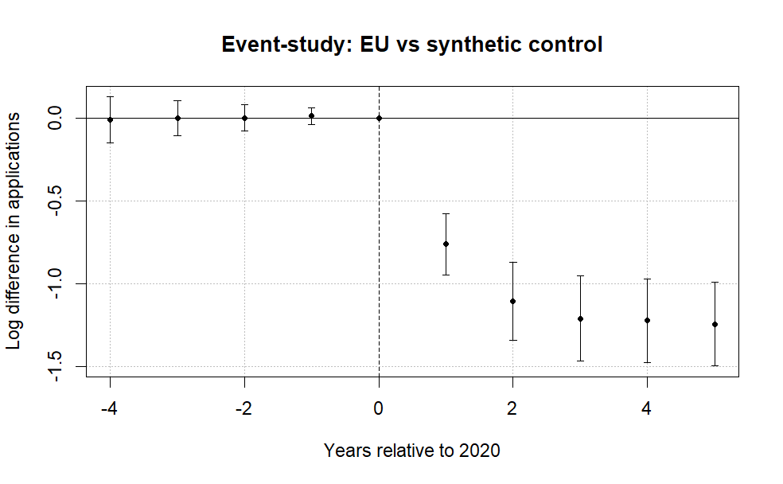
Note: The figure plots coefficients from a difference-in-differences event-study comparing EU applicants to a synthetic control group of non-EU countries. The horizontal axis shows years relative to 2020, the last pre-treatment year. Points represent estimated differences in log applicant counts and bars denote 95% confidence intervals clustered at the country level. The dashed vertical line marks the final pre-treatment year. Pre-treatment coefficients are small and close to zero, while a sharp decline in EU applicant numbers emerges beginning in 2021 after the tuition reform took effect. A joint Wald test cannot reject the null that the pre-treatment coefficients are jointly zero (p = 0.96), providing no strong evidence of differential pre-trends.

Figure 1 reports the event-study coefficients from equation (1). The pre-treatment leads are small and a joint Wald test fails to reject that they are jointly zero (p = .96), providing no evidence of differential pre-trends in this short window. The post-treatment decline persists through 2024 and 2025, which is inconsistent with a purely transitory pandemic explanation. Pre-trend evidence alone cannot rule out post-treatment COVID effects or other contemporaneous shocks.
A leads-only specification likewise finds no evidence of anticipatory adjustment before the reform. The early leads show no systematic pattern and are jointly statistically indistinguishable from zero (p = .96).
Allowing country-specific dynamic effects yields similar patterns, with post-treatment coefficients consistently negative across EU countries and pre-treatment estimates near zero (Figure 2). The one exception is Portugal, whose applicant count did not immediately fall in 2021, which traces to a UCAS reporting issue where some Recorded Prior Acceptances were mistakenly submitted as Portugal-domiciled in the 2021 cycle, so the true count is lower than reported (UCAS, 2022).

Figure 2. Saturated DiD event-study estimates by country.

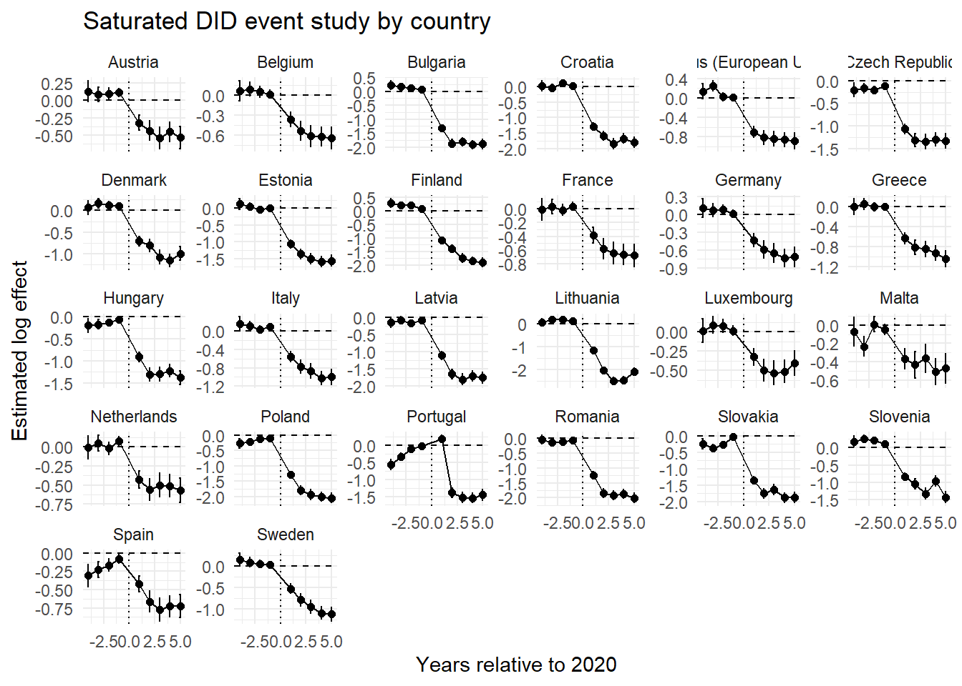
Note: Each panel reports country-specific dynamic treatment effects from the saturated difference-in-differences specification comparing EU countries with the pooled control group. Coefficients represent differences in log applicant counts relative to the baseline year (2020).

Baseline elasticity estimates and heterogeneous price shocks
Let $C$ denote the set of origin countries, partitioned into the treated EU markets $Ω⊂C$, with $J=\left|Ω\right|$, and the candidate donor pool $D=C∖Ω$ of non-EU markets. The counterfactual European Union gives a synthetic untreated group, letting us estimate the weighted saturated two-way DiD model:
$$\log{(A_{it})} = α_{i} + γ_{t} +\sum_{\begin{aligned}j∈Ω \\ \end{aligned}}^{ }{β_{j} \left(1\left\{i=j\right\}×Post_{t}\right)} +ρ^{'}X+ ε_{it}$$ | (2)

where $A_{it}$ denotes the applicant count from origin country $i∈C$ in year $t∈[2016, 2025]$, $1\left\{i=j\right\}$ indicates EU member states, and $Post_{t}$ marks the new tuition regime in 2021. Importantly, as long as the two groups remain under different but unchanged tuition fee regimes, their relative applicant-count trajectories should remain stable. When the treated group moves from the UK home-fee regime into the international fee regime already faced by the control group, $β_{j}$ will capture the resulting change in the treated group’s applicant-count trajectory relative to the control group. This relative change identifies the reduction in applicant numbers when the treated group ceased to benefit from UK home-fee status.

To compare the initial and later post-reform periods, we split the post-treatment window into 2021–2023 and 2024–2025. The specification becomes:
$$\begin{matrix}\log{(A_{it})} & = & α_{i} + γ_{t} + \sum_{\begin{aligned}j∈Ω \\ \end{aligned}}^{ }{β_{j} \left(1\left\{i=j\right\}×Pos{tBrexit}_{t}\right)} \\ & + & \sum_{\begin{aligned}j^{ }∈Ω \\ \end{aligned}}^{ }{σ_{j^{ }} \left(1\left\{i=j\right\}×Pos{tCovid}_{t}\right)}+ρ^{'}X+ ε_{it }\end{matrix}$$ | (3)

Here βjβj is the country-specific log effect for 2021–2023 and σj σj is the corresponding effect for 2024–2025. Their difference is descriptive. Because other time-varying shocks may differ across the two windows, it does not separately identify a causal COVID component or a pure willingness-to-pay shift.
The supplementary materials show that $β_{j}$, with $j∈Ω$, maps to a structural elasticity through the following transformation:

$η_{j}=\frac{β_{j}}{k_{j}}$,

Here $η_{j}$ is the price elasticity, expected negative given the downward-sloping demand curve. To allow heterogeneous $k$’s, under Plan 2 graduates repaid 9% of annual earnings above a statutory threshold (UK Government, n.d.-a), which for the relevant cohort is £27,295 per year. Annual repayments are $R_{t}=0.09⋅max\{0,Y_{t}-τ\}$, where τ is the threshold and Y_{t} follows a deterministic wage path with growth rate g. The loan is written off 30 years after repayment becomes due (UK Government, n.d.-b), so the horizon is T=30. Interest accrues at RPI plus up to three points depending on income (UK Government, n.d.-c). Rather than replicate the full income-dependent interest schedule, we model the loan’s burden as the present value of expected repayments, discounting at a constant rate δ:

$$p_{jt}=min\left\{0.09max\left[0, w_{j}^{GBP}{\left(1+g\right)}^{t-1}-τ\right], {\left[L-\sum_{s=1}^{t-1}{p_{js}}\right]}_{+}\right\}$$
$$PV_{loan}\left(w_{j}^{GBP}\right)=max\left\{1, \sum_{t=1}^{30}{\frac{p_{jt}}{{\left(1+δ\right)}^{t}}}\right\}$$

Here L = £9,250 and [x]+=maxx,0[x]+ = max{x, 0}. In the baseline we set δ=3%the discount rate to 3% and nominal wage growth to 2%. Repayments are capped at the remaining principal, and the present value is floored at £1 solely to keep the logarithm defined. The calculation is intentionally stylized and does not reproduce the full income-dependent interest schedule.
We calculate the present value using the average country-specific wage in pounds, so k becomes a function of that wage:

$$k_{j}=log22200-logPV_{loan}\left(w_{j}^{GBP}\right)$$

Here PVloanwjGBPPVloan(wjGBP) is the present value of the income-contingent UK loan, £22,200 is the average post-Brexit fee used in the calibration, and wjwj is the 2024 average annual salary converted from euros to pounds at 0.85.
Intuitively, read the calculation from the perspective of a 2024 graduate asking how much they would actually repay under the old income-contingent system given their expected first wage. We take the 2024 wage, project it over 30 years, compute annual repayments under the loan rule, and discount them back to 2024, giving the effective price of the old regime. Discounting the £22,200 price would be inappropriate, since it would recast a current tuition obligation as a deferred repayment stream. The asymmetry is institutional, not arbitrary: the old price is mediated through a future repayment contract, while the new price is a direct posted fee.
Discounting matters because under the standard shift from £9,250 with no heterogeneity, $k$ is 0.875. Clifton-Sprigg et al. (2025) assume one price change (£9,250 to £22,200), whereas the equation above relaxes that. The extension is especially relevant given Solís’s (2017) finding that credit access raises immediate college enrollment by 100 percent and ever-enrolling by 50 percent.
We then relate these elasticities to observable economic fundamentals. Specifically, we estimate correlations of the form:
$$\frac{β_{j}}{k_{j}} = θ_{0} +γ\log\left(GDPpc_{j}\right)+X^{'}ρ+ u_{ }$$ | (4)
Here ρ'Xρ′X contains country-specific structural covariates. These second-stage regressions describe cross-sectional associations and are not interpreted as separately identified causal mechanisms.

- Results

Estimated baseline elasticities
Figure 3 reports country-specific elasticities from the difference-in-differences estimates, translating the treatment effects into implied demand responses to the Brexit shock.

Figure 3. Decomposition of the post-Brexit demand elasticities by treated country.

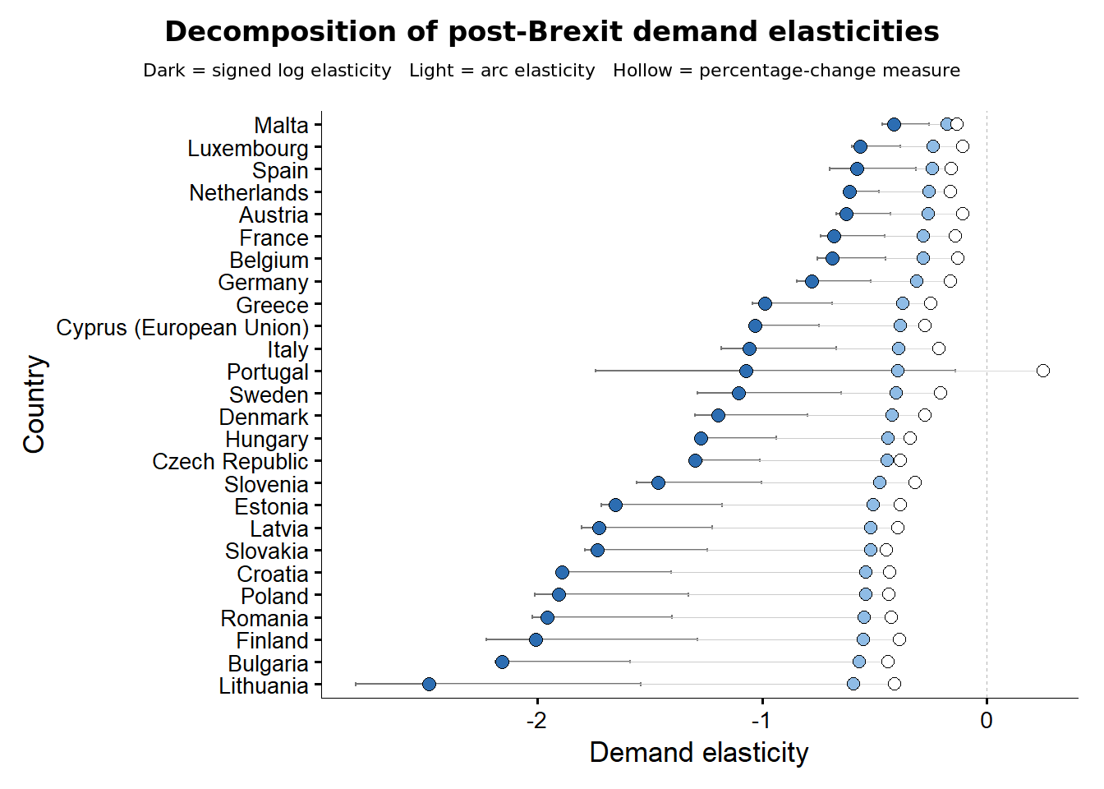
Note: Signed structural log elasticities divide each country-specific effect βj by the common log price change of 0.8755. Arc elasticities use [exp(βj) − 1]/1.4, while the mechanical percentage-change measure uses the observed change in applications divided by 1.4. R uses natural logarithms. The saturated estimates use Driscoll–Kraay standard errors with one lag. See the online appendix.

The estimates show a large and widespread post-reform contraction. Country-specific effects correspond to applicant reductions ranging from about 30% for Malta to about 89% for Lithuania and 85% for Bulgaria, relative to the control group. The average effect implies a decline of approximately 67%. The implied signed elasticities are negative in every treated country, but their magnitudes vary substantially. Under the common price-shock assumption, lower-income origins such as Bulgaria, Romania, Lithuania, Croatia, and Latvia appear more responsive than Malta, Spain, Luxembourg, the Netherlands, and Austria
. The loan adjustment below shows why this ranking should not be interpreted as stable preference heterogeneity.
The country-specific effects are also positively associated with GDP per capita, meaning wealthier countries experienced smaller declines (Figure 4). This gradient is strongest in fixed-effects specifications and remains visible when the saturated model includes the observed macroeconomic controls. Pooled and fixed-effects models answer different conditional comparisons, so the contrast is treated as a specification result rather than proof that one estimator has removed every source of confounding.
The correlations weaken only when (k_j), calculated under (\delta=3%) and (g=2%), is allowed to vary across countries according to the income-contingent loan systems to which EU students were previously exposed. Under this adjustment, the previously positive income gradient in the TWFE elasticity estimates becomes statistically insignificant. This, combined with the results presented in the previous paragraph, shows that the estimated income gradient is highly sensitive both to the treatment of loan conditions and to the control of persistent cross-country heterogeneity. Therefore, the baseline unadjusted estimates may systematically overstate the price elasticity for some country groups and understate it for others. We return to this issue in the discussion section.

Figure 4. Correlations between the DiD (FEs and No FEs elasticities) and logarithm of GDP per capita

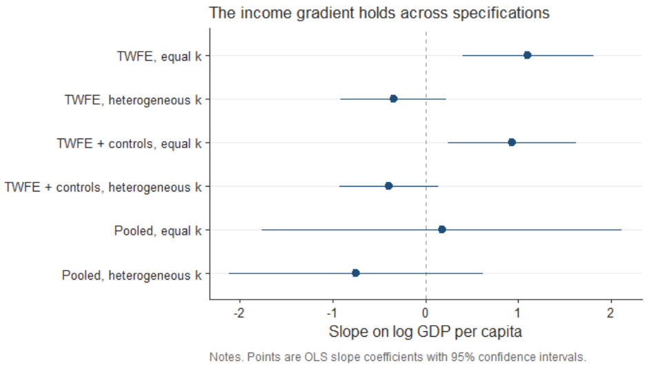

Descriptive initial and later post-reform effects

Figure 5 compares country-specific log effects in the initial 2021–2023 window with those in 2024–2025. The differences between the dots describe how the estimated post-reform association changed across the two periods.

Figure 5. Initial and later post-reform log effects on the same measurement axis.

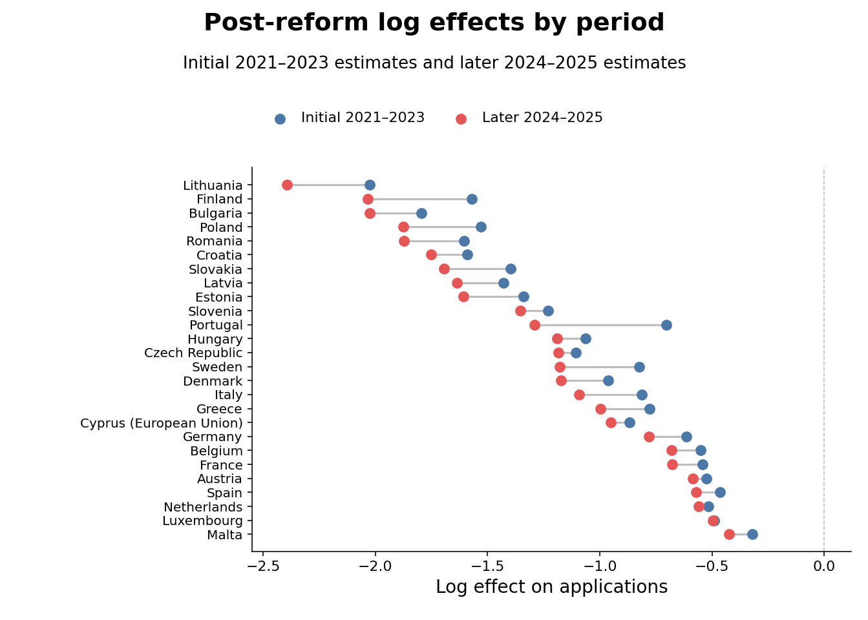
Note: The figure reports country-specific log effects, not elasticities. The initial period is 2021–2023 and the later period is 2024–2025. Both sets of estimates use Driscoll–Kraay standard errors with one lag. The period split is descriptive and does not separately identify a COVID effect.
For nearly all EU origin countries, the 2024–2025 estimates remain strongly negative and are often more negative than the 2021–2023 estimates. This persistence is inconsistent with a fully transitory disruption, although the split cannot assign the difference uniquely to tuition, COVID, or other contemporaneous changes.

The initial estimates range from −0.321 for Malta to −2.026 for Lithuania; the corresponding 2024–2025 estimates are −0.423 and −2.394. Excluding Portugal, whose 2021 count has a documented reporting issue, the later coefficients are generally larger in absolute value. These patterns support persistence but do not identify a COVID-specific causal component.

ATT wealth heterogeneity

Table 3. Average treatment effect and macroeconomic interactions with country and year fixed effects and Driscoll–Kraay standard errors (L = 1)
 | (I) | (II) | (III) | (IV) | (V)
$ATT$ | -1.109*** | -1.05*** | -0.981*** | -0.961*** | -1.211***
 | (0.098) | (0.110) | (0.101) | (0.092) | (0.120)
$c_log\left(GDPpc\right)$ |  | -0.720* | -0.447 | -0.687* | 0.018
 |  | (0.265) | (0.266) | (0.290) | (0.300)
$c_log\left(Pop15_64\right)$ |  |  | 3.077*** | 3.213*** | 2.631***
 |  |  | (0.460) | (0.519) | (0.462)
$c_YU$ |  |  |  | -0.014* | -0.008+
 |  |  |  | (0.004) | (0.004)
$ATT×c_log\left(GDPpc\right)$ |  |  |  |  | 0.808***
 |  |  |  |  | (0.136)
ATT×c_logPop15_65Pop15_64 |  |  |  |  | 0.100***
 |  |  |  |  | (0.013)
$ATT×c_YU$ |  |  |  |  | 0.011
 |  |  |  |  | (0.006)
Obs. | 520 | 468 | 468 | 468 | 468
R2 Adj | 0.957 | 0.958 | 0.964 | 0.964 | 0.970
R2 Within | 0.585 | 0.586 | 0.644 | 0.652 | 0.708
Note: Models I–V use two-way fixed effects. Model I uses 520 observations for 52 countries in 2016–2025. Models II–V use 468 observations in 2016–2024 because the World Bank controls are capped at 2024. GDP per capita is NY.GDP.PCAP.PP.KD, purchasing-power-parity GDP per capita in constant 2021 international dollars. Logged GDP and population are demeaned over the estimation sample before interactions are formed. All models use Driscoll–Kraay standard errors with one lag. Significance codes are + p < .10, * p < .05, ** p < .01, and *** p < .001.

The uncontrolled ATT is −1.109, equivalent to exp(−1.109) − 1 = −67.0%. Reconciling it with Conlon et al.’s (2021) long-run elasticity of −0.354 requires a specific attribution. Applied to the 140% gross fee increase, that elasticity assigns a log quantity change of −0.354 × ln(2.4) = −0.310 to price, or exp(−0.310) − 1 = −26.7%. The remaining −0.799 log points would be attributed to non-price channels. At their more elastic bound of −0.648, the price channel accounts for a larger share, leaving a residual log change of −0.542. This decomposition is accounting, not separate causal identification of the residual.
The same arithmetic runs in reverse. Attributing the whole of our ATT to price, the annual fee increase required for an elasticity of −0.354 to generate it is exp(1.11/0.354) =22.9, a rise of 2,194 percent. Against the pre-Brexit home fee of £9,250, that implies an annual charge of approximately £212,200 rather than the roughly £22,200 actually levied once EU applicants moved to international rates. Even the elastic bound of −0.648 requires exp(1.109 / 0.648) = 5.5, an increase of 454 percent, or about £51,200 a year. However, such change will be possible only for countries where the income-contingent loan is effectively equal to zero in present value terms. To obtain Conlon et al. (2021) number of $η_{j}=-0.354$ we have to solve for a denominator that gives $k=\frac{1.109}{0.354}=3.13$, so $PV_{loan}=\frac{£22,200}{e^{3.13}}=£968$. That is 10.5 percent of the £9,250 principal, and under our baseline calibration it corresponds to an expected graduate wage of about £18,250 a year. Therefore, the estimates are equal only for an applicant whose income-contingent loan was worth about a tenth of its face value in present-value terms.

Table 3 also relates the post-reform effect to country-level economic characteristics. The ATT remains large and negative as the observed controls are added. In the interacted specification, the GDP-per-capita and working-age-population interactions are positive and precisely estimated, while the youth-unemployment interaction is not statistically distinguishable from zero. These conditional associations are consistent with smaller contractions in wealthier and demographically larger origins, but they do not independently identify the underlying mechanisms.
Figure 6 reports country-specific elasticities under homogeneous $k_{j}$, showing no meaningful change in the estimates beyond a slight downward shift in the ATT that does not warrant further investigation.

Figure 6. Saturated DiD specifications with macroeconomic controls added. Namely GDP per capita (PPP, constant prices), population and the percentage of youth unemployment as separate models.

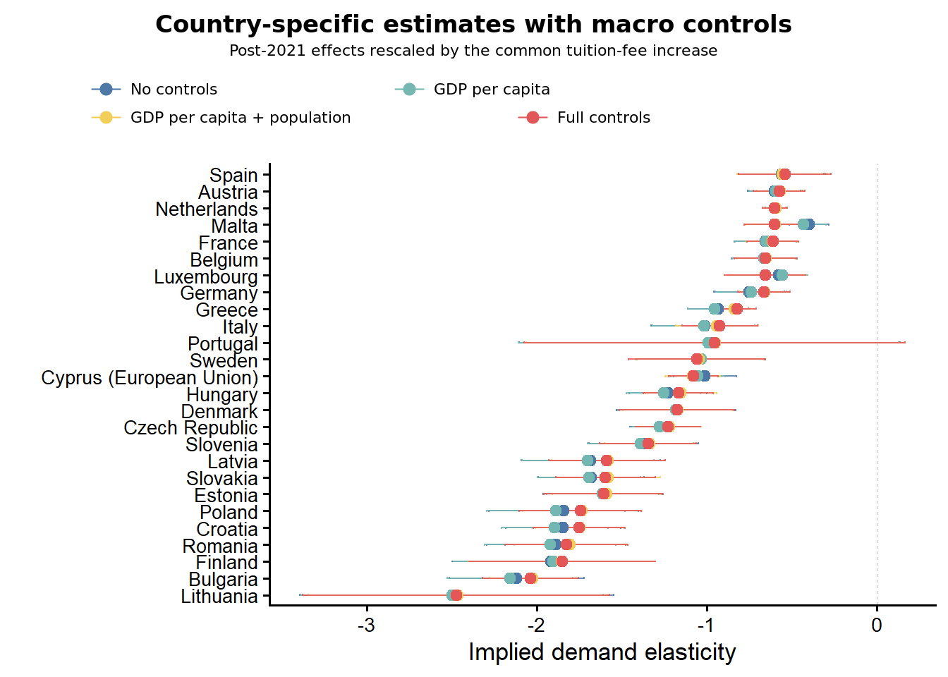
Note: All saturated models use the demeaned version of the free covariates – namely, the GDP per capita, the population and the youth unemployment. Used are Driscoll-Kraay (L=1) standard errors consistently and across all the presented models. Details in the online appendix.

- Robustness

Control group robustness
We assess sensitivity to control-group choice using several alternative donor pools and an Ireland-only comparison. Prior work motivates these checks, but it does not eliminate the need to evaluate them in the present sample (Clifton-Sprigg et al., 2025).
- The event-study estimates provide no evidence of differential pre-trends in the available window.

- The leads-only specification provides no evidence of anticipatory adjustment.
- The Croatian accession design in Clifton-Sprigg et al. (2025) provides related quasi-experimental evidence from an earlier policy change.
- We compare the
baseline with four alternatives: very poor countries (14 controls), very rich countries (12 controls), OECD countries (14 controls), and Ireland alone. The three multi-country groups are detailed in Table 4.
Table 4. Sample compositions for the alternative control groups
 | Poor | Rich | OECD
Control-group composition | Pakistan, Nepal, Bangladesh, Ethiopia, Uganda,  Tanzania, United Republic of, Rwanda, Mozambique, Malawi,  Sierra Leone, Ghana, Nigeria, Kenya, Zimbabwe | United States of America, Canada, Australia, Norway, Switzerland,  Singapore, Qatar, United Arab Emirates, Kuwait, Saudi Arabia,  Israel, Japan | Australia, Canada, Chile, Colombia, Iceland, Israel, Japan,  Korea, Republic of, Mexico, New Zealand, Norway, Switzerland,  Turkey, United States of America
EU group | 26
Observations | 400 | 380 | 400
Note: Detailed descriptive statistics for these groups are reported in the supplementary materials.

A further concern is that the Graduate Route, introduced in July 2021, may have raised the appeal of UK study independently of tuition by letting international graduates stay up to two years after finishing (Home Office, 2021), therefore treating the control group and biasing the effect downwards. This is mitigated in two ways. First, because the Route reached treated and control countries alike after 2021, any common increase in appeal is absorbed by year fixed effects and cannot identify the DiD coefficient. Second, the Ireland-only specification is also introduced specifically for that purpose, since Irish citizens kept Common Travel Area rights and did not rely on the Route as other international students did, which limits control-group contamination.
Because this design does not build the control group by constrained optimization, we weight the counterfactual as:
$$w_{j}=\frac{\frac{1}{d_{j}+0.001}}{\frac{1}{J}\sum_{k=1}^{J}{\frac{1}{d_{k}+0.001}}}$$
where $d_{j}=\sqrt{\frac{1}{T}{\sum_{t<2021}^{ }{\left(log\left(A_{jt}\right)-\overline{log\left(A_{t}^{EU}\right)}\right)}}^{2}}$. The results are presented in Figures 7 and 8 for the ATT and the country-specific responses, respectively.

Figure 7. Robustness of the Brexit effect across alternative control-group definitions (pooled DiD estimates).

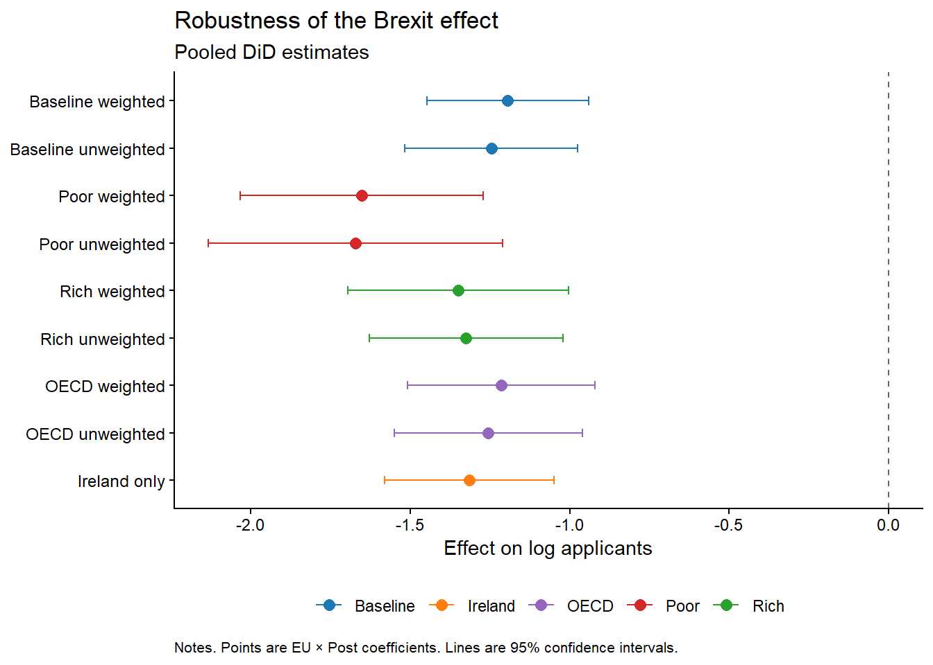
Note: Points are EU × Post coefficients from the pooled difference-in-differences specification; horizontal bars denote 95% confidence intervals. Baseline is the synthetic donor pool used in the main specification; Poor, Rich, and OECD are the alternative control groups described in Table 4, each shown weighted and unweighted; Ireland is a single-country comparison.

Figure 8. Saturated difference-in-differences robustness across control-group specifications.

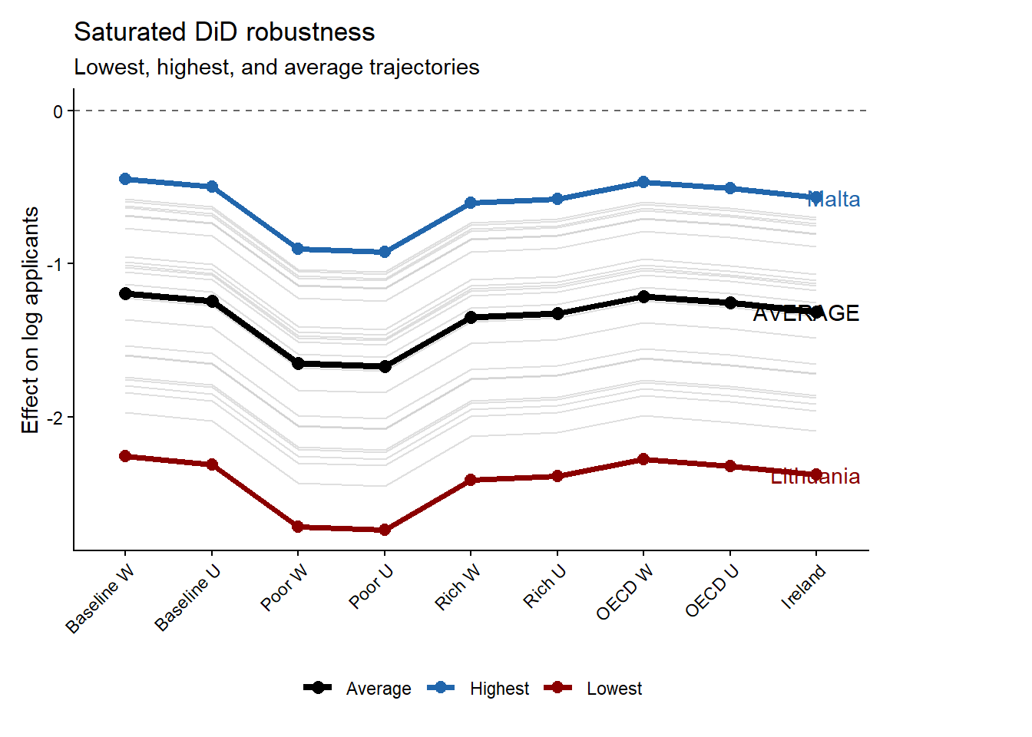
Note: Grey lines show country-specific dynamic treatment trajectories under each alternative control-group specification; the black line marks the cross-specification average. Malta (blue) and Lithuania (red) mark the upper and lower bounds of the estimated effects.
Figures 7 and 8 show that the estimated EU × Post coefficient remains large and negative across the baseline, OECD, high-income, low-income, and Ireland comparisons. Point estimates move because each pool supplies a different benchmark, but the sign and broad magnitude are stable. This reduces, without eliminating, concern that the result is driven by one donor definition.

kj
The low-income control group produces the most negative estimate. The Ireland comparison also remains close to the other specifications, which is informative about common shocks affecting nearby or culturally connected markets and about the Graduate Route. These exercises are sensitivity checks and do not separately identify every contemporaneous channel. As a further check, the standalone synthetic difference-in-differences estimator applied to the corrected full donor pool gives an ATT of −1.272 with a fixed-weight jackknife standard error of 0.105 and a 95% confidence interval from −1.478 to −1.067. This estimate is close to the main pooled effect.

Robustness of the country-specific price shock kj
A natural objection to the loan correction is mechanical: because kjkj falls with income, dividing βjβj by kjkj may alter the income gradient automatically. We therefore construct a placebo denominator with the same range and the same negative direction with income as the observed kj, but without the repayment threshold, cap, horizon, or discounting.
kjplacebo=logwj-minlogwimax(logwi)-min(logwi) ×maxki-minki+minki
kjplacebo=maxilogwi-logwjmaxilogwi-minilogwimaxiki-miniki+miniki.
By construction, the placebo denominator spans the same interval as kjkj and falls monotonically with log wages. The real kjkj is generated by the capped present value of income-contingent repayments, while the placebo is a linear rescaling of log wages. We divide βj by each denominator and re-estimate the income gradient.
Under the common price change, the income-gradient slope is 1.118 (HC1 p = .0006, n = 25). Under the real loan-adjusted kjkj it is −0.359 and statistically indistinguishable from zero (HC1 p = .244, n = 25). Under the direction-correct income-only placebo, it is −0.278 and statistically significant (γHC1 p = .0004, n = 25). Thus, an arbitrary monotone income rescaling does not reproduce the near-zero gradient. This diagnostic supports the importance of the loan mapping’s shape, but it is not a separate causal test of the mechanism.
A further peer-review concern is the sensitivity of the present value to calibration. We recompute the present values and re-estimate the correlations across loan-correction settings (Figure 9). Across the discount-rate sweep the loan-adjusted gradient stays insignificant throughout, its p-value above 5% at every calibration. The wage-growth sweep is more nuanced: the gradient is significant only at the two lowest calibrations, g = 0 (p ≈ 0.04) and g = 0.5% (p ≈ 0.05), and insignificant from g = 1% on. The underlying slope runs from about −0.722 at g = 0% to about 0.291 at 4%, reversing sign, while standard errors barely move. The disappearance of the gradient therefore holds across the discount-rate sweep and the baseline and most plausible positive wage-growth calibrations, though not the entire parameter space.

Figure 9. Sensitivity of the loan-corrected income gradient to the discount rate and wage growth rate assumptions.

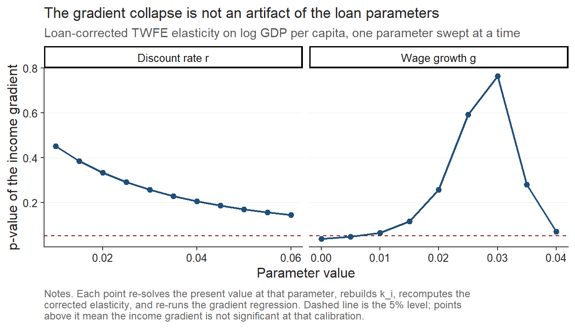
Note: The figure plots the p-value of the income gradient, that is the slope of the loan-corrected elasticity on log GDP per capita (PPP) as the discount rate (δ) and the annual wage growth rate (g) are varied around their baseline calibration (δ = 3%, g = 2%), holding all other parameters at the values described in the main text. GDP per capita is in PPP terms (constant international dollars) with data from 2022. The dashed line marks the 5% significance level, so points above it indicate calibrations where the income gradient is not statistically significant.

Rambachan-Roth parallel-trends checks and synthetic difference-in-differences comparison
In response to a further round of peer review we run two additional robustness checks. The first re-examines the parallel-trends assumption behind the event study using the HonestDiD implementation of the sensitivity analysis of Rambachan and Roth (2023), which replaces the binary test of whether pre-trends are flat with a measure of how large a post-treatment violation of parallel trends would have to be before the estimated effect loses its significance. Because the pre-treatment leads are jointly indistinguishable from zero (a joint Wald test gives p = 0.96) and are about two orders of magnitude smaller than the post-treatment coefficients, the loan-driven collapse in EU applicant numbers survives the relative-magnitudes sensitivity analysis across the full range of violations we examine. The robust confidence set for the first post-treatment year never crosses zero, running from −0.94 to −0.58 when no violation is permitted (Mbar equal to zero), from −0.95 to −0.56 when the post-period distortion is allowed to be as large as the worst pre-period deviation (Mbar equal to one), and still only from −0.98 to −0.53 at twice that size (Mbar equal to two). The breakdown value therefore exceeds two, so the result is not an artifact of an assumed pre-trend (Roth, 2022).
The second check re-estimates 26 separate synthetic difference-in-differences regressions, one per treated country, so the Arkhangelsky et al. (2021) estimator collapses to $N_{tr}=1$:
τjsdid=Yj,post-t≤T0 λtjYjt-i∈D​ωijYi, post-t≤T0 λtjYit
Table 5 compares these estimates with the saturated weighted DiD coefficients. After consistently removing aggregates, territories, dependencies, and UK home nations from the donor pool, the two sets correlate at 0.978 and have a mean absolute difference of 0.163 log points. Portugal has the largest discrepancy at 0.418 log points, consistent with its documented 2021 reporting issue. The ranking is similar across designs, although several level differences remain economically meaningful.

Table 5. Per-country saturated DiD (TWFE) and synthetic difference-in-differences estimates
Country | Saturated TWFE | Synthetic DiD | Difference
Lithuania | -2.173 | -2.264 | 0.091
Bulgaria | -1.887 | -1.930 | 0.043
Finland | -1.756 | -1.773 | 0.017
Romania | -1.711 | -1.910 | 0.199
Poland | -1.668 | -1.971 | 0.303
Croatia | -1.655 | -1.803 | 0.148
Slovakia | -1.516 | -1.872 | 0.356
Latvia | -1.512 | -1.743 | 0.232
Estonia | -1.447 | -1.547 | 0.099
Slovenia | -1.280 | -1.318 | 0.038
Czech Republic | -1.137 | -1.411 | 0.274
Hungary | -1.114 | -1.379 | 0.265
Denmark | -1.046 | -1.145 | 0.098
Sweden | -0.967 | -1.048 | 0.081
Portugal | -0.939 | -1.358 | 0.418
Italy | -0.925 | -1.002 | 0.077
Cyprus (European Union) | -0.902 | -0.969 | 0.066
Greece | -0.866 | -1.010 | 0.144
Germany | -0.681 | -0.779 | 0.097
Belgium | -0.603 | -0.715 | 0.113
France | -0.597 | -0.754 | 0.157
Austria | -0.549 | -0.640 | 0.092
Netherlands | -0.535 | -0.688 | 0.153
Spain | -0.508 | -0.829 | 0.322
Luxembourg | -0.493 | -0.623 | 0.130
Malta | -0.362 | -0.585 | 0.223
Note: Coefficients are on the log-applicant scale. Saturated TWFE effects are the country-specific EU × Post coefficients from the weighted model with 520 country-year observations. Synthetic DiD effects are 26 single-treated-unit estimates against 136 eligible sovereign-country controls. The correlation is 0.978 and the mean absolute difference is 0.163 log points.

- Discussion

Were poor EU students really priced out because of elastic demand?
A natural reading is that students from lower-income EU countries have more elastic demand. But this assumes the reform generated the same effective price change everywhere, which is unlikely. Before Brexit, tuition was financed through income-contingent loans, so the relevant price depended on expected earnings not the nominal fee, and removing the loans generated larger effective price increases for lower-income applicants.
To show how elasticities depend on loan valuation, we map the ATT coefficient $(β=-1.109)$ across a range of starting incomes (Figure 10). When the loan has low present value (low expected earnings), Brexit is a large effective shock and the implied elasticity is mechanically smaller in magnitude (about −0.4). When the present value approaches the nominal amount (high earnings), the effective shock is smaller and the implied elasticity larger in magnitude.

Figure 10. Implied demand elasticity as a function of the economic value of the UK student loan.

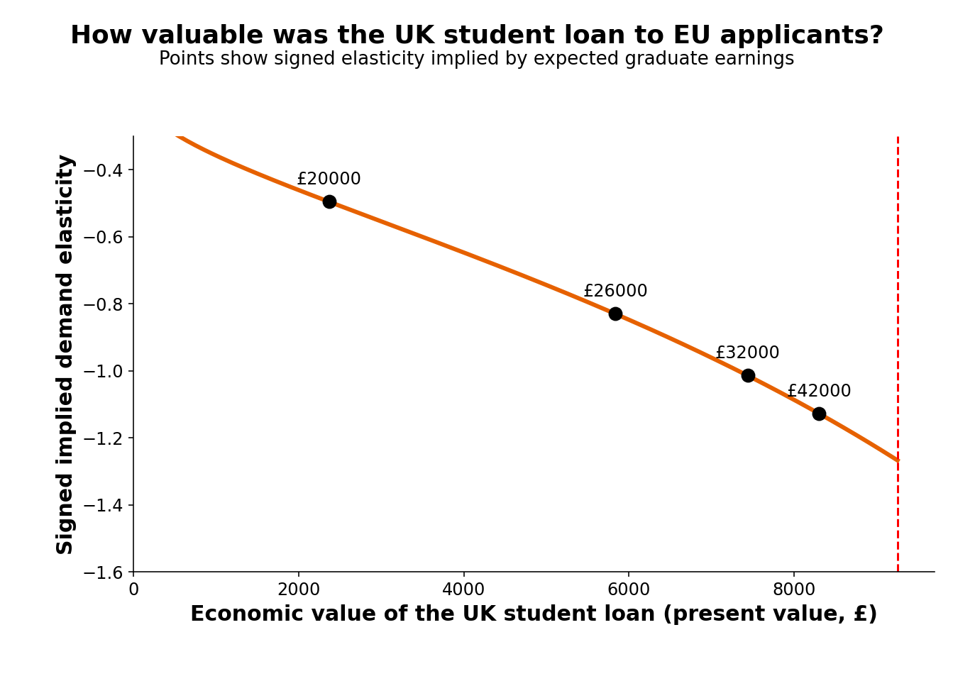
Note: The figure translates the pooled treatment effect into signed elasticities under alternative present values of the pre-Brexit loan. The convention is η = β/k, so the elasticities remain negative. Points correspond to illustrative expected graduate earnings.

To examine whether cross-country heterogeneity persists after this adjustment, we define the signed loan-corrected elasticity as ηj'=-βjkj η′j = βj/kj. Figure 11 compares the common-k and loan-adjusted values. The baseline calibration uses a 3% discount rate, a 9% repayment rate above the threshold, 2% nominal wage growth, and a 30-year horizon. The sensitivity analysis supports the baseline across the discount-rate sweep and most positive wage-growth calibrations, but not every point in the parameter grid.

Figure 11. Income gradient in demand elasticity.

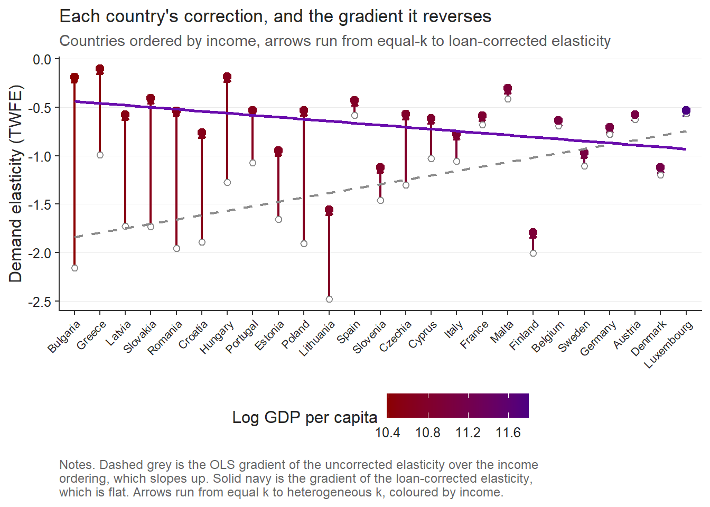
Note: The figure compares signed elasticities under a common price shock with elasticities using country-specific loan values. Countries are ordered from lowest to highest log GDP per capita at purchasing-power parity. The horizontal axis is therefore a country-ranking axis. The signed convention is η′j = βj/kj, so negative values indicate downward-sloping demand.

Before the loan adjustment, the slope of elasticity on log GDP per capita is 1.118 (HC1 p = .0006). After using the country-specific effective price shocks, the slope is −0.359 (HC1 p = .244). The difference is consistent with treatment intensity accounting for much of the raw income gradient, subject to the maintained loan-calibration assumptions.
After correction, Finland, Denmark, Slovenia, Germany, and Luxembourg have some of the largest elasticity magnitudes. One possible interpretation is that applicants from these countries have more domestic or international substitutes. The current data do not measure those alternatives directly, so this explanation remains a hypothesis rather than an established mechanism.

Politically, the decline from poorer EU countries reflects the withdrawal of an institution that had quietly equalized opportunity across Europe. The income-contingent loan meant students did not need to arrive with wealth, only the expectation of future earnings. When it disappeared for EU applicants, the effective cost of UK study rose sharply for those from poorer economies. What looks like elastic demand is better understood as the sudden loss of a mechanism that let talent travel without immediate financial means. In that sense the reform did not simply reveal price sensitivity; it exposed how fragile educational mobility is once the supporting institutions are removed.

What are the real determinants of the corrected elasticity?

Figure 12. Alternative correlations between the corrected income elasticity and macroeconomic fundamentals.

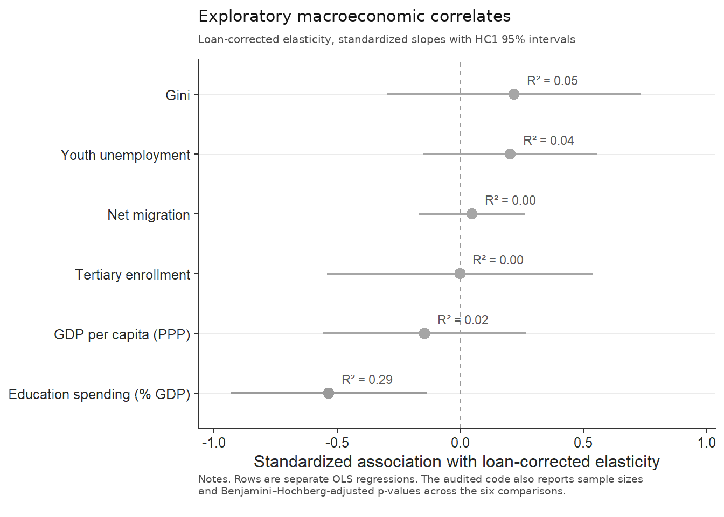
Note: Each row is a separate cross-sectional OLS regression with HC1 robust standard errors using 2022 World Bank data. Elasticities are signed negative values. The accompanying code also reports sample sizes and Benjamini–Hochberg-adjusted p-values across the six exploratory comparisons.
Figure 12 shows that most macroeconomic indicators have wide confidence intervals and low explanatory power in these small cross sections. GDP per capita, tertiary enrollment, net migration, youth unemployment, and inequality do not show precise bivariate associations with the rescaled elasticity. These results are descriptive and should not be read as evidence that the listed variables have no structural role.

Education spending as a share of GDP has the largest unadjusted bivariate association in Figure 12. Because six outcomes are examined in a small and variably complete cross section, this relationship is exploratory; its Benjamini–Hochberg-adjusted p-value and sample size should be considered alongside the raw confidence interval. A plausible interpretation is that domestic educational investment proxies for substitution opportunities, but the current regressions do not identify that channel.
More broadly, the loan-corrected elasticity may reflect both price responsiveness and the availability of credible alternatives. Testing this interpretation would require direct measures of program quality, capacity, portability of support, and destination substitution. The present bivariate correlations are a starting point for that analysis, not a causal conclusion.

- Conclusion

This manuscript establishes three main findings. First, the estimated price elasticities of international student demand are considerably larger than the ranges of 0.10-0.40 commonly reported in the literature, with absolute magnitudes exceeding 2 for some EU-origin countries. Second, the cross-country ordering of these elasticities changes once they are rescaled using country-specific valuations of the lost income-contingent loan. Under a common price shock, applicants from lower-income countries appear substantially more responsive. Once the effective price change incorporates the heterogeneous value of the loan, the relationship between elasticity and national income becomes statistically insignificant.
Much of the initial heterogeneity is therefore consistent with differences in the financial intensity of the Brexit shock instead of stable differences in preferences. The remaining elasticity variation has an exploratory association with education spending, but that result is sensitive to small samples and multiple testing. Future work should test the proposed substitution mechanism with direct measures of domestic educational opportunity.
These findings open a wider research agenda concerning the effects of Brexit on higher education mobility across the European Union. One immediate question concerns what happened to the demand displaced from the United Kingdom. If these applicants did not abandon international study and instead moved towards adjacent systems, the contraction in UK demand may have generated significant pressures elsewhere. Ireland is an especially relevant case because it remained inside the European Union while offering an English-language higher education system close to the United Kingdom. The reallocation of demand towards Ireland or similar destinations may have placed pressure on university capacity, student accommodation, staffing, and other parts of the receiving system. Establishing whether such displacement occurred, and whether the receiving systems were able to absorb it, would extend the analysis from the loss of demand in the United Kingdom to the wider European consequences of the reform.
A second question concerns the difference between domestic and cross-border demand elasticities. Most studies of higher education demand examine decisions made within the borders of the provider country and predominantly involve domestic students. These students are more closely tied to their national institutional environment and are often protected by financial mechanisms specifically designed around the domestic tuition system. This may help explain why conventional estimates are smaller than those obtained here. International applicants face a different choice. They can substitute between national education systems, while the financial support available in their home country may not cover the heterogeneous tuition fees charged abroad. National student-support systems are generally designed for domestic education and are rarely portable across the European Union.
The same percentage increase in tuition can therefore produce very different responses depending on the applicant’s origin and available alternatives. An increase in the price of UK higher education for a Lithuanian applicant is economically different from an equivalent increase faced by a domestic UK student. The Lithuanian applicant can redirect the application towards another European system, yet does not have access to the financial support provided to domestic UK students. The resulting elasticity reflects the tuition increase, the availability of alternative destinations, and the absence of portable financial support. The large elasticities estimated in this manuscript may therefore reveal a broader distinction between domestic and international student demand. Price responsiveness depends on the geographical scope of the choice, the alternatives available to applicants, and the institutions that allow educational finance to cross national borders.

References
Abadie, A. (2021). Using synthetic controls: Feasibility, data requirements, and methodological aspects. Journal of Economic Literature, 59(2), 391–425. https://doi.org/10.1257/jel.20191450
Arel-Bundock, V. (2022). WDI: World Development Indicators and other World Bank data (R package version 2.7.8) [Computer software]. https://CRAN.R-project.org/package=WDI
Arel-Bundock, V., Enevoldsen, N., & Yetman, C. J. (2018). countrycode: An R package to convert country names and country codes. Journal of Open Source Software, 3(28), 848. https://doi.org/10.21105/joss.00848
Arkhangelsky, D., Athey, S., Hirshberg, D. A., Imbens, G. W., & Wager, S. (2021). Synthetic difference-in-differences. American Economic Review, 111(12), 4088–4118. https://doi.org/10.1257/aer.20190159
Brown, R. (2011). After Browne: The new competitive regime for English higher education (CSHE Research & Occasional Paper Series No. CSHE.7.11). Center for Studies in Higher Education, University of California, Berkeley. https://escholarship.org/uc/item/9569q5n5
Calhoun, C. (2017). Populism, nationalism and Brexit. In W. Outhwaite (Ed.), Brexit: Sociological responses (pp. 57–76). Anthem Press. https://calhoun.faculty.asu.edu/sites/g/files/litvpz3321/files/publications/articles/populism_brexit.pdf
Campbell, R., & Siegel, B. (1967). The demand for higher education in the United States, 1919–1964. American Economic Review, 57(3), 482–494. https://www.jstor.org/stable/1812115
Clifton-Sprigg, J., Homburg, I., Huyghe, A., & Vujić, S. (2025). International student migration: Did Brexit close the door to EU students? (IZA Discussion Paper No. 18178). IZA Institute of Labor Economics. https://www.iza.org/publications/dp/18178/international-student-migration-did-brexit-close-the-door-to-eu-students
Conlon, G., Lader, R., Halterbeck, M., & Hedges, S. (2021). EU exit: Estimating the impact on UK higher education (Research Report No. DFE-RR1093). Department for Education. https://assets.publishing.service.gov.uk/government/uploads/system/uploads/attachment_data/file/958998/EU_exit_estimating_the_impact_on_UK_higher_education.pdf
Crawford, C., Maris, R., Petit, F., & Wyness, G. (2025). Degrees of demand: Price elasticity in higher education (CEPEO Working Paper Series No. 25-13). UCL Centre for Education Policy and Equalising Opportunities. https://ideas.repec.org/p/ucl/cepeow/25-13.html
Cuibus, M., Walsh, P. W., & Němeček, F. (2025). Student migration to the UK. The Migration Observatory, COMPAS, University of Oxford. https://migrationobservatory.ox.ac.uk/resources/briefings/student-migration-to-the-uk/
Driscoll, J. C., & Kraay, A. C. (1998). Consistent covariance matrix estimation with spatially dependent panel data. Review of Economics and Statistics, 80(4), 549–560. https://doi.org/10.1162/003465398557825
Dwenger, N., Storck, J., & Wrohlich, K. (2012). Do tuition fees affect the mobility of university applicants? Evidence from a natural experiment. Economics of Education Review, 31(1), 155–167. https://doi.org/10.1016/j.econedurev.2011.10.004
European Central Bank. (2021, July 8). ECB’s Governing Council approves its new monetary policy strategy. https://www.ecb.europa.eu/press/pr/date/2021/html/ecb.pr210708~dc78cc4b0d.en.html
Eurostat. (2025). Average full-time adjusted salary per employee [Data set]. https://doi.org/10.2908/NAMA_10_FTE
Findlay, A., King, R., Stam, A., & Ruiz-Gelices, E. (2006). Ever reluctant Europeans: The changing geographies of UK students studying and working abroad. European Urban and Regional Studies, 13(4), 291–318. https://doi.org/10.1177/0969776406065429
Heller, D. E. (1997). Student price response in higher education: An update to Leslie and Brinkman. The Journal of Higher Education, 68(6), 624–659. https://doi.org/10.1080/00221546.1997.11779004
Hemelt, S. W., & Marcotte, D. E. (2011). The impact of tuition increases on enrollment at public colleges and universities. Educational Evaluation and Policy Analysis, 33(4), 435–457. https://doi.org/10.3102/0162373711415261
Home Office. (2021, July 1). Graduate route for best and brightest launches. GOV.UK. https://www.gov.uk/government/news/graduate-route-for-best-and-brightest-launches
Hoxby, C. M. (1997). How the changing market structure of U.S. higher education explains college tuition (NBER Working Paper No. 6323). National Bureau of Economic Research. https://doi.org/10.3386/w6323
Hubble, S., & Bolton, P. (2018). Higher education tuition fees in England (House of Commons Library Briefing Paper No. 8151). House of Commons Library. https://commonslibrary.parliament.uk/research-briefings/cbp-8151/
Leslie, L. L., & Brinkman, P. T. (1987). Student price response in higher education: The student demand studies. Journal of Higher Education, 58(2), 181–204. https://doi.org/10.1080/00221546.1987.11778239
Locke, W., & Marini, G. (2021). The rapid increase in faculty from the European Union in UK higher education institutions and the possible impact of Brexit. In F. Huang & A. R. Welch (Eds.), International faculty in Asia (Vol. 21). Springer. https://doi.org/10.1007/978-981-33-4980-3_12
Luthra, R. R. (2020). Mitigating the hostile environment: The role of the workplace in EU migrant experience of Brexit. Journal of Ethnic and Migration Studies, 47(1), 190–207. https://doi.org/10.1080/1369183x.2020.1726173
Macdonald, C., & Stratta, E. (2001). From access to widening participation: Responses to the changing population in higher education in the UK. Journal of Further and Higher Education, 25(2), 249–258. https://doi.org/10.1080/03098770120050909
Mayhew, K. (2022). Brexit and UK higher education. Oxford Review of Economic Policy, 38(1), 179–187. https://doi.org/10.1093/oxrep/grab043
McFadden, D. (1974). Conditional logit analysis of qualitative choice behavior. In P. Zarembka (Ed.), Frontiers in econometrics (pp. 105–142). Academic Press. https://eml.berkeley.edu/reprints/mcfadden/zarembka.pdf
McQuone, R., & Simons, J. (2025). Counting the cost: Modelling the economic impact of a potential levy on international student fees. Public First. https://www.publicfirst.co.uk/couting-the-cost
Neville, R., Rowe, F., & Singleton, A. (2024). Unraveling the Brexit–COVID-19 nexus: Assessing the decline of EU student applications into UK universities. Data & Policy, 6, Article e45. https://doi.org/10.1017/dap.2024.42
Rambachan, A., & Roth, J. (2023). A more credible approach to parallel trends. Review of Economic Studies, 90(5), 2555–2591. https://doi.org/10.1093/restud/rdad018
Roth, J. (2022). Pretest with caution: Event-study estimates after testing for parallel trends. American Economic Review: Insights, 4(3), 305–322. https://doi.org/10.1257/aeri.20210236
Sá, F. (2014). The effect of tuition fees on university applications and attendance: Evidence from the UK. SSRN. https://doi.org/10.2139/ssrn.2481553
Sá, F. (2017). The effect of university fees on applications, attendance and course choice: Evidence from a natural experiment in the UK [Accepted manuscript]. King’s College London. https://kclpure.kcl.ac.uk/ws/files/97277490/The_E_ect_of_University_Fees_SA_Accepted13July2017_GREEN_AAM.pdf
Sá, F. (2019). The effect of university fees on applications, attendance and course choice: Evidence from a natural experiment in the UK. Economica, 86(343), 607–634. https://doi.org/10.1111/ecca.12278
Savoca, E. (1990). Another look at the demand for higher education: Measuring the price sensitivity of the decision to apply to college. Economics of Education Review, 9(2), 123–134. https://doi.org/10.1016/0272-7757(90)90040-C
Solís, A. (2017). Credit access and college enrollment. Journal of Political Economy, 125(2), 562–622. https://doi.org/10.1086/690829
UCAS. (2022). UCAS undergraduate sector-level end of cycle data resources 2021 [Data set]. https://www.ucas.com/data-and-analysis/undergraduate-statistics-and-reports/ucas-undergraduate-sector-level-end-of-cycle-data-resources-2021
UK Government. (n.d.-a). Repaying your student loan: What you pay. GOV.UK. https://www.gov.uk/repaying-your-student-loan/what-you-pay
UK Government. (n.d.-b). When your student loan gets written off or cancelled. GOV.UK. https://www.gov.uk/repaying-your-student-loan/when-your-student-loan-gets-written-off
UK Government. (n.d.-c). How interest is calculated (Plan 2). GOV.UK. https://www.gov.uk/guidance/how-interest-is-calculated-plan-2
World Bank. (2025). World Development Indicators [Data set]. https://databank.worldbank.org/source/world-development-indicators

From $\frac{ΔlnQ}{ΔlnP}=β$ we have that $ΔlnQ=-1.109$, hence $ΔlnP=\frac{1.109}{0.354}=3.13$, therefore $\frac{P_{1}}{P_{0}}=e^{3.13}=22.94$ and subtracting 1 gives 2194%.

