The Brexit Tuition Shock and the Price Elasticity of International Students: Evidence from a Natural Experiment

Stoycho Rusinov*

*Center for the Study of Democracy, Sofia

New Bulgarian University, Department of Informatics

email: stoycho.rusinov@csd.eu

ABSTRACT
This paper estimates the price elasticity of EU demand for UK higher education using the Brexit-induced loss of Home Fee status and student-loan access as a quasi-experimental tuition shock. Unlike standard higher-education demand studies that rely on enrollment outcomes, the analysis uses UCAS application data, allowing demand to be observed before universities ration admissions. The average post-Brexit treatment effect implies a decline in applications of roughly 70 percent, with country-specific elasticities varying substantially across the EU. Initial estimates suggest that applicants from lower-income member states were more price elastic, while wealthier countries experienced smaller demand contractions. However, once elasticities are rescaled using country-specific effective price shocks that account for the removal of income-contingent loans, the income gradient collapses and becomes statistically indistinguishable from zero. This indicates that much of the apparent cross-country heterogeneity reflects heterogeneous treatment intensity rather than stable differences in underlying preferences. The findings suggest that the UK student-loan system functioned as an important equalizing institution for European educational mobility, and that its removal transformed a nominally uniform tuition reform into a highly uneven economic shock across EU origin countries. The loan-adjusted elasticities are strongly correlated with the percentage of GDP allocated for educational investment.

JEL codes: I22; I23; F22; J61; D12; C23

Keywords: Brexit; international student mobility; higher education demand; tuition fees; price elasticity; EU students; UCAS applications; difference-in-differences; synthetic control; income-contingent loans; educational mobility; heterogeneous treatment effects.

- Introduction

International higher-education demand studies often struggle to isolate own-price elasticity because elasticity calculations usually rely on enrollment changes in response to price shifts. This approach is problematic because enrollment is an equilibrium outcome, shaped by both student preferences and capacity-constrained admission decisions (Hoxby, 1997; Bound et al., 2010). As a result, standard demand models using enrollment data conflate the desire to attend with the university's choice to admit.

In this paper, we assume that UCAS application data captures expressed demand before seats are rationed. Whether a student applies through the UCAS portal does not depend on how many places are available, as rationing occurs after applications are submitted. Our study uses cross-country variation, rather than traditional within-country, individual-level variation, to estimate international price responsiveness (i.e., demand elasticity).

To further clarify causal inference, we utilize the exogenous Brexit-induced tuition shock to estimate price elasticities at the origin-country level. The loss of Home Fee status and access to loans resulted from an external policy change, not a university pricing decision, creating a quasi-experimental setting for inferring willingness-to-pay. This causal design enables us to reconstruct country-specific, constant-elasticity demand functions for international applications around pre-Brexit price levels.

We show that under specific assumptions, applicants from lower-income EU countries exhibit highly elastic responses, significantly reducing their demand in response to the price hike. This heterogeneity implies that, while the UK higher education market faced a uniform regulatory shock, it also effectively filtered out price-sensitive consumers while retaining those with greater ability to pay. However, we later revisit these elasticity estimates by adopting a different perspective on credit risk valuation prior to Brexit, showing that much of the observed demand heterogeneity is driven by the structure of the student loan system itself. The result is the following set of contributions:

Poorer EU economies initially exhibit very high demand elasticities, and demand elasticities strongly correlate with GDP per capita.

When elasticities are rescaled using country-specific shocks from the value of the income-contingent loan, the income gradient shrinks to near zero, implying that most cross-country heterogeneity comes from treatment differences rather than preferences. The rescaled elasticity is more closely linked to the share of GDP invested in education than to GDP per capita itself.
- Context
  - Brexit and higher education
Over the preceding decades, the UK higher education system has expanded under policies of widened access (Macdonald & Stratta, 2001; Brown, 2011). Although price elasticity in higher education is generally moderate (Hoxby, 2000), most studies focus on individual-level characteristics (Leslie, 2003), leaving macro-level effects less explored. Brexit was a multifaceted phenomenon that began as a political movement but ultimately led to the UK’s exit from the EU, which was described as a populist pushback against globalization and a shift away from “London” (Calhoun, 2017). One of its most significant outcomes, however, was the rupture of academic ties between the UK and the EU, with 2020 marking the final year that EU students paid domestic-level tuition; fees then doubled or tripled, making Brexit one of the largest tuition policy changes of the 21st century (Cuibus & Walsh, 2024; Mayhew, 2022).
This shift also reshaped student mobility, although a declining trend in UK students heading to Europe was noted as early as 2006 (Findlay et al., 2006), partly offset by increased flows to North America and Australia. Locke and Marini (2021) note that in the decade preceding the Referendum on the UK’s membership of the European Union (EU), there had been a rapid increase in foreign faculty in UK higher education institutions (HEIs), particularly from other EU countries. Many institutions had come to rely on academics from other EU countries, as well as those from outside the EU, for a significant part of their research, teaching, and other activities. Locke and Marini (2021) indicate that the growth in academic outflow to the UK (from 2004/2005 to 2017/2018) was most pronounced in countries such as Bulgaria, Croatia, Estonia, Latvia, and Lithuania. Luthra (2020) argues that the rejection of free movement created vulnerability among EU staff, highlighting feelings of insecurity regarding their legal rights and public acceptance within their workplaces.
The causal design of the Brexit shock was implemented later (once UCAS data became available). For example, Neville et al. (2024) document sharp post-2021 declines in EU applications and acceptances, even after controlling for COVID-19 conditions. Clifton-Sprigg et al. (2025) explicitly conclude that the introduction of international tuition fees, rather than the referendum result or visa changes, caused the substantial contraction in EU study mobility. Our contribution advances these designs by treating the fee increase as a quasi-experimental price shock to identify origin-specific price elasticities from uncensored applications and by accounting for income-specific loan valuation. We therefore extend the literature by moving away from measuring how much demand fell to uncovering why it fell and what this implies for pricing and market structure.
  - Previous attempts to capture demand elasticities in higher education

Our use of DiD designs to recover structural demand parameters has a lineage in the IO literature, as Bresnahan (1982) showed that market-level price and quantity variation can identify demand elasticities when supply-side conduct is explicitly modeled. The present paper adapts this logic to a quasi-experimental setting, using the Brexit shock to identify the slope of country-level isoelastic demand curves. We extend the standard literature in the economics of education by building on Sá (2014), the closest methodological predecessor, who used the same UCAS application data and similar DiD logic to derive elasticities of 0.14–0.26 for domestic students. Her key finding is that credit-constrained students are not disproportionately affected, due to income-contingent loans equalizing access, a claim directly tested by Brexit, which removes those loans for an identifiable group. Our results extend the loan valuation mechanics by demonstrating that the income gradient in demand elasticities across EU countries collapses once elasticities are corrected for heterogeneous loan present values.

Endogeneity between demand and supply for higher education is another concern. Hoxby (1997) argues that increased competition in higher education can lead to higher tuition because institutions respond by differentiating their products, increasing quality, sorting students more sharply, and adjusting subsidies. In that account, rising tuition is an endogenous feature of a new competitive equilibrium. The Brexit design differs sharply in that the increase in tuition for EU students was not driven by institutional competition, quality upgrading, or a university-level pricing strategy. It was an externally imposed regulatory shock that removed Home Fee status and access to income-contingent loans while leaving the underlying educational product largely unchanged. This corresponds directly to Leslie and Brinkman (1987), who define demand elasticity as ε = (E/P), where E is the percentage change in enrollment, and P is the percentage change in price. If elasticity is derived from time-series variation rather than cross-sectional variation, then increasing competition can generate endogenous price shifts within the institutions affected.

Furthermore, Leslie and Brinkman (1987) explain that when we have a tuition elasticity from a time-series study, we cannot directly use it as a total-cost elasticity, because tuition and total cost did not move proportionally over time. This is why Brexit represents such an important empirical event, because it generated implicit tuition variation by sharply changing the effective price faced by EU applicants, allowing the analysis to identify how demand responds to changes in the actual cost of study rather than to nominal tuition alone. Campbell & Siegel (1967) present an example in which tuition rose 148% between 1927 and 1963, more than the total direct costs, so their tuition elasticity of −0.44 understates the true total cost elasticity.

Leslie and Brinkman (1987) further conclude that for every $100 increase in tuition price, given the 1982-83 average weighted higher education prices of $3,420 for tuition and room and board, one would expect a 18-24-year-old participation rate drop of about three-quarters of a percentage point. Since the national higher education participation rate was about 0.33 in 1982, U.S. enrollments would decline by about 2.1 percent for each $ 100 price increase, all other factors equal. This implies a price elasticity of about -0.73, which is largely consistent with some of our own estimates.

Savoca (1990) argues that standard enrollment-based estimates understate true demand sensitivity by conflating application behavior with admissions and matriculation decisions. Under the assumption that tuition and admissions policy are set independently, the price elasticity of enrollment equals the sum of the application and matriculation elasticities – a combined figure she estimates at −0.49, suggesting the true demand elasticity may be more than twice as large as conventional estimates. Following the modern wave of more robust causal evidence, Dwenger et al. (2012) corroborate this direction of effect in a different setting – among German high-school graduates, residing in a state with tuition fees reduces the probability of applying to a home-state university by 2 percentage points (against a baseline of 69%), with stronger responses among higher-achieving students.

To understand why the Brexit-derived elasticities may be larger than the standard estimates in the literature, consider, for example, Heller (1997), who argues that tuition increases reduce enrollment (so higher education is not a luxury good). The studies reviewed by Heller (1997) converge on the finding that each $100 tuition increase lowers enrollment by roughly 0.5 to 1.0 percentage points, which is consistent with Leslie and Brinkman (1987). Reductions in financial aid also reduce enrollment, though the effect varies by aid type. Lower-income students are more sensitive to changes in tuition and aid than middle- and upper-income students. The results presented in Hemelt and Marcotte (2011) are also relevant because they confirm the standard negative relationship between tuition and enrollment, but their design is also not directly comparable to Brexit.

Another branch in the literature is the BLP-type models (building on McFadden, 1974), which derive elasticities from estimated heterogeneity in preferences across differentiated alternatives; the present design derives elasticity from observed variation in exposure to a large policy-induced price shock. The former is better suited for recovering substitution matrices across choices; the latter is better suited for identifying a destination-level demand response to a discrete change in the relative price of UK higher education.
- Data
The primary data source is the most recent release of the UCAS database (2025), covering application cycles from 2016 to 2025. UCAS provides centralized information on applications to UK higher education institutions, enabling us to observe applicant behavior before admissions decisions are made. This is particularly important for our empirical design, as applications capture expressed demand before institutional rationing takes place. The dataset reports application counts by country of domicile along with additional demographic breakdowns. In this study, application series are constructed by aggregating counts across all available categories of sex and gender to obtain total demand from each origin country, while nationality is retained as the key dimension of variation.
A natural extension would be to derive gender-, age-, or subject-specific elasticities from the same data; we leave this for future work and focus here on aggregate flows due to space constraints.
The unit of observation is the origin-country–year, yielding a panel dataset that includes both EU countries (the treated group) and non-EU countries used to construct the “pseudo EU” (the artificial control group). The main outcome variable is the logarithm of the number of applications from country i in year t, which captures cross-country variation in demand over time. To analyze heterogeneity in responses to the Brexit-induced tuition shock, the UCAS data are merged with macroeconomic indicators, including GDP per capita and labor-market variables from the World Bank. The descriptive statistics are presented in Table 1.

Table 1. Descriptive statistics of the core variable in the analysis for both the treated and control groups.
Years: 2016 to 2025 |  | Control countries: 26 | Treated countries: 26
Group: | Treated | Control | $$Post_{t}$$
Variable: | Applicants
Min | 30 | 80 | 0
Max | 5550 | 8355 | 1
Mean | 1275 | 1772 | 0.5
Median | 655 | 867.5 | 0.5
N | 260 | 260 | 520

Country-specific average wages w_{j} are taken from Eurostat's Average full-time adjusted salary per employee indicator (nama_10_fte) for 2024 (Eurostat, 2025). The series reports gross annual salaries in current euros, harmonized across Member States by adjusting national-accounts wages with a full-time equivalent ratio from the EU Labour Force Survey. This wage enters the loan present-value calculation PV_{loan}(w_{j}) and determines the country-specific effective price shock k_{j}.
Macroeconomic controls are drawn from the World Bank's World Development Indicators, accessed via the WDI R package (Arel-Bundock, 2022): GDP per capita in constant USD (NY.GDP.PCAP.KD), working-age population aged 15–64 (SP.POP.1564.TO), and youth unemployment for ages 15–24 (SL.UEM.1524.ZS). Country codes were harmonised to ISO3 using the countrycode package (Arel-Bundock et al., 2018), and the series were merged with the UCAS panel on country–year. World Bank data are available through 2024 (World Bank, 2025).
It is also important to note that we use country-level data and not university-specific data (as in Sá (2014) or Clifton-Sprigg et al. (2025), for example) because of an internal limitation of the UCAS data itself. Once a student creates a registration in the UCAS web portal, they can choose up to 5 universities at once. Furthermore, the student can be accepted to all five of them. This results in double, and sometimes triple, counting of the same applicant. This internal limitation is absent when the series is country-level aggregated, because in this design, each applicant is counted only once per country.

- Empirical strategy
  - Constructing the counterfactual European Union
To execute the DiD design, we first construct the synthetic control set $℘,$ a synthetic copy of the European Union obtained by combining countries unaffected by the Brexit-induced tuition shock but structurally comparable in number of applications and income distribution. To construct this set we compared each EU origin market to the most behaviorally similar top 3 non-EU origins based on log-scaled, normalized pre-Brexit application trajectories using Euclidean distance minimization. We evaluate the pre-treatment dynamics of the candidate control countries using event-study diagnostics. Countries displaying systematic divergence from the EU group in the pre-Brexit period are excluded from the donor pool to preserve the parallel-trend requirement of the difference-in-differences design. We compared the Control and the Treated GDP, applicants and accepted applicants’ distributions to ensure that the union was replicated not just in pre-COVID dynamics but also in wealth and admission probabilities (so students are not discouraged from applying based on the previous experience of their peers).
The resulting donor pool is presented on table A1. Because the saturated difference-in-differences specification measures each treated unit relative to the omitted reference category, the counterfactual in the regression is effectively the average trajectory of the donor pool. Since several EU origins share the same nearest neighbors, some donor countries appear multiple times in the matching procedure. To maintain a control group comparable in size to the treated sample and to preserve the dispersion of economic conditions observed across EU origin markets, we augment the donor pool with Australia, Peru, Mauritius, Qatar, Albania, and Ireland. These additions broaden the income distribution of the control group and ensure that the donor pool reproduces the heterogeneity of GDP per capita present in the EU sample rather than concentrating excessively on lower-income origins.
Using this construction, the set of affected countries is denoted as Ω.
Therefore, the entire sample is $Ξ=Ω∪℘$. On figure 1 we plot the empirical distributions of the EU countries as well as the selected control countries. The applications and accepted applications distributions are very similar. In terms of GDP per capita, however, the EU has higher density in the 50000 GDP per capita threshold which was expected due to the macroeconomic convergence in the region. The peaks of the distributions appear to be following a similar trajectory (bimodality around the 50-k threshold).
Figure 1 Empirical densities of the GDP, number of applications and Accepted applications for the EU students and the control group. (in time)
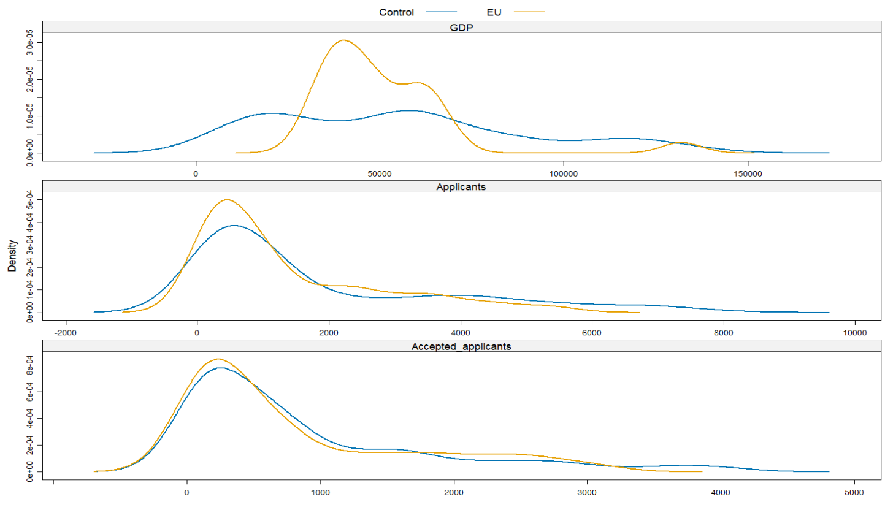
Source. Own-calculations
  - Identification strategy and parallel trends
In a comparable perspective, the closest design to ours – Sá (2014) – exploits within-country, across-time variation in fees. The treatment in her case is binary and uniform: Scottish students either pay or don't, and English students face one fee level, then another. There is no cross-sectional variation in the size of the price shock. In this paper, however, we exploit cross-country, across-time variation, where the price shock itself, kⱼ, differs across countries because the present value of the foregone loan differs with the average wage. This means the identifying variation has two dimensions simultaneously – whether you are treated (EU vs. non-EU) and how intensely you are treated (which EU country you are from). This corrects an internal limitation in Sá's (2014) design, which cannot separately identify these because all treated students face the same fee change. This resonates with the fact that Sá's identification still relies on only 2 countries and 1 treatment switch, resulting in fewer effective independent treatment clusters.
Following these design choices, we estimate a dynamic difference-in-differences specification. This traces the evolution of applications around the Brexit tuition reform:
$$\log{A_{it}}=α_{i}+γ_{t}+\sum_{l≠0}{δ_{l}}\left(EU_{i}×1\left\{t-2020=l\right\}\right)+ε_{it}$$ | (1)
The coefficients $δ_{l}$ measures those year-by-year deviations in log applications for EU-origin countries relative to the omitted pre-reform year ($l=0$, corresponding to 2020).
Figure 2. Event-study estimates comparing EU applicants to the synthetic control group.
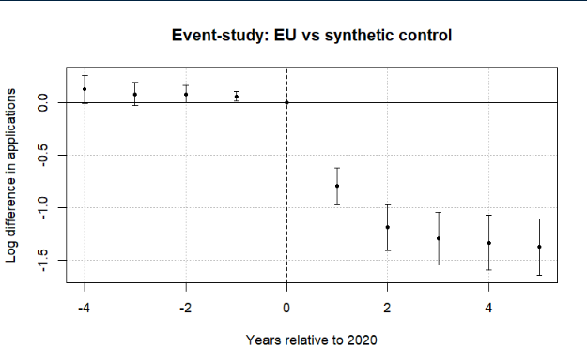
Note: The figure plots coefficients from a difference-in-differences event-study comparing EU applicants to a synthetic control group of non-EU countries. The horizontal axis shows years relative to 2020, the last pre-treatment year. Points represent estimated differences in log applications and bars denote 95% confidence intervals clustered at the country level. The dashed vertical line marks the final pre-treatment year. Pre-treatment coefficients are small and close to zero, while a sharp decline in EU applications emerges beginning in 2021 after the tuition reform took effect. A joint Wald test cannot reject the null that the pre-treatment coefficients are jointly zero (p = 0.12), providing no strong evidence of differential pre-trends.

Figure 2 reports the event-study coefficients from equation (1). The pre-treatment coefficients (leads) are generally small and close to zero, although several leads are marginally statistically significant when standard errors are clustered at the country level and a joint Wald test fails to reject the null hypothesis that the pre-treatment coefficients are jointly equal to zero (p = 0.12).
The overall trends in the data (especially clear with the release of the 2025 data) rule out the possibility that the change in the number of applications was due to COVID. No observable recovery is visible in figure. 2, especially in the periods when COVID has largely abated (2024 and 2025), with the decline going deeper the more years have passed since the event. Due to a small positive divergence in the Post-Referendum applications, we can conclude that the UK higher education system did not become less appealing due to migration concerns – if anything, candidates were even more motivated to apply.
Figure 3 Leads-only test without anticipation effects.
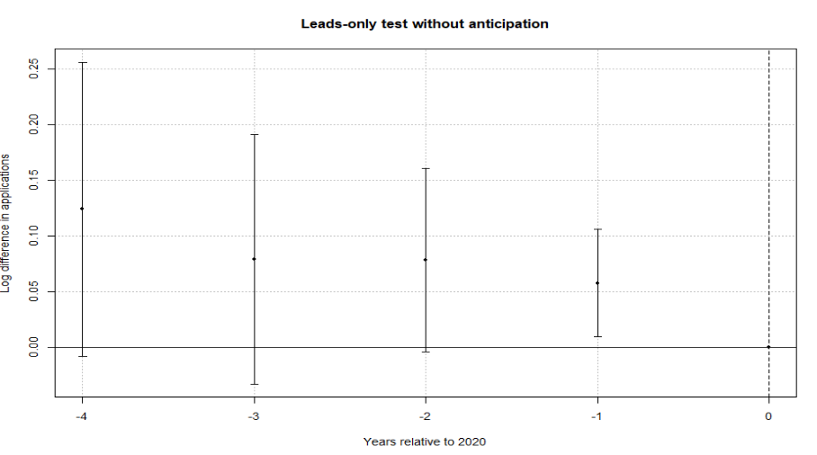
Note: The figure plots coefficients from a leads-only specification testing whether EU applications diverged from the synthetic control group prior to the Brexit tuition reform. The horizontal axis shows years relative to 2020, the last pre-treatment year. Points represent estimated differences in log applications and bars denote 95% confidence intervals clustered at the country level. The dashed vertical line marks the final pre-treatment year. The estimates display no systematic pre-treatment pattern, and a joint Wald test fails to reject the null that the early leads are jointly zero (p = 0.12), providing no strong evidence of anticipation effects.

To further assess identification, we implement two additional tests. First, a leads-only specification finds no evidence of anticipation effects, suggesting that applicants did not adjust behavior prior to the reform (Figure 3). Second, a placebo exercise with randomly assigned treatment produces coefficients centered around zero, indicating that the estimated effects are not driven by mechanical features of the estimation procedure (Figure A1).
Finally, allowing for country-specific dynamic effects yields similar patterns: post-treatment coefficients are consistently negative across EU countries, while pre-treatment estimates remain close to zero (Figure 4). The only exception is Portugal, whose applications did not immediately collapse in 2021. This can be traced to a UCAS data reporting issue: in the 2021 cycle some Recorded Prior Acceptances (RPAs) were mistakenly submitted as domiciled in Portugal, so the true number of Portugal-domiciled RPAs is lower than the reported figure for that cycle (UCAS, 2022).

Figure 4. Saturated DiD event-study estimates by country.
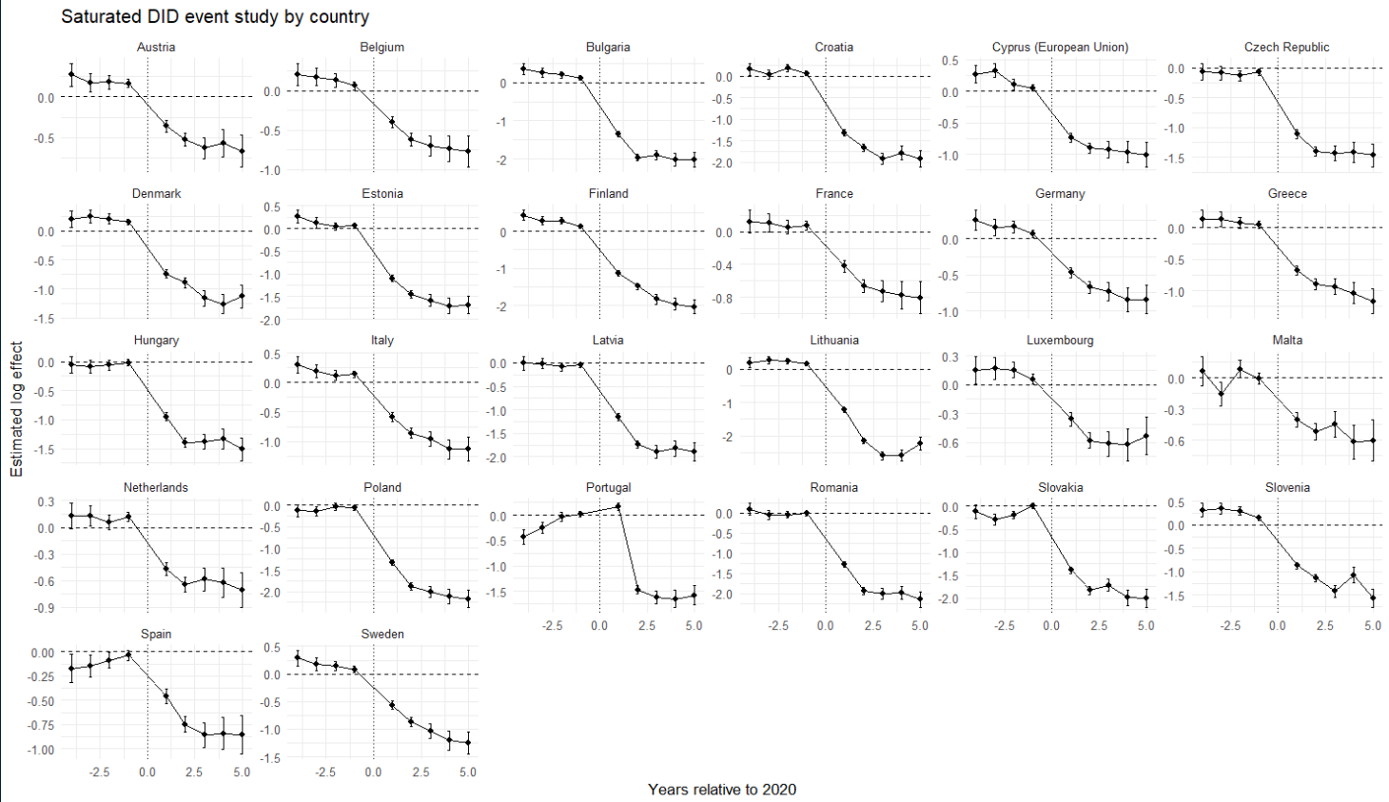
Note: Each panel reports country-specific dynamic treatment effects from the saturated difference-in-differences specification comparing EU countries with the pooled control group. Coefficients represent log differences in applications relative to the baseline year (2020). Error bars denote 95% confidence intervals. All results were completely replicated in Python and the output was the same.
  - Baseline elasticities estimates
The empirical justification of the counterfactual European Union allows us to create a synthetic untreated group, enabling us to estimate the saturated two-way DiD model:
$$\log{(A_{it})} = α_{i} + γ_{t} +\sum_{\begin{aligned}j∈Ω \\ \end{aligned}}^{ }{β_{j} \left(1\left\{i=j\right\}×Post_{t}\right)} +ρ^{'}X+ ε_{it}$$ | (2)
where ($A_{it}$) denotes applications (or acceptance rates) from origin country ($i∈Ξ$) in year ($t∈\left[2016, 2025\right]$), $1\left\{i=j\right\}$ is an indicator for EU member states, and $Post_{t}$ marks the introduction of the new tuition regime in 2021. The interaction coefficient ($β_{j}$) captures the magnitude of the country-specific collapse in applications under a homogeneous price shock, relative to the omitted category.
To distinguish between short-run and persistent effects, we further split the post-treatment period into two phases: 2021–2023, which captures the immediate response following the reform, and 2024 onward, which reflects longer-run adjustments. The specification becomes:
$$\begin{matrix}\log{(A_{it})} & = & α_{i} + γ_{t} + \sum_{\begin{aligned}j∈Ω \\ \end{aligned}}^{ }{β_{j} \left(1\left\{i=j\right\}×Pos{tBrexit}_{t}\right)} \\ & + & \sum_{\begin{aligned}j^{ }∈Ω \\ \end{aligned}}^{ }{σ_{j^{ }} \left(1\left\{i=j\right\}×Pos{tCovid}_{t}\right)}+ρ^{'}X+ ε_{it }\end{matrix}$$ | (3)
from here follows the interpretation of $β_{j}$ as the short-run country specific response (Brexit + COVID uncertainty) and${ σ}_{j^{ }}$​ is the persistent structural response (pure willingness-to-pay shift). The difference $β_{j}-σ_{j^{ }}=ω_{j}$ provides the specific COVID impact on demand elasticities (mathematical proof for this in the supplementary materials).
We show in the supplementary materials that the $β_{j},$ with $j∈Ω$, coefficient can be mapped to a structural elasticity parameter through the following transformation (Bresnahan (1982) style):
$η_{j}=\frac{β_{j}}{k_{j}}$,
To allow heterogeneous $k$’s, under the Plan 2 for the contingent student loan, graduates had to repay 9% of annual earnings above a statutory repayment threshold (UK Government, n.d.-a). For the relevant cohort, the repayment threshold is £27,295 per annum. Annual repayments are therefore defined as $R_{t}=0.09⋅\max{\{0,Y_{t}-τ\}}$ in which τ denotes the repayment threshold and Y_{t​} follows a deterministic wage path with annual growth rate g. The loan is written off 30 years after the April in which repayment becomes due (UK Government, n.d.-b), implying a finite repayment horizon T=30. Interest accrues at the Retail Price Index (RPI) plus up to three percentage points, depending on income (UK Government, n.d.-c). Rather than replicate the full income-dependent interest schedule, we model the economic burden of the loan as the present value of expected repayments and discount repayment flows at a constant rate δ. The present value of the loan is therefore defined as:
$$PV_{loan}\left(w_{j}\right)=\sum_{t=1}^{30}{\frac{0.09⋅\max{\{0,w_{j}{\left(1+g\right)}^{t-1}-τ\}}}{{\left(1+δ\right)}^{t}}}$$
In the baseline specification, we set δ=3%. We estimate the present value based on the average country specific wage ($w_{j})$ and $k$ becomes a function of the average wage:
$$k_{j}=\log{22200}-\log{PV_{loan}(w_{j})}$$
in this formula $PV_{loan}(w_{j})$ is the present value of the income contingent UK loan, 22200 is the average post-Brexit price and $w_{j}$ is the average annual salary in Euro. Under the standard shift from 9250 pounds and no heterogeneity assumption $k$ is 0.86. Clifton-Sprigg (2025) assumes one unique price change (from the old price of 9250 to 22200) but the above equation allows us to relax this assumption. This extension is especially relevant in light of Solís (2017) findings that credit access leads to a 100 percent increase in immediate college enrollment and a 50 percent increase in the probability of ever enrolling.
We then relate these elasticities to observable economic fundamentals. Specifically, we estimate correlations of the form:
$$β_{j} = θ_{0} + δ_{1}\log\left(GDPpc_{j}\right)+ρ^{'}X+ u_{ }$$ | (4)
Where $ρ^{'}X$ is a list of country specific covariates that control for structural characteristics at the country level. This exercise documents that income strongly predicts the magnitude of the shock, consistent with a segmented higher-education market in which price sensitivity varies systematically with economic fundamentals.
- Results
  - Estimated baseline elasticities
Following the empirical strategy, Figure 5 reports country-specific elasticities derived from the difference-in-differences estimates. We translate the estimated treatment effects into implied demand responses to the Brexit tuition shock.
Figure 5. Decomposition of the post-Brexit demand elasticities by treated country.
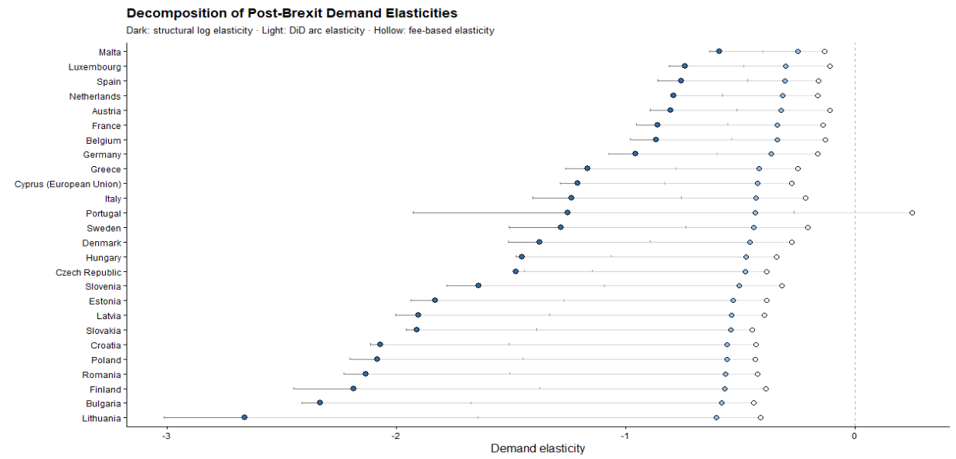
Note: The structural log elasticities are obtained from the division of the country-specific effect ($β_{j})$ by 0.86. The Arc elasticities are obtained by $\left(e^{β}-1\right)/1.4$ and the mechanical arc elasticities by $ΔApplications_{2020}^{2021}/1.40$. This graph was replicated both in Python and R and was the same across software implementations.
The results indicate a large and widespread contraction in demand. Across EU countries, applications declined substantially following the introduction of international tuition fees, with estimated effects corresponding to reductions of roughly 45% to 90% relative to the control group. The average effect implies a decline of approximately 70%. All DiD elasticities lie strictly below zero, confirming that the Brexit-induced tuition shock caused a contraction in EU demand for UK higher education across the entire Union. However, the magnitude of this response varies substantially. Wealthier EU countries such as Malta, Spain, Luxembourg, the Netherlands, and Austria cluster near elasticities between −0.7 and −1.0, indicating relatively inelastic demand. By contrast, lower-income EU countries – including Bulgaria, Romania, Lithuania, Croatia, and Latvia – exhibit elasticities below −2, with Lithuania approaching −3, indicating relatively elastic demand.
This heterogeneity aligns closely with cross-country differences in income. Regressing the estimated country-specific responses on GDP per capita reveals a strong positive relationship where wealthier countries experience smaller declines in applications (Table 2). The strong positive relationship between GDP per capita and demand elasticity emerges only when elasticities are estimated using fixed effects specifications. This reflects the ability of the TWFE estimator to isolate the causal impact of the Brexit-induced tuition shock by removing both country-specific baseline differences and common time shocks. In contrast, pooled estimates conflate treatment effects with cross-country heterogeneity in levels and trends, obscuring the underlying relationship. As a result, the GDP gradient disappears when identification is not enforced.
An important consideration is that the tuition reform altered not only nominal prices but also the availability of income-contingent loans. The baseline elasticity estimates, however, rest on the assumption that the Brexit reform generated a uniform effective price change across EU countries. We argue in the discussion section that this assumption is unlikely to hold, and that once it is relaxed, the cross-country pattern changes substantially. Details on the construction of elasticity measures and alternative definitions are provided in Appendix A.
Table 2. Correlations between the DiD (FEs and No FEs elasticities) and logarithm of GDP per capita (source WB R pool)
 | TWFE elasticities | Pooled elasticities
$\log\left(GDPpc\right)$ | 1.11*** | 0.076
 | (0.361) | (0.987)
Const. | -13.44*** | -1.87
 | (3.916) | (10.69)
Observations | 24 | 24
Adj. R² | 0.266 | -0.045
  - Estimated COVID specific elasticities
Figure 6 compares the immediate post-Brexit demand elasticities with the persistent elasticities observed after pandemic disruptions had abated. The difference between the dots is consistent with the effect derived in the supplementary materials.
Figure 6. Post Brexit and post-COVID Demand elasticities compared on the same measurement axis.
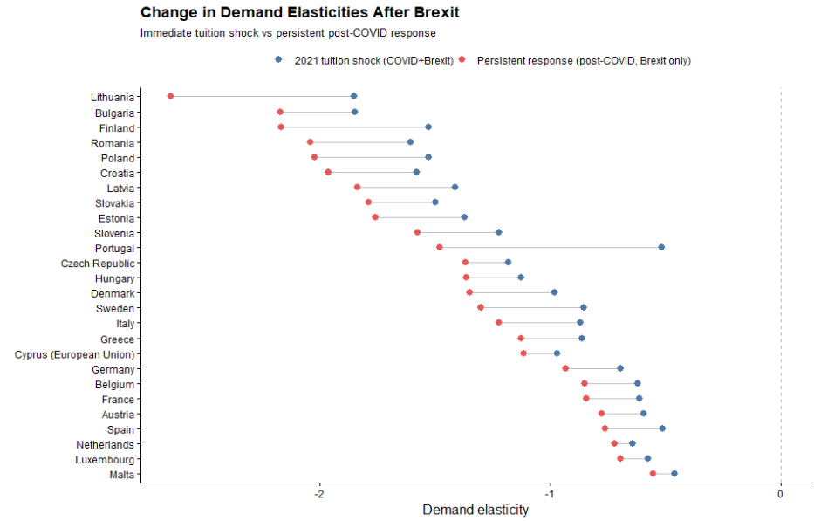
It is also important to mention that for nearly all EU origin countries, the persistent post-COVID elasticities remain strongly negative and closely aligned with the initial post-2021 estimates. The persistence of the elasticities confirms that price sensitivity, rather than short-run volatility, is the dominant mechanism behind the observed demand contraction.
For higher-income EU countries, elasticities become slightly less negative once COVID effects dissipate, suggesting partial normalization of demand at the margin. In contrast, for lower-income EU countries, elasticities remain highly elastic especially in the post-COVID period, with little evidence of recovery (the gap between the post-COVID and the Brexit elasticity appears to widen more for poorer countries).
  - ATT wealth heterogeneity
Table 3. ATE coefficient and interactions. FEs are always entity and time. Standard errors are Driscoll & Kraay (1998) (L=1)
 | (I) | (II) | (III) | (IV) | (V) | (VI)
$$ATT$$ | -1.27*** | -1.1*** | -7.16*** | -1.13*** | -0.99*** | -7.37***
 | (0.122) | (0.1) | (0.703) | (0.126) | (0.109) | (1.75)
$$\log{(GDPpc)}$$ |  | -0.05 | 0.281* |  | -0.73* | -0.29
 |  | (0.151) | (0.119) |  | (0.288) | (0.25)
$$\log{(Pop16_54)}$$ |  | 4.03*** | 3.498*** |  | 2.77*** | 2.34***
 |  | (0.3) | (0.381) |  | (0.519) | (0.53)
$$YU$$ |  | -0.02*** | -0.015** |  | -0.02*** | -0.012*
 |  | (0.004) | (0.004) |  | (0.006) | (0.006)
$$ATT×\log{(GDPpc)}$$ |  |  | 0.438*** |  |  | 0.47***
 |  |  | (0.073) |  |  | (0.102)
$$ATT×\log{(Pop16_54)}$$ |  |  | 0.094*** |  |  | 0.08***
 |  |  | (0.017) |  |  | (0.015)
$$ATT× YU$$ |  |  | 0.006 |  |  | 0.02***
 |  |  | (0.006) |  |  | (0.004)
Obs | 520 | 459 | 459 | 520 | 459 | 459
R2 Adj | 0.952 | 0.706 | 0.971 | 0.590 | 0.670 | 0.718
R2 Within | 0.613 | 0.703 | 0.761

Note: Models (I) through (V) are estimated with the standard TWFE estimator, while (VI) is estimated with a Poisson regression (see Berge (2018)) based on MLE. All regressions from (I) to (V) were replicated with the standard “linear models” package in Python, while (VI) was estimated using “substitutes”. All regressions are replicable in both R and Python. The data is sourced from the World Bank API resources, except for Jersey that was excluded due to data restrictions. Since the series for 2025 were not yet available at time of writing, they were excluded, giving 459 observations (51 countries × 9 years).
Table 3 reports regressions that relate the magnitude of the Brexit demand shock to country-level economic characteristics. Across all specifications, the baseline effect remains large, negative, and statistically significant, confirming a substantial contraction in EU demand following the tuition reform. At the same time, there is clear evidence of heterogeneity. The interaction between the Brexit treatment and GDP per capita is positive and statistically significant, indicating that higher-income countries experience smaller declines in applications. This is consistent with lower price sensitivity in wealthier contexts.
Labor market conditions also play an important role. The interaction with youth unemployment is positive and significant, suggesting that weaker labor market prospects attenuate the decline in applications. When employment opportunities for young cohorts deteriorate, studying abroad becomes a relatively more attractive option, reducing the responsiveness to higher tuition fees. By contrast, demographic factors such as population size do not materially affect the results and provide limited explanatory power.
Figure 7. Saturated DiD specifications with macroeconomic controls added. Namely GDP per capita (constant prices), population and the percentage of youth unemployment as separate models.
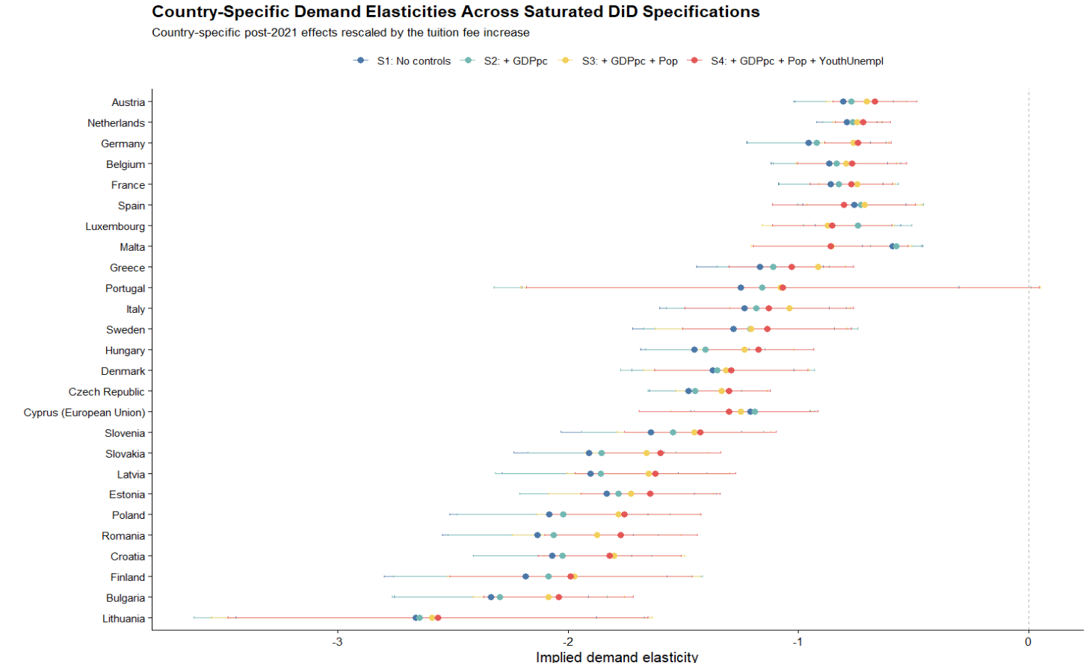
- Robustness
We assess the robustness of the baseline results along three dimensions: the choice of control group, the estimation method, and potential omitted variable bias. First, we re-estimate the treatment effect using alternative control groups, including only OECD countries, only high-income countries, and only low-income countries. The estimated effects remain consistently negative and of similar magnitude across all specifications, with overlapping confidence intervals. This indicates that the results are not driven by the composition of the control group (Table 4). We combine this with multiple changes in the estimator - the doubly robust estimator of Callaway and Sant’Anna (2021) as an alternative to the standard two-way fixed effects model as well as the Poisson, MLE-based regression estimates (see Berge (2018)). The resulting estimates are very close to the baseline results, and event-study diagnostics continue to show no evidence of differential pre-trends.
Table 4. Estimates obtained from Doubly Robust estimator and the Standard TWFE model. Standard errors are reported in parenthesis. Both models estimate the coefficients with the number of observations presented in the “Sample decomposition” table.
 | (1) Doubly Robust | (2) TWFE | (3) Poisson MLE
Panel A: Baseline estimates
Synthetic control | −1.197* | −1.265*** | −1.132***
 | (0.106) | (0.122) | (0.126)
Panel B: Alternative samples
Poor countries | −1.48* | −1.67*** | -1.59***
 | (0.156) | (0.200) | (0.167)
Rich countries | −1.23* | −1.32*** | -1.16***
 | (0.122) | (0.130) | (0.13)
OECD countries | −1.18* | −1.26*** | -1.198***
 | (0.125) | (0.130) | (0.13)

Table 5. Sample compositions for the alternative control groups
 | Synthetic | Poor | Rich | OECD
Control group | 24 | 14 | 13 | 14
EU group | 26 | 26 | 26 | 26
Observations | 450 | 400 | 390 | 400
Note: To avoid the proliferation of too many tables detailed statistical description of the used groups is provided in the supplementary materials section.

Figure 8. Stratified cluster bootstrap distribution of the Brexit treatment effect.
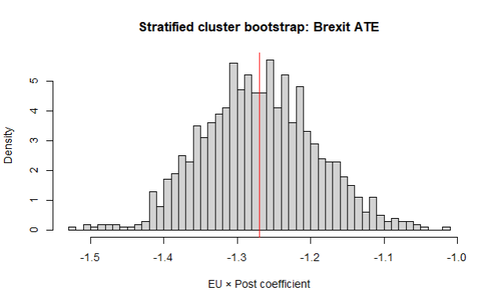
Note: The histogram reports the distribution of the EU×Post coefficient obtained from 1,000 stratified cluster bootstrap replications, resampling treated and non-treated countries separately with replacement. In each replication, the model $\log{(Applicants)}∼EU×Post$ is re-estimated with country and year fixed effects. The bootstrap mean estimate is −1.270, with bootstrap standard deviation 0.078. The 95% percentile bootstrap confidence interval is [−1.413,−1.114]. The red vertical line marks the bootstrap mean.
Second, we examine the sensitivity of the estimates to sampling variation and unobserved confounding. A stratified cluster bootstrap shows that the estimated treatment effect is tightly centered around the baseline value and remains consistently negative across replications.
Finally, we apply the sensitivity analysis framework of Cinelli and Hazlett (2020). The results indicate that an omitted variable would need to explain a very large share of the residual variation in both treatment and outcome to eliminate the estimated effect (approximately 70%). Given the inclusion of country and year fixed effects, such a confounder appears implausibly strong (Figure 9).
Figure 9. Sensitivity analysis for omitted variable bias (sensemakr).
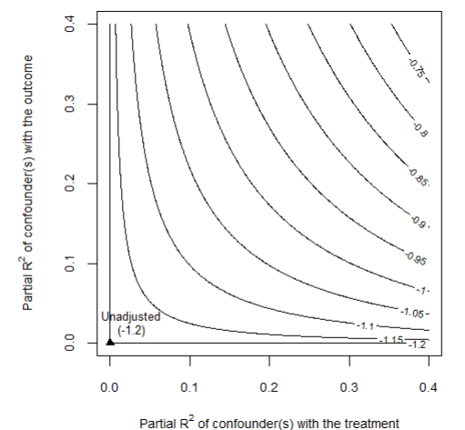
Note: The contour plot shows how the estimated EU×Post coefficient changes under hypothetical unobserved confounding. The axes represent the partial R² of a potential confounder with the treatment and the outcome.
- Discussion
  - Were poor EU students really priced out because of elastic demand?
A natural interpretation of the results is that students from lower-income EU countries exhibit more elastic demand for UK higher education. However, this interpretation relies on the assumption that the tuition reform generated the same effective price change across countries. In practice, this assumption is unlikely to hold. Prior to Brexit, tuition was financed through income-contingent loans, meaning that the relevant economic price depended on expected future earnings rather than the nominal fee. As a result, the removal of these loans likely generated larger effective price increases for applicants from lower-income countries.
To illustrate how elasticities, depend on loan valuation, we compute implied elasticities using the average treatment effect coefficient $β=-1.28$ and map it across a range of starting income levels (Figure 10). When the loan is expected to have a low present value (e.g., for applicants with low expected earnings), the Brexit reform constitutes a large effective price shock, and the implied elasticity is mechanically smaller in magnitude (approximately −0.4). Conversely, when the loan’s present value approaches its nominal amount (high expected earnings), the effective price shock is smaller, and the implied elasticity is larger in magnitude
Figure 10 Implied demand elasticity as a function of the economic value of the UK student loan.
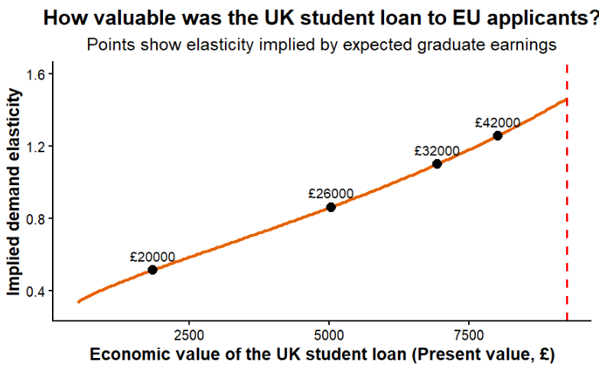
Note: The figure translates the estimated treatment effect into implied demand elasticities under different assumptions about the present value of the UK student loan to EU applicants. Points correspond to elasticity estimates implied by alternative expected graduate earning scenarios.
To examine whether structural heterogeneity in demand persists after accounting for this mechanism, we define corrected elasticities as $η_{j}^{'}=β_{j}{/k}_{j}$. Dividing by heterogeneous $k_{j}$removes the portion of elasticity variation that is mechanically induced by differential effective price shocks. Any remaining systematic variation in $η_{j}^{'}$ therefore reflects structural heterogeneity in willingness to pay rather than loan-valuation mechanics. After recomputing the elasticities using heterogeneous price changes across the Union, we re-estimated the correlation with GDP per capita. Figure 11 shows that this time the correlation reverses sign and becomes negative.
Figure 11. Income gradient in demand elasticity.
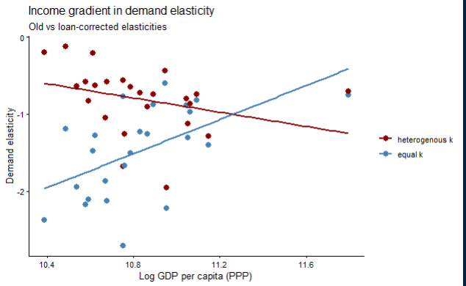
Note: The figure compares baseline elasticity estimates with elasticities corrected for heterogeneous loan value across countries. The horizontal axis shows log GDP per capita (PPP). Lines represent fitted linear relationships.
Before correcting for heterogeneous treatment intensity, demand elasticities display a strong and statistically significant positive relationship with origin-country income (δ = 1.06, p = 0.01, Figure 11). However, once elasticities are rescaled using country-specific effective price shocks derived from the present value of the income-contingent loan, the income gradient collapses, becomes statistically indistinguishable from zero and reverses sign (δ = −0.50, p = 0.12). The difference between the two income gradients indicates that a substantial portion of the observed cross-country heterogeneity reflects variation in treatment intensity rather than structural differences in preferences.
After this correction, countries such as Finland, Denmark, Slovenia, Germany, and Luxembourg display the largest elasticities. These are precisely the countries with substantial high-quality domestic alternatives, where UK higher education is one option among many and demand can adjust readily to a price change. Applicants from lower-income EU countries, by contrast, face fewer high-quality domestic alternatives and may view UK education as a pathway to substantially higher lifetime earnings; their application behavior is therefore less responsive to tuition increases than raw demand responses would suggest.
From a political perspective, the decline in applications from poorer EU countries reflects the withdrawal of an institution that had quietly equalized opportunity across Europe. The UK’s income-contingent loan system meant that students did not need to arrive with wealth; they needed only the expectation of future effort and earnings. When that system disappeared for EU applicants, the effective cost of studying in the UK rose dramatically for those from poorer economies. What appears in the data as “elastic demand” is therefore better understood as the sudden loss of a mechanism that had allowed talent to travel across borders without the constraint of immediate financial means. In that sense, the Brexit tuition reform did not simply reveal price sensitivity – it exposed how fragile educational mobility can be when the institutions that support it are removed.
  - What are the real determinants of the corrected elasticity?
Table 6. Alternative correlations between the corrected income elasticity and macroeconomic fundamentals.
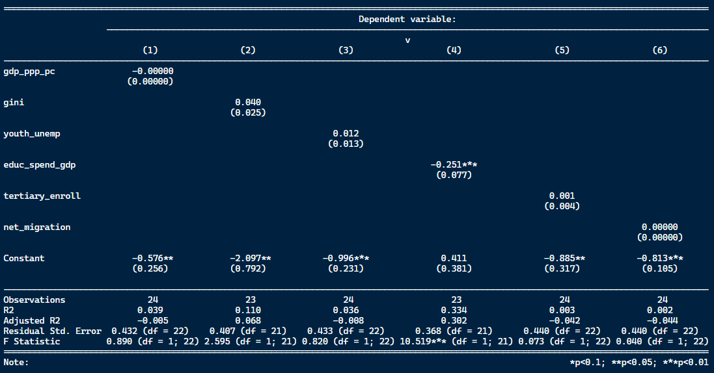
Note: Performed is simple cross-sectional OLS with HC1 robust standard errors.

Appendix
Table A1. Counterfactual construction: donor countries used to match each treated EU country in the synthetic European Union.
Treated | Austria | Belgium | Bulgaria | Croatia | Cyprus (EU) | Czech Republic
Matched | Jersey | Switzerland | Norway | Macao | Singapore | Turkey
 | Vietnam | Russian Federation | Canada |  | Canada | Kuwait
 |  |  |  |  | United States of America | Thailand
Treated | Denmark | Estonia | Finland | France | Germany | Poland
Matched | Jordan | Vietnam | Russian Federation | Malaysia | United States of America | United States of America
 | Bahrain | Bahrain | Switzerland | Hong Kong | Malaysia
 |  |  |  |  | Singapore
Treated | Greece | Hungary | Italy | Latvia | Lithuania | Luxembourg
Matched |  | Thailand | Singapore | Vietnam | Norway | Bahrain
 | Canada | Kuwait | Canada | Jersey | Canada | Jordan
 |  |  | United States of America
Treated | Portugal | Romania | Malta | Netherlands | Sweden | Spain
Matched | Switzerland | Canada | Israel | Russian Federation | Norway | Canada
 |  | Norway |  | Switzerland | Saudi Arabia | Singapore
 |  |  |  |  |  | Pakistan
Treated | Slovakia | Slovenia
Matched | Kuwait | Serbia
 | Thailand

Figure A1. Placebo with randomized treatment assignment.
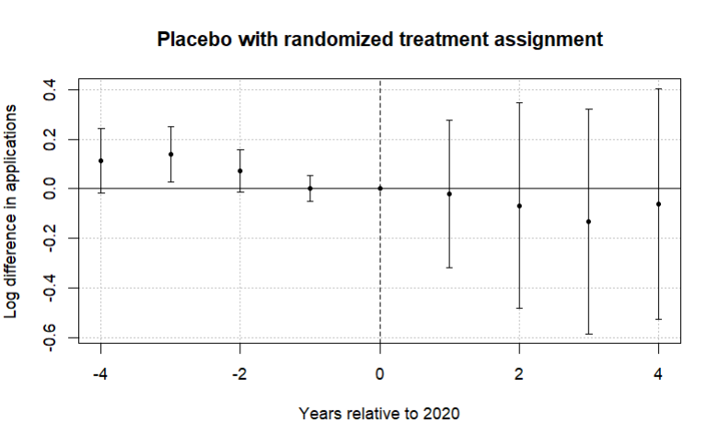
Note: The figure reports coefficients from an event-study specification in which treatment status is randomly assigned across countries. The horizontal axis shows years relative to 2020, the last pre-treatment year. Points represent estimated differences in log applications and bars denote 95% confidence intervals clustered at the country level. The dashed vertical line marks the final pre-treatment year. In contrast to the main specification, the placebo estimates fluctuate around zero and display no systematic post-treatment pattern, suggesting that the large decline in EU applications observed in the baseline results is unlikely to arise from mechanical features of the estimation procedure.

References
Berge, Laurent. (2018). "Efficient estimation of maximum likelihood models with multiple fixed-effects: the R package FENmlm." CREA Discussion Papers, 13.
Bound, J., Lovenheim, M. F., & Turner, S. (2010). Why have college completion rates declined? American Economic Journal: Applied Economics, 2(3), 129–157.
Bresnahan, T. F. (1982). The oligopoly solution concept is identified. Economics Letters, 10(1–2), 87–92. https://doi.org/10.1016/0165-1765(82)90121-5
Brown, R. (2011). After Browne: The new competitive regime for English higher education.
Calhoun, C. (2017). Populism, nationalism and Brexit. In W. Outhwaite (Ed.), Brexit: Sociological responses (pp. 57–76). Anthem Press.
Callaway, B., & Sant'Anna, P. H. C. (2021). Difference-in-differences with multiple time periods. Journal of Econometrics, 225(2), 200–230. https://doi.org/10.1016/j.jeconom.2020.12.001
Campbell, R., and B. Siegel. “The Demand for Higher Education in the United States 1919-1964.” American Economic Review, 57 (1967), 482-94.
Cinelli, C., & Hazlett, C. (2020). Making sense of sensitivity: Extending omitted variable bias. Journal of the Royal Statistical Society: Series B (Statistical Methodology), 82(1), 39–67. https://doi.org/10.1111/rssb.12348
Clifton-Sprigg, J., Homburg, I., Huyghe, A., & Vujić, S. (2025). International student migration: Did Brexit close the door to EU students? (IZA Discussion Paper No. 18178). IZA Institute of Labor Economics.
Cuibus, M., & Walsh, P. W. (2024). Student migration to the UK. Migration Observatory briefing, COMPAS, University of Oxford. Retrieved from https://www.migrationobservatory.ox.ac.uk
Driscoll, J.C., Kraay, A.C. (1998), ‘Consistent covariance matrix estimation with spatially dependent panel data’, Review of Economics and Statistics, Vol. 80, No. 4, pp. 549–560. https://doi.org/10.1162/003465398557825
Dwenger, N., Storck, J., & Wrohlich, K. (2012). Do tuition fees affect the mobility of university applicants? Evidence from a natural experiment. Economics of Education Review, 31(1), 155–167. https://doi.org/10.1016/j.econedurev.2011.10.004
Findlay, A., King, R., Stam, A., & Ruiz-Gelices, E. (2006). Ever reluctant Europeans: The changing geographies of UK students studying and working abroad. European Urban and Regional Studies, 13(4), 291–318. https://doi.org/10.1177/0969776406065429 (Original work published 2006).
Heller, D. E. (1997). Student price response in higher education: An update to Leslie and Brinkman. Journal of Higher Education, 68(6), 624–659.
Hemelt, S. W., & Marcotte, D. E. (2011). The impact of tuition increases on enrollment at public colleges and universities. Educational Evaluation and Policy Analysis, 33(4), 435–457.
Hoxby, C. M. (1997). How the changing market structure of U.S. higher education explains college tuition. NBER Working Paper No. 6323.
Hoxby, C. M. (2000). The economics of higher education: Analyzing the role of tuition fees and price sensitivity in HE demand. Journal of Economic Perspectives, 14(4), 149–169. https://doi.org/10.1257/jep.14.4.149
Leslie, D. (2003). Using success to measure quality in British higher education: Which subjects attract the best-qualified students? Journal of the Royal Statistical Society: Series A (Statistics in Society), 166(3), 329–347. https://doi.org/10.1111/1467-985X.00280
Leslie, L. L., & Brinkman, P. T. (1987). Student price response in higher education: The student demand studies. Journal of Higher Education, 58(2), 181–204. https://doi.org/10.1080/00221546.1987.11778239
Locke, W., & Marini, G. (2021). The rapid increase in faculty from the European Union in UK higher education institutions and the possible impact of Brexit. In F. Huang & A. R. Welch (Eds.), International faculty in Asia (Vol. 21). Springer, Singapore. https://doi.org/10.1007/978-981-33-4980-3_12
Luthra, R. R. (2020). Mitigating the hostile environment: The role of the workplace in EU migrant experience of Brexit. Journal of Ethnic and Migration Studies, 47(1), 190–207. https://doi.org/10.1080/1369183x.2020.1726173
Macdonald, C., & Stratta, E. (2001). From access to widening participation: Responses to the changing population in higher education in the UK. Journal of Further and Higher Education, 25(2), 249–258. https://doi.org/10.1080/03098770120050909
Mayhew, K. (2022). Brexit and UK higher education. Oxford Review of Economic Policy, 38(1), 179–187. https://doi.org/10.1093/oxrep/grab0
McFadden, D. (1974). Conditional logit analysis of qualitative choice behavior. In P. Zarembka (Ed.), Frontiers in Econometrics. Academic Press.
Neville, R., Rowe, F., & Singleton, A. (2024). Unraveling the Brexit–COVID-19 nexus: assessing the decline of EU student applications into UK universities. Data & Policy, 6, e45. doi:10.1017/dap.2024.42
Sá, F. (2014). The effect of tuition fees on university applications and attendance: Evidence from the UK (IZA Discussion Paper No. 8364). Institute for the Study of Labor (IZA). https://ftp.iza.org/dp8364.pdf
Savoca, E. (1990). Another look at the demand for higher education: Measuring the price sensitivity of the decision to apply to college. Economics of Education Review, 9(2), 123–134. https://doi.org/10.1016/0272-7757(90)90040-C
Solís, A. (2017). Credit access and college enrollment. Journal of Political Economy, 125(2). https://doi.org/10.1086/690829
UCAS. (2022). UCAS undergraduate sector-level end of cycle data resources 2021. https://www.ucas.com/data-and-analysis/undergraduate-statistics-and-reports/ucas-undergraduate-sector-level-end-of-cycle-data-resources-2021
UK Government. (n.d.-a). Repaying your student loan: What you pay. GOV.UK. https://www.gov.uk/repaying-your-student-loan/what-you-pay
UK Government. (n.d.-b). When your student loan gets written off or cancelled. GOV.UK. https://www.gov.uk/repaying-your-student-loan/when-your-student-loan-gets-written-off
UK Government. (n.d.-c). How interest is calculated (Plan 2). GOV.UK. https://www.gov.uk/guidance/how-interest-is-calculated-plan-2
Eurostat. (2025). Average full time adjusted salary per employee [Data set]. https://doi.org/10.2908/NAMA_10_FTE
Arel-Bundock, V. (2022). WDI: World Development Indicators and other World Bank data (R package version 2.7.8) [Computer software]. https://CRAN.R-project.org/package=WDI
Arel-Bundock, V., Enevoldsen, N., & Yetman, C. J. (2018). countrycode: An R package to convert country names and country codes. Journal of Open Source Software, 3(28), 848. https://doi.org/10.21105/joss.00848
World Bank. (2025). World Development Indicators [Data set]. https://databank.worldbank.org/source/world-development-indicators

Note that the elasticities produced under the two-ways and one way-estimators are going to have a perfectly collinear relationship. The only difference will be in the constant (the shift factor). Note that the TWFE estimator is defined as ${\hat{β}}_{j}^{TWFE}={\hat{β}}_{j}^{OWFE}-c$ where $c$ is a constant and denotes the average time effect and will be absorbed the shift factor In the OLS cross-section.

