The Brexit Tuition Shock and the Price Elasticity of International Students: Evidence from a Natural Experiment

Stoycho Rusinov*

*Center for the study of Democracy, Sofia

*New Bulgarian University, Department of informatics

email: stoycho.rusinov@csd.eu

ABSTRACT

This paper estimates the price elasticity of EU demand for UK higher education using the Brexit-induced loss of Home Fee status and student-loan access as a quasi-experimental tuition shock. Unlike standard higher-education demand studies that rely on enrolment outcomes, the analysis uses UCAS application data, allowing demand to be observed before admissions rationing by universities. A synthetic control group of non-EU origin countries is constructed to approximate the counterfactual trajectory of EU applications in the absence of the reform. Dynamic difference-in-differences estimates show a large and persistent decline in EU applications after 2021, with no strong evidence of differential pre-trends or anticipation effects. The average post-Brexit treatment effect implies an application decline of roughly 70 percent, with country-specific elasticities varying substantially across the EU. Initial estimates suggest that applicants from lower-income member states were more price elastic, while wealthier countries experienced smaller demand contractions. However, once elasticities are rescaled using country-specific effective price shocks that account for the removal of income-contingent loans, the income gradient collapses and becomes statistically indistinguishable from zero. This indicates that much of the apparent cross-country heterogeneity reflects heterogeneous treatment intensity rather than stable differences in underlying preferences. The findings suggest that the UK student-loan system functioned as an important equalizing institution for European educational mobility, and that its removal transformed a nominally uniform tuition reform into a highly uneven economic shock across EU origin countries.

JEL codes: I22; I23; F22; J61; D12; C23

Keywords: Brexit; international student mobility; higher education demand; tuition fees; price elasticity; EU students; UCAS applications; difference-in-differences; synthetic control; income-contingent loans; educational mobility; heterogeneous treatment effects.

- Introduction

International higher-education demand studies often struggle to isolate own-price elasticity because enrollment is an equilibrium outcome, jointly determined by student preferences and capacity-constrained admission decisions (Hoxby, 1997; Bound et al., 2010). Standard demand models using enrollment data conflate the desire to attend with the university's decision to admit. To separate these mechanisms, one requires detailed data on applicant preferences, institutional capacities, and admission rules-data that is rarely available.

In this paper, we assume that UCAS application data captures expressed demand prior to the administrative rationing of seats because whether a student will apply for a specific institution through the UCAS portal is independent of how many places the university has made available (the rationing happens post the event of applying). From a comparative perspective, our study exploits cross-country variation – rather than the conventional within-country, individual-level variation – to estimate international price responsiveness (i.e., demand elasticity).

To further aid identification we utilize the exogenous Brexit-induced tuition shock to estimate price elasticities at the origin-country level. Because the loss of Home Fee status and access to loans was a policy shock rather than a strategic pricing decision by universities, it provides a quasi-experimental setting to recover willingness-to-pay. The results allow the reconstruction of country specific constant-elasticity demand functions for international applications around the pre-Brexit price level.

We show that under specific assumptions applicants from lower-income EU countries exhibit highly elastic responses, significantly reducing their demand in response to the price hike. This heterogeneity implies that while the UK higher education market faced a uniform regulatory shock it also effectively filtering out price-sensitive consumers while retaining those with a higher ability to pay. However, we later revisit this elasticity estimates by adopting a different perspective on credit risk valuation prior to Brexit, showing that much of the observed demand heterogeneity is driven by the structure of the student loan system. The result is the following set of contributions:
- Poorer EU economies initially exhibit very high demand elasticities, highlighting the starting variability across member states.
- Those demand elasticities show a strong positive correlation with GDP per capita
- Building on this result, when elasticities are further rescaled using country-specific effective price shocks derived from the present value of the income-contingent loan, the income gradient collapses to a level statistically indistinguishable from zero. This shift suggests that much of the cross-country heterogeneity in elasticities reflects differences in treatment intensity, rather than underlying preferences. Notably, the newly computed elasticity becomes strongly correlated with the percentage of GDP invested in education.
Taken together, these findings demonstrate that our methodology enables the analysis of country-specific variance and provides insights into the nature of heterogeneous higher education demand within the EU context.
- Context
  - Brexit and higher education

Over preceding decades, the UK higher education system has expanded under policies of widened access (Macdonald & Stratta, 2001; Brown, 2011). Although price elasticity in higher education is generally moderate (Hoxby, 2000), most studies focus on individual-level characteristics, leaving macro-level effects less explored (for example, see Leslie (2003)). Brexit was a multifaceted phenomenon that began as a political movement but ultimately led to the UK’s exit from the EU – described as a populist pushback against globalization and a shift away from “London” (Calhoun, 2017). One of its most significant outcomes, however, was the rupture of academic ties between the UK and the EU, with 2020 marking the final year that EU students paid domestic-level tuition; fees then doubled or tripled, making Brexit one of the largest tuition policy changes of the 21st century (Cuibus & Walsh, 2024). This shift also reshaped student mobility, although a declining trend in UK students heading to Europe was noted as early as 2006 (Findlay et al., 2006), partly offset by increased flows to North America and Australia. Furthermore, Locke and Marini (2021) note that in the decade preceding the Referendum on the UK’s membership of the European Union (EU), there had been a rapid increase in foreign faculty in UK higher education institutions (HEIs), particularly from other EU countries. Many institutions had come to rely on academics from other EU countries, as well as those from outside the EU, for a significant part of their research, teaching and other activities. Locke and Marini (2021) indicate that the growth in academic outflow to UK (from 2004/2005 to 2017/2018) had been most pronounced in countries like Bulgaria, Croatia, Estonia, Latvia and Lithuania. Luthra (2020) argues that the rejection of free movement created vulnerability among EU staff, highlighting feelings of insecurity regarding their legal rights and public acceptance within their workplaces.
The causal designs of the Brexit shock came later (once data from UCAS became available). For example, Neville et al. (2024) document sharp post-2021 declines in EU applications and acceptances, even after controlling for COVID-19 conditions. Clifton-Sprigg et al. (2025) explicitly conclude that the introduction of international tuition fees - rather than the referendum result or visa changes - caused the substantial contraction in EU study mobility. Our contribution advances these designs by treating the fee increase as a quasi-experimental price shock to identify origin-specific price elasticities from uncensored applications; extending the analysis through 2023/25, after pandemic disruptions abated, to isolate persistent price responsiveness from COVID-era volatility; and accounting for income-specific loan valuation. We therefore move from measuring how much demand fell to uncovering why it fell and what this implies for pricing and market structure.
  - Previous attempts to capture demand elasticities in higher education

Hoxby (1997) argues that increased competition in higher education can generate higher tuition because institutions respond by differentiating products, increasing quality, sorting students more sharply, and adjusting subsidies. In that account, rising tuition is an endogenous feature of a new competitive equilibrium. The Brexit design differs sharply. The increase in tuition for EU students was not produced by institutional competition, quality upgrading, or a university-level pricing strategy. It was an externally imposed regulatory shock that removed Home Fee status and access to income-contingent loans while leaving the underlying educational product largely unchanged. The observed fall in EU applications therefore challenges the view that large tuition increases can be interpreted primarily as the price counterpart of improved quality or market differentiation. In this setting, the same product became more expensive for a specific group of students, allowing the paper to isolate price sensitivity more directly.

Leslie and Brinkman (1987) defines demand elasticity as ε = E/P, where E is the percentage change in enrollment and P is the percentage change in price. This is inherently problematic as enrollment is an equilibrium outcome (as demonstrated by Hoxby (1997) increasing competition can generate endogenous price shifts within the institutions affected), therefore any change in this parameter will be endogenous to the own institutional rationing. Leslie and Brinkman (1987) further explain that when we have a tuition elasticity from a time-series study, we cannot directly use it as a total-cost elasticity, because tuition and total cost did not move proportionally over time. Campbell & Siegel (1976) present an example where between 1927 and 1963, tuition rose 148% more than total direct costs so their tuition elasticity of −0.44 understates the true total cost elasticity. In comparison to this result, the Brexit shock is unambiguously a total cost shock as the fee change from £9,250 to £22,200 is the dominant component, and it is the entire treatment. There is no tuition/total-cost decomposition problem because the design is not utilizing time-series price variation where tuition and living costs drifted apart over decades.

Leslie and Brinkman’s (1987) state that for every $100 increase in tuition price— given 1982-83 average weighted higher education prices of $3,420 for tuition and room and board — one would expect an 18-24-year-old participation rate drop of about three-quarters of a percentage point. Since the national higher education participation rate was about 0.33 in 1982, U.S. enrollments would decline by about 2.1 percent for each $ 100 price increase, all other factors equal. This implies a price elasticity of about -0.73 which is largely consistent with some of our own estimates.

Savoca (1990) argues that standard enrolment-based estimates may understate true demand sensitivity because they conflate application behavior with admissions and matriculation decisions. Under the assumption that tuition and admissions policy are set independently, the price elasticity of enrolment equals the sum of the application and matriculation elasticities. In her estimate, this combined elasticity is −0.49, suggesting that the true elasticity of demand may be more than twice as large as conventional estimates in the literature.

To understand why the Brexit derived elasticities will be larger it is noteworthy to consider, for example, Heller (1997) who also uncovers several structural factors about demand elasticities that will later become relevant for our results. First, tuition increases reduce enrolment (so higher education is not a luxury good). The reviewed studies converge on the finding that each $100 tuition increase lowers enrolment by roughly 0.5 to 1.0 percentage points, consistent with Leslie and Brinkman (1987). Reductions in financial aid also reduce enrolment, though the effect varies by aid type. Lower-income students are more sensitive to changes in tuition and aid than middle- and upper-income students. The results presented in Hemelt and Marcotte (2011) are also relevant because they confirm the standard negative relationship between tuition and enrolment, but their design is also not directly comparable to Brexit. Their estimates come from domestic U.S. public universities and enrolment outcomes, while the present paper studies international UCAS applications before admissions rationing and exploits a large policy-induced price shock.

Another branch in the literature are the BLP-type models derive elasticities from estimated heterogeneity in preferences across differentiated alternatives, the present design derives elasticity from observed variation in exposure to a large policy-induced price shock. The former is better suited for recovering substitution matrices across choices; the latter is better suited for identifying a destination-level demand response to a discrete change in the relative price of UK higher education.
- Data
The primary data source is the most recent release of the UCAS database (2025), covering application cycles from 2016 to 2025. UCAS provides centralized information on applications to UK higher education institutions, allowing us to observe applicant behavior prior to admissions decisions. This is particularly important for our empirical design, as applications capture expressed demand before institutional rationing takes place. The dataset reports application counts by country of domicile along with additional demographic breakdowns. In this study, application series are constructed by aggregating counts across all available categories of sex and gender to obtain total demand from each origin country, while nationality is retained as the key dimension of variation.
The unit of observation is the origin country–year, yielding a panel dataset that includes both EU countries (treated group) and a set of non-EU countries used to construct the synthetic control group. The main outcome variable is the logarithm of the number of applications from country i in year t, which captures cross-country variation in demand over time. To analyze heterogeneity in responses to the Brexit-induced tuition shock, the UCAS data are merged with macroeconomic indicators, including GDP per capita and labor market variables obtained from World Bank sources. The descriptive statistics are presented on table 1.
Table 1. Descriptive statistics of the core variable in the analysis for both the treated and control groups.
Years: 2016 to 2025 |  | Control countries: 26 | Treated countries: 26
Group: | Treated | Control | $$Post_{t}$$
Variable: | Applicants
Min | 30 | 80 | 0
Max | 5550 | 8355 | 1
Mean | 1275 | 1772 | 0.5
Median | 655 | 867.5 | 0.5
N | 260 | 260 | 520

- Empirical strategy
  - Constructing the counterfactual European Union
To execute the DID design, we first construct the synthetic control set $℘,$ a synthetic copy of the European Union obtained by combining countries unaffected by the Brexit-induced tuition shock but structurally comparable in number of applications and income distribution. To construct this set we compared each EU origin market to the most behaviorally similar top 3 non-EU origins based on log-scaled, normalized pre-Brexit application trajectories using Euclidean distance minimization. We evaluate the pre-treatment dynamics of the candidate control countries using event-study diagnostics. Countries displaying systematic divergence from the EU group in the pre-Brexit period are excluded from the donor pool to preserve the parallel-trend requirement of the difference-in-differences design. We compared the Control and the Treated GDP, applicants and accepted applicants’ distributions to ensure that the union was replicated not just in pre-Covid dynamics but also in wealth and acceptance chances (so students are not discouraged to apply based on previous experience of their peers).
The resulting donor pool is presented on table A1. Because the saturated difference-in-differences specification measures each treated unit relative to the omitted reference category, the counterfactual in the regression is effectively the average trajectory of the donor pool. Since several EU origins share the same nearest neighbors, some donor countries appear multiple times in the matching procedure. To maintain a control group comparable in size to the treated sample and to preserve the dispersion of economic conditions observed across EU origin markets, we augment the donor pool with Australia, Peru, Mauritius, Qatar, Albania, and Ireland. These additions broaden the income distribution of the control group and ensure that the donor pool reproduces the heterogeneity of GDP per capita present in the EU sample rather than concentrating excessively on lower-income origins.
Using this construction, the set of affected countries is denoted as Ω.
Therefore the entire sample is $Ξ=Ω∪℘$. On figure 1 we plot the empirical distributions of the EU countries as well as the selected control countries. The applications and accepted applications distributions are very similar. In terms of GDP per capita, however, the EU has higher density in the 50000 GDP per capita threshold which was expected due to the macroeconomic convergence in the region. The peaks of the distributions appear to be following a similar trajectory (bimodality around the 50-k threshold).
Figure 1 Empirical densities of the GDP, number of applications and Accepted applications for the EU students and the control group. (in time)
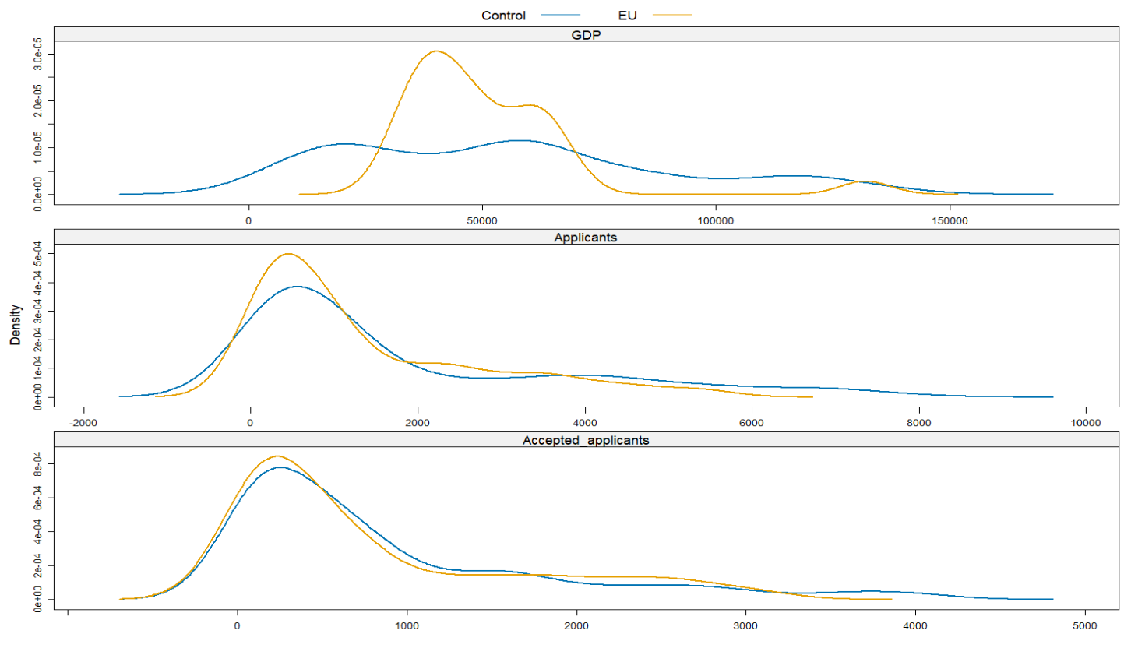
Source. Own-calculations
  - Identification strategy and parallel trends
We estimate a dynamic difference-in-differences specification to trace the evolution of applications around the Brexit tuition reform:
$$\log{A_{it}}=α_{i}+γ_{t}+\sum_{l≠0}{δ_{l}}\left(EU_{i}×1\left\{t-2020=l\right\}\right)+ε_{it}$$ | (1)
The coefficients $δ_{l}$ measures those year-by-year deviations in log applications for EU-origin countries relative to the omitted pre-reform year ($l=0$, corresponding to 2020).
Figure 2. Event-study estimates comparing EU applicants to the synthetic control group.
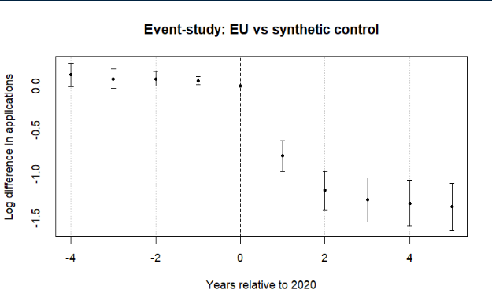
Note: The figure plots coefficients from a difference-in-differences event-study comparing EU applicants to a synthetic control group of non-EU countries. The horizontal axis shows years relative to 2020, the last pre-treatment year. Points represent estimated differences in log applications and bars denote 95% confidence intervals clustered at the country level. The dashed vertical line marks the final pre-treatment year. Pre-treatment coefficients are small and close to zero, while a sharp decline in EU applications emerges beginning in 2021 after the tuition reform took effect. A joint Wald test cannot reject the null that the pre-treatment coefficients are jointly zero (p = 0.12), providing no strong evidence of differential pre-trends.
Figure 2 reports the event-study coefficients from equation (1). The pre-treatment coefficients (leads) are generally small and close to zero, although several leads are marginally statistically significant when standard errors are clustered at the country level and a joint Wald test fails to reject the null hypothesis that the pre-treatment coefficients are jointly equal to zero (p = 0.12).
The overall trends in the data (especially clear with the release of the 2025 data) rule out the possibility that the change in the number of applications was due to COVID. No observable recovery is visible in figure. 2, especially in the periods when COVID has largely abated (2024 and 2025), with the decline going deeper the more years have passed since the event. Due to a small positive divergence in the Post-Referendum applications, we can conclude that the UK higher education system did not become less appealing due to migration concerns – if anything, candidates were even more motivated to apply.
Figure 3 Leads-only test without anticipation effects.
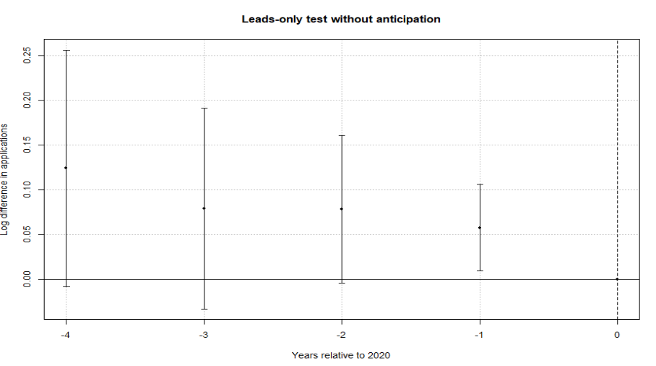
Note: The figure plots coefficients from a leads-only specification testing whether EU applications diverged from the synthetic control group prior to the Brexit tuition reform. The horizontal axis shows years relative to 2020, the last pre-treatment year. Points represent estimated differences in log applications and bars denote 95% confidence intervals clustered at the country level. The dashed vertical line marks the final pre-treatment year. The estimates display no systematic pre-treatment pattern, and a joint Wald test fails to reject the null that the early leads are jointly zero (p = 0.12), providing no strong evidence of anticipation effects.
To further assess identification, we implement two additional tests. First, a leads-only specification finds no evidence of anticipation effects, suggesting that applicants did not adjust behavior prior to the reform (fig 3.). Second, a placebo exercise with randomly assigned treatment produces coefficients centered around zero, indicating that the estimated effects are not driven by mechanical features of the estimation procedure (fig A1).
Finally, allowing for country-specific dynamic effects yields similar patterns as post-treatment coefficients are consistently negative across EU countries, while pre-treatment estimates remain close to zero (fig 4). The only exception to this is the Portuguese case where the applications did not immediately collapse in 2021. This can be traced down to a UCAS data reporting problem, where in the 2021 cycle, some RPAs were mistakenly submitted as domiciled in Portugal, meaning that the true number of Portugal domiciled RPAs is lower than the reported number of Portugal domiciled RPAs for the 2021 cycle (UCAS, 2022).

Figure 4. Saturated DID event-study estimates by country.
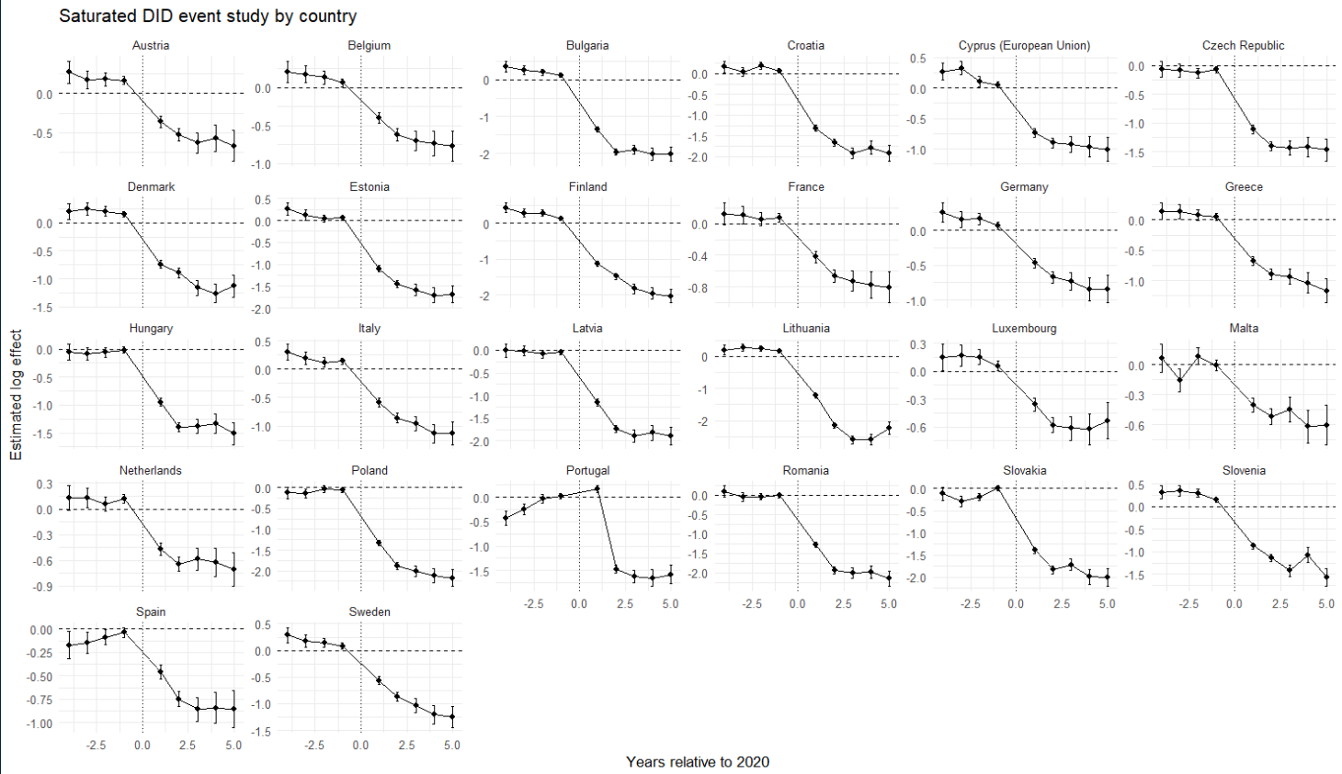
Note: Each panel reports country-specific dynamic treatment effects from the saturated difference-in-differences specification comparing EU countries with the pooled control group. Coefficients represent log differences in applications relative to the baseline year (2020). Error bars denote 95% confidence intervals. All results were completely replicated in Python and the output was the same.
  - Baseline elasticities estimates
The empirical justification of the counterfactual European Union allows to create a synthetic untreated group enabling us to estimate the saturated two-ways DID model:
$$\log{(A_{it})} = α_{i} + γ_{t} +\sum_{\begin{aligned}k∈Ω \\ \end{aligned}}^{ }{β_{k} \left(1\left\{i=k\right\}×Post_{t}\right)} +ρ^{'}X+ ε_{it}$$ | (2)
where ($A_{it}$) denotes applications (or acceptance rates) from origin country ($i∈Ξ$) in year ($t∈\left[2016, 2025\right]$), $1\left\{i=k\right\}$ is an indicator for EU member states, and $Post_{t}$ marks the introduction of the new tuition regime in 2021. The interaction coefficient ($β_{k}$) captures the magnitude of the collapse in Applications under non-heterogeneous markets relative to the omitted category.
To distinguish between short-run and persistent effects, we further split the post-treatment period into two phases: 2021–2023, which captures the immediate response following the reform, and 2024 onward, which reflects longer-run adjustments. The specification becomes:
$$\begin{matrix}\log{(A_{it})} & = & α_{i} + γ_{t} + \sum_{\begin{aligned}k∈Ω \\ \end{aligned}}^{ }{β_{k} \left(1\left\{i=k\right\}×Pos{tBrexit}_{t}\right)} \\ & + & \sum_{\begin{aligned}k^{ }∈Ω \\ \end{aligned}}^{ }{σ_{k^{ }} \left(1\left\{i=k^{'}\right\}×Pos{tCovid}_{t}\right)}+ρ^{'}X+ ε_{it }\end{matrix}$$ | (3)
from here follows the interpretation of $β_{k}$ as the short-run country specific response (Brexit + COVID uncertainty) and${ σ}_{k^{ }}$​ is the persistent structural response (pure willingness-to-pay shift). The difference $β_{k}-σ_{k^{ }}=ω_{k}$ provides the specific COVID impact on demand elasticities (mathematical proof for this in the supplementary materials).
We show in the supplementary materials that the $β_{i},$ with $i∈Ω$, coefficient can be mapped to a structural elasticity parameter through the following transformation (Bresnian 1987 style):
$η_{i}=\frac{β_{i}}{k_{i}}$,
where $k_{i}$ is defined as:
$$k_{i}=\log{22200}-\log{PV_{loan}(w_{i})}$$
in this formula $PV_{loan}(w_{i})$ is the present value of the income contingent UK loan, 22200 is the average post-Brexit price and $w_{i}$ is the average annual salary in Euro. Under the standard shift from 9250 pounds and no heterogeneity assumption $k$ is 0.86. Clifton-Sprigg (2025) assumes one unique price change (from the old price of 9250 to 22200) but the above equation allows us to relax this assumption.
We then relate these elasticities to observable economic fundamentals. Specifically, we estimate correlations of the form:
$$β_{i∈Ω} = θ_{0} + δ_{1}\log\left(GDPpc_{i∈Ω}\right)+ρ^{'}X+ u_{ }$$ | (4)
Where $ρ^{'}X$ is a list of country specific covariates that control for structural characteristics at the country level. This exercise documents that income strongly predicts the magnitude of the shock, consistent with a segmented higher-education market in which price sensitivity varies systematically with economic fundamentals.
- Results
  - Estimated elasticities
Following the empirical strategy, Figure 5 reports country-specific elasticities derived from the difference-in-differences estimates. We translate the estimated treatment effects into implied demand responses to the Brexit tuition shock.
Figure 5. Decomposition of the post-Brexit demand elasticities by treated country.
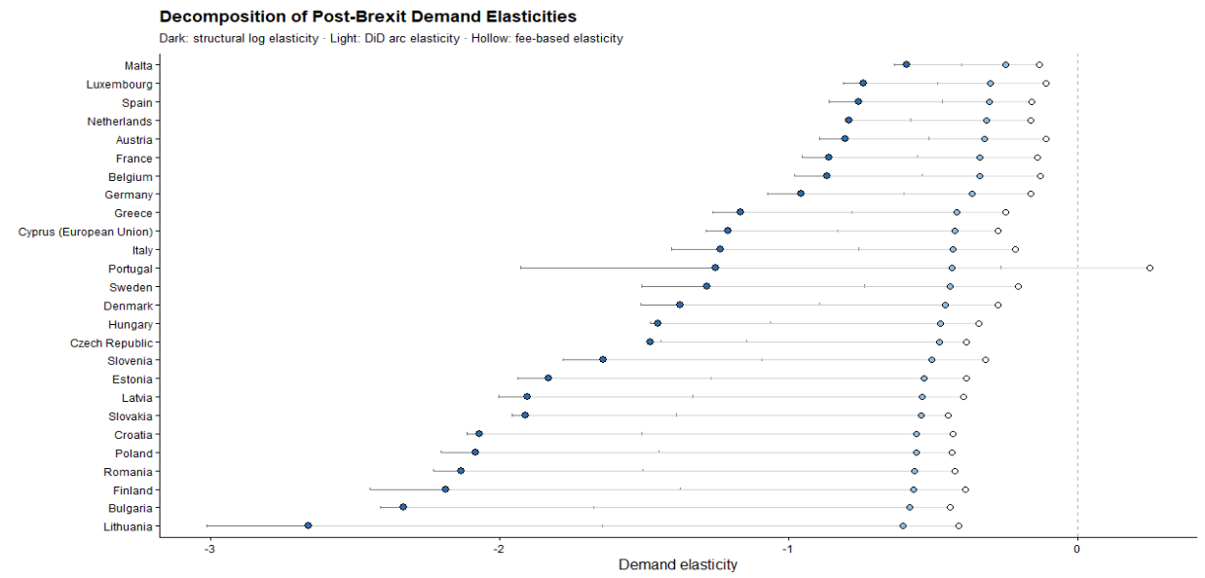
Note: The structural log elasticities are obtained from the division of the country-specific effect ($β_{k})$ by 0.86. The Arc elasticities are obtained by $\left(e^{β}-1\right)/1.4$ and the mechanical arc elasticities by $ΔApplications_{2020}^{2021}/1.40$. This graph was replicated both in Python and R and was the same across software implementations.
The results indicate a large and widespread contraction in demand. Across EU countries, applications declined substantially following the introduction of international tuition fees, with estimated effects corresponding to reductions of roughly 45% to 90% relative to the control group. The average effect implies a decline of approximately 70%. All DID elasticities lie strictly below zero, confirming that the Brexit-induced tuition shock caused a contraction in EU demand for UK higher education across the entire Union. However, the magnitude of this response varies substantially. Wealthier EU countries such as Malta, Spain, Luxembourg, the Netherlands, and Austria cluster near elasticities between −0.7 and −1.0, indicating relatively inelastic demand. By contrast, lower-income EU countries – including Bulgaria, Romania, Lithuania, Croatia, and Latvia exhibit elasticities exceeding −2, with Lithuania approaching −3, indicating relatively elastic demand.
This heterogeneity aligns closely with cross-country differences in income. Regressing the estimated country-specific responses on GDP per capita reveals a strong positive relationship where wealthier countries experience smaller declines in applications (table 2). The strong positive relationship between GDP per capita and demand elasticity emerges only when elasticities are estimated using fixed effects specifications. This reflects the ability of the TWFE estimator to isolate the causal impact of the Brexit-induced tuition shock by removing both country-specific baseline differences and common time shocks. In contrast, pooled estimates conflate treatment effects with cross-country heterogeneity in levels and trends, obscuring the underlying relationship. As a result, the GDP gradient disappears when identification is not enforced.
An important consideration is that the tuition reform altered not only nominal prices but also the availability of income-contingent loans. Because these loans effectively reduce the cost of education, their removal may have generated larger effective price increases for applicants from lower-income countries. In the discussion section, we account for this by adjusting elasticities using country-specific effective price changes. Details on the construction of elasticity measures and alternative definitions are provided in Appendix A.
Table 2. Correlations between the DID (FEs and No FEs elasticities) and logarithm of GDP per capita (source WB R pool)
 | TWFE elasticities | Pooled elasticities
$\log\left(GDPpc\right)$ | 1.11*** | 0.076
 | (0.361) | (0.987)
Const. | -13.44*** | -1.87
 | (3.916) | (10.69)
Observations | 24 | 24
Adj. R² | 0.266 | -0.045
  - Estimated COVID specific elasticities
Figure 6 compares the immediate post-Brexit demand elasticities with the persistent elasticities observed after pandemic disruptions had abated. The difference between the dots is consistent with the effect derived in the supplementary materials.
Figure 6. Post Brexit and post-COVID Demand elasticities compared on the same measurement axis.
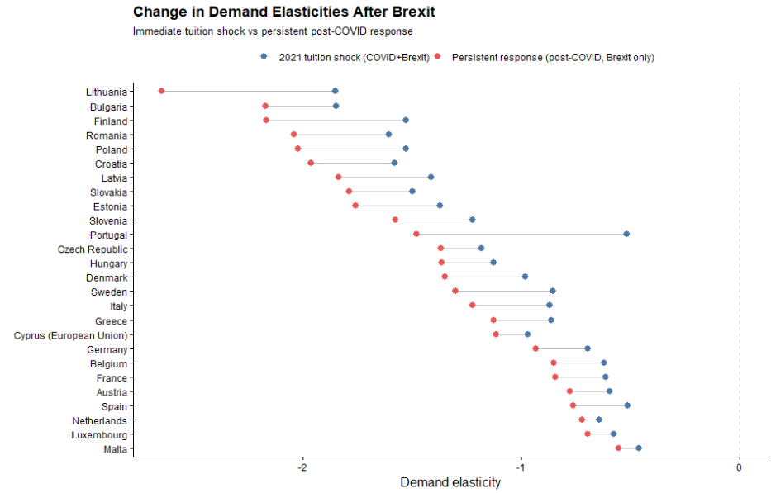
It is also important to mention that for nearly all EU origin countries, the persistent post-COVID elasticities remain strongly negative and closely aligned with the initial post-2021 estimates. The persistence of the elasticities confirms that price sensitivity, rather than short-run volatility, is the dominant mechanism behind the observed demand contraction.
For higher-income EU countries, elasticities become slightly less negative once COVID effects dissipate, suggesting partial normalization of demand at the margin. In contrast, for lower-income EU countries, elasticities remain highly elastic especially in the post-COVID period, with little evidence of recovery (the gap between the post-COVID and the Brexit elasticity appears to widen more for poorer countries).
  - ATT wealth heterogeneity
Table 3. ATE coefficient and interactions. FEs are always entity and time. Standard errors are Driscoll-Kraay (L=1)
 | (I) | (II) | (III) | (IV) | (V) | (VI)
$$ATT$$ | -1.27*** | -1.1*** | -7.16*** | -1.13*** | -0.99*** | -7.37***
 | (0.122) | (0.1) | (0.703) | (0.126) | (0.109) | (1.75)
$$\log{(GDPpc)}$$ |  | -0.05 | 0.281* |  | -0.73* | -0.29
 |  | (0.151) | (0.119) |  | (0.288) | (0.25)
$$\log{(Pop16_54)}$$ |  | 4.03*** | 3.498*** |  | 2.77*** | 2.34***
 |  | (0.3) | (0.381) |  | (0.519) | (0.53)
$$YU$$ |  | -0.02*** | -0.015** |  | -0.02*** | -0.012*
 |  | (0.004) | (0.004) |  | (0.006) | (0.006)
$$ATT×\log{(GDPpc)}$$ |  |  | 0.438*** |  |  | 0.47***
 |  |  | (0.073) |  |  | (0.102)
$$ATT×\log{(Pop16_54)}$$ |  |  | 0.094*** |  |  | 0.08***
 |  |  | (0.017) |  |  | (0.015)
$$ATT× YU$$ |  |  | 0.006 |  |  | 0.02***
 |  |  | (0.006) |  |  | (0.004)
Obs | 520 | 459 | 459 | 520 | 459 | 459
R2 Adj | 0.952 | 0.706 | 0.971 | 0.590 | 0.670 | 0.718
R2 Within | 0.613 | 0.703 | 0.761

Note: Models (1) through (V) are estimated with the standard TWFE estimator, while (VI) and (VII) are estimated with Poisson regressions (see Berge (2018)) based on MLE. All regressions from (I) to (V) were replicated with the standard “linear models” package in Python, while (VI) and (VII) were estimated using “substitutes”. All regressions are replicable in both R and Python. The data is sourced from the World Bank API resources, except for Jersey that was excluded due to data restrictions. Since the series for 2025 were not available they were excluded from the estimation (therefore the 459 observations (51 countries * 9 Years per panel)).
Table 3 reports regressions that relate the magnitude of the Brexit demand shock to country-level economic characteristics. Across all specifications, the baseline effect remains large, negative, and statistically significant, confirming a substantial contraction in EU demand following the tuition reform. At the same time, there is clear evidence of heterogeneity. The interaction between the Brexit treatment and GDP per capita is positive and statistically significant, indicating that higher-income countries experience smaller declines in applications. This is consistent with lower price sensitivity in wealthier contexts.
Labor market conditions also play an important role. The interaction with youth unemployment is positive and significant, suggesting that weaker labor market prospects attenuate the decline in applications. When employment opportunities for young cohorts deteriorate, studying abroad becomes a relatively more attractive option, reducing the responsiveness to higher tuition fees. By contrast, demographic factors such as population size do not materially affect the results and provide limited explanatory power.
Figure 7. Saturated DID specifications with macroeconomic controls added. Namely GDP per capita (constant prices), population and the percentage of youth unemployment as separate models.
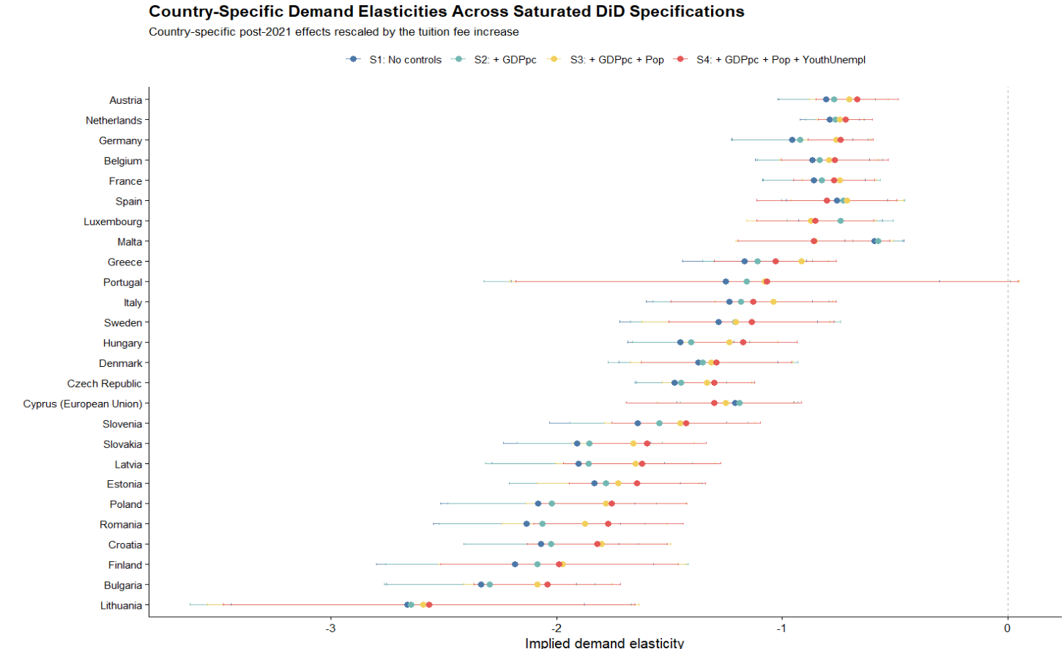
- Robustness
We assess the robustness of the baseline results along three dimensions: the choice of control group, the estimation method, and potential omitted variable bias. First, we re-estimate the treatment effect using alternative control groups, including only OECD countries, only high-income countries, and only low-income countries. The estimated effects remain consistently negative and of similar magnitude across all specifications, with overlapping confidence intervals. This indicates that the results are not driven by the composition of the control group (table 4). We combine this with multiple changes in the estimator - the doubly robust estimator of Callaway and Sant’Anna (2021) as an alternative to the standard two-way fixed effects model as well as the Poisson, MLE-based regression estimates (see Berge (2018)). The resulting estimates are very close to the baseline results, and event-study diagnostics continue to show no evidence of differential pre-trends.
Table 4. Estimates obtained from Doubly Robust estimator and the Standard TWFE model. Standard errors are reported in parenthesis. Both models estimate the coefficients with the number of observations presented in the “Sample decomposition” table.
 | (1) Doubly Robust | (2) TWFE | (3) Poisson MLE
Panel A: Baseline estimates
Synthetic control | −1.197* | −1.265*** | −1.132***
 | (0.106) | (0.122) | (0.126)
Panel B: Alternative samples
Poor countries | −1.48* | −1.67*** | -1.59***
 | (0.156) | (0.200) | (0.167)
Rich countries | −1.23* | −1.32*** | -1.16***
 | (0.122) | (0.130) | (0.13)
OECD countries | −1.18* | −1.26*** | -1.198***
 | (0.125) | (0.130) | (0.13)

Table 5. Sample compositions for the alternative control groups
 | Synthetic | Poor | Rich | OECD
Control group | 24 | 14 | 13 | 14
EU group | 26 | 26 | 26 | 26
Observations | 450 | 400 | 390 | 400
Note: To avoid the proliferation of too many tables detailed stastical description of the used groups is provided in the supplementary materials section.

Figure 8. Stratified cluster bootstrap distribution of the Brexit treatment effect.
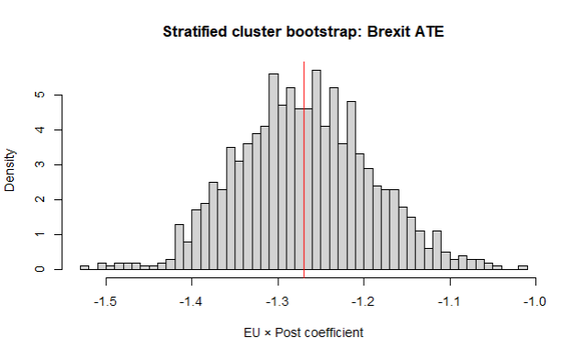
Note: The histogram reports the distribution of the EU×PostEU coefficient obtained from 1,000 stratified cluster bootstrap replications, resampling treated and non-treated countries separately with replacement. In each replication, the model $\log{(Applicants)}∼EU×Post$ is re-estimated with country and year fixed effects. The bootstrap mean estimate is −1.270, with bootstrap standard deviation 0.078. The 95% percentile bootstrap confidence interval is [−1.413,−1.114]. The red vertical line marks the bootstrap mean.
Second, we examine the sensitivity of the estimates to sampling variation and unobserved confounding. A stratified cluster bootstrap shows that the estimated treatment effect is tightly centered around the baseline value and remains consistently negative across replications.
Finally, we apply the sensitivity analysis framework of Cinelli and Hazlett (2020). The results indicate that an omitted variable would need to explain a very large share of the residual variation in both treatment and outcome to eliminate the estimated effect (~70%). Given the inclusion of country and year fixed effects, such a confounder appears implausibly strong. (fig 9).
Figure 9. Sensitivity analysis for omitted variable bias (sensemakr).
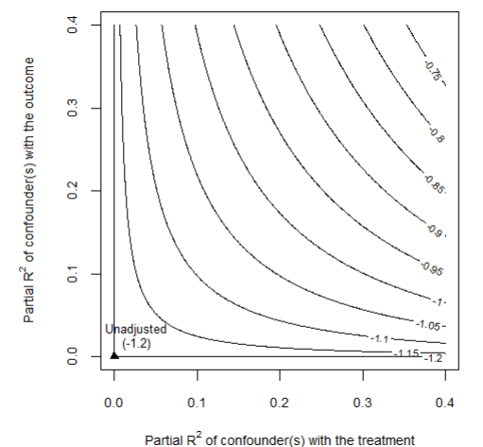
Note: The contour plot shows how the estimated EU×PostEU coefficient changes under hypothetical unobserved confounding. The axes represent the partial R² of a potential confounder with the treatment and the outcome.
- Discussion
  - Were poor EU students really priced out because of elastic demand?
A natural interpretation of the results is that students from lower-income EU countries exhibit more elastic demand for UK higher education. However, this interpretation relies on the assumption that the tuition reform generated the same effective price change across countries. In practice, this assumption is unlikely to hold. Prior to Brexit, tuition was financed through income-contingent loans, meaning that the relevant economic price depended on expected future earnings rather than the nominal fee. As a result, the removal of these loans likely generated larger effective price increases for applicants from lower-income countries.
To illustrate how elasticities, depend on loan valuation, we compute implied elasticities using the average treatment effect coefficient $β=-1.28$ and map it across a range of starting income levels (Figure 10). When the loan is expected to have a low present value (e.g., for applicants with low expected earnings), the Brexit reform constitutes a large effective price shock, and the implied elasticity is mechanically smaller in magnitude (approximately −0.4). Conversely, when the loan’s present value approaches its nominal amount (high expected earnings), the effective price shock is smaller, and the implied elasticity is larger in magnitude
Figure 10 Implied demand elasticity as a function of the economic value of the UK student loan.
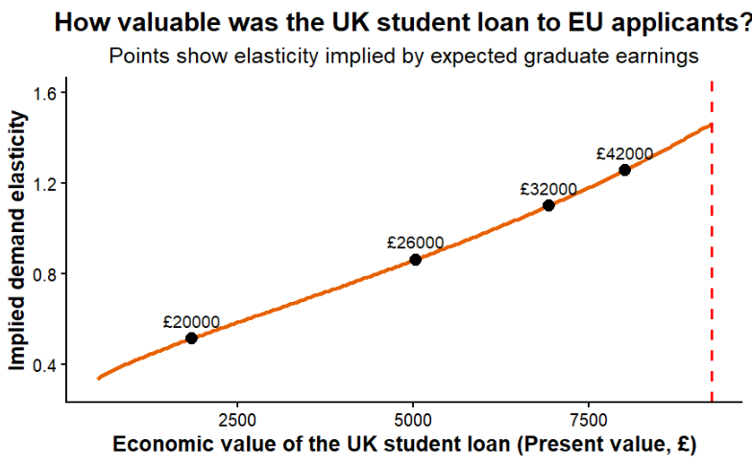
Note: The figure translates the estimated treatment effect into implied demand elasticities under different assumptions about the present value of the UK student loan to EU applicants. Points correspond to elasticity estimates implied by alternative expected graduate earning scenarios.
To examine whether structural heterogeneity in demand persists after accounting for this mechanism, we define corrected elasticities as $η_{i}^{'}=β_{i}{/k}_{i}$. Dividing by heterogeneous $k_{i}$removes the portion of elasticity variation that is mechanically induced by differential effective price shocks. Any remaining systematic variation in $η_{i}^{'}$ therefore reflects structural heterogeneity in willingness to pay rather than loan-valuation mechanics. After recomputing the elasticities heterogenous price changes across the Union we re-estimated the correlation with GDP per capita. Figure 11 shows that this time the same correlation was completely reversed becoming negative.
Figure 11. Income gradient in demand elasticity.
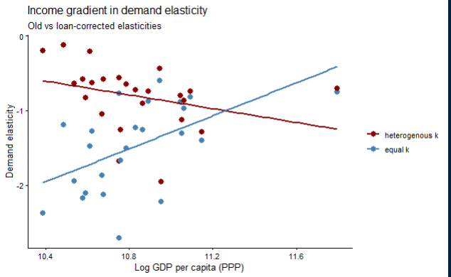
Note: The figure compares baseline elasticity estimates with elasticities corrected for heterogeneous loan value across countries. The horizontal axis shows log GDP per capita (PPP). Lines represent fitted linear relationships.
Before correcting for heterogeneous treatment intensity, demand elasticities display a strong and statistically significant positive relationship with origin-country income (δ = 1.06, p = 0.01, fig 11). However, once elasticities are rescaled using country-specific effective price shocks derived from the present value of the income-contingent loan, the income gradient collapses and becomes statistically indistinguishable from zero (δ′ = −0.50, p = 0.12). The difference between the gradients (Δ = −1.56) indicates that a substantial portion of the observed cross-country heterogeneity reflects variation in treatment intensity rather than structural differences in preferences.
Under the new calculations countries like Finland, Denmark, Slovenia, Germany and Luxembourg have comparably large elasticities. These are exactly the countries where a lot of university options are actually available. This implies that applicants from lower-income countries face fewer high-quality domestic alternatives and may view UK education as a pathway to significantly higher lifetime earnings. As a result, their application behavior may be less responsive to tuition increases than raw demand responses would suggest.
From a political perspective, the decline in applications from poorer EU countries reflects the withdrawal of an institution that had quietly equalized opportunity across Europe. The UK’s income-contingent loan system meant that students did not need to arrive with wealth; they needed only the expectation of future effort and earnings. When that system disappeared for EU applicants, the effective cost of studying in the UK rose dramatically for those from poorer economies. What appears in the data as “elastic demand” is therefore better understood as the sudden loss of a mechanism that had allowed talent to travel across borders without the constraint of immediate financial means. In that sense, the Brexit tuition reform did not simply reveal price sensitivity – it exposed how fragile educational mobility can be when the institutions that support it are removed.
  - What are the real determinants of the corrected elasticity?
Table 5. Alternative correlations between the corrected income elasticity and macroeconomic fundamentals.
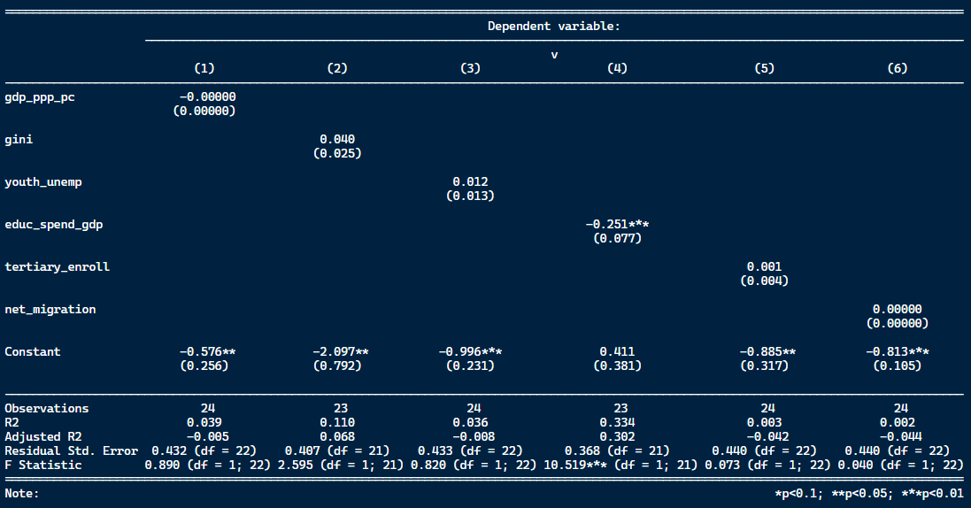
Note: Performed is simple cross-sectional OLS with HC1 robust standard errors.

Appendix
Table A 2. Counterfactual construction: donor countries used to match each treated EU country in the synthetic European Union.
Treated | Austria | Belgium | Bulgaria | Croatia | Cyprus (EU) | Czech Republic
Matched | Jersey | Switzerland | Norway | Macao | Singapore | Turkey
 | Vietnam | Russian Federation | Canada |  | Canada | Kuwait
 |  |  |  |  | United States of America | Thailand
Treated | Denmark | Estonia | Finland | France | Germany | Poland
Matched | Jordan | Vietnam | Russian Federation | Malaysia | United States of America | United States of America
 | Bahrain | Bahrain | Switzerland | Hong Kong | Malaysia
 |  |  |  |  | Singapore
Treated | Greece | Hungary | Italy | Latvia | Lithuania | Luxembourg
Matched |  | Thailand | Singapore | Vietnam | Norway | Bahrain
 | Canada | Kuwait | Canada | Jersey | Canada | Jordan
 |  |  | United States of America
Treated | Portugal | Romania | Malta | Netherlands | Sweden | Spain
Matched | Switzerland | Canada | Israel | Russian Federation | Norway | Canada
 |  | Norway |  | Switzerland | Saudi Arabia | Singapore
 |  |  |  |  |  | Pakistan
Treated | Slovakia | Slovenia
Matched | Kuwait | Serbia
 | Thailand

Figure A1. Placebo with randomized treatment assignment.
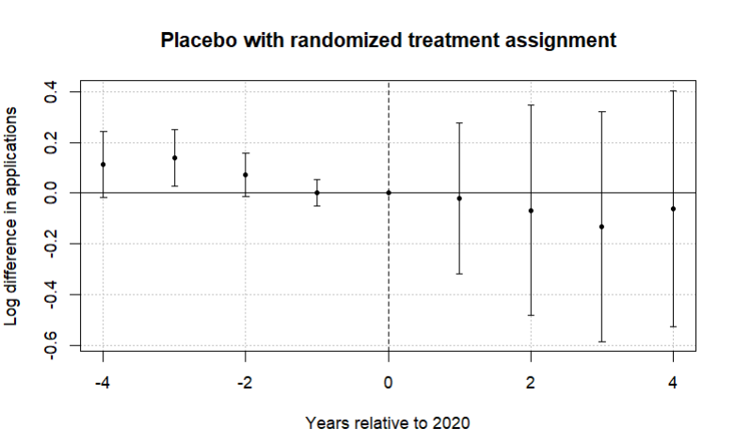
Note: The figure reports coefficients from an event-study specification in which treatment status is randomly assigned across countries. The horizontal axis shows years relative to 2020, the last pre-treatment year. Points represent estimated differences in log applications and bars denote 95% confidence intervals clustered at the country level. The dashed vertical line marks the final pre-treatment year. In contrast to the main specification, the placebo estimates fluctuate around zero and display no systematic post-treatment pattern, suggesting that the large decline in EU applications observed in the baseline results is unlikely to arise from mechanical features of the estimation procedure.

References
Bound, J., Lovenheim, M. F., & Turner, S. (2010). Why have college completion rates declined? American Economic Journal: Applied Economics, 2(3), 129–157.
Hoxby, C. M. (1997). How the changing market structure of U.S. higher education explains college tuition. NBER Working Paper No. 6323.
McFadden, D. (1974). Conditional logit analysis of qualitative choice behavior. In P. Zarembka (Ed.), Frontiers in Econometrics. Academic Press.
Neville, R., Rowe, F., & Singleton, A. (2024). Unraveling the Brexit–COVID-19 nexus: assessing the decline of EU student applications into UK universities. Data & Policy, 6, e45. doi:10.1017/dap.2024.42
Clifton-Sprigg, J., Homburg, I., Huyghe, A., & Vujić, S. (2025). International student migration: Did Brexit close the door to EU students? (IZA Discussion Paper No. 18178). IZA Institute of Labor Economics.
Calhoun, C. (2017). Populism, nationalism and Brexit. In W. Outhwaite (Ed.), Brexit: Sociological responses (pp. 57–76). Anthem Press.
Cuibus, M., & Walsh, P. W. (2024). Student migration to the UK. Migration Observatory briefing, COMPAS, University of Oxford. Retrieved from https://www.migrationobservatory.ox.ac.uk
Findlay, A., King, R., Stam, A., & Ruiz-Gelices, E. (2006). Ever reluctant Europeans: The changing geographies of UK students studying and working abroad. European Urban and Regional Studies, 13(4), 291–318. https://doi.org/10.1177/0969776406065429 (Original work published 2006).
Locke, W., & Marini, G. (2021). The rapid increase in faculty from the European Union in UK higher education institutions and the possible impact of Brexit. In F. Huang & A. R. Welch (Eds.), International faculty in Asia (Vol. 21). Springer, Singapore. https://doi.org/10.1007/978-981-33-4980-3_12
Luthra, R. R. (2020). Mitigating the hostile environment: The role of the workplace in EU migrant experience of Brexit. Journal of Ethnic and Migration Studies, 47(1), 190–207. https://doi.org/10.1080/1369183x.2020.1726173
Macdonald, C., & Stratta, E. (2001). From access to widening participation: Responses to the changing population in higher education in the UK. Journal of Further and Higher Education, 25(2), 249–258. https://doi.org/10.1080/03098770120050909
Brown, R. (2011). After Browne: The new competitive regime for English higher education.
Hoxby, C. M. (2000). The economics of higher education: Analyzing the role of tuition fees and price sensitivity in HE demand. Journal of Economic Perspectives, 14(4), 149–169. https://doi.org/10.1257/jep.14.4.149
Leslie, D. (2003). Using success to measure quality in British higher education: Which subjects attract the best-qualified students? Journal of the Royal Statistical Society: Series A (Statistics in Society), 166(3), 329–347. https://doi.org/10.1111/1467-985X.00280
Mayhew, K. (2022). Brexit and UK higher education. Oxford Review of Economic Policy, 38(1), 179–187. https://doi.org/10.1093/oxrep/grab0
Driscoll, J.C., Kraay, A.C. (1998), ‘Consistent covariance matrix estimation with spatially dependent panel data’, Review of Economics and Statistics, Vol. 80, No. 4, pp. 549–560. https://doi.org/10.1162/003465398557825
UK Government. (n.d.-a). Repaying your student loan: What you pay. GOV.UK. https://www.gov.uk/repaying-your-student-loan/what-you-pay
UK Government. (n.d.-b). When your student loan gets written off or cancelled. GOV.UK. https://www.gov.uk/repaying-your-student-loan/when-your-student-loan-gets-written-off
UK Government. (n.d.-c). How interest is calculated (Plan 2). GOV.UK. https://www.gov.uk/guidance/how-interest-is-calculated-plan-2
Berge, Laurent. (2018). "Efficient estimation of maximum likelihood models with multiple fixed-effects: the R package FENmlm." CREA Discussion Papers, 13.
UCAS. (2022). UCAS undergraduate sector-level end of cycle data resources 2021. https://www.ucas.com/data-and-analysis/undergraduate-statistics-and-reports/ucas-undergraduate-sector-level-end-of-cycle-data-resources-2021
Campbell, R., and B. Siegel. “The Demand for Higher Education in the United States 1919-1964.” American Economic Review, 57 (1967), 482-94.
Savoca, E. (1990). Anotherlo ok at thed emandf orh ighere ducation: Measuringt hep rice sensitivityof thed ecisiont o applyt o college.E conomicso fE ducationR eview,9 (2), 123-134.
Heller, D. E. (1997). Student price response in higher education: An update to Leslie and Brinkman. Journal of Higher Education, 68(6), 624–659.
Hemelt, S. W., & Marcotte, D. E. (2011). The impact of tuition increases on enrollment at public colleges and universities. Educational Evaluation and Policy Analysis, 33(4), 435–457.
Hoxby, C. M. (1997). How the changing market structure of U.S. higher education explains college tuition. NBER Working Paper No. 6323.

Since $e=\frac{ΔErollment}{ΔPrice}=\frac{-2.1\%}{\left(\frac{100}{3420}\right)}≈-0.73$
Note that the elasticities produced under the two-ways and one way-estimators are going to have a perfectly collinear relationship. The only difference will be in the constant (the shift factor). Note that the TWFE estimator is defined as ${\hat{β}}_{i}^{TWFE}={\hat{β}}_{i}^{OWFE}-c$ where $c$ is a constant and denotes the average time effect and will be absorbed the shift factor In the OLS cross-section.

