The Brexit Tuition Shock and the Price Elasticity of International Students: Evidence from a Natural Experiment

Stoycho Rusinov*

*Center for the study of Democracy, Sofia

*New Bulgarian University, Department of informatics

email: stoycho.rusinov@csd.eu
- Introduction

International higher-education demand studies often struggle to isolate own-price elasticity because enrollment is an equilibrium outcome, jointly determined by student preferences and capacity-constrained admission decisions (Hoxby, 1997; Bound et al., 2010). Standard demand models using enrollment data conflate the desire to attend with the university's decision to admit. To separate these mechanisms, one requires detailed data on applicant preferences, institutional capacities, and admission rules-data that is rarely available.

In this paper, we assume that UCAS application data captures expressed demand prior to the administrative rationing of seats because whether a student will apply for a specific institution through the UCAS portal is independent of how many places the university has made available (the rationing happens post the event of applying). From a comparative perspective, our study exploits cross-country variation – rather than the conventional within-country, individual-level variation – to estimate international price responsiveness (i.e., demand elasticity).

To further aid identification we utilize the exogenous Brexit-induced tuition shock to estimate price elasticities at the origin-country level. Because the loss of Home Fee status and access to loans was a policy shock rather than a strategic pricing decision by universities, it provides a quasi-experimental setting to recover willingness-to-pay. The results allow the reconstruction of country specific constant-elasticity demand functions for international applications around the pre-Brexit price level.

We show that under specific assumptions applicants from lower-income EU countries exhibit highly elastic responses, significantly reducing their demand in response to the price hike. This heterogeneity implies that while the UK higher education market faced a uniform regulatory shock it also effectively filtering out price-sensitive consumers while retaining those with a higher ability to pay. However, we later revisit this elasticity estimates by adopting a different perspective on credit risk valuation prior to Brexit, showing that much of the observed demand heterogeneity is driven by the structure of the student loan system. The result is the following set of contributions:
- Poorer EU economies initially exhibit very high demand elasticities, highlighting the starting variability across member states.
- Those demand elasticities show a strong positive correlation with GDP per capita
- Building on this result, when elasticities are further rescaled using country-specific effective price shocks derived from the present value of the income-contingent loan, the income gradient collapses to a level statistically indistinguishable from zero. This shift suggests that much of the cross-country heterogeneity in elasticities reflects differences in treatment intensity, rather than underlying preferences. Notably, the newly computed elasticity becomes strongly correlated with the percentage of GDP invested in education.
Taken together, these findings demonstrate that our methodology enables the analysis of country-specific variance and provides insights into the nature of heterogeneous higher education demand within the EU context.

- Context
  - Brexit and higher education

Over preceding decades, the UK higher education system has expanded under policies of widened access (Macdonald & Stratta, 2001; Brown, 2011). Although price elasticity in higher education is generally moderate (Hoxby, 2000), most studies focus on individual-level characteristics, leaving macro-level effects less explored (for example, see Leslie (2003)). Brexit was a multifaceted phenomenon that began as a political movement but ultimately led to the UK’s exit from the EU – described as a populist pushback against globalization and a shift away from “London” (Calhoun, 2017). One of its most significant outcomes, however, was the rupture of academic ties between the UK and the EU, with 2020 marking the final year that EU students paid domestic-level tuition; fees then doubled or tripled, making Brexit one of the largest tuition policy changes of the 21st century (Cuibus & Walsh, 2024). This shift also reshaped student mobility, although a declining trend in UK students heading to Europe was noted as early as 2006 (Findlay et al., 2006), partly offset by increased flows to North America and Australia. Furthermore, Locke and Marini (2021) note that in the decade preceding the Referendum on the UK’s membership of the European Union (EU), there had been a rapid increase in foreign faculty in UK higher education institutions (HEIs), particularly from other EU countries. Many institutions had come to rely on academics from other EU countries, as well as those from outside the EU, for a significant part of their research, teaching and other activities. Locke and Marini (2021) indicate that the growth in academic outflow to UK (from 2004/2005 to 2017/2018) had been most pronounced in countries like Bulgaria, Croatia, Estonia, Latvia and Lithuania. Luthra (2020) argues that the rejection of free movement created vulnerability among EU staff, highlighting feelings of insecurity regarding their legal rights and public acceptance within their workplaces.
The causal designs of the Brexit shock came later (once data from UCAS became available). For example, Neville et al. (2024) document sharp post-2021 declines in EU applications and acceptances, even after controlling for COVID-19 conditions. Clifton-Sprigg et al. (2025) explicitly conclude that the introduction of international tuition fees - rather than the referendum result or visa changes - caused the substantial contraction in EU study mobility. Our contribution advances these designs by treating the fee increase as a quasi-experimental price shock to identify origin-specific price elasticities from uncensored applications; extending the analysis through 2023/25, after pandemic disruptions abated, to isolate persistent price responsiveness from COVID-era volatility; and accounting for income-specific loan valuation. We therefore move from measuring how much demand fell to uncovering why it fell and what this implies for pricing and market structure.
  - Previous attempts to capture demand elasticities in higher education

The divergence between arc and log elasticities is a mechanical consequence of estimating a local derivative using a large discrete price change along a nonlinear demand curve.
- Empirical strategy
  - Constructing the counterfactual European Union
To execute the DID design, we first construct the synthetic control set $℘,$ a synthetic copy of the European Union obtained by combining countries unaffected by the Brexit-induced tuition shock but structurally comparable in number of applications and income distribution. To construct this set we compared each EU origin market to the most behaviorally similar top 3 non-EU origins based on log-scaled, normalized pre-Brexit application trajectories using Euclidean distance minimization. We evaluate the pre-treatment dynamics of the candidate control countries using event-study diagnostics. Countries displaying systematic divergence from the EU group in the pre-Brexit period are excluded from the donor pool to preserve the parallel-trend requirement of the difference-in-differences design. We compared the Control and the Treated GDP, applicants and accepted applicants’ distributions to ensure that the union was replicated not just in pre-Covid dynamics but also in wealth and acceptance chances (so students are not discouraged to apply based on previous experience of their peers).
The resulting donor pool is presented on table A1. Because the saturated difference-in-differences specification measures each treated unit relative to the omitted reference category, the counterfactual in the regression is effectively the average trajectory of the donor pool. Since several EU origins share the same nearest neighbors, some donor countries appear multiple times in the matching procedure. To maintain a control group comparable in size to the treated sample and to preserve the dispersion of economic conditions observed across EU origin markets, we augment the donor pool with Australia, Peru, Mauritius, Qatar, Albania, and Ireland. These additions broaden the income distribution of the control group and ensure that the donor pool reproduces the heterogeneity of GDP per capita present in the EU sample rather than concentrating excessively on lower-income origins.
Using this construction, the set of affected countries is denoted as Ω.
Therefore the entire sample is $Ξ=Ω∪℘$. On figure 2 we plot the empirical distributions of the EU countries as well as the selected control countries. The applications and accepted applications distributions are very similar. In terms of GDP per capita, however, the EU has higher density in the 50000 GDP per capita threshold which was expected due to the macroeconomic convergence in the region. The peaks of the distributions appear to be following a similar trajectory (bimodality around the 50-k threshold).
Figure 1 Empirical densities of the GDP, number of applications and Accepted applications for the EU students and the control group. (in time)
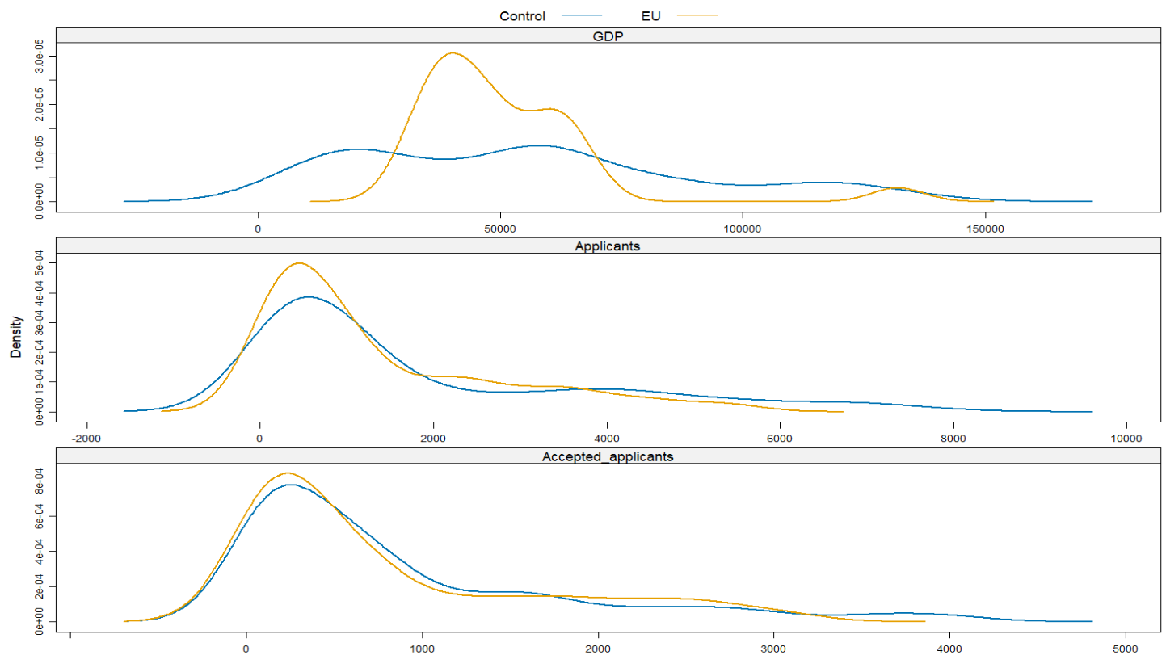
Source. Own-calculations
  - Identification strategy and parallel trends
We estimate a dynamic difference-in-differences specification to trace the evolution of applications around the Brexit tuition reform:
$$\log{A_{it}}=α_{i}+γ_{t}+\sum_{l≠0}{δ_{l}}\left(EU_{i}×1\left\{t-2020=l\right\}\right)+ε_{it}$$ | (5)
The coefficients $δ_{l}$ measures those year-by-year deviations in log applications for EU-origin countries relative to the omitted pre-reform year ($l=0$, corresponding to 2020).
Figure 2. Event-study estimates comparing EU applicants to the synthetic control group.
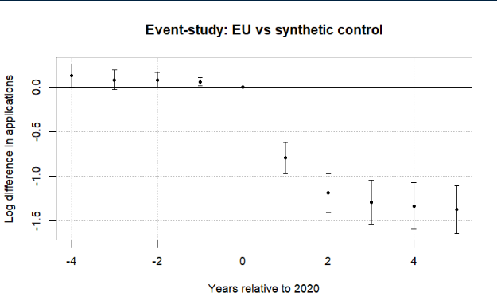
Note: The figure plots coefficients from a difference-in-differences event-study comparing EU applicants to a synthetic control group of non-EU countries. The horizontal axis shows years relative to 2020, the last pre-treatment year. Points represent estimated differences in log applications and bars denote 95% confidence intervals clustered at the country level. The dashed vertical line marks the final pre-treatment year. Pre-treatment coefficients are small and close to zero, while a sharp decline in EU applications emerges beginning in 2021 after the tuition reform took effect. A joint Wald test cannot reject the null that the pre-treatment coefficients are jointly zero (p = 0.12), providing no strong evidence of differential pre-trends.
Figure 2 reports the event-study coefficients from equation (3). The pre-treatment coefficients (leads) are generally small and close to zero, although several leads are marginally statistically significant when standard errors are clustered at the country level and a joint Wald test fails to reject the null hypothesis that the pre-treatment coefficients are jointly equal to zero (p = 0.12).
The overall trends in the data (especially clear with the release of the 2025 data) rule out the possibility that the change in the number of applications was due to COVID. No observable recovery is visible in figure. 2, especially in the periods when COVID has largely abated (2024 and 2025), with the decline going deeper the more years have passed since the event. Due to a small positive divergence in the Post-Referendum applications, we can conclude that the UK higher education system did not become less appealing due to migration concerns – if anything, candidates were even more motivated to apply.
Figure 3 Leads-only test without anticipation effects.
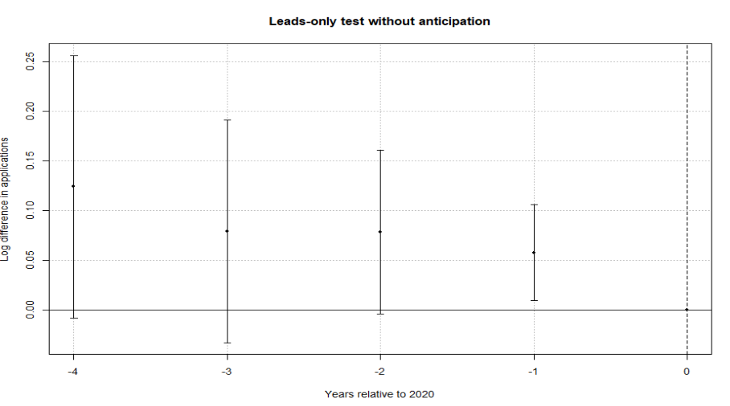
Note: The figure plots coefficients from a leads-only specification testing whether EU applications diverged from the synthetic control group prior to the Brexit tuition reform. The horizontal axis shows years relative to 2020, the last pre-treatment year. Points represent estimated differences in log applications and bars denote 95% confidence intervals clustered at the country level. The dashed vertical line marks the final pre-treatment year. The estimates display no systematic pre-treatment pattern, and a joint Wald test fails to reject the null that the early leads are jointly zero (p = 0.12), providing no strong evidence of anticipation effects.
To further assess identification, we implement two additional tests. First, a leads-only specification finds no evidence of anticipation effects, suggesting that applicants did not adjust behavior prior to the reform (fig 3.). Second, a placebo exercise with randomly assigned treatment produces coefficients centered around zero, indicating that the estimated effects are not driven by mechanical features of the estimation procedure (fig A1).
Finally, allowing for country-specific dynamic effects yields similar patterns: post-treatment coefficients are consistently negative across EU countries, while pre-treatment estimates remain close to zero (fig 4). This result allows for the saturated DID design and the estimation of the country specific elasticities.

Figure 4. Saturated DID event-study estimates by country.
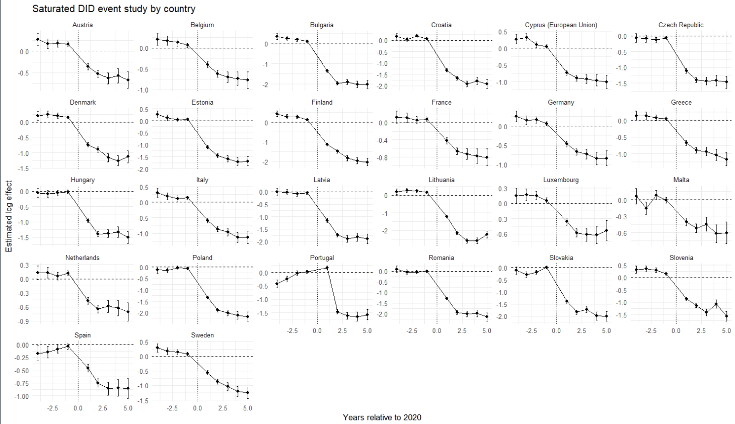
Note: Each panel reports country-specific dynamic treatment effects from the saturated difference-in-differences specification comparing EU countries with the pooled control group. Coefficients represent log differences in applications relative to the baseline year (2020). Error bars denote 95% confidence intervals. All results were completely replicated in Python and the output was the same.
  - Baseline elasticities estimates
The empirical justification of the counterfactual European Union allows to create a synthetic untreated group enabling us to estimate the saturated two-ways DID model:
$$\log{(A_{it})} = α_{i} + γ_{t} +\sum_{\begin{aligned}k∈Ω \\ \end{aligned}}^{ }{β_{k} \left(1\left\{i=k\right\}×Post_{t}\right)} +ρ^{'}X+ ε_{it}$$ | (7)
where ($A_{it}$) denotes applications (or acceptance rates) from origin country ($i∈Ξ$) in year ($t∈\left[2016, 2025\right]$), $1\left\{i=k\right\}$ is an indicator for EU member states, and $Post_{t}$ marks the introduction of the new tuition regime in 2021. The interaction coefficient ($β_{k}$) captures the magnitude of the collapse in Applications under non-heterogeneous markets relative to the omitted category.
To distinguish between short-run and persistent effects, we further split the post-treatment period into two phases: 2021–2023, which captures the immediate response following the reform, and 2024 onward, which reflects longer-run adjustments. The specification becomes:
$$\begin{matrix}\log{(A_{it})} & = & α_{i} + γ_{t} + \sum_{\begin{aligned}k∈Ω \\ \end{aligned}}^{ }{β_{k} \left(1\left\{i=k\right\}×Pos{tBrexit}_{t}\right)} \\ & + & \sum_{\begin{aligned}k^{ }∈Ω \\ \end{aligned}}^{ }{σ_{k^{ }} \left(1\left\{i=k^{'}\right\}×Pos{tCovid}_{t}\right)}+ρ^{'}X+ ε_{it }\end{matrix}$$ | (8)
from here follows the interpretation of $β_{k}$ as the short-run country specific response (Brexit + COVID uncertainty) and${ σ}_{k^{ }}$​ is the persistent structural response (pure willingness-to-pay shift). The difference $β_{k}-σ_{k^{ }}=ω_{k}$ provides the specific COVID impact on demand elasticities (mathematical proof for this in the supplementary materials).
We show in the supplementary materials that the $β_{i},$ with $i∈Ω$, coefficient can be mapped to a structural elasticity parameter through the following transformation (Bresnian 1987 style):
$η_{i}=\frac{β_{i}}{k_{i}}$,
where $k_{i}$ is defined as:
$$k_{i}=\log{22200}-\log{PV_{loan}(w_{i})}$$
in this formula $PV_{loan}(w_{i})$ is the present value of the income contingent UK loan, 22200 is the average post-Brexit price and $w_{i}$ is the average annual salary in Euro. Under the standard shift from 9250 pounds and no heterogeneity assumption $k$ is 0.86. Clifton-Sprigg (2025) assumes one unique price change (from the old price of 9250 to 22200) but the above equation allows us to relax this assumption.
We then relate these elasticities to observable economic fundamentals. Specifically, we estimate correlations of the form:
$$β_{i∈Ω} = θ_{0} + δ_{1}\log\left(GDPpc_{i∈Ω}\right)+ρ^{'}X+ u_{ }$$ | (9)
Where $ρ^{'}X$ is a list of country specific covariates that control for structural characteristics at the country level. This exercise documents that income strongly predicts the magnitude of the shock, consistent with a segmented higher-education market in which price sensitivity varies systematically with economic fundamentals.
- Results
  - Estimated elasticities
Following the empirical strategy, Figure 5 reports country-specific elasticities derived from the difference-in-differences estimates. We translate the estimated treatment effects into implied demand responses to the Brexit tuition shock.
Figure 5. Decomposition of the post-Brexit demand elasticities by treated country.
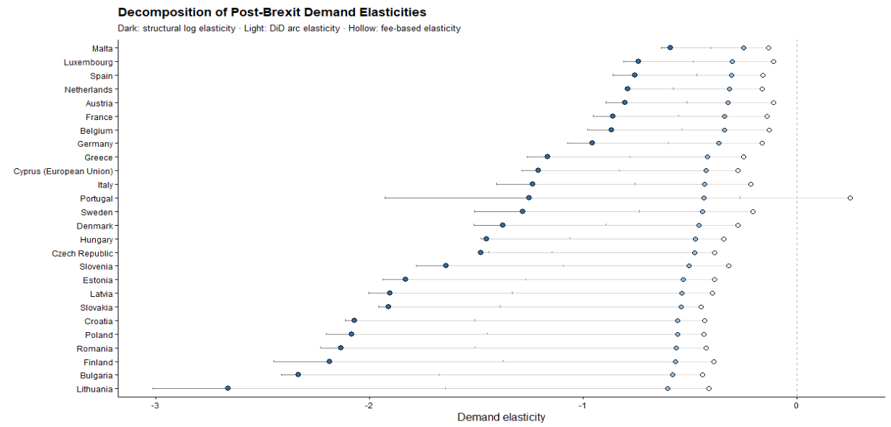
Note: The structural log elasticities are obtained from the division of the country-specific effect ($β_{k})$ by 0.86. The Arc elasticities are obtained by $\left(e^{β}-1\right)/1.4$ and the mechanical arc elasticities by $ΔApplications_{2020}^{2021}/1.40$. This graph was replicated both in Python and R and was the same across software implementations.
The results indicate a large and widespread contraction in demand. Across EU countries, applications declined substantially following the introduction of international tuition fees, with estimated effects corresponding to reductions of roughly 45% to 90% relative to the control group. The average effect implies a decline of approximately 70%. All DID elasticities lie strictly below zero, confirming that the Brexit-induced tuition shock caused a contraction in EU demand for UK higher education across the entire Union. However, the magnitude of this response varies substantially. Wealthier EU countries such as Malta, Spain, Luxembourg, the Netherlands, and Austria cluster near elasticities between −0.7 and −1.0, indicating relatively inelastic demand. By contrast, lower-income EU countries – including Bulgaria, Romania, Lithuania, Croatia, and Latvia exhibit elasticities exceeding −2, with Lithuania approaching −3, indicating relatively elastic demand.
This heterogeneity aligns closely with cross-country differences in income. Regressing the estimated country-specific responses on GDP per capita reveals a strong positive relationship: wealthier countries experience smaller declines in applications (table 2). However, an important consideration is that the tuition reform altered not only nominal prices but also the availability of income-contingent loans. Because these loans effectively reduce the cost of education, their removal may have generated larger effective price increases for applicants from lower-income countries. In the discussion section, we account for this by adjusting elasticities using country-specific effective price changes. Details on the construction of elasticity measures and alternative definitions are provided in Appendix A.
Table 1. Correlations between the DID (FEs and No FEs elasticities) and logarithm of GDP per capita (source WB R pool)
 | TWFE elasticities | OWFE elasticities | Pooled elasticities
$\log\left(GDPpc\right)$ | 1.11***
 | (0.361)
Const. | -13.44***
 | (3.916)
Observations | 24 | 24 | 24
R² | 0.266
  - Estimated COVID specific elasticities
Figure 6 compares the immediate post-Brexit demand elasticities with the persistent elasticities observed after pandemic disruptions had abated. The difference between the dots is consistent with the effect derived in the supplementary materials.
Figure 6. Post Brexit and post-COVID Demand elasticities compared on the same measurement axis.
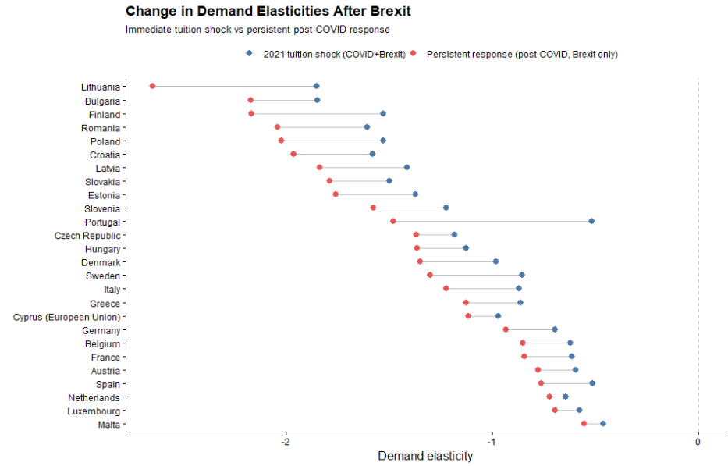
It is also important to mention that for nearly all EU origin countries, the persistent post-COVID elasticities remain strongly negative and closely aligned with the initial post-2021 estimates. The persistence of the elasticities confirms that price sensitivity, rather than short-run volatility, is the dominant mechanism behind the observed demand contraction.
For higher-income EU countries, elasticities become slightly less negative once COVID effects dissipate, suggesting partial normalization of demand at the margin. In contrast, for lower-income EU countries, elasticities remain highly elastic especially in the post-COVID period, with little evidence of recovery (the gap between the post-COVID and the Brexit elasticity appears to widen more for poorer countries).
  - ATT wealth heterogeneity
Table 2. ATE coefficient and interactions. FEs are always entity and time. Standard errors are Driscoll-Kraay (L=1)
 | (I) | (II) | (III) | (IV) | (V) | (VI)
$$ATT$$ | -1.27*** | -1.1*** | -7.16*** | -1.13*** | -0.99*** | -7.37***
 | (0.122) | (0.1) | (0.703) | (0.126) | (0.109) | (1.75)
$$\log{(GDPpc)}$$ |  | -0.05 | 0.281* |  | -0.73* | -0.29
 |  | (0.151) | (0.119) |  | (0.288) | (0.25)
$$\log{(Pop16_54)}$$ |  | 4.03*** | 3.498*** |  | 2.77*** | 2.34***
 |  | (0.3) | (0.381) |  | (0.519) | (0.53)
$$YU$$ |  | -0.02*** | -0.015** |  | -0.02*** | -0.012*
 |  | (0.004) | (0.004) |  | (0.006) | (0.006)
$$ATT×\log{(GDPpc)}$$ |  |  | 0.438*** |  |  | 0.47***
 |  |  | (0.073) |  |  | (0.102)
$$ATT×\log{(Pop16_54)}$$ |  |  | 0.094*** |  |  | 0.08***
 |  |  | (0.017) |  |  | (0.015)
$$ATT× YU$$ |  |  | 0.006 |  |  | 0.02***
 |  |  | (0.006) |  |  | (0.004)
Obs | 520 | 459 | 459 | 520 | 459 | 459
R2 Adj | 0.952 | 0.706 | 0.971 | 0.590 | 0.670 | 0.718
R2 Within | 0.613 | 0.703 | 0.761

Note: Models (1) through (V) are estimated with the standard TWFE estimator, while (VI) and (VII) are estimated with Poisson regressions (see Berge (2018)) based on MLE. All regressions from (I) to (V) were replicated with the standard “linear models” package in Python, while (VI) and (VII) were estimated using “substitutes”. All regressions are replicable in both R and Python. The data is sourced from the World Bank API resources, except for Jersey that was excluded due to data restrictions. Since the series for 2025 were not available they were excluded from the estimation (therefore the 459 observations (51 countries * 9 Years per panel)).
Table 3 reports regressions that relate the magnitude of the Brexit demand shock to country-level economic characteristics. Across all specifications, the baseline effect remains large, negative, and statistically significant, confirming a substantial contraction in EU demand following the tuition reform. At the same time, there is clear evidence of heterogeneity. The interaction between the Brexit treatment and GDP per capita is positive and statistically significant, indicating that higher-income countries experience smaller declines in applications. This is consistent with lower price sensitivity in wealthier contexts.
Labor market conditions also play an important role. The interaction with youth unemployment is positive and significant, suggesting that weaker labor market prospects attenuate the decline in applications. When employment opportunities for young cohorts deteriorate, studying abroad becomes a relatively more attractive option, reducing the responsiveness to higher tuition fees. By contrast, demographic factors such as population size do not materially affect the results and provide limited explanatory power.

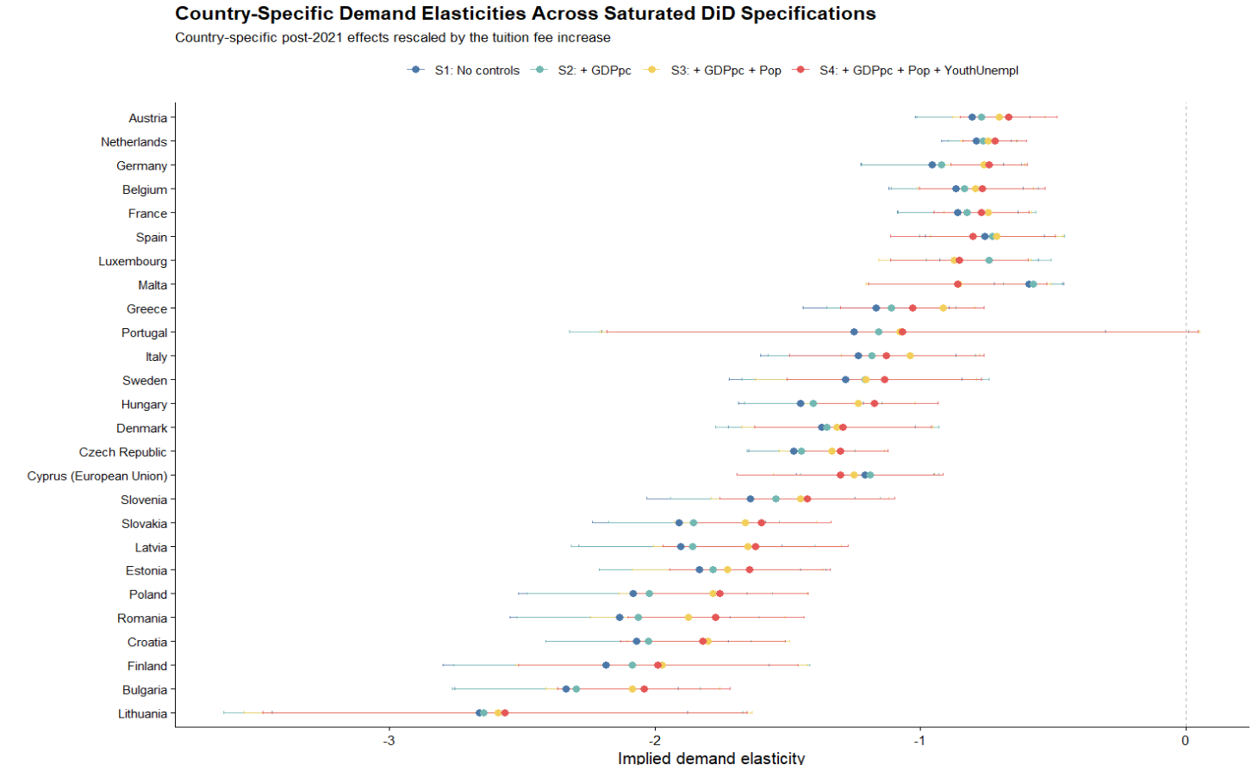
- Robustness
We assess the robustness of the baseline results along three dimensions: the choice of control group, the estimation method, and potential omitted variable bias. First, we re-estimate the treatment effect using alternative control groups, including only OECD countries, only high-income countries, and only low-income countries. The estimated effects remain consistently negative and of similar magnitude across all specifications, with overlapping confidence intervals. This indicates that the results are not driven by the composition of the control group (table 4). We combine this with multiple changes in the estimator - the doubly robust estimator of Callaway and Sant’Anna (2021) as an alternative to the standard two-way fixed effects model as well as the Poisson, MLE-based regression estimates (see Berge (2018)). The resulting estimates are very close to the baseline results, and event-study diagnostics continue to show no evidence of differential pre-trends.
Table 3. Estimates obtained from Doubly Robust estimator and the Standard TWFE model. Standard errors are reported in parenthesis. Both models estimate the coefficients with the number of observations presented in the “Sample decomposition” table.
Estimator | Doubly Robust | TWFE | MLE – Poisson
Own synthetic group | -1.197* | -1.265*** | -1.132***
 | (0.106) | (0.122) | (0.126)
Poor countries | -1.48* | -1.67***
 | (0.156) | (0.20)
Rich countries | -1.23* | -1.32***
 | (0.122) | (0.13)
OECD countries | -1.18* | -1.26***
 | (0.125) | (0.13)
Samples  decomposition | Own synthetic group | Poor countries | Rich countries | OECD countries
Control group | 24 | 14 | 13 | 14
EU group | 26
Observations | 52*10=450 | 40*10=400 | 39*10=390 | 40*10=400

Figure 4. Stratified cluster bootstrap distribution of the Brexit treatment effect.
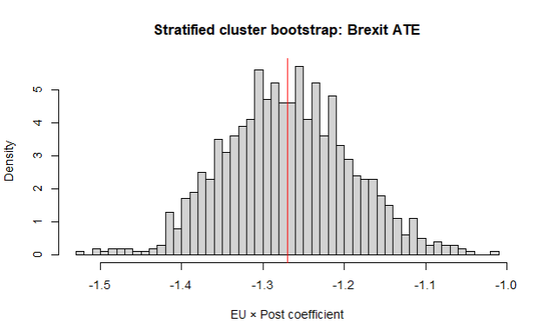
Note: The histogram reports the distribution of the EU×PostEU coefficient obtained from 1,000 stratified cluster bootstrap replications, resampling treated and non-treated countries separately with replacement. In each replication, the model $\log{(Applicants)}∼EU×Post$ is re-estimated with country and year fixed effects. The bootstrap mean estimate is −1.270, with bootstrap standard deviation 0.078. The 95% percentile bootstrap confidence interval is [−1.413,−1.114]. The red vertical line marks the bootstrap mean.
Second, we examine the sensitivity of the estimates to sampling variation and unobserved confounding. A stratified cluster bootstrap shows that the estimated treatment effect is tightly centered around the baseline value and remains consistently negative across replications.
Finally, we apply the sensitivity analysis framework of Cinelli and Hazlett (2020). The results indicate that an omitted variable would need to explain a very large share of the residual variation in both treatment and outcome to eliminate the estimated effect (~70%). Given the inclusion of country and year fixed effects, such a confounder appears implausibly strong. (fig 10).
Figure 5. Sensitivity analysis for omitted variable bias (sensemakr).
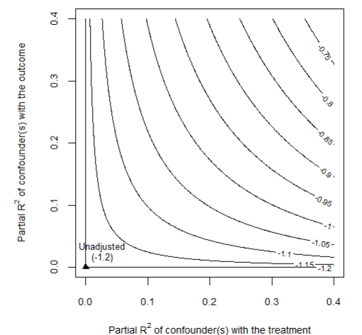
Note: The contour plot shows how the estimated EU×PostEU coefficient changes under hypothetical unobserved confounding. The axes represent the partial R² of a potential confounder with the treatment and the outcome.
- Discussion
  - Were poor EU students really priced out because of elastic demand?
A natural interpretation of the results is that students from lower-income EU countries exhibit more elastic demand for UK higher education. However, this interpretation relies on the assumption that the tuition reform generated the same effective price change across countries. In practice, this assumption is unlikely to hold. Prior to Brexit, tuition was financed through income-contingent loans, meaning that the relevant economic price depended on expected future earnings rather than the nominal fee. As a result, the removal of these loans likely generated larger effective price increases for applicants from lower-income countries.
To illustrate how elasticities, depend on loan valuation, we compute implied elasticities using the average treatment effect coefficient $β=-1.28$ and map it across a range of starting income levels (Figure X). When the loan is expected to have a low present value (e.g., for applicants with low expected earnings), the Brexit reform constitutes a large effective price shock, and the implied elasticity is mechanically smaller in magnitude (approximately −0.4). Conversely, when the loan’s present value approaches its nominal amount (high expected earnings), the effective price shock is smaller, and the implied elasticity is larger in magnitude
Figure 6 Implied demand elasticity as a function of the economic value of the UK student loan.
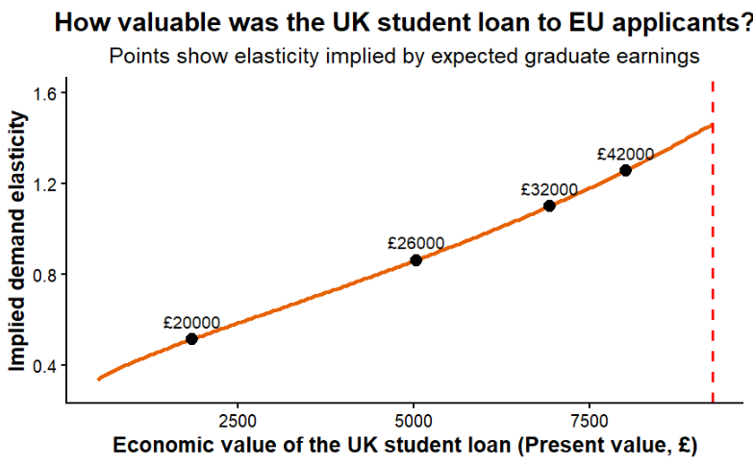
Note: The figure translates the estimated treatment effect into implied demand elasticities under different assumptions about the present value of the UK student loan to EU applicants. Points correspond to elasticity estimates implied by alternative expected graduate earning scenarios.
To examine whether structural heterogeneity in demand persists after accounting for this mechanism, we define corrected elasticities as $η_{i}^{'}=β_{i}k_{i}$. Dividing by heterogeneous $k_{i}$removes the portion of elasticity variation that is mechanically induced by differential effective price shocks. Any remaining systematic variation in $η_{i}^{'}$ therefore reflects structural heterogeneity in willingness to pay rather than loan-valuation mechanics. After recomputing the elasticities heterogenous price changes across the Union we re-estimated the correlation with GDP per capita. Figure 12 shows that this time the same correlation was completely reversed becoming negative.
Figure 7. Income gradient in demand elasticity.
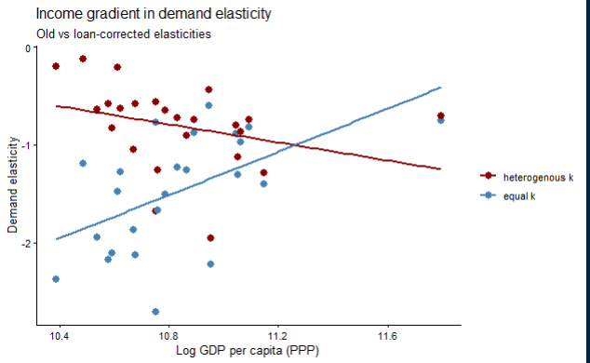
Note: The figure compares baseline elasticity estimates with elasticities corrected for heterogeneous loan value across countries. The horizontal axis shows log GDP per capita (PPP). Lines represent fitted linear relationships.
Before correcting for heterogeneous treatment intensity, demand elasticities display a strong and statistically significant positive relationship with origin-country income (δ = 1.06, p = 0.01, fig X). However, once elasticities are rescaled using country-specific effective price shocks derived from the present value of the income-contingent loan, the income gradient collapses and becomes statistically indistinguishable from zero (δ′ = −0.50, p = 0.12). The difference between the gradients (Δ = −1.56) indicates that a substantial portion of the observed cross-country heterogeneity reflects variation in treatment intensity rather than structural differences in preferences.
Under the new calculations countries like Finland, Denmark, Slovenia, Germany and Luxembourg have comparably large elasticities. These are exactly the countries where a lot of university options are actually available. This implies that applicants from lower-income countries face fewer high-quality domestic alternatives and may view UK education as a pathway to significantly higher lifetime earnings. As a result, their application behavior may be less responsive to tuition increases than raw demand responses would suggest.
From a political perspective, the decline in applications from poorer EU countries reflects the withdrawal of an institution that had quietly equalized opportunity across Europe. The UK’s income-contingent loan system meant that students did not need to arrive with wealth; they needed only the expectation of future effort and earnings. When that system disappeared for EU applicants, the effective cost of studying in the UK rose dramatically for those from poorer economies. What appears in the data as “elastic demand” is therefore better understood as the sudden loss of a mechanism that had allowed talent to travel across borders without the constraint of immediate financial means. In that sense, the Brexit tuition reform did not simply reveal price sensitivity – it exposed how fragile educational mobility can be when the institutions that support it are removed.

Appendix

Table A 4. Counterfactual construction: donor countries used to match each treated EU country in the synthetic European Union.
Treated | Austria | Belgium | Bulgaria | Croatia | Cyprus (EU) | Czech Republic
Matched | Jersey | Switzerland | Norway | Macao | Singapore | Turkey
 | Vietnam | Russian Federation | Canada |  | Canada | Kuwait
 |  |  |  |  | United States of America | Thailand
Treated | Denmark | Estonia | Finland | France | Germany | Poland
Matched | Jordan | Vietnam | Russian Federation | Malaysia | United States of America | United States of America
 | Bahrain | Bahrain | Switzerland | Hong Kong | Malaysia
 |  |  |  |  | Singapore
Treated | Greece | Hungary | Italy | Latvia | Lithuania | Luxembourg
Matched |  | Thailand | Singapore | Vietnam | Norway | Bahrain
 | Canada | Kuwait | Canada | Jersey | Canada | Jordan
 |  |  | United States of America
Treated | Portugal | Romania | Malta | Netherlands | Sweden | Spain
Matched | Switzerland | Canada | Israel | Russian Federation | Norway | Canada
 |  | Norway |  | Switzerland | Saudi Arabia | Singapore
 |  |  |  |  |  | Pakistan
Treated | Slovakia | Slovenia
Matched | Kuwait | Serbia
 | Thailand

Figure A1. Placebo with randomized treatment assignment.
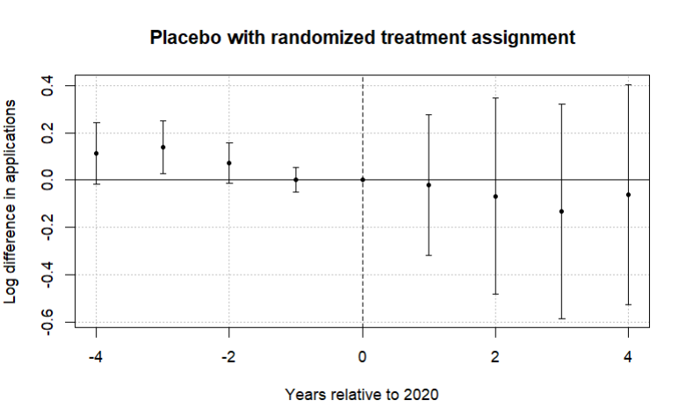
Note: The figure reports coefficients from an event-study specification in which treatment status is randomly assigned across countries. The horizontal axis shows years relative to 2020, the last pre-treatment year. Points represent estimated differences in log applications and bars denote 95% confidence intervals clustered at the country level. The dashed vertical line marks the final pre-treatment year. In contrast to the main specification, the placebo estimates fluctuate around zero and display no systematic post-treatment pattern, suggesting that the large decline in EU applications observed in the baseline results is unlikely to arise from mechanical features of the estimation procedure.

References
Bound, J., Lovenheim, M. F., & Turner, S. (2010). Why have college completion rates declined? American Economic Journal: Applied Economics, 2(3), 129–157.
Hoxby, C. M. (1997). How the changing market structure of U.S. higher education explains college tuition. NBER Working Paper No. 6323.
McFadden, D. (1974). Conditional logit analysis of qualitative choice behavior. In P. Zarembka (Ed.), Frontiers in Econometrics. Academic Press.
Neville, R., Rowe, F., & Singleton, A. (2024). Unraveling the Brexit–COVID-19 nexus: assessing the decline of EU student applications into UK universities. Data & Policy, 6, e45. doi:10.1017/dap.2024.42
Clifton-Sprigg, J., Homburg, I., Huyghe, A., & Vujić, S. (2025). International student migration: Did Brexit close the door to EU students? (IZA Discussion Paper No. 18178). IZA Institute of Labor Economics.
Calhoun, C. (2017). Populism, nationalism and Brexit. In W. Outhwaite (Ed.), Brexit: Sociological responses (pp. 57–76). Anthem Press.
Cuibus, M., & Walsh, P. W. (2024). Student migration to the UK. Migration Observatory briefing, COMPAS, University of Oxford. Retrieved from https://www.migrationobservatory.ox.ac.uk
Findlay, A., King, R., Stam, A., & Ruiz-Gelices, E. (2006). Ever reluctant Europeans: The changing geographies of UK students studying and working abroad. European Urban and Regional Studies, 13(4), 291–318. https://doi.org/10.1177/0969776406065429 (Original work published 2006).
Locke, W., & Marini, G. (2021). The rapid increase in faculty from the European Union in UK higher education institutions and the possible impact of Brexit. In F. Huang & A. R. Welch (Eds.), International faculty in Asia (Vol. 21). Springer, Singapore. https://doi.org/10.1007/978-981-33-4980-3_12
Luthra, R. R. (2020). Mitigating the hostile environment: The role of the workplace in EU migrant experience of Brexit. Journal of Ethnic and Migration Studies, 47(1), 190–207. https://doi.org/10.1080/1369183x.2020.1726173
Macdonald, C., & Stratta, E. (2001). From access to widening participation: Responses to the changing population in higher education in the UK. Journal of Further and Higher Education, 25(2), 249–258. https://doi.org/10.1080/03098770120050909
Brown, R. (2011). After Browne: The new competitive regime for English higher education.
Hoxby, C. M. (2000). The economics of higher education: Analyzing the role of tuition fees and price sensitivity in HE demand. Journal of Economic Perspectives, 14(4), 149–169. https://doi.org/10.1257/jep.14.4.149
Leslie, D. (2003). Using success to measure quality in British higher education: Which subjects attract the best-qualified students? Journal of the Royal Statistical Society: Series A (Statistics in Society), 166(3), 329–347. https://doi.org/10.1111/1467-985X.00280
Mayhew, K. (2022). Brexit and UK higher education. Oxford Review of Economic Policy, 38(1), 179–187. https://doi.org/10.1093/oxrep/grab0
Driscoll, J.C., Kraay, A.C. (1998), ‘Consistent covariance matrix estimation with spatially dependent panel data’, Review of Economics and Statistics, Vol. 80, No. 4, pp. 549–560. https://doi.org/10.1162/003465398557825
UK Government. (n.d.-a). Repaying your student loan: What you pay. GOV.UK. https://www.gov.uk/repaying-your-student-loan/what-you-pay
UK Government. (n.d.-b). When your student loan gets written off or cancelled. GOV.UK. https://www.gov.uk/repaying-your-student-loan/when-your-student-loan-gets-written-off
UK Government. (n.d.-c). How interest is calculated (Plan 2). GOV.UK. https://www.gov.uk/guidance/how-interest-is-calculated-plan-2
Berge, Laurent. (2018). "Efficient estimation of maximum likelihood models with multiple fixed-effects: the R package FENmlm." CREA Discussion Papers, 13.

