The Brexit Tuition Shock and the Price Elasticity of International Students: Evidence from a Natural Experiment

Stoycho Rusinov*

James Rafiki Aketch**

*Center for the Study of Democracy, Sofia

New Bulgarian University, Department of Informatics

email: stoycho.rusinov@csd.eu

**School of Economics, University College Dublin

ABSTRACT
This paper estimates the price elasticity of EU demand for UK higher education using the Brexit-induced loss of Home Fee status and student-loan access as a quasi-experimental tuition shock. Unlike standard higher-education demand studies that rely on enrollment outcomes, the analysis uses UCAS application data, allowing demand to be observed before universities ration admissions. The average post-Brexit treatment effect implies a decline in applications of roughly 66 percent, with country-specific elasticities varying substantially across the EU. Initial estimates suggest that applicants from lower-income member states were more price elastic, while wealthier countries experienced smaller demand contractions. However, once elasticities are rescaled using country-specific effective price shocks that account for the removal of income-contingent loans, the income gradient collapses and becomes statistically indistinguishable from zero. This indicates that much of the apparent cross-country heterogeneity reflects heterogeneous treatment intensity rather than stable differences in underlying preferences. The findings suggest that the UK student-loan system functioned as an important equalizing institution for European educational mobility, and that its removal transformed a nominally uniform tuition reform into a highly uneven economic shock across EU origin countries. The loan-adjusted elasticities are strongly correlated with the percentage of GDP allocated for educational investment.

JEL codes: I22; I23; F22; J61; D12; C23

Keywords: Brexit; international student mobility; higher education demand; tuition fees; price elasticity; EU students; UCAS applications; difference-in-differences; synthetic control; income-contingent loans; educational mobility; heterogeneous treatment effects.
- Introduction

International higher-education demand studies often struggle to isolate own-price elasticity because elasticity calculations usually rely on enrollment changes in response to price shifts. This approach is problematic because enrollment is an equilibrium outcome, shaped by both student preferences and capacity-constrained admission decisions (Hoxby, 1997; Bound et al., 2010). As a result, standard demand models using enrollment data conflate the desire to attend with the university's choice to admit.

In this paper, we assume that UCAS application data captures expressed demand before seats are rationed. Whether a student applies through the UCAS portal does not depend on how many places are available, as rationing occurs after applications are submitted. Our study uses cross-country variation, rather than traditional within-country, individual-level variation, to estimate international price responsiveness (i.e., demand elasticity).

To further clarify causal inference, we utilize the exogenous Brexit-induced tuition shock to estimate price elasticities at the origin-country level. The loss of Home Fee status and access to loans resulted from an external policy change, not a university pricing decision, creating a quasi-experimental setting for inferring willingness-to-pay. This causal design enables us to reconstruct country-specific, constant-elasticity demand functions for international applications around pre-Brexit price levels.

We show that under specific assumptions, applicants from lower-income EU countries exhibit highly elastic responses, significantly reducing their demand in response to the price hike. This heterogeneity implies that, while the UK higher education market faced a uniform regulatory shock, it also effectively filtered out price-sensitive consumers while retaining those with greater ability to pay. However, a more substantial contribution we make is that we later revisit these same elasticity estimates by adopting a different perspective on credit risk valuation prior to Brexit, showing that much of the observed demand heterogeneity is driven by the structure of the student loan system itself. This leads to the discovery that even though poorer EU economies initially exhibit very high demand elasticities, and demand elasticities strongly correlate with GDP per capita, when elasticities are rescaled using country-specific shocks from the value of the income-contingent loan, the income gradient shrinks to near zero, implying that most cross-country heterogeneity comes from treatment differences rather than preferences. The rescaled elasticity is more closely linked to the share of GDP invested in education than to GDP per capita itself.
- Context
  - Brexit and higher education
Over the preceding decades, the UK higher education system has expanded under policies of widened access (Macdonald & Stratta, 2001; Brown, 2011). Although price elasticity in higher education is generally moderate (Hoxby, 1996), most studies focus on individual-level characteristics (Leslie, 2003), leaving macro-level effects less explored. Brexit was a multifaceted phenomenon that began as a political movement but ultimately led to the UK’s exit from the EU, which was described as a populist pushback against globalization and a shift away from “London” (Calhoun, 2017). One of its most significant outcomes, however, was the rupture of academic ties between the UK and the EU, with 2020 marking the final year that EU students paid domestic-level tuition; fees then doubled or tripled, making Brexit one of the largest tuition policy changes of the 21st century (Cuibus & Walsh, 2024; Mayhew, 2022).
This shift also reshaped student mobility, although a declining trend in UK students heading to Europe was noted as early as 2006 (Findlay et al., 2006), partly offset by increased flows to North America and Australia. Locke and Marini (2021) note that in the decade preceding the Referendum on the UK’s membership of the European Union (EU), there had been a rapid increase in foreign faculty in UK higher education institutions (HEIs), particularly from other EU countries. Many institutions had come to rely on academics from other EU countries, as well as those from outside the EU, for a significant part of their research, teaching, and other activities. Locke and Marini (2021) indicate that the growth in academic outflow to the UK (from 2004/2005 to 2017/2018) was most pronounced in countries such as Bulgaria, Croatia, Estonia, Latvia, and Lithuania. Luthra (2020) argues that the rejection of free movement created vulnerability among EU staff, highlighting feelings of insecurity regarding their legal rights and public acceptance within their workplaces.
The causal design of the Brexit shock was implemented later (once UCAS data became available). For example, Neville et al. (2024) document sharp post-2021 declines in EU applications and acceptances, even after controlling for COVID conditions. Clifton-Sprigg et al. (2025) explicitly conclude that the introduction of international tuition fees, rather than the referendum result or visa changes, caused the substantial contraction in EU study mobility. Our contribution advances these designs by treating the fee increase as a quasi-experimental price shock to identify origin-specific price elasticities from uncensored applications and by accounting for income-specific loan valuation. We therefore extend the literature by moving away from measuring how much demand fell to uncovering why it fell and what this implies for pricing and market structure.
  - Previous attempts to capture demand elasticities in higher education

Our use of DiD designs to recover structural demand parameters has a lineage in the IO literature, as Bresnahan (1982) showed that market-level price and quantity variation can identify demand elasticities when supply-side conduct is explicitly modeled. The present paper adapts this logic to a quasi-experimental setting, using the Brexit shock to identify the slope of country-level isoelastic demand curves. We extend the standard literature in the economics of education by building on Sá (2014), the closest methodological predecessor, who used the same UCAS application data and similar DiD logic to derive elasticities of 0.14–0.26 for domestic students. Her key finding is that credit-constrained students are not disproportionately affected, due to income-contingent loans equalizing access, a claim directly tested by Brexit, which removes those loans for an identifiable group. Our results extend the loan valuation mechanics by demonstrating that the income gradient in demand elasticities across EU countries collapses once elasticities are corrected for heterogeneous loan present values.

Endogeneity between demand and supply for higher education is another concern. Hoxby (1997) argues that increased competition in higher education can lead to higher tuition because institutions respond by differentiating their products, increasing quality, sorting students more sharply, and adjusting subsidies. In that account, rising tuition is an endogenous feature of a new competitive equilibrium. The Brexit design differs sharply in that the increase in tuition for EU students was not driven by institutional competition, quality upgrading, or a university-level pricing strategy. It was an externally imposed regulatory shock that removed Home Fee status and access to income-contingent loans while leaving the underlying educational product largely unchanged. This corresponds directly to Leslie and Brinkman (1987), who define demand elasticity as ε = (E/P), where E is the percentage change in enrollment, and P is the percentage change in price. If elasticity is derived from time-series variation rather than cross-sectional variation, then increasing competition can generate endogenous price shifts within the institutions affected.

Furthermore, Leslie and Brinkman (1987) explain that when we have a tuition elasticity from a time-series study, we cannot directly use it as a total-cost elasticity, because tuition and total cost did not move proportionally over time. This is why Brexit represents such an important empirical event, because it generated implicit tuition variation by sharply changing the effective price faced by EU applicants, allowing the analysis to identify how demand responds to changes in the actual cost of study rather than to nominal tuition alone. Campbell & Siegel (1967) present an example in which tuition rose 148% between 1927 and 1963, more than the total direct costs, so their tuition elasticity of −0.44 understates the true total cost elasticity.

Leslie and Brinkman (1987) further conclude that for every $100 increase in tuition price, given the 1982-83 average weighted higher education prices of $3,420 for tuition and room and board, one would expect a 18-24-year-old participation rate drop of about three-quarters of a percentage point. Since the national higher education participation rate was about 0.33 in 1982, U.S. enrollments would decline by about 2.1 percent for each $ 100 price increase, all other factors equal. This implies a price elasticity of about -0.73, which is largely consistent with some of our own estimates.

Savoca (1990) argues that standard enrollment-based estimates understate true demand sensitivity by conflating application behavior with admissions and matriculation decisions. Under the assumption that tuition and admissions policy are set independently, the price elasticity of enrollment equals the sum of the application and matriculation elasticities – a combined figure she estimates at −0.49, suggesting the true demand elasticity may be more than twice as large as conventional estimates. Following the modern wave of more robust causal evidence, Dwenger et al. (2012) corroborate this direction of effect in a different setting – among German high-school graduates, residing in a state with tuition fees reduces the probability of applying to a home-state university by 2 percentage points (against a baseline of 69%), with stronger responses among higher-achieving students.

To understand why the Brexit-derived elasticities may be larger than the standard estimates in the literature, consider, for example, Heller (1997), who argues that tuition increases reduce enrollment (so higher education is not a luxury good). The studies reviewed by Heller (1997) converge on the finding that each $100 tuition increase lowers enrollment by roughly 0.5 to 1.0 percentage points, which is consistent with Leslie and Brinkman (1987). Reductions in financial aid also reduce enrollment, though the effect varies by aid type. Lower-income students are more sensitive to changes in tuition and aid than middle- and upper-income students. The results presented in Hemelt and Marcotte (2011) are also relevant because they confirm the standard negative relationship between tuition and enrollment, but their design is also not directly comparable to Brexit.

Another branch in the literature is the BLP-type models (building on McFadden, 1974), which derive elasticities from estimated heterogeneity in preferences across differentiated alternatives; the present design derives elasticity from observed variation in exposure to a large policy-induced price shock. The former is better suited for recovering substitution matrices across choices; the latter is better suited for identifying a destination-level demand response to a discrete change in the relative price of UK higher education.
- Data
The primary data source is the most recent release of the UCAS database (2025), covering application cycles from 2016 to 2025. UCAS provides centralized information on applications to UK higher education institutions, enabling us to observe applicant behavior before admissions decisions are made. This is particularly important for our empirical design, as applications capture expressed demand before institutional rationing takes place. The dataset reports application counts by country of domicile along with additional demographic breakdowns. In this study, application series are constructed by aggregating counts across all available categories of sex and gender to obtain total demand from each origin country, while country of domicile is retained as the key dimension of variation. A natural extension would be to derive gender-, age-, or subject-specific elasticities from the same data; we leave this for future work and focus here on aggregate flows due to space constraints.
The unit of observation is the origin-country–year, yielding a panel dataset that includes both EU countries (the treated group) and non-EU countries used to construct the “pseudo EU” (the artificial control group). The main outcome variable is the logarithm of the number of applications from country i in year t, which captures cross-country variation in demand over time. To analyze heterogeneity in responses to the Brexit-induced tuition shock, the UCAS data are merged with macroeconomic indicators, including GDP per capita and labor-market variables from the World Bank. The descriptive statistics are presented in Table 1.

Table 1. Descriptive statistics of the core variable in the analysis for both the treated and control groups.
Variable | n | mean | sd | median | min | max
Applicants | 520,00 | 1765,11 | 3903,00 | 667,50 | 30,00 | 36385,00
log_app |  | 6,60 | 1,25 | 6,50 | 3,40 | 10,50
EU |  | 0,50 | 0,50 | 0,50 | 0,00 | 1,00
Post |  | 0,50 | 0,50 | 0,50 | 0,00 | 1,00
did |  | 0,25 | 0,43 | 0,00 | 0,00 | 1,00
event_time |  | 0,50 | 2,88 | 0,50 | -4,00 | 5,00
regression_weight |  | 1,00 | 0,77 | 1,00 | 0,00 | 4,18
GDPpc |  | 30109,19 | 24708,24 | 21004,77 | 871,09 | 110873,12
Pop15_65 |  | 42676261 | 138080102 | 6552301 | 305378 | 988168271
YouthUnempl |  | 15,21 | 8,35 | 13,52 | 0,30 | 47,22
EduSpendGDP |  | 4,59 | 1,43 | 4,59 | 0,38 | 8,74
c_log_GDPpc |  | 0,00 | 1,08 | 0,07 | -3,12 | 1,73
c_log_Pop15_65 |  | 0,00 | 1,73 | -0,22 | -3,29 | 4,80
c_YouthUnempl |  | 0,00 | 8,35 | -1,69 | -14,91 | 32,01

Country-specific average wages w_{j} are taken from Eurostat's Average full-time adjusted salary per employee indicator (nama_10_fte) for 2024 (Eurostat, 2025). The series reports gross annual salaries in current euros, harmonized across Member States by adjusting national-accounts wages with a full-time equivalent ratio from the EU Labour Force Survey. This wage enters the loan present-value calculation PV_{loan}(w_{j}) and determines the country-specific effective price shock k_{j}. We use the 2024 wage because a student enrolling in 2021 would complete a standard three-year undergraduate cycle in 2024. The 2024 wage is therefore treated as the first post-graduation wage, and the simulated repayment schedule begins from that year.
Macroeconomic controls are drawn from the World Bank's World Development Indicators, accessed via the WDI R package (Arel-Bundock, 2022): GDP per capita in constant USD (NY.GDP.PCAP.KD), working-age population aged 15–64 (SP.POP.1564.TO), and youth unemployment for ages 15–24 (SL.UEM.1524.ZS). Country codes were harmonised to ISO3 using the countrycode package (Arel-Bundock et al., 2018), and the series were merged with the UCAS panel on country–year. World Bank data are available through 2024 (World Bank, 2025). Since Lebanon was missing GDP per capita and “youth unemployment for ages 15–24” for 2024 we decided to use the arithmetic average from the previous two years to fill in those two values so the panel can be completely balanced.
It is also important to note that we use country-level data and not university-specific data (as in Sá (2014) or Clifton-Sprigg et al. (2025), for example) because of an internal limitation of the UCAS data itself. Once a student creates a registration in the UCAS web portal, they can choose up to 5 universities at once. Furthermore, the student can be accepted to all five of them. This results in double, and sometimes triple, counting of the same applicant. This internal limitation is absent when the series is country-level aggregated, because in this design, each applicant is counted only once per country.

- Empirical strategy
  - Constructing the counterfactual European Union
The control group is constructed in two stages, with the full derivation reported in Online Appendix I. First, each origin country’s pre-treatment application path is converted into a standardized log-applicant trajectory for the years from 2014 to 2020. This data restriction was selected because Croatia joined the EU (becoming a treated country) in 2013. Therefore, in order to avoid contaminating the general pre-treatment trajectories we limited the entire sample only to the 2014 – 2020 window. We also limit the analytical sample to only those countries that maintain a consistent flow of at least 100 applications per annum. For every treated EU country, the three closest non-EU donor countries are then selected using Euclidean distance between standardized pre-treatment paths, so donor choice is based on trajectory shape and independent of market size.
Second, synthetic-control weights are estimated separately for each treated country over the pre-treatment period and then collapsed into a single global donor-weight vector used in the saturated DiD regressions. Treated observations receive unit weight, while donor weights are scaled so that the aggregate control mass equals the aggregate treated mass. This keeps the outcome in logged levels while using the donor pool only to construct a comparable weighted counterfactual. The full list of the “counterfactual” European Union, including the regression weights is presented on Table 2 below.
Table 2. Donor countries used to construct the synthetic counterfactual European Union, with global and regression weights.
Donor country | Global weight | Weight in the regression $(2)×26$
Korea, Republic of | 0.16 | 4.18
Trinidad and Tobago | 0.12 | 3.08
Russian Federation | 0.11 | 2.80
Malaysia | 0.10 | 2.53
Mauritius | 0.08 | 2.07
Egypt | 0.07 | 1.85
New Zealand | 0.04 | 1.11
United States of America | 0.04 | 1.10
Qatar | 0.04 | 1.00
Israel | 0.04 | 1.00
Zimbabwe | 0.04 | 0.96
United Arab Emirates | 0.04 | 0.92
Indonesia | 0.03 | 0.80
Mexico | 0.02 | 0.62
Australia | 0.02 | 0.44
Tanzania, United Republic of | 0.02 | 0.43
China | 0.01 | 0.33
Norway | 0.01 | 0.33
Lebanon | 0.01 | 0.27
Ireland | 0.01 | 0.20
Switzerland | 0.00 | <0.01
Turkey | 0.00 | <0.01
Botswana | 0.00 | <0.01
Iran, Islamic Republic of | 0.00 | <0.01
Uganda | 0.00 | <0.01
Brunei Darussalam | 0.00 | <0.01

  - Identification strategy and parallel trends
In a comparable perspective, the closest design to ours – Sá (2014) – exploits within-country, across-time variation in fees. The treatment in her case is binary and uniform: Scottish students either pay or don't, and English students face one fee level, then another. There is no cross-sectional variation in the size of the price shock. In this paper, however, we exploit cross-country, across-time variation, where the price shock itself, kⱼ, differs across countries because the present value of the foregone loan differs with the average wage. This means the identifying variation has two dimensions simultaneously – whether you are treated (EU vs. non-EU) and how intensely you are treated (which EU country you are from). This corrects an internal limitation in Sá's (2014) design, which cannot separately identify these because all treated students face the same fee change. This resonates with the fact that Sá's identification still relies on only 2 countries and 1 treatment switch, resulting in fewer effective independent treatment clusters.
Following these design choices, we estimate a dynamic difference-in-differences specification. This traces the evolution of applications around the Brexit tuition reform:
$$\log{A_{it}}=α_{i}+γ_{t}+\sum_{l≠0}{δ_{l}}\left(EU_{i}×1\left\{t-2020=l\right\}\right)+ε_{it}$$ | (1)
The coefficients $δ_{l}$ measure those year-by-year deviations in log applications for EU-origin countries relative to the omitted pre-reform year ($l=0$, corresponding to 2020). We, again, perform the regression with the weights supplied from the previous subsection.
Figure 1. Event-study estimates comparing EU applicants to the synthetic control group.
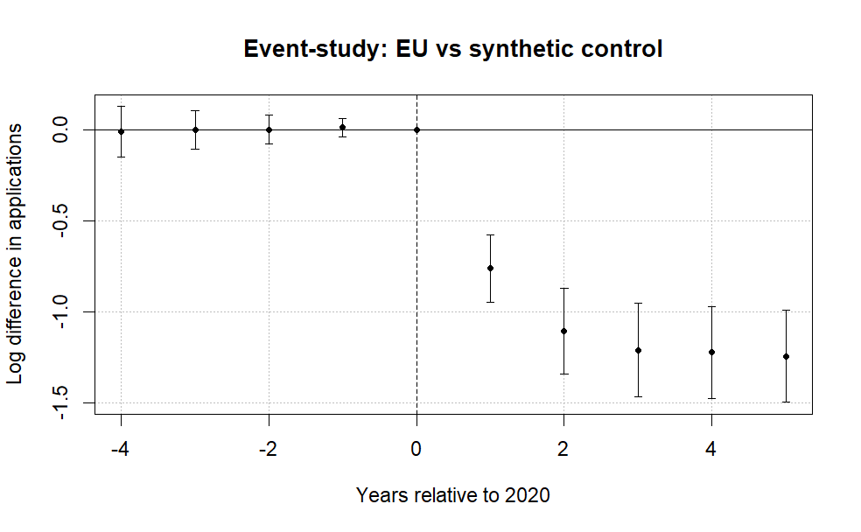
Note: The figure plots coefficients from a difference-in-differences event-study comparing EU applicants to a synthetic control group of non-EU countries. The horizontal axis shows years relative to 2020, the last pre-treatment year. Points represent estimated differences in log applications and bars denote 95% confidence intervals clustered at the country level. The dashed vertical line marks the final pre-treatment year. Pre-treatment coefficients are small and close to zero, while a sharp decline in EU applications emerges beginning in 2021 after the tuition reform took effect. A joint Wald test cannot reject the null that the pre-treatment coefficients are jointly zero (p = 0.96), providing no strong evidence of differential pre-trends.

Figure 1 reports the event-study coefficients from equation (1). The pre-treatment coefficients (leads) are very small and a joint Wald test fails to reject the null hypothesis that the pre-treatment coefficients are jointly equal to zero (p = 0.96). This is evidence that the overall trends in the data (especially clear with the release of the 2025 data) rule out the possibility that the change in the number of applications was due to COVID. No observable recovery is visible in Figure 1, especially in the periods when COVID has largely abated (2024 and 2025), with the decline going deeper the more years have passed since the event. Due to a small positive divergence in the Post-Referendum applications, we can conclude that the UK higher education system did not become less appealing due to migration concerns – if anything, candidates were even more motivated to apply.
Figure 2. Leads-only test without anticipation effects.
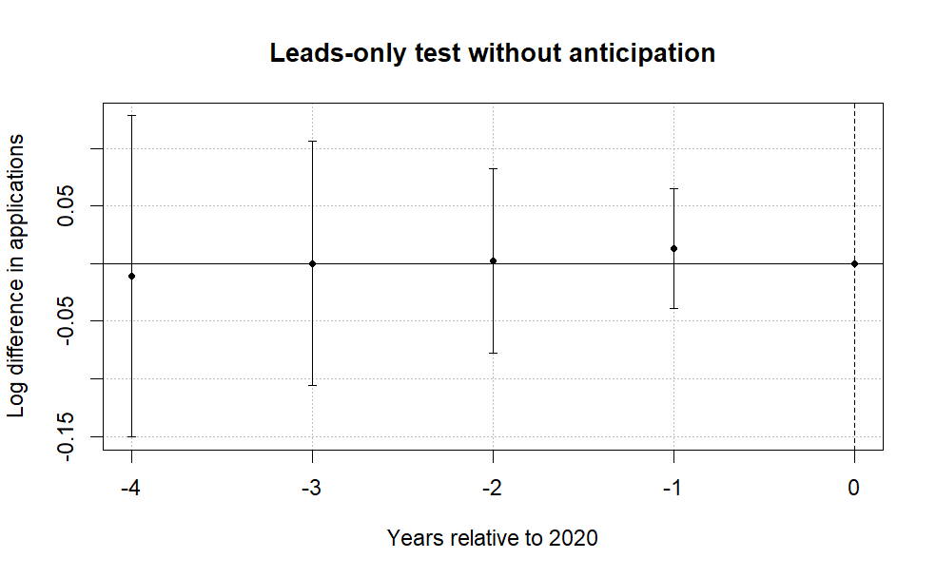
Note: The figure plots coefficients from a leads-only specification testing whether EU applications diverged from the synthetic control group prior to the Brexit tuition reform. The horizontal axis shows years relative to 2020, the last pre-treatment year. Points represent estimated differences in log applications and bars denote 95% confidence intervals clustered at the country level. The dashed vertical line marks the final pre-treatment year. The estimates display no systematic pre-treatment pattern, and a joint Wald test fails to reject the null that the early leads are jointly zero (p = 0.96), providing no strong evidence of anticipation effects.

To further assess identification, we implement two additional tests. First, a leads-only specification finds no evidence of anticipation effects, suggesting that applicants did not adjust behavior prior to the reform (Figure 2).
Finally, allowing for country-specific dynamic effects yields similar patterns: post-treatment coefficients are consistently negative across EU countries, while pre-treatment estimates remain close to zero (Figure 3). The only exception is Portugal, whose applications did not immediately collapse in 2021. This can be traced to a UCAS data reporting issue because in the 2021 cycle some Recorded Prior Acceptances (RPAs) were mistakenly submitted as domiciled in Portugal, so the true number of Portugal-domiciled RPAs is lower than the reported figure for that cycle (UCAS, 2022).
Figure 3. Saturated DiD event-study estimates by country.
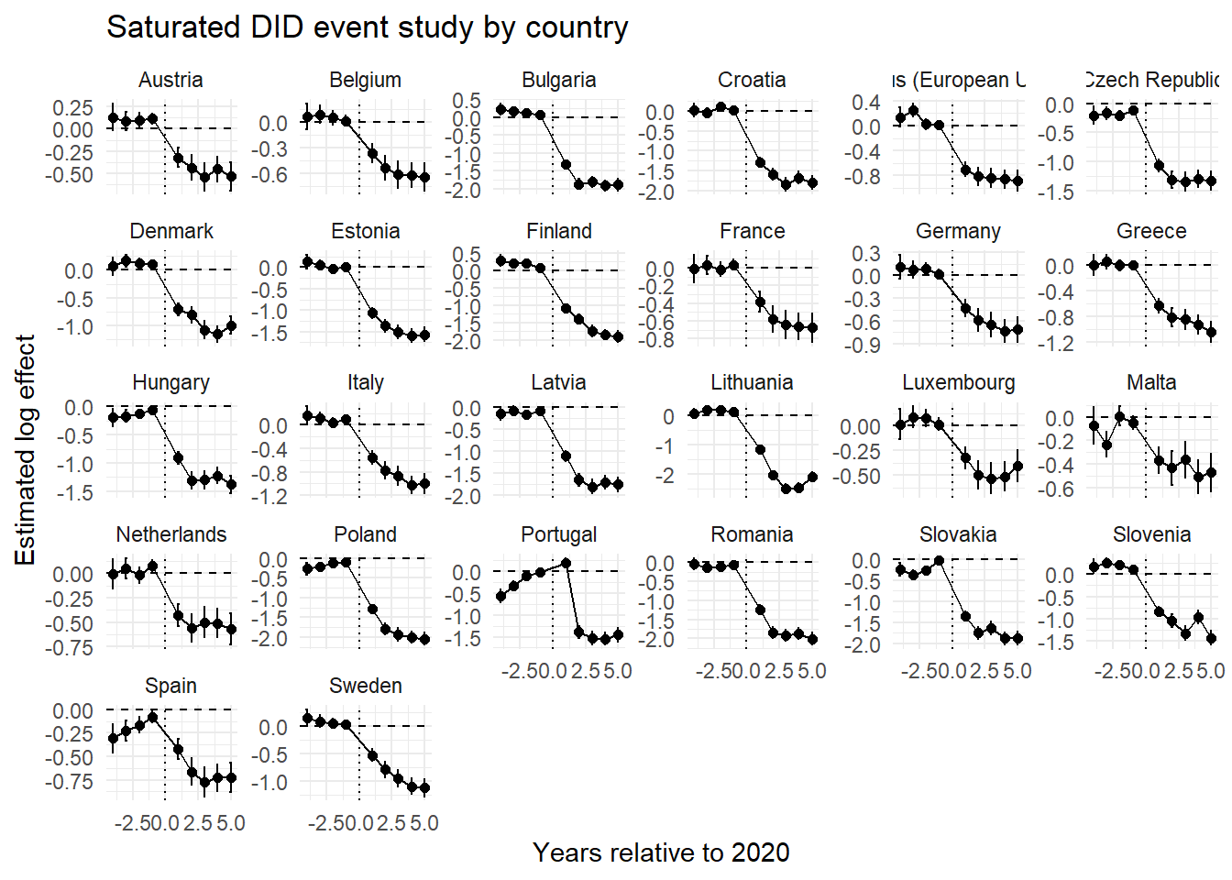
Note: Each panel reports country-specific dynamic treatment effects from the saturated difference-in-differences specification comparing EU countries with the pooled control group. Coefficients represent log differences in applications relative to the baseline year (2020). Error bars denote 95% confidence intervals. All results were completely replicated in Python and the output was the same.
  - Baseline elasticities estimates and the heterogenous k
Let $C$ denote the set of origin countries, partitioned into the treated EU markets such that $Ω⊂C$, with $J=|Ω|$, and the candidate donor pool $D=C\backslash Ω$ of non-EU markets. The empirical justification of the counterfactual European Union allows us to create a synthetic untreated group, enabling us to estimate the weighted saturated two-way DiD model:
$$\log{(A_{it})} = α_{i} + γ_{t} +\sum_{\begin{aligned}j∈Ω \\ \end{aligned}}^{ }{β_{j} \left(1\left\{i=j\right\}×Post_{t}\right)} +ρ^{'}X+ ε_{it}$$ | (2)
where ($A_{it}$) denotes applications from origin country ($i∈C$) in year ($t∈\left[2016, 2025\right]$), $1\left\{i=j\right\}$ is an indicator for EU member states, and $Post_{t}$ marks the introduction of the new tuition regime in 2021. The interaction coefficient ($β_{j}$) captures the magnitude of the country-specific collapse in applications under a homogeneous price shock, relative to the synthetic EU.
To distinguish between short-run and persistent effects, we further split the post-treatment period into two phases: 2021–2023, which captures the immediate response following the reform, and 2024 onward, which reflects longer-run adjustments. The specification becomes:
$$\begin{matrix}\log{(A_{it})} & = & α_{i} + γ_{t} + \sum_{\begin{aligned}j∈Ω \\ \end{aligned}}^{ }{β_{j} \left(1\left\{i=j\right\}×Pos{tBrexit}_{t}\right)} \\ & + & \sum_{\begin{aligned}j^{ }∈Ω \\ \end{aligned}}^{ }{σ_{j^{ }} \left(1\left\{i=j\right\}×Pos{tCovid}_{t}\right)}+ρ^{'}X+ ε_{it }\end{matrix}$$ | (3)
from here follows the interpretation of $β_{j}$ as the short-run country specific response (Brexit + COVID uncertainty) and${ σ}_{j^{ }}$ is the persistent structural response (pure willingness-to-pay shift). The difference $β_{j}-σ_{j^{ }}=ω_{j}$ provides the specific COVID impact on demand elasticities (mathematical proof for this in the supplementary materials).
We show in the supplementary materials that the $β_{j},$ with $j∈Ω$, coefficient can be mapped to a structural elasticity parameter through the following transformation (Bresnahan (1982) style):
$η_{j}=\frac{β_{j}}{k_{j}}$,
Where $η_{j}$ is the price elasticity (with expected negative sign due to the negative slope of the demand curve). To allow heterogeneous $k$’s, under the Plan 2 for the contingent student loan, graduates had to repay 9% of annual earnings above a statutory repayment threshold (UK Government, n.d.-a). For the relevant cohort, the repayment threshold is £27,295 per annum. Annual repayments are therefore defined as $R_{t}=0.09⋅\max{\{0,Y_{t}-τ\}}$ in which τ denotes the repayment threshold and Y_{t} follows a deterministic wage path with annual growth rate g. The loan is written off 30 years after the April in which repayment becomes due (UK Government, n.d.-b), implying a finite repayment horizon T=30 years. Interest accrues at the Retail Price Index (RPI) plus up to three percentage points, depending on income (UK Government, n.d.-c). Instead of replicating the full income-dependent interest schedule, we model the economic burden of the loan as the present value of expected repayments and discount repayment flows at a constant rate δ. The present value of the loan is therefore defined as:
$$PV_{loan}\left(w_{j}\right)=\max\left\{\sum_{t=1}^{30}{\frac{0.09⋅\max\left\{0,w_{j}{\left(1+g\right)}^{t-1}-τ\right\}}{{\left(1+δ\right)}^{t}}},1\right\}$$
In the baseline specification, we set $δ=3\%$ and $g=2\%$. The maximum operator is defined in this way so the logarithmic transformation will be defined even for zero valued present values of the income contingent loan. We set annual nominal wage growth to g=0.02, treating wages as growing at a conservative nominal rate anchored to the ECB’s symmetric 2% medium-term inflation target. The ECB’s Governing Council states that price stability is best maintained by aiming for 2% inflation over the medium term, with negative and positive deviations treated as equally undesirable (European Central Bank, 2021).
European Central Bank. (2021, July 8). ECB’s Governing Council approves its new monetary policy strategy. https://www.ecb.europa.eu/press/pr/date/2021/html/ecb.pr210708~dc78cc4b0d.en.html
We estimate the present value based on the average country specific wage ($w_{j})$ and $k$ becomes a function of the average wage:
$$k_{j}=\log{22200}-\log{PV_{loan}(w_{j})}$$
in this formula $PV_{loan}(w_{j})$ is the present value of the income contingent UK loan, £22,200 is the average post-Brexit price and $w_{j}$ is the average annual salary in Euro (for 2024).
Intuitively, the calculation can be read from the perspective of a student graduating in 2024. The student asks how much they would actually repay under the old income-contingent loan system, given their expected first post-graduation wage. We therefore use the 2024 wage as the starting point, project it forward over 30 years, calculate annual repayments under the loan rule, and discount those future repayments back to 2024. This gives the effective price of the old regime. Upon peer-review objections, we would like to mention that discounting the £22,200 price would be inappropriate in this setup because it would reclassify a current tuition obligation as if it were a deferred income-contingent repayment stream. The asymmetry is therefore institutional and not arbitrary. The old price is mediated through a future repayment contract, whereas the new price is a direct posted fee.
This step of discounting here is crucial because under the standard shift from 9250 pounds and no heterogeneity assumption $k$ is 0.875. Clifton-Sprigg (2025) assumes one unique price change (from the old price of 9250 to 22200) but the above equation allows us to relax this assumption. This extension is especially relevant in light of Solís’s (2017) findings that credit access leads to a 100 percent increase in immediate college enrollment and a 50 percent increase in the probability of ever enrolling.
We then relate these elasticities to observable economic fundamentals. Specifically, we estimate correlations of the form:
$$\frac{β_{j}}{k_{j}} = θ_{0} +γ\log\left(GDPpc_{j}\right)+X^{'}ρ+ u_{ }$$ | (4)
Where $ρ^{'}X$ is a list of country specific covariates that control for structural characteristics at the country level. This exercise documents that income strongly predicts the magnitude of the shock, consistent with a segmented higher-education market in which price sensitivity varies systematically with economic fundamentals.
- Results
  - Estimated baseline elasticities
Following the empirical strategy, Figure 4 reports country-specific elasticities derived from the difference-in-differences estimates. We translate the estimated treatment effects into implied demand responses to the Brexit tuition shock.
Figure 4. Decomposition of the post-Brexit demand elasticities by treated country.
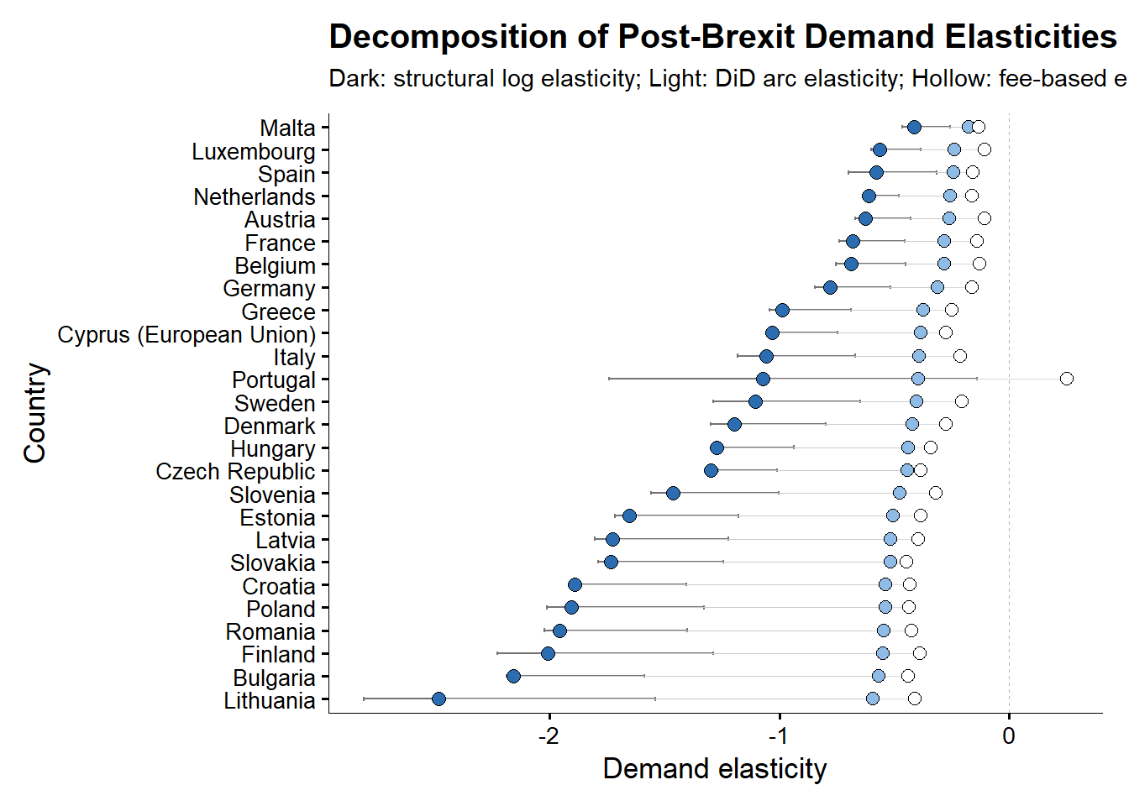
Note: The structural log elasticities are obtained from the division of the country-specific effect ($β_{j})$ by 0.875. The Arc elasticities are obtained by $\left(e^{β}-1\right)/1.4$ and the mechanical arc elasticities by $ΔApplications_{2020}^{2021}/1.40$. This graph was replicated both in Python and R and was the same across software implementations. The transformation of $e^{β}-1$ is valid only if the software is using logarithmic transformations in natural logarithms. Since R uses natural logarithms as default this transformation is safe. Used are Driscoll-Kraay (L=1) standard errors consistently and across all the presented models. Details in the online appendix.
The results indicate a large and widespread contraction in demand. Across EU countries, applications declined substantially following the introduction of international tuition fees, with estimated effects corresponding to reductions of roughly 30% (Malta) to the worst cases of 89% in Lithuania and 85% in Bulgaria, relative to the control group. The average effect implies a decline of approximately 66%. All DiD elasticities lie strictly below zero, confirming that the Brexit-induced tuition shock caused a contraction in EU demand for UK higher education across the entire Union. However, the magnitude of this response varies substantially. Wealthier EU countries such as Malta, Spain, Luxembourg, the Netherlands, and Austria cluster near elasticities between −0.42 and −0.6, indicating relatively inelastic demand. By contrast, lower-income EU countries – including Bulgaria, Romania, Lithuania, Croatia, and Latvia – exhibit elasticities below −2, with Lithuania approaching −3, indicating relatively elastic demand. This leads to the misleading interpretation that the demand in poorer countries is less resilient to tuition changes as well as that students from such countries are less “motivated” to apply. We later show that this is an incorrect interpretation.
This heterogeneity also aligns closely with cross-country differences in income. Regressing the estimated country-specific responses on GDP per capita reveals a strong positive relationship where wealthier countries experience smaller declines in applications (Figure 5). The strong positive relationship between GDP per capita and demand elasticity emerges only when elasticities are estimated using fixed effects specifications. This reflects the ability of the TWFE estimator to isolate the causal impact of the Brexit-induced tuition shock by removing both country-specific baseline differences and common time shocks. In contrast, pooled estimates conflate treatment effects with cross-country heterogeneity in levels and trends, obscuring the underlying relationship. As a result, the GDP gradient disappears when identification is not enforced. Furthermore, even when the elasticities are estimated with additional controls, included in the saturated DiD regression, the correlation with GDP per capita remains strong. This correlation appears to weaken only once $k_{j}$ ($δ=3\%$ and $g=2\%$) is assumed heterogeneous and dependent on the income contingent loans the EU students were previously exposed to. The direction of the previously positive gradient loses significance once k is made heterogeneous. (Figure 5).

Figure 5. Correlations between the DiD (FEs and No FEs elasticities) and logarithm of GDP per capita
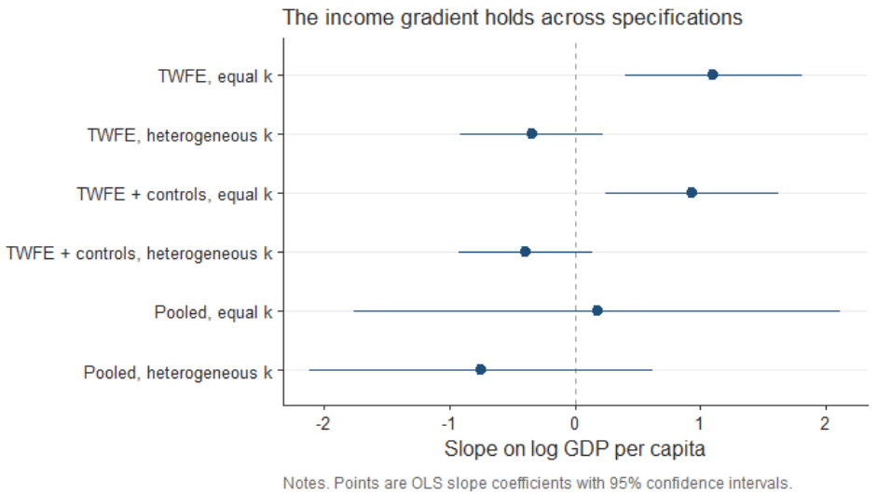

An important consideration is that the tuition reform altered not only nominal prices but also the availability of income-contingent loans. The baseline elasticity estimates, however, rest on the assumption that the Brexit reform generated a uniform effective price change across EU countries. We argue in the discussion section that this assumption is unlikely to hold, and that once it is relaxed, the cross-country pattern changes substantially. Details on the construction of elasticity measures and alternative definitions are provided in Appendix A.
  - Estimated COVID specific elasticities
Figure 6 compares the immediate post-Brexit demand elasticities with the persistent elasticities observed after pandemic disruptions had abated. The difference between the dots is consistent with the effect derived in the supplementary materials.
Figure 6. Post Brexit and post-COVID Demand elasticities compared on the same measurement axis.
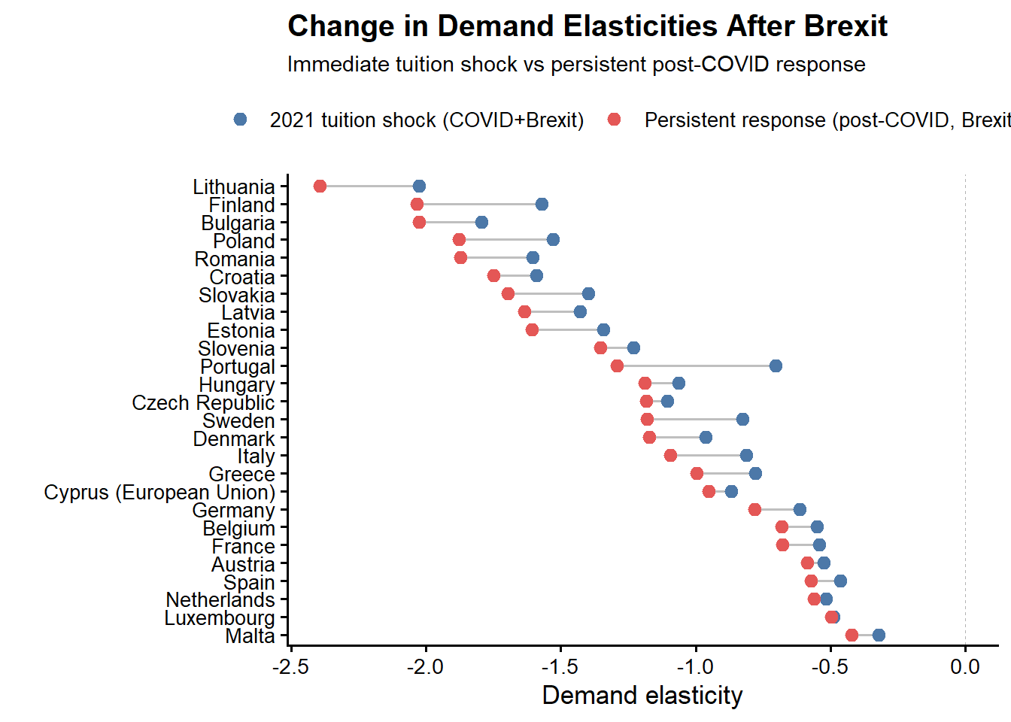
Note: Used are the naïve elasticities across all the models. The COVID coefficients are coded for the period 2021-2023, while 2024 to 2025 are assumed to be only the persistency effects of the Brexit tuition regime. Used are Driscoll-Kraay (L=1) standard errors consistently and across all the presented models. Details in the online appendix.

It is also important to mention that for nearly all EU origin countries, the persistent post-COVID elasticities remain strongly negative and closely aligned with the initial post-2021 estimates. The persistence of the elasticities confirms that price sensitivity, rather than short-run volatility, is the dominant mechanism behind the observed demand contraction.
For higher-income EU countries, elasticities become slightly less negative once COVID effects dissipate, suggesting partial normalization of demand at the margin. In contrast, for lower-income EU countries, elasticities remain highly elastic especially in the post-COVID period, with little evidence of recovery (the gap between the post-COVID and the Brexit elasticity appears to widen more for poorer countries).
  - ATT wealth heterogeneity
Table 3. ATE coefficient and interactions. FEs are always entity and time. Standard errors are Driscoll & Kraay (1998) (L=1)
 | (I) | (II) | (III) | (IV) | (V)
$$ATT$$ | -1.109*** | -1.093*** | -1.019*** | -1.006*** | -1.168***
 | (0.098) | (0.099) | (0.088) | (0.082) | (0.096)
$$c_log{(GDPpc)}$$ |  | -0.344* | -0.111 | -0.150 | -0.002
 |  | (0.127) | (0.120) | (0.144) | (0.089)
$$c_\log{(Pop16_54)}$$ |  |  | 2.989*** | 3.125*** | 2.462***
 |  |  | (0.314) | (0.355) | (0.271)
$$c_YU$$ |  |  |  | -0.011** | -0.008*
 |  |  |  | (0.003) | (0.003)
$$ATT×c_\log{(GDPpc)}$$ |  |  |  |  | 0.477***
 |  |  |  |  | (0.062)
$$ATT×c_\log{(Pop16_54)}$$ |  |  |  |  | 0.086***
 |  |  |  |  | (0.014)
$$ATT×c_YU$$ |  |  |  |  | 0.004
 |  |  |  |  | (0.007)
Obs. | 520 | 520 | 520 | 520 | 520
R2 Adj | 0.957 | 0.957 | 0.964 | 0.964 | 0.972
R2 Within | 0.585 | 0.593 | 0.654 | 0.660 | 0.731

Note: Models (I) through (V) are estimated with the standard TWFE estimator. The data is sourced from the World Bank API resources giving 520 observations (52 countries over the 2016 to 2025 window). The c_log variables are demeaned before being included in the regression so the interactions with the ATT in model (V) will be comparable. The formula used for the demeaning was $\log\left(x_{i}\right)-\overline{\log\left(x_{i}\right)}$ removing the entire cross-sectional mean, not the within-group one, which allows the entity fixed effects to retain their original meaning. Used are Driscoll-Kraay (L=1) standard errors consistently and across all the presented models. Details in the online appendix.

Table 3 reports regressions that relate the magnitude of the Brexit demand shock to country-level economic characteristics. Across all specifications, the baseline effect remains large, negative, and statistically significant, confirming a substantial contraction in EU demand following the tuition reform. At the same time, there is clear evidence of heterogeneity. The interaction between the Brexit treatment and GDP per capita is positive and statistically significant, indicating that higher-income countries experience smaller declines in applications. This is consistent with lower price sensitivity in wealthier contexts.
Labor market conditions also play an important role. The interaction with youth unemployment is positive and significant, suggesting that weaker labor market prospects attenuate the decline in applications. When employment opportunities for young cohorts deteriorate, studying abroad becomes a relatively more attractive option, reducing the responsiveness to higher tuition fees. By contrast, demographic factors such as population size do not materially affect the results and provide limited explanatory power.
Figure 7. Saturated DiD specifications with macroeconomic controls added. Namely GDP per capita (constant prices), population and the percentage of youth unemployment as separate models.
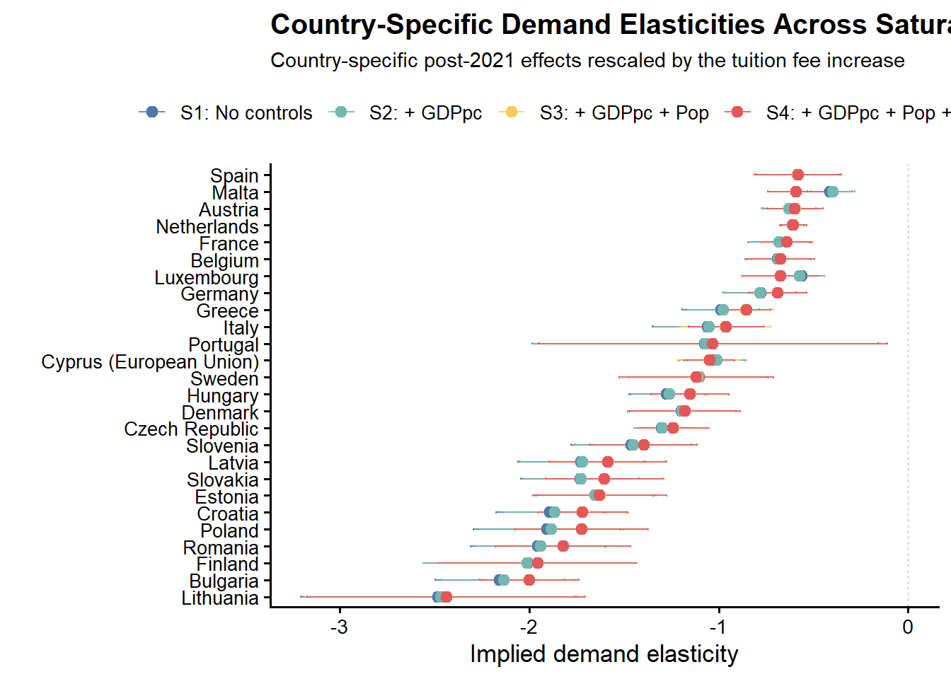
Note: All saturated models use the demeaned version of the free covariates – namely, the GDP per capita, the population and the youth unemployment. Used are Driscoll-Kraay (L=1) standard errors consistently and across all the presented models. Details in the online appendix.
- Robustness
  - Control group robustness
We assess the robustness of the baseline results mainly against the choice of the control group. This is because previous work has already confirmed that (Clifton-Sprigg et al. (2025)):
- The Brexit shock was indeed a valid quasi-experiment with stable pre-trends
- There were no anticipation effects and no major spillovers from the Brexit referendum in 2016
- Clifton-Sprigg even performed a robustness exercise by using the Croatian case that in itself created quasi-experimental evidence when the country joined the Union.
What remains is to ensure that the result is not dependent on the choice of the control group and that, regardless of its construction, we should not expect grossly different results on average. To achieve that goal, we construct four alternative control groups to our own, namely very poor countries (14 in total), very rich countries (13 in total), only OECD countries (14 in total), and Ireland as a single-country comparison. The three multi-country compositions are described in further detail in Table 4.

Table 4. Sample compositions for the alternative control groups
 | Poor | Rich | OECD
Control group composition | Pakistan, Nepal, Bangladesh, Ethiopia, Uganda,  Tanzania, United Republic of, Rwanda, Mozambique, Malawi,  Sierra Leone, Ghana, Nigeria, Kenya, Zimbabwe | United States of America, Canada, Australia, Norway, Switzerland,  Singapore, Qatar, United Arab Emirates, Kuwait, Saudi Arabia,  Israel, Japan, Hong Kong | Australia, Canada, Chile, Colombia, Iceland, Israel, Japan,  Korea, Republic of, Mexico, New Zealand, Norway, Switzerland,  Turkey, United States of America
EU group | 26
Observations | 400 | 390 | 400
Note: To avoid the proliferation of too many tables detailed statistical description of the used groups is provided in the supplementary materials section.
Since under this new design the construction of the control group is not based on constrained optimization we use the following formula for the weighting of the counterfactual:
$$w_{j}=\frac{\frac{1}{d_{j}+0.001}}{\frac{1}{J}\sum_{k=1}^{J}{\frac{1}{d_{k}+0.001}}}$$

where $d_{j}=\sqrt{\frac{1}{T}{\sum_{t<2021}^{ }{\left(\log\left(A_{jt}\right)-\overline{\log\left(A_{t}^{EU}\right)}\right)}}^{2}}$. The results are presented in Figures 8 and 9 for the ATT and the country-specific responses, respectively.

Figure 8. Robustness of the Brexit effect across alternative control-group definitions (pooled DiD estimates).

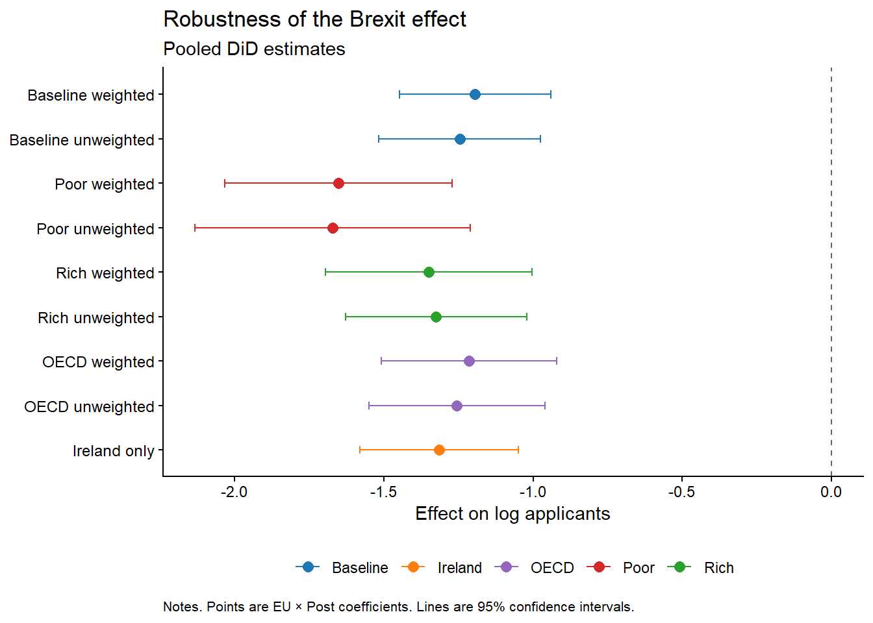
Note: Points are EU × Post coefficients from the pooled difference-in-differences specification; horizontal bars denote 95% confidence intervals. Baseline is the synthetic donor pool used in the main specification; Poor, Rich, and OECD are the alternative control groups described in Table 4, each shown weighted and unweighted; Ireland is a single-country comparison.
Figure 9. Saturated difference-in-differences robustness across control-group specifications.

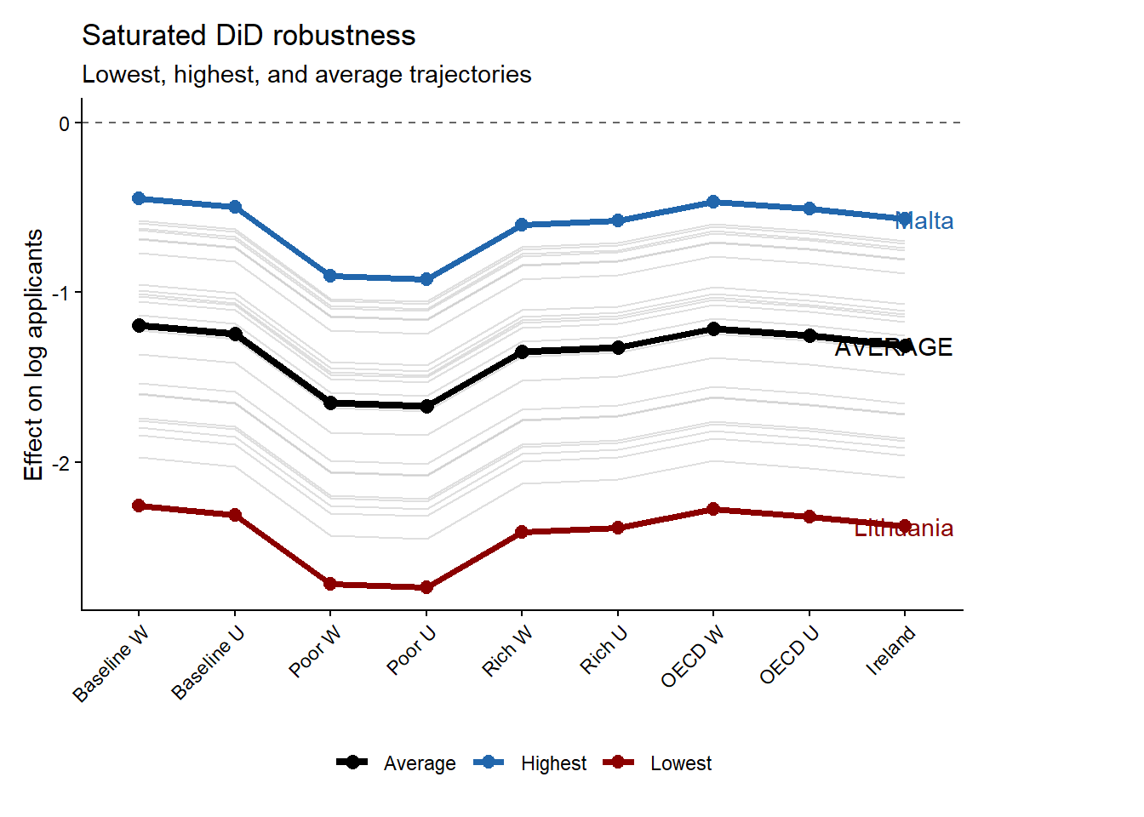
Note: Grey lines show country-specific dynamic treatment trajectories under each alternative control-group specification; the black line marks the cross-specification average. Malta (blue) and Lithuania (red) mark the upper and lower bounds of the estimated effects.

The robustness exercises on Figures 8 and 9 show that the estimated Brexit effect is not an artifact of a particular donor-pool construction. Across all alternative control groups, the coefficient on EU × Post remains large, negative, and far from zero. Whether the control group is built from the baseline synthetic donor pool, OECD countries, high-income countries, low-income countries, or Ireland alone, the estimated collapse in EU applications remains of similar order of magnitude. The point estimates move because each donor pool implies a different untreated benchmark, but none of the alternative specifications changes the substantive conclusion.
The poor-country control group generates the most negative estimates. This is informative because it shows that the decline is not a generic post-pandemic fall in applications from low-income origins. If that were the mechanism, low-income non-EU countries should absorb much of the EU decline and push the coefficient toward zero. The Ireland-only specification is also useful as a diagnostic. Ireland is deeply connected to the UK higher-education market through language, proximity, and institutional familiarity, so it provides a demanding comparison. It is also the only EU country not affected by the shift in tuitions. If the result were driven by common shocks to nearby or culturally connected markets, the comparison with Ireland should substantially weaken the estimate. It does not. The estimate remains close to the other robustness results, reinforcing the interpretation that the post-2021 break reflects the EU-specific loss of Home Fee status and loan access. Figure 9 also strengthens the robustness of the main results by showing that the ranking of the post-Brexit responses is preserved regardless of the chosen baseline. Another important point is that the weighting of the control group appears to affect the final estimates only at the margin, providing robust evidence that both the order and the magnitude of the collapse were stable enough for the inferences made in this paper. As a further check that does not rely on the constrained donor weights, we estimate the average treatment effect on the full donor pool with the standalone synthetic difference-in-differences estimator of Arkhangelsky et al. (2021). The estimator returns an ATT of -1.23 (jackknife standard error 0.10, with a 95% confidence interval from -1.43 to -1.02), which falls squarely within the range of the pooled and saturated estimates reported above and confirms that the headline collapse in EU applications does not hinge on how the counterfactual is weighted.

  - $k_{j}$ robustness
A natural objection to the loan correction is mechanical. Because the loan-adjusted price change $k_{j}$ falls with income, dividing the estimated effect ${\hat{β}}_{j}$ by $k_{j}$ will attenuate any income gradient almost automatically, so the collapse of the gradient could reflect nothing more than division by an income-correlated quantity and not necessarily the economic content of the loan. To separate these, we construct a placebo denominator that carries the income dependence of $k_{j}$ but none of its structure. We take log wages as a pure monotone income signal, with no repayment threshold, no finite horizon, and no discounting, and rescale it by a min-max transformation onto the exact range spanned by the real $k_{j}$. Writing the rescaling explicitly:
$$k_{j}^{placebo}=\left[\frac{\log{w_{j}}-\min\left(\log{w_{i}}\right)}{\max{(\log{w_{i}}})-\min{(log{w_{i}})} }\right]×\left(\max{k_{i}}-\min{k_{i}}\right)+\min{k_{i}}$$
By construction, $k_{j}^{placebo}$ spans the identical interval to $k_{j}$, with its minimum and maximum pinned to $\min{k_{i}}$ and $\max{k_{i}}$, so the two denominators differ only in how they map income onto that interval and not in scale. The real $k_{j}$ bends through the present value of the income-contingent loan, saturating at higher incomes as graduates repay the full principal, whereas $k_{j}^{placebo}$ rises monotonically in log income without saturating. We then form placebo elasticities ${\hat{β}}_{j}$ divided by $k_{j}^{placebo}$ and re-estimate the income gradient.
The results isolate the loan mechanism. Under a common price change the gradient is steep and significant ($γ$= 1.11, p = 0.001, n=25). Under the real loan-adjusted $k_{j}$ it flattens to insignificance ($γ$ = -0.35, p = 0.27, with a confidence interval spanning zero, n=25). Under the placebo income-only denominator, rescaled to the same range, the gradient remains steep and significant ($γ$ = 0.87, p = 0.038. n=25). A monotone income divisor therefore does not reproduce the collapse. What dissolves the income gradient is not division by an income-correlated quantity in general, but specifically the curvature the income-contingent loan imposes on the effective price change, in particular its saturation at higher expected earnings. This is direct evidence that the loan-valuation channel, not the mechanical income rescaling, drives the disappearance of the income gradient and it serves as the most fundamental defence of the general mechanism presented here.
Another criticism faced during peer review is the sensitivity of the present value calculation to changes in the calibrated parameters. To address this, we recompute the present values and reestimate the correlations with the following loan-correction mechanisms. This is shown in Figure 10. When the interest rate is allowed to vary, the insignificant wealth correlation gradually diminishes as the interest rate rises. This is mainly because the negative coefficient also increases in magnitude, while the standard errors remain largely unchanged, which is exactly the point, as the income correlation appears to change direction when the treatment is left heterogeneous. The correlation is also significant when the annual wage growth rate is around 1%, with the coefficient extremely negative (starting at -0.722 at a growth rate of 0%), and standard errors largely unchanged. Alternatively, as earnings increase further, the correlation slowly reverses sign, becoming positive but still insignificant. At a wage growth rate of around 4%, the slope is now positive at 0.291 but insignificant.
Figure 10. Sensitivity of the loan-corrected income gradient to the discount rate and wage growth rate assumptions.

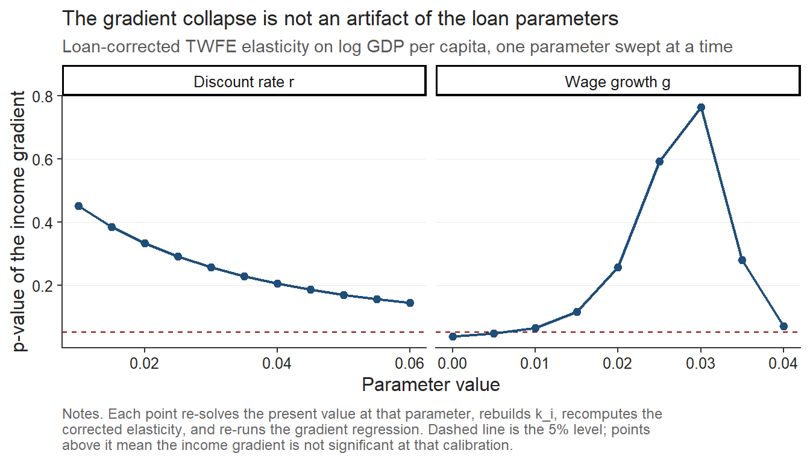
Note: The figure plots the estimated correlation (γ) between the loan-corrected elasticity and log GDP per capita as the discount rate (δ) and the annual wage growth rate (g) are varied around their baseline calibration (δ = 3%, g = 2%), holding all other parameters at the values described in the main text. GDP data is from 2022.

  - Variance-covariance estimator concerns and Rambachan-Roth parallel-trends checks
Upon more peer review concerns we also repeat the results from the standard parallel trends tests in early sections through the HonestDID package and we also reestimate the variance covariance matrices with bootstrapped cluster estimations in the online appendix section.
- Discussion
  - Were poor EU students really priced out because of elastic demand?
A natural interpretation of the results is that students from lower-income EU countries exhibit more elastic demand for UK higher education. However, this interpretation relies on the assumption that the tuition reform generated the same effective price change across countries. In practice, this assumption is unlikely to hold. Prior to Brexit, tuition was financed through income-contingent loans, meaning that the relevant economic price depended on expected future earnings rather than the nominal fee. As a result, the removal of these loans likely generated larger effective price increases for applicants from lower-income countries.
To illustrate how elasticities, depend on loan valuation, we compute implied elasticities using the average treatment effect coefficient $β=-1.08$ and map it across a range of starting income levels (Figure 11). When the loan is expected to have a low present value (e.g., for applicants with low expected earnings), the Brexit reform constitutes a large effective price shock, and the implied elasticity is mechanically smaller in magnitude (approximately −0.4). Conversely, when the loan’s present value approaches its nominal amount (high expected earnings), the effective price shock is smaller, and the implied elasticity is larger in magnitude
Figure 11. Implied demand elasticity as a function of the economic value of the UK student loan.
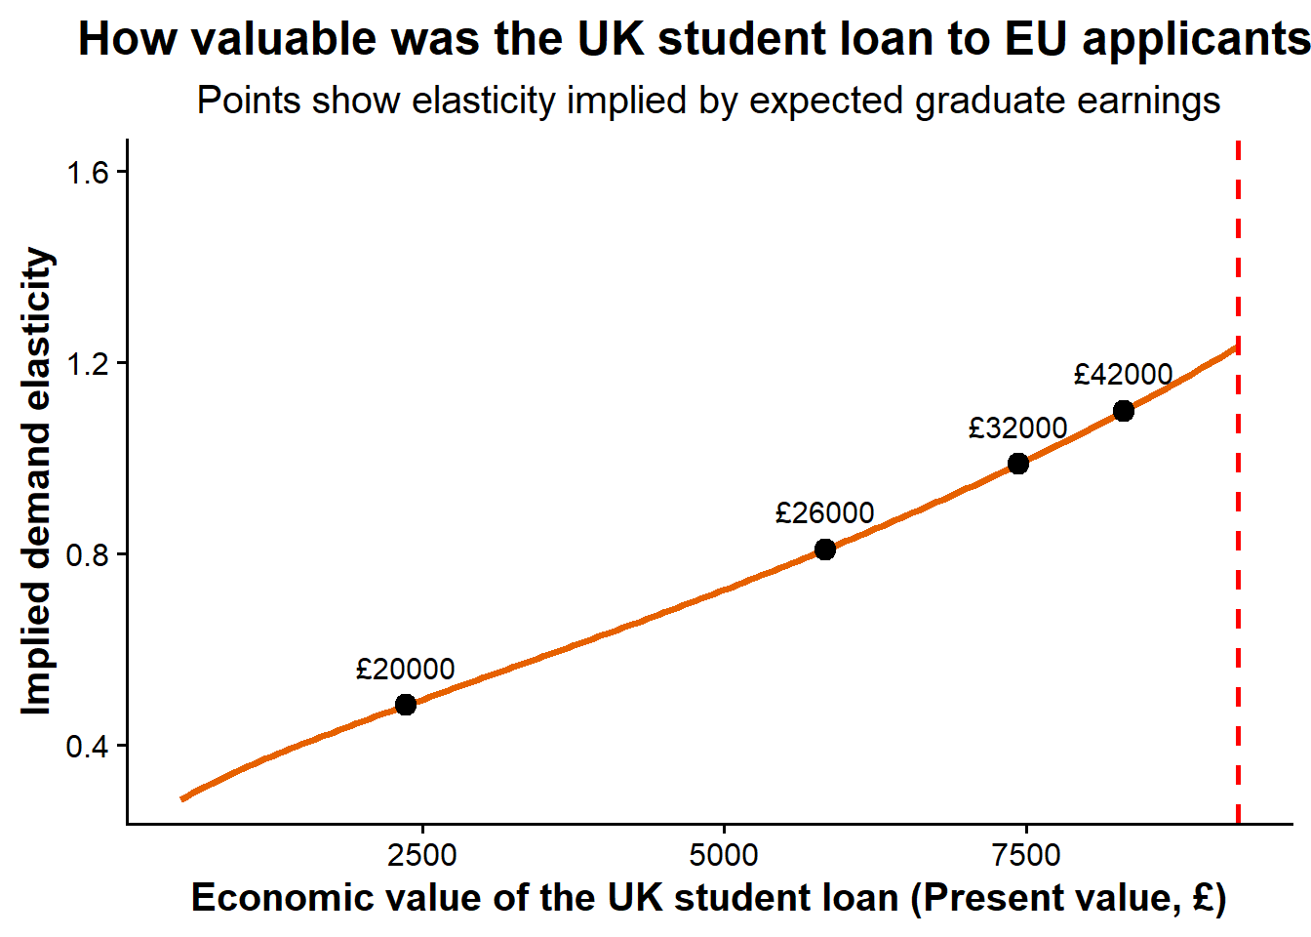
Note: The figure translates the estimated treatment effect into implied demand elasticities under different assumptions about the present value of the UK student loan to EU applicants. Points correspond to elasticity estimates implied by alternative expected graduate earning scenarios.
To examine whether structural heterogeneity in demand persists after accounting for this mechanism, we define corrected elasticities as $η_{j}^{'}=β_{j}{/k}_{j}$. As we mentioned earlier, dividing by heterogeneous $k_{j}$removes the portion of elasticity variation that is mechanically induced by differential effective price shocks. We showed that after recomputing the elasticities using heterogeneous price changes across the Union, we re-estimated the correlation with GDP per capita. Figure 12 shows the exact ways in which the point estimates changed from the old fixed $k$ to the new loan corrected $k$. For simplicity we kept the main assumption of $δ=0.03,$ the repayment rate above threshold as 9%, the nominal wage growth at 2% and the repayment horizon at 30 years. In the robustness section we showed that the result is robust to changes in the interest rate and growth rates.

Figure 12. Income gradient in demand elasticity.
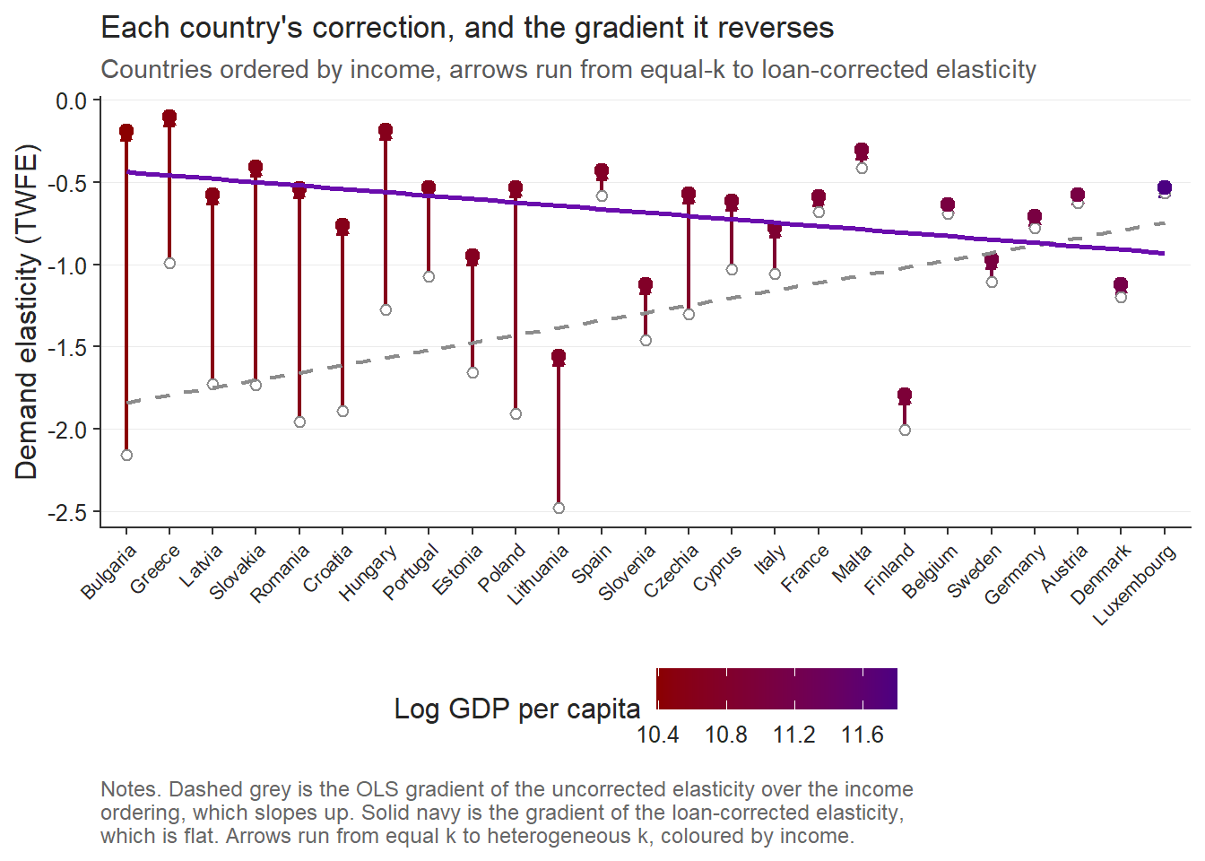
Note: The figure compares baseline elasticity estimates with elasticities corrected for heterogeneous loan value across countries. The horizontal axis shows log GDP per capita (PPP). Lines represent fitted linear relationships.

Figure 12 shows that before correcting for heterogeneous treatment intensity, demand elasticities display a strong and statistically significant positive relationship with origin-country income ($γ$ = 1.11, p = 0.004, Figure 12). However, once elasticities are rescaled using country-specific effective price shocks derived from the present value of the income-contingent loan, the income gradient collapses, becomes statistically indistinguishable from zero ($γ$ = −0.345, p = 0.12). As we established in the robustness section, the difference between the two income gradients indicates that a substantial portion of the observed cross-country heterogeneity reflects variation in treatment intensity rather than structural differences in preferences.
After this correction, countries such as Finland, Denmark, Slovenia, Germany, and Luxembourg display the largest elasticities. These are precisely the countries with substantial high-quality domestic alternatives, where UK higher education is one option among many and demand can adjust readily to a price change. Applicants from lower-income EU countries, by contrast, face fewer high-quality domestic alternatives and may view UK education as a pathway to substantially higher lifetime earnings; their application behavior is therefore less responsive to tuition increases than raw demand responses would suggest.
From a political perspective, the decline in applications from poorer EU countries reflects the withdrawal of an institution that had quietly equalized opportunity across Europe. The UK’s income-contingent loan system meant that students did not need to arrive with wealth; they needed only the expectation of future effort and earnings. When that system disappeared for EU applicants, the effective cost of studying in the UK rose dramatically for those from poorer economies. What appears in the data as “elastic demand” is therefore better understood as the sudden loss of a mechanism that had allowed talent to travel across borders without the constraint of immediate financial means. In that sense, the Brexit tuition reform did not simply reveal price sensitivity – it exposed how fragile educational mobility can be when the institutions that support it are removed.

  - What are the real determinants of the corrected elasticity?
Figure 13. Alternative correlations between the corrected income elasticity and macroeconomic fundamentals.
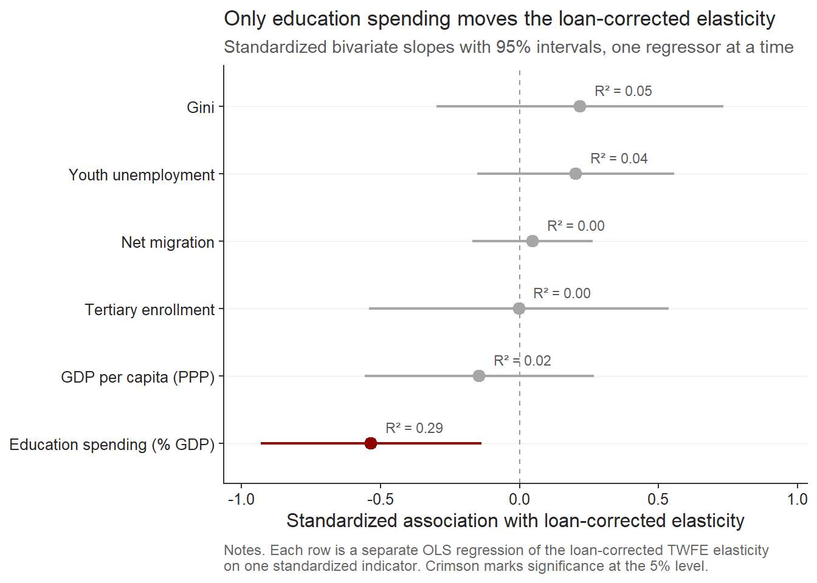
Note: Performed is simple cross-sectional OLS with HC1 robust standard errors. World bank data is from the year 2022.

Figure 13 shows that most standard macroeconomic indicators explain little the residual variation in the new rescaled elasticities. GDP per capita, tertiary enrollment, net migration, youth unemployment, and inequality all have wide confidence intervals crossing zero and very low explanatory power. This is important because it means that the corrected elasticity is no longer simply a disguised income measure. Once the loan channel is removed, richer countries are not systematically more or less responsive to the tuition shock.
Surprisingly, the only variable that clearly moves the loan-corrected elasticity is education spending as a share of GDP. Its coefficient is negative and statistically significant, with the largest explanatory power among the tested covariates. Substantively, this suggests that countries investing more heavily in education display stronger residual price responsiveness to UK tuition increases. This result also changes the interpretation of post-Brexit heterogeneity.
Before the correction, poorer countries appeared to have the most elastic demand because their observed application declines were largest relative to a uniform nominal fee shock. After correcting for the unequal value of the lost loan, the remaining elasticity is better explained by the structure of educational opportunity, not by national income itself. This result therefore points toward a two-stage mechanism. The raw collapse in applications from lower-income EU countries reflects the removal of an equalizing credit institution. The remaining variation in corrected elasticities reflects substitution possibilities created by national education systems. Brexit first removed the financial bridge that allowed students from poorer economies to access UK higher education. After that correction is made, the strongest determinant of residual responsiveness is whether the origin country already invests enough in education to make exit from the UK market easier.
Ultimately, this is a sovereignty argument. Countries that invest in their own systems give their students exit options, which mechanically makes those students look price-sensitive to UK tuition, not because they're poorer or more fragile but because they're not captive. That inverts the usual read entirely. The "resilient" applicants from poor countries with high measured elasticity-after-correction aren't fragile, they're the ones with somewhere else to go.

References
Arel-Bundock, V. (2022). WDI: World Development Indicators and other World Bank data (R package version 2.7.8) [Computer software]. https://CRAN.R-project.org/package=WDI
Arel-Bundock, V., Enevoldsen, N., & Yetman, C. J. (2018). countrycode: An R package to convert country names and country codes. Journal of Open Source Software, 3(28), 848. https://doi.org/10.21105/joss.00848
Arkhangelsky, D., Athey, S., Hirshberg, D. A., Imbens, G. W., & Wager, S. (2021). Synthetic difference-in-differences. American Economic Review, 111(12), 4088–4118. https://doi.org/10.1257/aer.20190159
Bound, J., Lovenheim, M. F., & Turner, S. (2010). Why have college completion rates declined? American Economic Journal: Applied Economics, 2(3), 129–157. https://doi.org/10.1257/app.2.3.129
Bresnahan, T. F. (1982). The oligopoly solution concept is identified. Economics Letters, 10(1–2), 87–92. https://doi.org/10.1016/0165-1765(82)90121-5
Brown, R. (2011). After Browne: The new competitive regime for English higher education (CSHE Research & Occasional Paper Series No. CSHE.5.10). Center for Studies in Higher Education, University of California, Berkeley. https://escholarship.org/uc/item/9569q5n5
Calhoun, C. (2017). Populism, nationalism and Brexit. In W. Outhwaite (Ed.), Brexit: Sociological responses (pp. 57–76). Anthem Press. Stable link: https://calhoun.faculty.asu.edu/sites/g/files/litvpz3321/files/publications/articles/populism_brexit.pdf
Campbell, R., & Siegel, B. (1967). The Demand for higher education in the United States, 1919–1964. American Economic Review, 57(3), 482–494. Stable link: https://www.jstor.org/stable/1812115
Clifton-Sprigg, J., Homburg, I., Huyghe, A., & Vujić, S. (2025). International student migration: Did Brexit close the door to EU students? (IZA Discussion Paper No. 18178). IZA Institute of Labor Economics. Stable link: https://www.iza.org/publications/dp/18178/international-student-migration-did-brexit-close-the-door-to-eu-students
Cuibus, M., & Walsh, P. W. (2024). Student migration to the UK. Migration Observatory Briefing, COMPAS, University of Oxford. https://www.migrationobservatory.ox.ac.uk
Driscoll, J. C., & Kraay, A. C. (1998). Consistent covariance matrix estimation with spatially dependent panel data. Review of Economics and Statistics, 80(4), 549–560. https://doi.org/10.1162/003465398557825
Dwenger, N., Storck, J., & Wrohlich, K. (2012). Do tuition fees affect the mobility of university applicants? Evidence from a natural experiment. Economics of Education Review, 31(1), 155–167. https://doi.org/10.1016/j.econedurev.2011.10.004
Eurostat. (2025). Average full-time adjusted salary per employee [Data set]. https://doi.org/10.2908/NAMA_10_FTE
Findlay, A., King, R., Stam, A., & Ruiz-Gelices, E. (2006). Ever reluctant Europeans: The changing geographies of UK students studying and working abroad. European Urban and Regional Studies, 13(4), 291–318. https://doi.org/10.1177/0969776406065429
Heller, D. E. (1997). Student price response in higher education: An update to Leslie and Brinkman. Journal of Higher Education, 68(6), 624–659. Stable link: https://www.jstor.org/stable/2959966
Hemelt, S. W., & Marcotte, D. E. (2011). The impact of tuition increases on enrollment at public colleges and universities. Educational Evaluation and Policy Analysis, 33(4), 435–457. https://doi.org/10.3102/0162373711415261
Hoxby, C. M. (1997). How the changing market structure of U.S. higher education explains college tuition (NBER Working Paper No. 6323). National Bureau of Economic Research. Stable link: https://www.nber.org/system/files/working_papers/w6323/w6323.pdf
Leslie, D. (2003). Using success to measure quality in British higher education: Which subjects attract the best-qualified students? Journal of the Royal Statistical Society: Series A (Statistics in Society), 166(3), 329–347. https://doi.org/10.1111/1467-985X.00280
Leslie, L. L., & Brinkman, P. T. (1987). Student price response in higher education: The student demand studies. Journal of Higher Education, 58(2), 181–204. https://doi.org/10.1080/00221546.1987.11778239
Locke, W., & Marini, G. (2021). The rapid increase in faculty from the European Union in UK higher education institutions and the possible impact of Brexit. In F. Huang & A. R. Welch (Eds.), International faculty in Asia (Vol. 21). Springer. https://doi.org/10.1007/978-981-33-4980-3_12
Luthra, R. R. (2020). Mitigating the hostile environment: The role of the workplace in EU migrant experience of Brexit. Journal of Ethnic and Migration Studies, 47(1), 190–207. https://doi.org/10.1080/1369183x.2020.1726173
Macdonald, C., & Stratta, E. (2001). From access to widening participation: Responses to the changing population in higher education in the UK. Journal of Further and Higher Education, 25(2), 249–258. https://doi.org/10.1080/03098770120050909
Mayhew, K. (2022). Brexit and UK higher education. Oxford Review of Economic Policy, 38(1), 179–187. https://doi.org/10.1093/oxrep/grab043
McFadden, D. (1974). Conditional logit analysis of qualitative choice behavior. In P. Zarembka (Ed.), Frontiers in econometrics (pp. 105–142). Academic Press. Stable link: https://eml.berkeley.edu/reprints/mcfadden/zarembka.pdf
Neville, R., Rowe, F., & Singleton, A. (2024). Unraveling the Brexit–COVID-19 nexus: Assessing the decline of EU student applications into UK universities. Data & Policy, 6, Article e45. https://doi.org/10.1017/dap.2024.42
Sá, F. (2014). The effect of tuition fees on university applications and attendance: Evidence from the UK (IZA Discussion Paper No. 8364). Institute for the Study of Labor (IZA). https://ftp.iza.org/dp8364.pdf
Savoca, E. (1990). Another look at the demand for higher education: Measuring the price sensitivity of the decision to apply to college. Economics of Education Review, 9(2), 123–134. https://doi.org/10.1016/0272-7757(90)90040-C
Solís, A. (2017). Credit access and college enrollment. Journal of Political Economy, 125(2), 562–622. https://doi.org/10.1086/690829
UCAS. (2022). UCAS undergraduate sector-level end of cycle data resources 2021 [Data set]. https://www.ucas.com/data-and-analysis/undergraduate-statistics-and-reports/ucas-undergraduate-sector-level-end-of-cycle-data-resources-2021
UK Government. (n.d.-a). Repaying your student loan: What you pay. GOV.UK. https://www.gov.uk/repaying-your-student-loan/what-you-pay
UK Government. (n.d.-b). When your student loan gets written off or cancelled. GOV.UK. https://www.gov.uk/repaying-your-student-loan/when-your-student-loan-gets-written-off
UK Government. (n.d.-c). How interest is calculated (Plan 2). GOV.UK. https://www.gov.uk/guidance/how-interest-is-calculated-plan-2
World Bank. (2025). World Development Indicators [Data set]. https://databank.worldbank.org/source/world-development-indicators

