The Brexit Tuition Shock and the Price Elasticity of International Students: Evidence from a Natural Experiment
Stoycho Rusinov*
James Rafiki Aketch**
*Center for the Study of Democracy, Sofia
New Bulgarian University, Department of Informatics
email: stoycho.rusinov@csd.eu

**School of Economics, University College Dublin

ABSTRACT
This paper estimates the price elasticity of EU demand for UK higher education, using the Brexit-induced loss of Home Fee status and student-loan access as a quasi-experimental tuition shock. Unlike standard demand studies that rely on enrollment outcomes, the analysis uses UCAS application data, so demand is observed before universities ration admissions. The average post-Brexit treatment effect implies a decline in applications of roughly 67 percent, with country-specific elasticities varying substantially across the EU. Initial estimates suggest applicants from lower-income member states were more price elastic, while wealthier countries saw smaller contractions. Once elasticities are rescaled using country-specific effective price shocks that account for the removal of income-contingent loans, the income gradient collapses and becomes statistically indistinguishable from zero. Much of the apparent cross-country heterogeneity therefore reflects heterogeneous treatment intensity, not stable differences in underlying preferences. The UK student-loan system functioned as an equalizing institution for European educational mobility, and its removal turned a nominally uniform tuition reform into a highly uneven economic shock across EU origin countries. The loan-adjusted elasticities correlate strongly with the share of GDP allocated to educational investment.

JEL codes: I22; I23; F22; J61; D12; C23
Keywords: Brexit; international student mobility; higher education demand; tuition fees; price elasticity; EU students; UCAS applications; difference-in-differences; synthetic control; income-contingent loans; educational mobility; heterogeneous treatment effects.

- Introduction

International higher-education demand studies struggle to isolate own-price elasticity because elasticity calculations typically rely on enrollment changes in response to price shifts, lack sufficient exogenous price variation to isolate the coefficient or suffer both problems at once. Many estimates of the price elasticity of college enrollment “treated the application decision as exogenous, focusing only on how price affects the college-going behavior of admitted applicants” (Savoca, 1990), and so “ignored the possibility that a tuition change affects enrollment through the applicant pool” itself (p. 127). Standard demand models using enrollment data therefore conflate the desire to attend with the university’s choice to admit. Similar problems have proliferated across studies such as McQuone and Simons (2025), which extend Conlon et al. (2021) and produce elasticities too small to explain the collapse in non-EU applications after the 2021 Brexit-related tuition hikes in the United Kingdom.
To address the previously mentioned concerns – related to both the absence of exogenous variation in tuition and enrollment as a bad proxy of demand – we treat the total number of Universities and Colleges Admissions Service (UCAS) applicants from each domicile as expressed domicile level demand before universities ration places. Consequently, applications in this design are observed before admission decisions and subsequent rationing affects offers and enrolment. Therefore, identification comes from within-country changes over time and from the exogenous Brexit shock. The loss of Home Fee status and loan access was imposed by external policy, not chosen by universities, making the change in effective prices plausibly exogenous to institution-level demand. Because the financial consequences varied across origin countries, Brexit generated heterogeneous price variation that identifies causal price elasticities at the origin-country level, which in turn recover country-specific constant-elasticity demand functions around pre-Brexit price levels.
We show, that it is misleading to read the larger decline from lower-income EU countries as evidence of inherently more elastic preferences. Although Brexit imposed a common regulatory change, its effective financial consequences differed substantially across origin countries. Assuming equal treatment intensity, the higher elasticities for poorer countries suggest the UK market disproportionately lost price-sensitive applicants while retaining those better able to pay. That interpretation changes once we value pre-Brexit access to income-contingent loans from each country’s perspective. After rescaling the same elasticities by country-specific changes in the value of this financing benefit, the positive relationship between elasticity and GDP per capita almost disappears, implying that most cross-country heterogeneity reflects treatment intensity generated by the loan system, not fundamental differences in preferences. The rescaled elasticities track the share of national income invested in education more closely than GDP per capita or other wealth proxies such as the Gini coefficient. Demand elasticity is thus not a universal parameter, and the estimated coefficient cannot be understood independently of the baseline financial conditions facing heterogeneous applicants.

- Context

Brexit and higher education
Between 1940 and the early 1990s the US market for baccalaureate education grew far more competitive, moving from largely local markets to a nationally integrated system. Hoxby (1997) argues this intensified competition over students and institutional quality and can explain real tuition increases of about 50 percent among selective private colleges. A related shift toward market competition later occurred in England, where reforms from 2012 expanded tuition-fee competition, encouraged private providers, and increased information for prospective students. Brown (2011) questioned whether these reforms would improve quality and financial sustainability, warning the evidence was limited and the system could become more stratified and wasteful. These reforms developed alongside a longer-standing commitment to widening participation, which sought to make higher education accessible to groups that had not traditionally considered it.
Expanding formal access does not guarantee that institutions adapt to a more diverse student body. Macdonald and Stratta (2001) found that tutors in an institution with a well-established access policy mostly helped non-traditional students adjust to existing provision, instead of reconsidering whether that provision reflected their needs.
Against the broader expansion of globalized higher education, Brexit was a major reversal of UK-EU integration. Calhoun (2017) reads the Leave vote partly as a populist reaction against London-centered globalization and cosmopolitan elites seen to have benefited disproportionately, accompanied by nostalgia for an earlier Britain and frustration with existing conditions. For higher education, the most consequential outcome was the rupture of academic and financial ties with the EU. The 2020/21 academic year was the last in which new EU students generally qualified for Home Fee status and government-supported loans. From 2021/22 they became liable for international fees, which often doubled or tripled their costs. Brexit therefore produced one of the largest discrete tuition shocks faced by a clearly defined group of students in twenty-first-century British higher education.
Brexit raised financial and reputational concerns about recruiting EU students and staff, accessing European research funding, and UK students studying abroad (Mayhew, 2022). Even so, the UK remained the world’s second most popular destination for international students in 2023. About 730,000 international students were enrolled at UK universities in 2023/24, some 25 percent of the student population, and their fees generated 23 percent of total university income (Cuibus et al., 2025). Cuibus et al. (2025) report that EU numbers fell sharply after Brexit and then stabilized, so that by 2023/24 EU students were only 7 percent of newly enrolled international students. Mayhew (2022) notes the decline in EU enrolments during 2021/22 was more than offset by growth among UK and non-EU students, which illustrates that enrolment is an equilibrium outcome jointly determined by applications, offers, acceptances, and institutional capacity.
This shift also reshaped student mobility. As early as 2006, Findlay et al. (2006) note that UK students’ decreasing mobility to Europe was more than compensated by rising flows to other destinations, especially North America and Australia (p. 291). Locke and Marini (2021) note a rapid pre-2016 increase in EU faculty in UK institutions, many of which had come to rely on academics from other EU countries for much of their research and teaching. Luthra (2020) argues that rejecting free movement left EU staff feeling insecure about their legal rights and public acceptance at work.

Previous attempts to capture demand elasticities in higher education
Causal evaluation of the 2021 reform became possible only once enough post-treatment UCAS observations accumulated. Before that, policy reports relied on forecasting. Conlon et al. (2021), for instance, estimated error-correction models and used the resulting elasticities to simulate the response to the new regime. Once data through 2022 arrived, the literature moved from ex ante forecasting to ex post evaluation. Neville et al. (2024) document a sharp decline in successful EU applications after 2021, even net of COVID-19. Clifton-Sprigg et al. (2025) separate the components of Brexit and conclude that international tuition fees, not the referendum result or visa requirements, drove the contraction in EU student mobility. Crawford et al. (2025) provide complementary evidence to Conlon et al. (2021) on demand elasticities.
Methodologically, Conlon et al. (2021), seeking a specific EU elasticity, acknowledge that tuition fees are among the variables that are the same across countries, then estimate elasticities from a country panel with no within-year cross-country price variation, so the tuition coefficient is identified only through the common time series. They nonetheless claim the cointegrating coefficient measures the causal effect over future periods (p. 19) and find a statistically significant long-run elasticity implying that a 10% fee increase for EU full-time first-year undergraduates lowers demand by 3.5% (an elasticity of 0.35, which we return to later). Clifton-Sprigg et al. (2025) divided the ATT implied change in applications by a 140% price change to obtain about 0.40. In the Appendix we show why this understates the true slope of an isoelastic demand curve when the price shock is large.
Our closest predecessor is Sá (2014, 2017, 2019), who used UCAS application data and a related difference-in-differences design to estimate the response to the 2012 tuition reform. The elasticity estimates are easy to conflate. The 2014 working paper reports magnitudes between 0.14 and 0.26, while later versions report both a reform-specific 0.110 and a full-period 0.356 (Sa, 2017; Sa, 2019). The gap between the latter two decomposes into four parts. First, the 0.110 divides the 18.7% application decline by the 170% arithmetic fee increase; on the log-log scale of Table 10 it becomes 0.207 over ln(27,000/10,000), or 0.208, accounting for 40.0% of the 0.246 gap. Second, valuing the reform by the sector-average increase from £10,395 to £24,120 (Sá, 2014, Section 6.1) rather than the maximum-fee increase from about £10,000 to £27,000 (Sá, 2017, Section 4) raises the implied elasticity to 0.246, a further 15.3%. Third, the 2014 coefficient of −0.250, using 2012 and 2013 as post-treatment, gives 0.297 and explains another 20.8%, consistent with the later recovery as the annual coefficient narrows from −0.237 in 2013 to −0.182 in 2014 and −0.172 in 2015. The remaining 24.0% reflects sample coverage and specification. Identification remains contestable.
Simultaneity between tuition and enrollment is a further identification concern, especially in earlier studies using aggregate variation. Leslie and Brinkman (1987) write the conventional elasticity as ε = E/P, with E the percentage change in enrollment and P the percentage change in price. Reading this ratio causally requires tuition to be exogenous to demand and to other determinants of enrollment, which is unlikely when identification relies on ordinary institutional variation over time. Hoxby (1997) shows that greater integration and competitiveness in the US market raised average tuition and quality, increased differentiation, strengthened sorting by student quality, and changed subsidies. Posted tuition may therefore respond to the same forces that drive enrollment, and when tuition rises alongside quality and differentiation the product is no longer held constant. Estimates from joint time-series variation may thus confound movement along a demand curve with changes in quality, strategy, and pricing. The Brexit design provides cleaner identifying variation, since the loss of Home Fee status and loan eligibility came from external regulation, not universities responding to contemporaneous EU demand.
Leslie and Brinkman (1987) also note that a tuition elasticity from a time-series study cannot be used directly as a total-cost elasticity, because tuition and total cost did not move proportionally over time. This is why Brexit matters empirically, since it generated implicit tuition variation by sharply changing the effective price faced by EU applicants, letting us identify how demand responds to the actual cost of study rather than nominal tuition alone. Campbell and Siegel (1967) give an example where tuition rose 148% between 1927 and 1963, more than total direct costs, so their tuition elasticity of −0.44 understates the true total-cost elasticity. Leslie and Brinkman (1987) further conclude that each $100 tuition increase, given 1982-83 average weighted prices of $3,420 for tuition and room and board, lowers the 18-24 participation rate by about three-quarters of a percentage point. With a national participation rate near 0.33 in 1982, US enrollments would fall about 2.1 percent per $100 increase, all else equal, implying a price elasticity of about −0.73, largely consistent with some of our estimates.
Savoca (1990) argues that enrollment-based estimates understate demand sensitivity by conflating application with admissions and matriculation decisions. If tuition and admissions policy are set independently, the enrollment elasticity equals the sum of the application and matriculation elasticities, which she estimates at −0.49, so true demand elasticity may be more than twice conventional estimates. Consistent with this, Dwenger et al. (2012) find that among German high-school graduates, living in a state with tuition fees lowers the probability of applying to a home-state university by 2 percentage points (against a 69% baseline), with stronger responses among higher-achieving students.
The Brexit-derived elasticities may exceed standard estimates. Heller (1997) argues tuition increases reduce enrollment, so higher education is not a luxury good, and the studies he reviews converge on each $100 increase lowering enrollment by roughly 0.5 to 1.0 percentage points, consistent with Leslie and Brinkman (1987). Aid cuts also reduce enrollment, with effects varying by aid type, and lower-income students are more sensitive to tuition and aid than middle- and upper-income students. Hemelt and Marcotte (2011) likewise confirm the negative tuition-enrollment relationship, though their design is not directly comparable to Brexit.
A further branch, BLP-type models (building on McFadden, 1974), derives elasticities from estimated preference heterogeneity across differentiated alternatives, whereas the present design derives elasticity from observed variation in exposure to a large policy-induced price shock. The former better recovers substitution matrices across choices; the latter better identifies a destination-level demand response to a discrete change in the relative price of UK higher education.

- Data
The primary source is the most recent UCAS release (2025), covering application cycles from 2016 to 2025. UCAS centralizes applications to UK institutions, letting us observe applicant behavior before admissions decisions, which is central to the design because applications capture expressed demand before rationing. The data report application counts by country of domicile with demographic breakdowns. We aggregate across all categories of sex and gender to obtain total demand from each origin country, keeping domicile as the key dimension of variation. Deriving gender-, age-, or subject-specific elasticities is a natural extension left for future work, as we focus on aggregate flows here for space.
The unit of observation is the origin-country-year, a panel of both EU countries (treated) and non-EU countries used to build the pseudo EU (control). The outcome is the log number of applications from country i in year t. To study heterogeneity in the response, the UCAS data are merged with World Bank macroeconomic indicators, including GDP per capita and labor-market variables. Table 1 reports descriptive statistics.

Table 1. Descriptive statistics of the core variable in the analysis for both the treated and control groups. Statistics are computed on the 468 country-year World Bank estimation sample (52 countries over 2016 to 2024). Education spending as a share of GDP is available for 321 of these observations and does not restrict the sample.
Variable | n | mean | sd | median | min | max
Applicants | 468 | 1767,95 | 3745,32 | 715,00 | 35,00 | 33660,00
log_app |  | 6,63 | 1,23 | 6,57 | 3,56 | 10,42
EU |  | 0,50 | 0,50 | 0,50 | 0,00 | 1,00
Post |  | 0,44 | 0,50 | 0,00 | 0,00 | 1,00
did |  | 0,22 | 0,42 | 0,00 | 0,00 | 1,00
event_time |  | 0,00 | 2,58 | 0,00 | -4,00 | 4,00
regression_weight |  | 1,00 | 0,77 | 1,00 | 0,00 | 4,18
GDPpc |  | 46395,02 | 26718,44 | 43080,63 | 2543,85 | 136772,44
Pop15_65 |  | 42599339 | 138073628 | 6552302 | 305378 | 988168271
YouthUnempl |  | 15,32 | 8,43 | 13,56 | 0,30 | 47,22
EduSpendGDP |  | 4,59 | 1,43 | 4,59 | 0,38 | 8,74
c_log_GDPpc |  | 0,00 | 0,78 | 0,15 | -2,68 | 1,30
c_log_Pop15_65 |  | 0,00 | 1,73 | -0,22 | -3,28 | 4,80
c_YouthUnempl |  | 0,00 | 8,43 | -1,75 | -15,02 | 31,91

Country-specific average wages w_j come from Eurostat’s Average full-time adjusted salary per employee indicator (nama_10_fte) for 2024 (Eurostat, 2025). The series reports gross annual salaries in current euros, harmonized across Member States via a full-time-equivalent ratio from the EU Labour Force Survey. This wage enters the loan present-value calculation PV_loan(w_j) and sets the country-specific effective price shock k_j. We use the 2024 wage because a student enrolling in 2021 completes a standard three-year cycle in 2024, so it serves as the first post-graduation wage and the simulated repayment schedule starts there.
Macroeconomic controls come from the World Bank’s World Development Indicators via the WDI R package (Arel-Bundock, 2022): GDP per capita in PPP constant international dollars (NY.GDP.PCAP.PP.KD), working-age population 15-64 (SP.POP.1564.TO), and youth unemployment 15-24 (SL.UEM.1524.ZS). Country codes were harmonized to ISO3 with the countrycode package (Arel-Bundock et al., 2018) and merged with the UCAS panel on country-year. World Bank data run through 2024 (World Bank, 2025). Lebanon was missing GDP per capita and youth unemployment for 2024, so we filled both with the average of the previous two years to keep the panel balanced.
We use country-level rather than university-specific data (unlike Sá, 2014, or Clifton-Sprigg et al., 2025) because of a UCAS limitation. Once a student registers, they can choose up to five universities and can be accepted at all five, which double- or triple-counts the same applicant. Country-level aggregation removes this problem, since each applicant is counted once per country.

- Empirical strategy

Constructing the counterfactual European Union
The control group is built in two stages, with the full derivation in Online Appendix I. First, each origin country’s pre-treatment path is converted into a standardized log-applicant trajectory for 2014 to 2020. We start in 2014 because Croatia joined the EU (becoming treated) in 2013, so this window avoids contaminating the pre-treatment trajectories, and we keep only countries with at least 100 applications per year. For every treated EU country, the three closest non-EU donors are selected by Euclidean distance between standardized pre-treatment paths, so donor choice depends on trajectory shape, not market size.
Second, synthetic-control weights are estimated separately for each treated country over the pre-treatment period, then collapsed into a single global donor-weight vector for the saturated DiD regressions. Treated observations receive unit weight, while donor weights are scaled so aggregate control mass equals aggregate treated mass. This keeps the outcome in logged levels while using the donor pool only to build a comparable weighted counterfactual. Table 2 lists the counterfactual European Union and its regression weights.

Table 2. Donor countries used to construct the synthetic counterfactual European Union, with global and regression weights.
Donor country | Global weight | Weight in the regression $\left(2\right)×26$
Korea, Republic of | 0.16 | 4.18
Trinidad and Tobago | 0.12 | 3.08
Russian Federation | 0.11 | 2.80
Malaysia | 0.10 | 2.53
Mauritius | 0.08 | 2.07
Egypt | 0.07 | 1.85
New Zealand | 0.04 | 1.11
United States of America | 0.04 | 1.10
Qatar | 0.04 | 1.00
Israel | 0.04 | 1.00
Zimbabwe | 0.04 | 0.96
United Arab Emirates | 0.04 | 0.92
Indonesia | 0.03 | 0.80
Mexico | 0.02 | 0.62
Australia | 0.02 | 0.44
Tanzania, United Republic of | 0.02 | 0.43
China | 0.01 | 0.33
Norway | 0.01 | 0.33
Lebanon | 0.01 | 0.27
Ireland | 0.01 | 0.20
Switzerland | 0.00 | <0.01
Turkey | 0.00 | <0.01
Botswana | 0.00 | <0.01
Iran, Islamic Republic of | 0.00 | <0.01
Uganda | 0.00 | <0.01
Brunei Darussalam | 0.00 | <0.01

An alternative is to estimate each treated country separately using the synthetic difference-in-differences estimator of Arkhangelsky et al. (2021). We use a common weighting scheme instead, because the country-specific coefficients later enter a second-stage regression on income and on k_j, and per-country donor selection would define each coefficient against a different counterfactual. That difference would not be random, since donor weights are chosen on pre-treatment fit, pre-treatment applications are income-related, and wealthier EU countries would draw on wealthier donors, so the induced error in the second-stage dependent variable would correlate with the regressor of interest. With five pre-treatment years, per-country weights would also be fitted largely to noise (Abadie, 2021). We nonetheless apply the estimator to the full donor pool later as a robustness check.

Identification strategy and parallel trends
The closest design to ours, Sá (2014, 2017,2019) exploits within-country, across-time variation in fees. Her treatment is binary and uniform, since Scottish students either pay or do not and English students face one fee level then another, with no cross-sectional variation in the size of the shock. We instead exploit cross-country, across-time variation, where the shock $k_{j}$ itself differs across countries because the present value of the foregone loan differs with the average wage. The identifying variation thus has two dimensions at once, whether you are treated (EU vs non-EU) and how intensely (which EU country you are from). This corrects a limitation in Sá (2014), which cannot separately identify these because all treated students face the same fee change, leaving the identification to rest on only 2 country-clusters regardless of the fact that she has more than 100,000 observations, and only 18 country-year contrasts.
The panel begins in 2016 so that no policy change specific to the treated group falls in the pre-treatment period. This is not innocuous, since designs anchored in the mid-2000s must absorb at least three earlier shocks acting on EU applicants alone. Bulgaria and Romania acceded on 1 January 2007 and Croatia on 1 July 2013, and accession confers Home Fee status immediately because higher education carries no transitional restrictions. Clifton-Sprigg et al. (2025) estimate Croatian applications more than tripled on accession, about 245 percent, indicating the discontinuity accession introduces. Transitional labour-market restrictions on Bulgarian and Romanian nationals ended in January 2014, a further change to the expected return to a UK degree for two treated countries. Finally, England raised the undergraduate fee cap from about £3,145 to £9,000 in 2012/13, which EU applicants paid because they held Home Fee status, a treated-group-specific price shock of the same kind arriving nine years earlier (Hubble & Bolton, 2018). The Brexit referendum also took place in 2016 and in 2017 there was a small increase in tuitions with 250 pounds per year that was the first change since 2012. Therefore, opening the window in 2016 places all of these outside the baseline. The cost is a shorter pre-period with fewer years to test divergence, which we accept as the price of a baseline uncontaminated by prior treatment of the same group.
Following these design choices, we estimate a weighted dynamic difference-in-differences specification. This traces the evolution of applications around the Brexit tuition reform:

$$\log{A_{it}}=α_{i}+γ_{t}+\sum_{l≠0}{δ_{l}}\left(EU_{i}×1\left\{t-2020=l\right\}\right)+ε_{it}$$ | (1)

The coefficients $δ_{l}$ measure year-by-year deviations in log applications for EU-origin countries relative to the omitted pre-reform year ($l=0$, i.e. 2020), again estimated with the weights from the previous subsection.
Figure 1. Event-study estimates comparing EU applicants to the synthetic control group.
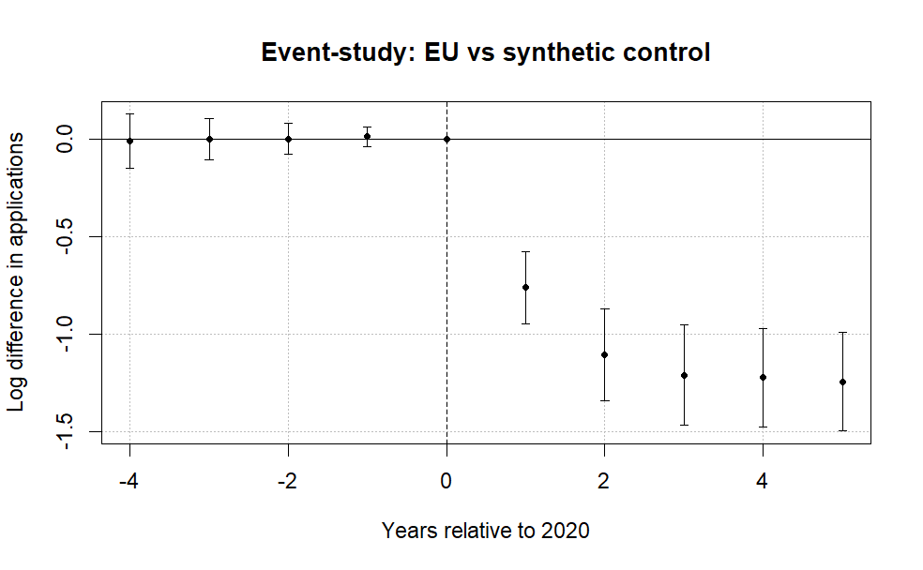
Note: The figure plots coefficients from a difference-in-differences event-study comparing EU applicants to a synthetic control group of non-EU countries. The horizontal axis shows years relative to 2020, the last pre-treatment year. Points represent estimated differences in log applications and bars denote 95% confidence intervals clustered at the country level. The dashed vertical line marks the final pre-treatment year. Pre-treatment coefficients are small and close to zero, while a sharp decline in EU applications emerges beginning in 2021 after the tuition reform took effect. A joint Wald test cannot reject the null that the pre-treatment coefficients are jointly zero (p = 0.96), providing no strong evidence of differential pre-trends.

Figure 1 reports the event-study coefficients from equation (1). The pre-treatment leads are very small and a joint Wald test fails to reject that they are jointly zero (p = 0.96), which, especially with the 2025 data, rules out COVID as the driver of the application change. No recovery is visible even once COVID had largely abated in 2024 and 2025, with the decline deepening as years pass. The small positive divergence in post-referendum applications suggests the UK system did not become less appealing because of migration concerns, and if anything candidates were more motivated to apply.
As a further check, a leads-only specification finds no anticipation effects, so applicants did not adjust before the reform in expectation of the future suppression of visa privileges. The estimates show no systematic pre-treatment pattern, and a joint Wald test cannot reject that the early leads are jointly zero (p = 0.96).
Allowing country-specific dynamic effects yields similar patterns, with post-treatment coefficients consistently negative across EU countries and pre-treatment estimates near zero (Figure 3). The one exception is Portugal, whose applications did not immediately collapse in 2021, which traces to a UCAS reporting issue where some Recorded Prior Acceptances were mistakenly submitted as Portugal-domiciled in the 2021 cycle, so the true count is lower than reported (UCAS, 2022).

Figure 3. Saturated DiD event-study estimates by country.
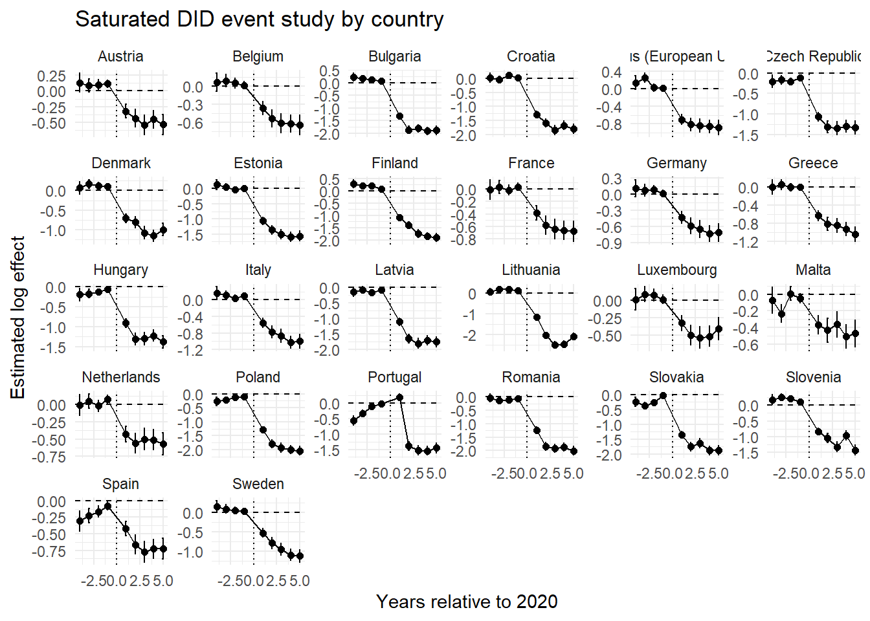
Note: Each panel reports country-specific dynamic treatment effects from the saturated difference-in-differences specification comparing EU countries with the pooled control group. Coefficients represent log differences in applications relative to the baseline year (2020).

Baseline elasticities estimates and the heterogenous k
Let $C$ denote the set of origin countries, partitioned into the treated EU markets $Ω⊂C$, with $J=\left|Ω\right|$, and the candidate donor pool $D=C∖Ω$ of non-EU markets. The counterfactual European Union gives a synthetic untreated group, letting us estimate the weighted saturated two-way DiD model:
$$\log{(A_{it})} = α_{i} + γ_{t} +\sum_{\begin{aligned}j∈Ω \\ \end{aligned}}^{ }{β_{j} \left(1\left\{i=j\right\}×Post_{t}\right)} +ρ^{'}X+ ε_{it}$$ | (2)

where $A_{it}$ denotes applications from origin country $i∈C$ in year $t∈[2016, 2025]$, $1\left\{i=j\right\}$ indicates EU member states, and $Post_{t}$ marks the new tuition regime in 2021. Importantly, as long as the two groups remain under different but unchanged tuition fee regimes, their relative application trajectories should remain stable. When the treated group moves from the UK home-fee regime into the international fee regime already faced by the control group, βj will capture the resulting change in the treated group’s application trajectory relative to the control group. This relative change identifies the applications lost when the treated group ceased to benefit from UK home-fee status.

To separate short-run from persistent effects, we split the post-treatment period into 2021-2023, the immediate response, and 2024 onward, the longer-run adjustment. The specification becomes:
$$\begin{matrix}\log{(A_{it})} & = & α_{i} + γ_{t} + \sum_{\begin{aligned}j∈Ω \\ \end{aligned}}^{ }{β_{j} \left(1\left\{i=j\right\}×Pos{tBrexit}_{t}\right)} \\ & + & \sum_{\begin{aligned}j^{ }∈Ω \\ \end{aligned}}^{ }{σ_{j^{ }} \left(1\left\{i=j\right\}×Pos{tCovid}_{t}\right)}+ρ^{'}X+ ε_{it }\end{matrix}$$ | (3)

Here $β_{j}$ is the short-run country-specific response (Brexit plus COVID uncertainty) and ${ σ}_{j^{ }}$ is the persistent structural response (a pure willingness-to-pay shift). The difference $β_{j}-σ_{j^{ }}=ω_{j}$ gives the COVID-specific impact on demand elasticities (proof in the supplementary materials).
The supplementary materials show that $β_{j}$, with $j∈Ω$, maps to a structural elasticity through the following transformation (Bresnahan, 1982, style):

$η_{j}=\frac{β_{j}}{k_{j}}$,

Here $η_{j}$ is the price elasticity, expected negative given the downward-sloping demand curve. To allow heterogeneous $k$’s, under Plan 2 graduates repaid 9% of annual earnings above a statutory threshold (UK Government, n.d.-a), which for the relevant cohort is £27,295 per year. Annual repayments are $R_{t}=0.09⋅max\{0,Y_{t}-τ\}$, where τ is the threshold and Y_{t} follows a deterministic wage path with growth rate g. The loan is written off 30 years after repayment becomes due (UK Government, n.d.-b), so the horizon is T=30. Interest accrues at RPI plus up to three points depending on income (UK Government, n.d.-c). Rather than replicate the full income-dependent interest schedule, we model the loan’s burden as the present value of expected repayments, discounting at a constant rate δ:

$$p_{jt}=min\left\{0.09max\left[0, w_{j}^{GBP}{\left(1+g\right)}^{t-1}-τ\right], {\left[L-\sum_{s=1}^{t-1}{p_{js}}\right]}_{+}\right\}$$
$$PV_{loan}\left(w_{j}^{GBP}\right)=max\left\{1, \sum_{t=1}^{30}{\frac{p_{jt}}{{\left(1+δ\right)}^{t}}}\right\}$$

where $L=£9,250$ and $[x]_{+}=max\left\{x,0\right\}$. In the baseline we set $δ=3\%$ and $g=2\%$. The maximum operator keeps the log transformation defined even at zero present value. We anchor nominal wage growth of g=0.02 to the ECB’s symmetric 2% medium-term inflation target, under which the Governing Council treats negative and positive deviations as equally undesirable (European Central Bank, 2021).
We estimate the present value based on the average country specific wage ($w_{j}^{GBP})$ and $k$ becomes a function of the average wage:

$$k_{j}=log22200-logPV_{loan}\left(w_{j}^{GBP}\right)$$

Here $PV_{loan}\left(w_{j}^{GBP}\right)$ is the present value of the income-contingent UK loan, £22,200 is the average post-Brexit price, and $w_{j}$ is the average annual salary in pounds (2024, converted from euros at 0.85)
Intuitively, read the calculation from the perspective of a 2024 graduate asking how much they would actually repay under the old income-contingent system given their expected first wage. We take the 2024 wage, project it over 30 years, compute annual repayments under the loan rule, and discount them back to 2024, giving the effective price of the old regime. Discounting the £22,200 price would be inappropriate, since it would recast a current tuition obligation as a deferred repayment stream. The asymmetry is institutional, not arbitrary: the old price is mediated through a future repayment contract, while the new price is a direct posted fee.
Discounting matters because under the standard shift from £9,250 with no heterogeneity, $k$ is 0.875. Clifton-Sprigg (2025) assumes one price change (£9,250 to £22,200), whereas the equation above relaxes that. The extension is especially relevant given Solís’s (2017) finding that credit access raises immediate college enrollment by 100 percent and ever-enrolling by 50 percent.
We then relate these elasticities to observable economic fundamentals. Specifically, we estimate correlations of the form:
$$\frac{β_{j}}{k_{j}} = θ_{0} +γ\log\left(GDPpc_{j}\right)+X^{'}ρ+ u_{ }$$ | (4)
Here $ρ^{'}X$ lists country-specific covariates for structural characteristics. This documents that income strongly predicts the size of the shock, consistent with a segmented market in which price sensitivity varies with economic fundamentals.

- Results

Estimated baseline elasticities
Figure 4 reports country-specific elasticities from the difference-in-differences estimates, translating the treatment effects into implied demand responses to the Brexit shock.

Figure 4. Decomposition of the post-Brexit demand elasticities by treated country.
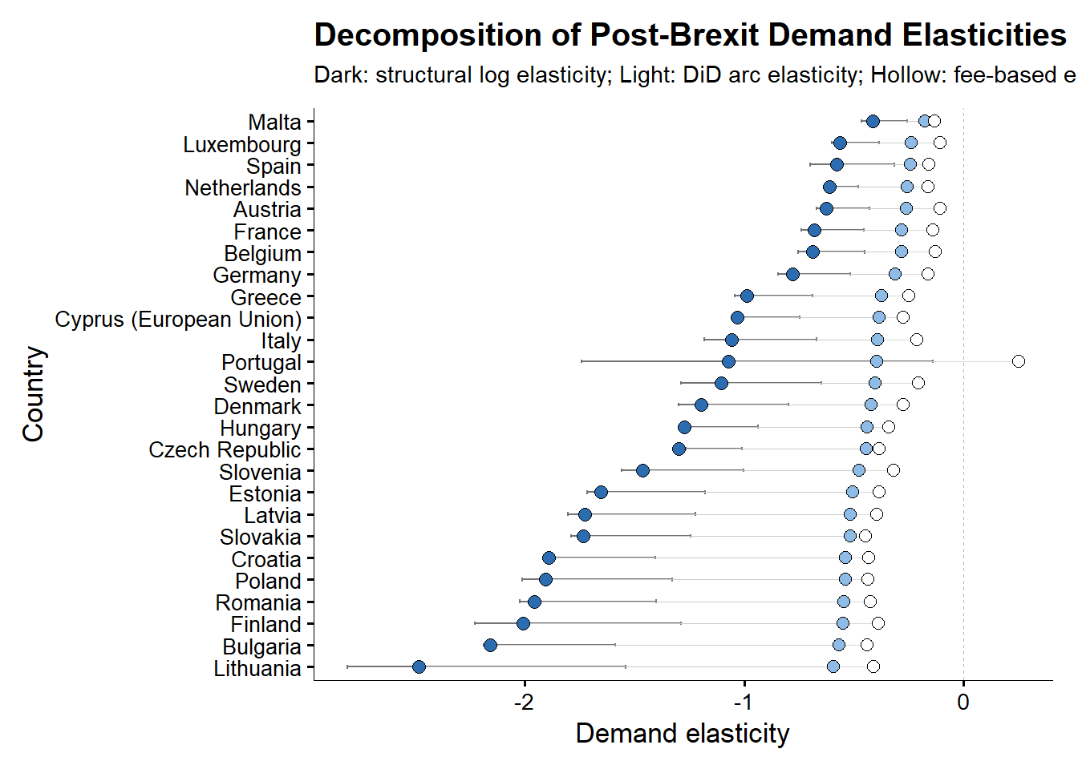
Note: The structural log elasticities are obtained from the division of the country-specific effect ($β_{j})$ by 0.875. The Arc elasticities are obtained by $\left(e^{β}-1\right)/1.4$ and the mechanical arc elasticities by $ΔApplications_{2020}^{2021}/1.40$. The transformation of $e^{β}-1$ is valid only if the software is using logarithmic transformations in natural logarithms. Since R uses natural logarithms as default this transformation is safe. Used are Driscoll-Kraay (L=1) standard errors consistently and across all the presented models. Details in the online appendix.

The results indicate a large and widespread contraction in demand. Across EU countries, applications declined substantially following the introduction of international tuition fees, with estimated effects corresponding to reductions of roughly 30% (Malta) to the worst cases of 89% in Lithuania and 85% in Bulgaria, relative to the control group. The average effect implies a decline of approximately 67%. All DiD elasticities lie strictly below zero, confirming that the Brexit-induced tuition shock caused a contraction in EU demand for UK higher education across the entire Union. However, the magnitude of this response varies substantially. Wealthier EU countries such as Malta, Spain, Luxembourg, the Netherlands, and Austria cluster near elasticities between −0.42 and −0.6, indicating relatively inelastic demand. By contrast, lower-income EU countries – including Bulgaria, Romania, Lithuania, Croatia, and Latvia – exhibit elasticities below −2, with Lithuania approaching −3, indicating relatively elastic demand. This leads to the misleading interpretation that the demand in poorer countries is less resilient to tuition changes as well as that students from such countries are less “motivated” to apply. We later show that this is an incorrect interpretation.
This heterogeneity also aligns closely with cross-country differences in income. Regressing the estimated country-specific responses on GDP per capita reveals a strong positive relationship where wealthier countries experience smaller declines in applications (Figure 5). The strong positive relationship between GDP per capita and demand elasticity emerges only when elasticities are estimated using fixed effects specifications. This reflects the ability of the TWFE estimator to isolate the causal impact of the Brexit-induced tuition shock by removing both country-specific baseline differences and common time shocks. In contrast, pooled estimates conflate treatment effects with cross-country heterogeneity in levels and trends, obscuring the underlying relationship. As a result, the GDP gradient disappears when identification is not enforced. Furthermore, even when the elasticities are estimated with additional controls, included in the saturated DiD regression, the correlation with GDP per capita remains strong.
The correlations weaken only when (k_j), calculated under (\delta=3%) and (g=2%), is allowed to vary across countries according to the income-contingent loan systems to which EU students were previously exposed. Under this adjustment, the previously positive income gradient in the TWFE elasticity estimates becomes statistically insignificant. This, combined with the results presented in the previous paragraph, shows that the estimated income gradient is highly sensitive both to the treatment of loan conditions and to the control of persistent cross-country heterogeneity. Therefore, the baseline unadjusted estimates may systematically overstate the price elasticity for some country groups and understate it for others. We return to this issue in the discussion section.

Figure 5. Correlations between the DiD (FEs and No FEs elasticities) and logarithm of GDP per capita
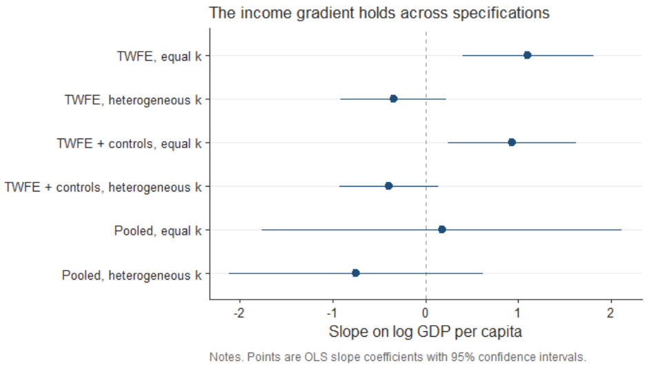

- Estimated COVID specific elasticities

Figure 6 compares the immediate post-Brexit demand elasticities with the persistent elasticities observed after pandemic disruptions had abated. The difference between the dots is consistent with the effect derived in the supplementary materials.

Figure 6. Post Brexit and post-COVID Demand elasticities compared on the same measurement axis.
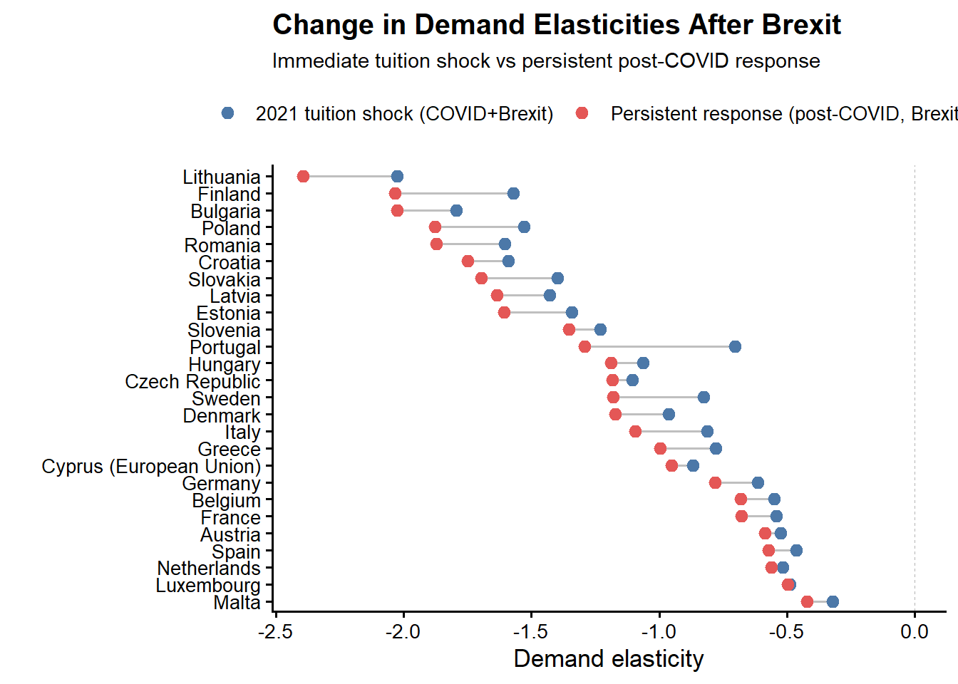
Note: Used are the naïve elasticities across all the models. The COVID coefficients are coded for the period 2021-2023, while 2024 to 2025 are assumed to be only the persistency effects of the Brexit tuition regime. Used are Driscoll-Kraay (L=1) standard errors consistently and across all the presented models. Details in the online appendix.
For nearly all EU origin countries the persistent post-COVID elasticities stay strongly negative and close to the initial post-2021 estimates. This persistence confirms that price sensitivity, not short-run volatility, drives the contraction. The 2024-2025 effects are at least as negative as the 2021-2023 effects, so there is little recovery once the COVID window passes, most clearly among lower-income countries though the deepening is visible across much of the income distribution.

The COVID-specific ATT coefficients run from −0.42 (down from −0.32) for Malta to −2.39 (down from −2.03) for Lithuania. Excluding Portugal for its data issue, the post-COVID coefficients are 2% to 42% larger in absolute magnitude. This contradicts a COVID-driven or mobility-attraction story and implies UK higher education grew steadily less popular among EU students until the system reached a stable equilibrium.

- ATT wealth heterogeneity

Table 3. ATE coefficient and interactions. FEs are always entity and time. Standard errors are Driscoll & Kraay (1998) (L=1)
 | (I) | (II) | (III) | (IV) | (V)
$ATT$ | -1.109*** | -1.05*** | -0.981*** | -0.961*** | -1.211***
 | (0.098) | (0.110) | (0.101) | (0.092) | (0.120)
$c_log\left(GDPpc\right)$ |  | -0.720* | -0.447 | -0.687* | 0.018
 |  | (0.265) | (0.266) | (0.290) | (0.300)
$c_log\left(Pop15_64\right)$ |  |  | 3.077*** | 3.213*** | 2.631***
 |  |  | (0.460) | (0.519) | (0.462)
$c_YU$ |  |  |  | -0.014* | -0.008+
 |  |  |  | (0.004) | (0.004)
$ATT×c_log\left(GDPpc\right)$ |  |  |  |  | 0.808***
 |  |  |  |  | (0.136)
$ATT×c_log\left(Pop15_65\right)$ |  |  |  |  | 0.100***
 |  |  |  |  | (0.013)
$ATT×c_YU$ |  |  |  |  | 0.011
 |  |  |  |  | (0.006)
Obs. | 520 | 468 | 468 | 468 | 468
R2 Adj | 0.957 | 0.958 | 0.964 | 0.964 | 0.970
R2 Within | 0.585 | 0.586 | 0.644 | 0.652 | 0.708
Note: Models (I) through (V) are estimated with the standard TWFE estimator. The data is sourced from the World Bank API resources where Model (I) uses the full panel of 520 observations (52 countries over the 2016 to 2025 window), while the specifications with World Bank controls (Models II to V) use 468 observations (52 countries over the 2016 to 2024 window), because the World Bank PPP GDP series carries no 2025 value so those country-years drop out. The c_log variables are demeaned before being included in the regression so the interactions with the ATT in model (V) will be comparable. The formula used for the demeaning was $log\left(x_{i}\right)-\overline{log\left(x_{i}\right)}$ removing the entir3e cross-sectional mean, not the within-group one, which allows the entity fixed effects to retain their original meaning. Used are Driscoll-Kraay (L=1) standard errors consistently and across all the presented models. Significance is marked as + p<0.1, * p<0.05, ** p<0.01, *** p<0.001. Details in the online appendix. The panel regressions use GDP per capita in purchasing power parity terms (constant international dollars)

Based on Table 3, the ATT of the uncontrolled model is −1.109, or exp(−1.109) − 1 = −67.0 percent, reconciles with the long-run −0.354 of Conlon et al. (2021) only under a specific attribution. Given the gross 140 percent fee increase, that coefficient assigns a log change of −0.354 × ln(2.4) = −0.310 to price, or exp(−0.310) − 1 = −26.7 percent, 27.9 percent of our effect. The residual of −0.799 falls to non-price components, exp(−0.799) − 1 = −55.0 percent. At their elastic bound of −0.648 the price channel absorbs 51.2 percent and the residual is exp(−0.542) − 1 = −41.8 percent. The heterogeneity results bound what a large non-price shock can do, since COVID produces at most a 43 percent effect for the most affected countries.
The same arithmetic runs in reverse. Attributing the whole of our ATT to price, the annual fee increase required for an elasticity of −0.354 to generate it is exp(1.11/0.354) =22.9, a rise of 2,194 percent. Against the pre-Brexit home fee of £9,250, that implies an annual charge of approximately £212,200 rather than the roughly £22,200 actually levied once EU applicants moved to international rates. Even the elastic bound of −0.648 requires exp(1.109 / 0.648) = 5.5, an increase of 454 percent, or about £51,200 a year. However, such change will be possible only for countries where the income-contingent loan is effectively equal to zero in present value terms. To obtain Conlon et al. (2021) number of $η_{j}=-0.354$ we have to solve for a denominator that gives $k=\frac{1.109}{0.354}=3.13$, so $PV_{loan}=\frac{£22,200}{e^{3.13}}=£968$. That is 10.5 percent of the £9,250 principal, and under our baseline calibration it corresponds to an expected graduate wage of about £18,250 a year. Therefore, the estimates are equal only for an applicant whose income-contingent loan was worth about a tenth of its face value in present-value terms.
Table 3 also reports regressions that relate the magnitude of the Brexit demand shock to country-level economic characteristics. Across all specifications, the baseline effect remains large, negative, and statistically significant, showing negligible change when additional controls were added. At the same time, there is clear evidence of heterogeneity. The interaction between the Brexit treatment and GDP per capita is positive and statistically significant, indicating that higher-income countries experience smaller declines in applications. This is consistent with lower price sensitivity in wealthier contexts. Working-age population also plays an important role. The interaction with population is positive and precisely estimated, which demonstrates that the contraction was further attenuated in demographically larger origin countries, where UK higher education is one option among a broader domestic and international set. By contrast, the interaction with youth unemployment is positive but statistically indistinguishable from zero in the fully interacted specification, so weaker youth labour markets do not measurably change the response to the fee shock.
Figure 7 reports country-specific elasticities under homogeneous $k_{j}$, showing no meaningful change in the estimates beyond a slight downward shift in the ATT that does not warrant further investigation.

Figure 7. Saturated DiD specifications with macroeconomic controls added. Namely GDP per capita (PPP, constant prices), population and the percentage of youth unemployment as separate models.
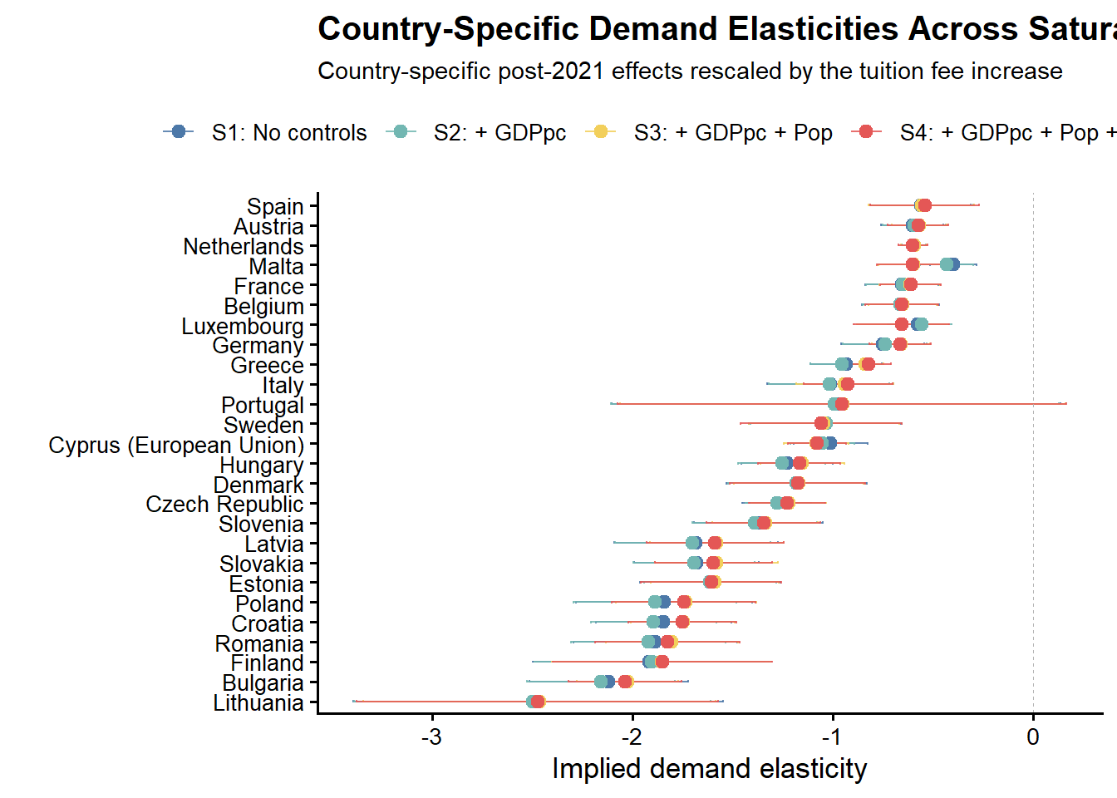
Note: All saturated models use the demeaned version of the free covariates – namely, the GDP per capita, the population and the youth unemployment. Used are Driscoll-Kraay (L=1) standard errors consistently and across all the presented models. Details in the online appendix.

- Robustness

Control group robustness
We test robustness mainly against the choice of control group, since prior work has already confirmed (Clifton-Sprigg et al., 2025):
- The Brexit shock was indeed a valid quasi-experiment with stable pre-trends
- There were no anticipation effects and no major spillovers from the Brexit referendum in 2016
- Clifton-Sprigg even performed a robustness exercise by using the Croatian case that in itself created quasi-experimental evidence when the country joined the Union.
What remains is to show the result does not depend on control-group construction. We build four alternatives to our own: very poor countries (14), very rich countries (13), OECD countries (14), and Ireland as a single-country comparison. The three multi-country groups are detailed in Table 4.
Table 4. Sample compositions for the alternative control groups
 | Poor | Rich | OECD
Control group co mposition | Pakistan, Nepal, Bangladesh, Ethiopia, Uganda,  Tanzania, United Republic of, Rwanda, Mozambique, Malawi,  Sierra Leone, Ghana, Nigeria, Kenya, Zimbabwe | United States of America, Canada, Australia, Norway, Switzerland,  Singapore, Qatar, United Arab Emirates, Kuwait, Saudi Arabia,  Israel, Japan, Hong Kong | Australia, Canada, Chile, Colombia, Iceland, Israel, Japan,  Korea, Republic of, Mexico, New Zealand, Norway, Switzerland,  Turkey, United States of America
EU group | 26
Obs ervations | 400 | 390 | 400
Note: To avoid the proliferation of too many tables detailed statistical description of the used groups is provided in the supplementary materials section.

A further concern is that the Graduate Route, introduced in July 2021, may have raised the appeal of UK study independently of tuition by letting international graduates stay up to two years after finishing (Home Office, 2021), therefore treating the control group and biasing the effect downwards. This is mitigated in two ways. First, because the Route reached treated and control countries alike after 2021, any common increase in appeal is absorbed by year fixed effects and cannot identify the DiD coefficient. Second, the Ireland-only specification is also introduced specifically for that purpose, since Irish citizens kept Common Travel Area rights and did not rely on the Route as other international students did, which limits control-group contamination.
Because this design does not build the control group by constrained optimization, we weight the counterfactual as:
$$w_{j}=\frac{\frac{1}{d_{j}+0.001}}{\frac{1}{J}\sum_{k=1}^{J}{\frac{1}{d_{k}+0.001}}}$$
where $d_{j}=\sqrt{\frac{1}{T}{\sum_{t<2021}^{ }{\left(log\left(A_{jt}\right)-\overline{log\left(A_{t}^{EU}\right)}\right)}}^{2}}$. The results are presented in Figures 8 and 9 for the ATT and the country-specific responses, respectively.

Figure 8. Robustness of the Brexit effect across alternative control-group definitions (pooled DiD estimates).
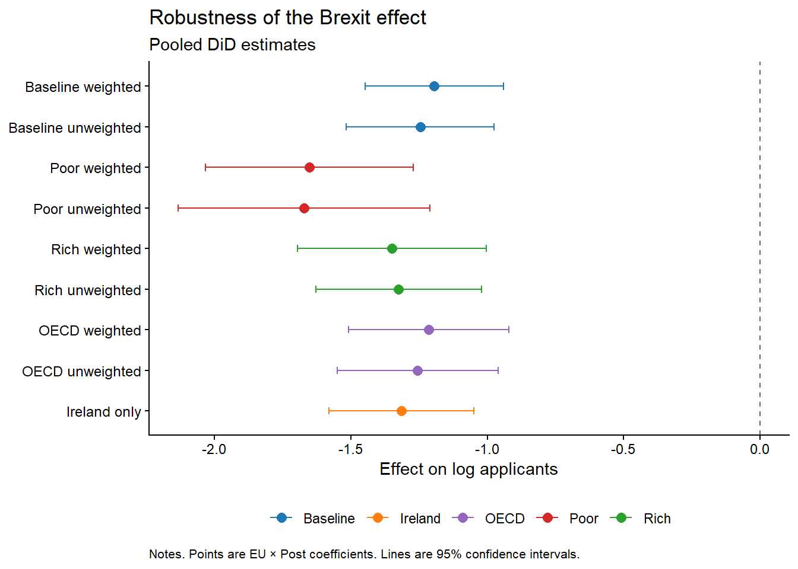
Note: Points are EU × Post coefficients from the pooled difference-in-differences specification; horizontal bars denote 95% confidence intervals. Baseline is the synthetic donor pool used in the main specification; Poor, Rich, and OECD are the alternative control groups described in Table 4, each shown weighted and unweighted; Ireland is a single-country comparison.

Figure 9. Saturated difference-in-differences robustness across control-group specifications.
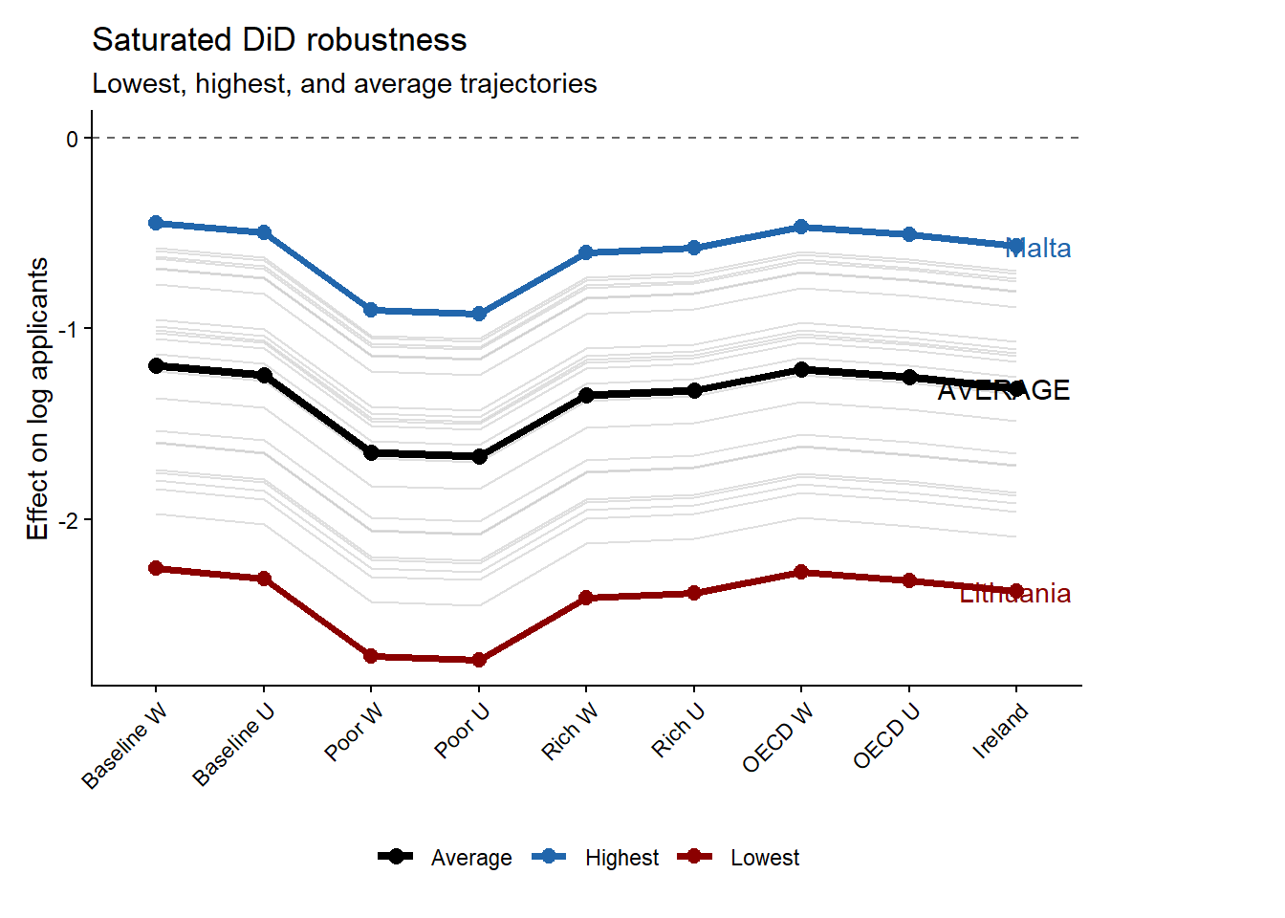
Note: Grey lines show country-specific dynamic treatment trajectories under each alternative control-group specification; the black line marks the cross-specification average. Malta (blue) and Lithuania (red) mark the upper and lower bounds of the estimated effects.
Figures 8 and 9 show the estimated effect is not an artifact of a particular donor pool. Across all alternatives the EU × Post coefficient stays large, negative, and far from zero. Whether the control group is the baseline synthetic pool, OECD, high-income, low-income, or Ireland alone, the estimated collapse is of similar order. Point estimates move because each pool implies a different benchmark, but none changes the substantive conclusion.

The poor-country control group generates the most negative estimates. This is informative because it shows that the decline is not a generic post-pandemic fall in applications from low-income origins. If that were the mechanism, low-income non-EU countries should absorb much of the EU decline and push the coefficient toward zero. The Irish case also survives as a robustness check against the Graduate route visa in 2021. Thereby demonstrating that if the result were driven by common shocks to nearby or culturally connected markets or the Graduate route visa, the comparison with Ireland should substantially weaken the estimate. It does not. The estimate remains close to the other robustness results, reinforcing the interpretation that the post-2021 break reflects the EU-specific loss of Home Fee status and loan access. Figure 9 also strengthens the robustness of the main results by showing that the ranking of the post-Brexit responses is preserved regardless of the chosen baseline. Another important point is that the weighting of the control group appears to affect the final estimates only at the margin, providing robust evidence that both the order and the magnitude of the collapse were stable enough for the inferences made in this paper. As a further check that does not rely on the constrained donor weights, we estimate the average treatment effect on the full donor pool with the standalone synthetic difference-in-differences estimator of Arkhangelsky et al. (2021). The estimator returns an ATT of -1.23 (jackknife standard error 0.10, with a 95% confidence interval from -1.43 to -1.02), which falls squarely within the range of the pooled and saturated estimates reported above and confirms that the headline collapse in EU applications does not hinge on how the counterfactual is weighted.

$k_{j}$ robustness
A natural objection to the loan correction is mechanical: because $k_{j}$ falls with income, dividing ${\hat{β}}_{j}$ by $k_{j}$ attenuates any income gradient almost automatically, so the collapse could be mere division by an income-correlated quantity. To separate these, we build a placebo denominator carrying the income dependence of $k_{j}$ but none of its structure. We take log wages as a pure monotone income signal, with no threshold, horizon, or discounting, and rescale by a min-max transform onto the exact range spanned by the real $k_{j}$:
$$k_{j}^{placebo}=\left[\frac{logw_{j}-min\left(logw_{i}\right)}{max(logw_{i})-min(logw_{i}) }\right]×\left(maxk_{i}-mink_{i}\right)+mink_{i}$$
By construction $k_{j}^{placebo}$ spans the same interval as $k_{j}$, with minimum and maximum pinned to $mink_{i}$ and $maxk_{i}$, so the two denominators differ only in how they map income onto that interval, not in scale. The real $k_{j}$ bends through the present value of the loan, saturating at higher incomes as graduates repay the full principal, whereas $k_{j}^{placebo}$ rises monotonically in log income without saturating. We then form placebo elasticities ${\hat{β}}_{j}$ over $k_{j}^{placebo}$ and re-estimate the gradient.
The results isolate the loan mechanism. Under a common price change the gradient is steep and significant ($γ$= 1.11, p = 0.001, n=25). Under the real loan-adjusted $k_{j}$ it flattens to insignificance ($γ$ = -0.37, p = 0.23, CI spanning zero, n=25). Under the placebo income-only denominator, rescaled to the same range, it stays steep and significant ($γ$ = 0.87, p = 0.038, n=25). A monotone income divisor therefore does not reproduce the collapse. What dissolves the gradient is not division by an income-correlated quantity in general but the curvature the income-contingent loan imposes on the effective price change, in particular its saturation at higher earnings. This is direct evidence that the loan-valuation channel, not the mechanical rescaling, drives the disappearance of the gradient, and it is the strongest defence of the mechanism.
A further peer-review concern is the sensitivity of the present value to calibration. We recompute the present values and re-estimate the correlations across loan-correction settings (Figure 10). Across the discount-rate sweep the loan-adjusted gradient stays insignificant throughout, its p-value above 5% at every calibration. The wage-growth sweep is more nuanced: the gradient is significant only at the two lowest calibrations, g = 0 (p ≈ 0.04) and g = 0.5% (p ≈ 0.05), and insignificant from g = 1% on. The underlying slope runs from about −0.722 at g = 0% to about 0.291 at 4%, reversing sign, while standard errors barely move. The disappearance of the gradient therefore holds across the discount-rate sweep and the baseline and most plausible positive wage-growth calibrations, though not the entire parameter space.

Figure 10. Sensitivity of the loan-corrected income gradient to the discount rate and wage growth rate assumptions.
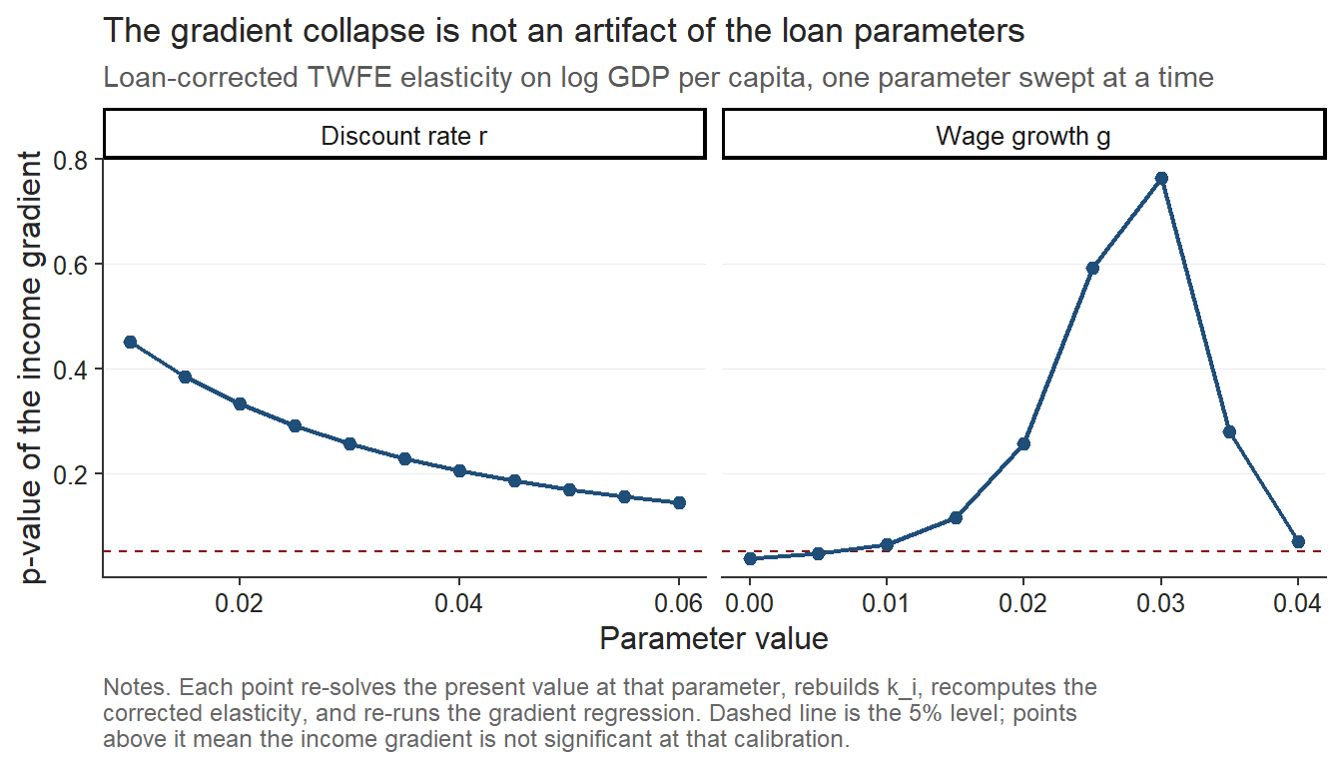
Note: The figure plots the p-value of the income gradient, that is the slope of the loan-corrected elasticity on log GDP per capita (PPP) as the discount rate (δ) and the annual wage growth rate (g) are varied around their baseline calibration (δ = 3%, g = 2%), holding all other parameters at the values described in the main text. GDP per capita is in PPP terms (constant international dollars) with data from 2022. The dashed line marks the 5% significance level, so points above it indicate calibrations where the income gradient is not statistically significant.

Rambachan-Roth parallel-trends checks and synthetic difference-in-differences comparison
In response to a further round of peer review we run two additional robustness checks. The first re-examines the parallel-trends assumption behind the event study using the HonestDiD implementation of the sensitivity analysis of Rambachan and Roth (2023), which replaces the binary test of whether pre-trends are flat with a measure of how large a post-treatment violation of parallel trends would have to be before the estimated effect loses its significance. Because the pre-treatment leads are jointly indistinguishable from zero (a joint Wald test gives p = 0.96) and are about two orders of magnitude smaller than the post-treatment coefficients, the loan-driven collapse in EU applications survives the relative-magnitudes sensitivity analysis across the full range of violations we examine. The robust confidence set for the first post-treatment year never crosses zero, running from −0.94 to −0.58 when no violation is permitted (Mbar equal to zero), from −0.95 to −0.56 when the post-period distortion is allowed to be as large as the worst pre-period deviation (Mbar equal to one), and still only from −0.98 to −0.53 at twice that size (Mbar equal to two). The breakdown value therefore exceeds two, so the result is not an artifact of an assumed pre-trend (Roth, 2022).
The second check re-estimates 26 separate synthetic difference-in-differences regressions, one per treated country, so the Arkhangelsky et al. (2021) estimator collapses to $N_{tr}=1$:
τjsdid=Yj,post-t≤T0 λtjYjt-i∈D​ωijYi, post-t≤T0 λtjYit
We then compare these estimated coefficients to the ones obtained from the saturated weighted DiD regression. This comparison is reported in Table 5. As the table shows, the difference between the two estimators is small, with a mean absolute difference of 0.13 log points and a correlation of 0.97 across the 26 countries, and the ranking of the country-specific effects is preserved across both designs. The largest single discrepancy is Portugal (0.41 log points), which is consistent with the UCAS reporting issue for the 2021 Portuguese cycle documented earlier. This provides a further and perhaps final confirmation of the robustness of the results reported above.

Table 5. Per-country saturated DiD (TWFE) and synthetic difference-in-differences estimates
Country | Saturated TWFE | Synthetic DiD | Difference
Lithuania | -2.173 | -2.203 | 0.03
Bulgaria | -1.887 | -1.876 | -0.011
Finland | -1.756 | -1.721 | -0.035
Romania | -1.711 | -1.883 | 0.172
Poland | -1.668 | -1.948 | 0.28
Croatia | -1.655 | -1.768 | 0.114
Slovakia | -1.516 | -1.851 | 0.335
Latvia | -1.512 | -1.715 | 0.203
Estonia | -1.447 | -1.504 | 0.056
Slovenia | -1.28 | -1.25 | -0.029
Czech Republic | -1.137 | -1.388 | 0.251
Hungary | -1.114 | -1.352 | 0.237
Denmark | -1.046 | -1.085 | 0.039
Sweden | -0.967 | -0.998 | 0.032
Portugal | -0.939 | -1.353 | 0.413
Italy | -0.925 | -0.948 | 0.023
Cyprus (European Union) | -0.902 | -0.907 | 0.004
Greece | -0.866 | -0.963 | 0.097
Germany | -0.681 | -0.731 | 0.05
Belgium | -0.603 | -0.664 | 0.061
France | -0.597 | -0.707 | 0.11
Austria | -0.549 | -0.587 | 0.039
Netherlands | -0.535 | -0.64 | 0.105
Spain | -0.508 | -0.808 | 0.3
Luxembourg | -0.493 | -0.572 | 0.079
Malta | -0.362 | -0.569 | 0.208
Note: Coefficients are on the log applicant scale. Saturated TWFE effects are the country-specific EU × Post coefficients from the weighted saturated difference-in-differences model (520 country-year observations). Synthetic DiD effects are 26 separate single-treated-unit synthetic difference-in-differences estimates (Arkhangelsky et al., 2021), each identified against the full non-EU donor pool. Across the 26 countries the two sets of estimates correlate at 0.97, with a mean absolute difference of 0.13 log points.

- Discussion

Were poor EU students really priced out because of elastic demand?
A natural reading is that students from lower-income EU countries have more elastic demand. But this assumes the reform generated the same effective price change everywhere, which is unlikely. Before Brexit, tuition was financed through income-contingent loans, so the relevant price depended on expected earnings not the nominal fee, and removing the loans generated larger effective price increases for lower-income applicants.
To show how elasticities depend on loan valuation, we map the ATT coefficient (β=-1.109) across a range of starting incomes (Figure 11). When the loan has low present value (low expected earnings), Brexit is a large effective shock and the implied elasticity is mechanically smaller in magnitude (about −0.4). When the present value approaches the nominal amount (high earnings), the effective shock is smaller and the implied elasticity larger in magnitude.

Figure 11. Implied demand elasticity as a function of the economic value of the UK student loan.
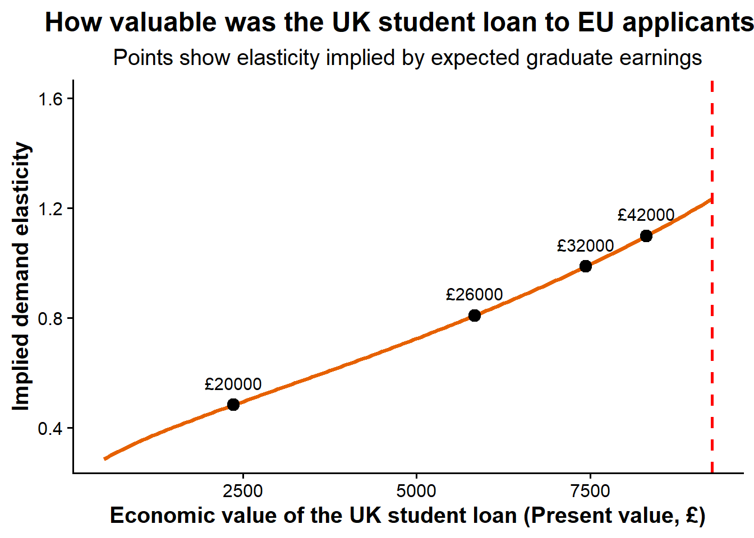
Note: The figure translates the estimated treatment effect into implied demand elasticities under different assumptions about the present value of the UK student loan to EU applicants. Points correspond to elasticity estimates implied by alternative expected graduate earning scenarios. The elasticity here is multiplied by -1 ($η_{j}^{'}=-β_{j}{/k}_{j}$) for illustrative purposes.

To examine whether structural heterogeneity in demand persists after accounting for this mechanism, we define corrected elasticities as $η_{j}^{'}={\frac{-β_{j}}{k_{j}}}_{ }$. As we mentioned earlier, dividing by heterogeneous $k_{j}$removes the portion of elasticity variation that is mechanically induced by differential effective price shocks in the results. We showed that after recomputing the elasticities using heterogeneous price changes across the Union, the correlation with GDP per capita vanishes. Figure 12 shows the exact ways in which the point estimates changed from the old fixed $k$ to the new loan corrected $k$. For simplicity we kept the main assumption of $δ=0.03,$ the repayment rate above threshold as 9%, the nominal wage growth at 2% and the repayment horizon at 30 years. In the robustness section we showed that the result is robust to changes in the discount rate and growth rates.

Figure 12. Income gradient in demand elasticity.
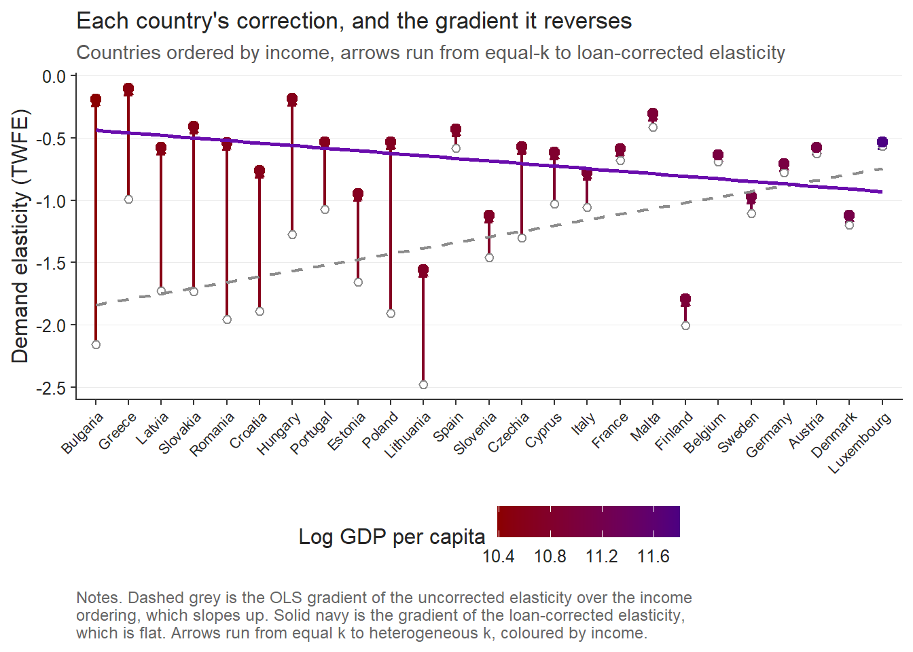
Note: The figure compares baseline elasticity estimates with elasticities corrected for heterogeneous loan value across countries. The horizontal axis orders the treated countries from lowest to highest log GDP per capita (PPP) and is labelled with country names, so it is a country-ranking axis and not a continuous GDP scale. The two fitted lines are estimated against this income ordering. Elasticities here are strictly negative as the direct ATT coefficient was divided by $k_{j},$ $\left(η_{j}^{'}={\frac{β_{j}}{k_{j}}}_{ }\right)$

Before correcting for treatment intensity, elasticities show a strong, significant positive relationship with origin-country income ($γ=1.11$, highly significant). Once rescaled by the country-specific effective price shocks from the loan’s present value, the gradient collapses to insignificance ($γ$ = −0.37). As the robustness section established, the difference between the two gradients shows that much of the observed heterogeneity reflects treatment intensity, not structural differences in preferences.
After correction, Finland, Denmark, Slovenia, Germany, and Luxembourg show the largest elasticities. These are precisely the countries with substantial high-quality domestic alternatives, where UK study is one option among many and demand adjusts readily to price. Lower-income applicants instead face fewer domestic alternatives and may view UK education as a path to much higher lifetime earnings, so their behavior is less responsive to tuition than raw responses suggest.

Politically, the decline from poorer EU countries reflects the withdrawal of an institution that had quietly equalized opportunity across Europe. The income-contingent loan meant students did not need to arrive with wealth, only the expectation of future earnings. When it disappeared for EU applicants, the effective cost of UK study rose sharply for those from poorer economies. What looks like elastic demand is better understood as the sudden loss of a mechanism that let talent travel without immediate financial means. In that sense the reform did not simply reveal price sensitivity; it exposed how fragile educational mobility is once the supporting institutions are removed.

What are the real determinants of the corrected elasticity?

Figure 13. Alternative correlations between the corrected income elasticity and macroeconomic fundamentals.
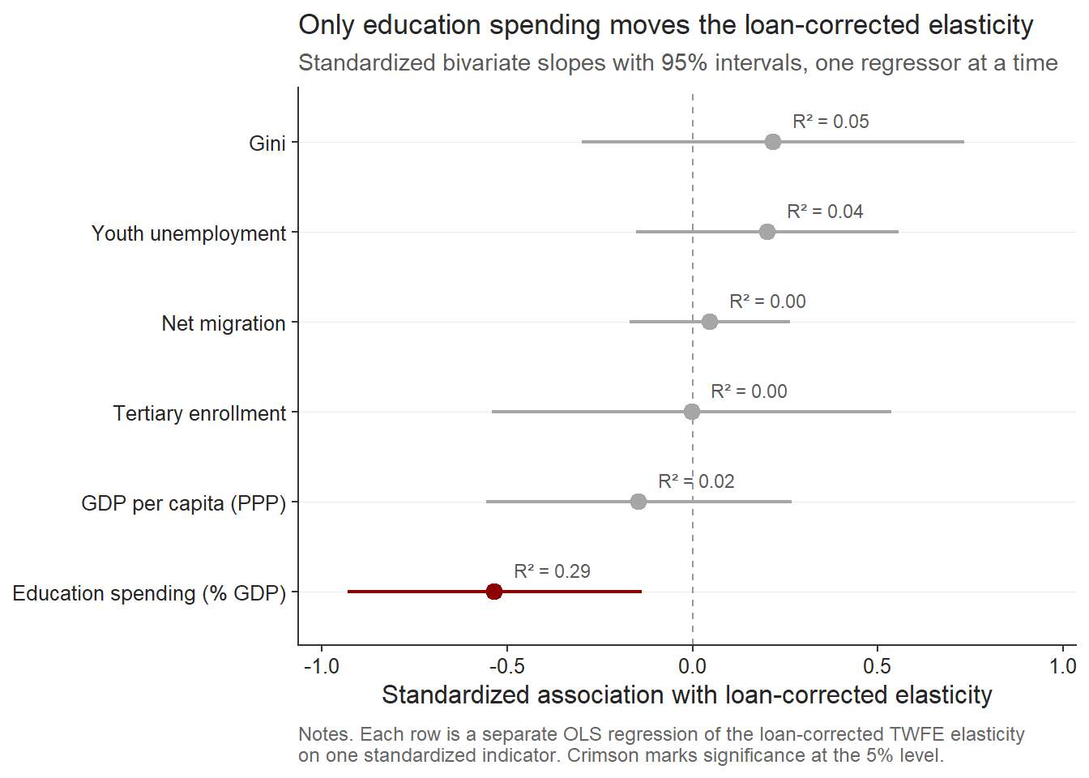
Note: Performed is simple cross-sectional OLS with HC1 robust standard errors. World bank data is from the year 2022. Elasticities are negative values.
Figure 13 shows most standard macroeconomic indicators explain little of the residual variation in the rescaled elasticities. GDP per capita, tertiary enrollment, net migration, youth unemployment, and inequality all have wide confidence intervals crossing zero and low explanatory power. The corrected elasticity is therefore no longer a disguised income measure: once the loan channel is removed, richer countries are not systematically more or less responsive.

The only variable that clearly moves the loan-corrected elasticity is education spending as a share of GDP, with a negative, significant coefficient and the largest explanatory power among those tested. Countries investing more in education show stronger residual price responsiveness to UK tuition increases, which also reframes the post-Brexit heterogeneity. Before correction, poorer countries looked most elastic because their application declines were largest against a uniform nominal fee shock. After correcting for the unequal value of the lost loan, the remaining elasticity is better explained by the structure of educational opportunity within the home-country. This points to a two-stage mechanism where the raw collapse from lower-income countries reflects the removal of an equalizing credit institution, while the remaining variation in corrected elasticities reflects the substitution possibilities national education systems create. Brexit first removed the financial bridge to UK study, and after that correction the strongest determinant of residual responsiveness is whether the origin country already invests enough in education to make exit financially less plausible.
Ultimately, this result is more naturally interpreted as a mobility argument than a pure price argument. Greater investment in the domestic higher education system is consistent with students having more credible local educational alternatives. Under the common corrected price shock, these additional alternatives are associated with greater measured responsiveness to UK tuition because students face a genuine choice between remaining at home and studying abroad. Conversely, lower corrected elasticities may indicate that applicants have fewer viable domestic options and therefore weaker ability to substitute away from UK study. In this sense, the corrected elasticity may capture not only price responsiveness, but also the degree of educational mobility created by the origin country's higher education system.

- Conclusion

This manuscript establishes three main findings. First, the estimated price elasticities of international student demand are considerably larger than the ranges of 0.10-0.40 commonly reported in the literature, with absolute magnitudes exceeding 2 for some EU-origin countries. Second, the cross-country ordering of these elasticities changes once they are rescaled using country-specific valuations of the lost income-contingent loan. Under a common price shock, applicants from lower-income countries appear substantially more responsive. Once the effective price change incorporates the heterogeneous value of the loan, the relationship between elasticity and national income becomes statistically insignificant.
Much of the initial heterogeneity therefore reflects differences in the financial intensity of the Brexit shock instead of stable differences in preferences. Third, the remaining variation in the corrected elasticities is most strongly associated with the share of GDP allocated to education. One possible interpretation is that countries investing less in their own higher education systems provide students with fewer credible domestic alternatives. External study may consequently become a more persistent form of educational exit, increasing the risk that young people enter other national systems and subsequently remain there.
These findings open a wider research agenda concerning the effects of Brexit on higher education mobility across the European Union. One immediate question concerns what happened to the demand displaced from the United Kingdom. If these applicants did not abandon international study and instead moved towards adjacent systems, the contraction in UK demand may have generated significant pressures elsewhere. Ireland is an especially relevant case because it remained inside the European Union while offering an English-language higher education system close to the United Kingdom. The reallocation of demand towards Ireland or similar destinations may have placed pressure on university capacity, student accommodation, staffing, and other parts of the receiving system. Establishing whether such displacement occurred, and whether the receiving systems were able to absorb it, would extend the analysis from the loss of demand in the United Kingdom to the wider European consequences of the reform.
A second question concerns the difference between domestic and cross-border demand elasticities. Most studies of higher education demand examine decisions made within the borders of the provider country and predominantly involve domestic students. These students are more closely tied to their national institutional environment and are often protected by financial mechanisms specifically designed around the domestic tuition system. This may help explain why conventional estimates are smaller than those obtained here. International applicants face a different choice. They can substitute between national education systems, while the financial support available in their home country may not cover the heterogeneous tuition fees charged abroad. National student-support systems are generally designed for domestic education and are rarely portable across the European Union.
The same percentage increase in tuition can therefore produce very different responses depending on the applicant’s origin and available alternatives. An increase in the price of UK higher education for a Lithuanian applicant is economically different from an equivalent increase faced by a domestic UK student. The Lithuanian applicant can redirect the application towards another European system, yet does not have access to the financial support provided to domestic UK students. The resulting elasticity reflects the tuition increase, the availability of alternative destinations, and the absence of portable financial support. The large elasticities estimated in this manuscript may therefore reveal a broader distinction between domestic and international student demand. Price responsiveness depends on the geographical scope of the choice, the alternatives available to applicants, and the institutions that allow educational finance to cross national borders.

References
Arel-Bundock, V. (2022). WDI: World Development Indicators and other World Bank data (R package version 2.7.8) [Computer software]. https://CRAN.R-project.org/package=WDI
Arel-Bundock, V., Enevoldsen, N., & Yetman, C. J. (2018). countrycode: An R package to convert country names and country codes. Journal of Open Source Software, 3(28), 848. https://doi.org/10.21105/joss.00848
Arkhangelsky, D., Athey, S., Hirshberg, D. A., Imbens, G. W., & Wager, S. (2021). Synthetic difference-in-differences. American Economic Review, 111(12), 4088–4118. https://doi.org/10.1257/aer.20190159
Abadie, A. (2021). Using synthetic controls: Feasibility, data requirements, and methodological aspects. Journal of Economic Literature, 59(2), 391–425. https://doi.org/10.1257/jel.20191450
Bound, J., Lovenheim, M. F., & Turner, S. (2010). Why have college completion rates declined? American Economic Journal: Applied Economics, 2(3), 129–157. https://doi.org/10.1257/app.2.3.129
Bresnahan, T. F. (1982). The oligopoly solution concept is identified. Economics Letters, 10(1–2), 87–92. https://doi.org/10.1016/0165-1765(82)90121-5
Brown, R. (2011). After Browne: The new competitive regime for English higher education (CSHE Research & Occasional Paper Series No. CSHE.5.10). Center for Studies in Higher Education, University of California, Berkeley. https://escholarship.org/uc/item/9569q5n5
Calhoun, C. (2017). Populism, nationalism and Brexit. In W. Outhwaite (Ed.), Brexit: Sociological responses (pp. 57–76). Anthem Press. Stable link: https://calhoun.faculty.asu.edu/sites/g/files/litvpz3321/files/publications/articles/populism_brexit.pdf
Campbell, R., & Siegel, B. (1967). The Demand for higher education in the United States, 1919–1964. American Economic Review, 57(3), 482–494. Stable link: https://www.jstor.org/stable/1812115
Clifton-Sprigg, J., Homburg, I., Huyghe, A., & Vujić, S. (2025). International student migration: Did Brexit close the door to EU students? (IZA Discussion Paper No. 18178). IZA Institute of Labor Economics. Stable link: https://www.iza.org/publications/dp/18178/international-student-migration-did-brexit-close-the-door-to-eu-students
Cuibus, M., & Walsh, P. W. & Němeček F. (2025). Student migration to the UK. The migration Observatory, COMPAS, University of Oxford. https://migrationobservatory.ox.ac.uk/resources/briefings/student-migration-to-the-uk/
Driscoll, J. C., & Kraay, A. C. (1998). Consistent covariance matrix estimation with spatially dependent panel data. Review of Economics and Statistics, 80(4), 549–560. https://doi.org/10.1162/003465398557825
Dwenger, N., Storck, J., & Wrohlich, K. (2012). Do tuition fees affect the mobility of university applicants? Evidence from a natural experiment. Economics of Education Review, 31(1), 155–167. https://doi.org/10.1016/j.econedurev.2011.10.004
Eurostat. (2025). Average full-time adjusted salary per employee [Data set]. https://doi.org/10.2908/NAMA_10_FTE
Findlay, A., King, R., Stam, A., & Ruiz-Gelices, E. (2006). Ever reluctant Europeans: The changing geographies of UK students studying and working abroad. European Urban and Regional Studies, 13(4), 291–318. https://doi.org/10.1177/0969776406065429
Heller, D. E. (1997). Student price response in higher education: An update to Leslie and Brinkman. Journal of Higher Education, 68(6), 624–659. Stable link: https://www.jstor.org/stable/2959966
Hemelt, S. W., & Marcotte, D. E. (2011). The impact of tuition increases on enrollment at public colleges and universities. Educational Evaluation and Policy Analysis, 33(4), 435–457. https://doi.org/10.3102/0162373711415261
Hoxby, C. M. (1997). How the changing market structure of U.S. higher education explains college tuition (NBER Working Paper No. 6323). National Bureau of Economic Research. Stable link: https://www.nber.org/system/files/working_papers/w6323/w6323.pdf
Hubble, S., & Bolton, P. (2018). Higher education tuition fees in England (House of Commons Library Briefing Paper No. 8151). House of Commons Library. https://commonslibrary.parliament.uk/research-briefings/cbp-8151/
Leslie, D. (2003). Using success to measure quality in British higher education: Which subjects attract the best-qualified students? Journal of the Royal Statistical Society: Series A (Statistics in Society), 166(3), 329–347. https://doi.org/10.1111/1467-985X.00280
Leslie, L. L., & Brinkman, P. T. (1987). Student price response in higher education: The student demand studies. Journal of Higher Education, 58(2), 181–204. https://doi.org/10.1080/00221546.1987.11778239
Locke, W., & Marini, G. (2021). The rapid increase in faculty from the European Union in UK higher education institutions and the possible impact of Brexit. In F. Huang & A. R. Welch (Eds.), International faculty in Asia (Vol. 21). Springer. https://doi.org/10.1007/978-981-33-4980-3_12
Luthra, R. R. (2020). Mitigating the hostile environment: The role of the workplace in EU migrant experience of Brexit. Journal of Ethnic and Migration Studies, 47(1), 190–207. https://doi.org/10.1080/1369183x.2020.1726173
Macdonald, C., & Stratta, E. (2001). From access to widening participation: Responses to the changing population in higher education in the UK. Journal of Further and Higher Education, 25(2), 249–258. https://doi.org/10.1080/03098770120050909
Mayhew, K. (2022). Brexit and UK higher education. Oxford Review of Economic Policy, 38(1), 179–187. https://doi.org/10.1093/oxrep/grab043
McFadden, D. (1974). Conditional logit analysis of qualitative choice behavior. In P. Zarembka (Ed.), Frontiers in econometrics (pp. 105–142). Academic Press. Stable link: https://eml.berkeley.edu/reprints/mcfadden/zarembka.pdf
Neville, R., Rowe, F., & Singleton, A. (2024). Unraveling the Brexit–COVID-19 nexus: Assessing the decline of EU student applications into UK universities. Data & Policy, 6, Article e45. https://doi.org/10.1017/dap.2024.42
Rambachan, A., & Roth, J. (2023). A more credible approach to parallel trends. Review of Economic Studies, 90(5), 2555–2591. https://doi.org/10.1093/restud/rdad018
Roth, J. (2022). Pretest with caution: Event-study estimates after testing for parallel trends. American Economic Review: Insights, 4(3), 305–322. https://doi.org/10.1257/aeri.20210236
Savoca, E. (1990). Another look at the demand for higher education: Measuring the price sensitivity of the decision to apply to college. Economics of Education Review, 9(2), 123–134. https://doi.org/10.1016/0272-7757(90)90040-C
Solís, A. (2017). Credit access and college enrollment. Journal of Political Economy, 125(2), 562–622. https://doi.org/10.1086/690829
UCAS. (2022). UCAS undergraduate sector-level end of cycle data resources 2021 [Data set]. https://www.ucas.com/data-and-analysis/undergraduate-statistics-and-reports/ucas-undergraduate-sector-level-end-of-cycle-data-resources-2021
UK Government. (n.d.-a). Repaying your student loan: What you pay. GOV.UK. https://www.gov.uk/repaying-your-student-loan/what-you-pay
UK Government. (n.d.-b). When your student loan gets written off or cancelled. GOV.UK. https://www.gov.uk/repaying-your-student-loan/when-your-student-loan-gets-written-off
UK Government. (n.d.-c). How interest is calculated (Plan 2). GOV.UK. https://www.gov.uk/guidance/how-interest-is-calculated-plan-2
World Bank. (2025). World Development Indicators [Data set]. https://databank.worldbank.org/source/world-development-indicators
Conlon, G., Lader, R., Halterbeck, M., & Hedges, S. (2021). EU exit: Estimating the impact on UK higher education (Research Report No. DFE-RR1093). Department for Education. https://assets.publishing.service.gov.uk/government/uploads/system/uploads/attachment_data/file/958998/EU_exit_estimating_the_impact_on_UK_higher_education.pdf
European Central Bank. (2021, July 8). ECB’s Governing Council approves its new monetary policy strategy. https://www.ecb.europa.eu/press/pr/date/2021/html/ecb.pr210708~dc78cc4b0d.en.html
McQuone, R., & Simons, J. (2025). Counting the cost: Modelling the economic impact of a potential levy on international student fees. Public First. https://www.publicfirst.co.uk/couting-the-cost
Sá, F. (2014). The effect of tuition fees on university applications and attendance: Evidence from the UK. SSRN. https://doi.org/10.2139/ssrn.2481553
Sá, F. (2017). The effect of university fees on applications, attendance and course choice: Evidence from a natural experiment in the UK [Accepted manuscript]. King’s College London. https://kclpure.kcl.ac.uk/ws/files/97277490/The_E_ect_of_University_Fees_SA_Accepted13July2017_GREEN_AAM.pdf
Sá, F. (2019). The effect of university fees on applications, attendance and course choice: Evidence from a natural experiment in the UK. Economica, 86(343), 607–634. https://doi.org/10.1111/ecca.12278
Home Office. (2021, July 1). Graduate route for best and brightest launches. GOV.UK. https://www.gov.uk/government/news/graduate-route-for-best-and-brightest-launches

https://www.exchangerates.org.uk/EUR-GBP-spot-exchange-rates-history-2024.html
From $\frac{ΔlnQ}{ΔlnP}=β$ we have that $ΔlnQ=-1.109$, hence $ΔlnP=\frac{1.109}{0.354}=3.13$, therefore $\frac{P_{1}}{P_{0}}=e^{3.13}=22.94$ and subtracting 1 gives 2194%.

