Mechanics and Energy Practice Paper
  - Original exam style questions • 60 marks • Suggested time: 70 minutes
Name _____________________________________ Class __________ Date ______________
Answer every question. Show the equation, substitution and unit in calculations. Use g = 9.8 N/kg unless otherwise stated. The photographs set the scene; numerical values come from the question or plotted graph.
Useful equations: average speed = distance/time a = (v − u)/t F = ma W = mg work done = Fd Eₖ = ½mv² ΔEₚ = mgΔh P = E/t

Question 1 A lap of the velodrome [10 marks]
Cyclists ride on a 250 m oval track. One rider completes two whole laps in 40 s, finishing at the starting line. The photograph gives context; assume the stated track distance is exact.
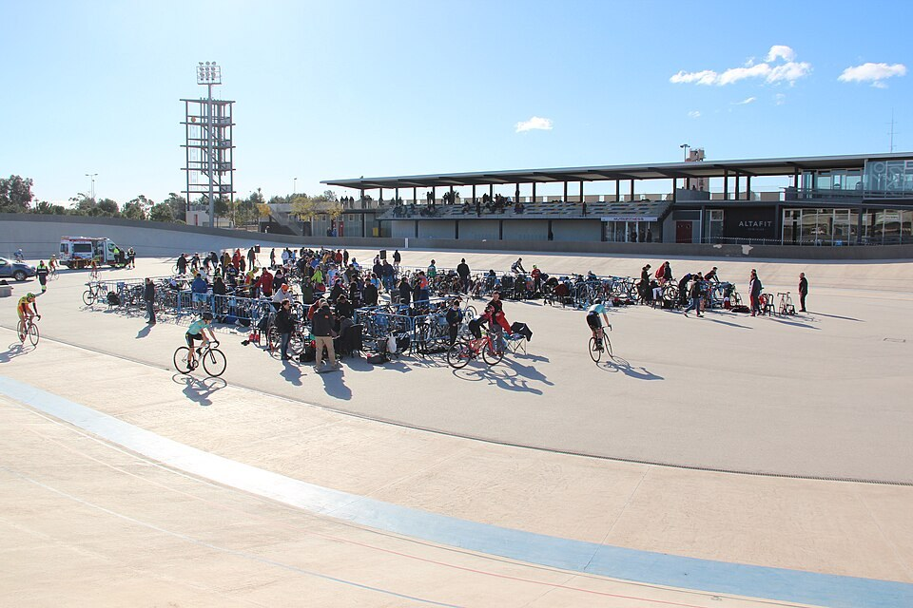
A track cycling venue. Photograph: Wikimedia Commons, CC0.
(a) Calculate the total distance travelled. [2]
____________________________________________________________________________________________
____________________________________________________________________________________________
(b) Calculate the average speed for the two laps. [2]
____________________________________________________________________________________________
____________________________________________________________________________________________
(c) State the displacement for the two laps and explain why it has this value. [2]
____________________________________________________________________________________________
____________________________________________________________________________________________
(d) Calculate the average velocity for the two laps. [2]
____________________________________________________________________________________________
____________________________________________________________________________________________
(e) The rider increases velocity along one straight from 5.0 to 13.0 m/s in 4.0 s. Calculate acceleration. [2]
____________________________________________________________________________________________

Question 2 A training trolley [10 marks]
A trolley moves along a straight track. The graph gives its speed over 14 s. Assume straight-line motion in one direction, so the area under the graph gives distance. Show how you divide the area into simple shapes.
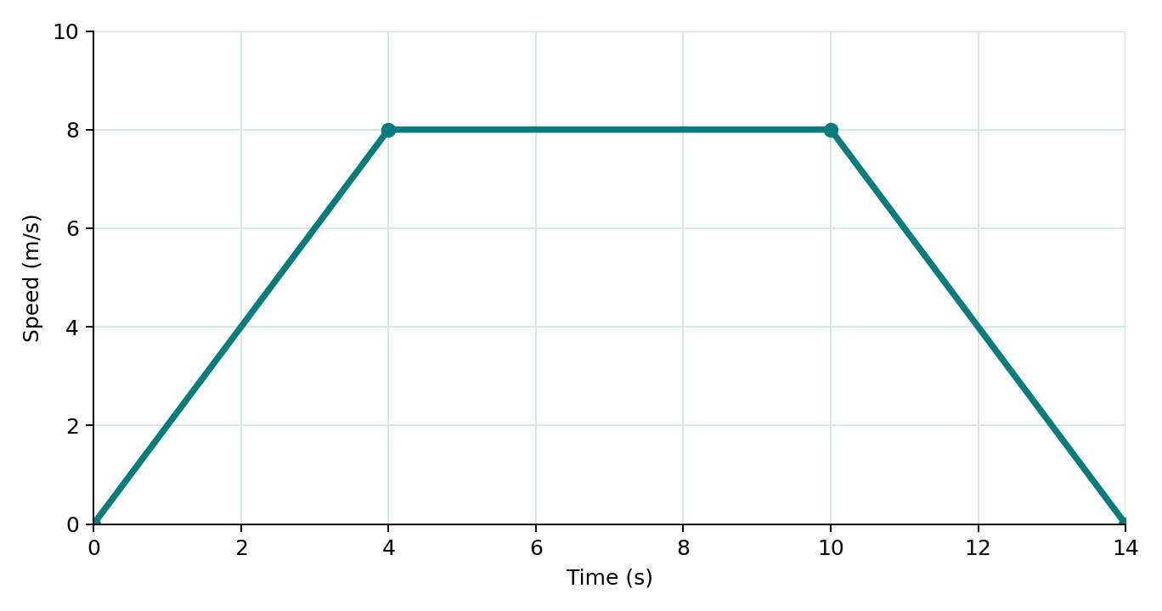
Speed of the trolley against time; each plotted point has an exact value.
(a) Calculate acceleration in the first 4 s. [2]
____________________________________________________________________________________________
____________________________________________________________________________________________
(b) State the motion between 4 and 10 s, using the graph to support your answer. [2]
____________________________________________________________________________________________
____________________________________________________________________________________________
(c) Calculate the distance travelled between 0 and 10 s. [3]
____________________________________________________________________________________________
____________________________________________________________________________________________
____________________________________________________________________________________________
(d) Calculate the distance travelled between 10 and 14 s. [2]
____________________________________________________________________________________________
____________________________________________________________________________________________
(e) State the total distance travelled in 14 s. [1]
____________________________________________________________________________________________

Question 3 Pushing a trolley [10 marks]
A person pushes a trolley of mass 40 kg on level ground. The horizontal push is 120 N to the right and the resistive force is 40 N to the left. Its weight acts downwards. The free-body figure shows forces acting on the trolley, not on the person.

A person pushing a trolley. Photograph: Wikimedia Commons, CC0.
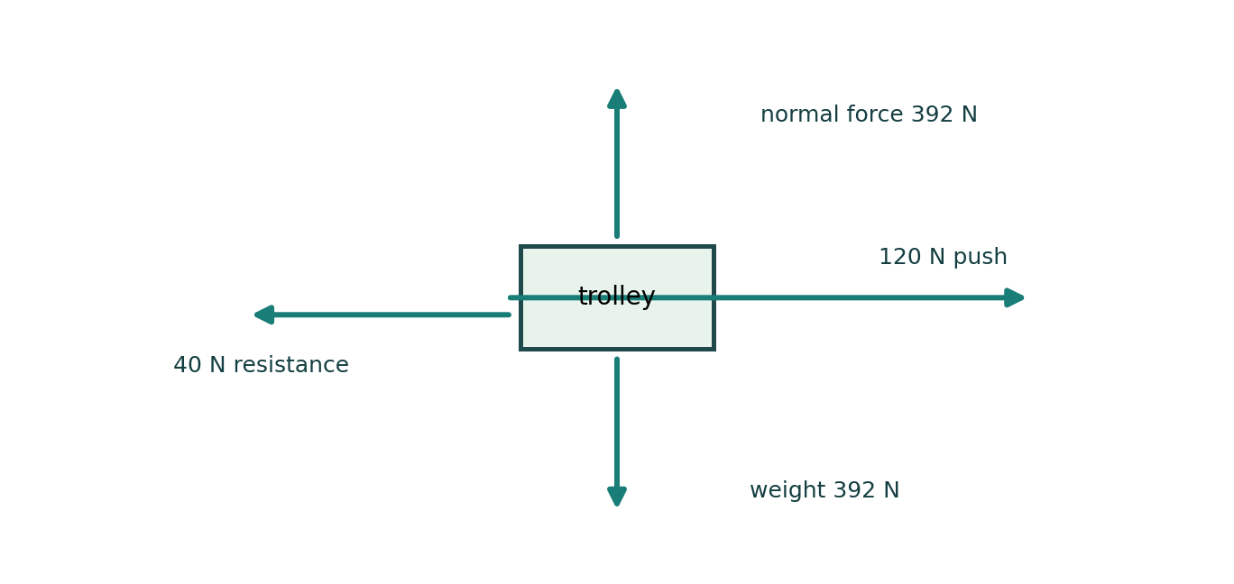
Force arrows on the trolley; upward and downward forces balance.
(a) Calculate the horizontal resultant force and give its direction. [2]
____________________________________________________________________________________________
____________________________________________________________________________________________
(b) Calculate the acceleration of the trolley. [2]
____________________________________________________________________________________________
____________________________________________________________________________________________
(c) Calculate the weight of the trolley. [2]
____________________________________________________________________________________________
____________________________________________________________________________________________
(d) Name the upward force and explain why its magnitude equals the weight. [2]
____________________________________________________________________________________________
____________________________________________________________________________________________
(e) The trolley wheels push backwards on the ground. State the reaction force and the object it acts on. [2]
____________________________________________________________________________________________

Question 4 A model coaster on a track [10 marks]
A model car of mass 2.0 kg starts from rest at a point 5.0 m above the bottom of a track. Treat the car as a single object. First assume that no energy is transferred to the surroundings; then consider resistive forces.
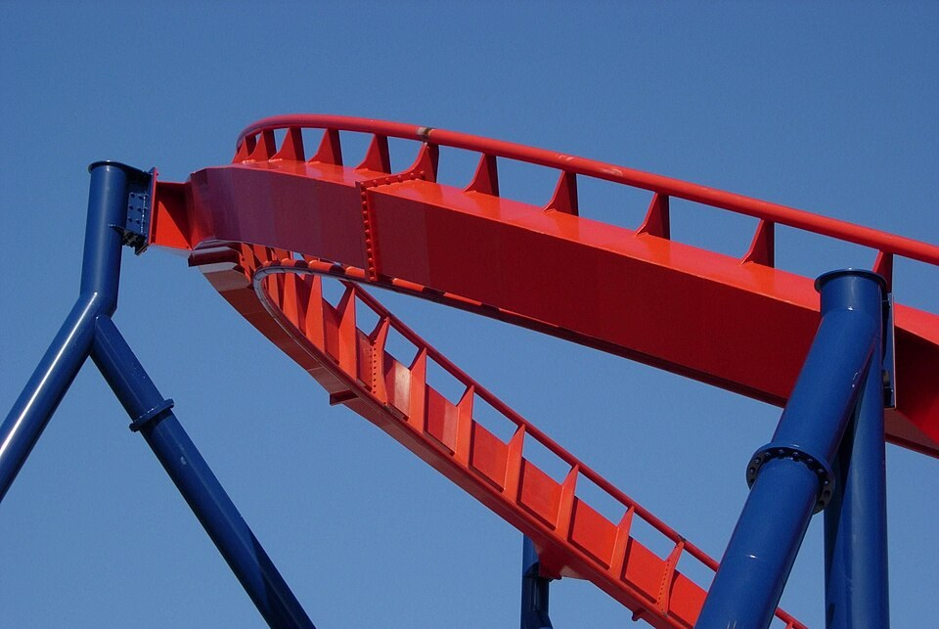
A roller coaster track. Photograph: Neal Ziring, public domain, Wikimedia Commons.
(a) Calculate the car’s initial gravitational potential energy relative to the bottom. [2]
____________________________________________________________________________________________
____________________________________________________________________________________________
(b) State the kinetic energy at the bottom if no energy is dissipated, and explain. [2]
____________________________________________________________________________________________
____________________________________________________________________________________________
(c) Calculate its speed at the bottom using Eₖ = ½mv². [3]
____________________________________________________________________________________________
____________________________________________________________________________________________
____________________________________________________________________________________________
(d) In a trial, the car has 82 J of kinetic energy at the bottom. Calculate energy transferred to other stores. [2]
____________________________________________________________________________________________
____________________________________________________________________________________________
(e) Name one store that could receive some of this energy. [1]
____________________________________________________________________________________________

Question 5 Climbing a staircase [10 marks]
Two students, each of mass 60 kg, climb the same staircase through a vertical height of 3.0 m. Student A takes 6.0 s, while student B takes 9.0 s. Assume the useful work against gravity equals the change in gravitational potential energy.
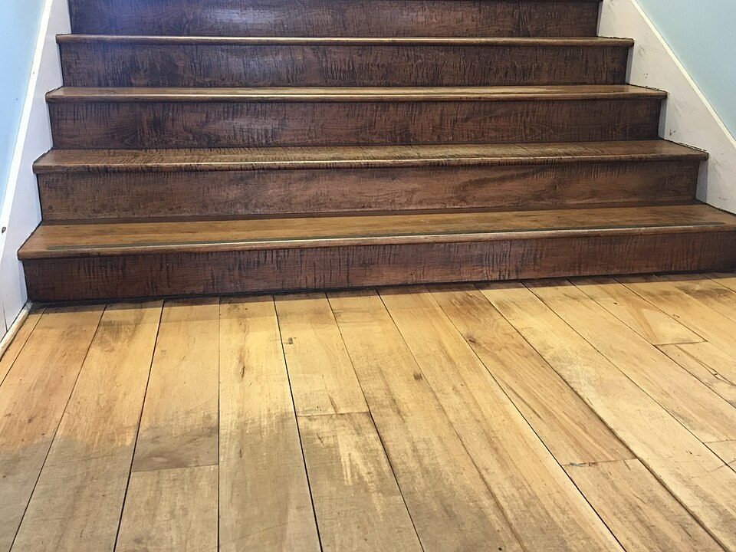
A staircase. Photograph: Wikimedia Commons, CC0.
(a) Calculate the gain in gravitational potential energy for one student. [3]
____________________________________________________________________________________________
____________________________________________________________________________________________
____________________________________________________________________________________________
(b) Calculate the average useful power of student A. [2]
____________________________________________________________________________________________
____________________________________________________________________________________________
(c) Calculate the average useful power of student B. [2]
____________________________________________________________________________________________
____________________________________________________________________________________________
(d) Explain why their useful powers differ although they climb the same height. [2]
____________________________________________________________________________________________
____________________________________________________________________________________________
(e) State the unit equivalence for one watt. [1]
____________________________________________________________________________________________

Question 6 A delivery winch [10 marks]
A motor drives a winch that lifts a crate vertically. The upward force exerted by the winch is 800 N over 25 m in 4.0 s. A second smaller crate of mass 6.0 kg is then set down motionless on a horizontal platform. The values in the question describe an idealised setup.
Moving a load. Photograph: Wikimedia Commons, CC0; used as context only.
(a) Calculate the work done by the 800 N force during the lift. [2]
____________________________________________________________________________________________
____________________________________________________________________________________________
(b) Calculate the average useful power delivered by the winch. [2]
____________________________________________________________________________________________
____________________________________________________________________________________________
(c) Calculate the weight of the 6.0 kg crate. [2]
____________________________________________________________________________________________
____________________________________________________________________________________________
(d) State the normal force on the motionless crate and its direction. [2]
____________________________________________________________________________________________
____________________________________________________________________________________________
(e) The winch is stopped while holding the first crate still. Explain why its upward force does no mechanical work on the stationary crate during this interval, even though a force acts. [2]
____________________________________________________________________________________________
____________________________________________________________________________________________

