Year 11 Electricity and Magnetism Answer Booklet
  - Mark scheme for the 60 mark exam style practice paper
Award the marks shown for each point. Accept equivalent scientific wording and correct alternative methods. In calculation questions, give the method marks when the stated working is correct even if a later arithmetic error occurs.

Question 1 Static electricity [8 marks]
(a) Electrons move from the wool cloth to the plastic rod (1); the cloth is left positively charged (1). [2]
(b) The negative rod repels electrons in the near side of the neutral paper (1); the near side becomes relatively positive while the far side becomes relatively negative (1); the attraction between opposite charges at the nearer side is stronger than the repulsion at the farther side, giving a net attraction (1). [3]
(c) Charge separation occurs in the cloud (1); the charged cloud induces opposite charge at the ground or creates a large potential difference (1); when the electric field is strong enough the air ionises and charge flows through the conducting path as a discharge (1). [3]

Question 2 Meters and a lamp [10 marks]
(a) X is an ammeter (1), placed in series so the same current passes through it and the lamp (1). Y is a voltmeter (1), connected in parallel across the lamp to measure its potential difference (1). [4]
(b) R = V ÷ I (1) = 9 ÷ 0.30 (1) = 30 Ω (1). [3]
(c) P = VI (1) = 9 × 0.30 = 2.7 W (1). [2]
(d) Each coulomb transfers 9 J of energy in the lamp. [1]

Question 3 Lamps in series [10 marks]
(a) Rtotal = R A + R B (1) = 4 + 8 = 12 Ω (1). [2]
(b) I = V ÷ Rtotal (1) = 12 ÷ 12 = 1.0 A through A and B (1). [2]
(c) V B = I × R B (1) = 1.0 × 8 = 8 V (1). [2]
(d) V A = 4 V, from IR or 12 − 8. [1]
(e) Total resistance increases (1), so current in the series circuit decreases (1), and the original lamps become dimmer because each transfers less power (1). [3]

Question 4 Lamps in parallel [10 marks]
(a) A has 6 V (1) and B has 6 V (1); each branch is across the battery. [2]
(b) I A = V ÷ R A (1) = 6 ÷ 6 = 1 A (1). [2]
(c) I B = V ÷ R B (1) = 6 ÷ 3 = 2 A (1). [2]
(d) Itotal = 1 + 2 = 3 A. [1]
(e) P B = VI (1) = 6 × 2 = 12 W (1). Accept V²/R. [2]
(f) The B branch is open, so only A draws current: 1 A. [1]

Question 5 A mixed circuit [10 marks]
(a) Vseries = IR (1) = 2.0 × 2 = 4 V (1). [2]
(b) Vparallel = 12 − 4 (1) = 8 V (1). [2]
(c) Ibranch = Vparallel ÷ Rbranch (1) = 8 ÷ 8 = 1 A in each branch (1). [2]
(d) At the junction 1 + 1 = 2 A (1). Around either complete loop 4 + 8 = 12 V (1). [2]
(e) New total R = 2 + 8 = 10 Ω (1); I = 12 ÷ 10 = 1.2 A (1). [2]

Question 6 Magnetic fields and a door lock [12 marks]
(a) The end nearest the bar magnet’s S pole becomes N (1). Opposite poles attract (1). [2]
(b) Award 1 for two curved external field lines emerging from N and entering S; 1 for arrows N → S. Do not award a straight line through the magnet as an external field line. [2]
(c) One approximately circular field line centred on the dot, with an anticlockwise arrow. [1]
(d) North pole. [1]
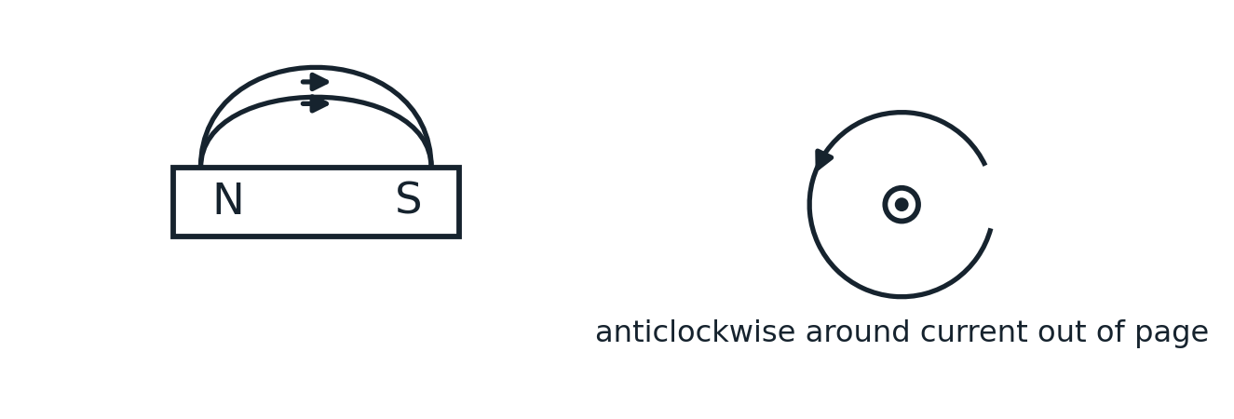

Question 6 e Extended response [6 marks]
Indicative content: Closing the switch allows current through the coil; the current produces a magnetic field and magnetises the soft iron core; the stronger field attracts the iron armature and moves the latch; opening the switch stops the current, the soft iron loses most magnetisation, and the return spring moves the armature back. More turns on the coil and a larger current each increase the field strength. Equivalent correct descriptions of the locking direction are acceptable.
Level 3 5–6 marks: Clear linked account of on and off operation, armature movement and core, with two valid strengthening methods. Level 2 3–4 marks: Mostly correct account of operation with some causal links and at least one relevant strengthening method. Level 1 1–2 marks: Isolated correct statements about the coil, core, attraction or switching. Level 0 0 marks: No relevant correct content.
For 6 marks, include all key stages with clear links. For 5 marks, allow one minor omission. Select the level first, then the mark within that level. [6]

Total 60 marks

