Year 11 Electricity and Magnetism Practice Paper
  - Original exam style questions • 60 marks • Suggested time 70 minutes
Name ____________________________________ Class __________ Date ______________
Answer every question. Show your working and include units in calculations. Write or draw in the spaces provided. Use the circuit figures for all numerical questions; the photographs provide context and do not specify the component values.
Useful equations: V = IR P = VI total series resistance = R₁ + R₂ + ...

Question 1 Static electricity [8 marks]
A pupil rubs a plastic rod with a wool cloth. The rod becomes negatively charged and attracts small neutral paper pieces.
(a) Describe the transfer of electrons between the cloth and rod, and state the charge left on the cloth. [2]
_____________________________________________________________________________________________
_____________________________________________________________________________________________
(b) Explain why the charged rod attracts a neutral paper piece. [3]
_____________________________________________________________________________________________
_____________________________________________________________________________________________
_____________________________________________________________________________________________
(c) Explain how a charged cloud can cause a lightning discharge to the ground. [3]
_____________________________________________________________________________________________
_____________________________________________________________________________________________
_____________________________________________________________________________________________

Photograph sources and licences
Meganbeckett27: https://commons.wikimedia.org/wiki/File:Electric_circuit_with_voltmeter_and_ammeter.JPG • https://creativecommons.org/licenses/by-sa/3.0/ (cropped)
Z22: https://commons.wikimedia.org/wiki/File:Exit_sign_-_inside.jpg • https://creativecommons.org/licenses/by-sa/4.0/ (cropped)
SeanShriner: https://commons.wikimedia.org/wiki/File:Nail_Electromagnet.JPG • https://creativecommons.org/licenses/by-sa/3.0/ (cropped)

Question 2 Meters and a lamp [10 marks]
A student tests a lamp for a lighting project. The photograph shows an example of laboratory meter apparatus. The circuit figure below shows the student’s test circuit; meters X and Y are unidentified. Assume the full 9 V is across the lamp.
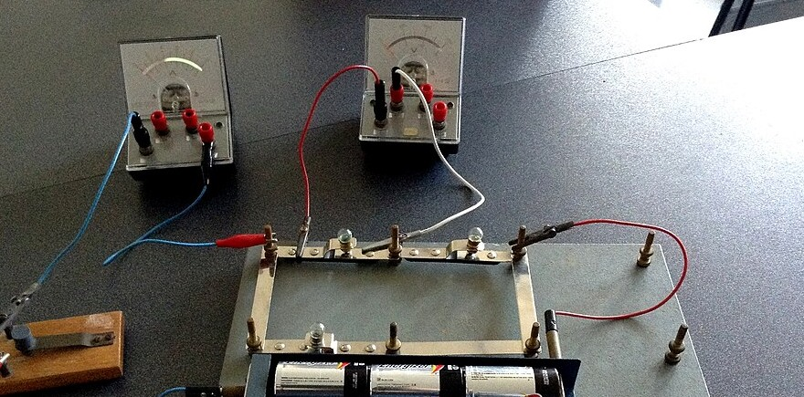
Photograph by Meganbeckett27, Wikimedia Commons, CC BY-SA 3.0; cropped. Source and licence links on page 1.
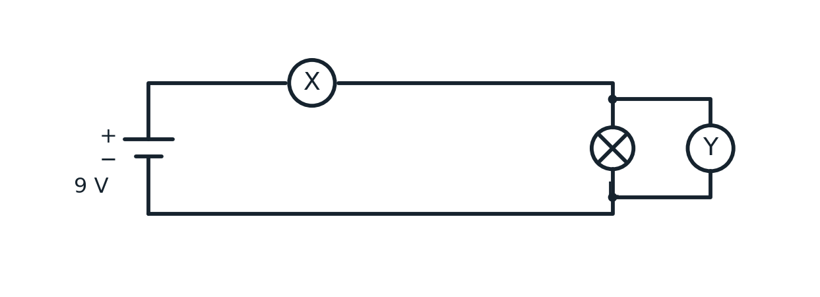
(a) Identify meters X and Y. Explain why each is connected in its shown position. [4]
_____________________________________________________________________________________________
_____________________________________________________________________________________________
_____________________________________________________________________________________________
(b) X reads 0.30 A. Calculate the resistance of lamp L at this operating point. Show your equation, substitution and answer with a unit. [3]
_____________________________________________________________________________________________
_____________________________________________________________________________________________
_____________________________________________________________________________________________
(c) Calculate the power transferred by the lamp. [2]
_____________________________________________________________________________________________
_____________________________________________________________________________________________
(d) State what a potential difference of 9 V means for each coulomb of charge passing through the lamp. [1]
_____________________________________________________________________________________________
_____________________________________________________________________________________________

Question 3 Lamps in series [10 marks]
The photograph shows two lamps in an opened emergency light. A student uses the circuit figure below to model two lamps A and B connected in series to a 12 V supply. For this question their resistances are 4 Ω and 8 Ω; treat them as constant.
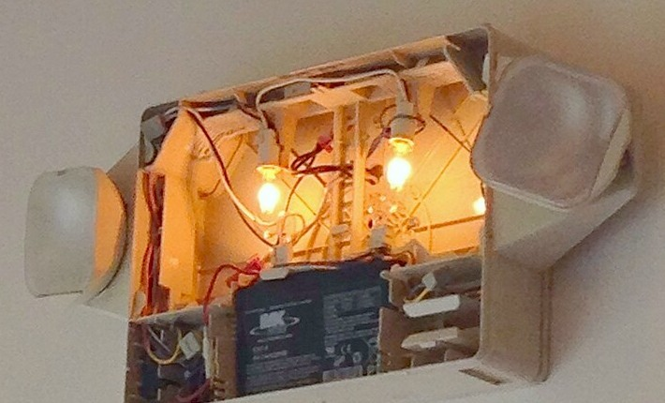
Photograph by Z22, Wikimedia Commons, CC BY-SA 4.0; cropped. Source and licence links on page 1.
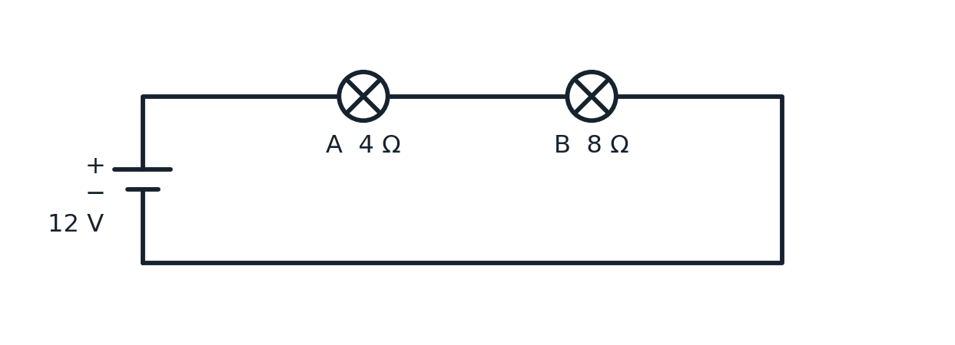
(a) Calculate the total circuit resistance. [2]
_____________________________________________________________________________________________
_____________________________________________________________________________________________
(b) Calculate the current through lamp A. [2]
_____________________________________________________________________________________________
_____________________________________________________________________________________________
(c) Calculate the potential difference across lamp B. [2]
_____________________________________________________________________________________________
_____________________________________________________________________________________________
(d) State the potential difference across lamp A. [1]
_____________________________________________________________________________________________
(e) Another lamp is added in series. Explain what happens to the total resistance, current and brightness of the original lamps. [3]
_____________________________________________________________________________________________
_____________________________________________________________________________________________
_____________________________________________________________________________________________

Question 4 Lamps in parallel [10 marks]
A student models the lighting in two rooms using the circuit figure below. Each room has one lamp; only the lamp in room B has switch S. S is closed at first. The lamp resistances are constant. Assume an ideal 6 V supply.
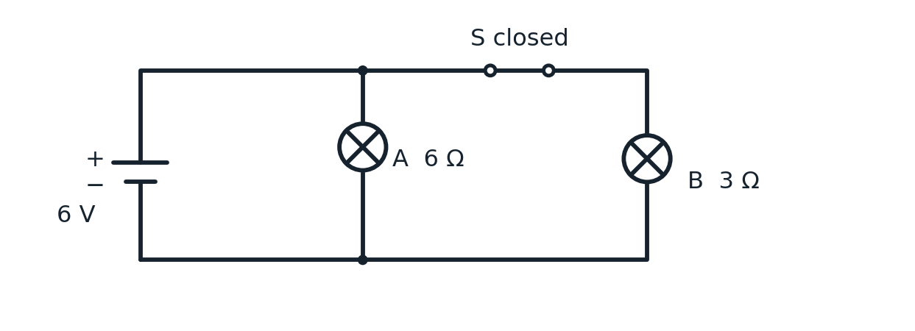
(a) State the potential difference across each lamp. [2]
_____________________________________________________________________________________________
_____________________________________________________________________________________________
(b) Calculate the current through lamp A. [2]
_____________________________________________________________________________________________
_____________________________________________________________________________________________
(c) Calculate the current through lamp B. [2]
_____________________________________________________________________________________________
_____________________________________________________________________________________________
(d) Calculate the total current supplied by the battery. [1]
_____________________________________________________________________________________________
(e) Calculate the power transferred by lamp B. [2]
_____________________________________________________________________________________________
_____________________________________________________________________________________________
(f) Switch S is opened. State the new current supplied by the battery. [1]
_____________________________________________________________________________________________

Question 5 A mixed circuit [10 marks]
A student models a low-voltage greenhouse heater using two 8 Ω heating elements. The circuit figure shows a 2 Ω resistor in series with the two parallel elements. The supply is 12 V and the ammeter reads 2.0 A. Assume ideal components.
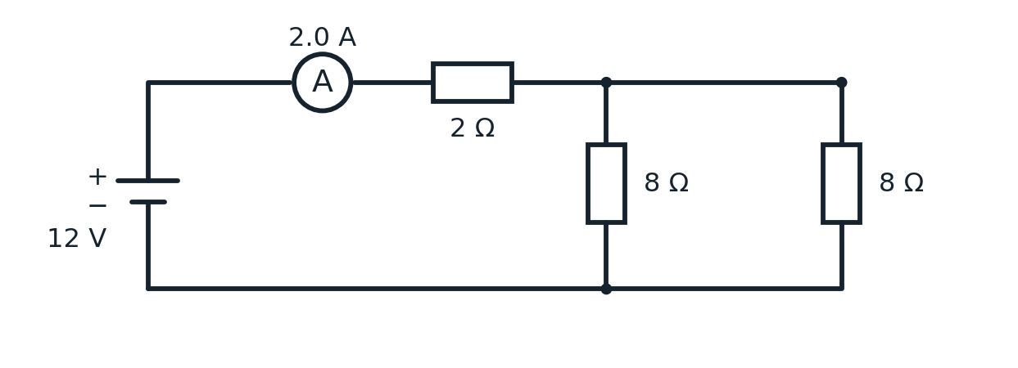
(a) Calculate the potential difference across the 2 Ω resistor. [2]
_____________________________________________________________________________________________
_____________________________________________________________________________________________
(b) Calculate the potential difference across the parallel branches. [2]
_____________________________________________________________________________________________
_____________________________________________________________________________________________
(c) Calculate the current in each 8 Ω branch. [2]
_____________________________________________________________________________________________
_____________________________________________________________________________________________
(d) Show that your answers obey both the junction rule for current and the loop rule for potential difference. [2]
_____________________________________________________________________________________________
_____________________________________________________________________________________________
(e) One 8 Ω branch breaks. Calculate the new total circuit resistance and battery current. [2]
_____________________________________________________________________________________________
_____________________________________________________________________________________________
_____________________________________________________________________________________________

Question 6 Magnetic fields and a door lock [12 marks]
The photograph shows wire wound around an iron core to make an electromagnet. A school model uses a similar coil with a soft iron core to attract an iron armature connected to a spring-loaded door latch. The field-line figure below shows a separate bar magnet near an unmagnetised nail and a wire viewed end-on; the dot means conventional current comes out of the page.
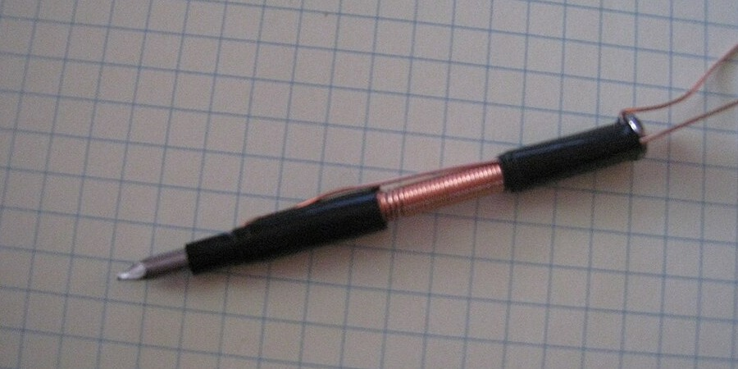
Photograph by SeanShriner, Wikimedia Commons, CC BY-SA 3.0; cropped. Source and licence links on page 1.
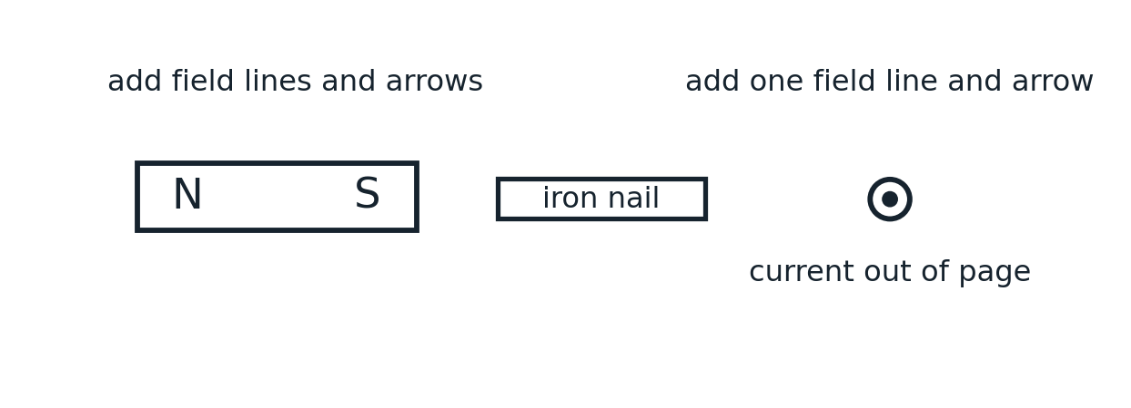
(a) State the pole induced at the end of the nail nearest the magnet and explain why the nail is attracted. [2]
_____________________________________________________________________________________________
(b) On the diagram, draw two external magnetic field lines around the bar magnet, including their direction arrows. [2]
(c) On the diagram, draw one circular magnetic field line around the wire, with a direction arrow. [1]
(d) Viewed from one end of a solenoid, current flows anticlockwise. State which magnetic pole this end becomes. Answer: __________ [1]
(e) Explain how closing and opening a switch moves the armature and operates the latch. Include the role of a soft iron core and two changes that would make the electromagnet stronger. [6]
_____________________________________________________________________________________________
_____________________________________________________________________________________________
_____________________________________________________________________________________________
_____________________________________________________________________________________________
_____________________________________________________________________________________________
_____________________________________________________________________________________________
_____________________________________________________________________________________________
_____________________________________________________________________________________________

