Year 11 Electricity and Magnetism Practice Paper
  - Original GCSE style questions • 60 marks • Suggested time 70 minutes
Name ____________________________________ Class __________ Date ______________
Answer every question. Show your working and include units in calculations. Write or draw in the spaces provided. The diagrams are part of the questions.
Useful equations: V = IR P = VI total series resistance = R₁ + R₂ + ...

Question 1 Static electricity [8 marks]
A pupil rubs a plastic rod with a wool cloth. The rod becomes negatively charged and attracts small neutral paper pieces. The diagram shows the arrangement after rubbing.
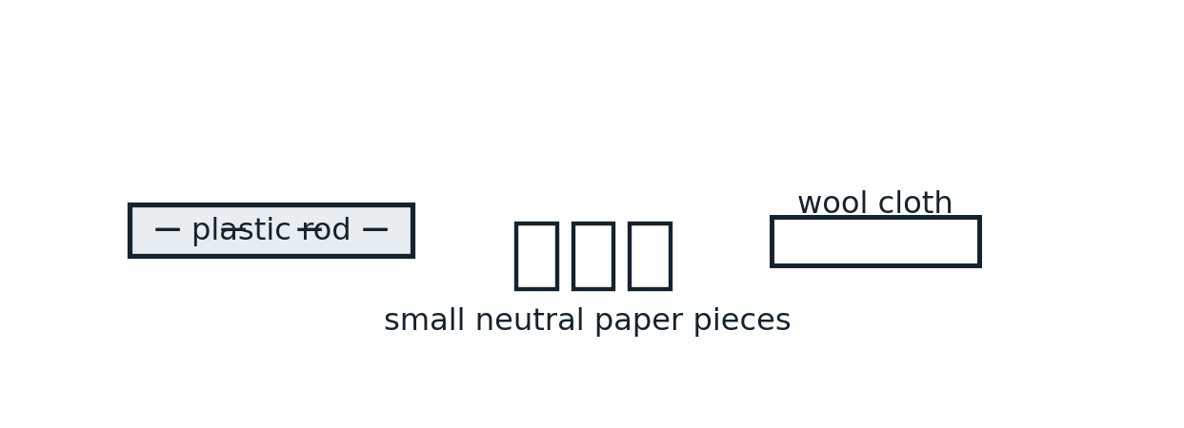
(a) Describe the transfer of electrons between the cloth and rod, and state the charge left on the cloth. [2]
_____________________________________________________________________________________________
_____________________________________________________________________________________________
(b) Explain why the charged rod attracts a neutral paper piece. [3]
_____________________________________________________________________________________________
_____________________________________________________________________________________________
_____________________________________________________________________________________________
(c) Explain how a charged cloud can cause a lightning discharge to the ground. [3]
_____________________________________________________________________________________________
_____________________________________________________________________________________________
_____________________________________________________________________________________________

Question 2 Meters and a lamp [10 marks]
A student tests a lamp for a model lighting project. Figure 2A shows the bench apparatus. Figure 2B is the circuit the student uses: the letters have been removed from meters X and Y. Assume the full 9 V is across the lamp.
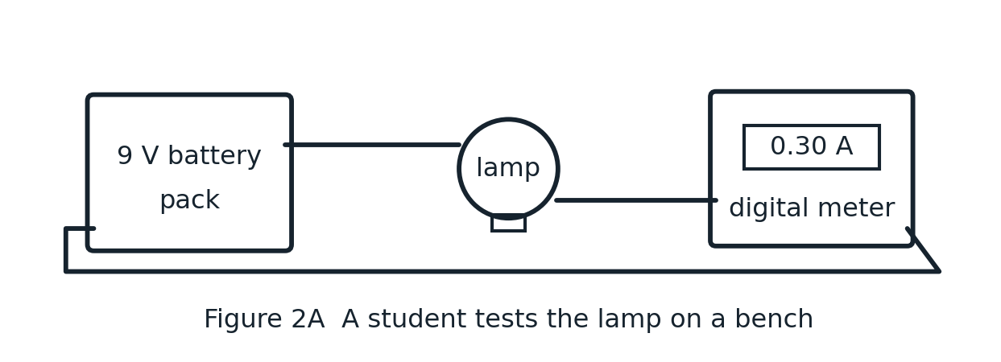
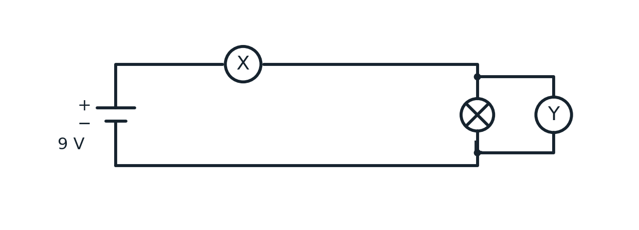
(a) Identify meters X and Y. Explain why each is connected in its shown position. [4]
_____________________________________________________________________________________________
_____________________________________________________________________________________________
_____________________________________________________________________________________________
(b) X reads 0.30 A. Calculate the resistance of lamp L at this operating point. Show your equation, substitution and answer with a unit. [3]
_____________________________________________________________________________________________
_____________________________________________________________________________________________
_____________________________________________________________________________________________
(c) Calculate the power transferred by the lamp. [2]
_____________________________________________________________________________________________
_____________________________________________________________________________________________
(d) State what a potential difference of 9 V means for each coulomb of charge passing through the lamp. [1]
_____________________________________________________________________________________________
_____________________________________________________________________________________________

Question 3 Lamps in series [10 marks]
A student builds a model vehicle with two rear lamps A and B. Figure 3A shows the model. Figure 3B shows the wiring to a 12 V supply. At this operating point the lamp resistances are 4 Ω and 8 Ω; treat them as constant.
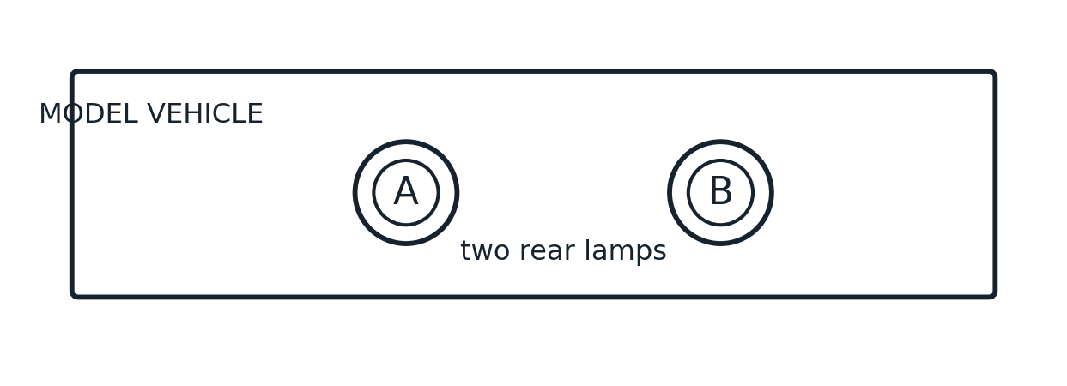
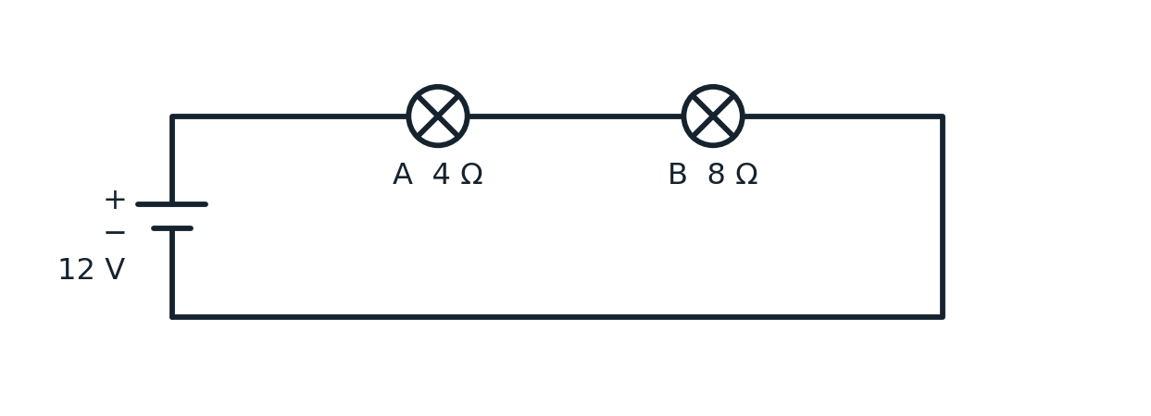
(a) Calculate the total circuit resistance. [2]
_____________________________________________________________________________________________
_____________________________________________________________________________________________
(b) Calculate the current through lamp A. [2]
_____________________________________________________________________________________________
_____________________________________________________________________________________________
(c) Calculate the potential difference across lamp B. [2]
_____________________________________________________________________________________________
_____________________________________________________________________________________________
(d) State the potential difference across lamp A. [1]
_____________________________________________________________________________________________
(e) Another lamp is added in series. Explain what happens to the total resistance, current and brightness of the original lamps. [3]
_____________________________________________________________________________________________
_____________________________________________________________________________________________
_____________________________________________________________________________________________

Question 4 Lamps in parallel [10 marks]
A student wires two rooms in a model house. Each room has a lamp; only room B has switch S. Figure 4A shows the model and Figure 4B shows its circuit with S closed. The lamp resistances are constant. Assume an ideal 6 V supply.
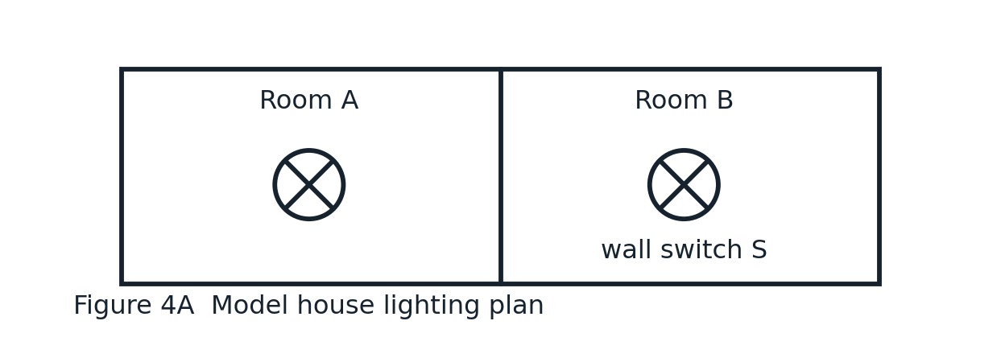
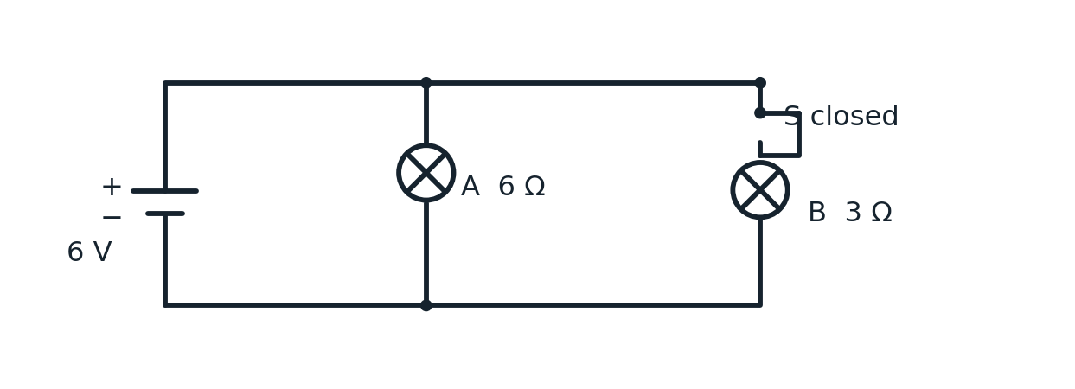
(a) State the potential difference across each lamp. [2]
_____________________________________________________________________________________________
_____________________________________________________________________________________________
(b) Calculate the current through lamp A. [2]
_____________________________________________________________________________________________
_____________________________________________________________________________________________
(c) Calculate the current through lamp B. [2]
_____________________________________________________________________________________________
_____________________________________________________________________________________________
(d) Calculate the total current supplied by the battery. [1]
_____________________________________________________________________________________________
(e) Calculate the power transferred by lamp B. [2]
_____________________________________________________________________________________________
_____________________________________________________________________________________________
(f) Switch S is opened. State the new current supplied by the battery. [1]
_____________________________________________________________________________________________

Question 5 A mixed circuit [10 marks]
A student tests a low-voltage greenhouse heater with two 8 Ω heating pads. Figure 5A shows the rig; Figure 5B shows a 2 Ω series resistor and the two parallel pads. The supply is 12 V and the ammeter reads 2.0 A. Assume ideal components.
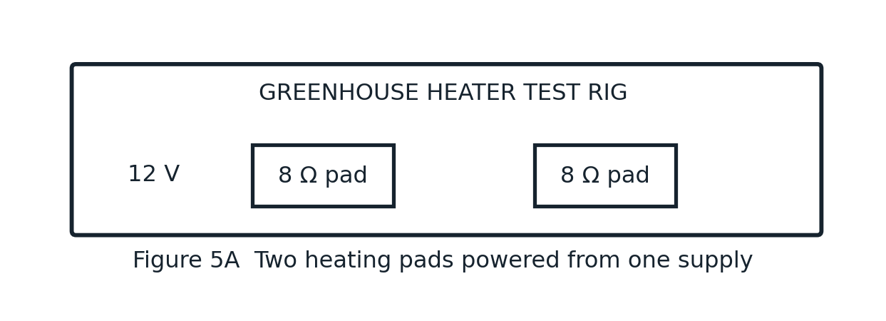
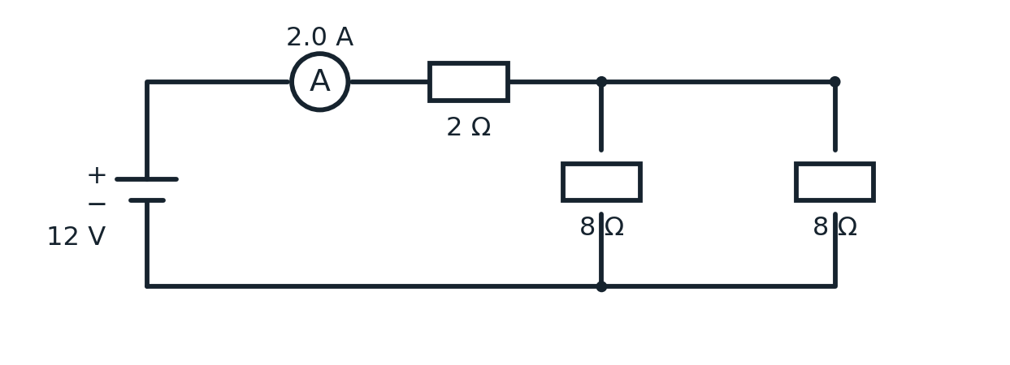
(a) Calculate the potential difference across the 2 Ω resistor. [2]
_____________________________________________________________________________________________
_____________________________________________________________________________________________
(b) Calculate the potential difference across the parallel branches. [2]
_____________________________________________________________________________________________
_____________________________________________________________________________________________
(c) Calculate the current in each 8 Ω branch. [2]
_____________________________________________________________________________________________
_____________________________________________________________________________________________
(d) Show that your answers obey both the junction rule for current and the loop rule for potential difference. [2]
_____________________________________________________________________________________________
_____________________________________________________________________________________________
(e) One 8 Ω branch breaks. Calculate the new total circuit resistance and battery current. [2]
_____________________________________________________________________________________________
_____________________________________________________________________________________________
_____________________________________________________________________________________________

Question 6 Magnetic fields and a door lock [12 marks]
A school model uses an electromagnet to operate a door latch. Figure 6A shows the coil, armature, spring and latch. Figure 6B shows a bar magnet near an unmagnetised nail and a wire viewed end-on: the dot means conventional current comes out of the page.
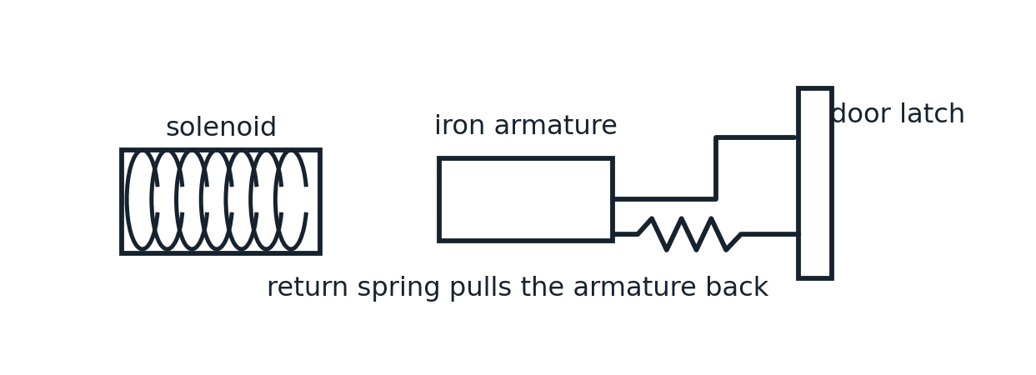
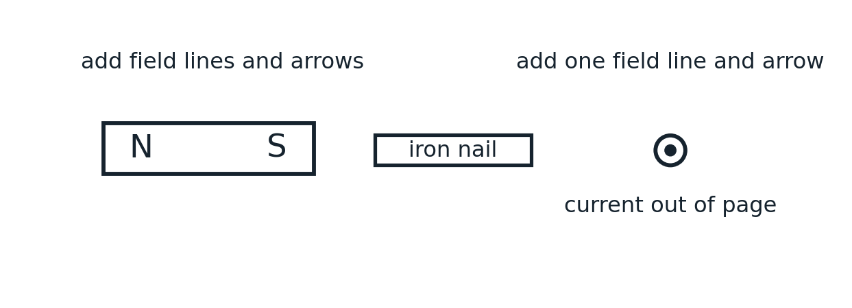
(a) State the pole induced at the end of the nail nearest the magnet and explain why the nail is attracted. [2]
_____________________________________________________________________________________________
(b) On the diagram, draw two external magnetic field lines around the bar magnet, including their direction arrows. [2]
(c) On the diagram, draw one circular magnetic field line around the wire, with a direction arrow. [1]
(d) Viewed from one end of a solenoid, current flows anticlockwise. State which magnetic pole this end becomes. Answer: __________ [1]
(e) Use Figure 6A to explain how closing and opening a switch moves the armature and operates the latch. Include the role of a soft iron core and two changes that would make the electromagnet stronger. [6]
_____________________________________________________________________________________________
_____________________________________________________________________________________________
_____________________________________________________________________________________________
_____________________________________________________________________________________________
_____________________________________________________________________________________________
_____________________________________________________________________________________________
_____________________________________________________________________________________________
_____________________________________________________________________________________________

