**Create Google Account Cheat Sheet**

1. Go to [www.google.com](http://www.google.com)
2. Click the sign in button on the top right.

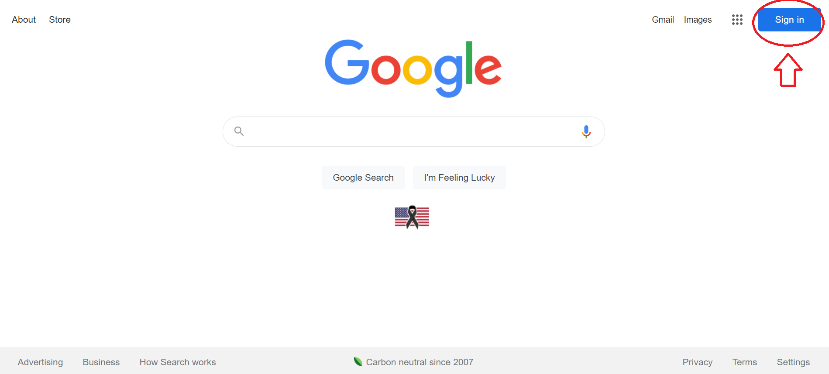

1. If you see a letter or picture in this space instead of the sign in button, then click that and go to add another account. This step is only necessary if you are already signed into a google account on your device.

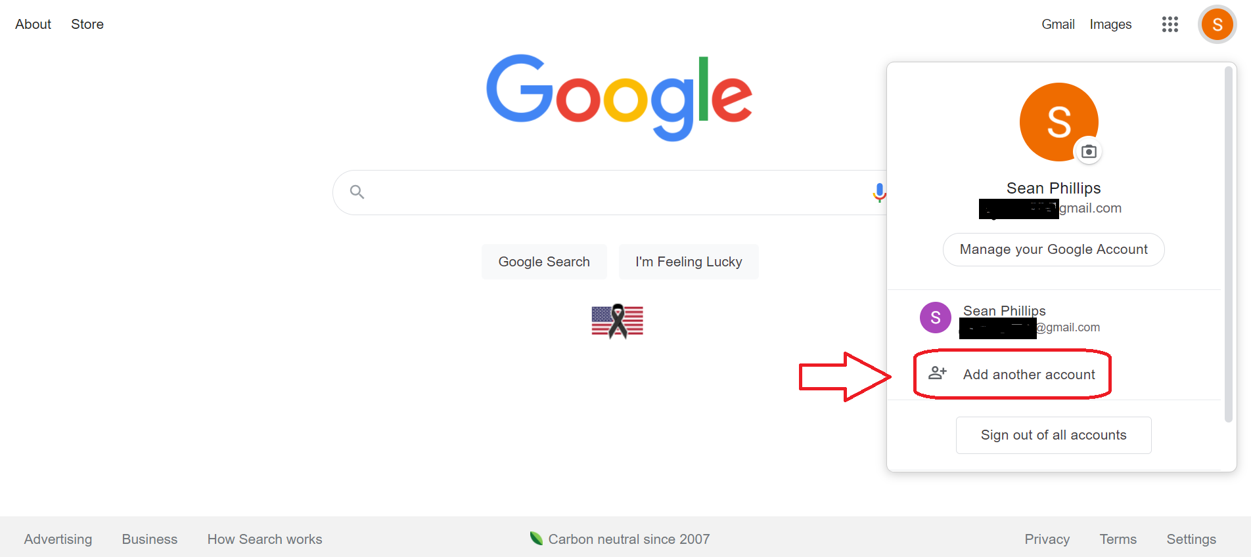

1. To setup a new google account click create account. If you’ve already done this then log in using your email and password.

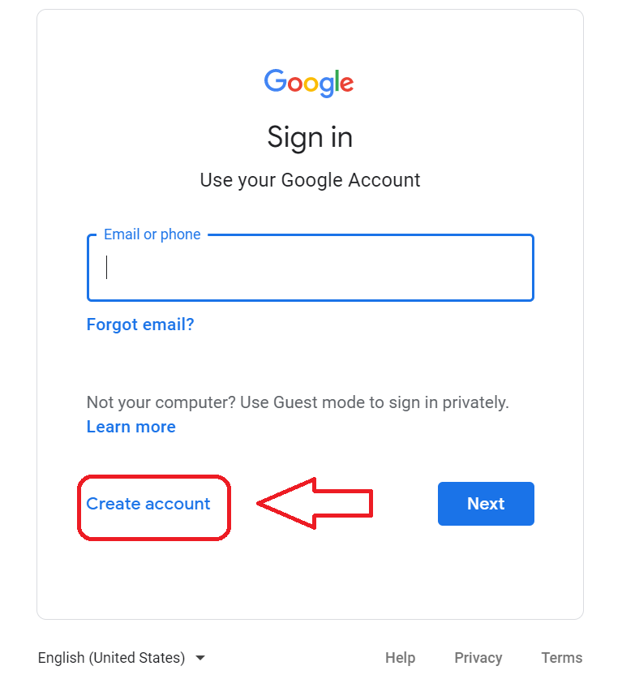

1. Click create account for myself.

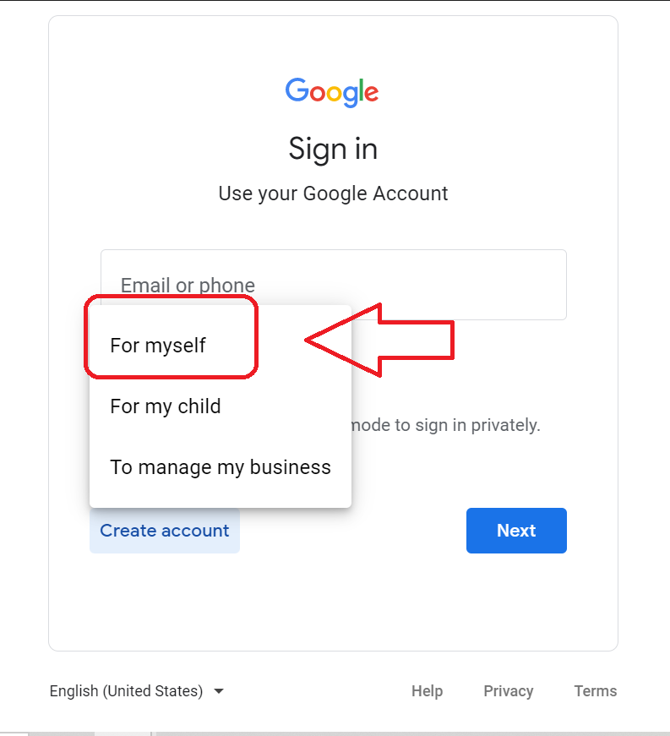

1. You will be prompted to enter your information. All fields are labeled on the website however I have provided arrows for additional support.
   1. The black arrow is where you enter your First and Last name.
   2. The green arrow is where you create what your new @gmail.com address will be. The program will indicate if the name you chose is being used by someone else and suggest replacements.
   3. The blue arrow is where you enter your new password. Remember a good password is unique, uses varied characters, and doesn’t use personal information in the password. Truly random passwords are best however, here is a couple tips for passwords. For example, Sphillips1 is a bad password for me. Sunshine31 would be better. This password is still not very complicated so a better option would be $unshEyeN385. This password has more special characters, is more random, and is still easier to remember then a truly random password.
   4. Click the next button shown by the red arrow.

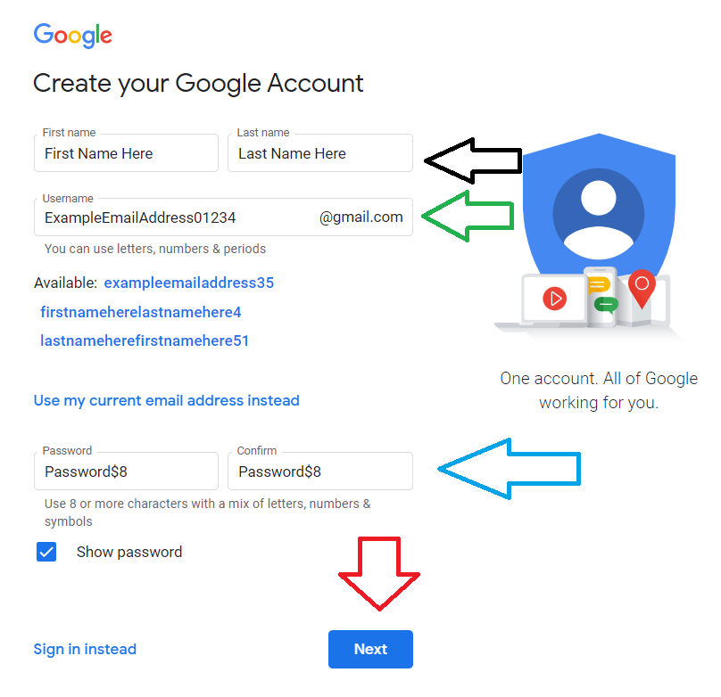

1. **VERY IMPORTANT.** This screen allows you to enter your phone number and an email address to be used as two-factor authentication. This should be done every time. Not only will it make your account much more secure it will make password resets far easier. The blue arrow indicates the gender selection button. Google does require you to answer this question however, they provide “custom” and “prefer not to say” as options.

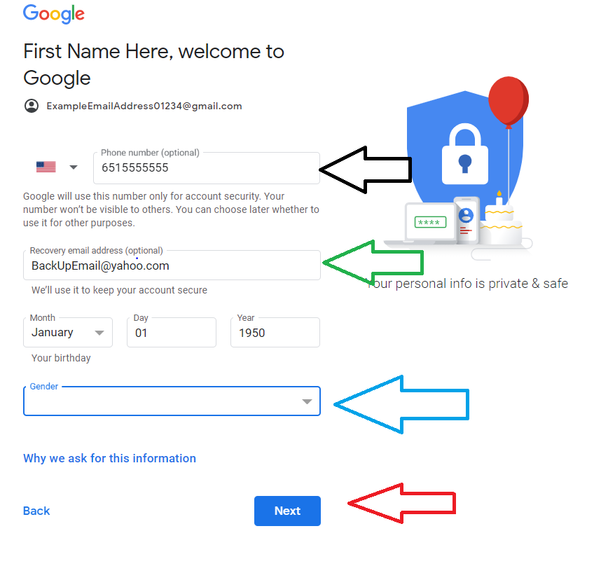

1. Google will send you a verification code to the phone number you provided. Enter the code they send you in the bar marked by the green arrow. If you have trouble getting the code, make sure your number is entered correctly as indicated by the black arrow. If you prefer a call to a text there is a button named “call instead” that I have labeled with a red star.

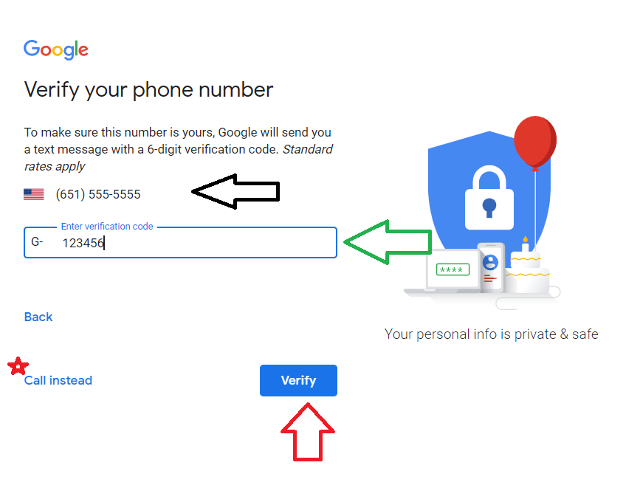

1. The next step is to agree to the terms of service. The agree button is all the way at the bottom on the right. This is the final step. Make sure to remember your chosen password. Congratulations on your new Google account.

