1. Given the function, I was able to play around with OpenGl to develop a 3d model. Function

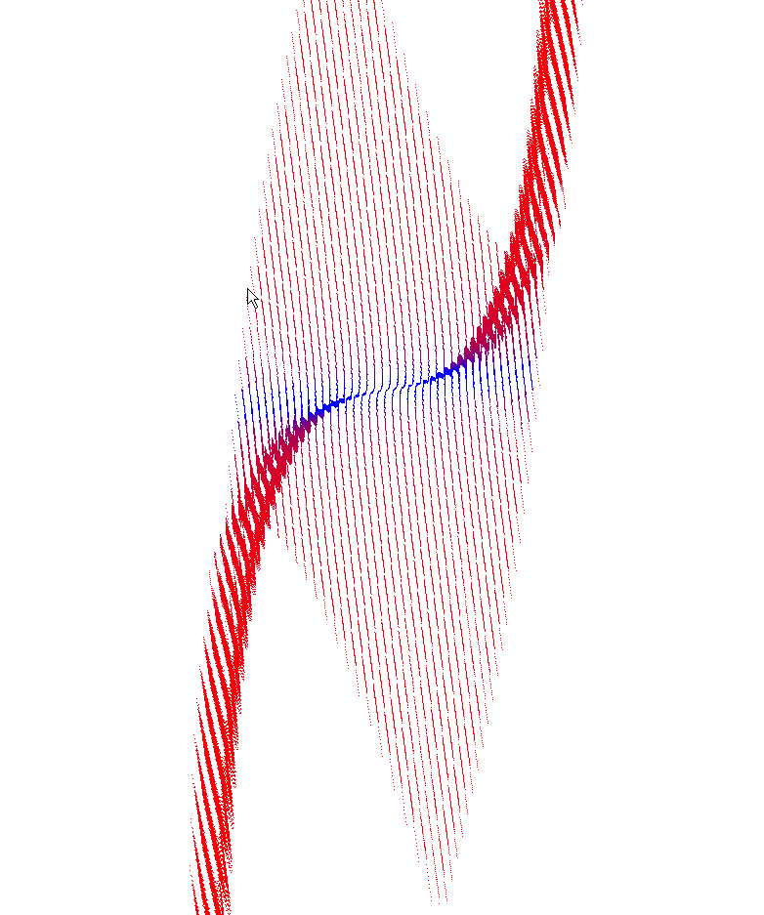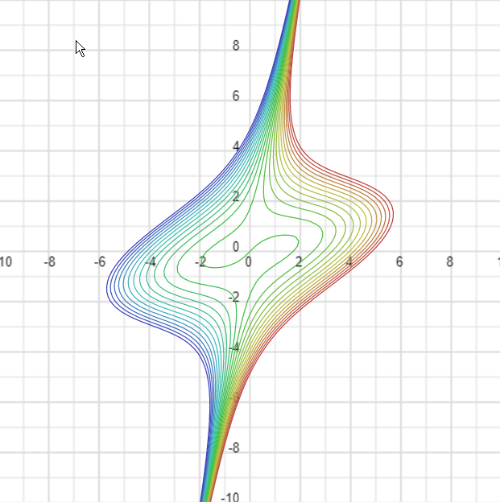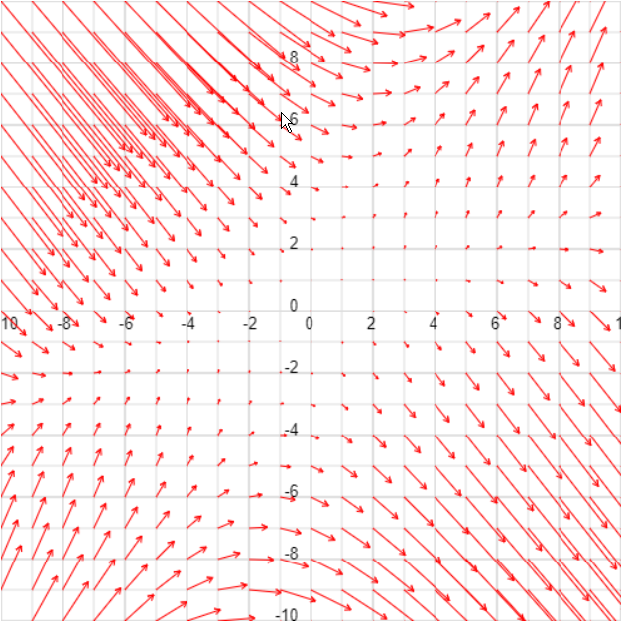

a. The gradient vectors are giving by solving the Derivative for the functions x and y.

d/x 🡪

d/y 🡪 -

This gives me the vector of motion for any given point (x, y). While looking at my 3d model I can help visually verify my work when searching for zero vectors by distinguishing slopes in space.

b.

X 🡪 3 = 🡪 1 = 🡪 ***1 =***

***Y 🡪***  1 =

**-----------------------------------------------------------------------------------**

D^2/X 🡪 (6x-6y, -6x+12y)

D^2/Y 🡪 (-6x+12y, 12x-6y)

Checking with mathlab code I got

**(1, 0) and (-1, 0) are local min and max**

**(*√*13/13, -2*√*13/13) and (-*√*13/13, 2*√*13/13) being saddle points.**

2.

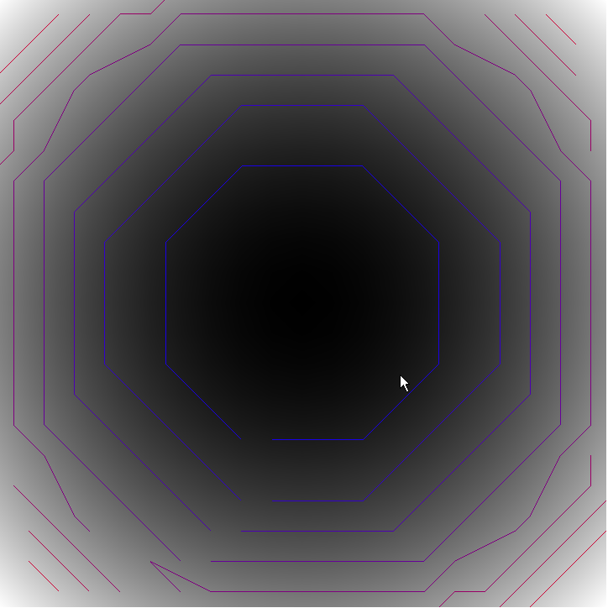

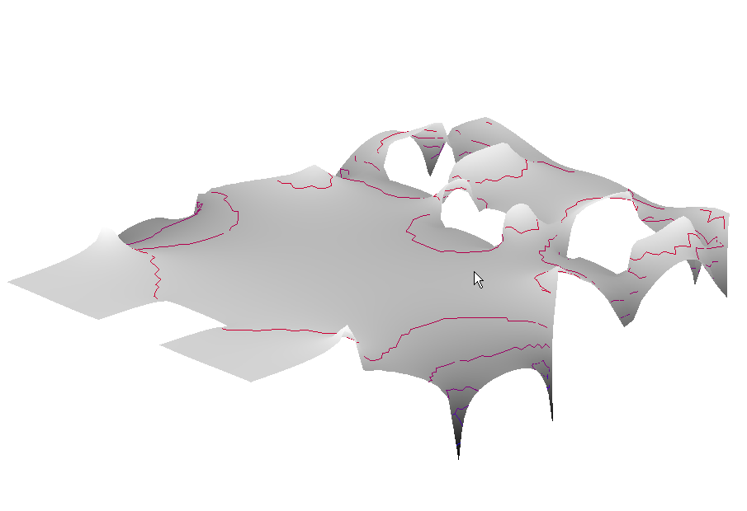A. I think contours are actually pretty intuitive to read. When comparing just contours to grey scale and color, contours give you more impression of elevation, whereas color just indicates change. With color it is hard to tell is the change is going up or down. With contours, this change seems to be much more distinct in direction on the z axis.

B. Combining contour with height is really cool. This gives a 3d image we can rotate and view. The contours generated seem to line up about where they need to be, and they give clear presence to each 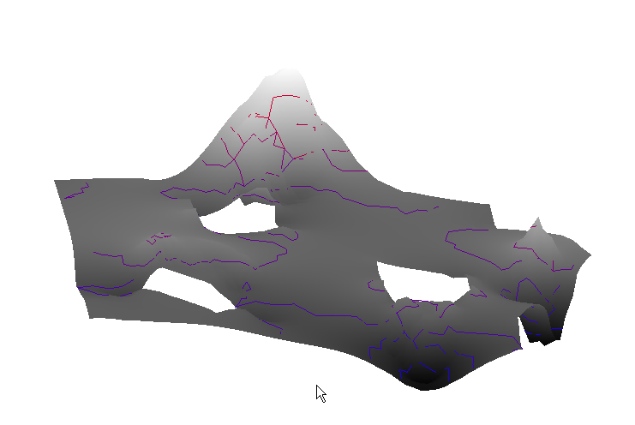elevation level. The data models look a lot like google map renderings, and what we would see in a mapping of height values.

C. With colors things get messy. Since we were asked to use the same colors from the last assignment, I had to mess with the contour coloring to getting something readable. I choose yellow that has a modified hue based on the map color. In red, the hue will shift into green, and in blue it will shift towards brown. The results can be found with image below:

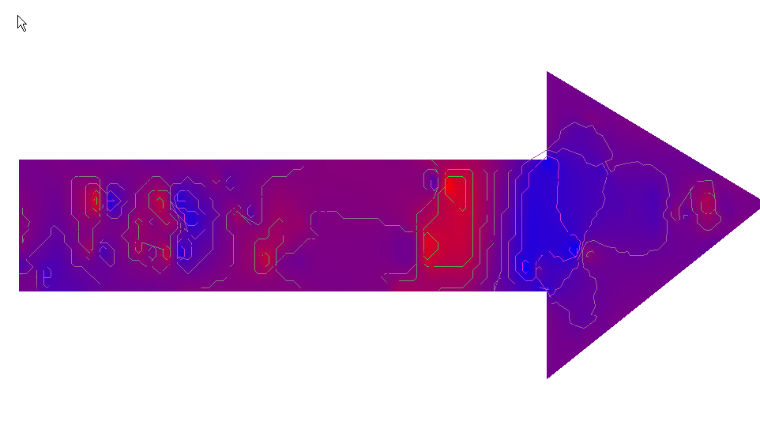

While still kind of busy, I can see this style of presentation being suitable for things like weather predictions.

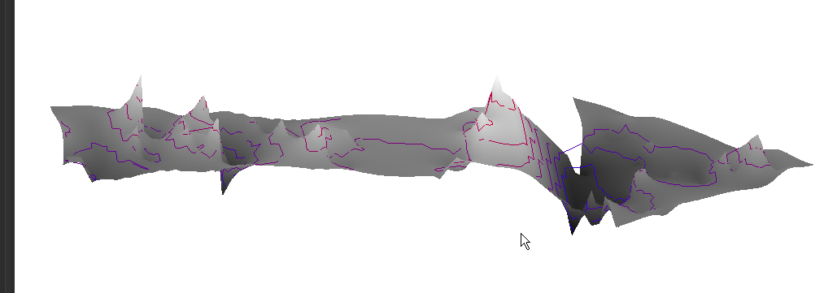

E. I think having a grey scale height map, with colored contours presents the best intuitive to read data (as seen above). It is quick to see and having less busy colors makes it more presentable.

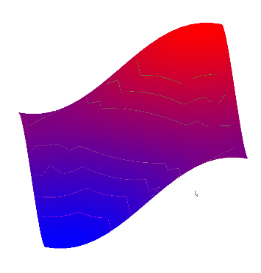 When adding color map, height, and contour coloring. It becomes increasingly difficult to preserve the data. I think this has to do with presenting the same data in too many ways. From my experience with this assignment, presenting data 2 methods combined seems to be perfect. When blending 3 or more methods things tend to look messy.

For 2d images I think color map with color contour works okay, but I visually prefer a grey scale map with color contours. If not grey scale, then very light colors could work better, just not full contrast like blue and red.

3.

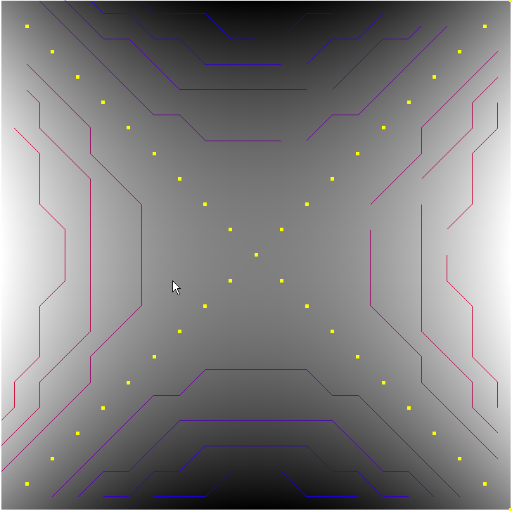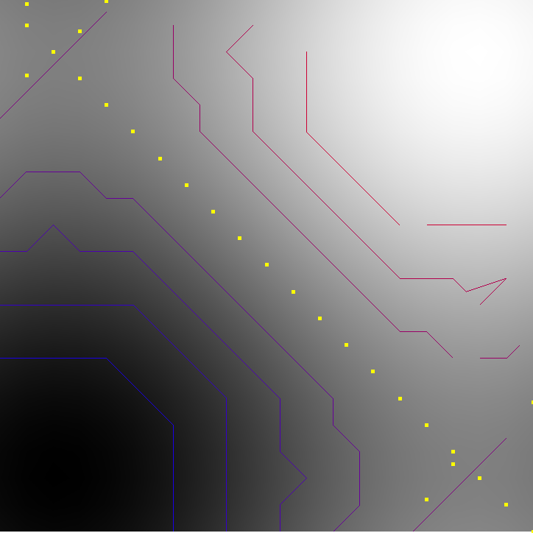

Sadly I spent about 12 hours alone of working out the critical points and was only able to achieve some success of a couple data sets. Extracting critical points let’s use visual max points, low points, and points where the change in elevation is the greatest (influx points). This can be important information depending on the data requirements. I think a good approach is to implement at least max and min points in contour maps to indicate where a peak is, bottom of a hole. This is usually always indicated on maps. Points like mountain peaks are always indicated, and this gives us more information of the formation of the terrain.