Demonstration of TU_Hand_5.0 Model in Gazebo: Usefullness (shown by successive screenshots)

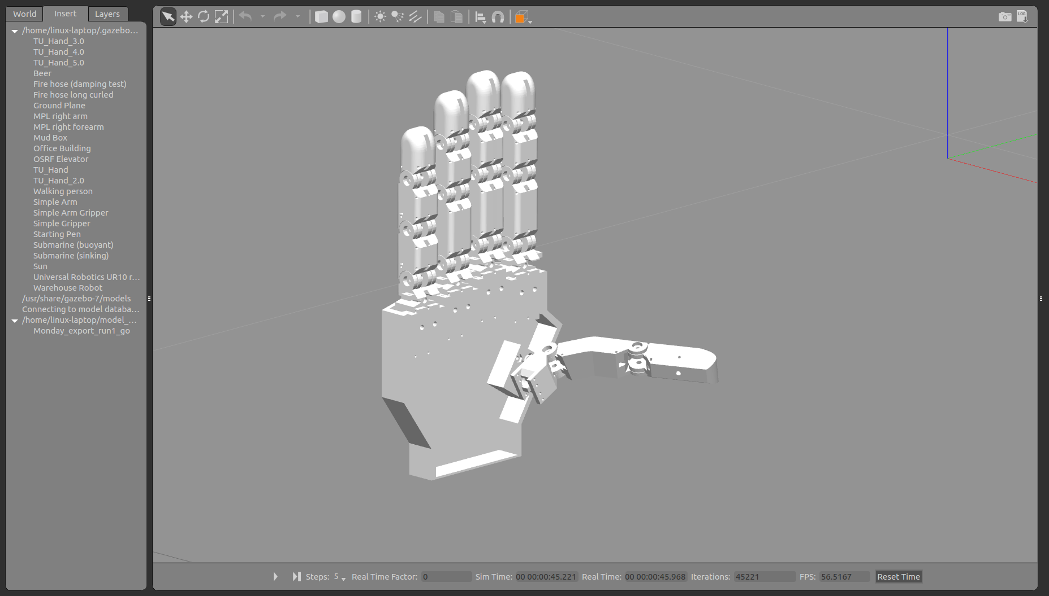

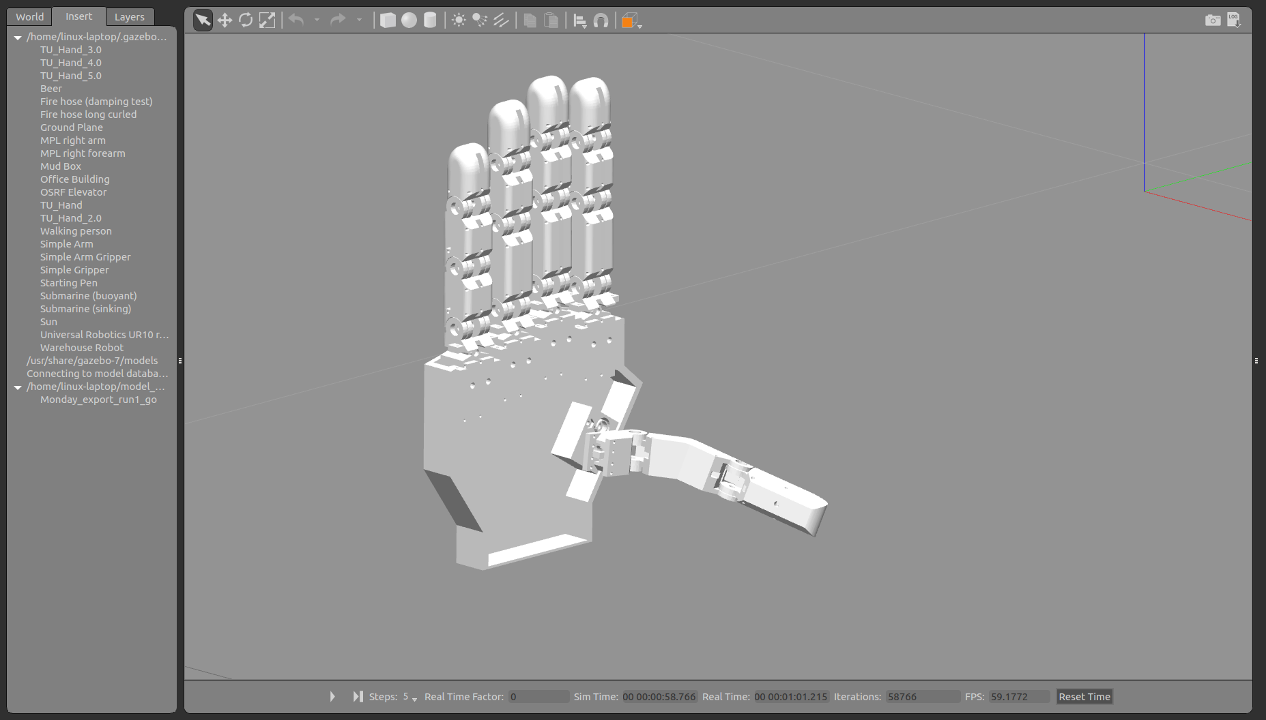
- As no control input to any joints is defined, all joints behave under gravity. The thumb MCP drops first, pulling the rest of the model with it.

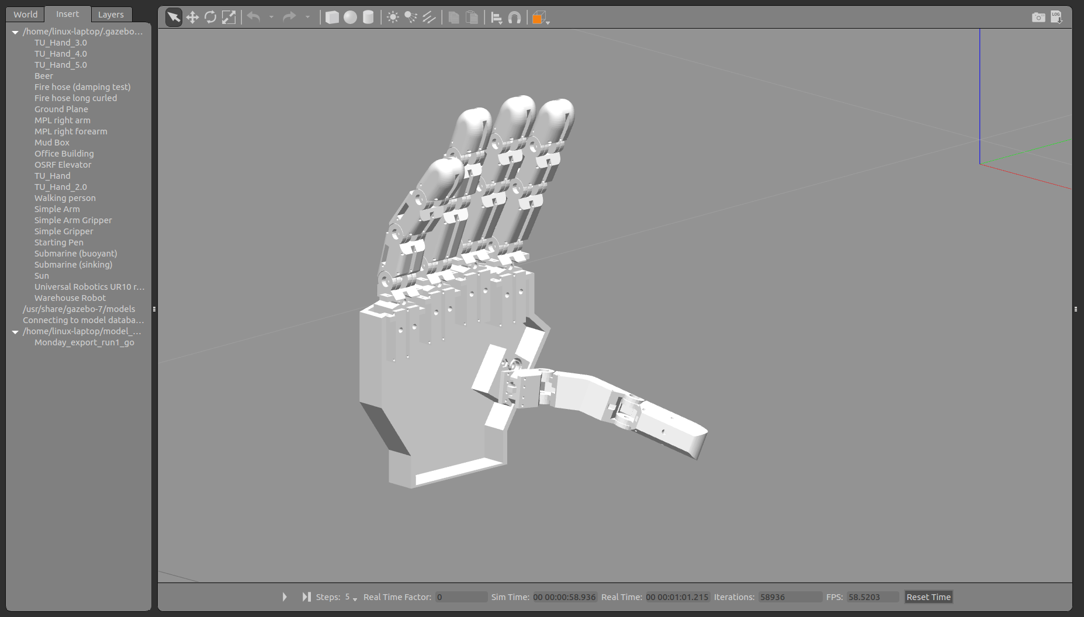

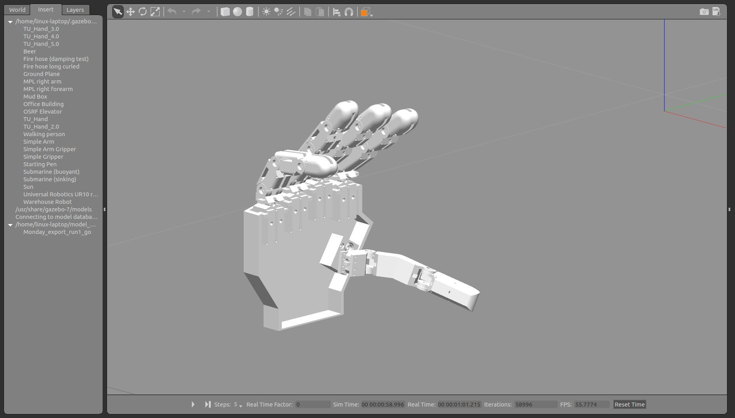
- The thumb’s stopping at its lower range of rotation also transmits a torque through the palm, pulling the fingers downward and causing them to flex inward. Note the reaction of each finger:
  - The Ring, Middle and Index fingers are each rotating almost in tandem (about the proximal MCP flexion axis) but at slightly different rates. The Index is the farthest here because it received the most input force from the dropping of the thumb, and the middle and ring follow at reasonable distances.
  - The Pinky is composed of 2 inertially identical links, therefore, instead of causing the middle flexion axis to remain at full extension as gravity takes hold, both joints of the pinky are about equally flexed by gravity. Note that like the other fingers, the MP/DP joint remains fully flexed (as the DP has the least significant inertial contribution). It has also fallen farther in general than the other fingers because of it’s proximal phalanx (which is really a middle phalanx)’s lesser inertial contribution.
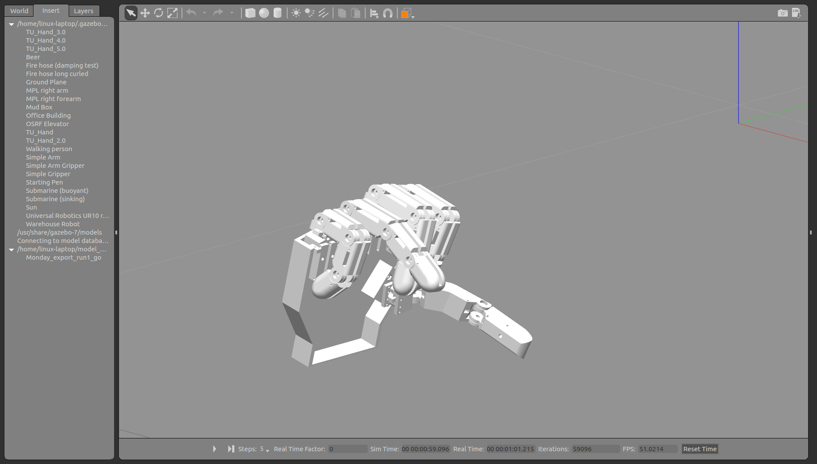
  - The hand falls forward as it is not linked to the global ground plane. All finger joints are somewhat flexed.
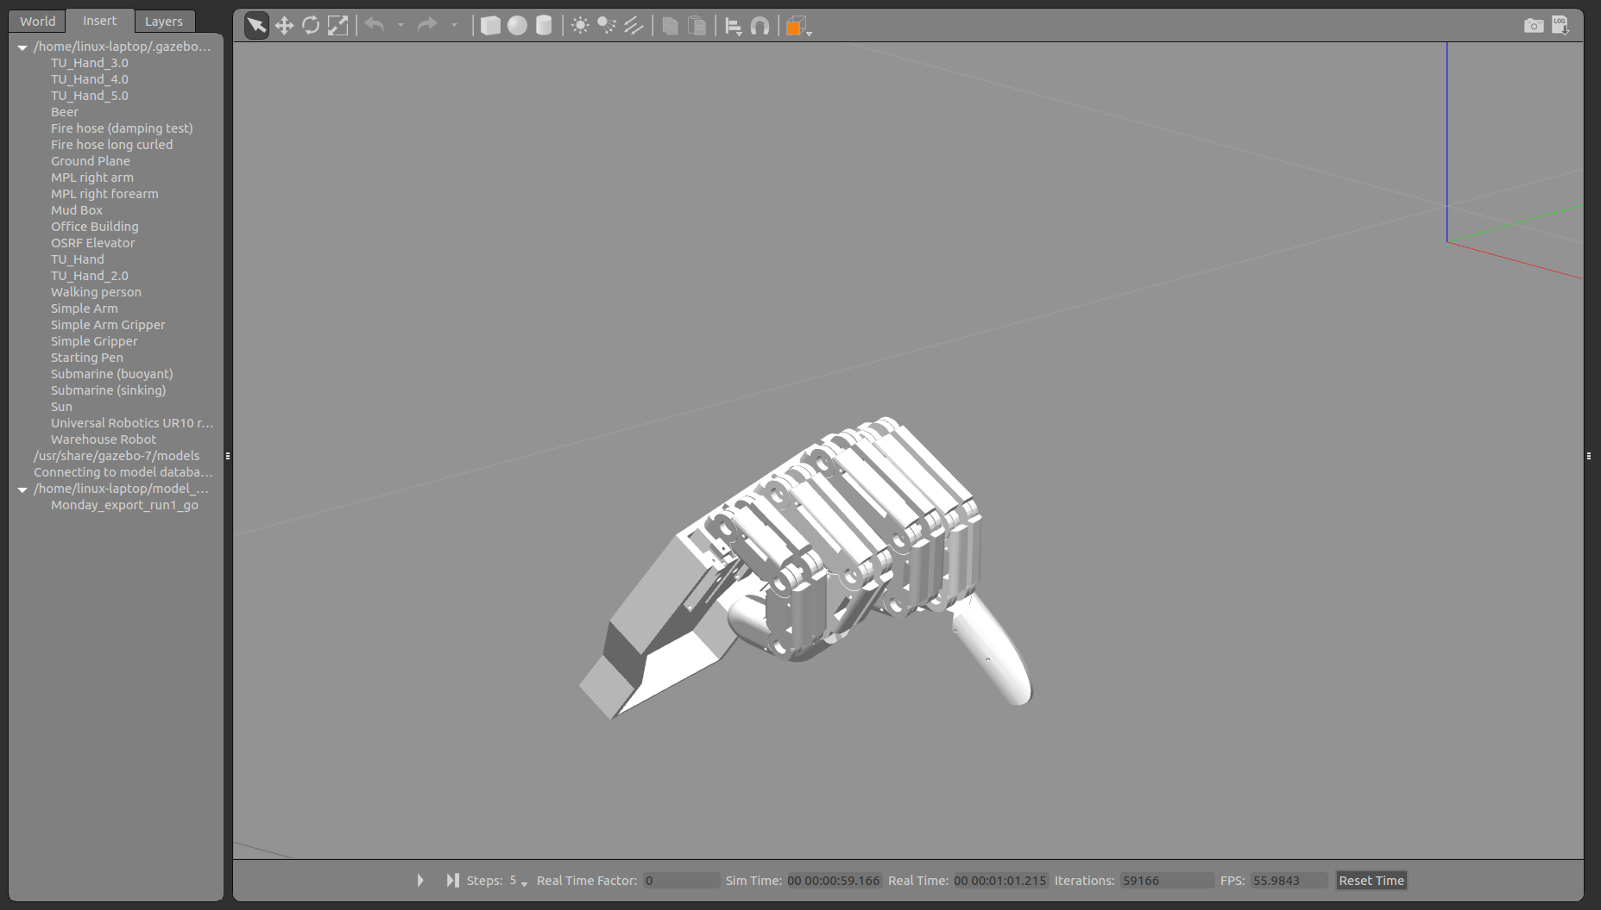
  - The inertial properties of the distal phalanges’ masses can be seen as they whip around and stop at their flexion joint limits (the hand made a full fist just before this screenshot) and from there all joints begin to release forward, momentum transferred into the palm when their joint limits were hit, and thus the fingers unfold somewhat as the hand falls forward.
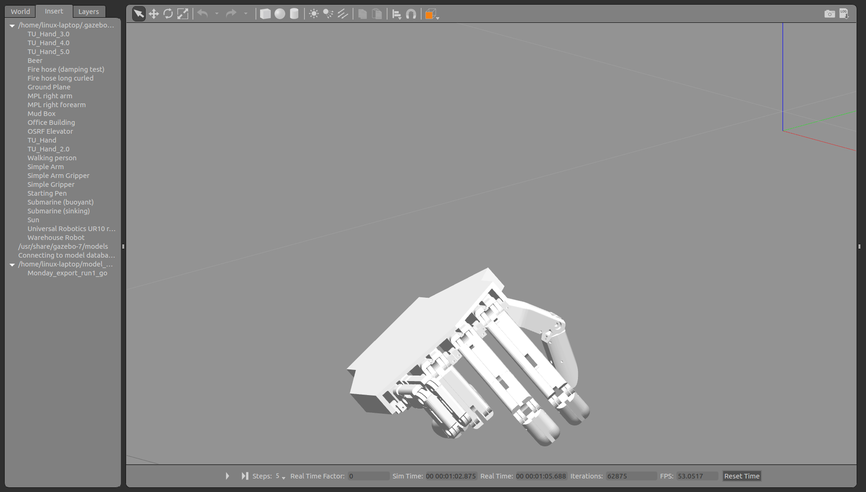
  - The final resting pose, fully underactuated excluding gravity, showing accurate joint limits.

