Term Project: Instant Messaging App
Architecture Document
Table of Contents
1 Introduction 2
1.1 Purpose 2
1.2 Target Audience 2
1.3 Terms and Definitions 2
2 Architectural Goals and Constraints 3
2.1 Security 3
2.2 Persistency 3
2.3 Reliability/Availability 3
3 System Overview 4
4 System Architecture 5
4.1 Front-end Architecture 5
4.2 Back-end Microservices Architecture 5
5 Database Design 6
6 Issue and Concerns 7

Introduction
Provide an overview of this architecture document and the product it describes.
The purpose of this document is to supply a comprehensive design of the Buzz App by focusing on usability, reliability, and maintainability. Buzz is an application that connects users from any location and enabling them to chat with other users.

Purpose
Provide a high-level description of the purpose of this document. How will this document help you or others when developing similar product?
This document will mainly address the context of the application and its notable requirements. The intention of this document is to help the team determine how the application will be structured. This document will give a detailed description of each component along with visuals to aid the team with developing. It is also intended for the project manager to use this document to validate that the team is meeting the feature requirements for the application.

Target Audience
Describe the target audience for this document.
The target audience for this document is the project manager and the development team. The project manager will be able to use this document to verify the team’s work and progress towards completion. The development team will use this document when developing to make certain that the requirements are fulfilled.

Terms and Definitions
Define any terms or acronyms you will be using in the remainder of this document.
The term app refers to application.

Architectural Goals and Constraints
Briefly describe the architecture of your product, then give more details respectively in both server side and client side. Tell us the architectural goals on non-functional system properties. (Chapter 4 p6-7) If there are constraints, how they affect or limit the system? (Chapter 4 p15-19)

Security
How does the system protect itself and users’ data from unauthorized attacks and intrusions? If it doesn’t, what are the constraints?

Persistency
How does the system achieve data persistency?

Reliability/Availability
Are there any constraints on the reliability/availability of the system features so that they cannot behave as expected by developers and users?
(You can add more topics of your choice.)

System Overview
A one-page, high-level system functionality and architecture description goes here. It should at least include the system’s user interface, user interface management, application services, shared infrastructure services and database management. (Chapter 4 p22, 35) Then a layered architectural model (Chapter 4 p21-22, 26-35) should be summarized according to your description about the system.

System Architecture
Describe the overview of both frontend and backend system architecture of your project.

Front-end Architecture
Provide a one-page, detailed description of the frontend architecture of your system. It should include the frontend framework or library, presentation, routing, functionalities, API components and any cloud-based software or platform (Chapter 5) you have used. Specify if you have used any PaaS or SaaS (Chapter 5 p16).
Then summarize your description into an architecture diagram.
This application, Buzz, is a software as a service. Meaning it is an application that is accessed through a web browser. The front-end architecture of Buzz consists of two major components, the Login Form and the Chat Room. Within each major component, there are multiple elements.
The folder structure of Buzz is simple and organized. All the code for the front end is located in the src folder. Within the src folder, there are two folders and the required files such as App.js, index.js, and their corresponding style sheet files. The two folders are titled LoginPage and ChatPage.
The LoginPage folder has the files LoginForm.jsx and its corresponding style sheet. The LoginForm.jsx file uses hooks and components from the Material UI library and handles the code for rendering the needed elements.

Figure 1.1 Login Page
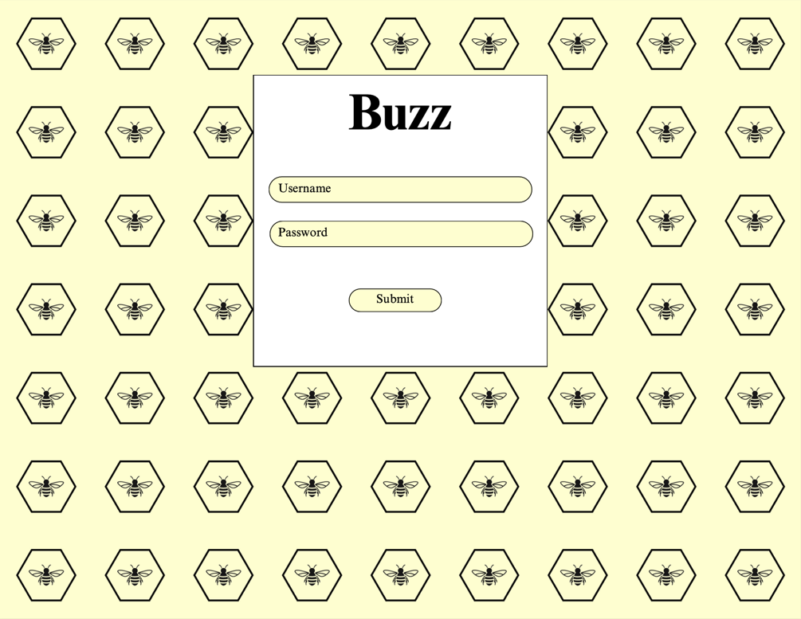
Figure 1.2 Registration Page
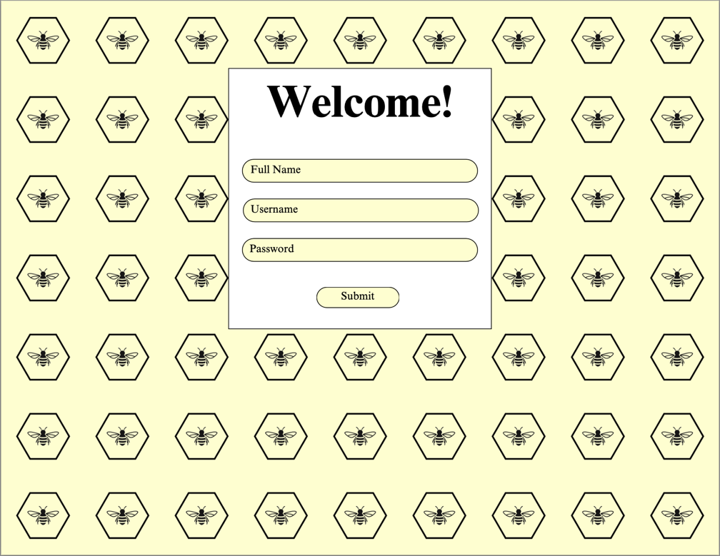

The main element in the LoginForm.jsx file is a box. Within that box, there are two textfields and two buttons. Each text field has its own purpose, one is for the username and the other is for the password. The first button is for submitting the user credentials. The other button is for a new user that wishes to create an account. When the user clicks the button for creating a new account, the state is updated by using the hook useState(). When the state is updated, the contents of the box are changed to fit the user’s request. For the register contents, there are three text fields and one button. Each of the text fields have their own purpose, one is for the user’s full name, one for their username, and the other for their password. When the user clicks the button, the information will be sent to the API and register them as a user.
The ChatPage folder consists of two files, the ChatPage.jsx and its corresponding style sheet file. The ChatPage.jsx handles the code for the two major elements and uses hooks and components from the Material UI library.

Figure 1.3 Chat Page, user has contacts but has not selected a chat room.
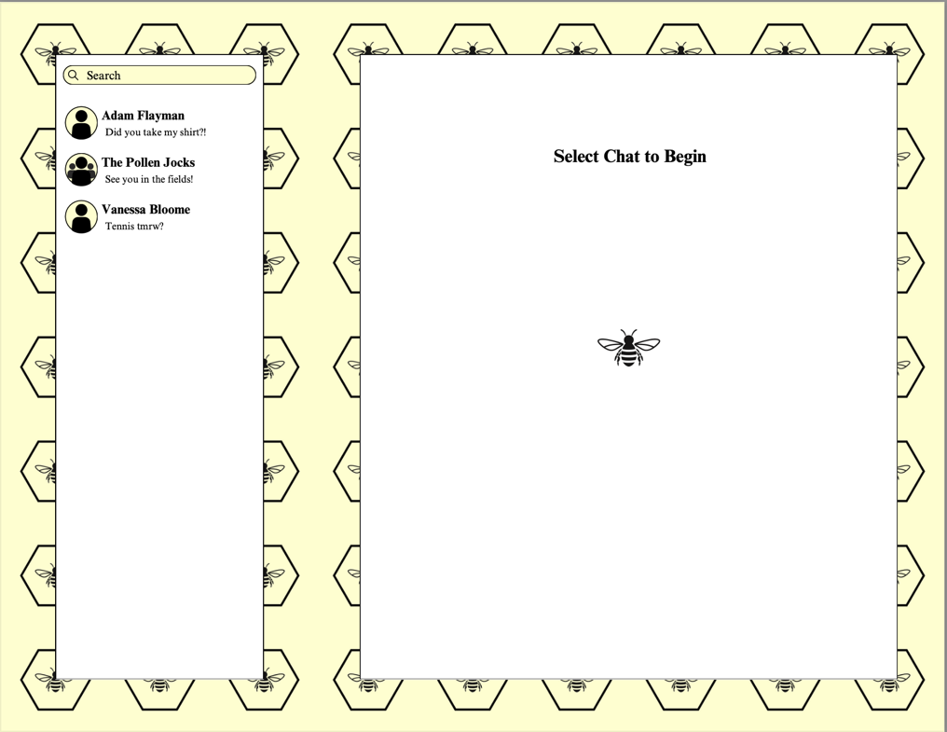

Figure 1.4 Chat Page, user has contacts and has selected a chat room.
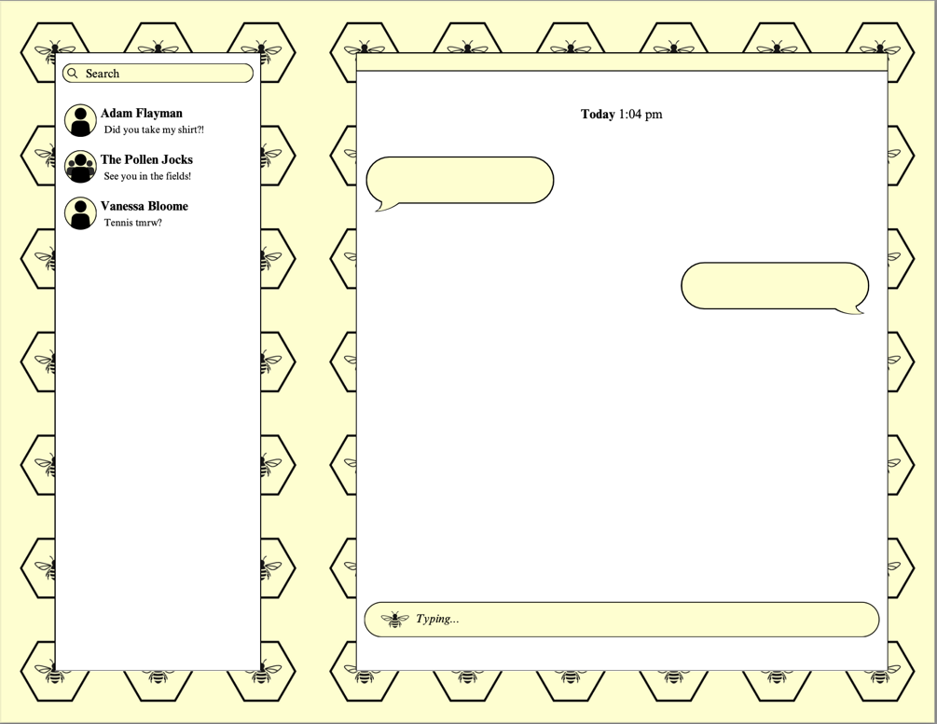

Figure 1.5 Chat Page, user has no contacts and has no chat rooms.
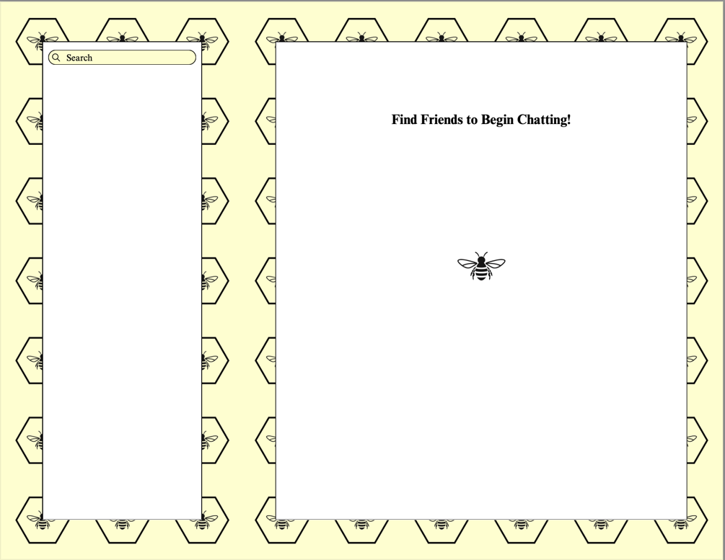

The first element is a box on the left side of the screen which has the user’s contacts. It also contains a search bar where the user can search for other users to chat with. The second element is a box that is located on the right side of the screen. This box is where the chats and conversations are displayed. For each chat that is sent in the chat room, there will be an icon next to the message that was sent by the user. At the bottom of the box, there will be a text field where the user types their message.

There different cases for the chat room consist of a user that has no contacts and no chat rooms, a user that has contacts but no chat room selected or has contacts and a chat room selected. Each of these cases would render a different screen. Most of the API calls are made in the chat room. Actions such as creating/deleting a chatroom, showing the history of a chat room, displaying created chat rooms, and sending a chat. There are also API calls made in the login page. For example, when the user is signing in, their information is sent to the API for authentication. When the user’s credentials are authenticated, they will be routed to the chat room. If their credentials are invalid, they will have two more attempts to provide the correct credentials. After three failed attempts, the user will be asked to visit the application at another time. When a user wants to register, they will click the new user button. From there, they will provide the information required to create an account and click the submit button. Once they click the submit button, their information will be sent to the API and the user will be routed to the chat room.

Back-end Microservices Architecture
Provide a one-page microservices (Chapter 6 p4-23) architecture design of your backend. You should specify how you break down coarse-grain features into microservices, and how microservices communicate with each other. If they all share one centralized database, how are you going to propagate data changes to services that have overlap in data usage? Please always balance fine-grain functionality and system performance.
Besides, the description should also include API gateway, and any cloud-based software or platform (Chapter 5) and IaaS, PaaS, SaaS (Chapter 5 p16) you have used.
Then summarize your description into an architecture diagram.

Database Design
This section should describe the design of the database or data hosting environment.
You should include which database you have chosen and what is the advantage of using it. Describe your database design and tell us how the design achieves interoperability between the user interface and the background data.
The database design should include all the data utilized by your product.

Issue and Concerns
Describe the issue and concerns you met with during product development.

