**WWF Madagascar**

**Manambolo Tsiribihina Land and Seascape**

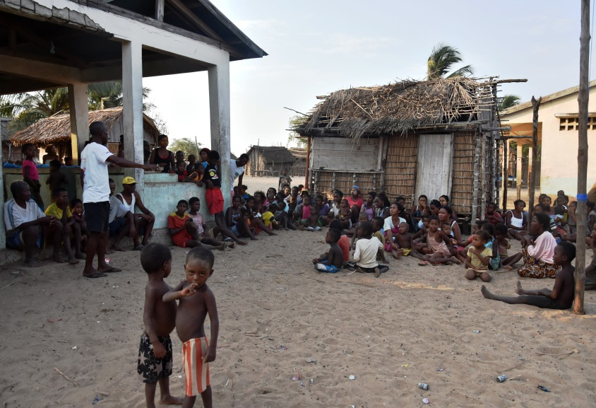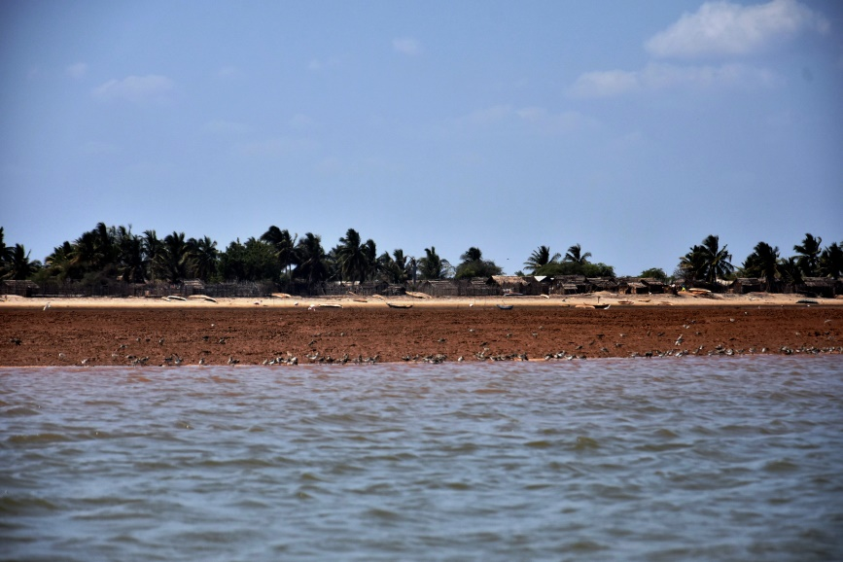

**© WWF MDCO**

**Baseline report on the implementation of the barefoot college project in the village of Ambakivao**

*Written by: Manambolo Tsiribihina Landscape Team and   
WWF Energy Access Team*

***November 2016***

**SUMMARY**

1. SUMMARY 2

2. GENERALITY ON THE VILLAGE 3

*2.1.* *Origin of the name of Village* 3

*2.2.* *Administrative delimitation and structure* 3

*2.3.* *Demographics* 3

*2.4.* *Infrastructure* 4

*2.5.* *Types of lighting in possession of the populations* 4

3. RESULTS OF THE FOCUS GROUP 5

*3.1.* *Methology of the focus group:* 5

*3.2.* *On constructions and infrastructures in the village:* 5

*3.3.* *On water sources* 6

*3.4.* *On livelihood:* 6

*3.5.* *On migration* 6

*3.6.* *On health issue:* 6

*3.7.* *On women participation and community spaces* 7

*3.8.* *Specific question of WWF* 7

4. Household Survey results 8

*4.1.* *Methodology and sample description* 8

*4.2.* *On lighting sources* 8

*4.3.* *Lighting system situation in the village* 8

5. CONCLUSION 10

# SUMMARY

Two focus groups and a questionnaire survey have been conducted in the Ambakivao prior to the implementation of the project in conformity with the Barefoot College methodology. The key aspects to be outlined are as follows:

*Lighting use:*

* 40% of the population uses kerosene lamp on average 2 hours per day. Their monthly expenditure is 5600 Ar. Each lamp consumes 1.4 liters per month and the households use the lamp on average 29 days per month.
* 95% use flashlights as a source of lighting, there are some who use 02 in a single household. On average, households use the lamps 03 hours a day and 30 days a month. The average expenditure on batteries is 3,700 Ar / month.
* 62% find that the lighting in their homes is insufficient

*Health issue*

* 48% of households declare that some member of their family have eye problem; 10% say that they have respiratory disease;
* All the interviewee confirmed that the most common diseases are coughs, colds and fever;
* There have already been four cases of house fire. The fires were all caused by candles through mishandling and because the houses are largely made of “vondro” (plant) and easily inflammable when they are dry;
* 50% of interviewed women in households according to respondents feel insecure during the night.
* 20% have their kitchen inside.

*Technology:*

* 95% of households have a mobile phone : 67% charge their mobile phones in local shops. The price for charging a phone is on average 300Ar

*Education :*

* 45% of the interviewee have children who read in the day at home,
* 30% have children doing homework at home in the evening
* 15% have children doing homework at home at night

# GENERALITY ON THE VILLAGE

## *Origin of the name of Village*

Ambakivao village, like the majority of the villages in the Manambolo Tsiribihina landscape, is endowed with immense wealth in terms of biodiversity resources whether marine or mangrove. In 1982, the first 02 settlers who sensitized people to come were BESABAKA (from the SAKALAVA ethnic group) and GREGOIRE (from the VEZO ethnic group). The Fokontany[1] is named AMBAKIVAO because the watercourse (VAVARANO, VAKY) of the locality has moved to the west, so a new one (VAOVAO) has formed. This is the root of the village name: VAKY + VAO (NEW).

## *Administrative delimitation and structure*

The Fokontany is part of the Rural Municipality of DELTA DE TSIRIBIHINA, District of BELO SUR TSIRIBIHINA and belongs to the MENABE Region. It is located at 36 km from the National Road. With an area of ​​2,600Km², it is bounded:

* In the North by LAPOTALY
* In the South by SOARANO SUR MER
* In the East by MAVOHATOKY
* In the West by the MOZAMBIQUE CANAL

The Village is composed by 5 hamlets: MILIKO ANKAPOLAKY, MANGARAHARA, BETANIA, AMBAKIVAO CENTER and NOSY MAINTSO. The capital of the Fokontany is in the hamlet of AMBAKIVAO. About 55% of the population lives in the Ambakivao hamlet.

Table 1 : repartition of the population by hamlets

|  |  |  |  |  |
| --- | --- | --- | --- | --- |
| VILLAGE | Hamlet | Household size | Household distribution | Population distribution |
| AMBAKIVAO | AMBAKIVAO | 5.57 | 54.27% | 55.86% |
|  | ANKAPOAKA MILIKOKY | 6.22 | 5.49% | 6.31% |
|  | BETANIA | 4.80 | 6.10% | 5.41% |
|  | MANGARAHARA | 5.00 | 6.10% | 5.63% |
|  | NOSY MAITSO | 5.17 | 28.05% | 26.80% |
| Total AMBAKIVAO | | **5.41** | **100%** | **100%** |

*Demographic situation of Ambakivao, Source : WWF – EFA NGO, 2016*

## *Demographics*

The population is estimated at 2,302 habitants with 448 households and the density is 1.12 inhabitants per km². The village has a young population in general: over 57.49% are under 17 years old. The active population (18 to 60 years) constitutes about 41.47% of the total population.

Table 2 : Distribution of the population by age category

|  |  |  |  |
| --- | --- | --- | --- |
| Age class | Male | Female | Total |
| under 6 years | 18,78% | 19,51% | 19,12% |
| 6 to 12 years | 20,96% | 22,68% | 21,77% |
| 12 to 18 years | 17,69% | 15,37% | 16,59% |
| 19 to 60 years | 41,48% | 41,46% | 41,47% |
| Over 60 years | 1,09% | 0,98% | 1,04% |
| Total | **100,00%** | **100,00%** | **100,00%** |
|  |  |  |  |

*Source : WWF – EFA NGO, 2016*

## *Infrastructure*

84% of constructions in the village are made of vegetal materials. The roofs of the houses are also mainly made of Vegetal (Vondro) and rarely in sheets. They are usually built with local materials. Infrastructures and socio-cultural equipment are non-existent. There is one football pitch in the Fokontany. There are some churches in Ambakivao (Adventist, Provident, Catholic, TAJEKRI and Herin'ny Fanahy), and a “Doany” (sacred place for Malagasy rituals). There are also some historical places.

## *Types of lighting in possession of the populations*

The majority (about 86%) use battery powered lamps (flashlight). About 11% use kerosene lamp. It is noteworthy that a few households (about 5 %) already use solar powered lamps. Some households use a combination of different types of lighting sources.

Table 3 : Types of lighting used

|  |  |
| --- | --- |
| Type of lighting | % household |
| generator, solar energy, battery lamp | 0.61% |
| generator, kerosene lamp, battery lamp | 0.61% |
| solar energy | 4.27% |
| solar energy; battery lamp | 0.61% |
| candle, kerosene lamp, battery lamp | 0.61% |
| kerosene lamp | 7.93% |
| kerosene lamp; battery lamp | 3.66% |
| battery lamp | 81.10% |
| Other | 0.61% |
| Total | **100%** |

*Source : WWF – EFA NGO, 2016*

# RESULTS OF THE FOCUS GROUP

## *Methology of the focus group:*

03 focus groups were carried out including 02 in Ambakivao center and 01 in Nosy Maitso: the hamlets with the most population compared to the other 03 hamlets;

* The focus groups were conducted by 03 of the Manambolo Tsiribihana landscape team :
  + Mario RATOVONIRINA, Responsible of monitoring and evaluation,
  + Eli TODIMANANA, Responsible of partnership and capacity building, and
  + Prisca Zandry ABDOUL, Socio-organizer;
* 32 households were represented: there were 21 women, 10 men and 01 child. During the second focus groups in Ambakivao Center, all of the 12 participants were women.

## *On constructions and infrastructures in the village:*

Regarding meeting places: they meet in the school for indoor meetings and at the marketplace in the center of the village when outdoor s. The majority of meetings take place in the marketplace;

* There is no library center but there is a partnership with WWF to establish one;
* The majority of students go to Belo Tsiribihina school which is at 6 hours of canoes (24 km). There are 02 primary school in the village center :01 public and 01 private;
* There is one Community Care Center or "toby AC" in the village that deals with non-serious diseases. There is no hospital but the villagers go to Belo sur Tsiribihina for serious illnesses;
* For hand work: there are canoe manufacturers (about 50% of the men in the village), there are also women who do crafts (about 10% of women). The percentage is based on the focus group participant estimation;
* There are no saving groups. A Solidarity Savings Group has been tried but it did not materialize;
* There are no specific groups on income-generating activities other than the fishermen's cooperative set up by WWF;
* The majority of people are Christians. There is one dominant party to which the majority of population adheres;
* There is no paved road in the village yet;
* For the other groupings in the village, there are 05 dominants: the CBRNM of the village, the fishermen's group denominated Zoto, the cooperative of the fishermen of Ambakivao, women's associations 08 March, women's association 'Vehivavy Mijoro'.

## *On water sources*

* There are 06 wells scattered in the village center of Ambakivao: 02 wells made of concrete, 03 wells in board and 01 well in the sand. In the other hamlets, the wells are directly in the sand.
* There is no pump or lake, the population collects rain water in rainy season but the raining season is generally very short. During the drying up season (September) the population drinks the water from the Tsiribihina River.

## *On livelihood:*

The vast majority of the population (90.80%) lives from selling of the products of fisheries. There are a few (4.29%) small shop owners or micro entrepreneurs in the village.

* The other sources of income are small scale carpentry, pirogue construction and women's craft. As a way to light the outdoors, only the small shop owners (03 households) use a solar powered lamp.

Table 4: Livelihood of the Ambakivao village population

|  |  |
| --- | --- |
| Source of monetary income | % household |
| Product of fisheries seller | 90.80% |
| Trader / entrepreneur | 4.29% |
| Product hunting / picking seller | 1.84% |
| Agricultural product seller | 1.23% |
| Craft seller | 1.23% |
| Official / employee of the government | 0.61% |
| Total | **100%** |

* *Source : WWF – EFA NGO, 2016*

## *On migration*

On the issue of migration, there are fishermen who migrate to other areas during periods when there are no products around the village. According to the focus targets, it concerns about 10% of the fishermen.

## *On health issue:*

* There is no reported kerosene poisoning, but there were 04 cases of house fire in the village caused by the uncontrolled use of candle in 2016. There is a report of 01 child suffering from eye irritation due to fumes.
* The other most common diseases in the village are: diarrhea, fever, colds, coughs, back pains.

## *On women participation and community spaces*

Women are particularly involved and actively participating in village meetings and community activities whether individually or in associations.  
Community space that could be used for the Rural Electronic Workshop: there is a big storage house that the villagers no longer use. The totality of the population wants solar energy and is ready to invest and then regularly pay the related costs.

## *Specific question of WWF*

Elements of the natural environment that villagers protect are mangroves, sea, channels, animals and biodiversity in mangroves. These elements are essential for their survival. Currently, villagers find that climate change is negatively affecting these resources and that conservation actions should not be stopped. The population finds that uncontrolled human activities such as the use of non-standard fishing gear, massive mangrove cuts affect the resources. Climate change also affects these resources considerably. The behavior adopted by the community is the awareness of their entourage. The activities carried out by the community to cope with this are the activities of the local Community Based Natural Resources Management (CBNRM), awareness, monitoring and patrol, reforestation, use of appropriate fishing gear. According to them, their efforts are still insufficient and should continue. They also have problems like the fear of retaliation and revenge in case of severe correction of environmental crime in their same village. The CBNRM “Lovainjafy” of Ambakivao was created in 2013 and formalized in 2014. There are still failures in the financial management and transparency from the leaders in the CBNRM that needs to be improved. The CBNRM needs more capacity building and monitoring with more frequent visits by stakeholders, especially from WWF.

# Household Survey results

## *Methodology and sample description*

The survey was carried out among 40 randomly selected households in hamlets. Among the surveyed 18 were women and were 22 men. The average age of the interviewed is of 42 years. Of those interviewed, 92% are married (according to the norms of custom) and 8% are single women with children.

## *On lighting sources*

- *Kerosene lamp*

The kerosene lamps used are artisanal simple types (metal). 16 of 40 (40%) of the people interviewed uses kerosene lamp. On average, the household members use the kerosene lamp about 2 hours per day. Their monthly expenditure is 5,600 Ar. Kerosene Consumption is 1.4 liters per month and the households use the lamp on average 29 days per month.

*- Candle use*

The use of candles as a source of lighting became very limited given the number of houses that caught fire because of the candles. But all respondents have candle reserves in their home and rarely use them.

- *Electric torch*

Among the respondents, 95% use flashlights as a source of lighting, there are some who use 02 in a single household. On average, households use the lamps 03 hours a day and 30 days a month. They use 4 to 10 non-chargeable batteries per month which constitutes an average spending of 3700 Ar / month on batteries. 5% (2/ 40) use torches with a solar panel in addition.

- *Fire wood as lighting*

The wood fires are still free given the extent of dry mangrove forest in the village. The households surveyed generally use it for cooking but not for lighting.

## *Lighting system situation in the village*

The average monthly expenditure in lighting is 6,550 Ar.

*As a main source of energy for cooking:*

* 17/40 (42)% use wood
* 21/40 (52%) use coal
* 2/40 (6%) use zebu dung

*On kitchen:*

* 32/40 (80%) have their kitchen outside;
* 8/40 (20%) have their kitchen inside.

*Reading for children:*

* 18/40 have children who do reading by day at home;
* 11/40 do less than 1 hour per day;
* 7/40 make reading on average between 1 to 2 hours per day.

*Realization of homework:*

* 5/40 have children doing homework at home in the morning;
* 12/40 have children doing homework at home in the evening;
* 6/40 have children doing homework at home at night;
* 17/40: NA.
* 15/40 (38%) find that the lighting in their homes is sufficient

*Activities of women in the village:*

* 25/40 cooks in general;
* 15/40 are either small shops or sewing or crafts or other income generating activities;
* Women participate in the household expenses with their activities and offer on average, for those who work, 91,000 Ar / month;
* 19/40 have confirmed that their means of drawing produces black smoke;
* 19/40 households also claim that the health problem that affects their family more is the health of their eyes; 04/40 said that it is respiratory disease;
* All confirmed that the most common diseases are coughs, colds and fever;
* There have already been four cases of house fire. The fires were all caused by candles through mishandling and because the houses are largely made of “vondro” (plant) and easily inflammable when they are dry;
* None of the households have a bank account;
* 20/40, ie 50% of women in households according to respondents feel insecure during the night.

*Group membership:*

* 10/40 are members of fishermen's cooperatives;
* 3/40 are in an association of young fishermen;
* 10/40 in a religious association; and
* 2/40 in a youth association.

*Decision making in the households:*

* 30/40 affirm that women participate in household decision making
* 34/40 told that they make important decisions together in their households
* 04/40 confirm that it is the mother who makes important decisions in their households
* 02/40 say that it is the father of the family alone who makes the important decisions in their households.

*Technology:*

* 38/40 (95%) of households have a mobile phone
* 34/40 or 67% charge their mobile phones in local shops
* 04/40 have their own solar panel and
* The price for charging a phone is on average 300Ar

*WWF specific issues*

* The elements most dependent on communities are:
  + Water
  + The soil
* The whole also highlighted the importance of mangroves

The majority of the inquiries find the state of health or the situation of the degraded natural resources while their means of subsistence depend entirely on these resources. Thus, the behaviors they adopted are the reforestation and amplification of local laws (DINA) for the protection of natural resources.

* 100% of respondents know of the existence of local CBNRM and confirm that its role is to protect mangroves
* 32/40 are members of COBA
* What is positive about their contribution to the CBNRM is to be able to participate in conservation activities and to be able to follow up the relations in their village and also in the village.
* What needs to be improved within CBNRM is that each of them must take their responsibility, there must be more sharing of knowledge and transparency. And that all members must participate in CBNRM activities.

# CONCLUSION

The village of Ambakivao is a very active village in the conservation of mangroves in the Menabe regions. The results of the surveys show that the population wants to have an improvement in their well-being by starting by improving the lighting system in their home. The village is still poor and only 37% find that the lighting in their house is sufficient. Indeed, the percentages confirm the need for improvement of the sources of energy that it is for the education of the children, the health in general and also especially for the safety of the population. Benefiting from the support of the lighting system would only increase the effectiveness of the sustainable management of mangroves that WWF institutes in villages such as Ambakivao.

1. The smallest administrative division in Madagascar.