**Academic Year: 2024-25 Semester: V**

**Class / Branch: TEIT Subject: DevOps Lab**

**Name of Instructor: Prof. Sujata Oak**

# Experiment No. 7

**Aim:** To implement selenium automation.

**Theory:**

Selenium is one of the most widely used open source Web UI (User Interface) automation testing suite.It was originally developed by Jason Huggins in 2004 as an internal tool at Thought Works. Selenium supports automation across different browsers, platforms and programming languages.

Selenium can be easily deployed on platforms such as Windows, Linux, Solaris and Macintosh. Moreover, it supports OS (Operating System) for mobile applications like iOS, windows mobile and android.

Selenium supports a variety of programming languages through the use of drivers specific to each language.Languages supported by Selenium include C#, Java, Perl, PHP, Python and Ruby.Currently, Selenium Web driver is most popular with Java and C#. Selenium test scripts can be coded in any of the supported programming languages and can be run directly in most modern web browsers. Browsers supported by Selenium include Internet Explorer, Mozilla Firefox, Google Chrome and Safari.

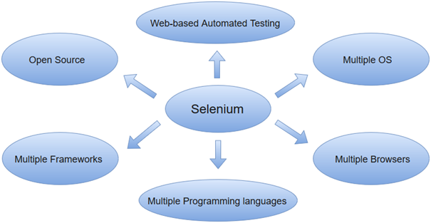

Selenium can be used to automate functional tests and can be integrated with automation test tools such as **Maven**, **Jenkins**, **& Docker** to achieve continuous testing. It can also be integrated with tools such as **TestNG**, & **JUnit** for managing test cases and generating reports.

**Automation Testing**

Automation testing uses the specialized tools to automate the execution of manually designed test cases without any human intervention. Automation testing tools can access the test data, controls the execution of tests and compares the actual result against the expected result. Consequently, generating detailed test reports of the system under test.

**Steps for Selenium Automation in DevOps on Ubuntu**

**STEP 1: Selenium IDE-Installation**

Selenium IDE is available only as Firefox and Chrome plug-in.

* Launch Mozilla Firefox browser.
* Open URL<https://addons.mozilla.org/en-us/firefox/addon/selenium-ide/>It will redirect you to the official add-on page of Firefox.
* Click on "Add to Firefox" button.

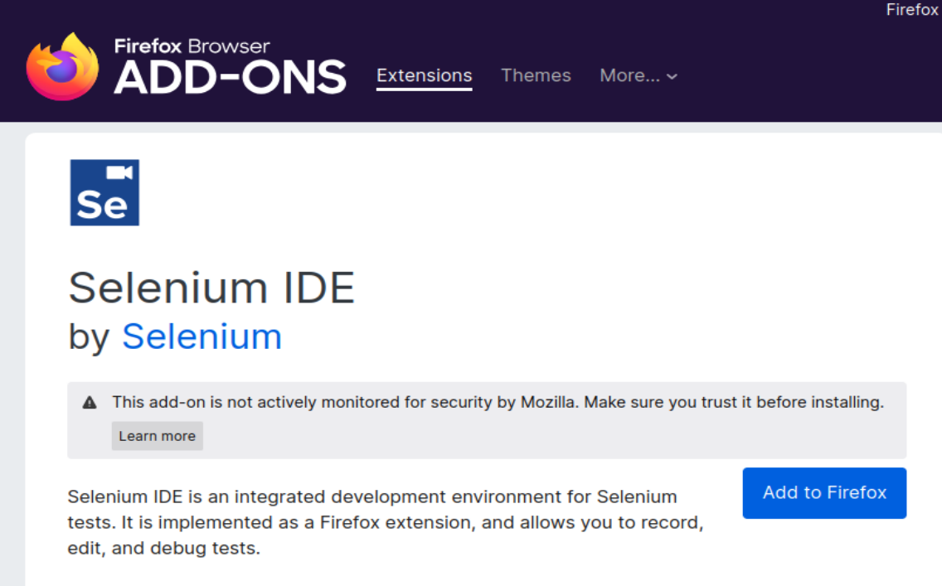

* A pop-up dialog box will be appeared asking you to add Selenium IDE as extension to your Firefox browser.
* Click on "Add" button.

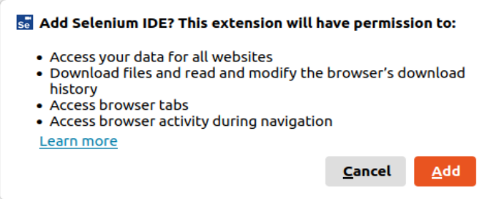

* Restart you Firefox browser.
* Go to the top right corner on your Firefox browser and look for the Selenium IDE icon.

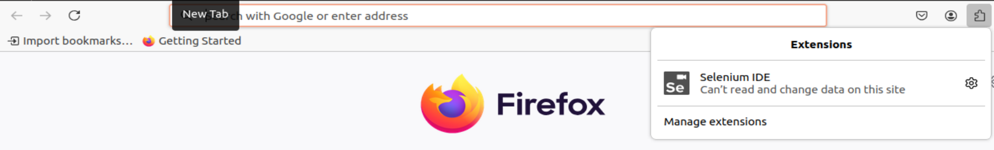

* Click on that icon to launch Selenium IDE.

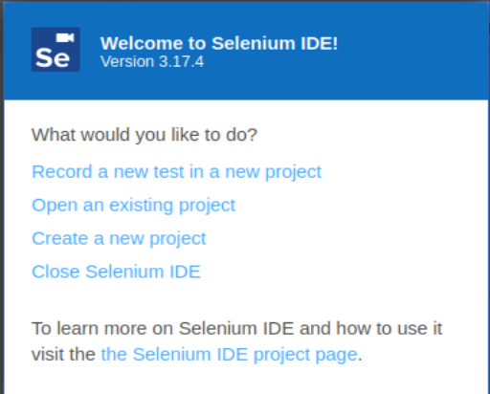

Click on : Create a new project

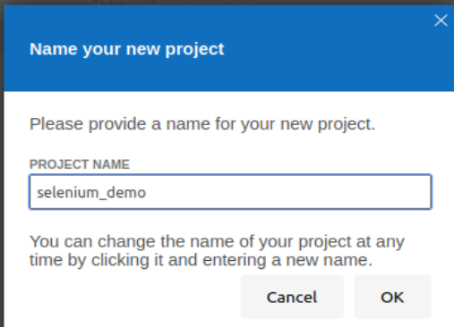

Click OK

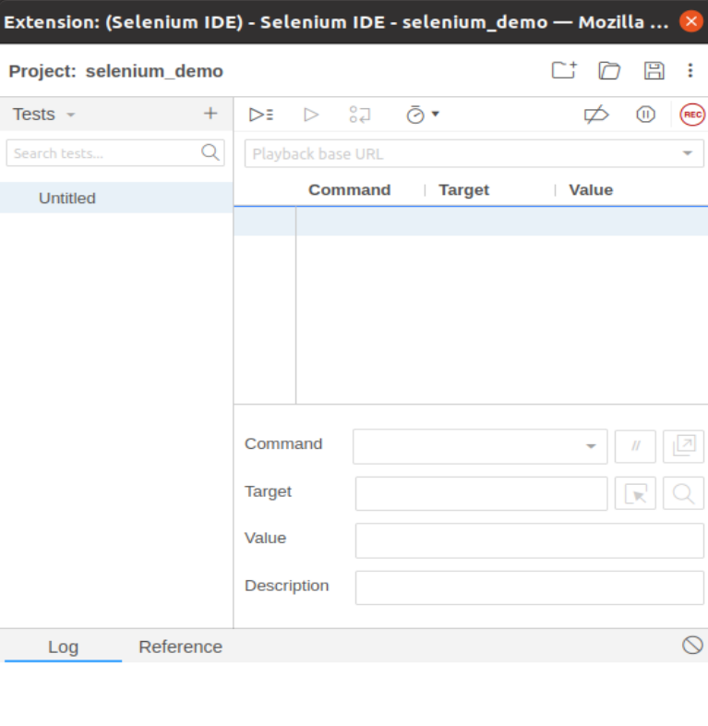

**STEP2:  Create a basic test case in Selenium ide.**

The entire test script creation process in Selenium IDE can be classified into three steps:

1. Recording (recording user interactions with the browser)
2. Playing back (executing the recorded script)
3. Saving the test suite

* Rename the project as "selenium_demo".
* Rename the test case as "javaTpoint_test".

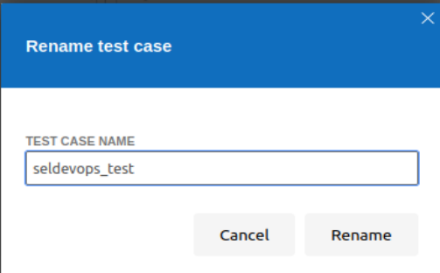

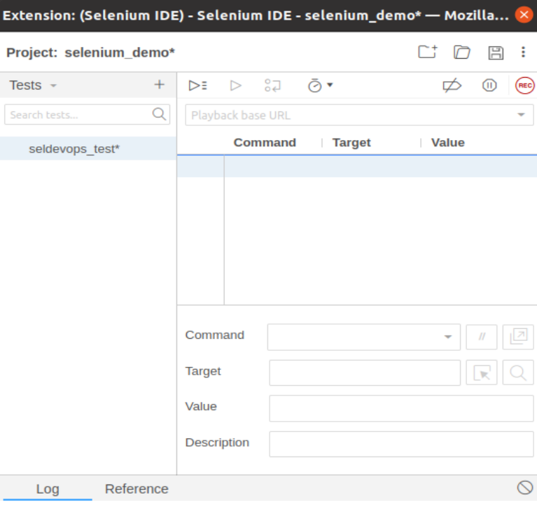

* Click on the "Start Recording" Button present on the top right corner on the IDE to start recording the test case.

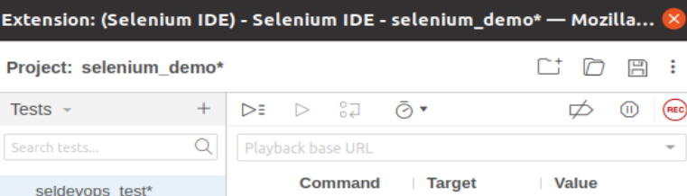

* Go to your Firefox browser and open URL:[www.google.com](https://www.javatpoint.com/www.google.com)
* 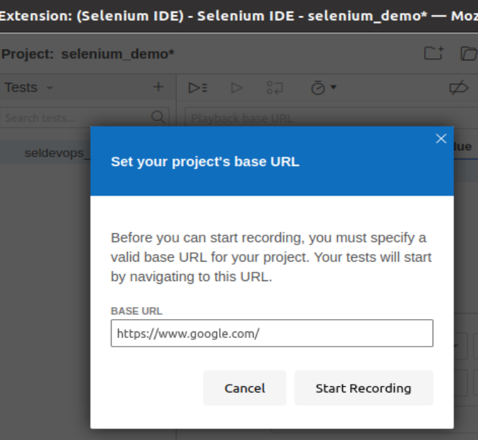
* It will redirect you to the Google search engine page.
* Type "Selenium DevOps Tutorials" in the Google search box.
* Hit enter to get the search results.
* Click on the link "How to Use DevOps in Selenium Testing" provided under the URL https://www.softwaretestinghelp.com/devops-in-selenium-testing/
* It will redirect you to <https://www.softwaretestinghelp.com/devops-in-selenium-testing/> tutorial web page. Meanwhile, you will get the notifications of the actions performed by the IDE at the extreme right corner of your web browser.

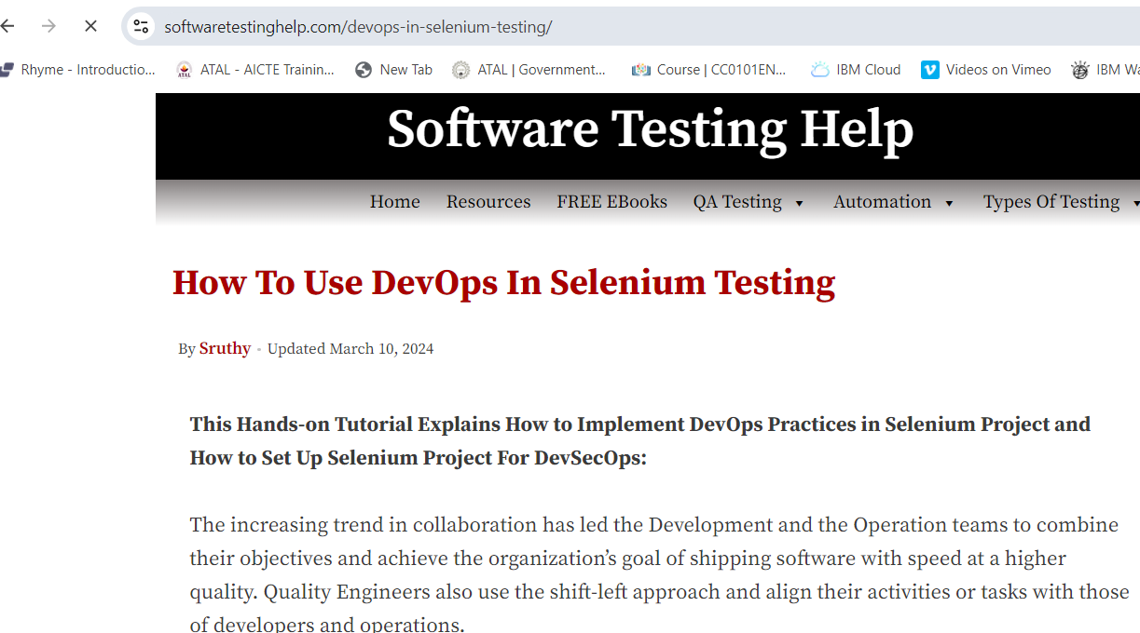

* The Test Editor box now contains the list of all of your interactions with the browser.

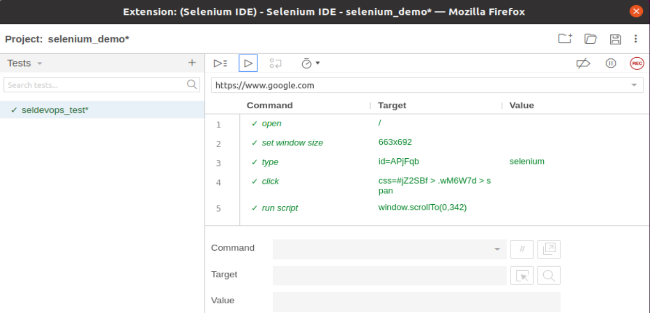

* Now, go the IDE and click on the "Stop Recording" button to stop recording your actions further.
* Now, we will proceed to the next step which includes executing the recorded script.

**STEP 3: Playing Back**

* Click on the "Run Current Test" button present on the tool bar menu of the IDE.  
  It will execute all of your interactions with the browser and gives you an overall summary of the executed test script.
* The Log pane displays the overall summary of the executed test scripts.

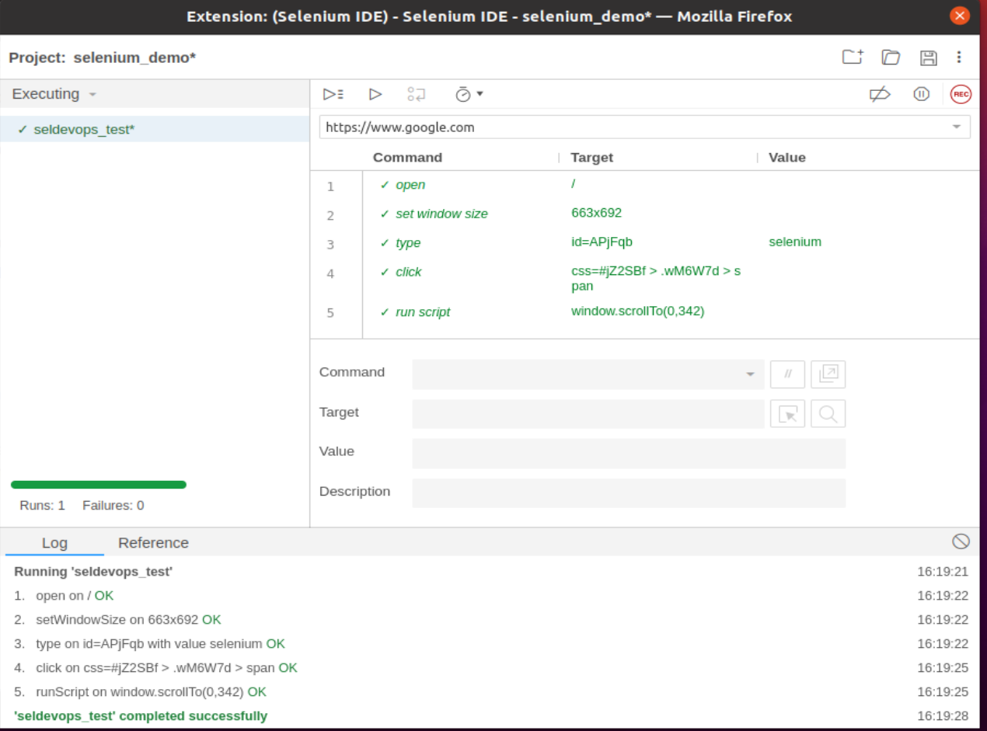

**Saving the test suite**

* Click on the save button present on the extreme right corner of the menu bar.
* Save the entire test suite as "SelDevOpsdemo.side” Test.
* The test suite can be found at the location provided in the above steps. Notice that the test script is saved in .side format.

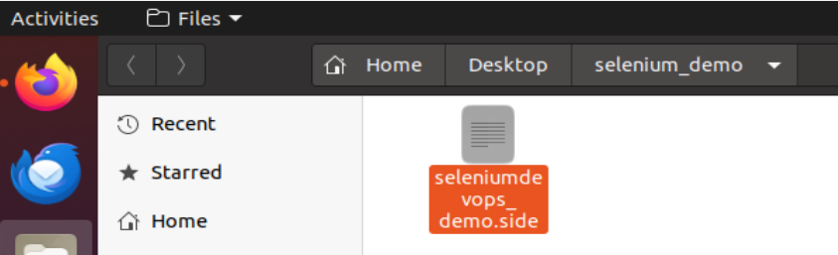

# Conclusion: This experiment demonstrated how to automate a test case in Selenium ide.