Action entry page

Type of SIA

IATS Display off and replace IATS name as ISWC (Inspector Scope of work through checklist) Add dropdown from list of checklist

SIA by Critical Elements (Add Dropdown)

SIA by Area (Add Dropdown)

Show Martix Table in Any place in SMS area

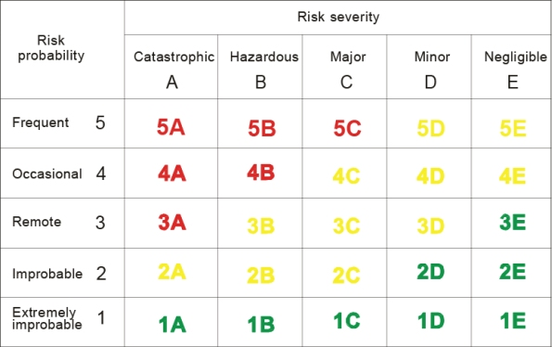

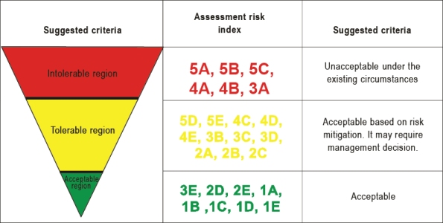

Safety performance indicator (SPI)- text box

Safety performance target (SPT)- text box

Remove text limit from all type of text box

IT’S May be 5000 words or even more or as less as three words

**EDP Form**

**Written Explanation For Admin Action before this Remedial Action (Text Box)1**

**Enforcement Decision Outcome before this Remedial Measure (Text Box)1**

**At last break legal/admin opinion as Admin Opinion (Text Box), Legal Opinion (Text Box), 2**

**And upload file separately for legal & admin. 2**

**Add Finding number 1**

**Add Safety Concern Number 1**

**Safety Concern Form**

(**Safety** Data Collection part)

**Safety Issue Number**

**SIA/ Tracking Number**

**Inspector Observation**

**Add Finding Tracking Number**

**Safety Concern**

**Safety Concern related to CE**

**Safety Concern related to Area**

**Witness Statement**

**Upload Evidence**

**Upload Checklist**

**Question**

**Answer**

**Type of Concern**

**Type of Issue**

**Violation of Regulation / Best Practice**

(General Part)

**POI/PAI/Responsible**

**Assigned Inspector**

**Finding Date**

**Finding Local Time**

**Place/Airport**

**Responsible PEL**

**Aircraft MSN**

**Aircraft Registration Number**

**Corrective Priority**

**Target Date**

(Risk Analysis and Assessment)

**Risk Statement**

**Risk Probability (drop down - Frequent 5 Occasional 4 Remote 3 Improbable2 Extremely improbable1 )**

**Risk Severity (Drop down-** catastrophic- critical-marginal-negligible)

**Risk Severity Statement**

Risk Assessment from Matrix Index

Determine Risk & Type of Action (High risk- Legal Action, Moderate Risk- Warning Letter, Lower Risk- Counselling, No Risk)

Risk Management

Corrective action

(Finalization)

Final Resolution Date

Final Resolution Inspector

Final Resolution Method

Residual Risk

Status/ Result

Add EDP number

Closing Note