**Aviation Safety Reporting Tracking And Management System**

**by**

**Md.Ashikuzzamn**

**ID: 112077**

A Report Presented in Partial Fulfillment

of the Requirements for the Degree of

Bachelor of Science in Computer Engineering

from the Department of

Computer Science and Engineering



**Independent University, Bangladesh**

**May 2014**

**Supervisor: Dr. Mahady Hasan**

All rights reserved. This work may not be

reproduced in whole or in part, by photocopy

or other means, without the permission of the author.

© XXXXXX 2015

**Approval**

This report entitled

Aviation Safety Reporting Tracking And Management System

by

Md.Ashikuzzaman

has been approved by

Dr.Mahady Hasan

The Department of Computer Science and Engineering,

Independent University, Bangladesh.

Supervisor: Dr.Mahady Hasan

The final copy of this report has been examined by the signatory and I find that both the content and the form meet acceptable presentation standards of scholarly work in the above mentioned discipline.

Signed ...................................

Date ...................................

# Originality Statement

I hereby declare that this submission is my own work and to the best of my knowledge it contains no materials previously published or written by another person, or substantial proportions of material which have been accepted for the award of any other degree or diploma at IUB or any other educational institution, except where due acknowledgement is made in the report. Any contribution made to the research by others, with whom I have worked at IUB or elsewhere, is explicitly acknowledged in the report. I also declare that the intellectual content of this report is the product of my own work, except to the extent that assistance from others in the project's design and conception or in style, presentation and linguistic expression is acknowledged.

Signed ...................................

Student Name

# Acknowledgement

Table of Contents

Originality Statement 2

Acknowledgement 3

ABSTRACT 5

Chapter 1: Introduction 6

1.1 Back ground of the Project

1.2 Scope of the project

1.3 Objective of the project

Chapter 2: Methodology 6

2.1 Model Applied to Develop the system: 6

2.2 Data Collection: 8

2.2.1 Interview: 8

2.2.2 Ethnography: 9

2.3 Design system

2.3.1 Data flow diagram (DFD)

2.3.2 Entity relationship diagram (ERD)

2.3.3 Normalization

2.3.4 UML

2.4 Programming/ coding convention

2.5 Testing Methodologies: 9

Unit testing: 9

System testing: 10

Performance Testing 10

2.6 Implementation Methodology

Chapter: 3 System Description

3.1 General description of current business processes (with rich picture)

3.2 Problems of the current system and their effects

3.3 Proposed system’s objectives/goals

3.4 System Constrains

3.5 Describe the proposed system (with rich picture)

3.6 Analyzing proposed system with respect to IS(TPS, MIS, DSS, EIS)

3.7 Stakeholder analysis

3.7.1 Identify the stakeholders

3.7.2 Justify the stakeholders

3.7.3 Roles of the stakeholders

4. Project Management

4.1 Schedule Analysis

4.1.1 Estimated Time Duration

4.1.2 Process dependencies (tab 1: task no, Task name, duration, dependencies)

4.1.3 Gantt Chart (fig)

4.2 Process Analysis

4.2.1 Work Breakdown Structure (fig 2)

4.2.2 Critical Path Analysis (fig 3)

4.2.3 Slack time analysis (para)

4.3 Budget Analysis

4.3.1 Assignment of resources (tab 2: resource id, name, percentage, std rate, ovr rate)

4.3.2 Allocation of resources. (tab3: task no, task name, resource id, involvement %)

5 Requirement analysis

5.1 Functional Requirements

5.2 Non Functional Requirements

5.3 System Requirement (Hardware, Software, Architecture, User)

5.4 User requirement

6 Feasibility Analysis:

6.1 Purpose

6.2 Economical Feasibility

6.2.1 Cost Benefit analysis

6.2.2 Net present value

6.2.3 Return on investment

6.2.4 Payback analysis

6.3 Technical Feasibility (hardware, software, other resources)

6.4 Operation Feasibility

6.5 Legal Feasibility

6.6 Candidate Matrix

6.7 Feasibility analysis matrix

7 Logical Design:

7.1 Data Flow Diagram

7.2 Entity Relationship Diagram

7.3 Data Dictionary

7.4 Use Cases

7.4.1 Context level

7.4.2 Use cases with subsystems and boundary

7.4.3 Narrations

7.5 Class Diagram

7.6 Sequence Diagram

7.7 Deployment Diagram

8 Physical Design:

8.1 Database Schema

8.2 Input Forms

8.2.1 Implementation methods

8.2.2 Controls and flow of controls

8.2.3 Input prototype and description

8.3 Output Reports

8.3.1 Internal/External Output

8.3.2 Type of Output

8.3.3 Implementing methodology

8.3.4 Design analysis & Customization

8.4 Interface Design

8.4.1 GUI Style and Consideration

9. Testing system

9.1. Unit Testing

9.2. Integration Testing

9.3. White Box Checking

9.4. Black Box Checking

9.5. Test Cases with samples

10 Implementation And Delivery

10.1. Plan to implement

11. Conclusion

11.1. Advantages

11.2. Recommendations

11.3. Conclusion

Appendix:

Reference:

# 

# ABSTRACT:

ASRTM is a Civil Aviation Authority management system. All the important services that civil aviation does like Accident incident investigation, Inspection, aircraft maintenance, Organization monitoring, Personal Licensing, Runway monitoring etc., the ASRTM can keep all the records and help the authority to manage and maintenance CAA.

Chapter 1: Introduction

* 1. Back ground of the Project:

According to ICAO rule all civil aviation authority should keep records of their work to central database. Again to convert the CAAB manual to digital system the authority decide to develop the ASRTM system.

* 1. Scope of the project:

This system covered basic CAA maintenance module like safety concern, Aircraft, Organization, personal licensing, Employee management, Accident Incident investigation, and ANS/AGA/Aerodrome inspection. Furthermore the system maintain an e-library, there are scope of volunteer reporting and wild life stick reporting.

* 1. Objective of the project:

Fulfill the ICAO requirement and digitalization of CAAB .

Chapter 2: Methodology

2.1 Model Applied to Develop the system:6

For developing the system agile method is used.

2.2 Data Collection:

2.2.1 Interview:

I alone with my supervisor collect data and information of particular module from concern department.

2.2.2 Studying Training Document:

ICAO standard manual and other documents.

2.3 Design system

2.3.1 Data flow diagram (DFD)

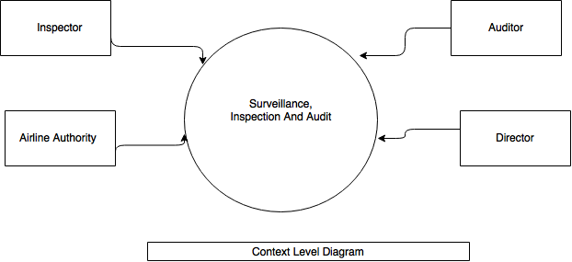

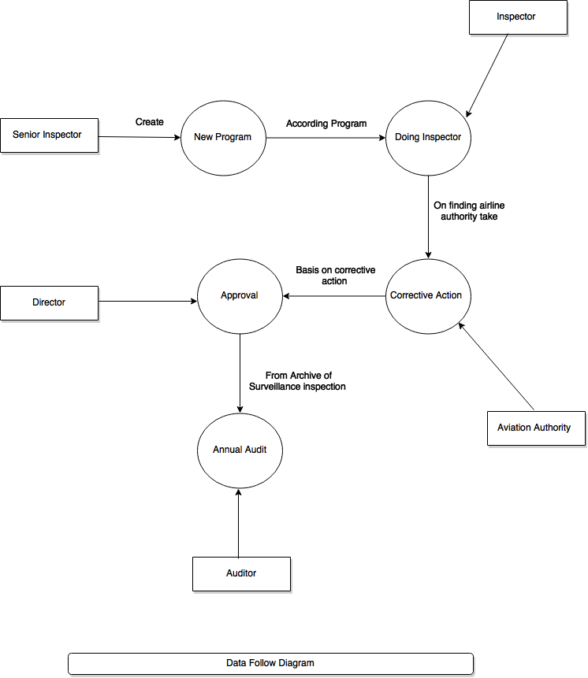

2.3.2 Entity relationship diagram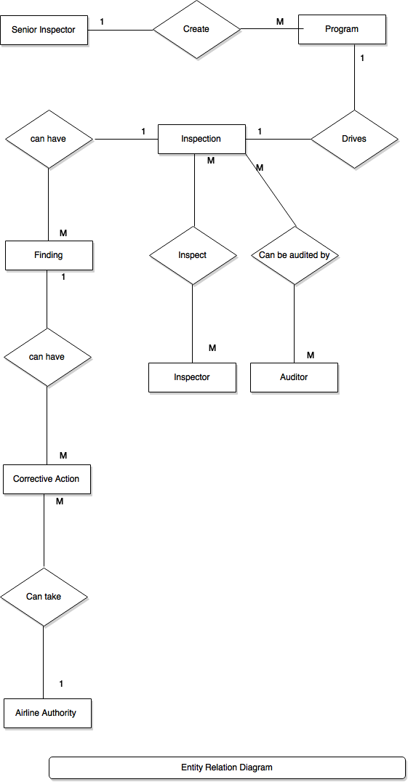

2.3.3 Normalization

2.3.4 UML

2.4 Programming/ coding convention

2.5 Testing Methodologies: 9

Unit testing: 9

System testing: 10

Performance Testing 10

2.6 Implementation Methodology