**Personal Info:**

Name: Md.Ashikuzzaman  
Address: Basundhara R/A, Dhaka Phone: +8801677007983   
E-mail:md.ashikuzzaman.ashik@gmail.com Nationality: Bangladeshi Gender: Male

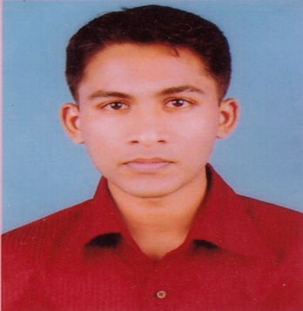

**Academic Information:**

|  |  |  |  |
| --- | --- | --- | --- |
| **Degree** | **Institute** | **Major** | **G.P.A** |
| S.S.C | Barguna Zilla School | Science | 4.88 out of 5.00 |
| H.S.C | Barguna Gov. Collage | Science | 5.00 out of 5.00 |
| B.Sc. | Independent University, Bangladesh (IUB) | CSC | 3.42 out of 4.00 |

**Have Enough Workable Knowledge with those Technologies:**

|  |  |
| --- | --- |
| **Technology** | **Description** |
| Programming Language | C++, python, PHP |
| PHP Framework | Laravel |
| CMS | Wordpress |
| Version Controlling System | GitHub |
| Database | MySQL |
| Scripting Language | JavaScript |
| Scripting Language framework | Ajax, JQuery |
| Markup & Style Sheet Language | HTML5, CSS3 |
| Style sheet framework | Bootstrap |
| OS | Windows, Android, Linux |
| Control Panel Management | Domain, Hosting |

**Experience in Development:**

|  |  |  |
| --- | --- | --- |
| **Subject** | **Title** | **Description** |
| Software Development | Accounting And Inventory Manager | Developed based on raw php, Ajax, html, css. Officially using at EverFirst Technology Ltd. A latest version of this software is an open source property now. Available at My [gitHub](https://github.com/strangerAshik)  Account. |
| Accounting Manager | Developed based on laravel a php framework. A latest version of this software is an open source property now. Available at My [gitHub](https://github.com/strangerAshik) Account. |
| Website Development | ComplianceBD.com | Design concept and development |
| binaryFall.com | Design concept and development |
| strangerAshik.webpers.com | Design concept and development and wp-theme development |
| Game Development | 3 GUTI | A simple and very basic JavaScript, html5 and css3 made game, is now an open source property. Available at My [gitHub](https://github.com/strangerAshik) Account. |

**Volunteer Work:**

|  |  |
| --- | --- |
| **Title** | **Description** |
| Open Source Contribution | All my open source project are available at [gitHub](https://github.com/strangerAshik) |
| Firefox Student Ambassador IUB [ FSAIUB ] | Worked as a trainer on web-maker tools |
| Blogging | It’s my hobby. After learning a new technology it’s become headache to write about it now-a-days. |
| Teacher Assistant | I worked as teacher assistant almost two years. My roll was helping student to solve their programming problem |